VIDEO LINK: PMDD rehabilitative proposal.pptx

A rehabilitative proposal for premenstrual dysphoric disorder using cognitive behavioural therapy

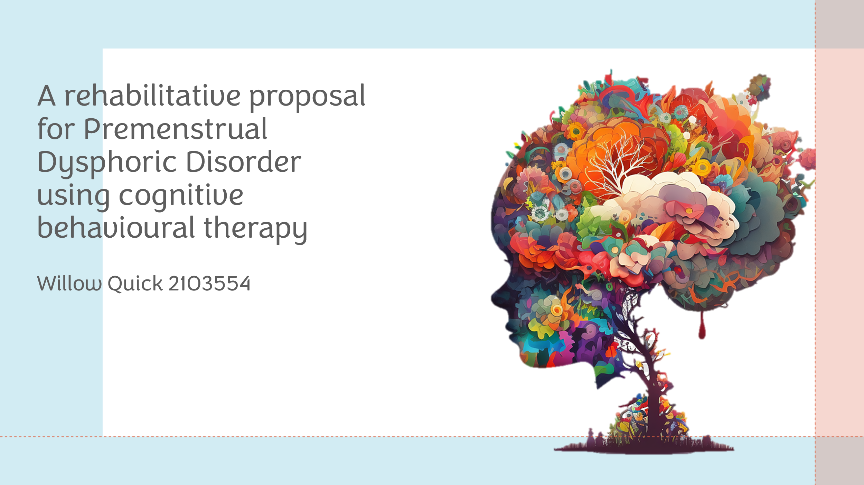

Lay Summary
Cognitive Behavioural Therapy (CBT) is the main method of treating individuals suffering from Premenstrual Dysphoric Disorder (PMDD). The symptoms of the condition itself are severe, including mood fluctuations and physical discomfort before menstruation. CBT provides individuals with achievable means of coping to navigate the difficulties of PMDD by systematically addressing negative thought patterns and maladaptive behaviours (Kancheva Landolt & Ivanov, 2020; Tiranini & Nappi, 2022). Recent research has demonstrated the efficacy of CBT in PMDD treatment, with significant decreases in mood disturbances and physical symptoms (Izadi-Mazidi et al., 2016; Weise et al., 2019). In order to measure the efficacy, the use of quantitative data analysis will be employed and the use of t-tests, ANOVAs, and linear regression analyses will allow for monitoring of symptoms. Implementing CBT into the treatment process not only addresses the psychological underlying causes of the condition, but also promotes increased awareness of triggers and adaptability (Hardy & Hardie, 2017).
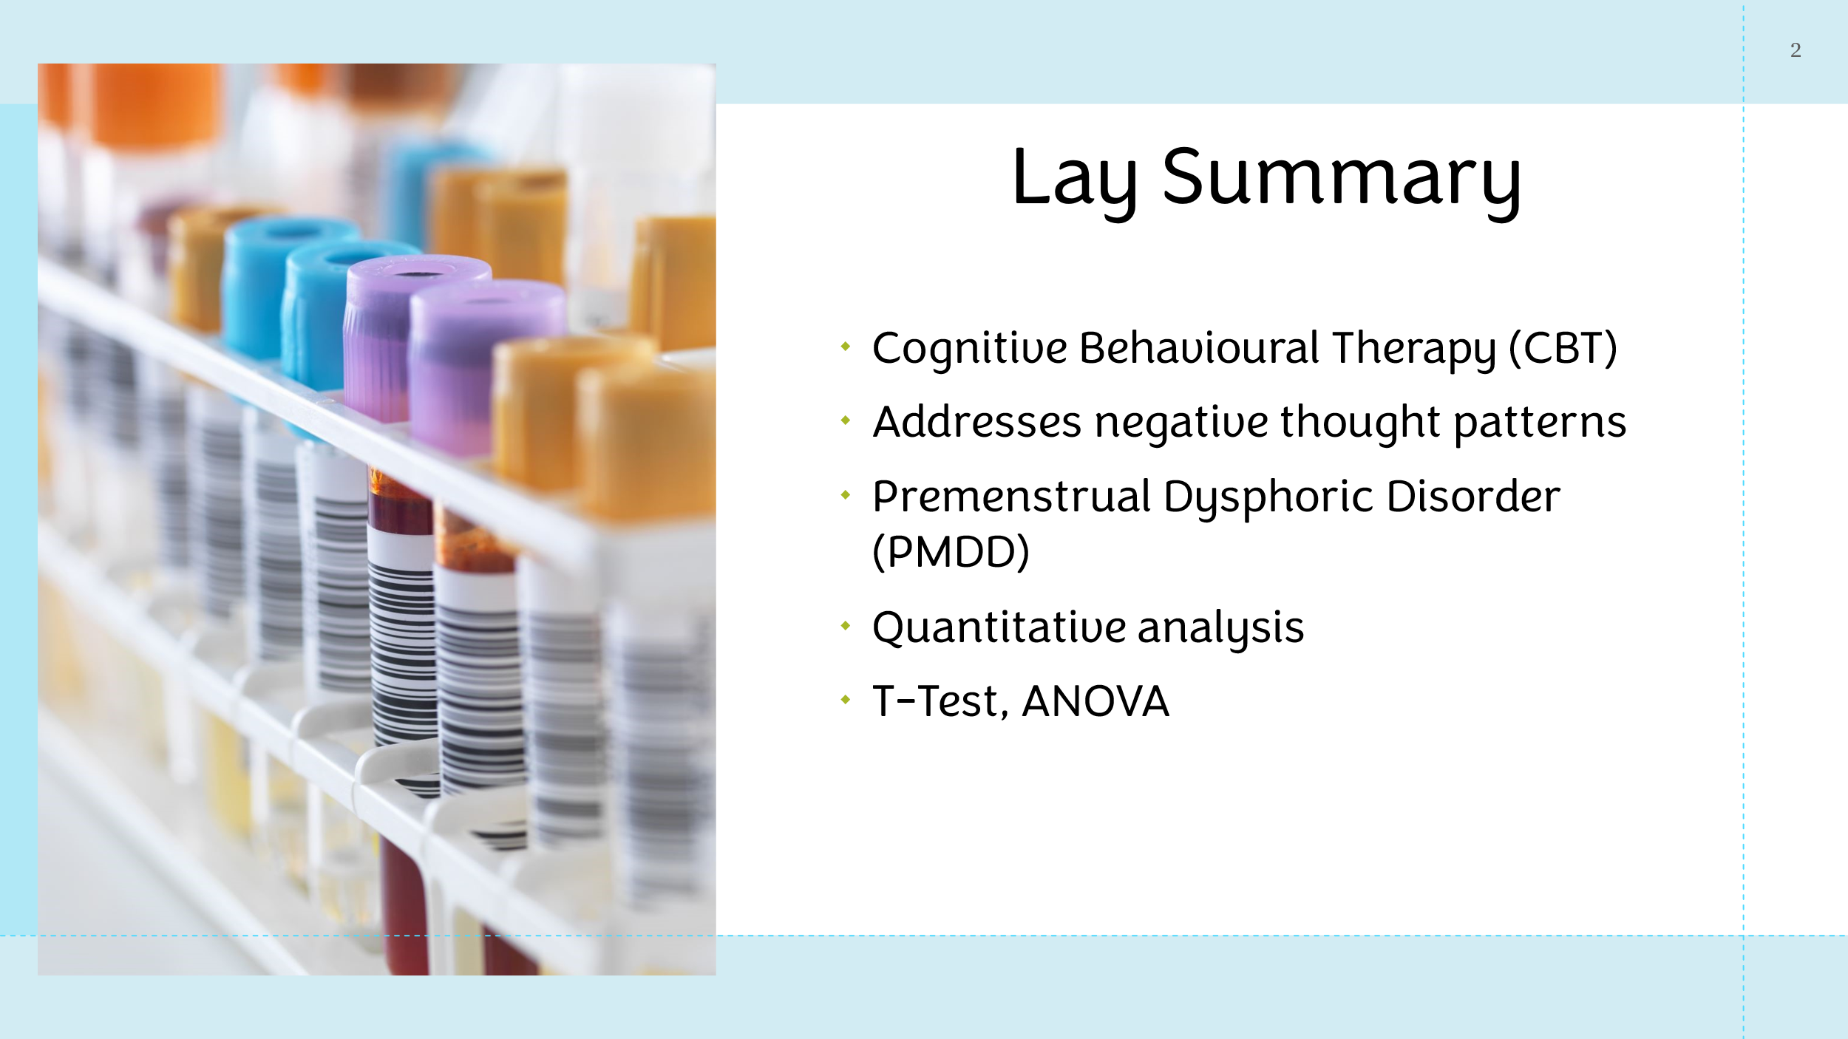

Background literature
A significant percentage of women suffer from PMDD, the most serious form of Premenstrual Syndromes (PMS), with estimated rates varying from 3 to 9% (Robinson & Ismail, 2015). PMDD is a condition that manifests as a range of emotional, behavioural, and physical symptoms that result from the ovulatory menstrual cycle's natural fluctuation in sex steroids (Rafique & Al-Sheikh, 2018; Thakrar et al., 2021). According to Eisenlohr-Moul (2019) and the International Classification of Diseases (2022), the symptoms must appear during the luteal stage of the menstrual cycle, usually three to four days before menstrual bleeding, and they must additionally improve in the first week after the bleeding begins.

A well-known method for treating the maladaptive thought patterns that underlie a variety of psychological disorders is CBT (Hofmann et al., 2012). Especially relevant in the setting of PMDD, where stress intensifies symptoms, CBT provides individuals with the techniques needed to overcome negativity and improve their ability to resolve problems through using balanced cognitive restructuring.
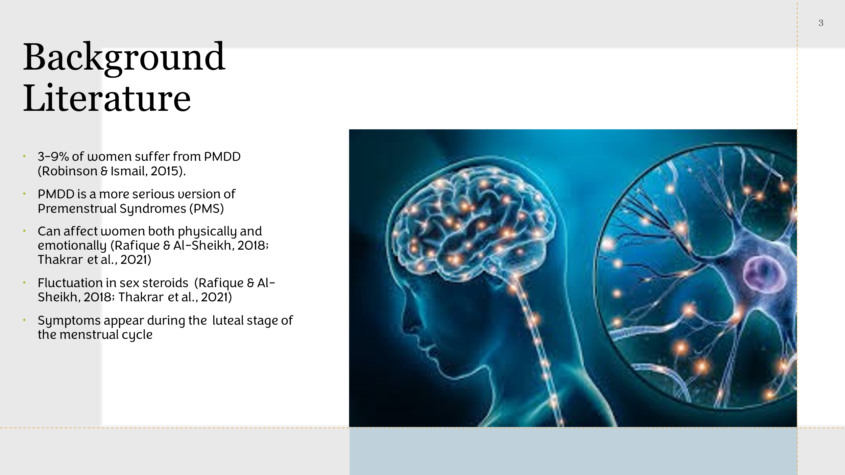
Premenstrual diseases continue to be poorly understood, despite advances in the understanding of the underlying pathophysiological processes. Hypotheses include increased susceptibility to hormonal variations during the luteal phase, abnormal serotonin activity, and abnormalities in progesterone and gamma-aminobutyric acid (GABA) neurotransmission. Interestingly, PMDD differs from other mood disorders in that its symptoms can be caused by fluctuations in ovarian hormone levels as opposed to long-term hormone exposure (Schmidt et al., 2017). In addition, PMDD symptoms disappear when menstrual cycling is absent, highlighting the disorder's unique connection to reproductive events including menopause and pregnancy (Reproductive Psychiatry Resource & Information Centre, 2008).
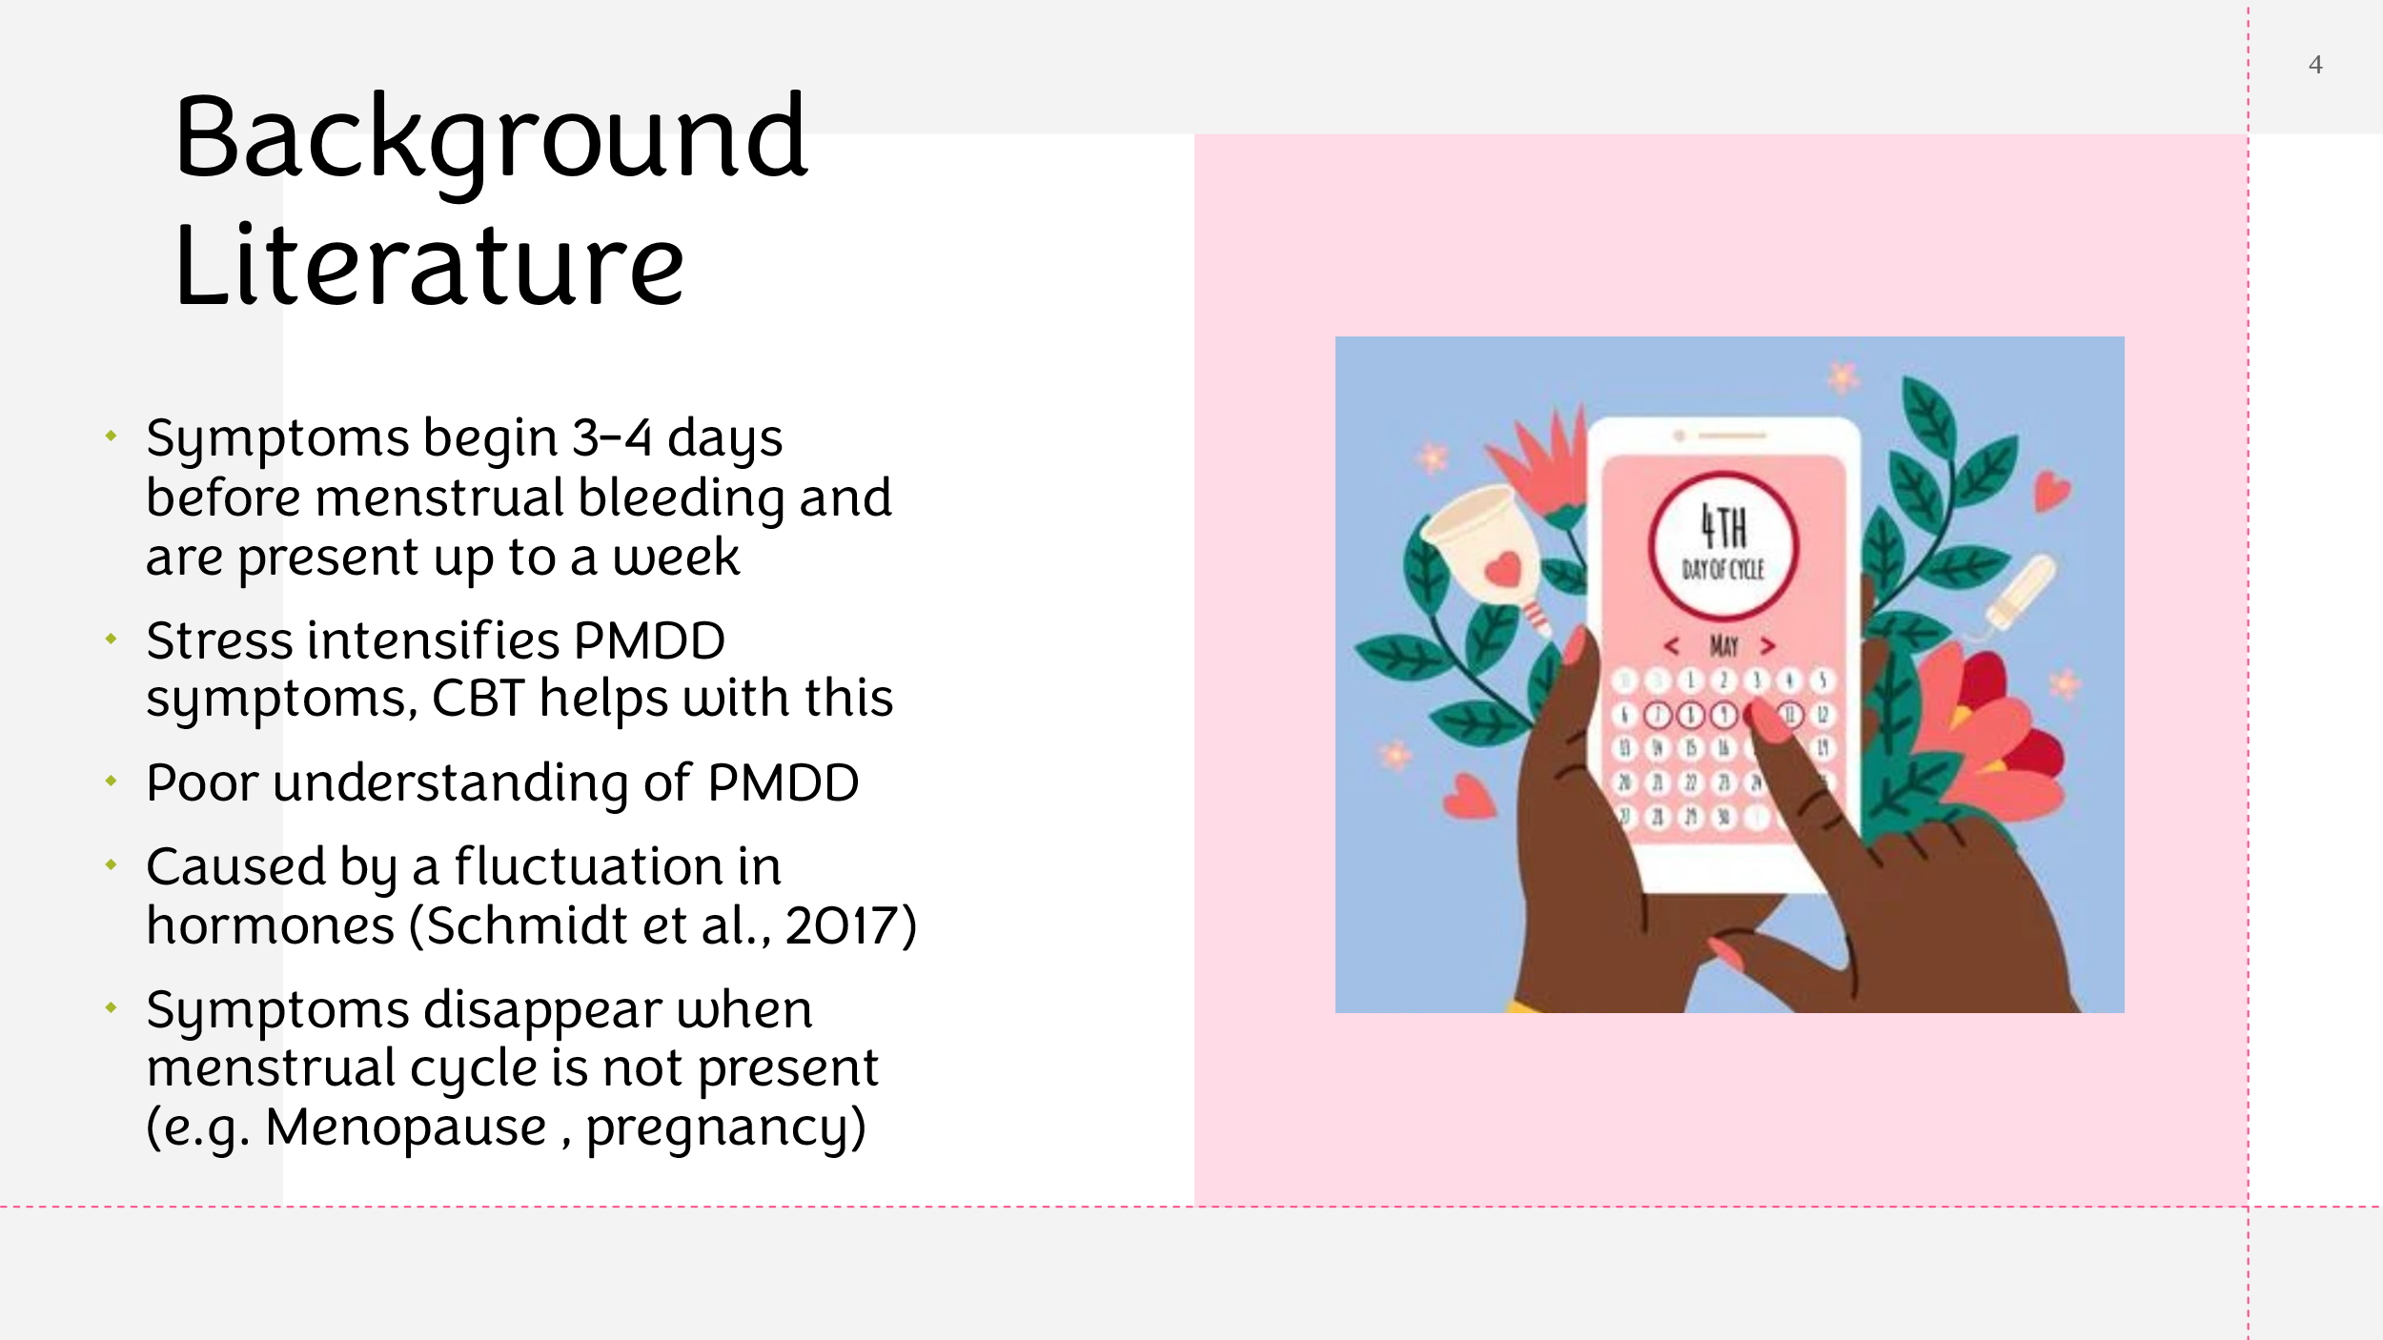
With the current literature missing key aspects such as definitions of both CBT and PMDD as well as its effectiveness, it was difficult to only include recent literature on this subject matter. This rehabilitation plan could have provided additional relevant data for those with PMDD symptoms if it had made use of recent findings. A more thorough examination of therapeutic approaches, such as medication and lifestyle changes, would enhance the subject matter and provide readers a more complete understanding of managing PMDD, regardless of whether CBT is mentioned as a treatment option.

Treatment
Treatment options for PMDD are restricted due to the complexity of the behavioural and emotional symptoms, the lack of knowledge regarding the cause of the disorder, and the inability to test for abnormalities (Alevizou et al., 2018).

It has also been demonstrated that fluoxetine administered in the luteal phase, at a dose of 90 mg two times a week, starting 14 days before menstruation, is effective (Miner et al., 2002). Additional research has demonstrated the effectiveness of sertraline (Kornstein et al., 2006) and fluoxetine (Nazari et al., 2012) at consistent doses in the treatment of severe PMDD. These studies were conducted during the luteal phase or at the beginning of symptoms.

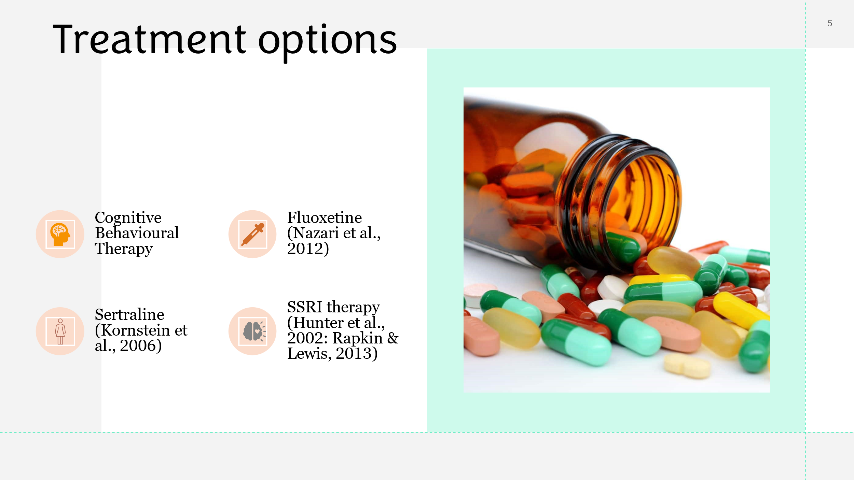
SSRI therapy has been successfully administered with CBT. At the 6-month mark, all CBT groups within the study conducted by Hunter et al., (2002) and Rapkin & Lewis, (2013), showed an improvement of statistical significance in PMS symptoms when compared with selective serotonin reuptake inhibitors (SSRIs) either individually or in conjunction. Moreover, there was better long-term recovery in the treatment groups that received CBT (Hunter et al., 2002: Rapkin & Lewis, 2013).

The research highlights how challenging it is to treat Premenstrual Dysphoric Disorder (PMDD) because of its complicated emotional and behavioural symptoms, our limited knowledge of its origin, and the absence of diagnostic tools. It does, however, offer confirmation of the effectiveness of some pharmaceutical treatments, specifically when taken during the luteal phase. It also highlights the collaborative advantages of combining cognitive behavioural therapy (CBT) with SSRIs, as evidenced by studies conducted by Rapkin & Lewis (2013) and Hunter et al. (2002), and this not only show a significant reduction in PMDD symptoms but additionally point to improved long-term outcomes with CBT. Ultimately, the combination of medication and CBT presents a promising route for long-term recovery and symptom management, even though treatment choices for PMDD are limited due to its complexity.

Proposed methodology
Design -
For those with a diagnosis of PMDD,, this study uses a randomised controlled trial (RCT) design to explore the effectiveness of a rehabilitative intervention utilising CBT. Participants will be allocated at random to one of two groups: the intervention group, which will get CBT, or the control group, which will receive conventional treatment (Borji-Navan et al., 2022).

Participants -
The target population consists of adult females who meet the DSM-5's diagnostic standards for PMDD (American Psychiatric Association, 2022). The recruitment of participants will take place through internet forums, community health facilities, and gynaecological clinics. A verified PMDD diagnosis, being between the ages of 18 and 45, and being competent to converse effectively in English are requirements for participation and will aid in the reliability of the rehabilitative proposal.

Criteria for exclusion -
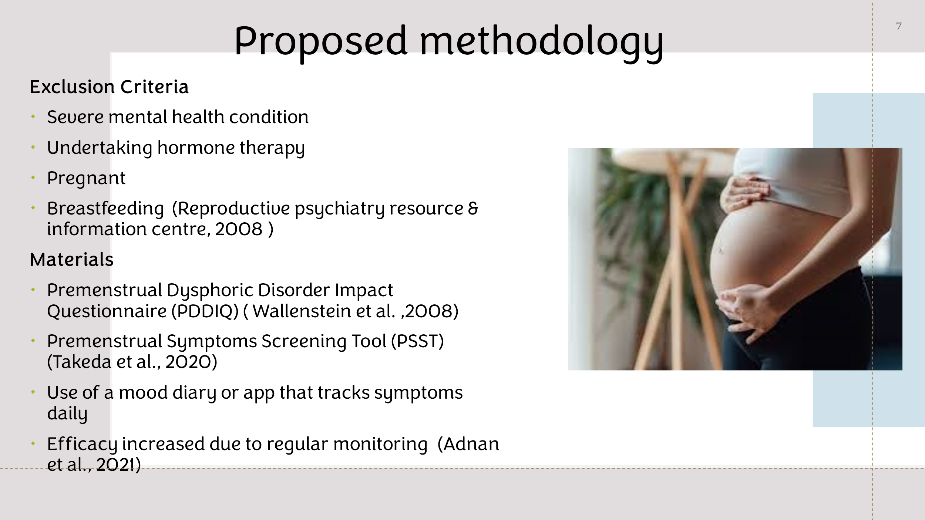
Severe comorbid mental illnesses, hormone therapy started within the previous three months, and being pregnant or breastfeeding at the time of application as well as those experiencing menopausal or pre-menopausal symptoms are all factors for exclusion (Reproductive psychiatry resource & information centre, 2008).

Materials -
The intervention procedure will commence with structured clinical interviews and the completion of standardised questionnaires, such as the Premenstrual Dysphoric Disorder Impact Questionnaire (PDDIQ) as described by Wallenstein et al., (2008) and the Premenstrual Symptoms Screening Tool (PSST) by Takeda et al., (2020). These tests are intended to evaluate symptom severity and validate the diagnosis of PMDD. In addition, participants will use a mood tracking app or diary, such as "Me v PMDD," "Clue app," or "Flo Health," to record daily fluctuations in mood, physical symptoms, and contextual factors. Participant comprehension of their PMDD experiences is deepened through regular monitoring with this tool, which increases the efficacy of the intervention (Adnan et al., 2021).

Procedure -
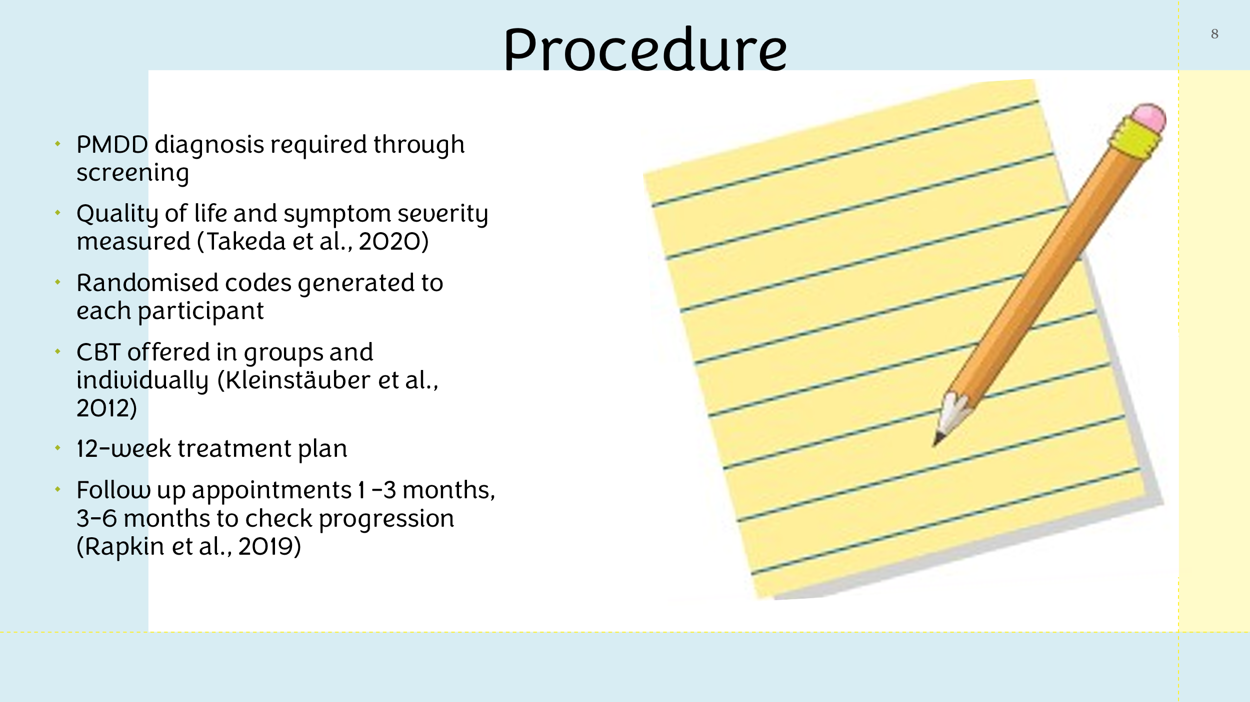
To confirm the diagnosis of PMDD, eligible individuals must complete an initial screening. Participants will also have an initial assessment of their quality of life and the severity of their symptoms (Takeda et al., 2020). Randomization codes generated by the computer will be used to assign participants at random to the intervention or control group. Individual CBT sessions aimed at treating PMDD symptoms will be provided to the intervention group for twelve weeks. The sessions will include behavioural therapy, cognitive restructuring as well as mindfulness. Participants in the control group will get routine medical attention (Kleinstäuber et al., 2012). In order to measure long-term results, post-intervention evaluations will be carried out shortly after the period of intervention, with subsequent evaluations scheduled at 3- and 6-month intervals (Rapkin et al., 2019).

Outcome measures
- Premenstrual Symptoms Screening Tool (PSST): A questionnaire where individuals can self-report their symptoms (Steege & Blumenthal, 2018).
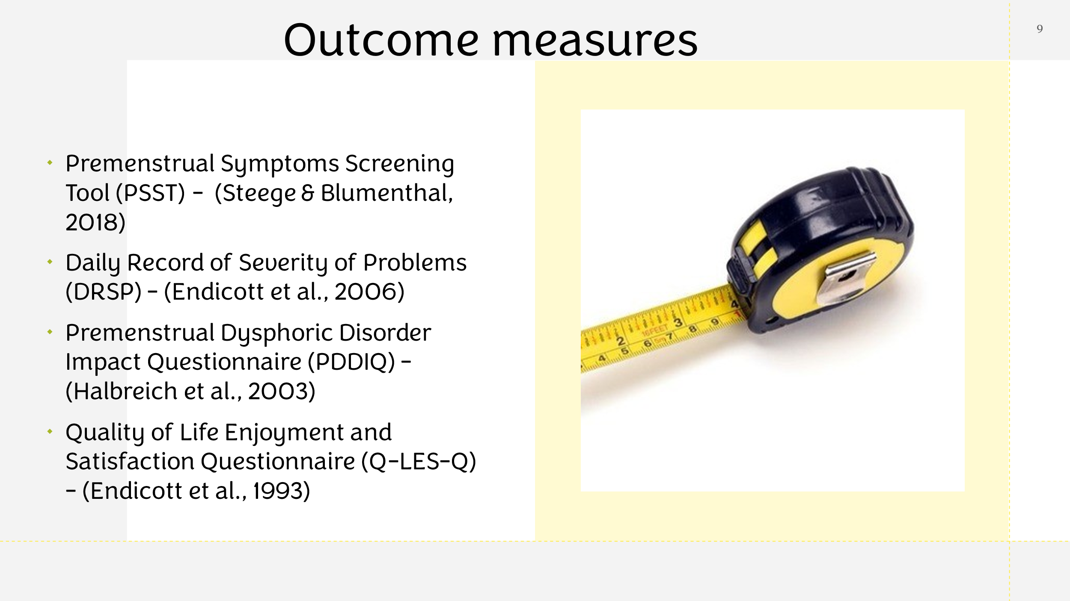
- Daily Record of Severity of Problems (DRSP): An app or diary used daily to track any changes in symptoms (Endicott et al., 2006).
- Premenstrual Dysphoric Disorder Impact Questionnaire (PDDIQ): A questionnaire in which PMDD patients receive tailored data to better understand the impairments associated with PMDD (Halbreich et al., 2003).
- Quality of Life Enjoyment and Satisfaction Questionnaire (Q-LES-Q): A questionnaire which shows the quality of life of the participants and whether they are physically healthy (Endicott et al., 1993).

Ethical considerations
- Informed consent: In order to give their informed consent, study participants must be aware of the goals, risks, and advantages. Two components of mitigation are voluntary involvement and clear information.

- Confidentiality: Personal data needs to be safeguarded. Strict data management methods and anonymity are necessary for mitigation.
- Respect for Autonomy: It's important to honour the decisions made by participants, throughout the investigation, mitigation takes preferences into account.
- Fair Treatment: Ensuring equal access for every individual involved diversity would mitigate this.
- Conflicts of interest: Transparency is essential when dealing with conflicts of interest. Mitigation strategies include transparency and accountable oversight.
- Regulatory compliance: Detailed documentation of the study is required and approval of an ethics panel or Institutional review board is required.

The study improves the internal validity of findings by guaranteeing comparability and fairness between the intervention and control groups by randomised allocation. The customised 12-week CBT sessions may result in improved symptom management. However, the study's generalizability may be limited by the recruiting strategies. Ethical issues have been taken into consideration, however it may be strengthened through focusing more attention to control group design and measurement tool validation.
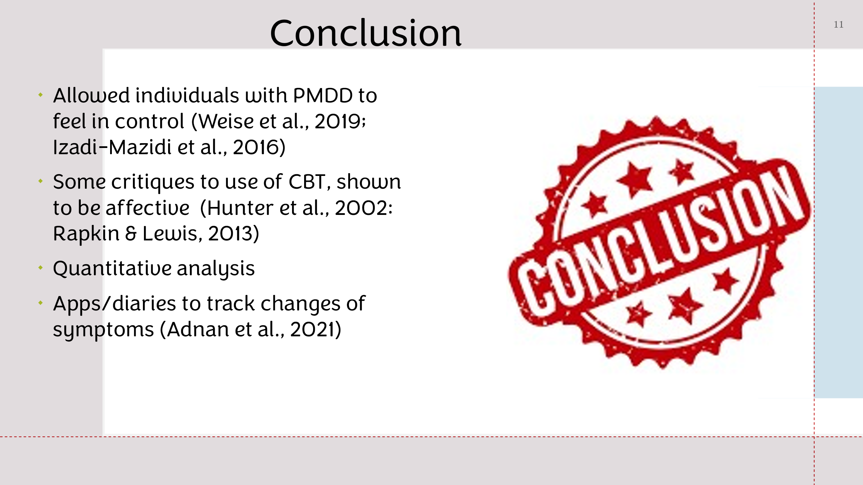
Conclusion
CBT has allowed individuals with PMDD to feel that they have a control over their symptoms and CBT has aided in minimising the overall symptoms experienced in PMDD patients (Weise et al., 2019; Izadi-Mazidi et al., 2016). Some studies criticised the use of CBT, however more recent research revealed it to be effective with PMDD (Hunter et al., 2002: Rapkin & Lewis, 2013). With the use of quantitative analysis and apps or diaries individuals are able to track their symptoms for any changes (Adnan et al., 2021) allowing those with PMDD to have a better quality of life overall.

Bibliography
Adnan, T., Coull, B. A., Jukic, A. M., & Mahalingaiah, S. (2021). The real-world applications of the symptom tracking functionality available to menstrual health tracking apps. Current Opinion in Endocrinology, Diabetes & Obesity, Publish Ahead of Print(3), 574–586. PubMed Central. https://doi.org/10.1097/med.0000000000000682
Alevizou, F., Vousoura, E., & Leonardou, A. (2018). Premenstrual Dysphoric Disorder: A Critical Review of Its Phenomenology, Etiology, Treatment and Clinical Status. Current Women S Health Reviews, 14(1), 59–66. Ingenta connect. https://doi.org/10.2174/1573404813666171027141849
American Psychiatric Association. (2022). Diagnostic and statistical manual of mental disorders. Diagnostic and Statistical Manual of Mental Disorders, Fifth Edition, Text Revision (DSM-5-TR), 5(5), 171–175. Psychiatry Online. https://doi.org/10.1176/appi.books.9780890425787
Borji-Navan, S., Mohammad-Alizadeh-Charandabi, S., Esmaeilpour, K., Mirghafourvand, M., & Ahmadian-Khooinarood, A. (2022). Internet-based cognitive-behavioral therapy for premenstrual syndrome: a randomized controlled trial. BMC Women’s Health, 22(1), 1–11. Springer Link. https://doi.org/10.1186/s12905-021-01589-7
Chan, K., Rubtsova, A. A., & Cari Jo Clark. (2023). Exploring diagnosis and treatment of premenstrual dysphoric disorder in the U.S. healthcare system: a qualitative investigation. BMC Women’s Health, 23(1), 33–58. BMC. https://doi.org/10.1186/s12905-023-02334-y
Eisenlohr-Moul, T. (2019). Premenstrual Disorders: A Primer and Research Agenda for Psychologists. The Clinical Psychologist, 72(1), 5–17. PubMed Central. https://doi.org/32362679
Hardy, C., & Hardie, J. (2017). Exploring premenstrual dysphoric disorder (PMDD) in the work context: a qualitative study. Journal of Psychosomatic Obstetrics & Gynecology, 38(4), 292–300. Taylor & Francis Online. https://doi.org/10.1080/0167482x.2017.1286473
Hofmann, S. G., Asnaani, A., Vonk, I. J. J., Sawyer, A. T., & Fang, A. (2012). The Efficacy of Cognitive Behavioral Therapy: a Review of Meta-Analyses. Cognitive Therapy and Research, 36(5), 427–440. Springer Link. https://doi.org/10.1007/s10608-012-9476-1
Hunter, M. S., Ussher, J. M., Browne, S. J., Cariss, M., Jelley, R., & Katz, M. (2002). A randomized comparison of psychological (cognitive behavior therapy), medical (fluoxetine) and combined treatment for women with premenstrual dysphoric disorder. Journal of Psychosomatic Obstetrics & Gynecology, 23(3), 193–199. Taylor & Francis Online. https://doi.org/10.3109/01674820209074672
International Classification of Diseases. (2022). ICD-11 for Mortality and Morbidity Statistics. Icd.who.int; International Classification of Diseases. https://icd.who.int/browse/2024-01/mms/en#1526774088
Itriyeva, K. (2022). Premenstrual syndrome and premenstrual dysphoric disorder in adolescents. Current Problems in Pediatric and Adolescent Health Care, 52(5), 101187. Science Direct. https://doi.org/10.1016/j.cppeds.2022.101187
Izadi-Mazidi, M., Davoudi, I., & Mehrabizadeh, M. (2016). Group Cognitive-Behavioral Therapy and Health-Related Quality of Life in Females With Premenstrual Syndrome. Iranian Journal of Psychiatry and Behavioral Sciences, In Press(InPress), 3. PubMed Central. https://doi.org/10.17795/ijpbs-4961
Kancheva Landolt, N., & Ivanov, K. (2020). Short report: cognitive behavioral therapy - a primary mode for premenstrual syndrome management: systematic literature review. Psychology, Health & Medicine, 26(10), 1–12. Taylor & Francis Online. https://doi.org/10.1080/13548506.2020.1810718
Kirkby, R. J. (1994). Changes in premenstrual symptoms and irrational thinking following cognitive-behavioral coping skills training. Journal of Consulting and Clinical Psychology, 62(5), 1026–1032. APA PsycNet. https://doi.org/10.1037/0022-006x.62.5.1026
Kleinstäuber, M., Witthöft, M., & Hiller, W. (2012). Cognitive-Behavioral and Pharmacological Interventions for Premenstrual Syndrome or Premenstrual Dysphoric Disorder: A Meta-Analysis. Journal of Clinical Psychology in Medical Settings, 19(3), 308–319. Research Gate. https://doi.org/10.1007/s10880-012-9299-y
Kornstein, S. G., Pearlstein, T. B., Fayyad, R., Farfel, G. M., & Gillespie, J. A. (2006). Low-dose sertraline in the treatment of moderate-to-severe premenstrual syndrome: efficacy of 3 dosing strategies. Journal of Clinical Psychiatry, 67(10), 1624.
Miner, C., Brown, E., McCray, S., Gonzales, J., & Wohlreich, M. (2002). Weekly luteal-phase dosing with enteric-coated fluoxetine 90 mg in premenstrual dysphoric disorder: A randomized, double-blind, placebo-controlled clinical trial. Clinical Therapeutics, 24(3), 417–433. Science Direct. https://doi.org/10.1016/s0149-2918(02)85043-3
Nakao, M., Shirotsuki, K., & Sugaya, N. (2021). Cognitive–behavioral therapy for management of mental health and stress-related disorders: Recent advances in techniques and technologies. BioPsychoSocial Medicine, 15(1), 1–4. BioPsychoSocial Medicine. https://doi.org/10.1186/s13030-021-00219-w
Nazari, H., Yari, F., Jariani, M., Marzban, A., & Birgandy, M. (2012). Premenstrual syndrome: a single-blind study of treatment with buspirone versus fluoxetine. Archives of Gynecology and Obstetrics, 287(3), 469–472. Springer Link. https://doi.org/10.1007/s00404-012-2594-x
Rafique, N., & Al-Sheikh, M. (2018). Prevalence of menstrual problems and their association with psychological stress in young female students studying health sciences. Saudi Medical Journal, 39(1), 67–73. Taylor & Francis Online. https://doi.org/10.15537/smj.2018.1.21438
Rapkin, A. J., Korotkaya, Y., & Taylor, K. C. (2019). Contraception counseling for women with premenstrual dysphoric disorder (PMDD): current perspectives. Open Access Journal of Contraception, Volume 10(2), 27–39. https://doi.org/10.2147/oajc.s183193
Rapkin, A. J., & Lewis, E. I. (2013). Treatment of Premenstrual Dysphoric Disorder. Women’s Health, 9(6), 537–556. Sage Journals. https://doi.org/10.2217/whe.13.62
Reproductive psychiatry resource & information centre. (2008, February 22). PMS & PMDD - MGH Center for Women’s Mental Health. MGH Centre for Women’s Mental Health; Harvard medical school. https://womensmentalhealth.org/specialty-clinics-2/pms-and-pmdd/#:~:text=In%20addition%2C%20PMDD%20mood%20symptoms
Robinson, L. L., & Ismail, K. M. (2015). Clinical epidemiology of premenstrual disorder: informing optimized patient outcomes. International Journal of Women’s Health, 7(7), 811–818. Taylor & Francis Online. https://doi.org/10.2147/IJWH.S48426
Schmidt, P. J., Martinez, P. E., Nieman, L. K., Koziol, D. E., Thompson, K. D., Schenkel, L., Wakim, P. G., & Rubinow, D. R. (2017). Premenstrual Dysphoric Disorder Symptoms Following Ovarian Suppression: Triggered by Change in Ovarian Steroid Levels But Not Continuous Stable Levels. American Journal of Psychiatry, 174(10), 980–989. Science Direct. https://doi.org/10.1176/appi.ajp.2017.16101113
Takeda, T., Yoshimi, K., & Yamada, K. (2020). Psychometric Testing of the Premenstrual Symptoms Questionnaire and the Association Between Perceived Injustice and Premenstrual Symptoms: A Cross-Sectional Study Among Japanese High School Students. International Journal of Women’s Health, Volume 12(6), 755–763. Dovepress. https://doi.org/10.2147/ijwh.s269392
Thakrar, P., Bhukar, K., & Oswal, R. (2021). Premenstrual dysphoric disorder: Prevalence, quality of life and disability due to illness among medical and paramedical students. Journal of Affective Disorders Reports, 4(4), 100112. Science Direct. https://doi.org/10.1016/j.jadr.2021.100112
Tiranini, L., & Nappi, R. E. (2022). Recent advances in understanding/management of premenstrual dysphoric disorder/premenstrual syndrome. Faculty Reviews, 11(11), 1–5. PubMed Central. https://doi.org/10.12703/r/11-11
Wallenstein, G. V., Blaisdell-Gross, B., Gajria, K., Guo, A., Hagan, M., Kornstein, S. G., & Yonkers, K. A. (2008). Development and Validation of the Premenstrual Symptoms Impact Survey (PMSIS): A Disease-Specific Quality of Life Assessment Tool. Journal of Women’s Health, 17(3), 439–450. PubMed Central. https://doi.org/10.1089/jwh.2007.0377
Weise, C., Kaiser, G., Janda, C., Kues, Johanna N., Andersson, G., Strahler, J., & Kleinstäuber, M. (2019). Internet-Based Cognitive-Behavioural Intervention for Women with Premenstrual Dysphoric Disorder: A Randomized Controlled Trial. Psychotherapy and Psychosomatics, 88(1), 16–29. Karger. https://doi.org/10.1159/000496237




