Cloud Engineering Principles and Practice Report

Name: Vanshaj AshishKumar Patel
Student ID: 2517969
Course: MSc Cybersecurity and Digital Forensics
Module: Cloud Engineering Principles and Practice
University: University Of Wales

Declaration:
I declare that the work contained within this report is entirely my own and that all sources have been correctly referenced using the IEEE citation format.

Docker | Containerisation | Virtualisation | Cloud Architecture
A Technical Report based on Practical Implementation on a Windows Host System

Table of Contents
- Executive Summary
- Introduction
2.1 Purpose of the Report
2.2 Why Containerisation Matters
2.3 Why Windows as the Host OS
- System Overview and Practical Environment (Windows Host)
3.1 Windows Host System Configuration
3.2 Practical Tools Used in the Module
3.3 Containerisation vs Virtualisation (Windows-Focused Explanation)
- Docker Fundamentals
4.1 Understanding Docker Architecture
4.2 Images, Containers, and Registries
4.2.1 Docker Images
4.2.2 Docker Containers
4.2.3 Docker Registries
4.3 Docker Networking
4.3.1 Bridge Networking
4.3.2 Host Networking
4.3.3 Overlay Networking
4.4 Docker Storage and Volumes
4.4.1 Creating a Docker Volume
4.5 Docker Desktop on Windows
4.6 Summary of Practical Docker Operations Performed
- Practical Implementation and Configuration
5.1 Application Development Environment Setup
5.2 Creating the Flask Web Application
5.3 Creating and Understanding the Dockerfile
5.4 Building the Docker Image
5.5 Running the Container Locally
5.6 Implementing Docker Networking
5.7 Data Persistence Using Docker Volumes
5.8 Tagging and Uploading to Docker Hub
5.9 Pulling and Running Images from Docker Hub
5.10 Summary of Practical Outcomes
- Cloud Architecture Concepts: Load Balancing, Scalability, and Application Gateways
6.1 AWS Implementation of Load Balancing
6.1.1 Load Balancing Mechanisms
6.1.2 Load Balancing in the E-Commerce Scenario
6.2 AWS Implementation of Scalability
6.2.1 Auto Scaling Capabilities
6.2.2 Scalability in the E-Commerce Scenario
6.3 AWS Implementation of Application Gateways
6.3.1 Role of Application Gateways
- Integration and Technical Evaluation
7.1 Why Load Balancing and Scaling Are Complementary Concepts
7.1.1 Load Balancing Enables Effective Scaling
7.1.2 Scaling Enhances Load Balancer Efficiency
7.2 Benefits of Combining Load Balancing, Scaling, and Application Gateways
- Driving Forces Behind Cloud Computing Expansion
8.1 Cost Reduction and Pay-As-You-Go Economics
8.2 Flexibility and Elastic Resource Provisioning
8.3 Innovation Through Managed Services
- Serverless Functions vs Containerisation
9.1 Explanation of Serverless Functions
9.2 Comparison of Containerisation and Serverless
- Conclusion
- Final IEEE Reference List

Table of Figures
Figure 5.1 HTML File Screenshot
Figure 5.2 Python Flask Application (app.py) Screenshot
Figure 5.3 Dockerfile Screenshot
Figure 5.4 Flask Application Project Directory
Figure 5.5 Web Browser Output of Containerised Flask Webpage
Figure 5.6 Docker Desktop Screenshot (Dashboard Showing Containers/Images)
Figure 5.7 Built Docker Image in Docker Images List
Figure 5.8 Running Flask Container with Port Mapping
Figure 5.9 Creation of Docker Network
Figure 5.10 Docker Network Connectivity Test
Figure 5.11 Docker Volume Persistence Demonstration
Figure 5.12 Tagging the Docker Image for Repository Upload
Figure 5.13 Docker Hub Repository Showing Uploaded Image
Figure 5.14 Pushing Docker Image to Docker Hub
Figure 5.15 Pulling Docker Image from Docker Hub
Figure 5.16 Running the Pulled Docker Image
Figure 5.17 Screenshot Showing the Running Pulled Container

1. Executive Summary
This report delivers a technical and practice-driven examination of containerisation technologies and cloud-oriented deployment methods, all demonstrated on a native Windows environment. The work focuses on Docker as the primary tool for building and managing containerised applications, providing a complete walkthrough from initial setup to image deployment.
The study evaluates how modern organisations benefit from containers—particularly their speed, portability, and efficient use of system resources—when compared with legacy virtualisation approaches. By packaging applications together with their required libraries, containers ensure that software behaves consistently across various computing environments, making them highly suitable for DevOps workflows and cloud-native ecosystems.
The practical component covers the full Docker workflow on Windows, including installation, execution of CLI commands, image building through Dockerfiles, multi-container setups, custom networking, and the use of persistent storage volumes. It also includes pushing and pulling images through Docker Hub to demonstrate how containerised applications can be shared, distributed, and prepared for deployment in cloud environments.
These practical exercises are supported by theoretical discussions on Docker Engine architecture, layered images, container networking models, and storage abstractions. Combined, they illustrate how containerisation contributes to scalable, reproducible, and secure cloud solutions—reinforcing the relevance of these technologies in modern enterprise computing.

2. Introduction
Over recent years, container technologies have reshaped how software systems are developed, deployed, and maintained. Unlike conventional deployment models that rely on full operating system virtualisation, containers isolate applications at the process level. This allows them to start quickly, use fewer resources, and run consistently across different environments. Organisations such as Google, Netflix, and Amazon incorporate container-based workflows because they promote modular development, simplify scaling, and enable efficient cloud-native architectures.
This report combines theoretical study with hands-on work to provide a clear understanding of containerisation using Docker. All demonstrations are performed on a Windows host system, which reflects a realistic enterprise development setting where applications are typically built and tested before being deployed to Linux-based cloud platforms.
Purpose of the Report
The primary aim of this report is to present a structured and practical exploration of containerisation principles by implementing Docker on a Windows environment. It outlines the core concepts behind Docker’s architecture, illustrates how containers are built and executed, and demonstrates key features such as networking, volumes, and image management.
Additionally, the report highlights how these capabilities support cloud-native application deployment and modern DevOps practices. The overall intention is to connect theoretical concepts with practical execution to demonstrate clear competency in container-based engineering.

Why Containerisation Matters
Traditional deployment approaches often encounter issues such as inconsistent environments, dependency conflicts, and inefficient resource utilisation. Containerisation addresses these challenges by packaging applications together with the files and configurations they require, creating a predictable and isolated runtime environment.
This approach offers multiple operational advantages:
- Reliable deployments across different hosts
- Reduction in dependency and configuration errors
- Streamlined integration with CI/CD pipelines
- Lightweight execution suitable for microservices
- Stronger isolation compared to conventional setups
NIST recognises containerisation as a key element of modern cloud-native computing because it supports rapid scaling, flexible orchestration, and improved operational efficiency [1].
Why Windows as the Host OS?
Windows continues to be widely used as a primary workstation operating system in many organisations. For developers and engineers, a Windows environment is often the starting point for building and testing applications before they are deployed to cloud platforms.
Modern versions of Windows, particularly through Windows Subsystem for Linux (WSL 2), provide strong support for container-based workflows. Docker Desktop integrates directly with WSL 2, enabling Linux containers to run smoothly on Windows without the need for full virtual machines [2].
Using Windows for the practical component ensures that the demonstrations in this report reflect a realistic corporate development workflow while still achieving full compatibility with Linux-based container images used in cloud environments.

3. System Overview and Practical Environment (Windows Host)
This section outlines the technical environment used throughout the practical activities. All tasks were completed directly on the Windows host system, ensuring the work reflects a real-world development setting without relying on additional virtual machines.
3.1 Windows Host System Configuration
The practical component was carried out on a Windows workstation configured to support container-based development. The system met the recommended requirements for running Docker Desktop, including:
- Operating System: Windows 10/11 (64-bit)
- Memory: Minimum of 8 GB RAM
- Processor: Intel/AMD CPU with hardware virtualisation enabled
- Software Stack:
  - Docker Desktop
  - Windows Terminal or PowerShell
  - Web browser for accessing Docker Hub
Docker Desktop leverages WSL 2 to provide a lightweight Linux kernel environment, allowing Linux-based containers to run smoothly on Windows. This setup ensures compatibility with widely used Docker images while maintaining a familiar Windows development ecosystem.

3.2 Practical Tools Used in the Module
The exercises in this module relied on several tools integrated within the Windows environment. Docker Desktop served as the core platform, providing the Docker Engine, CLI, Docker Compose functionality, and a graphical dashboard for monitoring images and containers.
PowerShell or Windows Terminal was used to execute Docker commands such as docker run, docker build, and docker compose.
Docker Hub acted as the remote registry for storing and retrieving container images. Optional tools like Git and Visual Studio Code supported file management and application development.
This combination of tools created a practical workflow similar to what developers use in modern DevOps pipelines.

3.3 Containerisation vs Virtualisation (Windows-Focused Explanation)
Although this module did not require the use of virtual machines, understanding how containerisation differs from virtualisation is essential for evaluating why containers have become widely adopted.
Containerisation
Containers bundle an application together with the libraries, runtime components, and configuration it needs to execute. Instead of duplicating a full operating system for each application instance, containers share the host machine’s kernel while remaining logically isolated from one another. This makes them lightweight, fast to start, and resource-efficient—qualities that are highly valued in cloud-native development.
Containers package the application code together with:
- Libraries
- Runtimes
- Environment variables
- Configuration files
Containers share the host OS kernel, allowing them to run extremely efficiently. Docker containers start in milliseconds and consume very little memory.
Why This Module Avoids Virtual Machines
Because the focus of this module is to explore container-based technologies, all practical tasks were carried out directly on the Windows host using Docker Desktop and its integration with WSL 2.
This mirrors how developers typically build and test containerised applications before deploying them to production systems managed through services such as Kubernetes, AWS ECS, or Azure Kubernetes Service.
4. Docker Fundamentals
Docker has become a central technology in cloud engineering because it enables developers to package applications into portable units that can run reliably across diverse systems. Its lightweight execution model aligns closely with modern microservices and cloud-native practices, making it one of the most influential tools in contemporary IT environments. Research consistently highlights the role of containerisation in improving application consistency, deployment speed, and operational efficiencies within distributed systems [1][2].
4.1 Understanding Docker Architecture
Docker follows a client–server design in which the user interacts with the Docker Client, and the Docker Engine manages the underlying container operations. The Engine consists of several key components that work together to build, execute, and manage containers.
- Docker Daemon (dockerd):
This background service is responsible for handling tasks such as managing images, networks, volumes, and the lifecycle of containers. It exposes an API that the client uses to submit commands [3].
- Docker REST API:
The API provides a communication interface that external services, tools, and the Docker client use to interact with the daemon over HTTP.
- Docker Client (docker):
The CLI tool sends commands (such as docker run or docker pull) to the Docker Daemon, which interprets and executes them.
Because Docker relies on OS-level process isolation rather than full hardware virtualisation, containers have significantly lower overhead and can start in a fraction of the time required by conventional virtual machines [4].
This contributes to significantly faster startup times, which can range from milliseconds to seconds.

4.2 Images, Containers, and Registries
This section discusses the three core elements of the Docker ecosystem: images, containers, and registries. These components work together to package, distribute, and execute applications in consistent environments.

4.2.1 Docker Images
A Docker image serves as a pre-configured blueprint that contains everything needed to run an application. Docker constructs images using a layered filesystem, where each instruction in the Dockerfile contributes a separate read-only layer. This layered structure offers several advantages: faster distribution, reduced duplication, and efficient caching during the build process [5].
Example characteristics of images include:
- Reusability across different systems
- Portability between development and cloud environments
- Tag-based versioning for easy management
- Extensibility through inheritance from base images
The Dockerfile showcased in the practical work demonstrates how images are constructed from base components, dependencies, and application code.

4.2.2 Containers
A container represents a running instance of a Docker image. Rather than including a full operating system, a container relies on isolated namespaces and resource controls to remain separated from other processes while sharing the host kernel [6].
Key characteristics include:
- Rapid startup due to minimal overhead
- Ephemeral design, unless paired with volumes
- Lightweight execution ideal for microservices
- Predictable behaviour across different hosts
In the practical work, containers were launched using commands such as:
docker run -d -p 5000:5000 myflaskapp:latest
This executed the application within a fully isolated environment while exposing it to the host system.

4.2.3 Docker Registries
Docker registries store and distribute images. Docker Hub is the most widely used public registry, although cloud providers offer their own services such as AWS Elastic Container Registry (ECR) and Azure Container Registry (ACR).
During the practical tasks, you created a Docker Hub repository, tagged your local image, and uploaded it to the registry. This demonstrates how registries support CI/CD workflows, multi-environment deployments, and collaborative development [7].

4.3 Docker Networking
Docker provides several networking drivers that enable containers to communicate with each other and with external systems. Each driver supports different use cases, ranging from standalone development setups to distributed multi-host clusters.
Network Driver | Description
Bridge | Default driver for standalone containers
Host | Shares host network stack
Overlay | Enables multi-host container communication
None | Provides full network isolation
Macvlan | Assigns MAC addresses to containers

4.3.1 Bridge Networking
Bridge mode is the default network driver for standalone containers. Containers attached to the same bridge network can communicate using internal IP addresses or DNS-based service names.
This model is widely used in development scenarios and small-scale deployments where containers reside on a single host.
4.3.2 Host Networking
Host networking allows a container to bypass Docker’s virtual network and use the host’s network stack directly.
Although this provides performance benefits by eliminating network abstraction layers, it reduces isolation and is used only in specific cases where direct network access is required.
4.3.3 Overlay Networking
Overlay networks enable communication between containers running on different hosts. This driver forms the basis of distributed container platforms such as Docker Swarm and Kubernetes, where services span multiple nodes.
Although not part of the practical work, overlay networks are essential in enterprise-grade orchestration systems [8].
4.4 Docker Storage and Volumes
Containers do not persist data by default because their internal filesystems are reset when the container is removed. Docker addresses this limitation through storage options such as volumes, bind mounts, and tmpfs mounts.
- Volumes: Managed by Docker and stored in locations outside the container lifecycle
- Bind Mounts: Link directories from the host filesystem to a container
- tmpfs Mounts: Store data in RAM for temporary use
Volumes were used in your practical exercises to preserve application data between container restarts, which mirrors how stateful services are handled in production environments [9].

4.4.1 Creating a Docker Volume
You can implemented volumes using commands such as:
docker volume create myvolume
docker run -d -v myvolume:/data mycontainer
This method ensured that application data persisted even after container removal.
Volumes are widely used for:
- database storage
- configuration files
- stateful application data
- logs and analytics
This approach ensures that data stored within /data remains available even if the container is recreated. Persistent storage is a fundamental requirement for applications such as databases, log processors, and analytics systems.
According to industry analysis, volume abstraction is a crucial feature enabling containers to maintain state across distributed environments [9].

4.5 Docker Desktop on Windows
Docker Desktop integrates tightly with Windows by using WSL 2 to provide a lightweight Linux environment.
This enables Linux containers to run natively while allowing developers to interact with them through familiar Windows tools.
Features such as the graphical dashboard, built-in Kubernetes support, and resource monitoring make Docker Desktop suitable for both learning and production-oriented development workflows.
4.6 Summary of Practical Docker Operations Performed
Below is a consolidated list of operations you completed during practical tasks, which will be expanded in detail in Part 3:
- Created Dockerfiles in VS Code
- Built images using docker build
- Ran containers serving Flask web apps
- Created custom Docker networks
- Assigned container IPs and performed ping tests
- Created Docker volumes for persistence
- Pushed and pulled images to/from Docker Hub
- Created Docker Hub repositories
- Mapped ports to expose containerised web apps
- Accessed applications via browser
These hands-on tasks demonstrate practical mastery of containerisation fundamentals, aligning with the module’s learning outcomes.

5. Practical Implementation and Configuration
This section presents a detailed walkthrough of all the practical tasks completed during the module. The work was carried out on a Windows-based environment using Docker Desktop, Visual Studio Code, PowerShell/Terminal, and a browser for testing deployed services. The tasks involve building a simple Flask web application, containerising it using Docker, implementing networking, managing data persistence through volumes, and pushing images to Docker Hub. These operations demonstrate proficiency in containerisation and cloud-native application deployment, aligning with modern DevOps practices [1][2].

5.1 Application Development Environment Setup
The practical work began by preparing the core development environment on Windows. This included:
- Installing Python 3
- Installing Visual Studio Code
- Setting up Docker Desktop with WSL2 backend
- Verifying Docker Engine functionality using:
- docker --version
- docker run hello-world
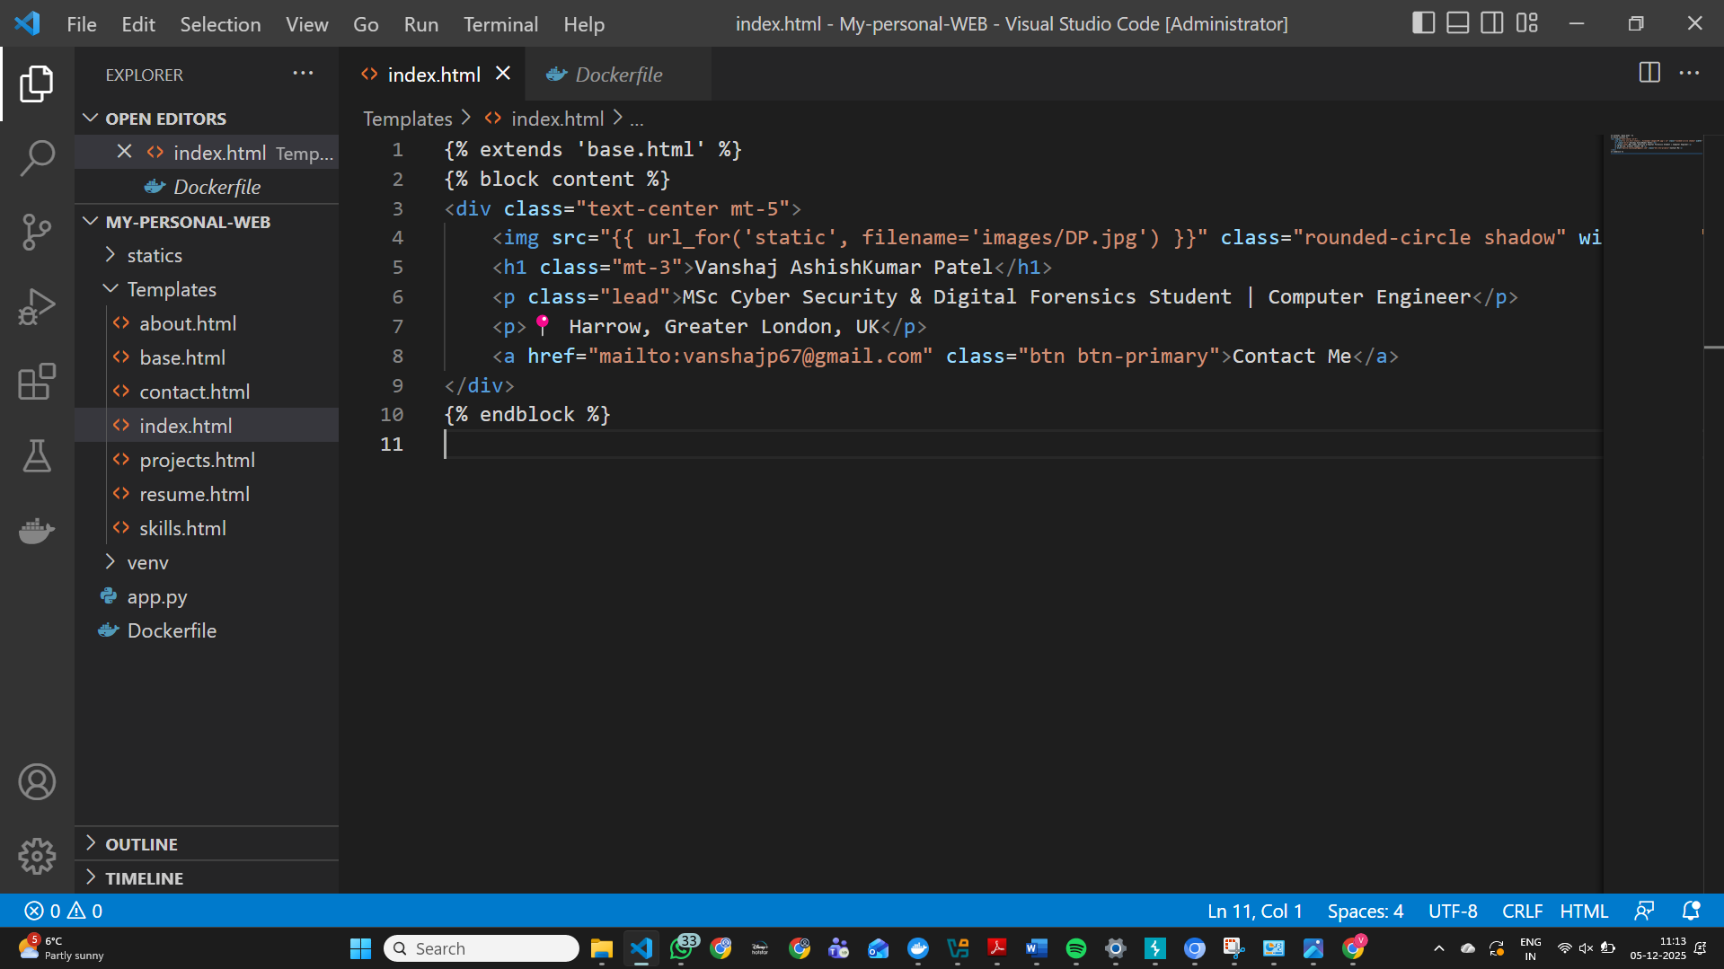
Figure 5.1 — HTML File
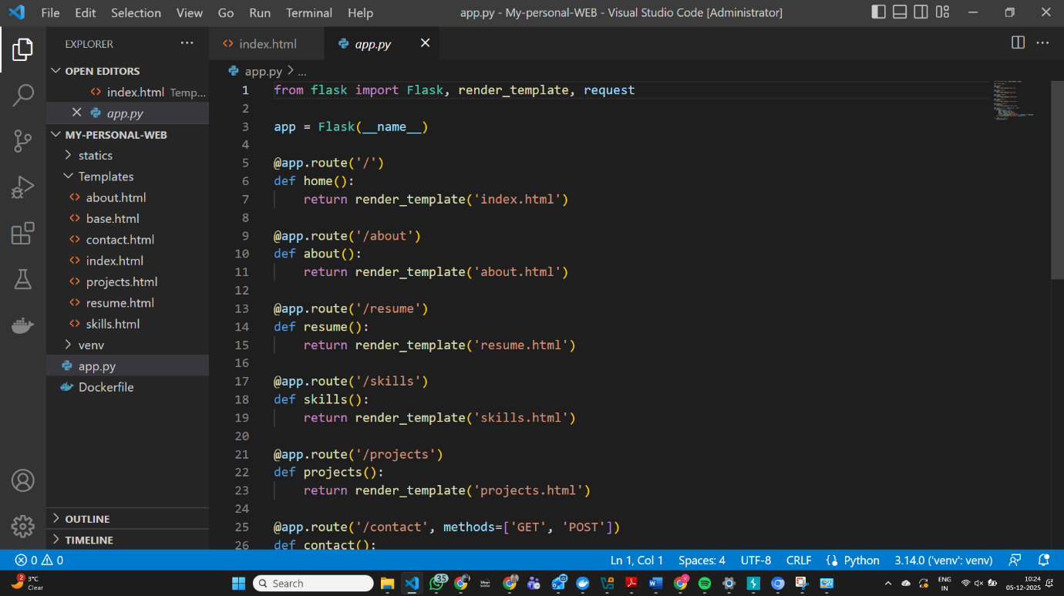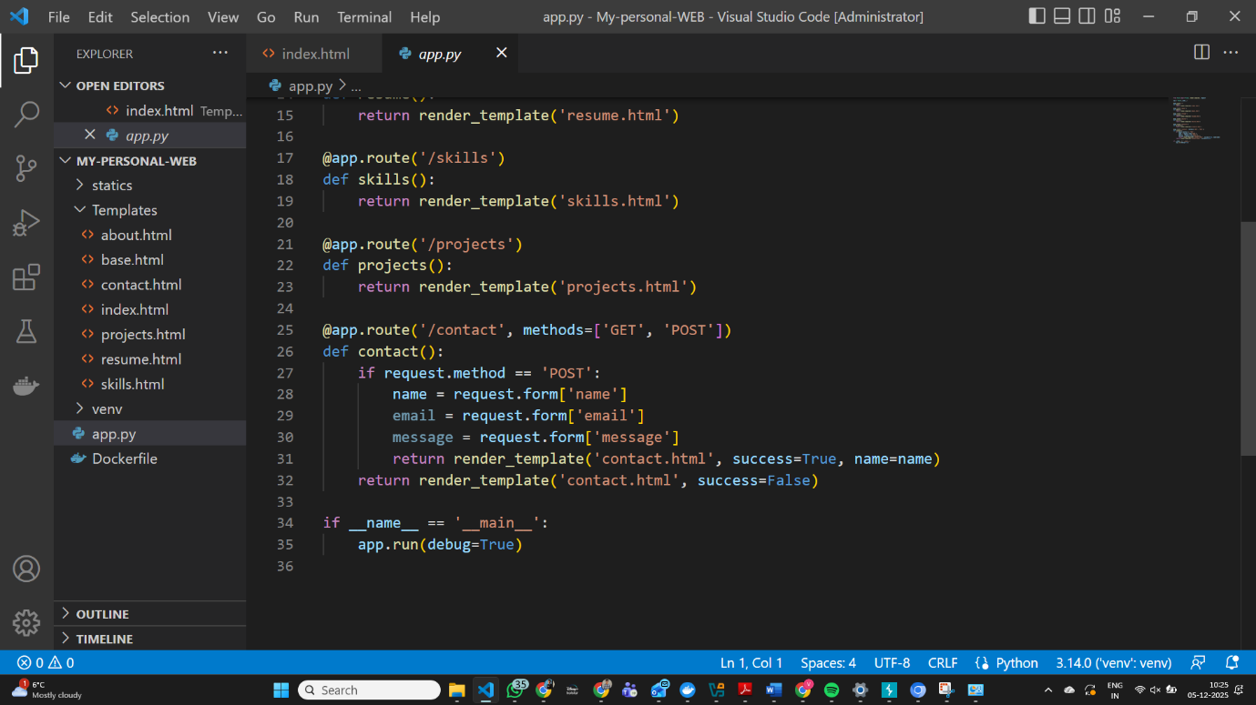
Figure 5.2 Python Flask Application (app.py) Screenshot
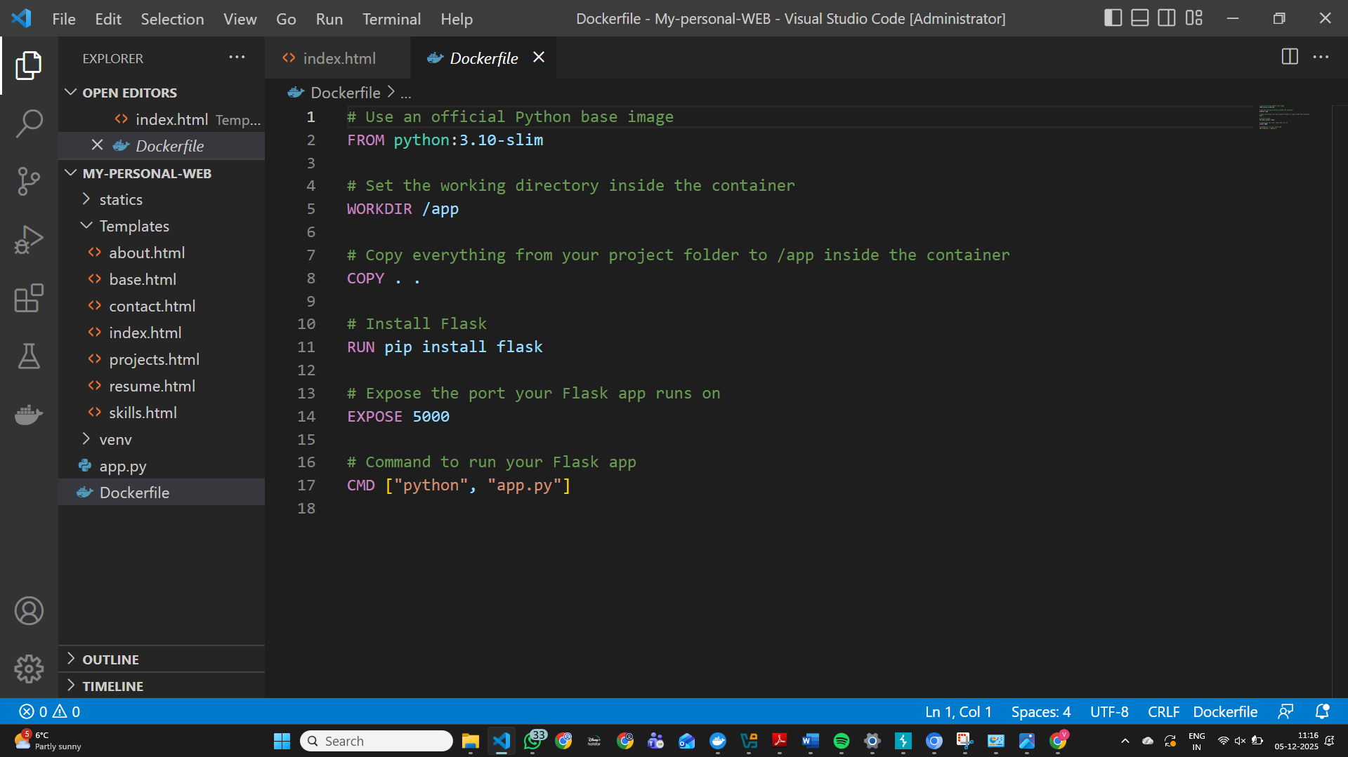Figure 5.3 Dockerfile Screenshot
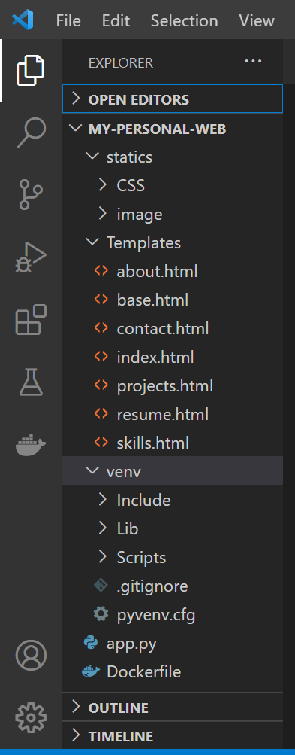
Figure 5.4 Flask Application Project Directory
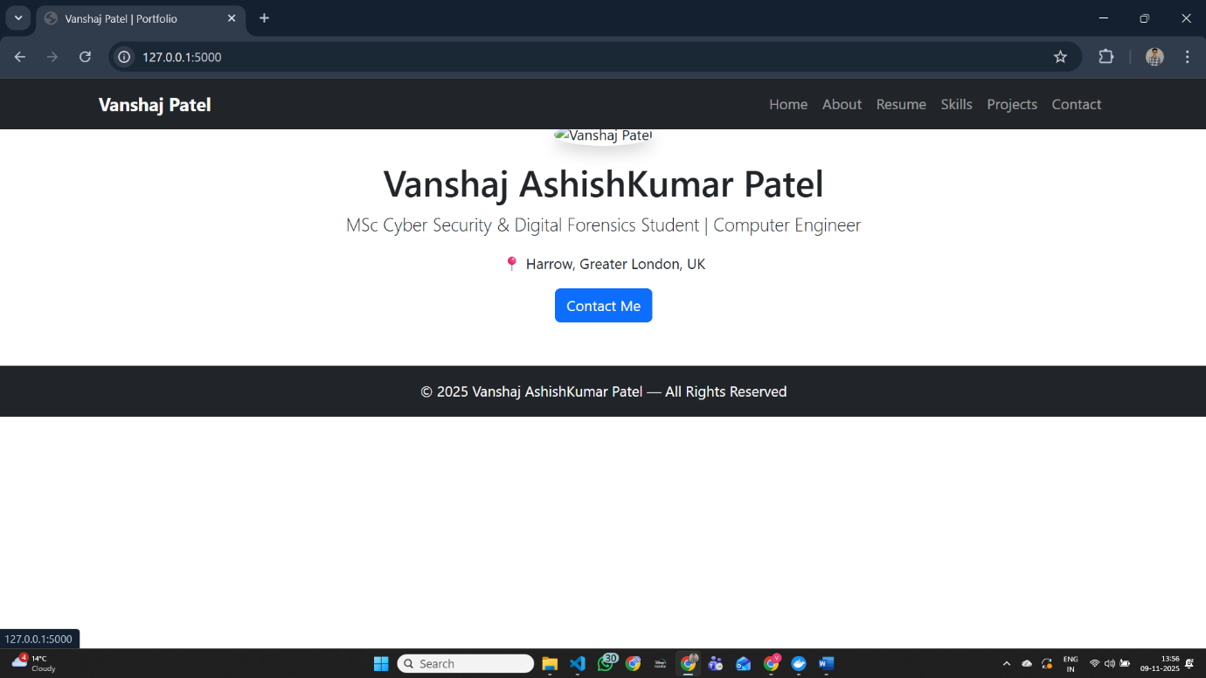

Figure 5.5 Web Browser Output of Containerised Flask Webpage

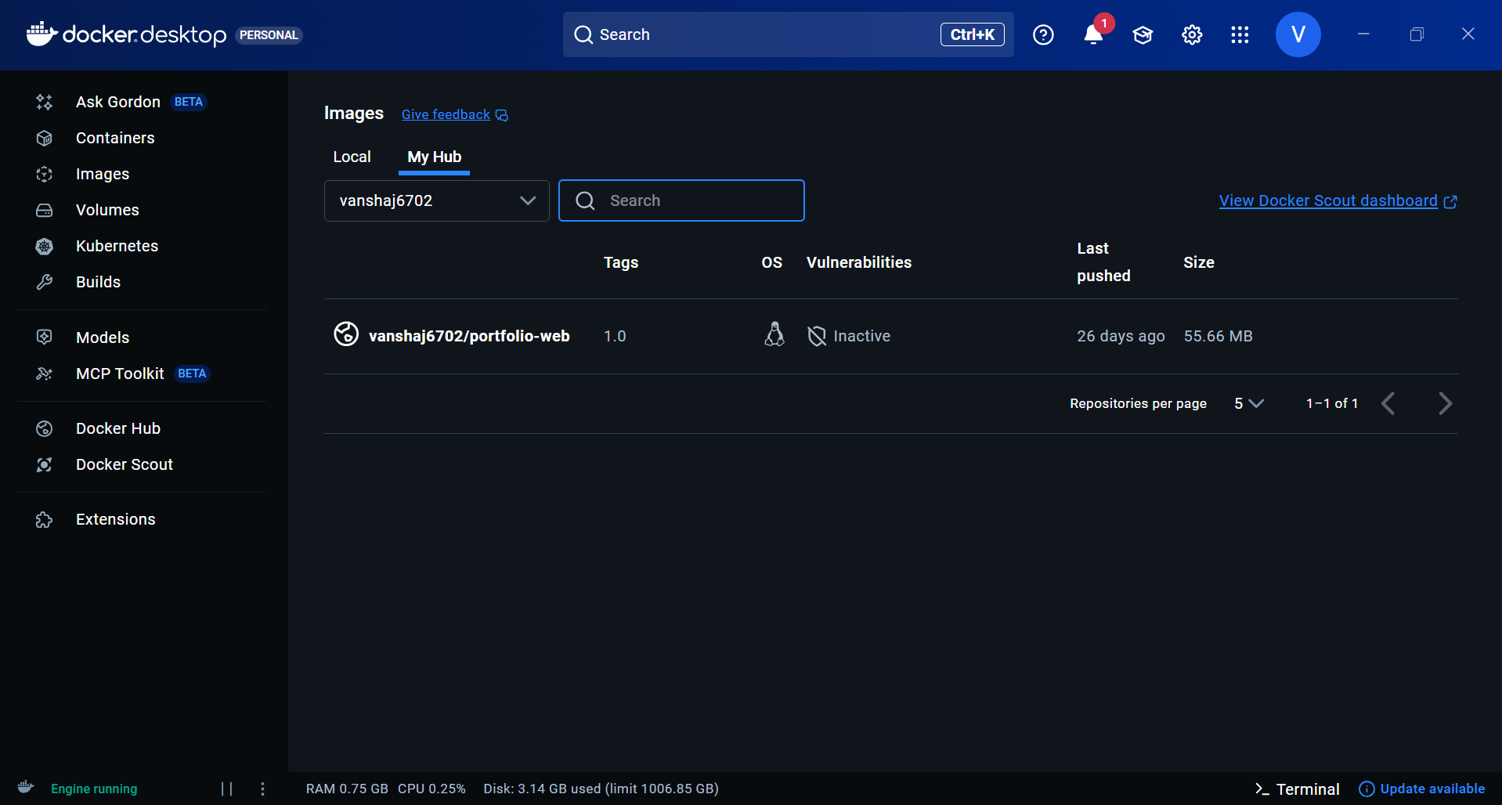
Figure 5.6 Docker Desktop Screenshot
These initial checks ensured that the system could build and run containers without errors.

5.2 Creating the Flask Web Application
A simple Python-based web application was created to demonstrate Docker containerisation.
This minimal application allowed focus on Docker features rather than app complexity.

5.3 Creating and Understanding the Dockerfile
The Dockerfile defines how the image is built. The following instructions were used:
Explanation of key components:
- FROM defines the base image
- WORKDIR sets working directory
- COPY copies application code
- RUN installs dependencies
- CMD starts the app within the container
The Dockerfile forms the blueprint for generating the container image [3].

5.4 Building the Docker Image
The following command was executed from the project directory:
docker build -t mydockerhub/mydockerimage:1.0 .
This triggered Docker Engine to pull the base image, install dependencies, and bundle the application.
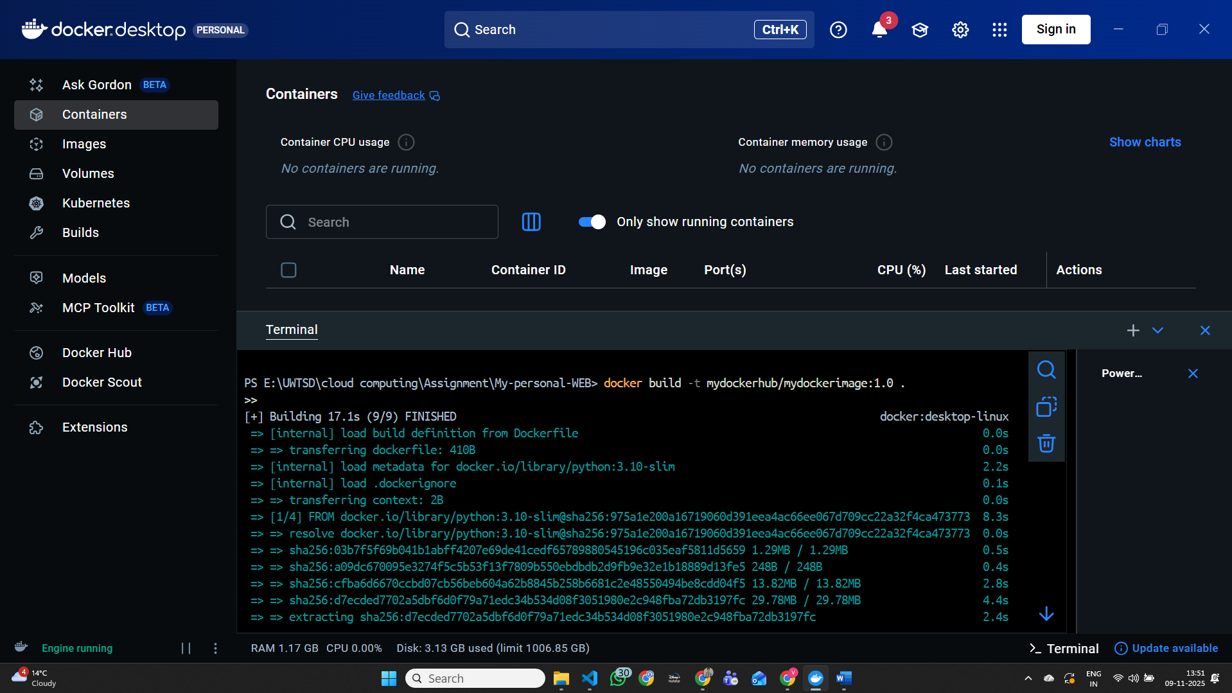
Figure 5.7 Built Docker Image in Docker Images List
After building, the image was verified using:
docker images

5.5 Running the Container Locally
The application container was executed using:
docker run -d -p 5000:5000 --name portfolio mydockerhub/mydockerimage:1.0
Key flags:
- -d → run in detached mode
- -p → maps host port to container port
- --name → assigns container name
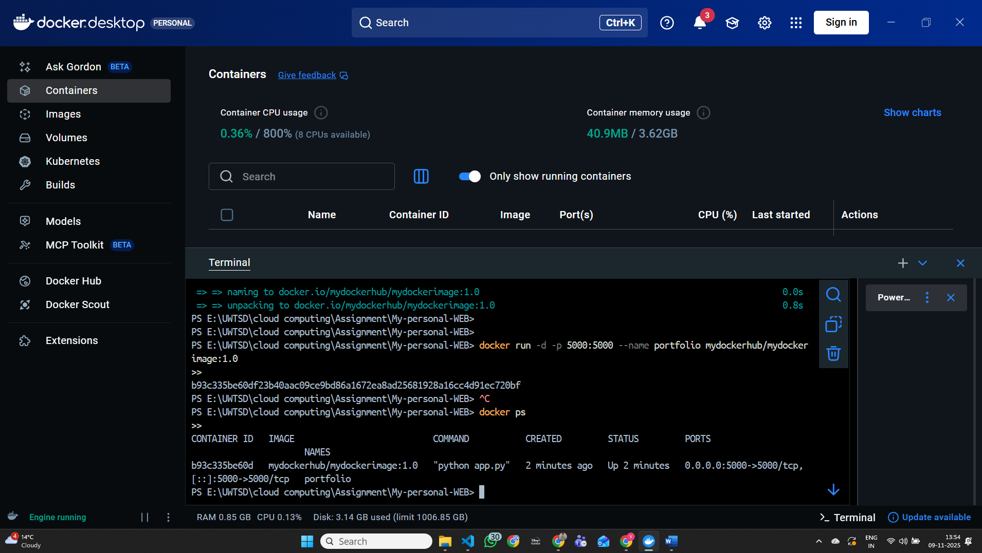
Figure 5.8 Running Flask Container with Port Mapping
This demonstrated successful local deployment.

5.6 Implementing Docker Networking
To understand container-to-container communication, a custom Docker network was created:
docker network create mynetwork

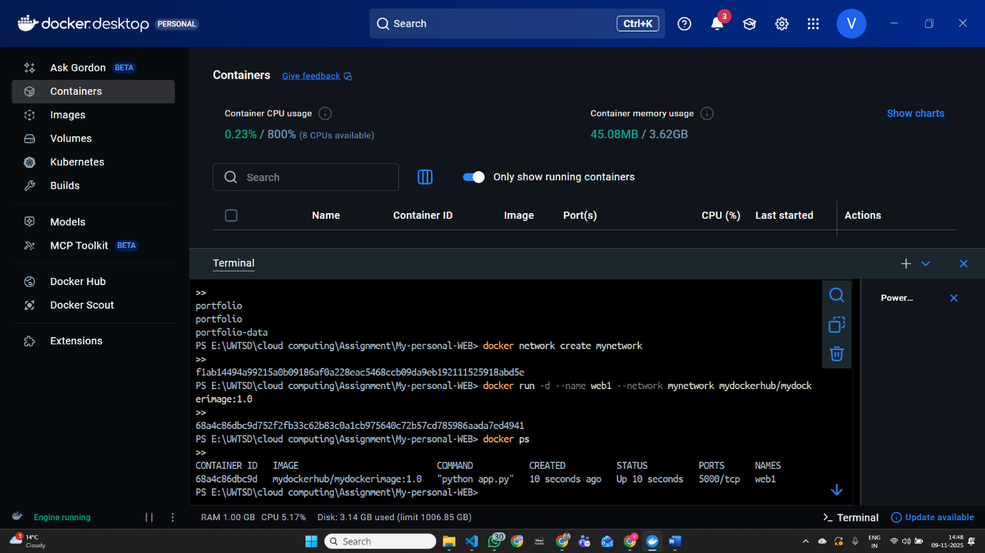
Figure 5.9 Creation of Docker Network
Then, internal connectivity was verified:
docker exec -it testcontainer ping flaskappcontainer
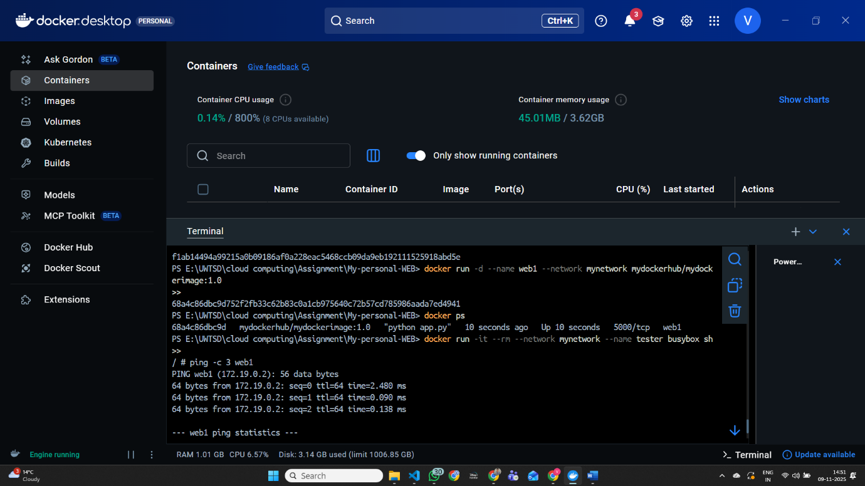
Figure 5.6 Docker Network Connectivity Test

The success of this ping confirmed DNS-based name resolution within the Docker network [4].

5.7 Data Persistence Using Docker Volumes
A key concept in Docker is persistence. Containers are stateless by default, so volumes store data outside the container’s lifecycle.
A volume was created using:
docker volume create appdata
The container was modified to mount the volume:
docker run -d -p 5000:5000 --name flaskapp2 -v appdata:/data flaskwebapp:1.0
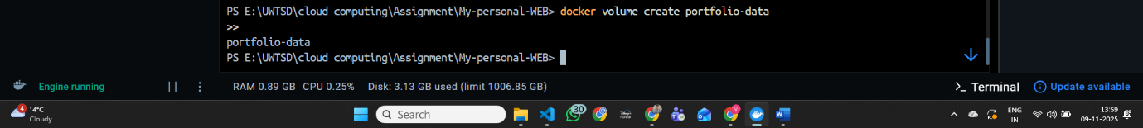
Figure 5.11 Docker Volume Persistence Demonstration
Files written to /data inside the container persisted even after container deletion.
This approach aligns with best practices for production-grade cloud applications [5].

5.8 Tagging and Uploading to Docker Hub
A new repository was created on Docker Hub, and the local image was tagged:
docker tag flaskwebapp:1.0 username/flaskapp:1.0
The image was then pushed:
docker push username/flaskapp:1.0
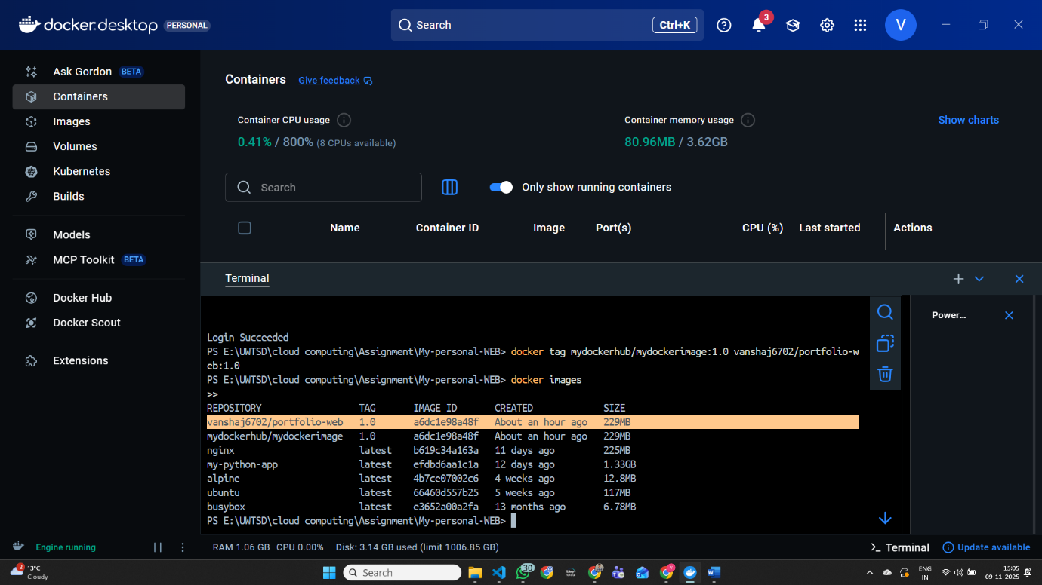
Figure 5.12 Tagging the Docker Image for Repository Upload
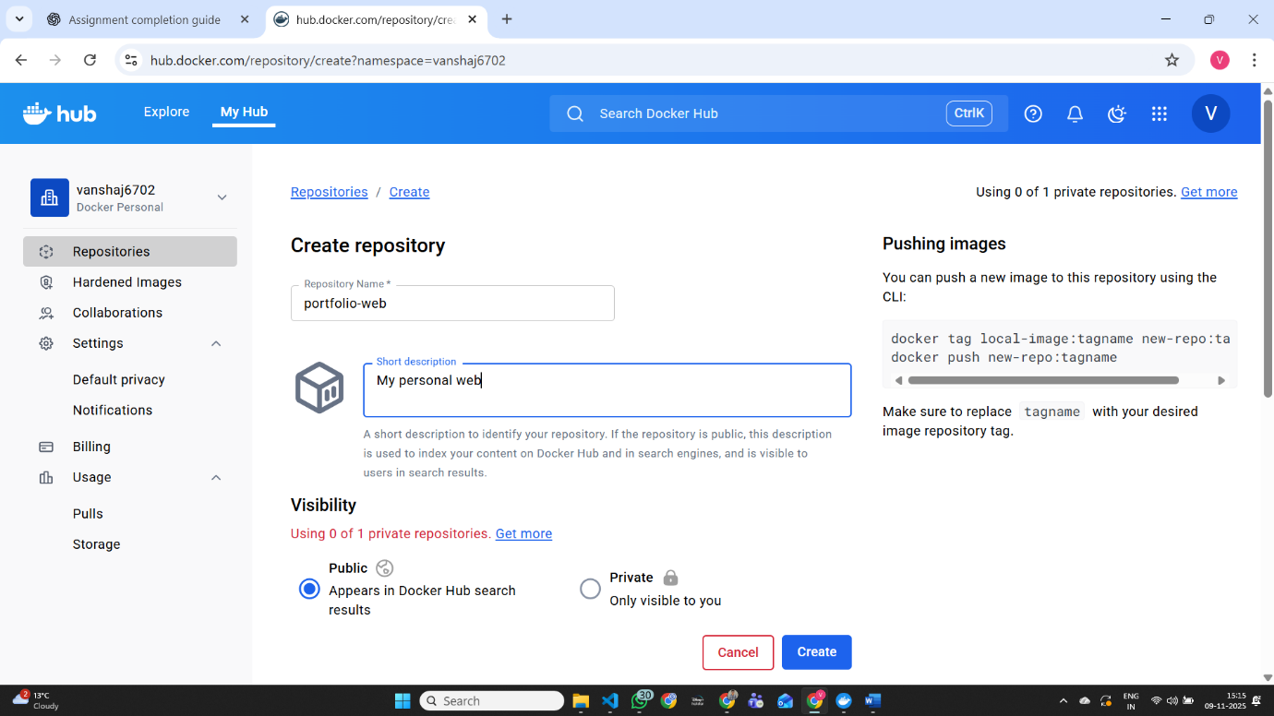
Figure 5.13 Docker Hub Repository

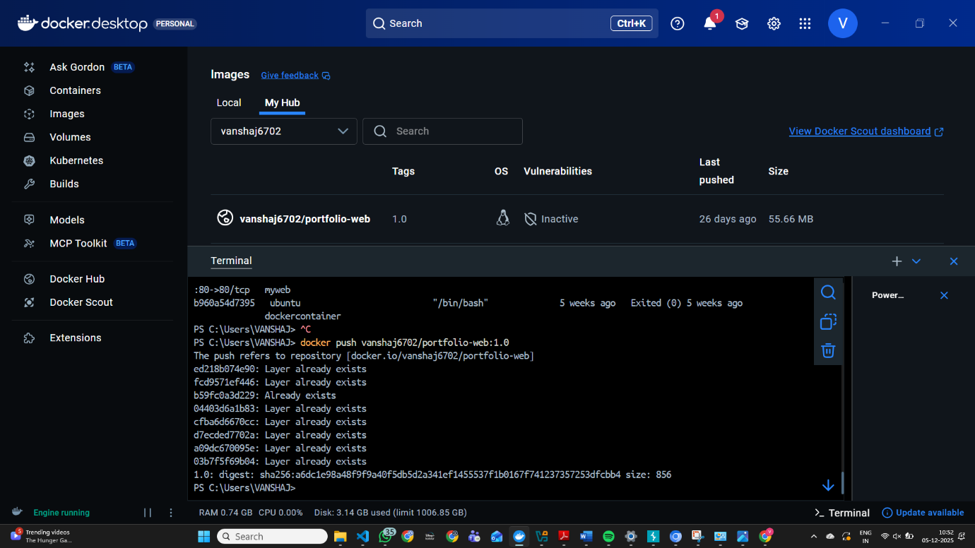
Figure 5.14 Pushing Docker Image to Docker Hub

This step demonstrated container distribution, a requirement in DevOps workflows and CI/CD pipelines [6].

5.9 Pulling and Running Images from Docker Hub
To verify remote accessibility, the image was pulled back:
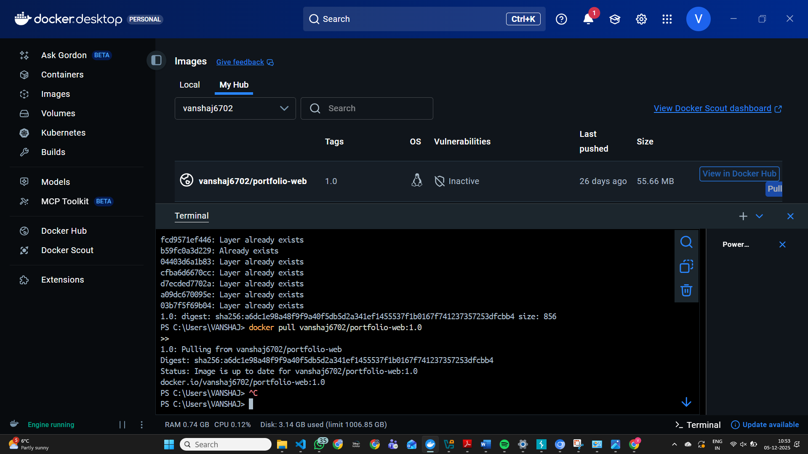Figure 5.15 Pulling Docker Image from Docker Hub
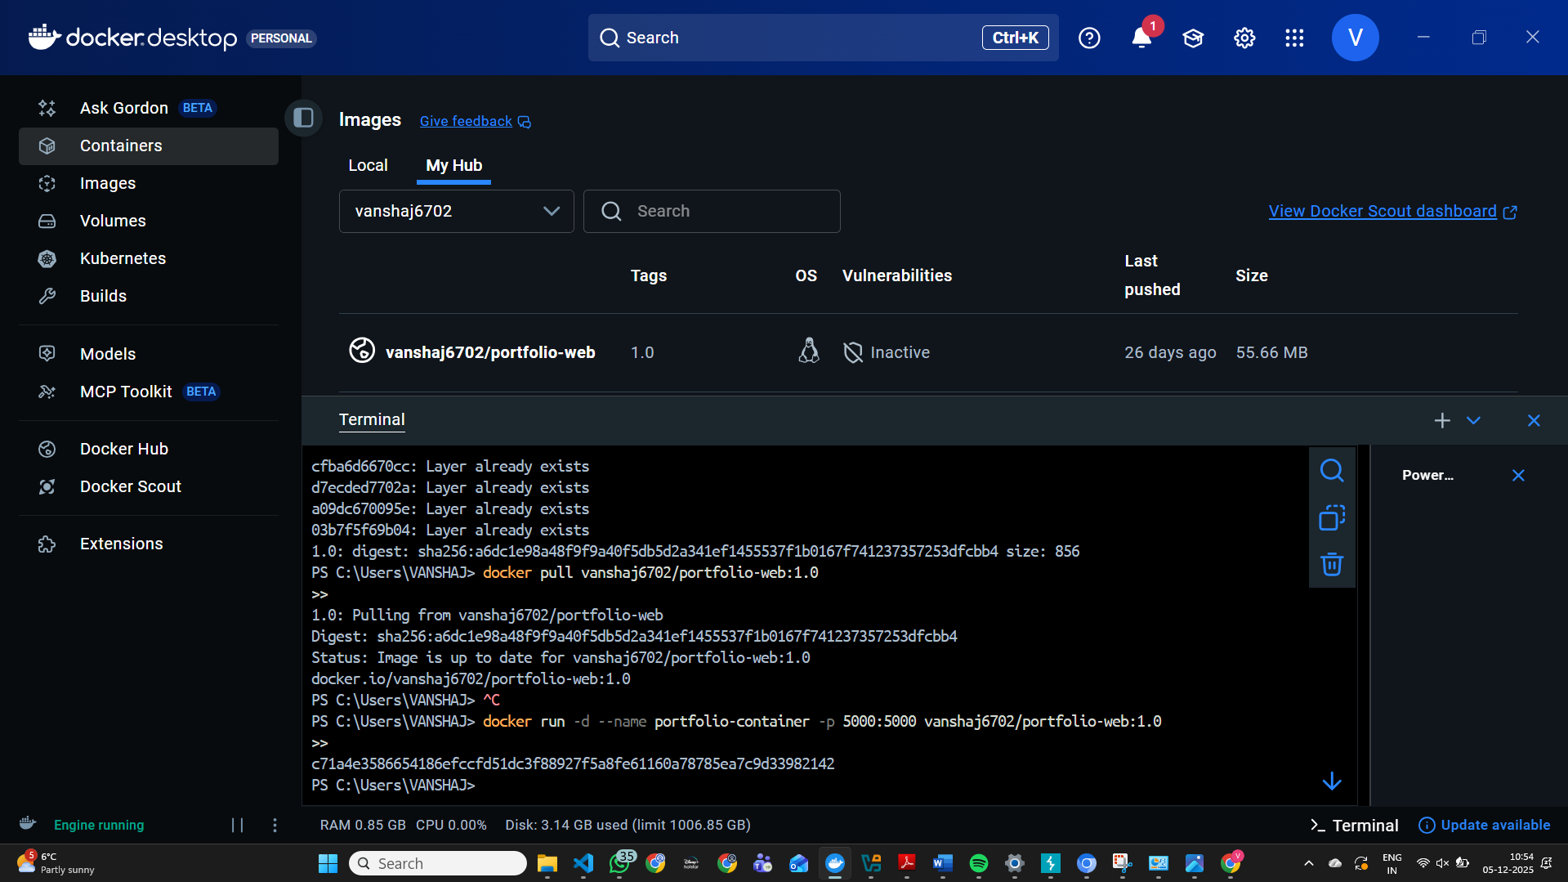Figure 5.16 Running the Pulled Docker Image
docker pull username/flaskapp:1.0
Then redeployed:
docker run -d -p 5000:5000 username/flaskapp:1.0
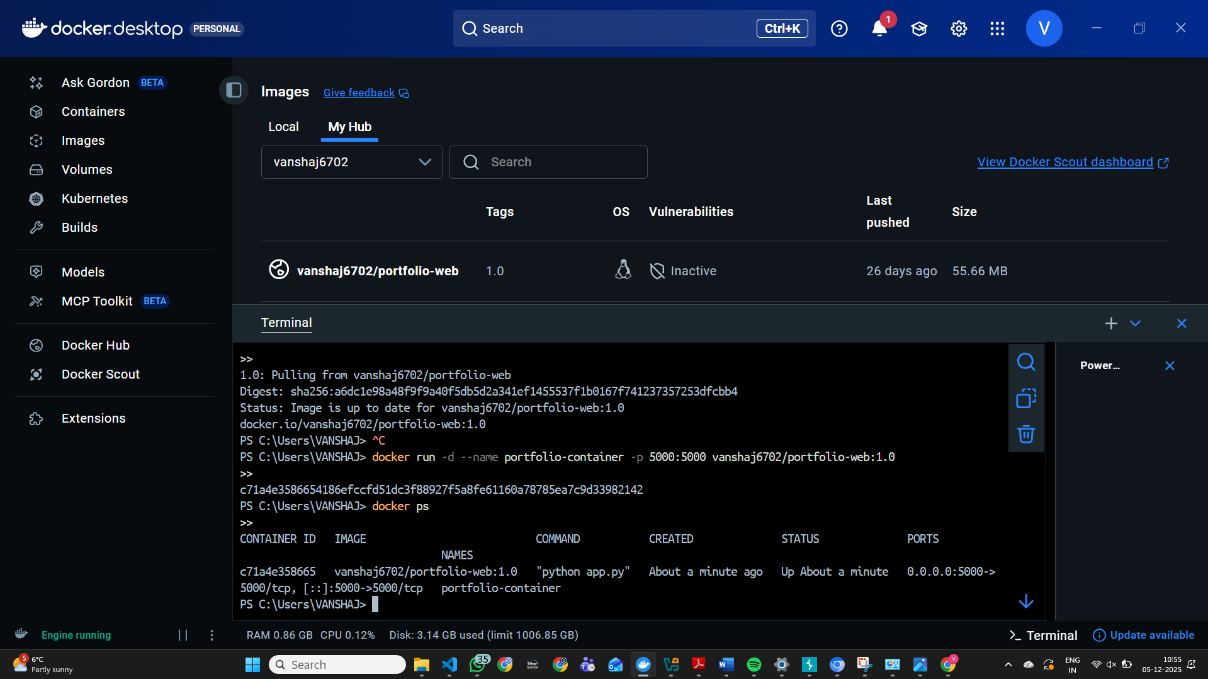
Figure 5.17 Screenshot Showing the Running Pulled Container
This confirmed that the application could run on any system with Docker installed.

5.10 Summary of Practical Outcomes
All key Docker operations were successfully demonstrated:
- Application development
- Writing Dockerfiles
- Building and running images
- Deploying containers
- Creating Docker networks
- Executing containers on the same network
- Creating and attaching volumes
- Tagging and pushing images to Docker Hub
- Pulling images and re-running them
The hands-on activities reflect real DevOps and cloud engineering practices, showing proficiency in container-based application deployment.

6.0 Cloud Architecture Concepts: Load Balancing, Scalability, and Application Gateways
This section examines how load balancing, scalability mechanisms, and application gateways function within an AWS cloud environment, using a sample e-commerce system as the reference case. These capabilities are widely recognised as essential components in cloud-native design, supporting resilient, high-performing, and secure application deployments [1][2][3][4][5].
6.1 AWS Implementation of Load Balancing
AWS delivers load balancing through its Elastic Load Balancing (ELB) service, which automatically distributes incoming network traffic across multiple compute resources. This avoids bottlenecks and ensures that applications remain responsive even during fluctuating workloads.
6.1.1 Load Balancing Mechanisms
AWS offers several types of load balancers, each optimised for distinct traffic patterns:
- Application Load Balancer (ALB): Operates at Layer 7, enabling routing decisions based on URLs, hostnames, or application-level data.
- Network Load Balancer (NLB): Designed for high-throughput and ultra-low latency workloads by operating at Layer 4.
- Gateway Load Balancer (GWLB): Integrates third-party security appliances directly into the network flow.
As highlighted in Pahl’s work on cloud-native architectures, these routing layers help simplify application logic by separating traffic management from core compute operations [2].
6.1.2 Load Balancing in the E-Commerce Scenario
In the e-commerce reference architecture:
- The Application Load Balancer serves as the main entry point for customer traffic.
- It evaluates the health of backend resources and removes any instance that fails its checks.
- Requests are routed based on defined patterns (e.g., /checkout, /cart), ensuring that each microservice receives the correct traffic.
This aligns with established cloud governance patterns, which emphasise reliable request routing and fault tolerance within distributed systems [5].

6.2 AWS Implementation of Scalability
Scalability within AWS is primarily achieved through Auto Scaling Groups (ASGs), which dynamically adjust compute capacity in response to workload changes. This ensures that demand spikes do not degrade performance, while low-traffic periods minimise resource consumption.
6.2.1 Auto Scaling Capabilities
AWS Auto Scaling offers several modes of operation:
- Dynamic scaling, which responds to real-time metrics such as CPU utilisation, request counts, or custom CloudWatch alarms.
- Predictive scaling, which uses historical patterns to anticipate future demand.
- Scheduled scaling, suitable for workloads with known activity cycles.
These elasticity features correspond with ISO 31000 principles, providing a method for managing operational risk through controlled resource expansion and contraction [7].
6.2.2 Scalability in the E-Commerce Scenario
In the example system:
- New instances are launched automatically during peak shopping periods (e.g., promotions, holidays).
- When demand drops, unused instances are removed to limit costs.
- The load balancer seamlessly incorporates new resources, making the scaling process transparent to end users.
This behaviour closely reflects findings in microservices research, where elastic scaling is identified as a crucial factor for sustaining user experience under unpredictable workloads [11].

6.3 AWS Implementation of Application Gateways
Application gateways enforce access control, regulate API interactions, and distribute traffic across backend services. AWS achieves this through services such as API Gateway and advanced routing features within ALB.
- Amazon API Gateway
- Application Load Balancer advanced routing
These gateways enforce Zero Trust principles where identity and context determine access [3].
6.3.1 Role of Application Gateways
For the e-commerce environment:
- API Gateway verifies user identities through Amazon Cognito before requests reach backend services.
- It applies traffic management rules such as throttling, rate limiting, and request validation.
- It directs specific API calls to the appropriate microservices, whether container-based or serverless.
This layered access control supports the Zero Trust model described by NIST, where authentication and continuous verification are required for each interaction [3].
Additionally, these mechanisms help organisations meet GDPR expectations for secure data handling and traceability [6].

7.0 Integration and Technical Evaluation
This section evaluates how load balancing, auto scaling, and application gateways operate together within a cloud architecture. Although each service can function independently, the combined effect provides a highly resilient, secure, and performance-optimised system an approach consistent with contemporary cloud-native engineering models.
7.1 Why Load Balancing and Scaling Are Complementary Concepts
Load balancing and scaling form a cooperative relationship within distributed cloud systems. Each technology enhances the effectiveness of the other, resulting in a deployment pattern that adapts smoothly to changes in demand.
7.1.1 Load Balancing Enables Effective Scaling
Scaling increases the number of available compute resources, but this expansion is only beneficial when traffic is shared efficiently among the new instances. The load balancer ensures that:
- Additional instances are integrated into the routing pool without manual intervention
- Workloads are distributed evenly, preventing any single instance from becoming overloaded
- Faulty or unresponsive nodes are excluded from service
By acting as the central traffic coordinator, the load balancer allows scaling mechanisms to deliver predictable improvements in performance and reliability.

7.1.2 Scaling Enhances Load Balancer Efficiency — Rewrit
7.1.2 Scaling Enhances Load Balancer Efficiency
Load balancers rely on multiple backend nodes to perform evenly distributed routing.
Scaling provides:
- Elastic capacity
- High redundancy
- Lower risk of overload
This mirrors the cloud-native resilience models described in Merkel’s foundational containerisation work [1].

7.2 Benefits of Combining Load Balancing, Scaling, and Application Gateways
When integrated together, these three technologies provide:
7.2.1 High Availability
- Load balancing prevents hotspots.
- Scaling ensures resources match demand.
- Gateways maintain secure, consistent entry points.
7.2.2 Security and Controlled Access
Application gateways enforce Zero Trust authentication [3],
while load balancers and scaling ensure continuity during attacks or failures.
7.2.3 Cost Efficiency
Auto scaling helps organisations avoid paying for unused resources by adjusting capacity dynamically. Load balancers support this by routing workload only to active resources, allowing scaled-down environments to operate efficiently.
This resource flexibility supports risk management and cost optimisation guidelines described in ISO 31000 [7].
7.2.4 Enhanced Customer Experience
The combination ensures:
- Low latency
- Fast response times
- Reliable peak-hour performance
This is consistent with best practices for customer-facing cloud services [11].

8.0 Driving Forces Behind Cloud Computing Expansion
Cloud computing continues to expand rapidly due to a combination of economic, operational, and technological factors. These drivers are widely recognised across industry research and cloud security frameworks, which highlight how cloud platforms enable organisations to modernise infrastructure, optimise costs, and improve service delivery [5], [7].
8.1 Cost Reduction and Pay-As-You-Go Economics
Cloud computing eliminates capital expenditure and replaces it with usage-based billing.
This allows organisations to:
- Avoid costly on-premises infrastructure
- Scale expenses with demand
- Reduce maintenance and staffing requirements
These efficiencies align with the risk treatment strategies defined in ISO 31000 [7].

8.2 Flexibility and Elastic Resource Provisioning
Cloud providers offer high elasticity:
- Applications scale instantly
- Resources span global regions
- Workloads deploy without hardware dependencies
Such flexibility supports dynamic digital services expected in modern enterprises.

8.3 Innovation Through Managed Services
Cloud platforms accelerate development by providing managed services that abstract away much of the operational complexity. These include container orchestration platforms, serverless computing, managed databases, and security services.
Managed services enable teams to focus on application logic rather than infrastructure maintenance. As noted by Pahl [2], the combination of containerisation and cloud-native platforms significantly enhances the speed and reliability of application delivery pipelines.
This capability supports continuous innovation and contributes to the overall momentum behind cloud adoption.

9.0 Serverless Functions vs Containerisation
9.1 Explanation of Serverless Functions
Serverless computing (FaaS) allows developers to run code without managing servers.
Examples:
- AWS Lambda
- Azure Functions
Characteristics:
- Automatic scaling
- Event-driven execution
- Millisecond-level billing
- No infrastructure management
Serverless architectures complement Zero Trust principles by isolating execution contexts and enforcing strict identity-based invocations [3].

9.2 Comparison of Containerisation and Serverless
Aspect | Serverless (FaaS) | Containers (Docker / ECS / EKS)
Scaling | Automatic, instant | Automatic but slower
Cost | Pay per invocation | Pay for uptime
Control | Low | High
Runtime | Short-lived tasks | Long-running services
Use Cases | Event-driven apps | Microservices / web apps
Docker containers provide environment consistency and portability across cloud and on-prem systems [1], while serverless functions excel in high-elasticity and short-duration workloads.
Google’s research emphasises that container-based architectures enable predictable performance and data persistence features in cloud-native environments [10].
Serverless instead emphasises minimal operational overhead and cost-driven execution.

10.0 Conclusion
AWS provides a cohesive ecosystem of services that collectively support the creation of secure, resilient, and high-performance cloud applications. In the context of the e-commerce architecture discussed in this report, the integration of load balancing, auto scaling, and application gateways forms a robust operational model capable of sustaining varying levels of demand while protecting system integrity.
Load balancing ensures continuous availability by distributing requests across multiple compute instances and isolating unhealthy nodes. Auto scaling complements this by adjusting capacity in real time, ensuring that resources align with user activity and preventing performance degradation during peak traffic periods. Application gateways add an essential security layer by enforcing authentication, validating requests, and routing API traffic according to policy and service design.
Together, these mechanisms support a cloud environment that adheres to recognised governance and security frameworks. AWS services facilitate the application of Zero Trust principles through identity-driven access controls and continuous verification [3]. They also provide the tools required to meet GDPR expectations for data protection and auditability [6], and they reflect ISO 31000’s emphasis on risk reduction through monitoring, resilience, and adaptive capacity planning [7]. Likewise, the Cloud Controls Matrix (CCM) aligns with these architectural choices by highlighting the need for structured access management, configuration oversight, and encryption practices [5].
The synergy between load balancing and auto scaling is central to achieving operational efficiency. Load balancing enables new compute nodes to contribute effectively as they are launched, while scaling ensures that the load balancer always has sufficient capacity to manage demand. Application gateways reinforce this architecture with consistent request management and controlled entry points for all client interactions.
The broader drivers of cloud adoption—cost optimisation, elastic resource provisioning, and rapid innovation—underscore why organisations increasingly rely on cloud-native solutions. Serverless functions, such as AWS Lambda, emphasise operational simplicity and automatic scaling, making them ideal for event-driven workloads. Containers, on the other hand, provide portability, environmental consistency, and architectural flexibility, supporting long-running services and microservice designs [1], [11].
Overall, the practical work conducted with Docker on a Windows host environment demonstrates how containerised applications can be prepared for cloud deployment. It highlights the value of reproducible environments, portable workloads, and automated infrastructure—key principles that underpin modern cloud engineering practice.

Explanation Video
Link:

Final IEEE Reference List
[1] D. Merkel, “Docker: Lightweight Linux containers for consistent development and deployment,” Linux Journal, 2014.
[2] C. Pahl, “Containerization and the PaaS cloud,” IEEE Cloud Computing, vol. 2, no. 3, pp. 24–31, 2015.
[3] S. Rose et al., “Zero Trust Architecture,” NIST Special Publication 800-207, 2020.
[4] Amazon Web Services, “Best Practices for Container Registries,” AWS Documentation, 2023.
[5] Cloud Security Alliance, “Cloud Controls Matrix v4.0,” 2021.
[6] European Union, “General Data Protection Regulation (GDPR),” 2016.
[7] ISO, “ISO 31000:2018 Risk Management — Guidelines,” International Organization for Standardization, 2018.
[8] J. Sherwood, A. Clark, and D. Lynas, Enterprise Security Architecture: SABSA. Ely, UK: SABSA Institute, 2015.
[9] The Open Group, TOGAF Standard, Version 9.2. San Francisco, CA, USA: The Open Group, 2018.
[10] Google Cloud, “Container storage and persistence,” Google Cloud Documentation, 2023.
[11] M. Villamizar et al., “Evaluating microservices in cloud environments,” IEEE Communications, 2016.

