Task 1

Question 1
(AC 1.1)

According to Collins Dictionary (2019) a professional relates to a person’s work that needs special training, for example doctor and solicitor. But MindTool (2022) quotes "Professionalism is not the job you do; it's how you do the job"; which involves achieving high standards whatever the role. Professionals are governed by code of conducts (Smith, Mitchell, 2022) which outline how an organisation expect its employees to behave (Indeed, 2022a). For example, CIPD’s code of conduct and ethics are the following: “positive and active impact on working lives, civic virtue and stewardship, good character, professional service and competence and personal responsibility” (CIPD, 2023).
People practices are the processes and approaches that are used across the employee lifecycle (CIPD, 2022a). CIPD People Professional map is used to make better decisions, act with confidence, drive change in an organisation and progress in a career (CIPD 2022a) and the people professional map is relevant to all people practice practitioners. The map suggests that people practise professionals uses a combination of knowledge, behaviour and specialist knowledge. Examples of core knowledge includes culture and behaviour, evidence-based practice, technology and people. Examples of specialist knowledge includes employer experience, equality, diversity and inclusion, talent management and wellbeing.
Core behaviour includes ethical practice, professional courage and valuing people. Strong personal professional and personal values are very important; it shows that peoples practitioners are trustworthy and genuine (Indeed, 2022b). Having values means that holding oneself to account and maintaining a certain level of professionalism and care in all that one does (Indeed, 2022b). These values include reliability, fairness, honesty and equality. A good people professional is not showing how good one’s core knowledge and specialist knowledge are but how they interact with one’s professional behaviour (Slay, Smith, 2011).

Question 2
AC 3.1

Peters (2020) explains how in the1980s Human Resources was criticised for the lack of strategic input and influence they contributed towards important decisions organisations made; HR stood apart from the organisation (Hughes-D’Aeth, 2016). A great deal of HR role was administrative duties and employees were anxious when they had to visit the Personnel Department (Pophal, 2023). Employees were knocking on HR’s door when there was a crisis but it was the last department to be acknowledged when the organisational had a success (Pophal, 2023).
By now, people practitioners help to strategize and anticipate any internal or external changes that might affect an organisation (Pophal, 2023). Technology has changed organisational practices and especially people practitioners where it is absolutely crucial that they are equipped to harness the power of technology (Bankok Post, 2018). Technology helps people practitioners to make people analytics and this information give support to the organisation to solve problems (CIPD, 2022c). HR data was not being used to its full potential even though they are sitting on a data gold mine (Marr 2018). Organisations are turning their data into insights, such as where to recruit the best candidates and how to identify suitable candidates (Marr 2018).
Another aspect that has changed in recent years is hybrid and home working. According to (Wood, 2022) by 2028, 73% percentage of all departments will have remote workers. Therefore, people professionals will need to ensure that there is a policy in place to provide training, develop communication and engagement activities to share outcome and feedback, as well as planning and responding on matters like technology, inclusion and facilities (CIPD, 2022b).
Hughes-D’Aeth (2016) said that there was little regard for employee wellbeing at work. She explains that she received hate mail after introducing a no smoking policy and how senior managers refused to co-operate. According to CIPD (2022e), by now there is a much broader understanding on health and wellbeing in many organisations, but many organisations are not embracing the agenda to full effect. CIPD’s Health and Wellbeing at Work 2022 report found that most organisations are taking additional wellbeing measure in response to the Covid-19 pandemic (People Management, 2023).

Question 3

AC 1.2
Personal values are “the lenses through which you view yourself and your world” (Life Values Inventory, 2021). Personal values help people to be who they are and give better understanding of who they are (Perry, 2022). Workplace values are the guiding principles that are most important to an employee about the way they go about the way that they work. These personal principles can be used to choose between right and wrong ways of working, and they can lead to important decisions and career choices (Mindtools, 2022b).
Compassion is one of my personal values. According to Pacific Prime (2022) this allows people to show that they care, are willing to help and show empathy (Pacific Prime, 2022). When an employee hands in their back to work form after returning from sick leave, many would just take the form without any further ado. I take the time to ask if they are feeling better and ensure they are ready to return to work. Although their managers would have done these checks, I do it to show them that I genuinely care and that I am happy to take time to listen to them.
Honesty is another value that I hold. Honesty in the workplace encourages trust among employees and also third parties (Frost, 2023). When giving unsuccessful candidates interview feedback, some people practitioners simply say that the successful candidate was better. This does not help them or boost their confidence and it does not put the organisation in a good light. I have honest conversation with them by explaining clearly in an appropriate manner how they could have done better, what they need to work on and what they did well.
Another value I have is patience. We have employees who do not know to check their annual leave balance, for example, Although I have explained and shown them many times, I sit down with them, so I can re-explain, without losing patience. I make sure that they are welcome to visit our office to get the information without them feeling they are a nuisance.
Question 4
AC 1.3
There are many situations where people professionals need to contribute to discussions. For example, a change in the organisation, discussing ideas or working with managers or to voice concerns about morally and ethical wrongdoing (CIPD, 2022a). Therefore, people professionals need to be confident in influencing others (CIPD, 2022a), make an impact (Smith, Mitchell, 2022) and have the courage to stick to appropriate values (CIPD, 2017). Lewis (2020) states that confidence is crucial. When people professionals believe in themselves and in their abilities their performance and work tends thrive.
Speaking up to authority can be very hard, especially if someone needs to speak the truth, calling on injustice on their watch (dictionary.com, 2023).
If a HR assistant was told by their manager that their new employee induction is taking too long and that there is no need to explain the organisation’s code of conduct and all the policies then the HR assistant needs to be brave. The assistant needs to tell the manager the importance of an organisation’s code of conduct to the new employee and the potential consequences of not knowing rules and policies. The manager’s obstruction results in the assistant’s value of fairness being side-lined.
Showing that they have the right knowledge and evidence based with credible sources strengthens people practitioner’s views and with backed up data there is a better possibility to influence (CIPD, 2022b). It shows that there is a strength behind that knowledge (Cheese, 2015). Communication and engaging with audiences is important to present ideas and one way of doing this according to Ulrich (2018) is to behave as if the audience is already committed, for example, by saying “our” policy instead of “my” policy. People practitioners need to ensure that important points are being communicated clearly and to show that they are willing to answer any questions without being defensive in answering such questions. Defensive behaviour shows that someone is easily threatened and has an unpleasant manner (Phillips, 2014).
According to Horn (2009) non-verbal language speaks louder than words and explains the importance of body language, eye contact and posture.

Question 5
AC1.4
Identifying and raising concerns within an organisation is an important aspect of people practice and all employees should feel able to do so. Concerns can be raised formally or informally or through whistleblowing (Taylor, Woodhams, 2022). Issues can be raised as a result of financial malpractice, illegal acts, health and safety risks, environmental damage, data mishandling or to conflicts within an organisation such as bullying, harassment or discrimination (CIPDh, 2022, Masood, 2018).
Issues should be raised in the first instance with a line manager and if the response is inadequate, then the complaint should be moved up the hierarchy within the organisation. Ideally each organisation should have a grievance policy and a standalone ‘speak up’ policy that’s backed up by senior managers and widely publicised to employees (CIPD, 2022h). According to one author the simplest way to raise an issue is to use a whistleblowing channel where wrongdoing can be reported anonymously (Masood, 2018). Concerns can also be raised with external agencies who have regulatory powers over the areas in question (gov.uk, 2022).
A number of very high-profile cases have highlighted the issues brought to light by whistle blowers. Perhaps the most interesting case from a people practitioner’s point of view is Enron, a Texas energy company. The disclosure by a whistle blower of widespread financial fraud, false accounting, insider trading and other illegalities eventually bankrupted the company, led to the imprisonment of a number of its chief officers and more important in the long run it substantially raised the level of ethical conduct by American corporations. (Segal, 2021). However, according to Winfield, Bishop, Porter (2004) the failure of Enron’s HR Department to create a formal complaints procedure independent of senior managers was the main reason why malpractice continued for so long.
Question 6
AC 2.1
Ethical people practice is 'doing the right thing' because that is the right thing to do (CIPD 2021b) not least because the benefits of having a well-defined ethical people practice are overwhelming for both organisations and employees.
It gives such companies a competitive advantage (Hill, 2019). Over half of U.S. consumers said they no longer buy from companies they see as unethical whilst 30% of them will support ethical companies on social media (Redlands, 2021). It can also create a more positive image in the marketplace, which can bring in new customers through word-of-mouth. (Hill, 2019). But reputations are based also on how an organisation values its relationship with staff and stakeholders (CIPD, 2021c). Companies that are fair and open in their dealings with employees have a better chance of retaining and recruiting the most talented people (Hill, 2019) whilst companies guilty of ethical violations have a high turnover of employees, recruit average performers and have overall cost inefficiency. (Hill, 2019) Complying ethic organizations also develop a work culture free from stress, which makes employees feel happier and become more productive. (Ventimiglo, 2015).
In other words, good ethical practice partly means engaging employees, and employee engagement is now seen as a psychological state. (CIPD 2021b) and the work of people such as Maslow, Pink and Rock are of assistance to People Practitioners. Maslow’s work can help HR professionals achieve many organisational goals, such as improved staff retention and employee engagement and enhance an organisation’s wellbeing strategy. This model helps to minimize perceived threats, and to maximize the positive feelings generated through reward when working alongside others (Mindtool, 2022c). But Pink on the other hand argues that traditional rewards to motivate employees are outdated, and employees will be self-motivated if they are given the freedom to do the work they enjoy (Mindtool, 2022c).

Question 7
AC 2.2
Employees need for flexible hours is getting more and more prominent. There are number of reasons for this, such as:
- full time nursery for under twos is nearly £15,000 a year (BBC News, 2023)
- people feel that their life is busy with not enough hours in a day (Richmond, 2012)
- reduce stress and increase productivity (Indeed 2023)
To design a flexible working policy all employees, need to be included, therefore feedback from various groups and different styles of feedback would be beneficial. For example:
- focus groups with employees who are parents, guardians, and with different religion and beliefs (more family time might be needed to celebrate other religious festivals and not Christian festivals), to bounce ideas and scenarios (Gibbs, 1997).
- individual interviews with employees with mental health issues, so they don’t have to share with other employees
- online staff survey to boost employee engagement (Harwood, Unknown). These would be a mix of open and closed question with room to make any comments and suggestions.
The purpose of these is for employees to truly give their input, their thoughts and feelings on how the policy would benefit them and what they think the obstacles would be (Steben, 2022).
After receiving all feedback, the data would be collated and analysed with a further discussion for HR, directorates, chief executive and union representation. The new policy might have core hours e.g. staff have to work between 10 and 11:45 and between 2:00 and 3:00, but they would need to let their manager know that they might need to leave at 3.
Training would be provided so line managers would know what they will need to do and what to expect.
Power DMS (2022) explains the importance of reviewing a policy. Therefore, after 6 months there would be another staff survey, and the same focus groups and individuals would attend the same sort of interview to make the feedback fair. Feedback for the new policy would be discussed and to see if it needs adjusting and developing.

TASK 2
AC 2.3 & AC 3.2
I decided to use 360-degree feedback to help with my self-assessment as it increases self-awareness and encourages personal development (Rogel, 2022). To assist me to learn more about this method I read various books. My questionnaire contained open questions as the respondents could give qualitative feedback (Peacock, 2007) with the opportunity to expand on their answers. I wrote a bilingual questionnaire to be inclusive and it is a very important value of mine.
I asked two of my peers to give me feedback as they are day-to-day colleagues, who know my strengths and weaknesses (Adam 2023). I asked my manager for another feedback because she has the responsibility to help me develop as a professional (Adam 2023).
I reflected on the feedback and it helped me to do my self-assessment. I used the CIPD self-assessment tool.

AC 3.3
I have decided that I need to work on my confidence. This was clear from the feedback received; and I tend to agree. Currently, I am shadowing my line manager in meetings, but eventually will be attending meetings alone. Therefore, boosting my confidence would not only give me self-esteem (Soken-Huberty, 2023), but it would really help me in my role to show my audience that I do have the relevant knowledge and I am confident in my work. Confidence also has a powerful impact on organisational culture (Burnett, 2021).
Appendix 2 shows what CIPD Learning Plan suggests what activities I should undertake to be more confident (CIPD, 2022).
I am also going to work on “keeping up to date with external trends and development” as I scored closer to ‘emerging’ than ‘exceeding’. I feel that this is important to assess any risks that could affect my organisation, therefore, it is possible to reduce possible threats (Morrison, 2016) and help to deal with a problem and adopt a strategic approach (Yuksel, 2012). The activities I will undertake are:
- PESTLE analysis, which would encourage the development of external and strategic thinking (CIPD 2021).
- Subscribe to top industry magazines and blogs, following experts on social media and attend conferences (Open Classroom 2019).
- Watching the news would educate and enlighten me on worldwide events (Kendrick 2017).
Tactile learning and being hands on is the best way for me to learn (Education Planner self-assessment tool 2022), so I will take this into consideration whilst doing these activities.
AC3.4
I am new to HR and nearly everything is unfamiliar to me. I decided to choose three aspects of people professional role where I think I have developed and learnt the most and I have chosen one activity for each aspect.
- Induction – research
- people analysis and Excel – attend a course
- interviews - shadowing.
Recently I was asked to give a new recruit their induction. When I get a new responsibility I want to ensure that I carry it out well and understand its importance. The activity I did was research. By reading various books, blogs and articles I realised the importance of onboarding, not only to the new employee but to the organisation (O'Neill 2023). I have learnt that onboarding is crucial as it is the introductory stage between new employees and the organisation (Pierce, unknown). The basic role of people practitioners will always be caring for employees (HRM Handbook, 2023) and helping them to blend in with the corporate culture and truly become part of the team (Verlinden, 2022).
Wilkinson, Taylor (2022) explain that onboarding can become a routine where important information can be overlooked, e.g. making sure that employee understand the organisation’s values, visions and culture (SpriggHR, 2020). Therefore, I took time to read our policies and code of conduct and made a tick box sheet to ensure that nothing was omitted. I showed this to my manager and she was very impressed with my effort and enthusiasm. She thought that everyone in the department can use this, not just myself.
For future development I will need to ensure that I know our latest policies. I will be looking in to Wilkinson, Taylor, (2022) ideas to appoint a ‘buddy’ to be part of onboarding process.
Another important aspect I have learnt is sickness absence analysis. I have learnt that absence management is about lowering employee absenteeism through policies and procedure (Natural HR, 2021). For an organisation absence causes issues like workload rearrangement, shift rescheduling and financial cost (Janza, 2021).
In our organisation we use Excel to interpret this data and I had not used this function to analyse data before. Therefore, my line manager suggested that I should partake an online training to help with my Excel skills.

This training really was an eye opener. Not only did I learn how to analyse the data and make graphs, but I came to truly appreciate the effect that the back to work interviews managers have with their employee has on the organisation. They are not just to ensure that they are well enough to return to work (worknest, 2023), but in these interviews they can gather as much information as they can for deeper analysis. With the information collected it is possible to work out mental health related absences, total cost of absence for the organisation, total days lost, absence by department, absence by age, gender etc. (Dale, 2019). I also learnt that it is possible to see individual employee trends.

In the near future I will be doing an online course on how to do a Bradford Factor report and I would investigate whether there is a need to update our return to work forms.

I had never been part of interviews before. To understand the process, my manager encouraged me to shadow interview panels and short listing processes. I learnt so much by doing this activity, such as:
- importance of fairness, e.g. only the HR department knows who applies for jobs, to avoid any discrimination during the short listing process
- the way to ask questions and listen and reacting to answers
- ensure that applicants are happy and try to make them feel at ease straight away
- no one has commented on the way the candidate looks or wears, it is always about the interview and the character
For future development I plan to ensure that I write as much notes as needed during interview to help to decide when marking at the end of the interviews and it will be a great help when someone asks for feedback. I also need to ensure that the interviews are fair e.g. if I ask one candidate to elaborate on a question, I need to do the same with all candidates (if necessary). I will also re-read CIPD’s Eight Ethical Lens.
I feel very positive about how I have progressed in the last 9 months. I am excited to develop my knowledge and what I have learnt so far. Recently I have passed my probationary period and my manager was very pleased with how I have developed and we have a plan in place to continue my development.

Apendix 1

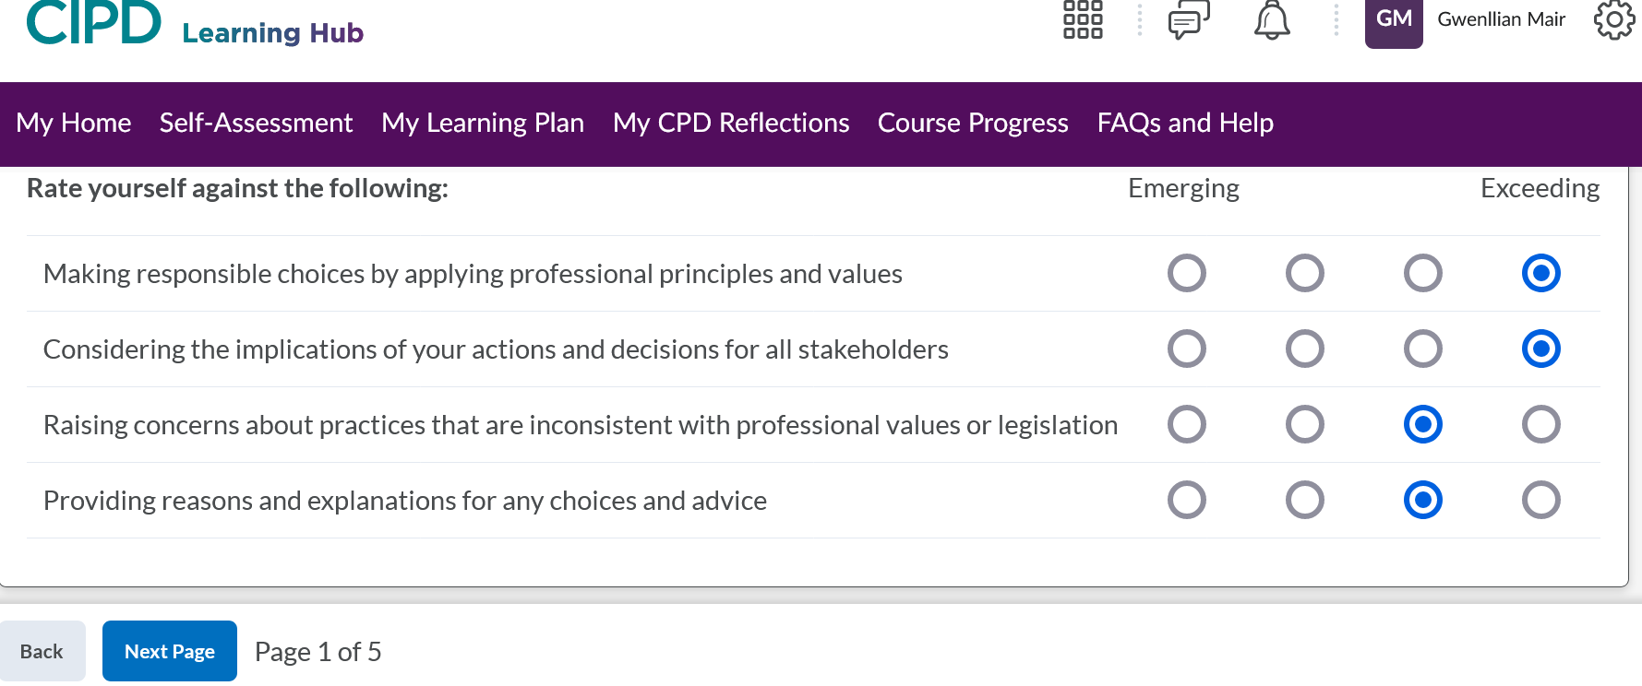

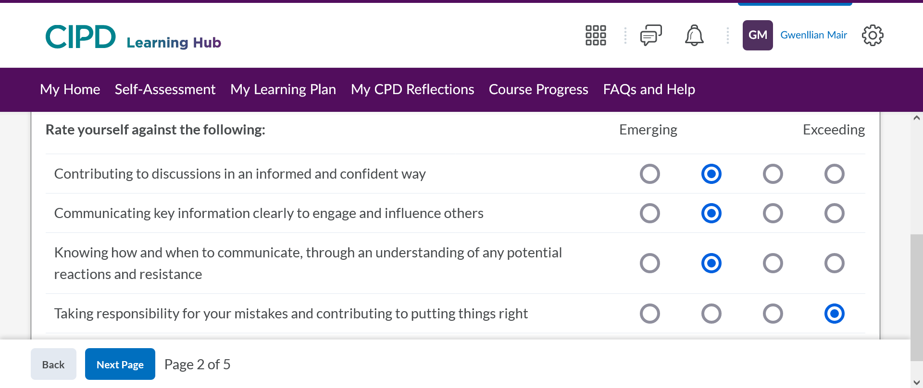

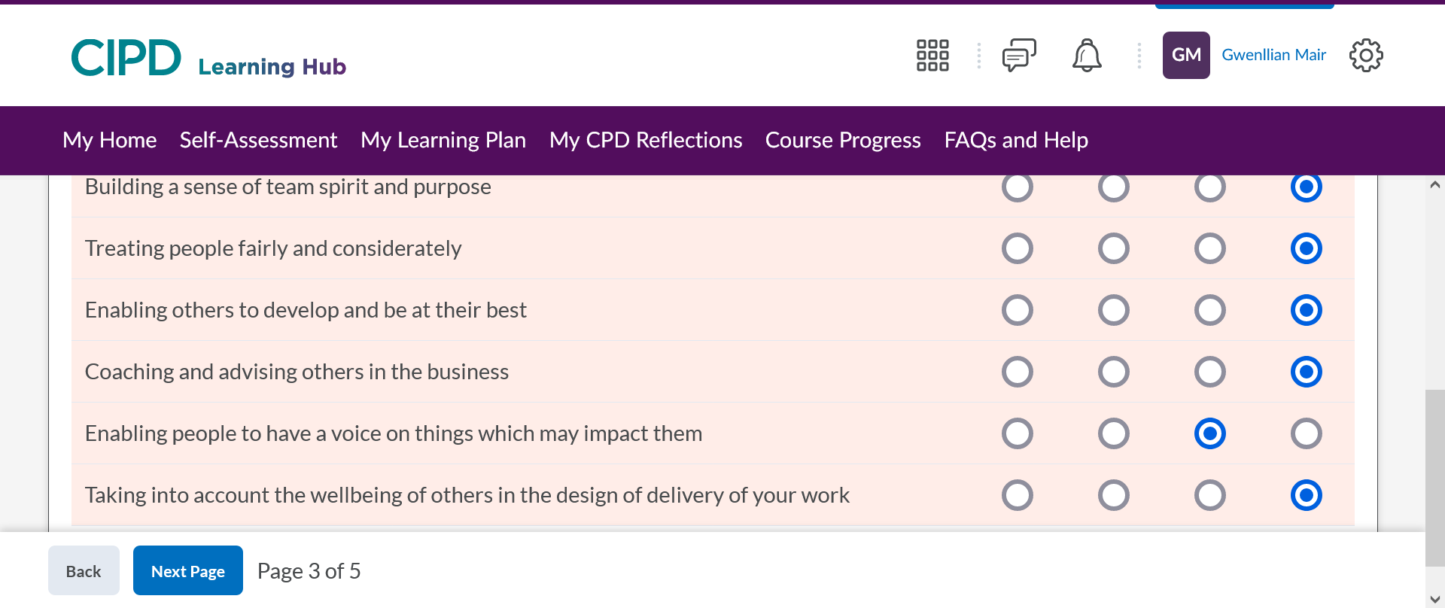

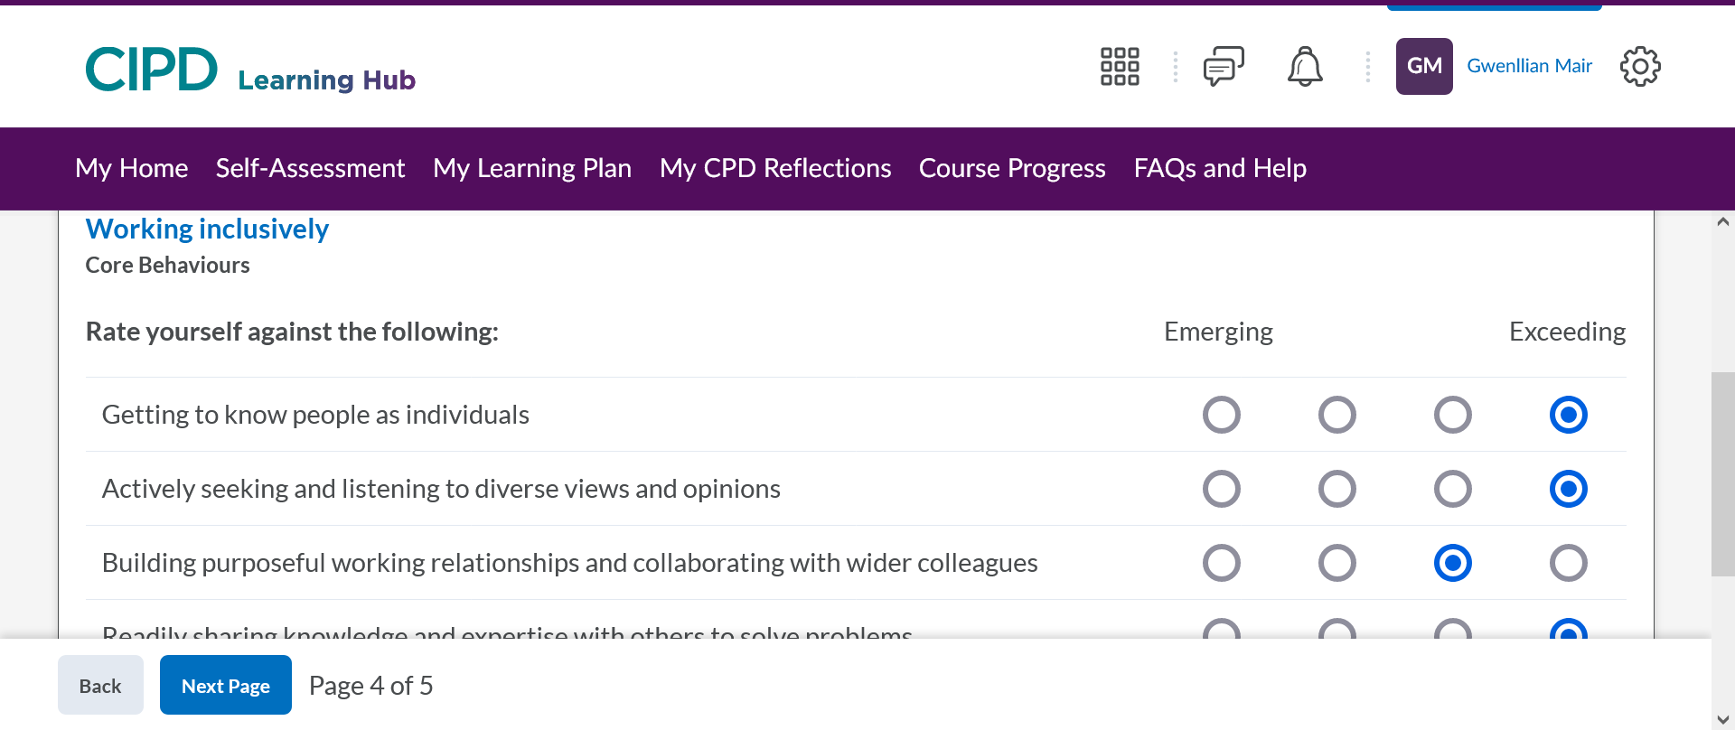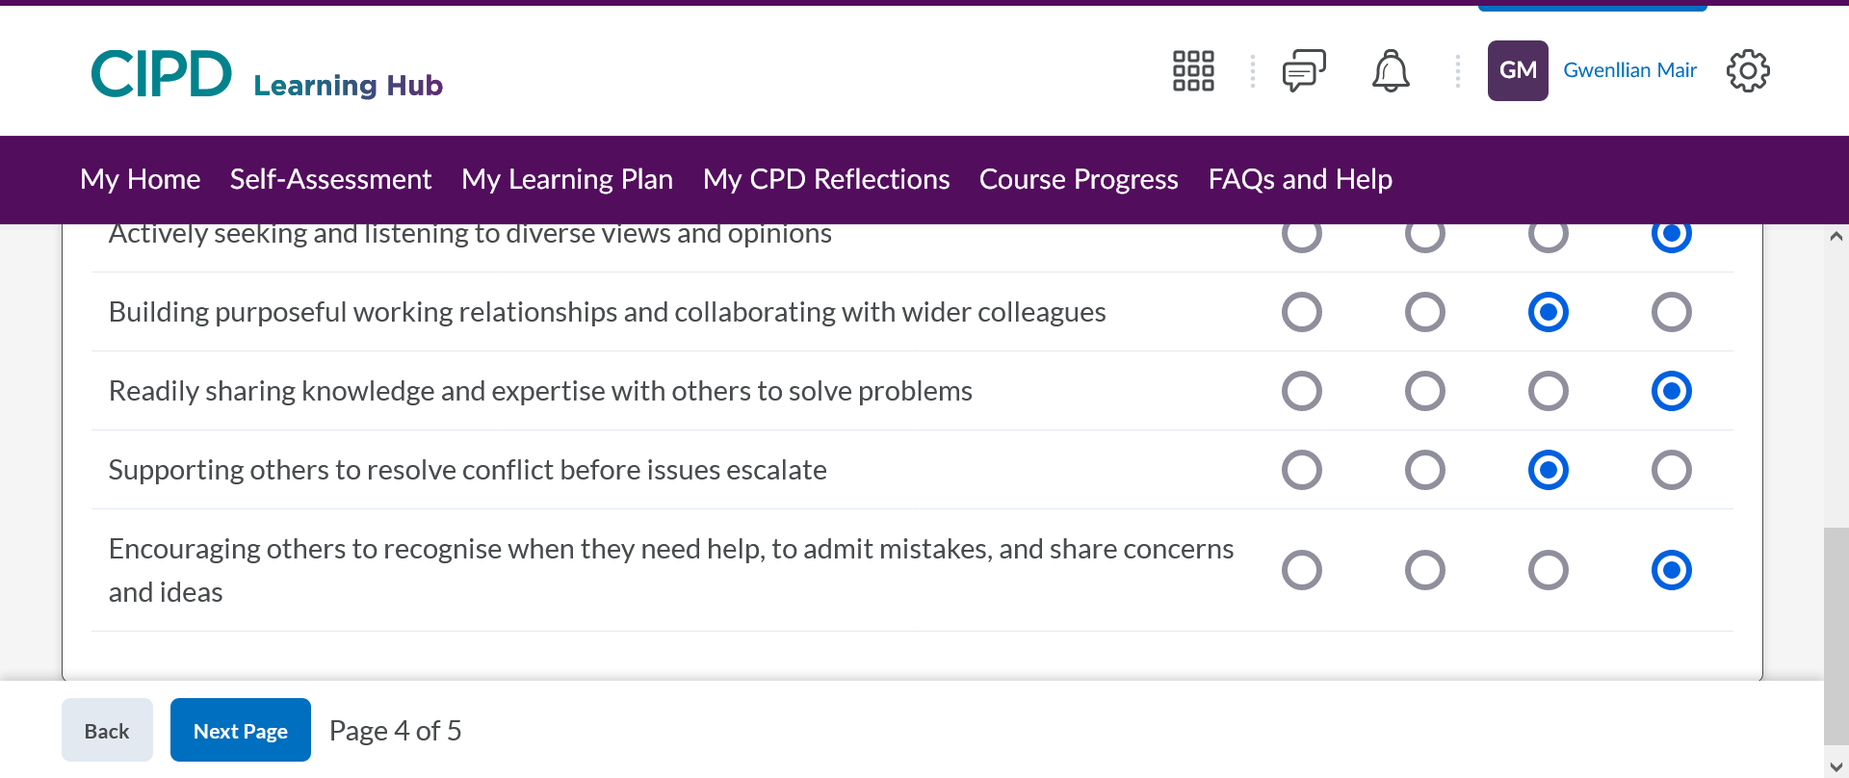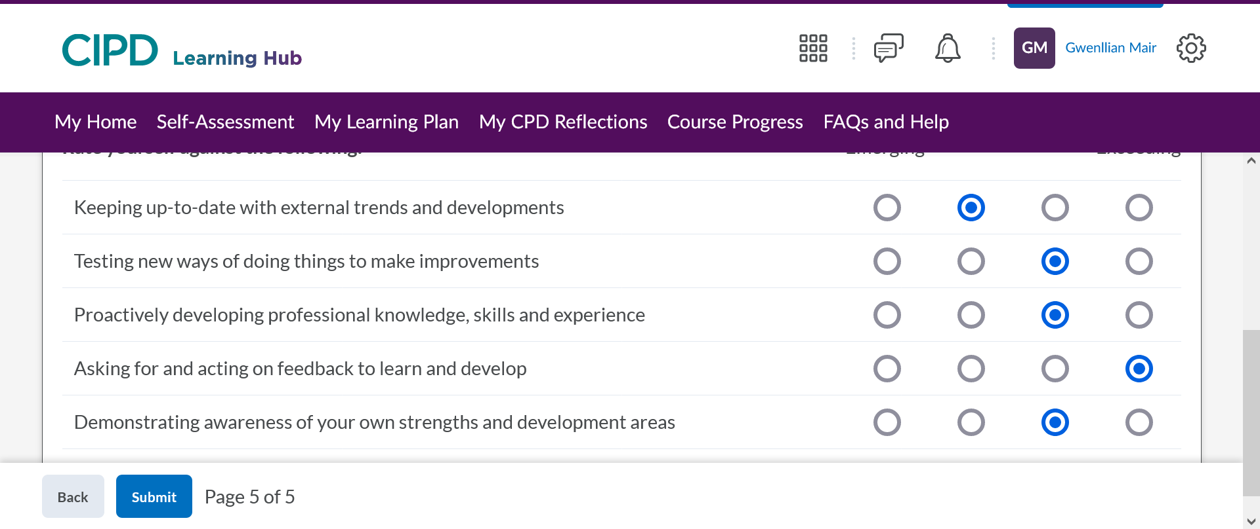

Appendix 2
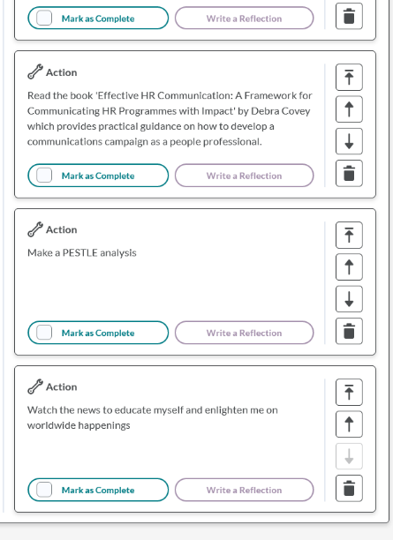
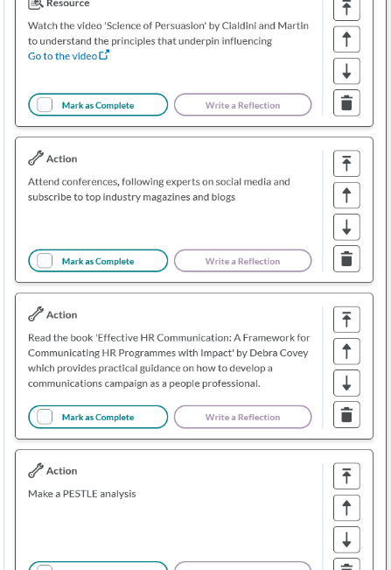
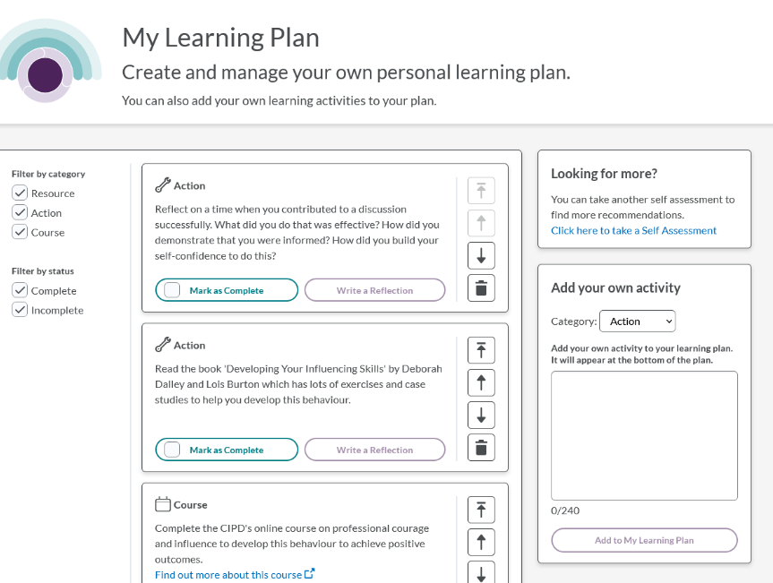

Bibliography

Adams, A. (2022) https://engagedly.com/who-all-should-give-360-degree-feedback/ (Accessed 07.03.2023)
Ainsworth, E. (2016) 360° Feedback A Transformational Approach Panoma Press Ltd: Herts
Article Library (unknown) https://www.yourarticlelibrary.com/organization/benefits-of-ethical-practices-in organizations/45117#:~:text=Morale%20and%20culture%3A,to%20stress%2C%20attrition%20and%20dissatisfaction. (Accessed 09.03.2023)
BBC News (2023) https://www.bbc.co.uk/news/education-64865602 (Accessed 11.03.2023)
Bankok Post (2018) https://www.bangkokpost.com/business/1442926/hr-needs-to-catch-up-with-the-tech-savvy-workforce (Accessed 19.02.2023)
Bika, N. (2023) https://resources.workable.com/tutorial/preparing-conduct-interview (Accessed 11.03.2023)
Burnett, A, (2021) https://www.linkedin.com/pulse/5-reasons-confidence-workplace-vital-alexandra (Accessed 07.03.2023)
Cheese, P. (2015) https://www.changeboard.com/article-details/16044/hr-needs-to-build-confidence-and-quickly/ (Accessed 25.02.2023)
CIPD https://www.cipd.co.uk/knowledge/fundamentals/relations/absence/factsheet#gref (Accessed 10.03.2023)
CIPD (2017) https://www.cipd.co.uk/news-views/nutshell/issue-64/acting-ethically-work#gref (Accessed 15.02.2023)
CIPD (2021a) https://www.cipd.co.uk/knowledge/strategy/organisational-development/pestle-analysis-factsheet#7992 (Accessed 08.03.2023)
CIPD (2021b) https://www.cipd.co.uk/knowledge/fundamentals/relations/engagement/factsheet (Accessed 09.03.2023)
CIPD (2021c) https://www.cipd.co.uk/knowledge/culture/ethics/role-hr-factsheet#gref (Accessed 09.03.2023)
CIPD (2022a) https://peopleprofession.cipd.org/profession-map/core-knowledge/people-practice#gref (Accessed 14.02.2023)
CIPD (2022b) https://peopleprofession.cipd.org/profession-map Accessed (14.02.2023)
CIPD (2022c) https://www.cipd.co.uk/knowledge/strategy/analytics/factsheet#gref (Accessed 19.02.2023)
CIPD (2022d) https://www.cipd.co.uk/knowledge/fundamentals/relations/flexible-working/planning-hybrid-working#gref (Accessed 19.02.2023)
CIPD (2022e) https://www.cipd.co.uk/knowledge/culture/well-being/factsheet (Accessed 18.02.2023)
CIPD (2022f) https://peopleprofession.cipd.org/profession-map/core-behaviours/professional-courage-influence (Accessed 08.03.2023)
CIPD (2022g) https://peopleprofession.cipd.org/profession-map/core-purpose/evidence-based (Accessed 25.02.2023)
CIPD (2022h) https://www.cipd.co.uk/knowledge/fundamentals/relations/communication/voice-factsheet (Accessed, 24.02.2023)
CIPD (2022i) https://learninghub.cipd.org/d2l/home/6720
CIPD (2023) https://www.cipd.co.uk/Images/cipd-code-of-conduct-and-ethics-v2_tcm18-112336.pdf (Accessed 15.02.2023)
Collins Dictionary (2019) https://www.collinsdictionary.com/dictionary/english/professional (Accessed 14.02.2023)
Dale, G. (2019) https://www.myhrtoolkit.com/blog/absence-data (Accessed 10.03.2023)

Deskbird (2023) https://www.deskbird.com/blog/flexitime (Accessed, 11.03.2023)
Dictionary.com (2023) https://www.dictionary.com/e/slang/speak-truth-to-power/
Education Planner (2022) http://www.educationplanner.org/students/self-assessments/learning-styles-quiz.shtml?event=results&A=8&V=4&T=8 (Accessed 08.03.2023)
Frost, S. (2023) https://smallbusiness.chron.com/highlight-honesty-workplace-36696.html (Accessed 25.02.2023)
Gibbs, S. (1997) https://sru.soc.surrey.ac.uk/SRU19.html (Accessed, 11.03.2023)
Government (2022) https://www.gov.uk/whistleblowing/who-to-tell-what-to-expect (Accessed, 24.02.2023)
Harwood, S. (unknown) https://www.wardwilliamshr.co.uk/blog/five-benefits-conducting-employee-survey/ (Accessed, 11.03.2023)
Hill, B. (2019) https://smallbusiness.chron.com/advantages-ethical-behavior-business-21067.html (Accessed 09.03.2023)
Horn, R. (2009) The Business Skills Hanbook CIPD: London
Hughes-D’Aeth, V. (2016) https://www.hrmagazine.co.uk/content/features/how-has-hr-evolved-in-the-last-25-years (Accessed 19.02.2023)
Indeed (2022a) https://uk.indeed.com/career-advice/career-development/code-of-conduct-examples (Accessed 15.02.2023)
Indeed (2022b) https://uk.indeed.com/career-advice/career-development/personal-professional-values (Accessed 17.02.2023)

Indeed (2023) https://www.indeed.com/career-advice/career-development/what-does-flexible-hours-mean (Accessed, 11.03.2023)
Janza, N (2021) https://www.spica.com/blog/drive-engagement-and-productivity-with-absence-management#why-is-having-an-absence-management-system-in-place-so-important (Accessed 10.03.2023)

Kendrick, J. (2017) https://patch.com/california/mountainview/why-you-should-watch-news (Accessed 08.03.2023)
Lewis, L. (2020) https://www.indeed.com/lead/confidence-at-work (Accessed 25.02.2023)
Life Values Inventory (2021) http://www.lifevaluesinventory.org (Accessed 22.02.2023)
Marr, B. (2018) https://www.forbes.com/sites/bernardmarr/2018/04/13/why-data-is-hrs-most-important-asset/?sh=162116ff6b0f (Accessed 19.02.2023)
Masood, A. (2018) https://www.questionpro.com/blog/whistleblowing/ (Accessed, 23.02.2023)
MindTools (2022a) https://www.mindtools.com/av44li2/professionalism (Accessed 15.02.2023)
MindTools (2022b) https://www.mindtools.com/ayjltrz/understanding-workplace-values (22.02.2023)
MindTool (2022c) https://www.mindtools.com/akswgc0/david-rocks-scarf-model (Accessed 09.03.2023)
Morrison, M. (2016) https://rapidbi.com/introduction-to-the-pestle-analysis-tool/ (Accessed 08.03.2023)
Natural HR (2021) https://www.naturalhr.com/2021/11/01/absence-management/ (Accessed 10.03.2023)

O'Neill, E. (2023) https://www.learnupon.com/blog/importance-of-onboarding/ (09.03.2023)
Open Classrooms (2019) https://blog.openclassrooms.com/en/2019/02/06/how-to-keep-up-to-date-with-the-latest-trends-in-your-industry/ (Accessed 08.03.2023)
Peacock. T, (2007) 360 Degree Feedback Pocketbook Alersford: Managements
Pierce, T. (unknown) PHR https://eddy.com/hr-encyclopedia/employee-lifecycle/ (Accessed 09.03.2023)

Pacific Prime (2022) https://www.pacificprime.com/blog/compassion-in-the-workplace.html (Accessed 24.02.2023)
People Management (2023), ‘How to tackle your nine biggest workplace mental health challenges’ People Management, Spring 2023, pp. 42
Perry, E. (2022) https://www.betterup.com/blog/meaning-of-personal-values (Accessed 22.02.2023)
Peters, R. (2022) https://peopleprofession.cipd.org/insights/articles/why-people-profession (Accessed 18.02.2022)
Phillips, B. (2014) https://www.throughlinegroup.com/2014/04/17/how-to-greet-tough-questions-without-defensiveness/ (Accessed 12.03.2023)
Pophal, L. (2023) https://www.visier.com/blog/the-100-year-history-human-resources-department/ (Accessed 18.02.2022)
Power DMS (2022) https://www.powerdms.com/policy-learning-center/why-it-is-important-to-review-policies-and-procedures (Accessed, 11.03.2023).
Redlands (2019) https://www.redlands.edu/study/schools-and-centers/business/sbblog/2019/may- (Accessed 09.03.2023)
Richmond, S. (2021) https://www.independent.co.uk/life-style/uk-families-weekly-quality-time-b1941948.html (Accessed 11.03.2023)
Rogel, C (2023) https://decision-wise.com/resources/articles/benefits-of-360-degree-feedback (Accessed 07.03.2023)
Segal, T. (2021) https://www.investopedia.com/terms/f/fasb.asp (Accessed, 24.02.2023)
Slay, H.S, Smith, D.A. (2011). In G Watson and S Reissner (2014) Developing Skills for Business Leadership, 2nd ed. Chapter 5. CIPD: London
Smith, J., Mitchell, J., Chapter 5 Woodhams, Taylor (2022) Human Resource Management People and Organisations 3rd edition Kogan Place Limited: London

Sodexo (unknown) https://www.sodexoengage.com/blog/rewards-recognition/applying-maslows-hierarchy-of-needs-theory-to-hr-responsibilities (Accessed 09.03.2023)
Soken-Huberty, E. (2023) https://theimportantsite.com/10-reasons-why-confidence-is-important/?utm_content=cmp-true (Accessed 08.03.2023)
SpriggHR, (2020) https://sprigghr.com/blog/360-degree-continuous-feedback/the-6-stages-of-the-employee-life-cycle/ (Accessed 09.03.2023)

Steben, R. (2022) https://officevibe.com/blog/importance-of-employee-feedback (Accessed, 11.03.2023)
Taylor, S., Wilkinson, K., Chapter 4 Woodhams, Taylor (2022) Human Resource Management People and Organisations 3rd edition Kogan Place Limited: London
Ulrich, D., (2018) https://www.linkedin.com/pulse/how-do-hr-professionals-influence-others-dave-ulrich (Accessed 25.02.2023)
University of Redlands (2021) https://www.redlands.edu/study/schools-and-centers/business/sbblog/2019/may-2019/ (Accessed 09.03.2023)
Ventimiglo, L. (2015) https://www.linkedin.com/pulse/benefits-importance-ethics-workplace-larry-ventimiglio (Accessed 09.03.2023)
Verlinden, N., (2022) https://www.aihr.com/blog/employee-life-cycle/ (Accessed 09/03/2023)
Wilkinson, K., Taylor, S. Chapter 2 Woodhams, C., Taylor, S. (2022) Human Resource Management People and Organisations 3rd edition
Wilkinson, M (2019) https://responsewebrecruitment.co.uk/online-recruitment-blog/how-to-make-interviewees-feel-at-ease/ (Accessed 10.03.2023)
Winfield, P.W., Bishop, R. and Porter, K. (2004). Core management for HR students and practitioners. Amsterdam; Oxford: Elsevier/Butterworth Heinemann.
Wood, T. (2022) https://bradfordjacobs.com/blog/what-are-the-benefits-of-recruiting-remotely/ (Accessed 19.02.2023)
Worknest (2023) https://worknest.com/blog/employers-return-work-interviews/ (Accessed 10.03.2023)

Yuksel, I, (2012) - Developing a Multi-Criteria Decision Making Model for PESTEL Analysis International Journal of Business and Management Vol 7 No24; published by Canadian Centre of Science and Education

