University of Wales Trinity Saint David

Powertrain & Sustainability
Module Code: M6X01206

Combustion and Emission Study: Modelling Fuels and NOx

Author Supervisor
Joshua Bass, P146018 Owen Williams

Excel Document: Assignment V2.xlsx

January 6th 2020
Table of Contents
Table of Figures 2
Introduction 4
Study of modelling fuel blend mixtures 5
Developing a NOx model 10
Appendix 12
References 14

Table of Figures

Figure 1: Table of Fuel Blends and Chemical compound 5
Figure 2: Mass Percentages calculated with a 50/50 fuel blend of iso-octane and methanol 5
Figure 3: 50/50 blend of Ethanol and Diesel using the VLOOKUP table 6
Figure 4: Lower and Higher heated values (MJ/kg) 7
Figure 5: Lower and Higher heated value using the VLOOKUP table 8
Figure 6: Mass of CO₂ produced per kg fuel burned 9
Figure 7: Mass of CO2 produced per kg fuel burned from VLOOKUP table 9
Figure 8: Goal Seek Table 10
Figure 9: Goal seek function in MS Excel 11
Figure 10: 6th Polynomial Order, Enthalpy (MJ) vs Flame Temperature (K) 12
Figure 11: NOx PPM of Equivalence ratio (Phi) 13
Figure 12: PPM against Phi at 40% volumetric efficiency 14
Figure 13: Initial flame temperatures effected by EGR % 15
Figure 14: Table of PPM with the effect of EGR 15
Figure 15: NOx PPM effected with EGR 0-20% 16
Figure 16: Simulation carried out using VLOOKUP and INDEX formulas 0
Figure 17: CO2 Curve Fit Polynomial 0
Figure 18: H2O Curve Fit Polynomial 0
Figure 19: N2 Curve Fit Polynomial 1
Figure 20: O2 Curve Fit Polynomial 1

Equation 1: Air Mass 6
Equation 2: Net Enthalpy for lower heated value (MJ) 7
Equation 3: Lower heated value (MJ/kg) 7
Equation 4: Goal Seek Enthalpy 10
Equation 5: Polynomial equation used for goal seek 11
Equation 6: Temperature Increase with Pressure 12
Equation 7: NOx (kmols/°) 13
Equation 8: Alpha (𝛼) 13

Introduction
The aim for this study relative to modelling fuel blend mixtures is to calculate mass percentages, air/fuel mass ratio for the stoichiometric combustion in the air, lower and higher heating values in which act upon the enthalpy of formation relative to each fuel blend and finally, calculating carbon dioxide mass in kg being produced of fuel burnt. In addition to this, to develop a NOx model for fuel blends running lean in relation to stoichiometric, where NOx contains a chemical configuration of nitrogen and oxygen atoms in numerous amounts. The objective for developing a NOx model, by calculating the initial adiabatic flame temperatures and temperature increase from the start of combustion at 10bar to the end of combustion at 40bar incrementing in 2bar for each degree in relation to each fuel equivalence ratio from 0.6 to 1. In addition, phi at 0.97, the rate of NOx production is at its maximum, the aim is to calculate how the exhaust gas recirculation (EGR) effects on the NOx parts per million (PPM) using the Zeldovich model.

Study of modelling fuel blend mixtures
Firstly, in this study, the mass percentage of each fuel blend; iso-octane and methanol mixtures were calculated in relation to a 50/50 blend. However, as can be seen in Figure 1, this table shows each fuel blend alongside their chemical compound founded in (Mcallister, et al., 2011). In addition, this table is fixed with calculations with given values, where a VLOOKUP formula can be used in MS Excel to find the corresponding value in this table array.
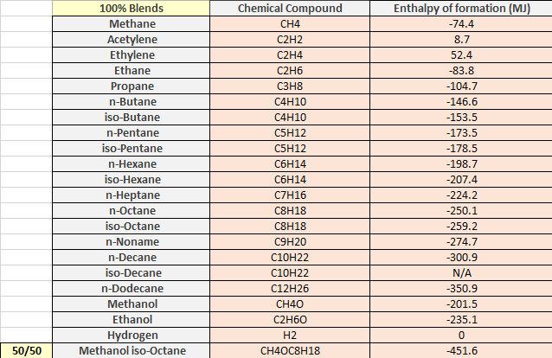

Figure 1: Table of Fuel Blends and Chemical compound
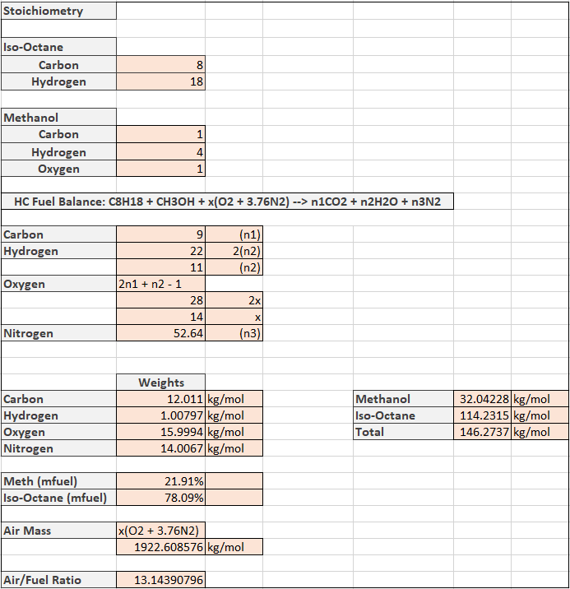
For example, Figure 2 shows the mass fuel percentages calculated for methanol and iso-octane, giving a value of 21.91% mass fuel for methanol sand 78.09% for iso-octane. To calculate the mass fuel percentages, carry out the amount of carbons, hydrogens and oxygen’s corresponding to their chemical compound and times them by their atomic weight giving the kg/mol for each fuel. In order to calculate their percentage, divide the mass of fuel by the total mass of both fuels combined.
Figure 2: Mass Percentages calculated with a 50/50 fuel blend of iso-octane and methanol
Looking back to Figure 2, the air mass was calculated using Equation 1;
x*(O₂ + (3.76*N₂))
Equation 1: Air Mass
Where O₂ and N₂ are their atomic weight. Once the mass fuel and air mass are calculated, the air to fuel mass ratio can be calculated dividing the total mass of fuel by the mass of air giving a result of 13.14.
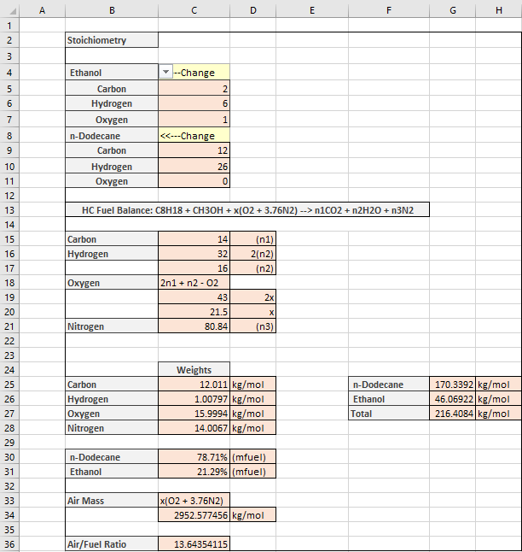
In addition, by using the VLOOKUP formula in MS Excel, a biodiesel could be calculated, using a 50/50 fuel blend of ethanol and diesel shown in Figure 3. This is created with a dropdown box in the following cells B4 and B8, where this determines the values according to the VLOOKUP table for carbon, hydrogen and oxygen, where this changes each value for n₁, n₂, n₃, x and the fuel weights which determine the fuel mass percentages, air mass and its air/fuel ratio.
Figure 3: 50/50 blend of Ethanol and Diesel using the VLOOKUP table
Furthermore, from the enthalpy of formations of the fuel blends iso-octane and methanol, the lower and higher heated values were calculated in MJ/kg shown in Figure 4. Referring back to Figure 1, states according to, (Mcallister, et al., 2011), the enthalpy of formation for each fuel blend and the enthalpy of formation for each gas followed firstly by Carbon Dioxide (CO₂), where CO₂ property table originated from, (Bhattacharjee, 2020). Secondly, water vapour (H2O), which originated from, (Bhattacharjee, 2020), where this shows the temperature increasing by 10 degree incriments as enthalphy (kj/kmol) increases, where changing units to x10⁻³ achieves (MJ/kmol) allowing a polynormial curve fit to the 6th order shown in the heading below; Developing a NOx model.
Calculate the lower heated value;
Step 1: Enthalpy needed for products (MJ), is equal to the fuel enthalpy of formations added together and enthalpy released from products (MJ), is equal to their carbons times their enthalpy of formation added by the amount of hydrogens times their enthalpy of formation. To find the net enthalpy;
Enthalpy released from products (MJ) – Enthalpy needed for products (MJ)
Equation 2: Net Enthalpy for lower heated value (MJ)
Step 2: To find the lower heated value;
Net Enthalpy (MJ) / Total mass of fuels (kg/mol)
Equation 3: Lower heated value (MJ/kg)
In relation to the lower heated value, the higher heated value can be calculated, to do this, simply take Equation 2, and add them together instead of subtracting and follow step 2 above.
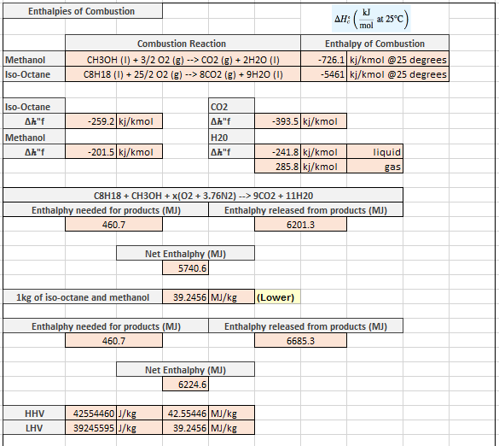

Figure 4: Lower and Higher heated values (MJ/kg)
The enthalpy of formation is defined as enthalpy change for the formation when one mole of a compound such as carbon dioxide, for example, the formation from its elements are carbon and oxygen. The convention of enthalpy states if, ΔHf <0 heat is released when the formations elements combine, and >0 when heat is immersed.
The difference between the lower and higher heating value of a fuel is defined by, (Hydrogen Tools, 2020), where the lower heating value, heat is released by combusting a stated quantity originally at 25°C, returning the combustion products to 150°C, where the supressed heat from the vaporisation of water in the reaction products are not recovered, where the higher heating value, heat released by a stated quantity originally at 25°C, once combusted and the products have returned back to a temperature of 25°C, which accounts the supressed heat of vaporisation of water in combustion produced.
Referring back to Figure 3, using the VLOOKUP formula in MS Excel, the following can be resulted for working out the lower and higher heated value for the two fuels used in Figure 3.
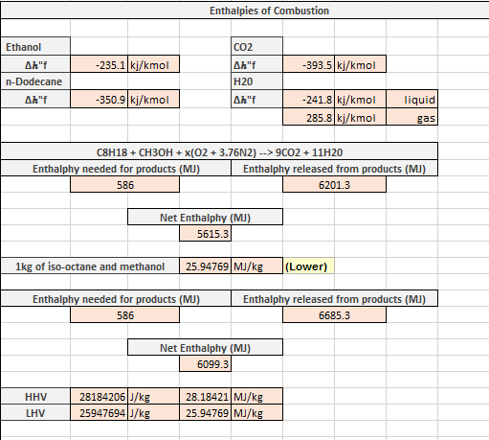

Figure 5: Lower and Higher heated value using the VLOOKUP table
To calculate the mass of CO₂ which is produced per kg of the corrolated fuel burnt, states the total amount of carbons is equal to the amount of molecules/kmol of CO₂. Firstly, to calculate the amount of kmol of fuels; iso-octane and methanol, times the amount of compounds by their molecular weights and add them together which is shown back in Figure 2. Secondly, to calculate the amount of kmol of CO₂, where the amount of carbon compounds is timesed by the weight of 1 carbon added by the weight of 2 oxygens, in relation to its chemical compound CO₂. So therefore divide 1kmol of CO₂ by 1kmol of the fuel blends; iso-octane and methanol, calculating a result of 2.712328767.
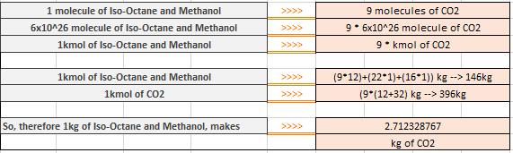

Figure 6: Mass of CO₂ produced per kg fuel burned
In addition, the result of using ethanol and diesel using the same process, results in a 2.847103375 kg of CO₂ produced.
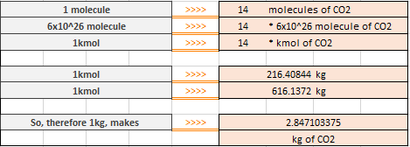

Figure 7: Mass of CO2 produced per kg fuel burned from VLOOKUP table
According to the article, (Khanna, 2020), an ideal fuel replicates these characterisitic properties such as; a high calorific value, proper ignition temperature where the temperature should neither be too low or too high, not contain any poisionus products during combustion, a moderate rate of combustion, easily controllable, avaliable, handle and transport, must be cheap and low moisture content.

Developing a NOx model
During this study, there are 2 available procedures; one which involves a goal seek and the other involving the VLOOKUP table with calculations matched to each cell which will simulate for each equivalence ratio (phi) ranging from 1 to 0.95 where it decreases 0.01 each time, where from 0.95 to 0.6, it decreases 0.05. In addition the exhaust gas recirculation (EGR) which ranges from a percentage of 0-50% incrementing in 5% each time.
Firstly, referring to the goal seek, constant numbers where associated according to their chemical compound. For instance, to develop a NOx model for iso-octane refer back to the study of modelling fuel blend mixtures and calculate the constants for n₁, n₂, x and n₃, which will be considered the starting point to calculate the value for enthalpy.
As seen in the table shown in Figure 8, to calculate the values for enthalpy;
(CO₂ * Enthalpy of Formation) + (H2O * Enthalpy of Formation) – (Phi * Fuel Enthalpy of Formation)
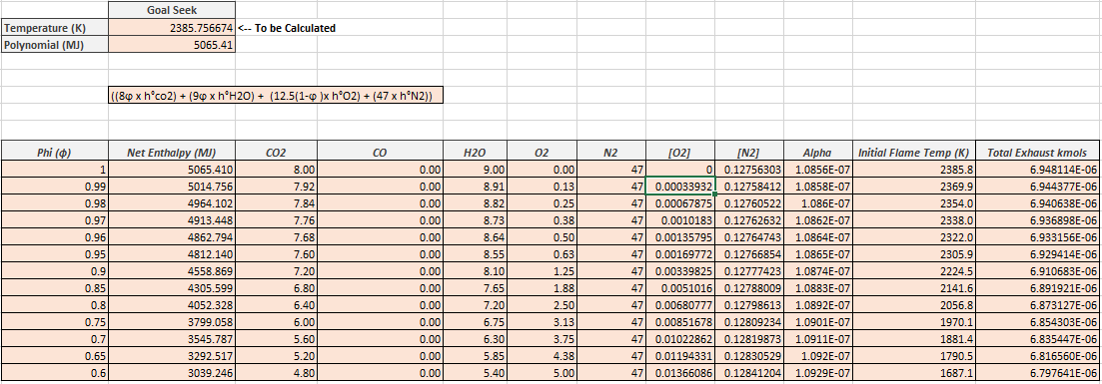
Equation 4: Goal Seek Enthalpy
Figure 8: Goal Seek Table

In addition, from finding the net enthalpy for each equivalence ratio, the goal seek can now be used to calculate the initial flame temperatures which are shown in Figure 8.
In order to set up the goal seek in MS Excel fix two cells, one to find the initial temperature which will change according to the enthalpy set in the other. This will be used according to the polynomial equation founded from the fuel tables; CO₂, (Bhattacharjee, 2020), H2O, (Bhattacharjee, 2020), N2, (Bhattacharjee, 2020) and O2, (Bhattacharjee, 2020).
The polynomial equation used to find the initial flame temperature using the goal seek was;
(Amount of Carbons * Phi * PolyCO₂) + (Amount of H2O * Phi * PolyH2O) + (Constant Value for x * (1-Phi) * PolyO2) + (N2 * PolyN2)
Equation 5: Polynomial equation used for goal seek
As shown in Figure 9, the goal seek function sets cell C4 which is the polynomial equation found above in Equation 5, which changes the value to your set enthalpy which reverse engineers the equation used to find the initial flame temperature changing in C3.
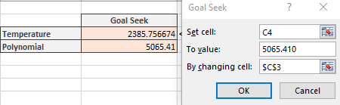

Figure 9: Goal seek function in MS Excel

As can be seen in the graph, Figure 10, shows as the enthalpy increases the flame temperature also increases. This is because when enthalpy increases there is more heat content in the system during the combustion process. This shows as you gather more heat content in the system, the initial flame temperature will rise.

Figure 10: 6th Polynomial Order, Enthalpy (MJ) vs Flame Temperature (K)
Furthermore, after calculating the initial flame temperatures through the goal seek function shown in Figure 9, assuming the pressure increase after start of combustion (0°C) starting at 10bar, increments in 2bar per degree to a peak value of 40bar shown below in Figure 11.
In order to calculate the flame temperature increase, as pressure increases 2bar per degree which is shown in Figure 11, using Equation 6;
Initial temperature*(P2/P1) ((Polytrophic index – 1) / (Polytrophic index))
Equation 6: Temperature Increase with Pressure
In addition, NOx (kmols/ m³) is the next step in this process. This equation used for NOx (kmols/ m³) is known as the Zeldovich model created by, (Merker, et al., 2005), there are many alternatives to this equation based on different measurements and assumed rate constants, such as, Heywood’s and Mcalister’s equations, which will be discussed further on.
In Merker’s zeldovich model equation, Z_{AB} also known as the gas kinetic collision rate is constant with a value of 4.7*10¹³ and –E_{A} which is the required energy needed for a reaction, with a value of -67,837, these are the two rate constants in Merker’s zeldovich model. Furthermore, the [N2] and [O2] concentrations need to be calculated in order to find NOx (kmols/m³) shown in
4.7*10¹³ * [N2] * ([O2]^{0.5}) * exp (-67,837 / Flame Temperature (K))
Equation 7: NOx (kmols/°)
To calculate [N2] and [O2], multiply their chemical compound by alpha and divide by the combustion volume. Alpha is known to change with phi the ratio lowers, there will be less fuel in the mixture, as this will change the concentration of [N2] and [O2].
Alpha (𝛼) = 6.16∙10⁻⁶ / Phi (𝜑) + 12.5(1 + 3.76)
Equation 8: Alpha (𝛼)
However, assuming the engine speed to be 1800rpm and volumetric efficiency to be 40%. Take Equation 7 and divide by the engine speed times by six, this change the units to °/second and then times the volumetric efficiency (*10⁻⁶) in order to get units from cc. Shown in the table below, Figure 11, using the above statement allowing units for NOx (kmols/ m³) for each degree as flame temperature increases. In order to calculate NOx parts per million, is the SUM of NOx (kmols/ m³) from 0-15 degrees (°), divided by the total exhaust kmols, which are calculated by adding the gas compounds together and times them by alpha.
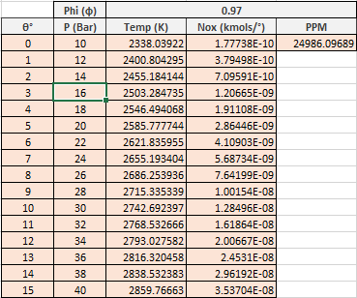

Figure 11: NOx PPM of Equivalence ratio (Phi)
Using the goal seek function finding NOx PPM for each phi at 0% EGR gives a graph as shown in Figure 12, this graph represents NOx PPM reaching optimum increase at 0.97 phi, this is because the high flame and burn zone temperatures, including the concentrations for [N2] and [O2] lead to higher rate of NOx production at this value.

Figure 12: PPM against Phi at 40% volumetric efficiency
In addition, adding the effect of E.G.R. on NOx PPM levels assuming the same volumetric efficiency of 40% and assuming EGR levels from 0-20% of the air/fuel contents.
Furthermore, add the effect of EGR to the gas compounds by multiplying the percentage, these gas compounds such as; carbon, hydrogen, oxygen and nitrogen, at each fuel equivalent ratio, which will change the initial flame temperatures according to the values inputted in the polynomial equation stated in Equation 5, and furthermore affect the concentrations, [N2] and [O2].

Referring back to Figure 9, this procedure was carried out again to find the following initial flame temperatures for the net enthalpy with the effect of EGR, as can be seen by the table in Figure 13
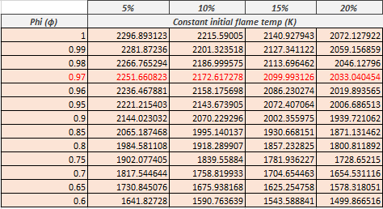

Figure 13: Initial flame temperatures effected by EGR %
Following the same procedures as shown in Figure 11, a table could be carried out to show the rate of NOx production and PPM with the effect of EGR shown below in Figure 14.
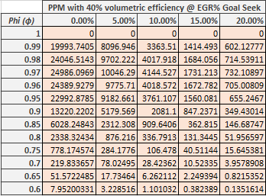

Figure 14: Table of PPM with the effect of EGR

Following from the table shown above in Figure 14, the graph below Figure 15, represents the effects EGR has on NOx PPM, where iso-octane without any effect from EGR produces high levels of NOx PPM. EGR is added in order to meet emission requirements, where EGR is recirculating burned gases back into the chamber to be burned again in the following cycle, thus reducing NOx production.

Figure 15: NOx PPM effected with EGR 0-20%
Furthermore, a VLOOKUP was created in MS Excel to compare the two procedures values for NOx PPM with the effect of EGR 0-20% to compare the accuracy between the goals seek and VLOOKUP simulation. This was firstly approached using the polynomial values given from the graphs in the Appendix; Figure 17, Figure 18, Figure 19 and Figure 20. In order to achieve the polynomial enthalpy according to temperature, times their enthalpy of formation by the gases according to their gas compound in the simulation according to EGR and fuel equivalence ratio.
Shown below in Figure 16, is the simulation carried out using VLOOKUP and INDEX formulas to calculate NOx PPM with the effect on EGR and fuel equivalence ratio according to their fuel type using the dropdown box stating iso-octane. This simulation will carry out the following procedures and equations used for the goal seek

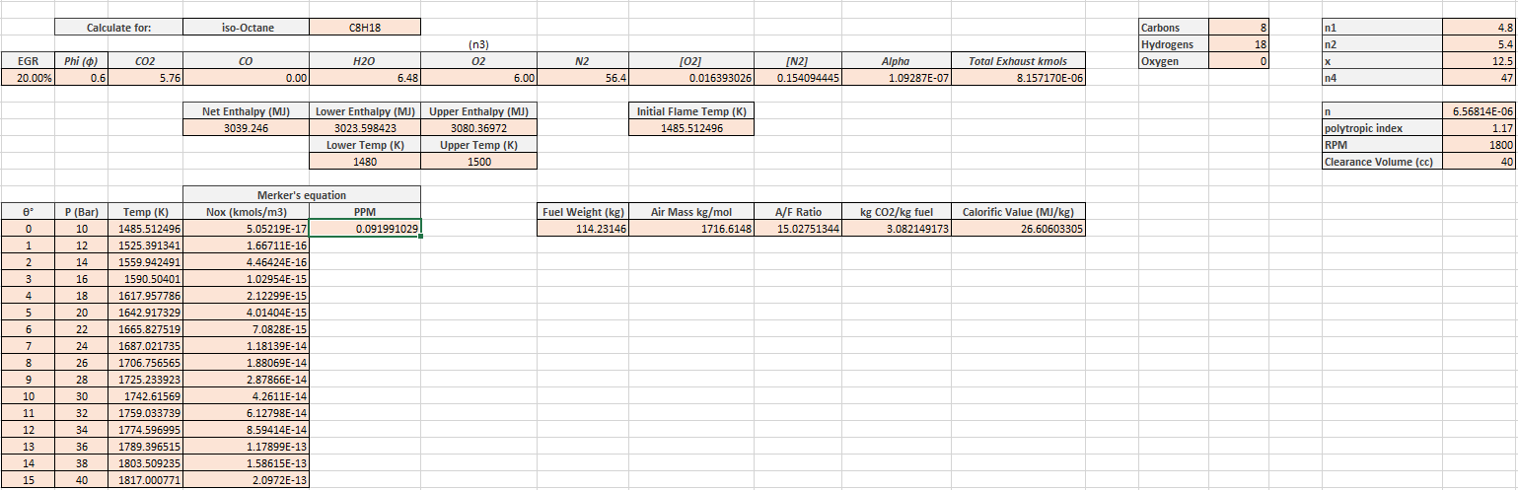
Figure 16: Simulation carried out using VLOOKUP and INDEX formulas

Conclusion
To conclude, to develop a NOx model with the effect of EGR shows the rate of NOx PPM decrease significantly as the EGR circulates back into the chamber through to the next cycle. However, shown in this study at 0.97 phi reaches optimum NOx PPM, where the high flame and burn zone temperatures, including the concentrations for [N2] and [O2] lead to higher rate of NOx production at this value.
Relative to the procedures used such as the goal seek and VLOOKUP method, they carry out similar values and shows the same trends. However, using the goal seek, it uses the value most accurate to the enthalpy inputted and uses the polynomial equation. In comparison to the VLOOKUP method, where this uses the polynomial equation to find the upper and lower enthalpy and temperatures and inputted to calculate the initial flame temperatures.

Appendix

Figure 17: CO2 Curve Fit Polynomial

Figure 18: H2O Curve Fit Polynomial

Figure 19: N2 Curve Fit Polynomial
Figure 20: O2 Curve Fit Polynomial

References
Bhattacharjee, S., 2020. Ideal Gas Enthalpy of Carbon Dioxide (CO2). [Online]
Available at: https://www.ohio.edu/mechanical/thermo/property_tables/combustion/CO2_enth.html
[Accessed 02 01 2020].
Bhattacharjee, S., 2020. Ideal Gas Enthalpy of Nitrogen (N2). [Online]
Available at: https://www.ohio.edu/mechanical/thermo/property_tables/combustion/nitrogen_enth.html
[Accessed 03 01 2020].
Bhattacharjee, S., 2020. Ideal Gas Enthalpy of Oxygen (O2). [Online]
Available at: https://www.ohio.edu/mechanical/thermo/property_tables/combustion/oxygen_enth.html
[Accessed 03 01 2020].
Bhattacharjee, S., 2020. Ideal Gas Enthalpy of Water Vapor (H2O). [Online]
Available at: Ideal Gas Enthalpy of Water Vapor (H2O)
[Accessed 2 01 2020].
Hydrogen Tools, 2020. Lower and Higher Heating Values of Fuels; Hydrogen Tools. [Online]
Available at: https://h2tools.org/hyarc/calculator-tools/lower-and-higher-heating-values-fuels
[Accessed 02 01 2020].
Khanna, B., 2020. What are the characteristics of an ideal fuel?. [Online]
Available at: http://www.preservearticles.com/geography/characteristics-of-an-ideal-fuel/535
[Accessed 02 01 2020].
Mcallister, S., Chen, J.-Y. & Fernandez-Pello, A., 2011. Fundamentals of Combustion Processes. Berkely: Mechanical Engineering Series.
Merker, G. P., Schwarz, C., Stiesch, G. & Otto, F., 2005. Simulating Combustion. Germany: Springer.

