
comteporay themes in management and leadership
Ayasha Khatun: 1712713

January 12, 2026
University of Wales Trinity Saint David

Summary
The purpose of this document is to critically analyse contemporary themes and management in leadership, and present an implementation plan of the outcome, the barriers and how women handle the leadership situations on a normal day at work. Women and children still face challenges despite the 21st century, in most parts of the world such as Africa, middle east and south Asia women are forced to stay home, give birth cook and clean.
This is study aims to look at barriers that women face not only in the mechanical engineering field but also in other sectors. Therefore, the system needs to change, and more training programmes such as workshops and role play must be adopted for women to achieve a higher standard despite already working hard.
The study aims to achieve changes across all sectors of the industry, equal pay, equal hours and same rewards that are applied to the men in the industry, women will have the same right as men.
Global leadership trends indicate a steady but complex shift toward gender parity. Since 2016, the integration of women into senior roles has been driven by systemic changes in higher education and targeted organizational interventions. While sectors like technology and media have led this growth, a strategic focus on the "broken rung" the transition to first time management remains essential for sustained progress. Therefore, Women can be enrolled into any job if they are support and sponsors, they can do it all with the right guidance from their partners family and children.
The plan is to change the educational policy in schools not just the United Kingdom but also around countries that are poor and unprivileged.

Table of Contents
Summary 1
Table of Figures 2
1. Implementation Plan 3
1.1 Introduction 3
2. Rationale 4
2.1 Aims and Objectives 5
2.2 Aims: 5
2.2 Action Plan 8
2.2.1 Time Plan 8
2.2.2 Risk Management and Strategies 9
3. Recommendations 10
4. Conclusion 10
Bibliography 12
Appendix 16
Appendix 1 17
Appendix 2 18
Appendix 3 18

Table of Figures
Figure 1 - Map of the World 4
Figure 2 – Example 4
Figure 3 - The Role of .... 4

Implementation Plan

Introduction
Mechanical engineers can see the future but also actualise it for the benefit of society. Domains encompass energy and environment, health and biosystems, security and defence, transportation, advanced manufacturing, data science, robotics, automation, complex systems, and machine learning (Frecker et al., 2024).
Women in executive positions are inefficient resulting in a strategic ga in the global economy. Based on Upper Echelons Theory (Hambrick, 2007) and the Resource-Based View of the firm (Barney, 1991), this argument asserts that gender diversity at the top of the organisational hierarchy increases cognitive variety, which reduces cohesiveness and boosts the formulation of strategic choices.
Women and girls are still facing challenges in other parts of the world such as Africa, and are forced to clean and cook, they are also forced to marry young and that constraints them from accomplishing their dreams (Tao, 2025).
Education supports careers through flexible learning models including part time learning, and distance opportunities and enable women to balance children and family (Reay, 2012) . There has been a rise in mechanical engineering and continues to exhibit a significant underrepresented for women around the globe, in leadership positions, which was the presentation on mechanical engineering and how women have shaped the world and are leading ways that is beyond the human mind. leadership identified cultural and structural barriers that restrict women’s progression despite comparable educational attainment (Acker, 2006).
Engineer’s roles have recently undergone an essential transformation. Engineers have historically been considered as specialists who were responsible for specific duties such as model design or intricate computations. However, the industry is transitioning in which engineers are more skilled in determining actions rather than simply carrying out tasks (Murad, 2024).
Research indicates the introduction of female role models, dissemination of career information, evaluation of gender-equitable materials, and engagement in practical science investigations Hoh, Y.K., (2007).
Institutions, universities, and corporations globally are conducting research on equality. Notably, there remain deficiencies in higher education pertaining to Science, Technology, Engineering, and Mathematics (STEM). This effort seeks to determine the factors influencing women's progression in STEM education in Brazil, particularly in engineering and computer science (Felipe et al., 2024).
International students reported feeling excluded within the community. Their experiences revealed a multiculturalism by limited intercultural awareness and sensitivity, factors included a lack of institution led initiatives to foster peer socialisation and minimal efforts to internationalise the curriculum (Tavares, 2024).

Rationale

Women make 70% of the global workforce in the health and social care industry, however, they maintain 25% of senior leadership positions in global health. In 2020, men occupied 73% of CEO positions within the world’s most influential health organizations, while women from low- and middle-income countries held only 5%. This underscores the persistent inequities and ongoing rejection of women from developing regions (Smith and Sinkford, 2022). See appendix 1
The key in female leadership is often a reflection of a "lifetime of bias" that begins in the classroom. Research by Francis and Skelton, (2025) reveals that early gender stereotyping in schools actively discourages girls from pursuing technical disciplines. In order to, finding echoed by qualitative accounts of women who felt "steered" away from STEM by gendered career guidance and for those who reach the corporate, the challenge shifts to the "Double Burden" the expectation to manage domestic labour while simultaneously performing "emotional labour" and mentorship in the workplace are not easy tasks that are frequently unrecognized in formal reviews (McKinsey, 2025).
Traditional societies, especially within the Arab world, cultural and religious beliefs create significant hurdles for women. Resistance often meets those seeking roles in leadership or "masculine" fields like engineering. According to Mantoura Nakad et al. (2025), these women must navigate societal uncertainty and family pressure, which in the slows the drive for gender equality.
Despite the increased focus in schools for both girls and boys to engage in cleaning or building toys, their gender roles are often fixed at home. Therefore, has resulted in employment issues, The societal views support the idea that boys are strong at mathematics and science, and girls are brilliant at English. more female engineers are needed into schools from a young age and use campaigns such as role models and hands on workshops to demonstrate what a female engineer looks like (Franklin et al., 2025).
A report from the World Economic Forum in 2023 shows that the number of women in top leadership positions has been growing since 2016. The technology, information, and media sectors have been leading the way. There were various sectors, where women in director posts climbed from 30.8% in 2016 to 33.2% in 2022 (Madhosingh, 2024).
By giving women access to credentials, and professional networks that were previously unattainable, higher education plays a crucial role in expanding their career options. Nonetheless, increased representation of women in leadership, professional, and STEM-related roles has resulted from female participation (Team and UNESCO, 2021)). As a result, institutions have been implementing more gender equality initiatives, such as mentorship programs and targeted outreach programs, to address historical imbalances (OECD, 2018).
It is necessary to investigate, the underrepresentation of women leadership positions across industries, it is imperative to evaluate the recent initiatives and organisational strategies aimed at fostering women’s advancement. Analysing the benefits, limitations, and measurables outcomes of these interventions in relation to women’s careers. Therefore, by providing valuable insights is essential.
Women do not receive the same level of career support as males, particularly entry and senior levels. Women are less likely than males to have a sponsor, and entry-level women receive significantly fewer sponsorships. Even when entry-level women have a sponsor, they're promoted at a slower rate than men (Krivkovich, et al., 2025) and Batra et al. (2025) argued that female representation on corporate boards significantly mitigates risk and earnings volatility by introducing diversity. In a market characterized by artificial intelligence and global instability. Despite these changes, educational planning and continuing to limit girl’s admittance into specific occupations particularly male dominated areas. See appendix 2
The ambitious goal of doubling of women in mechanical engineering by 2030, the American Society of Mechanical Engineers (ASME) is spearheading a massive industry-wide shift. Moving from a current baseline of roughly 17% to a target of 35%, the initiative focuses on systemic change rather than just recruitment (Fallon, 2024). See appendix 3
Changes happening within the education policy are boosting crucial skills, increased focus on financial education, digital literacy, and improving climate and sustainability education. Currently schools are facing issues regarding the policy and procedures, women give birth and need to be away for a certain period and are being judged for their race, age, gender in particularly if they are from the ethnic minority background. Heymann et al., 2023)

Aims and Objectives

Aims:
Aims: To enhance the wellbeing of women in leadership roles around the world including local councils and communities and build a strong foundation for the younger generation, in addition to maintaining professional networks, role play and funding for a brighter future within leadership for women and young children and changing the views on educational policy.
Objectives: To develop and leverage an authenticate leadership style that aligns with their personal values and strengths, rather than confirming to traditional male standards and to possible implement the change in different sectors such as, the education sector, within the next 7 to 8 years or possibly more.

Figure 1 – The state of the leadership gender gap
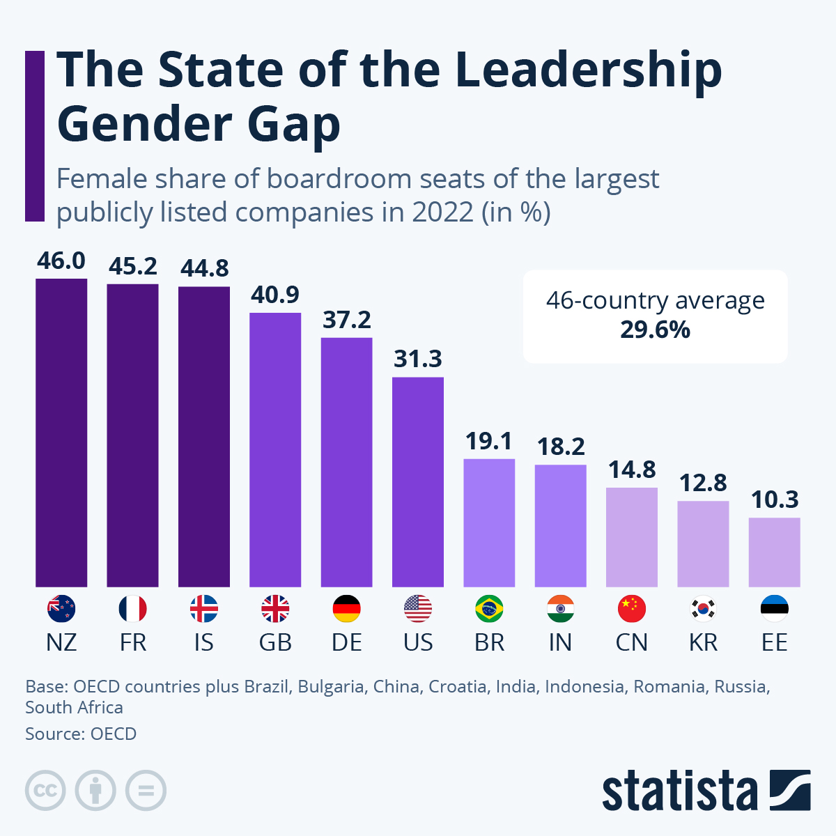
Source (Fleck, 2024)
Figure 2 – Trends for mechanical engineering over the years, and how the innovation has increased.
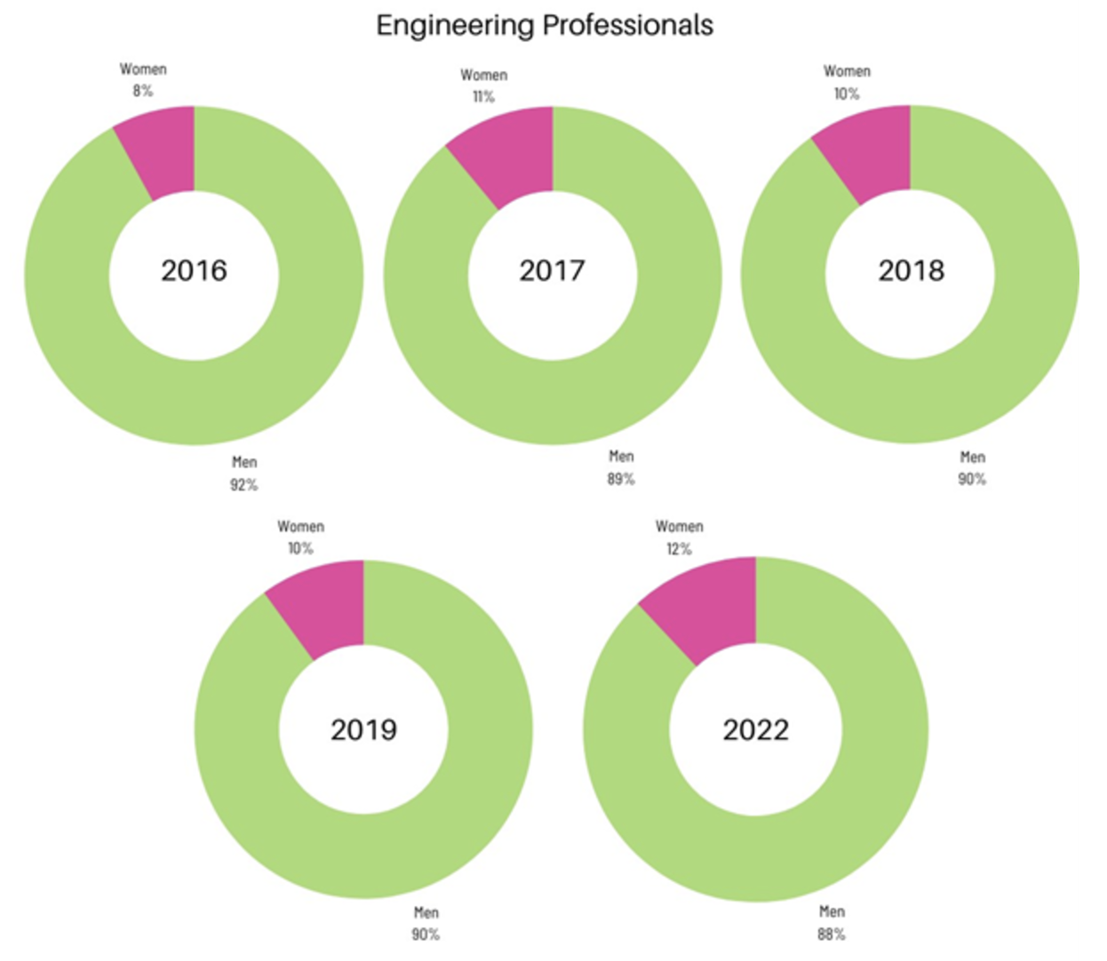

Source (Engineeringmanagement.org, 2025)

Figure 3 – measuring the success of women in leadership roles
‌ 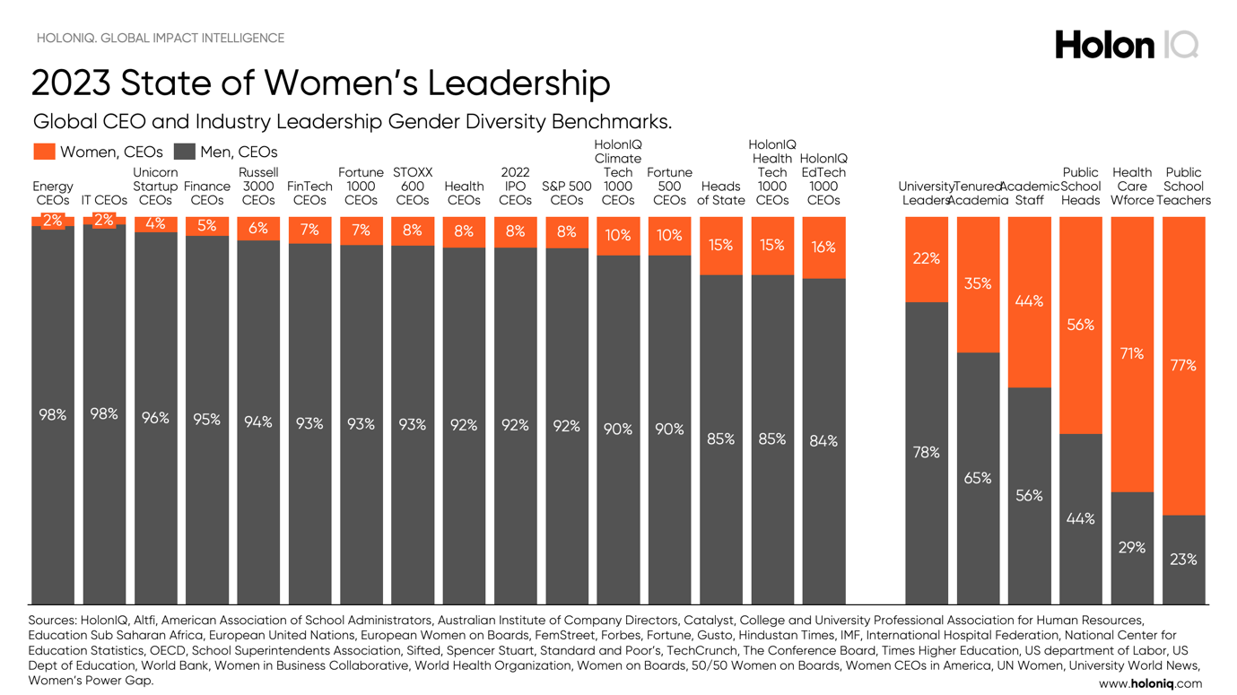
Source (Bing, 2026)

Action Plan
To ask for permission from stakeholders, teachers, parents, students, union and government, and government body. Formulate succinct policy directives customised for primary implementers (Honig, 2006).
The new curriculum is being developed in collaboration with teachers, curriculum specialists, students, and parents. The full curriculum will be published in spring 2027, and schools will begin teaching it in September 2028 (media officer, 2025).
Ensuring accountability at all levels, acknowledging and comprehending the competencies of implementers, and consistently permitting and monitoring feedback Winstone, N. E. and Carless, D. (2021).
Rachel Reeves, stated:
‘The UK is at the forefront of promoting gender equality in corporate boardrooms, but we must continue our efforts.’ In addition to this she also said, ‘It is crucial to eliminate the barriers that hinder many women from being represented in leadership roles. Furthermore, she mentioned that this will allow top talent to ascend to the highest levels of leadership in businesses, which is vital for fostering economic growth throughout Britain.
(For, 2025), noted that the UK is leading the worldwide effort to enhance the presence of women on corporate boards and in executive leadership roles.

2.2.1 Time Plan
Approach governing bodies, demand lobby and government for permission (Lewis and Roberts, 2026). Take permission from the council specially in the United Kingdom( Local.gov.uk, 2025). Some may take 6 months, and some may take 6 years (Dooley, 2025) argued that the fees will in the educational field will rise by 3.1% and everyone will receive equal by 2026. The Education Secretary today announced plans for a more robust and efficient system, backed by an initial £20 million investment to launch new regional improvement teams (Department for Education, 2025).
(Editorial, 2025) pinpoints that the children aged 10-11 will be able to take their first GCSE by 2029.
(Bromley, 2021) stated the process can take several years now it is all about getting people on board.

2.2.2 Risk Management and Strategies
Teachers, students, and staff leaders will need to be addressed and their vote matters.
Lack of funding, lack of materials., ensure funds are in place before committing to any projects.
Monitor outcomes and take in feedback as necessary.
Ensure sensitive and confidential data is locked away.
Cyber security threats will increase.
Currently schools are facing issues regarding the policy and procedures, women give birth and need to be away for certain a period.
School governing bodies need to lessen the regulations for fluctuations in the financial economy.

Recommendations
Women need to be supported by family, friends, for a more stable career.
Women and children need training programmes or coaching and mentoring as a startup or recap.
The educational policy will change going forward, more subjects will be added and more opportunities for female leadership will arise
A continued effort is needed to promote reforms that encourage stronger employer engagement, for all sectors around the world, while also challenging proposals such as compulsory contributions that could create barriers to participation.
Education and gender biased jobs need to be implemented overseas such as, south Asia, Africa, and the parts of the Middle East.
A pay rise is required regardless of race age and gender.

Conclusion
Employment opportunity has advanced gender equity across the West; however, significant barriers remain. For example, Australia designed to mandate transparency and merit-based hiring, yet women still face a glass ceiling across leadership STEM.
As noted by Dabic et al. (2023), gender equality is often incorrectly viewed as a "zero sum game," where progress for women is perceived as a loss for men, hindering cultural adoption of policies. Appointing women to the highest levels of management can even help offset deep-rooted preconceptions that are represented in language. Although these advantages are evident, merely 10% of Fortune 500 companies are headed by women. Schools will introduce more women, and new subjects will be introduced and applied (Novotney, 2023).
The under-representation of women in executive positions is an inefficient use of human Research that indicates female leaders often utilise transformational leadership approaches, which are positively associated with organisational resilience and increase employee position (Eagly, et al., 2003).
Gender balance within leadership serves as a critical tool for improving ethical accountability and strengthening risk mitigation strategies (Adams and Ferreira, 2009). Consequently, the inclusion of women in executive roles is more than a matter of social justice; it is a strategic necessity for maintaining competitiveness in today’s volatile global economy.
Girls and boys need to have the same equation in terms of freedom and education, once that is adopted in countries such as India, Bangladesh, Pakistan, Africa and other rural areas around the world, there will be a better place.
Most women have turned online in majority of the work. Transitioning from working in the office regardless of the job. Woman to fully transition and make a difference within a few days. However, with certain responsibilities in mind, it is not always a choice but a lifelong commitment due to several factors.
The data proves that intentional intervention works. However, to achieve full parity, the focus must shift from simply increasing the number of women to evaluating the impact of the strategies used to promote them. Analysing the limitations of current interventions is essential for developing more resilient, and career pathways for women.
While flexible educational pathways have expanded women’s access to professional development, disparities remain within mechanical engineering, particularly in leadership roles. Women continue to encounter cultural barriers that limit their advancement, even when their qualifications match those of their male counterparts. Yet their contributions to engineering demonstrate not only technical expertise but also transformative leadership that challenges long assumptions about the field. As engineering shifts toward roles that demand strategic thinking and rather than purely technical execution, ensuring equitable opportunities for women becomes essential. Addressing these barriers is not only a matter of fairness but a necessary step toward fostering a more innovative, diverse, engineering profession.

Bibliography
Adams, R.B. and Ferreira, D. (2009) ‘Women in the boardroom and their impact on governance and performance’, Journal of Financial Economics, 94(2), pp. 291–309.
Acker, J. (2006) ‘Inequality regimes: Gender, class and race in organisations, ‘ Gender and society, 20(4), pp. 4410-464.
Barney, J.B. (1991) ‘Firm resources and sustained competitive advantage’, Journal of Management, 17(1), pp. 99–120.
Batra, S., Yadav, M., Kumar, P. and Singh, A.K. (2025) ‘Gender diversity and corporate risk nexus: does board size matter?’, International Journal of Social Economics, 52(1). doi: 10.1108/IJSE-03-2025-0269.
Bromley , M. (2021). Navigating Change in Education. [online] Nationalcollege.com. Available at: https://nationalcollege.com/news/what-to-expect-in-the-2025-26-academic-year [Accessed 12 Jan. 2026].
Dabić, M., Posinković, T.O., Maley, J.F., Božidar Vlačić, Marzi, G. and Kraus, S. (2023). Exploring the Multifaceted Challenges of Women in Engineering: A Comprehensive Literature Review. IEEE Transactions on Engineering Management, [online] 71, pp.3325–3339. doi:https://doi.org/10.1109/tem.2023.3342980.
Editorial (2025). The Guardian view on education reform: Labour risks missing its chance to change schools. [online] the Guardian. Available at: https://www.theguardian.com/commentisfree/2025/nov/10/the-guardian-view-on-education-reform-labour-risks-missing-its-chance-to-change-schools [Accessed 12 Jan. 2026].
Lewis, J. and Roberts, N. (2026). Reforming the educational assessment system. [online] House of Commons Library. Available at: https://commonslibrary.parliament.uk/research-briefings/cdp-2025-0185/ [Accessed 12 Jan. 2026].
Local.gov.uk. (2025). Must know: A guide to education. [online] Available at: https://www.local.gov.uk/publications/must-know-guide-education [Accessed 12 Jan. 2026].
Department for Education (2025). Government sets out plans to target ‘stuck’ schools. [online] GOV.UK. Available at: https://www.gov.uk/government/news/government-sets-out-plans-to-target-stuck-schools [Accessed 12 Jan. 2026].
Dooley, O. (2025). Education policy in 2025: what to expect - PLMR. [online] PLMR. Available at: https://plmr.co.uk/2025/01/education-policy-in-2025-what-to-expect/ [Accessed 12 Jan. 2026].
‌

Dr. Samantha Madhosingh (2024). 5 Reasons More Women Leaders Are Needed At The Top. [online] Forbes. Available at: https://www.forbes.com/sites/drsamanthamadhosingh/2024/03/07/5-reasons-more-women-leaders-are-needed-at-the-top/ [Accessed 7 Jan. 2026].
Eagly, A.H., Johannesen-Schmidt, M.C. and Van Engen, M.L. (2003) ‘Transformational, transactional, and laissez-faire leadership styles: a meta-analysis comparing women and men’, Psychological Bulletin, 129(4), pp. 569–591.
Fallon, A. (2024). Challenges and Prospects for Women in ME - ASME Foundation. [online] ASME Foundation -. Available at: https://www.asmefoundation.org/2024/05/20/leapfrog-to-the-new-generation-of-engineers-2/ [Accessed 12 Jan. 2026].
Felipe, L., Maria, L., Oliveira, Y., Santos, A.M., Barbosa, C.E., Xexéo, G. and Jano (2024). Women’s Journey in STEM Education in Brazil: A Rapid Review on Engineering and Computer Science. IEEE Access, [online] 12, pp.112576–112593. doi:https://doi.org/10.1109/access.2024.3442879.
Fleck, A. (2024). Infographic: The State of the Leadership Gender Gap. [online] Statista Daily Data. Available at: https://www.statista.com/chart/4871/the-countries-with-the-most-women-in-the-boardroom/ [Accessed 10 Jan. 2026].
For, D. (2025). UK businesses lead the way with record numbers of female leaders. [online] GOV.UK. Available at: https://www.gov.uk/government/news/uk-businesses-lead-the-way-with-record-numbers-of-female-leaders [Accessed 7 Jan. 2026].
Francis B and Skelton, C. (2005) Reassessing gender and. Achievement: Questioning contemporary key debates. London, Routledge.
Franklin, B., Humphris, E.S. and Field, J. (2025). How can we help encourage more women into engineering? [online] Institution of Civil Engineers (ICE). Available at: https://www.ice.org.uk/news-views-insights/inside-infrastructure/help-encourage-more-women-into-engineering [Accessed 11 Jan. 2026].
Frecker, M., Dames, C., Cagan, J., Siegel, D.J., Pelegri, A., Jacobi, A., Erickson, D. and Ranjan, D. (2024). What is Mechanical Engineering? Mechanical Engineering, [online] 146(4), pp.1–1. doi:https://doi.org/10.1115/1.2024-july4.
Hambrick, D.C. (2007) ‘Upper echelons theory: an update’, Academy of Management Review, 32(2), pp. 334–343.
Heymann, J., Sheleana Varvaro-Toney, Raub, A., Kabir, F. and Sprague, A. (2023). Race, ethnicity, and discrimination at work: a new analysis of legal protections and gaps in all 193 UN countries. Equality Diversity and Inclusion An International Journal, [online] 42(9), pp.16–34. doi:https://doi.org/10.1108/edi-01-2022-0027.
Hoh. Y.K. (2007) ‘Outstanding Women in Mechanical Engineering’, International journal of mechanical engineering education, 35(3), pp. 198–206. Available at: https://doi.org/10.7227/IJMEE.35.3.4.
Krivkovich, A., Goldstein, D. and McConnell, M. (2025). Women in the Workplace 2025. [online] McKinsey & Company. Available at: https://www.mckinsey.com/capabilities/people-and-organizational-performance/our-insights/women-in-the-workplace [Accessed 8 Jan. 2026].
Madhosingh, S. (2024). 5 Reasons More Women Leaders Are Needed At The Top. [online] Forbes. Available at: https://www.forbes.com/sites/drsamanthamadhosingh/2024/03/07/5-reasons-more-women-leaders-are-needed-at-the-top/.
Mediaofficer (2025). What you need to know about the changes to the National Curriculum – The Education Hub. [online] Blog.gov.uk. Available at: https://educationhub.blog.gov.uk/2025/11/what-you-need-to-know-about-the-changes-to-the-national-curriculum/ [Accessed 7 Jan. 2026].
Murad, J. (2024). The Evolution of Mechanical Engineering - Process Automation. [online] Jousef Murad. Available at: https://www.engineered-mind.com/engineering/the-evolution-of-mechanical-engineering/ [Accessed 6 Jan. 2026].
Novotney, A. (2023). Women leaders make work better. Here’s the science behind how to promote them. [online] https://www.apa.org. Available at: https://www.apa.org/topics/women-girls/female-leaders-make-work-better [Accessed 8 Jan. 2026].
OECD (2018). Education at a Glance 2018. [online] Education at a glance. OECD indicators/Education at a glance. Organization for Economic Cooperation and Development. doi:https://doi.org/10.1787/eag-2018-en.
Rea, D. (2012) ‘what would a socially just education look like?’, British journal of sociology of education, 33 (5), pp. 587-599.
Smith, S.G. and Sinkford, J.C. (2022). Gender equality in the 21st century: Overcoming barriers to women’s leadership in global health. Journal of Dental Education, [online] 86(9), pp.1144–1173. doi:https://doi.org/10.1002/jdd.13059.
Tavares, V. (2024). Feeling excluded: international students experience equity, diversity and inclusion. (2024). International Journal of Inclusive Education. [online] doi:https://doi.org/10.1080//13603116.2021.2008536.
Team, R. and UNESCO (2021). Global Education Monitoring Report. [online] UNESCO Publishing. Available at: https://digitallibrary.un.org/record/4020380?v=pdf [Accessed 10 Jan. 2026].
Tao, S. (2025). Tackling the Toughest Barrier for Girls: Social Norms. [online] The Education and Development Forum (UKFIET). Available at: https://www.ukfiet.org/2025/tackling-the-toughest-barrier-for-girls-social-norms/ [Accessed 12 Jan. 2026].
Winstone, N. E. and Carless, D. (2021) ‘Who is feedback for? The influence of accountability and quality assurance agendas on the enactment of feedback processes’, Assessment in Education: Principles, Policy & Practice, 28(3), pp. 261–278. doi: 10.1080/0969594X.2021.1926221.
‌

‌

‌

‌

Appendix

Appendix 1
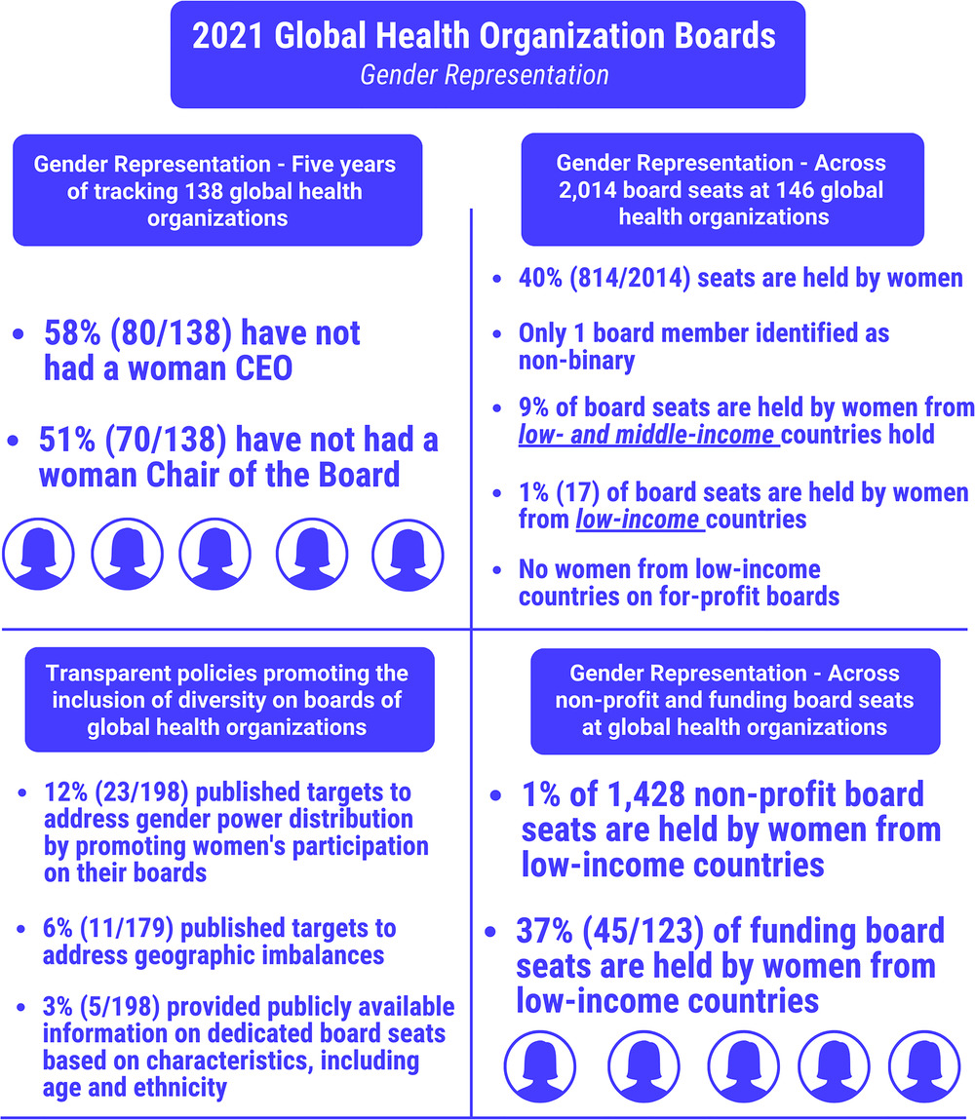

Appendix 2
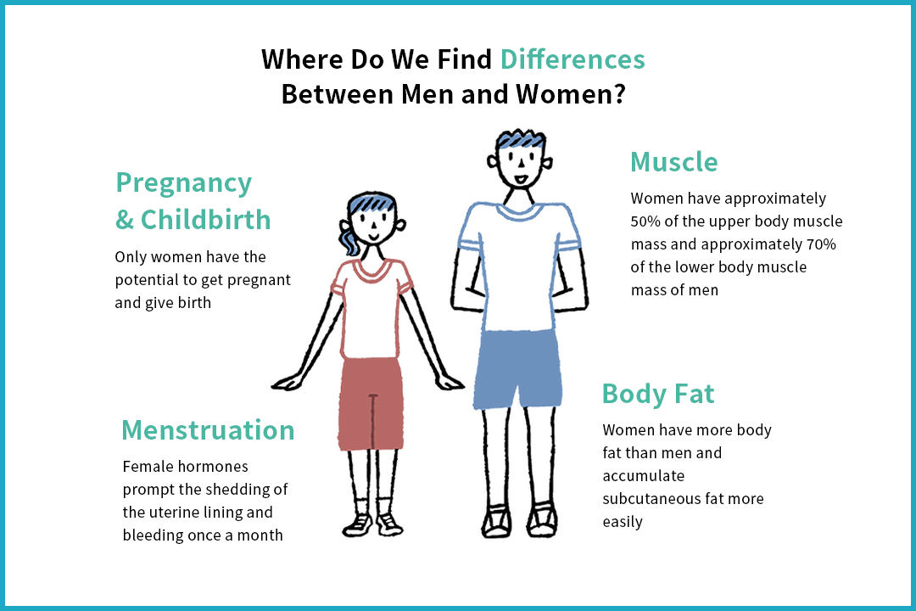
Source (Bing, 2025)

Appendix 3

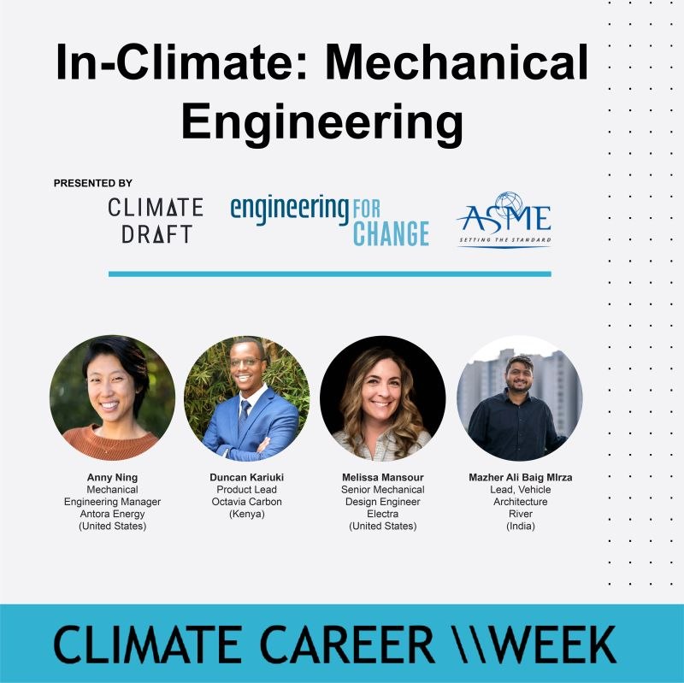
(Bing, 2024)

