Mathew Jones (2317425)
Computing (SOFTWARE eNGINEERING
API Creation
Cloud Based Web Services
Contents
Introduction 2
REST APIs 2
Advantages of REST APIs 2
Disadvantages of Rest APIs 2
REST APIs use cases 2
SOAP 3
Advantages of SOAP 3
Disadvantages of SOAP 3
SOAP Use Cases 3
GraphQL 4
Advantages of GraphQL 4
Disadvantages of GraphQL 4
GraphQL Use Cases 4
Demonstrate basic operations 5
Implementing a PATCH operation 7
Workflow process 8
Software Testing 10
References 12

Introduction
Modern software applications are often required to communicate with each other and the current method they communicate are APIs or application programming interfaces. They define how data can be requested and exchange between each system. There are many APIs but one of the most common APIs is REST API which will be discussed about in the paper as well as SOAP and GraphQL which are also APIs. They 3 APIs will be compared looking at the advantages, disadvantages and their best use cases. Additionally, there will be evidence in regard to creating and an API, using operations such as GET, POST, PATCH and DELETE.

REST APIs
REST stands for representational state transfer and is an architectural style which is used to connect distributed hypermedia systems. They allow applications to access resources inside of another application, service or database [1]. REST APIs use HTTP methods such as GET, POST, PUT, PATCH and Delete to perform actions such as creating, retrieving, updating or deleting information, these four are commonly known as CRUD.

Advantages of REST APIs
REST APIs have a highly compatible with other applications as it uses the same language, code and architecture. This also makes it very flexible as it can adapt to most applications. They are able to handle lots of information and still operate fine. They use tokens for authentication, which is difficult to breach as they are unique, additionally you are able to improve security by using another authentication method. Finally, APIs have easy and a lot simpler than other APIs [2].

Disadvantages of Rest APIs
The disadvantages of REST APIs are they can be more complex and familiarity with other web architecture is advised. You must be connected to the web to execute operations; this can only be an issue has its performance can be negatively affected by poor internet speeds [2].

REST APIs use cases
The use cases for REST APIs are:
- Web services
- Mobile applications
- IOT devices
- E-Commerce platforms [3]

SOAP
SOAP also known as simple object access protocol is a protocol used to exchange information between different systems. It used XML to format data and commonly follows strict rules which are defined in a contract called WSDL or Web services description language. It is used often in enterprise systems as they require higher level of security and reliability [4].

Advantages of SOAP
SOAP uses encryption and authentication which increases security greatly and makes it suitable for systems which handle sensitive data. There is a strict structure so the server and client should know how messages are to be formatted. Additionally, SOAP supports transaction handling and built-in error handling, this useful for when systems become more complex [5].

Disadvantages of SOAP
The disadvantages of SOAP are it’s more complex, so development is slower and performance is impacted as there is more overhead. Due to these reasons SOAP is also harder implement, test and are less flexible. SOAP is not as popular than other APIs due to these reasons [5].

SOAP Use Cases
The use cases for SOAP APIs are:
- Banking systems
- Financial transactions
- Booking flights
- Companies require strict validation [6]

GraphQL
GraphQL was developed by Facebook and is a query-based API. It typically uses a single endpoint, and the client specifies what data it requires, and the server returns only the specified data [7].

Advantages of GraphQL
GraphQL is able to specify the exact data you require which avoids a common issue of over-fetching and under-fetching which leads to an efficient data fetching system. When data requires accessing or analysing a special language called declarative query language can be used to clearly explain what information is require without worrying about technical details of how to retrieve it. These complex data requirements can be expressed easier. The Schema used is easy to understand for developers and outlines the exact structure and data types for servers and clients. This assists in removing confusion and ensures communications is smooth between different areas of the application. Additionally, as stated above GraphQL uses a single endpoint which makes the whole process a lot simpler [8].

Disadvantages of GraphQL
When initially using GraphQL for the first time it can be quite a learning curve as setting up the schema is more complex. There is also a potential for over-fetching which will negatively impact the performance, care is to be taken to prevent this. Security can also be an issue; to prevent this rate limiting and query validations are important security measures to protect against attacks [8].

GraphQL Use Cases
The use cases for GraphQL are:
- Social media platforms
- Mobile and web apps
- Real-time dashboards and data aggregation
- API aggregation and versioning
- Data caching [9]

Demonstrate basic operations
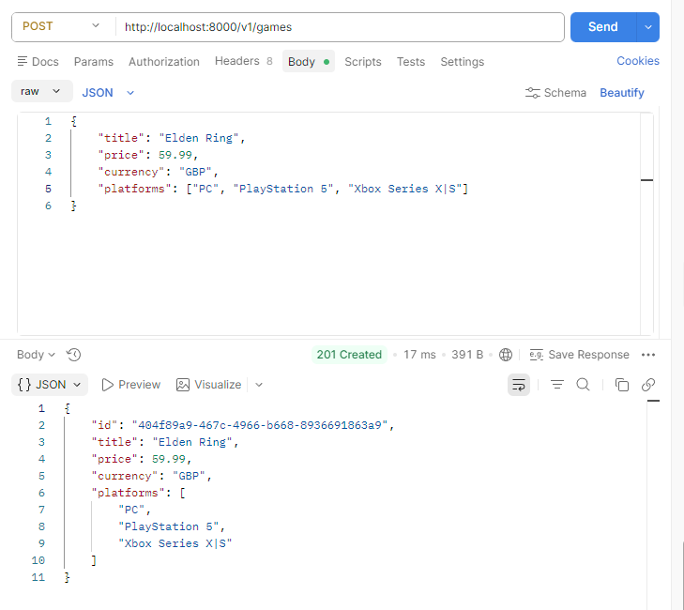
Below demonstrates the POST operation. Entering the game details into title, price, currency, platform and then entering execute will input the data into then API

The image below demonstrates the GET operation. Clicking the execute the button will show all games inputted into the API
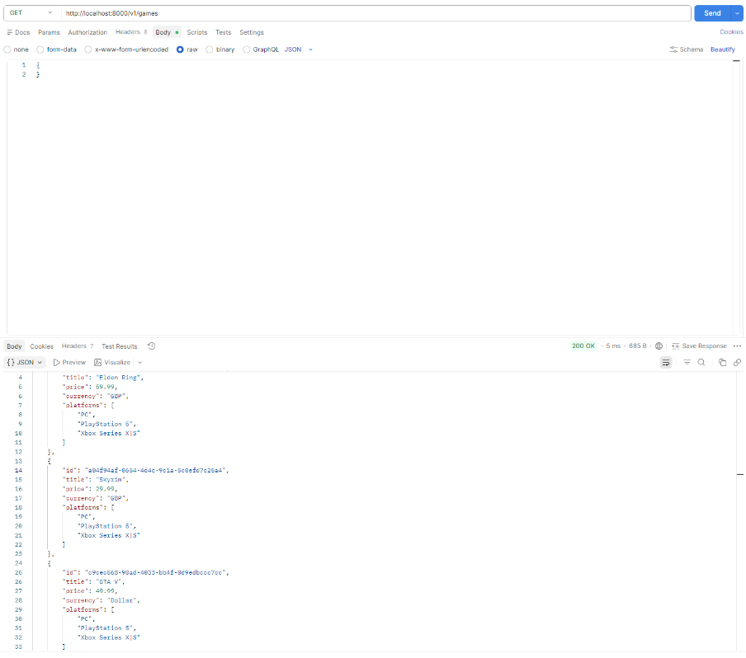

To remove a game from the API, the Delete operation will need to be used. Below is evidence of the DELETE operation being used and then checking will the GET operation that the game has actually been deleted from the API.
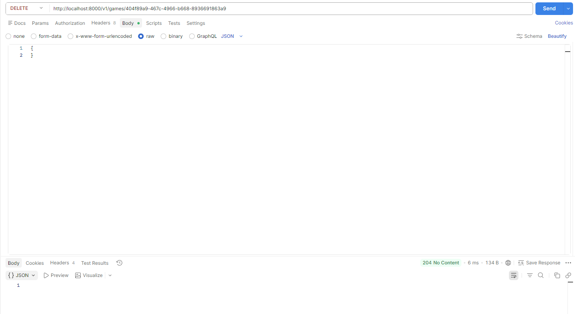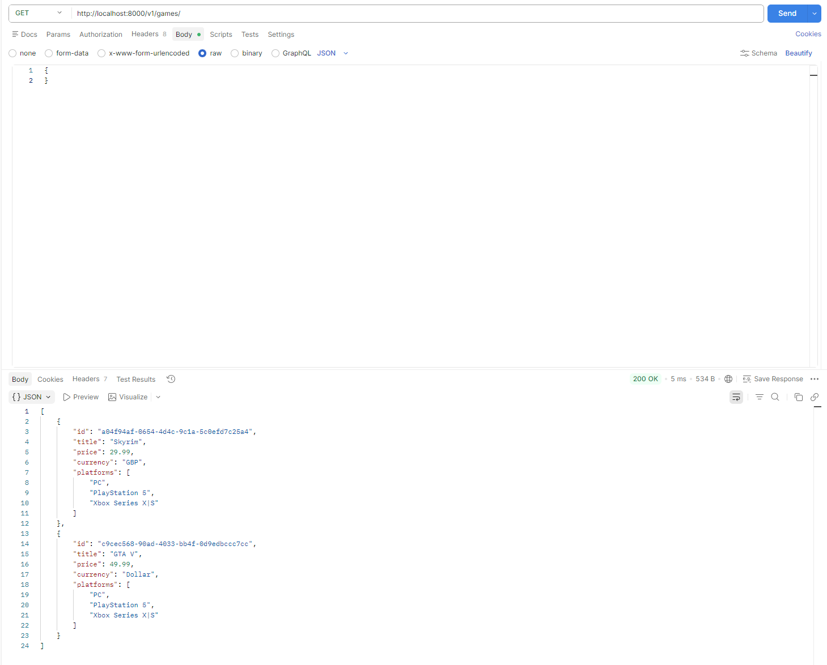

Implementing a PATCH operation
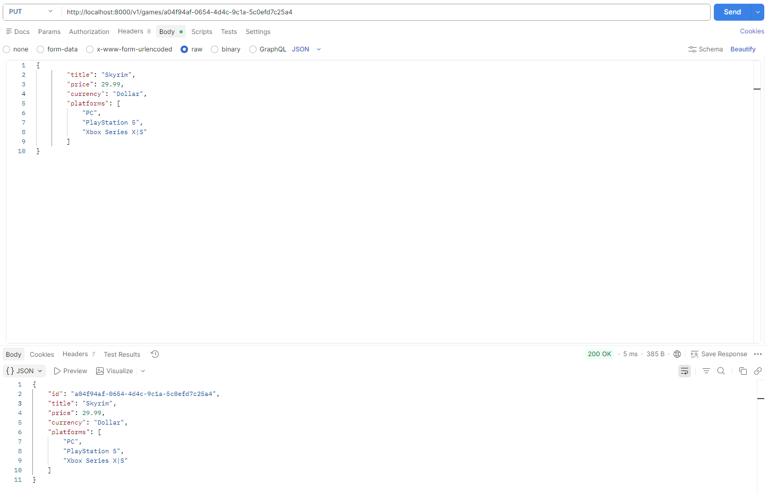
To demonstrate the PUT operation Skyrim currency was changed to dollar.
Using the PATCH operation the price of the game was changed from 29.99 dollars to 19.99 dollars.
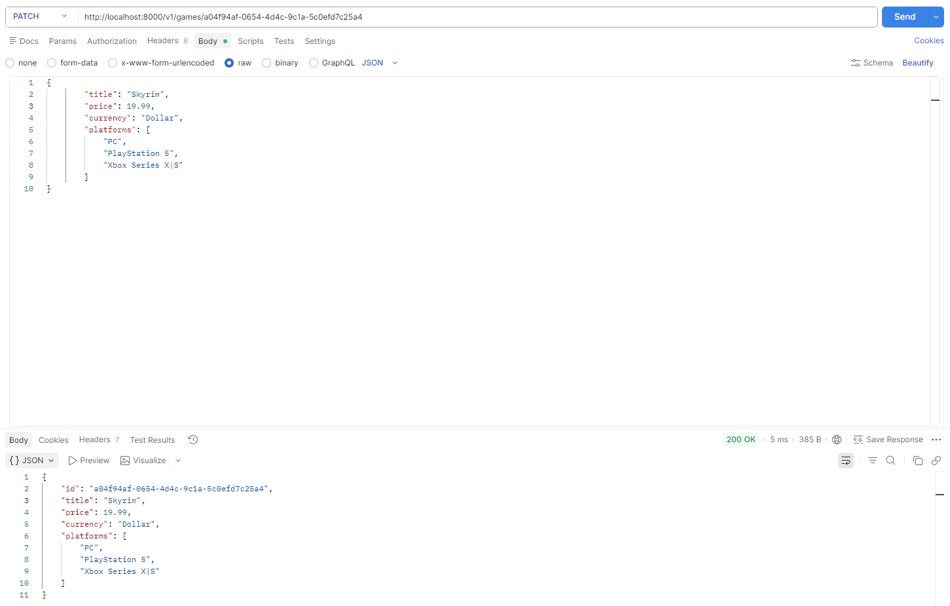

Below is evidence from the Get operation that it has succesfully changed to 15 pounds.
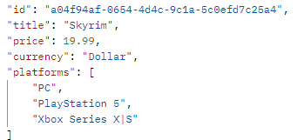

Workflow process
Below is an order being create by using the ID of a game and a POST operation.
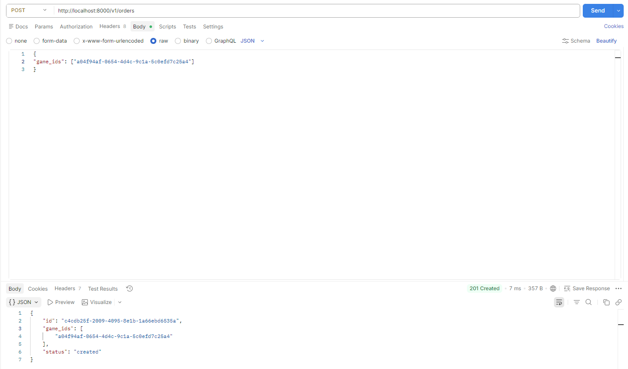
This Get operation will check the status of the order, the order has been created but has not yet been delivered.
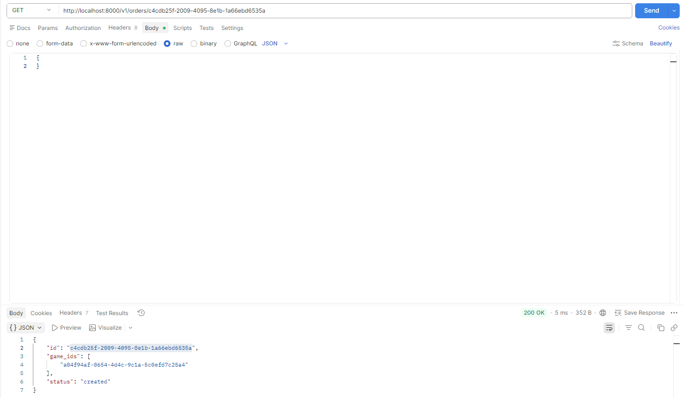

This PUT operation will update the Order ID status to delivered.
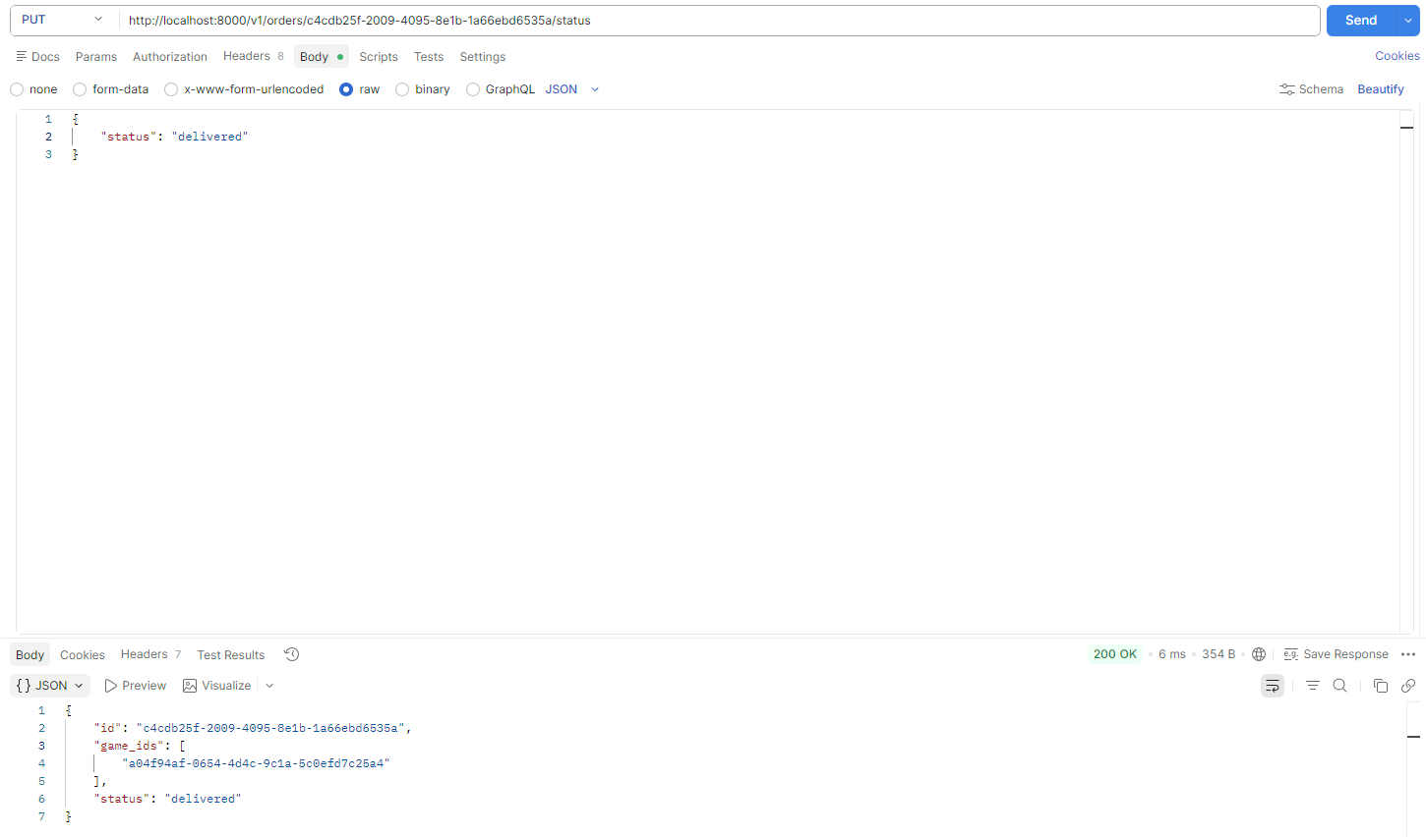

Below is just evidence of the PUT operation successfully updating the status of the item.
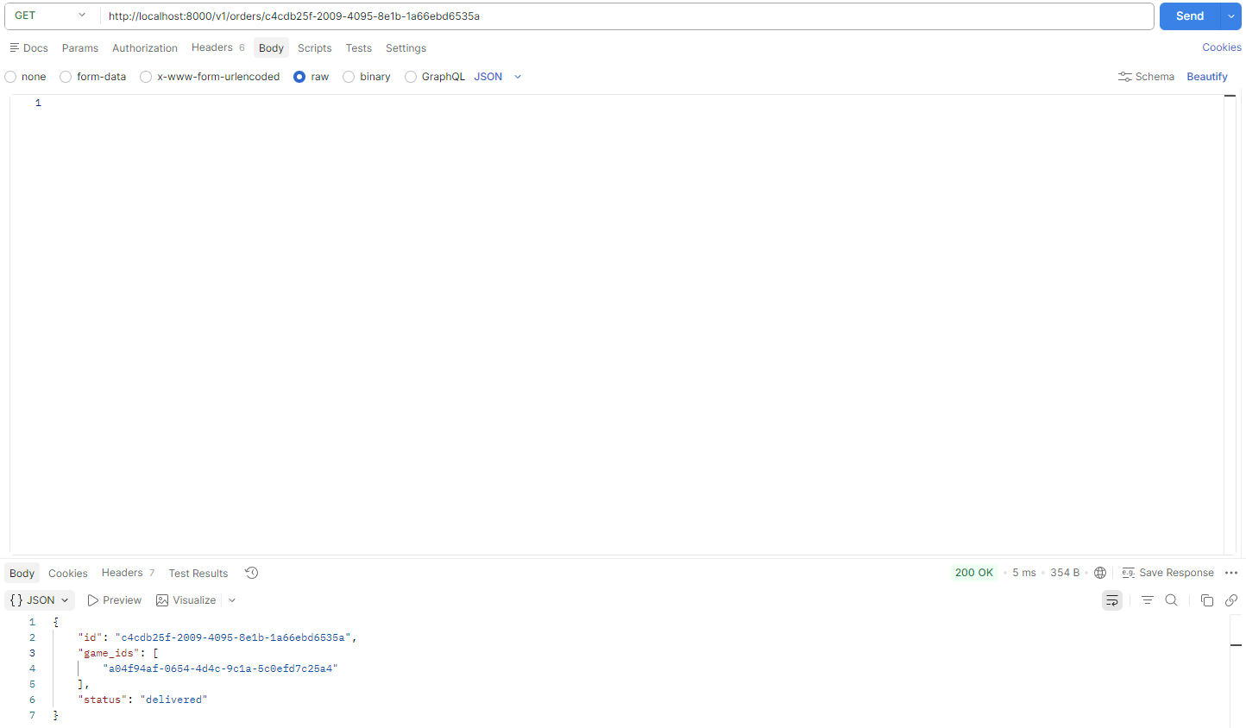

Software Testing
Test Title: | Create game
Test Author: | Mathew Jones
Test Description:
This test verifies that a new game can be created using the POST operation. The user submits valid game data including the title, price, currency and platform the game is on.
Expected Outcome:
The API returns HTTP 201 created and responds with the newly created game including a unique ID

Test Title: | List Games
Test Author: | Mathew Jones
Test Description:
This test verifies that all stored game can be retrieved using the GET operation.
Expected Outcome:
The API returns HTTP 200 ok and a list containing all games currently stored in the system.

Test Title: | Update game using PATCH
Test Author: | Mathew Jones
Test Description:
This test verifies that a game can be partially updated using the PATCH operation. Only the fields provided in the request are modified.
Expected Outcome:
The API returns HTTP 200 ok and only the specific fields are updated while all other fields remain unchanged.

Test Title: | Create order
Test Author: | Mathew Jones
Test Description:
This test verifies the first stage of the workflow where an order is created containing a list of game IDs using the POST operation
Expected Outcome:
The API returns HTTP 201 created, and the order is stored with its stat set to “Created”.

Test Title: | Deliver order
Test Author: | Mathew Jones
Test Description:
This test verifies the second stage of the workflow where an existing order is marked as delivered using the PUT operation.
Expected Outcome:
The API returns HTTP 200 ok and the order status change from “created” to “delivered”.

Test Title: | Replace game using PUT
Test Author: | Mathew Jones
Test Description:
This test verifies that an existing game can be fully replaced using PUT endpoint.
Expected Outcome:
The API returns HTTP 200 ok and the game is updated with the new values provided.

Test Title: | Delete Game
Test Author: | Mathew Jones
Test Description:
This test verifies that an existing game can be deleted using the DELETE endpoint.
Expected Outcome:
The API returns HTTP 204 “no content” and the game is removed from the system.

References
[1] IBM Team. "What Is a REST API (RESTful API)? | IBM." IBM. Accessed: Dec 12 2025. [Online]. Available: https://www.ibm.com/think/topics/rest-apis
[2] PowerMBA Team. "What Is a REST API? Definition, Benefits & Examples." ThePowerMBA. Accessed: Dec 15 2025. [Online]. Available: https://www.thepowermba.com/en/blog/rest-api-what-it-is
[3] BrowserStack Team. "What is a REST API? Examples, Use Cases, and Best Practices." BrowserStack. Accessed: Dec 13 2025. [Online]. Available: https://browserstack.wpengine.com/guide/rest-api/
[4] Lane Kin. "What Is a SOAP API?" Postman. Accessed: Dec 15 2025. [Online]. Available: https://blog.postman.com/soap-api-definition/
[5] AWS Amazon Team. "What is Cloud Computing?›Cloud Computing Concepts Hub›Application Integration What's the Difference Between SOAP and REST?" AWS Amazon. Accessed: Dec 14 2025. [Online]. Available: https://aws.amazon.com/compare/the-difference-between-soap-rest/
[6] B. Pedro."Nordic APIs | Cases When Using SOAP Makes Sense" Nordic APIs. (-03-022015). Accessed: Dec 14, 20252025, [Blog]. Available at: https://nordicapis.com/common-cases-when-using-soap-makes-sense/
[7] Hygraph Team. "What Is GraphQL and How It Works - GraphQL Academy." Hygraph. Accessed: Dec 14 2025. [Online]. Available: https://hygraph.com/learn/graphql
[8] GeeksforGeeks Team. "Advantage & Disadvantage of GraphQL." GeeksforGeeks. Accessed: Dec 14 2025. [Online]. Available: https://www.geeksforgeeks.org/graphql/advantage-disadvantage-of-graphql/
[9] KongHQ Team. "What is GraphQL? Use Cases and Examples." KongHQ. Accessed: Dec 15 2025. [Online]. Available: https://konghq.com/blog/learning-center/graphql

