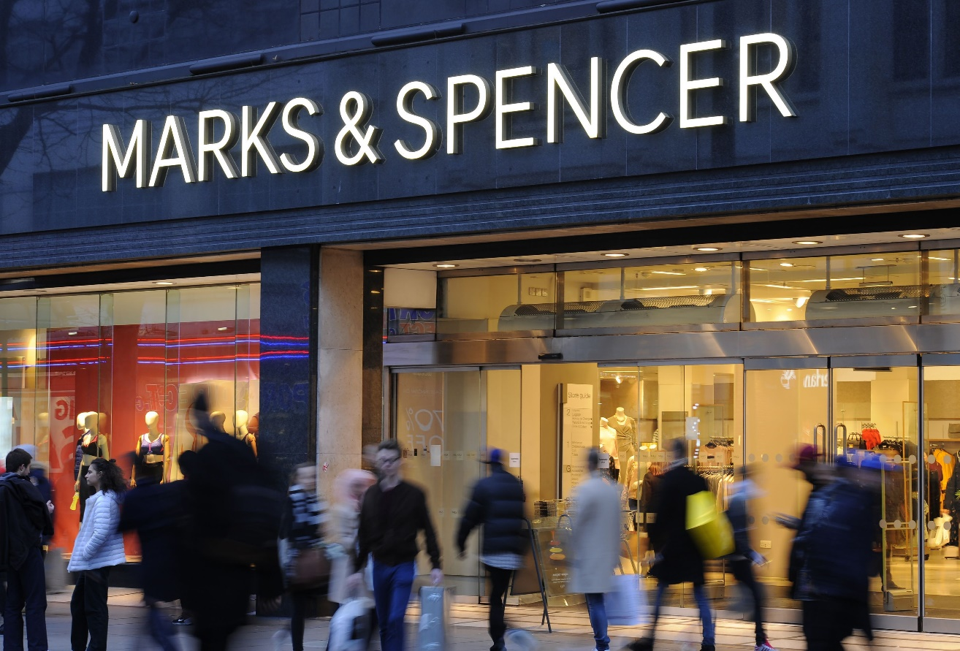
Yen Yen Lai
(1710668)
University of Wales
Trinity Saint David

20th July 2018
Marks & Spencer Report
Executive Summary

By announcing further store closures in May 2018, Marks & Spencer has made yet another controversial decision to remain profitable.

This research looks back at the root of the problem, from customer reacts to the company’s products to the 5 years transformation strategy to compete in UK retail market. Recommendations include providing a quicker delivery service and locating the Food Hall and Café together, to give the store some sparkle back during this tough trading period.

Contents

1 Terms of Reference 3
2 Procedures 4
2.1 Books, journals and websites 4
3 Findings 5
3.1 Introduction 5
3.2 Attempts to revive the sales 5
3.3 Impact of the problem 5
3.4 Analysis of Marks and Spencer 6
3.4.1 SWOT analysis of Marks and Spencer (Figure 1) 6
3.4.2 PESTLE of Marks and Spencer (Figure 2) 7
3.4.3 Stakeholder Analysis 8
3.4.4 Stakeholder Analysis Diagram (Figure 3) 9
3.4.5 How stakeholders help to resolve the problems 10
4 Conclusion 11
5 Recommendation 12
5.1 Restoring The Basics 12
5.2 Shaping The Future 12
5.3 Making M&S Special 12
6 Appendices 13
7 References 15
8 Bibliography 16

Terms of Reference

On 18 June 2018, Marks and Spencer’s Marketing department requested a report on the factors and causes of declining sales for their clothing and homeware departments, poorer than expected internet sales, and loss of reputation in the retail market.

The researcher is to submit the report with recommendations to the directors by 20 July 2018, at the forthcoming Board of Directors meeting at the Head Office.

Procedures

The researcher will use SWOT theory to identify the company’s current problems in the UK market, also PESTLE factors to help to understand how these problems impact business performance and the potential to make improvements in the retail market.

Books, journals and websites

A wide variety of materials has been used to write this report included:
- The Financial Times Newspaper and website.
- The Guardian Newspaper and website.
- Winning the Reputation Game: Creating Stakeholder Value and Competitive
Advantage.
- Breakthrough Problem Solving with Action Learning: Concepts and Cases.

Findings

Introduction

Marks and Spencer (M&S) are one of the best known British retailers in the world. It has 1035 stores across the UK, 428 international stores, and generated revenue of £10.7bn in the year ending 31 March 2018. It started as a humble Penny Bazaar in Leeds back in 1884 and grew to become one of most recognised own-brand stores. It’s widely acclaimed products include quality clothing, good British food and homeware targeted at the middle-classes. It has also expanded into finance, energy and opticians in recent years. Like many other famous brand names it has lost some of its sparkle and profits have declined in the last fifteen years. Although its stores remain on many High Streets, it is no longer a must visit store for the younger shopper and working classes.

Attempts to revive the sales

The researcher found that M&S did have a revival when it collaborated with George Davies to launch the Per Una brand in 2001 (Hall, 2008). The brand attracted upper working-class customers and became the key product that increased M&S’s profits that year. It continues to bring in annual sales of around £500m. M&S bought the brand from Mr Davies for £125m in 2004, but changing designers led to persistent falls in sales that have caused the brand to be placed under review this year (Craven, 2018).

When the company launched its “This is not just food, this is M&S food” advertisement in 2004, food sales increased by 3,000 per cent. The company used sales data to actively monitor the success of the advertising campaign. Mark Sweney reported: ‘the idea was to focus on reinstilling M&S’s core historical attributes of quality, service and value was so successful, has revived the fortunes of M&S.’ (Sweney, 2006) The campaign restored M&S reputation and won an award as Advertiser of the Year 2006 which provided further feedback from the industry on the success of the campaign.

When the company hired Marc Boland as chief executive in November 2009, he announced a three years plan to revamp stores, scrapped the clothing line for over-50s and abandoned plans to sell white goods. (Brown, 2016) The company fortunes did not improve. Full year results for 2012/2013 reported underlying profit before tax fell to £665.2m (compared to £687.2m for 2011/2012). Clothing and general merchandise sales continued to fall, and Christmas season market share was lost to competitors, The trend continued in 2013/2014 with underlying profit before tax down to £623m (-3.9%).

Impact of the problem

From the above case study, the research has found the company tried communicating with customers through advertisement, and rebranding to attract younger customers. The new strategy to revamp its image and boost sales was not successful, as trends only have a short life span, so profits continued to fall below expectations.

Investors in the share market lost confidence in M&S performance leading to shares falling to the lowest price reported by Financial Times on 12 March 2016 (Btyce, 2016). The decline in share price continued through 2017, and the latest news is that the chief executive is closing around 100 underperforming stores. The decision is designed to contract the business and continue with the five year transformation strategy (Marks and Spencer, 2018) to remain profitable and sustainable.

Analysis of Marks and Spencer

The researcher used SWOT theory to analyse what the strengths and weakness, identify threats that could change into opportunities for the company.

SWOT analysis of Marks and Spencer (Figure 1)
Strengths
Well known British household brand: M&S are one of the most recognisable British leading brand on the high street. The M&S green logo, people identify with it and many loyal customers still believe the company represents “Value for Money”. The customer base increased after M&S launched it own loyalty card ‘Sparks’, which was later linked with other financial products offered by the company.

Weakness
Ageing customer base: Most of M&S’s loyal customers are the over-50s. The company has been unable to attract Generation X and Millennials to shop in the stores, because their clothing ranges and the brand itself is seen as old-fashioned and uninspiring. M&S really needs to reconnect with female shoppers, particularly younger females.

Threats
Competition pressure: Clothing sales continue to underperform due to stiff competition from competitors such as Next, Gap, and Zara. It continues to lose market share in womenswear because buyers are unable to predict bestselling items and place enough stock on the shelves (Wood, 2016).

Fast Fashion clothing trends: How fast a store can bring in the latest must-have designs from catwalk to shop floor highly affect the total profit the store could make. This failure to quickly reproduce clothes at cheap prices caused M&S to be labelled as slow on trends and is paramount in the failure to attract the Millennial market.

Opportunities
Increasing online sales: The company should embrace the rise of internet shopping to increase choice and product availability online. Internet ‘Offers’ or ‘Outlets’ could help push stagnant fashion stock and create additional demand for good sellers. Through online fashion sales M&S could regain some of its lost market share.

Connecting with Generation X and the Millennials on Facebook, Instagram, LinkedIn, Pinterest and YouTube to generate new interest and get insights into what they would buy. This would help the buyers to more accurately predict stock demand. More capital invested into upgrading technology will increase sales to local customers and international markets.

Healthy Eating range: As more customers are conscious of healthy choices; M&S is fast on this trend by dedicating a whole web page ‘Health Hub’ for its customers. The Eat Well sunflower sticker on it food and drinks products, calorie counted ready meals and even a nutrition advice online encourage customers to make better choices for themselves. All the healthy choice ranges are available to order online as well which helps to push up sales. This is seen as a long-term winner to continue attract younger customers.

PESTLE of Marks and Spencer (Figure 2)

PESTLE refers to external factors and understanding how each of them impacts the business and its potential to remain positive in the retail market.

Political
New government regulations on public health and safety have made M&S changed or updated its food supply. The increasing pressure to reduce salt and sugar contents in all food and drinks, means M&S needs to review and change accordingly to comply with Food Standard Agency guidance.

There are new opportunities in the Eat Well range, by reducing salt and sugar in most of their products, or providing a low salt and sugar option. Health conscious customers especially the younger age group will welcome this change, on the plus side help improve the relationship between M&S with its younger age group customers.

Social-Cultural
The younger generation prefer to use internet for communication, shopping, exchange information etc. Changing of shopping habits to go digital has impacted all business, particularly small shop that rely on support from the local and community. Marketing strategies must account for this to attract younger shoppers.

M&S have invested billions of pounds on improving IT systems and website development when Bolland as chief executive (Wood, 2016). The current chief executive state that ‘The continued migration of clothing and home online, the development of global competition, the growth of home delivery in food and the march of the discounters all amount to threats to our business and market position. These, together with a challenging UK consumer market, mean that we have to modernise our business to ensure we are competitive and reignite our culture. Accelerate change is the only option.” (Marks and Spencer, 2018)

With modernisation strategy adapted to social-cultural change, getting the product mix right, responding to customer wants and needs, M&S can recover past glories.

Ecological
Global warming and climate change is a hot topic. The government has put on pressure to all business to change theirs practises, examine the life cycle of its products from the suppliers to disposal to reduce carbon footprint.

M&S improved its ethical-trading and sustainable-sourcing via its “Plan A 2020” ten years ago to comply with new environment rules and regulations. “Plan A 2025” for sustainability began on 2017. M&S stated that they have reduced carrier bag usage by 80%, are the world’s first and only carbon neutral major retailer and 100% of wood and paper comes from more sustainable sources (Marks and Spencer, 2018). This significant achievement is due to the company being transparent on product sourcing, using more Fairtrade products, and helping to transform local communities. With sustainability becoming an increasingly necessary and lucrative strategy, the company is ahead of its competitors in this area (Ivory Research.com, 2018)

Stakeholder Analysis

Stakeholders can affect or be affected by the organisation’s actions, objectives and policies. In this instance, the primary stakeholders are employees, customers, suppliers and the chief executive.

Employees and local communities have little power to change company policy or strategy, although they serve as the backbone and labour group for it. Employees act in best interest of the organisation, because they provide good customer services, and uphold the organisation’s image to customers.

Suppliers are important stakeholder and affect stock supplies. They have a large interest because the more orders the company places the more profit they are going to make. The organisation needs to trust its suppliers to deliver products on schedule so that they don’t run out of stock.

Customer have a huge influence on profit and decision making. The company needs feedback from customers to decide what they are going to sell.

Shareholders and the chief executive both have power to control decision making and high interest in making the organisation successful, one as primary and the other as secondary stakeholders. Investors are able to influence decisions during board meetings. The shareholders need to know what the organisation’s strategy is and how money is spent each financial year. As a decision maker for the organisation, the chief executive has the most power to drive the company plan forward, raising capital for expansion or internal upgrades.

Secondary stakeholders that do not engage directly with the company are: government, local communities, shareholders and the media.

Government are affected by the organisation’s decisions regarding store closures, because it often means unemployment rate will rise, and more benefits being paid out. Any new legislation and taxation could impact the organisation’s profits, such as the new sugar tax on soft drinks that has forced the organisation to increase prices.

Local communities are widely involved with the ‘Plan A 2020’ and will continue support the extension of it ‘Plan A 2025’. Their rely on the organisation to offer a clean, sustainable environment in the future. In partnership with communities, the organisation can help improve neighbourhoods, and drive change toward healthier lifestyles.

The media plays a vital role in portraying the image of the company to the public. Reporting the organisation’s store closure decision generates high interest from the public, leading to discussion on social media platforms, and extra hits on their website.

Stakeholder Analysis Diagram (Figure 3)

Figure 3: Stakeholder mapping for Marks and Spencer
LEVEL OF INTEREST
Low High

(Key players, Manage closely)

Shareholders

Chief Executive/Chairman
(Monitor, Minimal effort)
Employees

Local Communities
(Consult, Keep informed)
Suppliers

Media/Reporters
(Inform, Keep satisfied)

Government

Customers
Low

P
O
W
E
R

High

How stakeholders helps

Employees and local communities that support the chief executive’s decision could help resolve the problem.

Although store closure may not seen as good news to employees, some can take early retirement, others may retrain moving to other departments, or re-locate to a new town. Generous redundancy offers and pension scheme can make this transition more smooth. This way the closure plan can be achieved according to deadlines, and M&S can start phase two sooner.

The decision to close will not be received well in the local communities, as there will be less money in the local economy. The company’s employees are well trained, and famous for going the extra mile for customers, therefore will be in demand by other local businesses, and the local council and government can help provide further training and funds to help the workers effected.

Conclusion

“M&S needs to change and change fast. We are now in the first phase of our transformation, restoring the basics so that we can deliver sustainable, profitable growth to investors, colleagues and the communities in which we operate.” (Steve Rowe, chief executive, 2018)

The above statement sums up what the company needs to do. It should continue to upgrade its IT system, offer more choice, cheaper prices, expand healthier options, engage with local communities, use local sourcing and bridge the age gap between its customers. With loyal supporter from shareholders and customers the company can and will deliver success in the future.

Recommendation

The researcher has completed a comprehensive look at the company’s 5 years transformation strategy by the chief executive and makes the following recommendations in conjunction with the strategy.

Restoring The Basics

There are still large numbers of loyal customer that do their food shopping in the Food Hall, shown in the fact that 61% of total revenue generated £5.9bn as of 31 March 2018 was from this area. Price cuts on the food range is a welcome decision as it makes them more affordable to a wider range of customers. The Simply Food chain has outflanked competitors such as Aldi and Lidl, which has the support and loyalty of its customers. M&S should conduct a food survey, bringing back some of the discontinued products missed by customers.

Recapture customer confidence by providing a more diverse food range, keeping prices low, cutting back on waste, promoting healthy eating, reflecting on cultural changes and showing that M&S is ready to provide greater choices for its customers.

Shaping The Future

The rise of online shopping including food, clothing, white goods, banking, and energy supply, makes the multi-billion pound investment on IT systems and website development worthwhile. The researcher suggests M&S continues to speed up on its delivery service for online orders, and provides more customer pick up points for click and collect orders.

Generation X and the Millennials no longer associate M&S stores as a place for shopping, because they prefer individualism. The researcher recommends seasonal collaborations with British designers to create iconic signature style clothes lines to draw attention from this age group. This kind of collaboration proved a huge success for Uniqlo. As a British retailer that support local manufacturers and designers, M&S should consider this as the next move forward in the future.

Making M&S Special

Relocate the Food Hall and Café along side each other. This clever approach is to create an atmosphere of glorious food and a sensation of smell, customer interact with the surrounding environment unconsciously. By directing customers through the Food Hall after a meal they may wish to have some more M&S quality food at home, or after completing the weekly shopping in the Food Hall customers may be enticed to eat something quick to fulfil the craving.

Appendices

Figure 1: SWOT Analysis of Marks and Spencer

Strengths  - Well known British household identity and brand.  - High quality products.  - Good customer services.  - Manager Training. | Weakness  - Slow sales growth compared with competitors.  - Ageing customer base.  - Weak logistic.
Opportunities  - Increasing online sales.  - Healthy Eating range.  - Internationalization – expand store to developing countries.  - Support local community ‘Plan A’. | Threats  - Competition pressure.  - Fast Fashion clothing trends.  - Increasing in Corporate Tax and labour minimum pay causing profit decrease.

Figure 2: PESTLE Analysis of Marks and Spencer

References

Brown, J.M. (2016) ‘Marc Bolland at M&S: the whole story’, Financial Times, 7 January, Available at: https://www.ft.com/content/01154adc-b512-11e5-8358-9a82b43f6b2f
(Accessed: 14 July 2018)

Bryce, E. (2016) ‘Marks and Spencer hit by guidance worries: London’, Financial Times, 12 March, Available at: https://search-proquest-com.openathens-proxy.swan.ac.uk/docview/1780025161?accountid=14680 (Accessed: 15 July 2018)

BusinessTeacher.org.uk. (2017) Marks and Spencer SWOT Analysis. [online]
Available at: https://businessteacher.org.uk/swot/marks-and-spencer.php (Accessed: 14 July 2018)

Campaign staff (2006) ‘Advertiser of the year – Marks and Spencer’ Campaignlive.co.uk, 14 December, Available at: https://www.campaignlive.co.uk/article/advertiser-year-marks-spencer/609744 (Accessed 15 July 2018)

Channel 5 (2018) ‘The Trouble with Marks & Spencer’, My5, 24 May, Available at: http://www.channel5.com/show/the-trouble-with/ (Accessed 14 July 2018)

Craven, N. (2018) ‘Per Una’ fashion range faces the axe from M&S: Iconic label launched in 2001 is put under review by chief executive after persistent fall in sales’, This is Money.co.uk 16 June, Available at: https://www.telegraph.co.uk/finance/newsbysector/retailandconsumer/3503266/Per-Una-founder-fashions-next-steps.html (Accessed: 14 July 2018)

Hall, J. (2008) ‘Per Una founder fashions next steps’, The Telegraph, 22 November, Available: https://www.telegraph.co.uk/finance/newsbysector/retailandconsumer/3503266/Per-Una-founder-fashions-next-steps.html (Accessed: 14 July 2018)

Ivory Research.com (no date) ‘Strategic Analyis of Marks & Spencer Plc’ [online]
Available at: https://www.ivoryresearch.com/samples/strategic-analysis-marks-spencer-plc/
(Accessed: 17 July 2018)

MarksandSpencer.com (2018) Marks and Spencer [online]
Available at: https://www.marksandspencer.com/ (Accessed: 14 July 2018)

Sweney, M. (2006) A successful ad campaign has revived the fortunes of Marks & Spencer, The Guardian, 6 November, Available at: https://www.theguardian.com/media/2006/nov/06/retail.mondaymediasection (Accessed: 15 July 2018)

UKEssays. (2013) Pestle Analysis On Marks & Spencer Market Marketing Essay. [online] Available at: https://www.ukessays.com/essays/marketing/pestle-analysis-on-marks-spencer-marketing-essay.php (Accessed: 15 July 2018)

Bibliography

Dowling, G.R. (2016) Winning the Reputation Game: Creating Stakeholder Value and Competitive Advantage. Cambridge, Massachusetts: The MIT Press.

Marquardt, M., Yeo, R., & Yeo, R.K. (2012) “Breakthrough Problem Solving with Action Learning : Concepts and Cases” [E book] Available at: ProQuest Ebook Central. (Accessed 15 July 2018)

Maund, A., Schriek, M. and Tinkler, P.K. (2017) “Certificate in Higher Education: Skills for the Workplace Student Yearbook” London: SAGE pp 229-278.

Solca, L., Rosso, A. and Wing, M. (2010) ‘Marks & Spencer: The Opportunity for a Shift in Strategy’ [E book] Available at: http://web.b.ebscohost.com.openathens-proxy.swan.ac.uk/ehost/command/detail?vid=0&sid=fd1196b2-c077-40cf-9449-2626604ce75d%40pdc-v-sessmgr01&bdata=JkF1dGhUeXBlPWNvb2tpZSxpcCxzaGliLHVpZCZzaXRlPWVob3N0LWxpdmUmc2NvcGU9c2l0ZQ%3d%3d#jid=B95D&db=bth (Accessed: 15 July 2018)

