
‘An investigation into how the Manchester Arena bombing in May 2017, has impacted the spectator experience, at music events in Cardiff.’
2018
Bronte Mary Murdoch
P151218
Integrated Master’s Degree in Tourism & Event Management
University of Wales Trinity Saint David
Business Campus
Supervisor- Jacqui Jones
Acknowledgements
Firstly, I would like to thank my wonderful family, Helen (Mother), Rosemary (Grandmother), Lucy (Sister) and George (Brother) for being my absolute inspiration in becoming a successful and career-driven woman. I would also like to thank my amazing boyfriend Josh for supporting me throughout my journey and for being my motivation. Without you all, none of this would’ve been possible so this one’s for you!
I would like to thank the staff at UWTSD for supporting me and guiding me through my journey at the University and thank you to Jacqui Jones, my Dissertation Supervisor, for making this last year at University extremely memorable.
Lastly, I would like to say a special thanks to Catherine Trapnell and Tima Omari who are my fellow direct entry students from Crosskeys College. You have both been my rocks throughout our 4 years together and I couldn’t have done any of this without you both.
Table of Contents
INTRODUCTION | PAGE 5
LITERATURE REVIEW | PAGE 6, 7, 8, 9, 10, 11, 12, 13, 14, 15, 16
METHODOLOGY | PAGE 17, 18, 19, 20, 21, 22, 23, 24
FINDINGS & DISCUSSION | PAGE 25, 26, 27, 28, 29, 30, 31, 32, 33, 34, 35, 36, 37, 38
CONCLUSION | PAGE 39
BIBLIOGRAPHY | PAGE 40-44
APPENDICES | PAGE 44-47
Introduction
The chosen topic of research for this study is: ‘how has the visitor experience, at music events in Cardiff, been affected following the Manchester Arena bombing in May 2017?’.
The motivator for this research study is the Manchester Arena bombing in May 2017, which occurred at the end of an Ariana Grande concert, where many people were injured and some lost their lives.
This particular terrorist incident, has had a profound effect on not only the British public but also its affected the public internationally, with many people now feeling unsafe when attending music events where they once would’ve felt safe and at ease. Although this wasn’t the first terrorist attack on the events industry, it was the first to have so many casualties and fatalities in young people and even children.
Many eyewitnesses at the Ariana Grande concert, the night in which the terrorist incident took place, recall security as being very laidback with no security checks being carried out, only ticket checks (Metro.co.uk, 2017). This causes many people to wonder how safe they will feel, when attending music events in the future, following this incident.
Part of the visitor experience for attendees at music events is safety within the events venue which is something that event organisers are now having to examine thoroughly following the tragic events in Manchester.
The context of this project has been formed around the knowledge of changes being made to the visitor experience for future events, following this terrorist incident in order to make attendees feel more comfortable. This study is going to be examining attendee’s thoughts and feelings on these changes and how they have affected the visitor experience.
This study is focusing on music events and venues in Cardiff which is the capital city of Wales. This will hopefully give the reader an insight into what changes are being made and what people’s thoughts and opinions are on this.
Aim & Objectives
Aim- To develop an understanding on how the visitor experience at music events in Cardiff, has and will be affected, particularly after the Manchester Arena bombing in May 2017.
Objectives-
-To investigate what the changes are to the visitor experience at music events in Cardiff.
-To investigate how these changes have made visitors feel in the lead up and implementation of the event.
-To review how safety and security measures are influencing attendee’s motivations.
-To determine what improvements, need to be made, if any, to better the visitor experience for all.
Literature Review
Introduction
The review of literature will provide a critical analysis of the literature surrounding the visitor experience at music events, that support the research aims and objectives. The Literature Review will also support the suitability of the research topic.
The purpose of a literature review is: ‘To demonstrate your familiarity with, and knowledge of the subject. A good review will inform the reader that the researcher is competent to undertake research in that particular area’ (Jones and Gratton, 2003, pg51).
The main theorists that are used within this Review of Literature are Getz, Donald (2005-2013), Tarlow, P.E. (2002), Taylor, T &Toohey, K. (2005) and Bowdin, G et al (2005-2006). The theorists listed above all specialise in event management which was the broader discussion at the start of the review.
The range of literature used are dated from 2001- 2018 (present day) as a lot of newspapers are used when discussing terrorism and the effects it has had on the events industry. This all leads up to the present day where terror attacks are still occurring around the world.
The sources that were used in this literature review were found in the University of Trinity Saint David’s campus library and online library, the University’s newspaper database ‘News Bank’, Google Scholar and Google itself.
All sources are relevant and support the research study’s question, the aim and the objectives.

Safety & Security at Music Events
When planning an event, organisers must adhere to the comprised acronym ‘APMC’ which stands for assess, plan, manage and control risks that face any event (Tarlow, P. E. 2002). It is the event planner’s responsibility to ensure safety to all that attend their events therefore, ‘APMC’ helps them to prepare for any possible risk.
According to Neggaz, Sihem (2017), the main risks to the security of any event are:
-Weather conditions
If an event is outdoors, the weather will play an important role in the safety of its attendees. Hot weather could put attendees at risk of dehydration or even heat stroke and if it’s cold weather, people could suffer from frostbite or hypothermia. Then there’s the threat of a storm, which could destroy equipment and pose a serious safety risk for attendees.
-Alcohol
Security at events needs to be vigilant where alcohol is for sale, as crowds can get out of control where alcohol can be overindulged.
-Medical emergencies
With any large crowd, it’s inevitable that someone will fall ill or become injured therefore, it’s very important that security staff have a plan in place for those who have a medical emergency.
-Petty disturbances
Theft and vandalism are also common at large events; therefore, security staff should remain vigilant in identifying and removing potential thieves and vandals.
-Major incidents of disorder
Major incidents of disorder are the real threats to safety in any event. These can be life threatening therefore, it’s vital to have response plans in place to deal with these major incidents. Major incidents of disorder can be anything from a protest to a terrorist attack. When making a response plan, security teams should consider and review past events where similar incidents have occurred. Neggaz, Sihem (2017) states; ‘Event organizers and security staff should carefully consider the different activities taking place at an event and the unique risks those activities pose.’
It is inevitable that there will be risks when bringing a crowd of people together and it is essential for event planners to consider not only one risk factor but also a wide possibility of variables that could lead to those potential risks (Tarlow, P. E. 2002).
Those variables include: Size of crowd, size and nature of the event site, the time of day, nature of the event, consumables that are on site (food, water, alcoholic beverages), age of the crowd, weather conditions and the location of the event venue such as rural locations and so on (Tarlow, P. E. 2002).
With each event being so different, an event planner must assess multiple potential risk factors whilst also baring past event history in mind in order to appropriately plan for future events.
Tarlow, P. E. (2002) states; ‘The actual degree of risk involved, then, depends on risk formulas that examine the probability of adverse effects occurring, the direct result of the threats, and the extent to which the venue or activity will be affected by the threats.’ This can be done through thorough risk assessment during the planning stage of the event.
Whilst safety and security at events has always been an important consideration for event planners for the protection of its attendees, the September 11, 2001 attacks on New York and Washington DC has forced them to consider a much larger issue as now the public fear for how they travel and also, how protected they are at events.
‘Since September 11, 2001, acts of war and terrorism are factors that every event risk manager must consider; even sport events or weddings are on the front line.’ -Peter Tarlow, 2002
The type of risks that were then considered, according to Berlonghi in McDonnell et al (1999) were confused organisation between staff, risks in marketing, risks in health and safety, risks in catering provision, risks in crowd management, risks in security where VIPs are present and risks in transport of items to and from the venue (Getz, D. 2013).
Terrorism was not yet considered in the planning or execution of an event or festival therefore, after the September 11 attacks, it caused event managers around the world to consider safety and security from a different angle. Securitymagazine.com, 2010 alleges; “The tragic events of 9/11 remain the single most important turning point in security’s new role within business environments both home and abroad.” This was a major terrorist incident that the world had experienced, and it left the public feeling overwhelmed and anxious as to what was going to happen next.
Event organisers were no exception as many worried that a terrorist attack could happen just about anywhere.
Knight, Jane Ali, and Alan Fyall. 2008 states; “Terrorist attacks targeting special events generate media attention, inflict massive casualties, maximise economic impact and build coalition support”
It caused event organisers to start understanding what influences a terrorist attack and why.
Taylor, T and Toohey, K (2005) states; “Event organizers have acted to realize a balance between effective risk management measures that offer appropriate security while not unduly deterring from spectators' enjoyment of the event.”
Safety and security has had to take a step up following the September 11 attacks however, event managers didn’t want that to affect the visitor experience.
The changes in security would’ve left a conflicted feeling among visitors with some feeling more at ease and others feeling on edge.
Getz, D. 2013 thought; “Stressors at events can lead to problems. These include excessive waiting, over-crowding, excessive sensory stimulation; overwhelming security, regulation or threats; fencing that prevents escape (people feeling trapped) and other restrictions on movement.”
This demonstrates how the changes in safety and security had to be dealt with in a sensitive manner to cater to the spectator’s experience.
Following the September 11 attacks, terrorist attacks continued to hit populated places all over the world however, a trend began where such attacks began to occur in entertainment spaces (New York Post, 2017).
One of the more recent attacks, was the Manchester Arena bombing during an Ariana Grande concert where 22 people were killed and many more injured, including young children (Time.com, 2017).
Tarlow, Peter E. 2002 states; “From a marketing standpoint, safety and security are two sides of the same coin… In other words, if an incident occurs the negative publicity is the same whether it is due to a safety or a security issue.” This statement illustrates how terrorism impacts not only the victims, but also the location where it occurs.
Many people become apprehensive to attend events because of this, which leads to a loss in revenue and so on. The Manchester Arena bombing was a realisation of how safety and security measures now had to change quickly to protect the public at events.
Prime Minister Theresa May spoke out following the incident quoting; “The police and others will look at security to ensure that people can enjoy music festivals and events this summer” (Financial Times, 2017).
Following the incident, police and security teams quickly put new safety and security plans into motion as the festival season in the UK was about to begin and both concerts and festivals were at risk of similar terrorist attacks.
Sands, Katie (2017), writing for the Wales Online newspaper, stated; ‘Concertgoers can expect to see armed police at major music events this summer as Cardiff and Swansea prepare to welcome some of the world’s biggest music acts to the stage.’
Following the Manchester Arena bombing, it was vital for those attending concerts and festivals, to feel protected and in Cardiff and Swansea, the armed forces quickly rallied together to provide safety and security for their attendees.
Assistant Chief Constable Richard Lewis, of South Wales Police, said: ‘We will continue to work with the organisers and review our response to these events… Our priority is to maintain a visible and reassuring presence in our communities and we will continue to provide the response the public would expect in order to keep them safe.’ (WalesOnline.co.uk, 2017)
It’s obvious that seeing armed police on the streets when attending a concert or festival will make attendees feel unease, which is why the armed officers on patrol are now using tactics that aren’t noticeable to the public but are designed to keep them safe (WalesOnline.co.uk, 2017).
Terrorism
Terrorism can be defined as: ‘an indirect strategy of using fear or terror induced by violent attacks or force (or the threat of its use) against one group of people (direct target) or their property as a means to, intimidate and coerce another group of people (indirect target) and influence their actions in order to reach further political objectives.’ (Schwenkenbecher, A. 2012).
Acts of terror have always existed throughout history and it has its roots in political movements throughout the 20th century. (Roser, Max. 2013).
Roser, Max. 2013 illustrates some of these examples being; ‘Guy Fawkes' failed attempt at reinstating a Catholic monarch is an example of an early terrorist plot motivated by religion.’ and ‘The Reign of Terror during the French Revolution is an example of state terrorism.’
These examples demonstrate the different motivations for terrorist attacks and how terrorism has been ever present in history.
Terrorism is now becoming ever present within both the tourism and event industry with the first transportation terrorist incident being, as previously mentioned, the September 11, 2001 attacks on New York and Washington DC.
The attacks on the World Trade Centre had confirmed that terrorism was taking on a new stance with terrorists now engaging in suicide and mass murder on an extreme scale (Roberts, Adam. 2014).
‘What happened on September 11 was a sinister new twist in an old story of fascination with political violence.’ -Roberts, Adam. 2014
Terrorism can have many different motivations from political to philosophical, ideological, racial, ethnic, religious or other natures that may be used to justify terrorist actions (Roberts, Adam. 2014).
In most instances, that have been seen in modern day history, terror motivations have been mostly political and religious. The main motivator for international terrorism, predominantly Islamic extremist groups, was the invasion of Iraq and Afghanistan as well as Pakistan, Syria and Yemen (Roser, Max. 2013).
Clarke, Richard A, a counter-terrorism expert that worked in the US National Security Council between 1992–2003, stated; ‘Far from addressing the popular appeal of the enemy that attacked us, Bush handed that enemy precisely what it wanted and needed, proof that America was at war with Islam, that we were the new Crusaders come to occupy Muslim land.’
He was strongly against George Bush’s decision to invade Iraq as he feared the ‘War on Terror’ would begin, and he was certainly correct as the War on Terror is now the leading cause of terrorism (Roser, Max. 2013).
Following the September 11, 2001 attacks, a series of suicide bombings occurred on London’s transportation system in 2005, by the same core group ‘Al Qaeda’ that launched the attacks on the World Trade Centre. There were 52 fatalities (Bergen, Peter. 2017).
On the 2nd May 2011, Al Qaeda’s leader ‘Osama Bin Laden’ was killed by US military forces after he was located in a secure location in Abbottabad, Pakistan (Dearden, Lisa. 2015).
Since 2011, Europe has seen a number of vehicle attacks as they are easy to obtain and they have the potential to cause many injuries and fatalities to easy targets such as pedestrians (Telegraph Reporters, 2018).
The list of destinations that have suffered vehicle attacks from 2016- 2018 are as follows (Telegraph Reporters, 2018):
Promenade des Anglais, Nice, 14 July 2016
Breitscheidplatz, Berlin, 19 December 2016
Westminster, London, 22 March 2017
Drottninggatan, Stockholm, 7 April 2017
London Bridge, London, 3 June 2017
Finsbury Park, London, 19 June 2017
Champs-Élysées, Paris, 19 June 2017
Levallois-Perret, Paris, 9 August 2017
Las Ramblas, Barcelona, 17 August 2017
Grosser Kiepenkerl, Münster, 7 April 2018
The internet has been a blessing for modern day life as it gives us connectivity around the world, but it is also a curse as it has become a powerful tool for terrorists to be able to communicate their message around the globe. This also allows them to employ new members and construct attacks in different regions of the world (Roser, Max. 2013).
Since Al Qaeda’s slow demise, the terrorist group known as ISIS (Islamic State), has tapped into the power of the internet and social media in which they distribute online propaganda to foreign fighters around the globe. Their message is reaching further than anyone could have anticipated which is why many lone terrorists are now coming to light by either suicide bombings or vehicle attacks (Roser, Max. 2013).
Hoffman, Bruce. 2013 states; ‘Terrorists are now able to bypass traditional print and broadcast media via the Internet, through inexpensive but professionally produced and edited videotapes, and even with their own dedicated 24/7 television and radio news stations.’

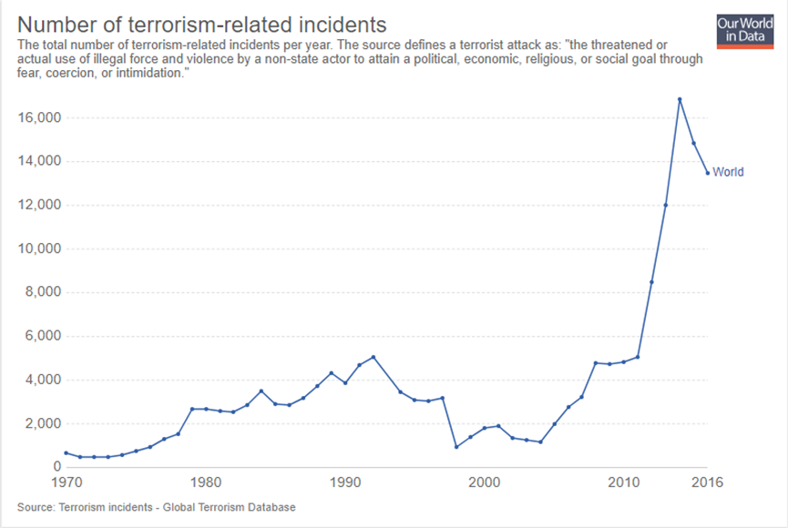

Global Terrorism Database (GTD). University of Maryland.
https://www.start.umd.edu/gtd/

A graph taken from the ‘Global Terrorism Database’ clearly illustrates the number of terrorism related incidents from 1970- 2016. As previously mentioned, terrorism has always existed in history but from 1992 to 1998 the number of incidents had dropped quite considerably. In 2001, the deadliest terrorist attack occurred on The World Trade Centre with a death toll of 2,996 (Gould, Eric D., and Esteban F. Klor, 2010) however, the number of terrorism related incidents after that had decreased until 2004. From 2004, the number of incidents began to increase steadily up until 2011, year of the death of Osama Bin Laden, where the number of incidents increasingly surges all the way up to 16, 860 in 2014 (GTD).

Terrorism History in Events
In any type of event, terrorism is always a threat as events provide terrorists with the opportunity to create panic and devastation during a time that is supposed to joyful.
Tarlow, P. E. (2002) states that the link between terrorism and events has been made for the following reasons:
-Events are often close to major transportation centres which would then be interrupted it would cause panic.
-Events are commercial and a terrorist incident may cause economic interruption and panic.
-Events impact many other industries such as restaurants, hotels, and entertainment and the negative impacts resulting from terrorism could cause widespread damage.
-Events often draw media coverage that enables terrorists to promote their cause to a large audience.
-Events require tranquillity or places where business can be conducted in a peaceful manner and therefore an act of terrorism interrupts this peaceful environment.
-Events must deal with people who have no history, therefore risk managers often do not have data bases for attendees. This lack of history makes it difficult to develop accurate profiles of the event stakeholders (attendees, participants, staff, volunteers) and to anticipate terrorist activities.
There is direct a link between transport and events as creating a successful event means having it in an accessible location for its attendees, and events need attendees for it to be able to occur or occur more than once (Barry, C. 2015).
Unfortunately, both industries have had terrorism linked to it and both have hugely suffered the consequences.
For example, some attendees may have to travel by aircraft when attending an event which is now an endangered mode of transport following the September 11, 2001 attacks and many other plane hijackings. This may leave a person to feel unconfident to travel which would then result in them not attending the event.
Barry, C. 2015 states; ‘The thought of being targeted by global terrorism is enough to prevent people from attending any event, which has led to a great decline of many different types of events that may have previously been well attended, particularly by people who are not local to the area.’
Event organisers and event attendees are having to consider life threatening possibilities when thinking of planning or attending an event, which is something no one could have fathomed before the Paris attacks which were carried out on the 13th November 2015.
The first attack occurred at the ‘State de France’ stadium where an international game of football was in play. There were also restaurant shootings however the deadliest attack of the night occurred at The Bataclan Theatre, where a rock band was performing on stage to hundreds of spectators (BBC News. 2015).
Several gunmen shot into the crowd leaving 89 people dead and over 100 injured (BBC News. 2015).
Deighton, Katie. (2015) states; ‘While events in the UK continue to take place, they are no longer viewed by the public as a low-risk affair; there is now a dark paradox between the enjoyment guests hope to get out of an event and the terror attack they pray they will not have to endure.’
The next act of terrorism that the world saw in events was the Manchester Arena bombing which occurred on the 22nd May 2017. A lone suicide bomber detonated a bomb in the foyer of the arena at an Ariana Grande concert, just after she had left the stage (Dodd, Vikram. 2017).
Dodd, Vikram. 2017 states; ‘The attack, which took place in the foyer, caused hundreds of people to flee in terror, with young people at the concert separated from their parents in the chaos… It left a scene of carnage inside the concert venue, where medics described treating wounds consistent with shrapnel injury.’
Vikram’s quote illustrates the level of chaos that unfolded once the bomb had detonated and, for it to happen at a concert with primarily a young audience, makes it even more devastating. This terrorist attack truly impacted the way a young person and their parents would feel about attending a concert which is where many people would once feel safe.
The attacker left 22 people dead and over 50 people injured (Dodd, Vikram. 2017).
The last concert attack that the world saw was on the 1st October 2017 in Las Vegas. A shooter opened fire from a hotel room, into a crowd at an outdoor concert, killing 58 people and injuring over 500 (Keneally, Meghan, and Madden, Pete .2017).
This attack comes in as the deadliest that the world has seen so far due to the amount of injuries that were caused.
Over the years, we are learning that concerts and festivals have become an attractive target for terrorists around the world due to the attractiveness of attacking ‘Westerners’ that are trying to enjoy themselves. A terrorist attack is the last thing that anyone would expect at an event that is supposed to be enjoyable and memorable which is what makes them an easy target (Greenberg, Karen J).
Visitor Experience
The visitor experience in any event is what makes it unique and it’s what sets it apart from anything else a person has been to before (Morgan, Michael. 2008).
Morgan, Michael. (2008) states; ‘Festivals and concerts provide a space and time away from everyday life in which intense extraordinary experiences can be created and shared.’
Morgan, M. (2008) illustrates how the visitor experience can impact attendees so positively by them allowing it to create memorable experiences, providing that it was perceived in an optimistic way.
A positive visitor experience creates satisfied visitors which then leads to additional visitors in the future and economic benefits for supporting businesses in the area (Jago L. et al 2003).
Music events create visitor expectations regarding the experience those visitors will have at the event. This expectation is often influenced by two aspects which are the performing artist and the organisation of the event. These factors are referred to as Critical Success Factors (CSFs) (BOWDIN et al 2006).
Management factors include: technical aspects, food and beverage, marketing, entrance, transport, information, venue layout, financial services, parking; community, staff and safety and security (SILVERS, J. 2004).
When visitors attend any event, they have certain motivations as to why they are attracted to the event or why they feel that they identify with its purpose in any way.
According to Crompton, J.L. & McKay, S.L. 1997, these motivations are as follows:
-Physical Organisation which is the body of the event and its practical qualities
-Relationships which leads to social interaction between the visitors and the performers and/or other visitors
-Personal benefits which means enjoyment, socialising and self-development
-Symbolic Meanings which is the identification with meanings and values of the event
-Culture which means the traditions and meanings of the festival
-Design Personality which is the design programming which create the personality of the event
When concerts occur, they work with whichever venue they are being held in to create a positive visitor experience for all that are attending.
Satisfied concert goers may then become repeat visitors to the same venue in future and they may provide positive word of-mouth advertising to family and friends which would then lead to new visitors and an overall increase in tourism revenue to the community (Goldblatt, JJ. 2002).
Safety and security has a big part to play in the visitor experience as it’s important that attendees feel safe when attending concerts. With terrorism becoming increasingly popular in music events, it’s vital that the safety and security measures are at an adequate level in the attendee’s eyes in order for them to feel comfortable.
Many venues around the world are now reviewing their safety and security strategies in order to ensure safety throughout shows including the Motorpoint Arena in Cardiff.
On their website, it states; ‘As a venue operator, the tragedy in Manchester struck particularly close to our heart… It goes without saying that the ongoing safety of our customers, staff and performers is of absolute paramount importance.’ (Motorpointarenacardiff.co.uk)
Following the Manchester Arena attack last year, the Motorpoint Arena’s security teams regularly review procedures and protocol and then relay that to all staff members to ensure they are vigilant at all times. They are in continuous consultation with local authorities and police to arrange appropriate security and they run regular training exercises for new security measures in order to provide the best visitor experience (Motorpointarenacardiff.co.uk).
They also now ask for no bags larger than A4 size to be bought into the arena and for visitors to be patient if things take a little longer than they are used to (Motorpointarenacardiff.co.uk).
These changes to safety and security measures will hopefully make attendees feel safer and at ease when attending concerts and any other music event.
Cardiff as a Host Destination
Special events, such as concerts and festivals, attract tourists to host destinations and they are able to highlight the destination to tourists that may not have known about it before (Faulkner, B. et al 2000).
Special events also play an important role in the creation of positive images, attitudes and perceptions towards host destinations (Chalip, L et al. 2003).
Cardiff is the Welsh capital city located on the south coast of the country. It’s a popular tourist destination and the city hosts many sporting events (Visitcardiff.com).
As a host destination, the city has a lot to offer with vibrant nightlife, a friendly atmosphere and many retail and dining options for visitors to enjoy (Visitcardiff.com).
Visitcardiff.com states; ‘The Welsh capital has a reputation for hosting major sporting competitions, with the Millennium Stadium located in the centre of the capital, and countless other sporting venues are situated in the city, it was even awarded European City of Sport in 2009 and 2014.’
The city is very well known for its sporting history however, it is also a great host destination for music events.
Cardiff had even been declared as ‘Music City’ in 2017 due to its Welsh nature of being well known as the ‘land of song’ and the city also has great venues for live music such as The Millennium Stadium and The Motorpoint Arena (BBC News, 2017).
The city is accessible via train, bus or car with the central station being located in the heart of the city near all major event venues and bus routes being easy to find and easy to use (Visitcardiff.com).
Cardiff has continued to thrive over the years particularly after their Tourism Strategy Plan and Action Plan 2009- 2014 was put into place (Businesswales.gov.wales).
The Destination Action Plan (DAP) identifies some of the following objectives for Cardiff, that are taken from the Tourism Strategy:
-To develop Cardiff's reputation as an urban activity destination
-To develop a regular, distinctive events programme to attract off-peak overnight visits
-To make improvements to transport infrastructure and transport options for visitors
-To develop welcome and information services for visitors
-To create first impressions and facilities for visitors
-To develop Cardiff as a sustainable and distinctive destination
-To promote and market Cardiff and the city region
In 2017, it was estimated that tourisms total contribution to the city was around 1.2bn, with mega-events such as The Champions League final, fuelling their tourism strategy (Financial Times, 2017).
The city was also ranked at the 10th most popular UK city according to visitor numbers by air and rail passengers (Financial Times, 2017).
Case Study
This research project is based around the tragic events that unfolded on the 22nd May 2017 at the Manchester Arena. It was the first time we had seen a terrorist attack on UK soil and on the UK’s event industry. Unfortunately, it has completely changed the concept of attending a concert especially for the younger audience.
Ariana Grande was performing, who is a singer from the US, and a lot of her fans are teenagers and children. This made the attack so much more shocking as no one could fathom how a person could put so many young person’s lives at risk.
The suicide bombers name was Salman Abedi and he was a UK Islamic resident (Coyle, Simon. 2017).
Since the attack, a gap in security measures at the concert were soon to be pointed out by attendees and it is thought that Abedi detonated his device in a security ‘soft-spot’ which was the arena’s foyer due to the lack of security in that area (Baker, Keiligh. 2017).
According to Baker, Keiligh. 2017, other concert attendees said that security were more interested in whether they were carrying bottles of water rather than checking them for weapons.
It later emerged that at an Ed Sheeran concert, at the same venue just under a month before, there was the same lack of security in the foyer area which alarmed some visitors.
A woman had left a review on TripAdvisor, under the name of ‘Anna W’, on the 23rd April and it stated; ‘Once we got in and bought a bottle of wine the top is taken off so they are not used as missiles but no check to see if you have any type of weapon/bomb in your bag in these times of terror attacks it’s not good enough for the crowd or the act on stage and it needs sorting.’
The review can be found on MailOnline.com (Baker, Keiligh. 2017).
These reviews are what fuelled the interest in pursuing this research project as the researcher felt it was important to see what changes are being made to security measures in venues today and how this has impacted the visitor experience.
Summary
To summarise the literature presented in this review, it is evident that the Manchester Arena bombing was a devastating attack on our events industry which will potentially affect the visitor experience for attendees at music events in the future. It has left so many people to question an environment, and its security, which was once viewed as non-violent and enjoyable.
As supported by the theorist Tarlow, P. E. (2002), terrorist attacks at events have the potential to cause widespread panic because of how devastating and unpredictable they can be. They can destroy numerous aspects of the visitor experience such as peace and conduct, enjoyment and visitors safety expectations.
Morgan, M. (2008) describes how the visitor experience can impact an attendee so positively as they can provide memorable experiences. However, when an act of terrorism occurs within the events space, the experience would become memorable for all of the wrong reasons which is why changes to safety and security needed to be made following the Manchester Arena bombing in May 2017.
In order to prevent such an incident from occurring again, changes to safety and security at music events needed to be made to ensure safety to all attendees.
Baker, K. 2017 describes how the suicide bomber detonated his device in the venue’s foyer where there were no security measures in place. This has now been identified as a ‘weak spot’ in security meaning that the foyer area is now a part of the event that need to be protected in order for attendees to feel safe.
Cardiff, the capital city of Wales, is the perfect location to examine the visitor experience in music events, following this incident, as it’s a vibrant city with a diverse audience (Visitcardiff.com). The city hosts many events from sports to music therefore, Cardiff and its events are a great case study that can be utilised for the purpose of this study.
Methodology
Introduction
The word research can mean something different for everyone therefore it can be hard to define, however, according to Hussey, J & Hussey, R, 1997 the most agreed definitions are that research is a process of inquiry or investigation, it’s systematic and methodological and it increases knowledge.
It is important to carry out research as it allows the researcher to explore a certain issue or subject that will then hopefully lead to solutions that could be beneficial to many people.
According to Hussey, J & Hussey, R, 1997; most research objectives are: to develop existing knowledge, to investigate a problem to provide a solution, to explore general issues or to construct a new procedure or system that could be used in the future.
When carrying out any research study, it’s important to choose the appropriate research method in order to obtain suitable data. The research question for this study is ‘An investigation into how the Manchester Arena bombing in May 2017, has impacted the spectator experience, at music events in Cardiff.’
A research question is vital to the study as it gives the project focus and direction (Hussey, J & Hussey, R, 1997).

Aims & Objectives
The overarching aim of the study is; ‘to develop an understanding on how the visitor experience at music events in Cardiff, has and will be affected, particularly after the Manchester Arena bombing in May 2017.’
The study’s objectives are:
-To investigate what the changes are to the visitor experience at music events in Cardiff.
-To investigate how these changes have made visitors feel in the lead up and implementation of the event.
-To review how safety and security measures are influencing attendee’s motivations.
-To determine what improvements, need to be made, if any, to better the visitor experience for all.

Review of Primary & Secondary data
When collecting research, the researcher can use two methods, either on their own or together as a mixed method approach. The methods are Primary Research and Secondary Research (Devault, Gigi. 2018).
According to Joop, J. and Hennie, R., the definitions of these methods are:
Primary data- Original data that is collected by the researcher for a specific research goal
Secondary data- Data that was collected for a different purpose such as another research question or another purpose.
Joop, J. and Hennie, R. 2005 states that both methods are important as they bring different benefits to the research project. Primary research is important as society needs researchers to conduct field research in order to have fresh data which will then turn to secondary data. Secondary data is then important for the researcher and the research project so that they are able to see what other researchers have said on the subject and it also then backs up the primary research (Joop, J. and Hennie, R. 2005).
Some examples of primary data are surveys, interviews and focus groups which are all conducted in person and examples of secondary data are books, journals and reports that have already been written by another researcher (Hussey, J. and Hussey, R. 1997).
Primary Data
Veal, A.J (1992) describes primary data as being information that has been collected by the researcher specifically for a research assignment. In other words, primary data is information that a researcher must gather because no other researcher has published information on the topic that would be accessible to the public.
Veal, A.J (1992) also states that primary data is original and it is normally directly related to the issue or problem. The researcher can collect primary data through various methods such as interviews, surveys, questionnaires etc.
Like any research method, primary data has its advantages and disadvantages.
Bell, J (2010) details the advantages and disadvantages of primary research in her book ‘Doing your Research Project’ and they are interpreted as:
The advantages of primary data are:
-Primary data is original and relevant to the topic of the research study so the level of accuracy is high.
-Primary data can be collected in number of ways such as interviews, questionnaires, surveys, focus groups etc.
-It can be also collected internationally through emails and posts. It can include a large population and it could have wide geographical coverage.
-Primary data is current and it can better give a realistic view to the researcher about the topic that’s under investigation.
The disadvantages of primary data are:
-For collection of primary data where interviews are concerned, the coverage is limited. For wider coverage, more researchers are required.
-Time and effort is required for data collection, therefore by the time the data has been collected, analysed and the report has been written up, the research problem may become outdated.
-Respondents may not give truthful answers which would give the researcher unreliable data.
-With more people, time and effort, the cost of the data collection may increase which means the importance of the research may go down.
-Incomplete questionnaires may negatively impact the research.
Secondary Data
Veal, A.J (1992) describes secondary data as being data that is collected by a party not related to the researcher’s study as it was initially collected for another purpose. This may be available in written, typed or in electronic forms.
Secondary data is used to gain initial insight into the research problem and it gives the research an idea or feeling of what form the project will take (Veal, A.J. 1992).
Veal, A.J. (1992) details the advantages and disadvantages of primary research in her book; ‘Doing your Research Project’ and they are interpreted as:
The advantages of secondary data are:
-It’s cheaper and faster to access.
-It provides a way for people all over the world to access the work.
-Secondary data gives an insight into which direction the project should take.
-Secondary data adds value to the research study.
Disadvantages of secondary data:
-The data collected may not be a reliable party so the reliability and accuracy of the data may decrease.
-Secondary data can also raise issues of authenticity.
-Secondary data may become old and out of date which then reduces its reliability.
When both primary and secondary data are used in a research study, the combination of both methods can give extensive coverage to the research topic and it is highly recommended to any researcher (Bell, J. 2010).
Research Design
‘Ideally, a researcher who understands the array of methods available through both quantitative and qualitative approaches will be able to address the ways to best study the issues related to leisure.’ - Henderson, K.A (1990)
There are a number of different major research methods that can be used when carrying out a research study. The method that has been chosen for this research study is the ‘mixed-method’ approach.
Ltd, White 2017 states; “One of the most advantageous characteristics of conducting mixed methods research is the possibility of triangulation, i.e., the use of several means (methods, data sources and researchers) to examine the same phenomenon.”

According to Veal, A.J. (1992), triangulation often utilises both Qualitative and Quantative data in the same study.
Matthews, B, and Ross, L. (2010) defines the differences between Qualitative and Quantative data and they are interpreted as follows:
-Quantitative data is designed to collect facts such as statistics which makes it very structured. It provides the researcher with undeniable conclusions for their research.
-Qualitative data is information that is less measurable such as a person’s impressions, opinions, and views.
SurveyMonkey.com describes qualitative data as follows; ‘A qualitative survey is less structured as it seeks to delve deep into the topic at hand to gain information about people’s motivations, thinking, and attitudes… While this brings depth of understanding to your research questions, it also makes the results harder to analyse.’
It is clear from the definitions listed, that this research study is using both Qualitative and Quantative data in the paper survey and online questionnaire that has been distributed to the public for the purpose of this study.
The advantage of using a mixed-method approach is that the researcher is then able to gain a better understanding of the research topic by looking at it from different viewpoints (Ltd, White 2017).
This study is going to be gathering mostly Qualitative data as the research question is looking at the ‘spectator experience’ at music events in Cardiff following the Manchester Arena bombing in May 2017 therefore, the data provided will be based on a lot of the public’s thoughts and opinions. However, there are questions in the survey that will have statistical answers that will need to be measured making it a ‘mixed-method’ approach.
The epistemological approach for the study is ‘Phenomenology’ which is research that focuses on experiences, events and occurrences (Dudovskiy, J. 2018).
According to Dudovskiy, J. 2018, the advantages of Phenomenology is that it helps the researcher to understand thoughts and feelings, it helps to adjust to new ideas and issues that have emerged in society and it can contribute to the development of new theories. Dudovskiy, J. (2018) also states that some of the disadvantages to the approach are that the interpretation and analysis of data could be hard as thoughts and feelings are hard to measure, the data collection can take up a lot of time and resources and the study could have low credibility.
Phenomenology is closely linked to ‘Inductive’ research which involves collecting data, analysing it and then developing theory behind it. Inductive research is explorative and its generally associated with qualitative research (Dudovskiy, J. 2018).

Method(s) of Data Collection
Initially, this research study was going to be using Questionnaires and Interviews as the method for data collection however, the interviews were unable to happen due to a shift in focus in terms of the research question. This meant that time was a restriction and the data collection methods had to be changed to an online survey and a ‘street survey’ which meant stopping visitors on the street outside of the Dua Lipa concert in the Motorpoint Arena, Cardiff on the 18th April 2018 (Veal, A.J. 1992).
As the researcher, I would have preferred to have carried out interviews with industry professionals such as stadium managers, that could have given me an insight into the changes in security at music concerts following the terrorist attack on Manchester Arena in May 2017. Unfortunately, this wasn’t able to occur due to time restrictions which is disappointing as I feel that information and insight that could’ve been gathered would’ve greatly benefited the cause of this study.
The online questionnaire was definitely the preferred data collection method due to the paper survey being costly and time consuming. It was also extremely difficult to persuade people to complete the paper survey as most people were on their way into the concert meaning they didn’t want to waste time completing a survey.
The online questionnaire was faster for both myself, as the researcher, to distribute and also for the respondents who were then able to access it.
DeFranzo, S. 2018 states; ‘With many online survey software solutions, creating online surveys is simple and can be administered to your population via email or social media networks within minutes.’
The online questionnaire was created through ‘SurveyMonkey.com’ which is an online survey development service which makes designing surveys quick and easy. It was then posted to my personal Facebook account where respondents could easily access it and complete it.
Design of Questionnaire
When designing a questionnaire for research purposes, it’s important to remember why the research is being carried out, in order to ensure the correct questions are then being asked in the questionnaire (Veal, A.J, 1992).
According to Veal, A.J (1992), the design process is as follows:
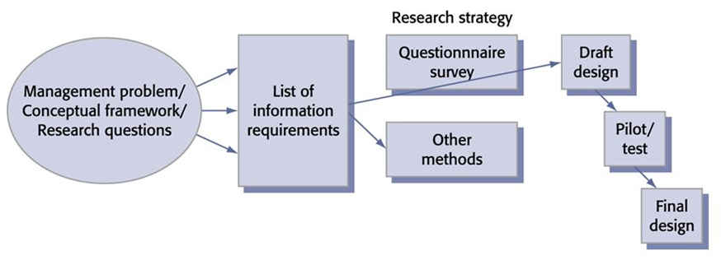
Firstly, the decision to carry out a research study is usually an issue in society that needs investigation which then leads to the research question. The researcher must then draw up a list of information requirements that need to be addressed within the questionnaire which can then be produced into a draft design of the questionnaire in order to see whether it is viable. The questionnaire is then known as the study’s ‘research strategy’ as it is the method in which the research study will gain its data.
Figure 9.6- Questionnaire design process
Veal, A.J (1992). Research Methods for Leisure & Tourism. 3rd ed.
According to Veal, A.J (1992), all of the questions listed in the questionnaire should relate to the information requirements of the study and they should all link back to the main research question.
In this study, there were two types of questionnaire used which are the paper survey and online survey. The paper survey was only completed by attendees at the Dua Lipa concert on 18th April 2018, which was held at The Motorpoint Arena in Cardiff, to find out what their visitor motivations were and whether any changes had been made to safety and security at music events in Cardiff and how that then made them feel.
The online survey’s questions had to be generalised as it was posted to Facebook which meant it couldn’t focus solely on one event.
According to Hussey, J, and Hussey, R (1997), there are many different types of survey question that could be asked within a questionnaire and each has its advantages and disadvantages.
CBN.com states that the type of question used in a questionnaire depends on; ‘The type of information you need, the depth of information you need, and the amount of time your respondents have available will all influence your choice of survey type.’
Matthews, B, and Ross, L (2010) states that the types of question that can be used are:
Closed questions- Questions that require a defined answer such as Yes or No
Rating scale questions- A type of closed question that requires the respondent to assess their feelings by numbers.
CBN.com states; ‘A balanced scale gives the respondent an equal number of positive and negative choices, with each point holding the same amount of weight.’
This allows respondents who don’t have strong feelings toward the question to select a neutral option so that they are answering truthfully.
Likert-type scales- This is a type of rating scale question as respondents are asked to agree or disagree with a certain statement.
Multiple choice questions- A question that requires one or more answers.
Open-ended questions- A question that asks the respondent to supply their own answer such as a comment box. No answer options are given.
In both the paper survey and online questionnaire that’s used for this research study, a variety of question types are used such as closed questions, rating scale questions and open-ended questions. Using a variety of questions meant that the most valuable data could be obtained.
As the researcher, I had to keep in mind, that for the ‘street survey’, respondents wouldn’t want to spend a lot of time completing it therefore, it had to be brief but it also had to ask the appropriate questions in order to get the information that was needed. This meant including a few more closed questions and adding more open-ended questions in the online questionnaire.
Sampling
The sampling method chosen for this research study is Probability which means ‘random selection’ (Press, W. 2018). More specifically, the study used ‘simple random sampling’ which is the most straightforward form of sampling as each member of a population is equally likely to be selected to take part in the research (Press, W. 2018).
As for the street survey, there wasn’t a pre-selected population sample due to the fact that there were no requirements for the survey. Dua Lipa’s fan base is primarily women whether that would be young women or middle-aged women therefore, most of the respondents to that survey were females. Again, the online survey was posted to my Facebook site where I have 695 friends who could have potentially completed my survey. This population size includes people of both genders, different nationalities, religion and so on. This means that any data received through this survey would be unbiased.
Piloting & Results of Pilot study
Unfortunately, due to the change of research question and shift in focus so late into the research process, I was unable to run a pilot study of both the street survey and online questionnaire as I didn’t manage my time wisely. This would have been really beneficial for
the study as it would have tested the feasibility of both research methods. This is definitely a recommendation for improvement for myself and future researchers.
Data Collection Techniques
As previously mentioned, the primary data collection methods are a paper survey and an online questionnaire. Secondary data collection has been through books taken from the University of Wales Trinity Saint David and literature found through Google Scholar and News Bank which is the University’s newspaper database. The main focus of the literature was event management which then filtered down to safety and security within events, terrorism, the visitor experience and lastly, the case study that the research question is based around. These are all key words that were used when searching for the literature.
Data Analysis Techniques
Firstly, as the online questionnaire was designed through SurveyMonkey.com, data analysis for those results can also be done on SurveyMonkey.com through charts and graphs for the quantitative results. Surveymonkey.com (2018) states that the easiest way of analysing the qualitative data is by taking a look at the top research questions, compare the relationship between variables and filter the results. From there the researcher is able to draw conclusions.
SurveyMonkey.com also has a service called NVivo which makes imports the qualitative data and it then analyses it by putting the data into categories and subcategories (Surveymonkey.com, 2018).
To analyse the paper survey, I am going to be using a Microsoft Excel spreadsheet in order to code the data and then analyse it. Leahy, J. 2018 states that by using Microsoft Excel, it’ll be simple to draw conclusions from the data.
Validity/Reliability
According to Veal, A.J (1992), the definitions of Validity and Reliability are as follows:
Validity- the extent to which the data collected truly reflects the issue being studied.
Reliability- the extent to which the research findings would be the same if the research was to be repeated at a later date.
The validity of this study may be difficult to measure as its strongly focused around attitudes and behaviours which will always leave doubts as to whether the responses to the research are true of their behaviour (Veal, A.J 1992).
The reliability of the study is also hard to judge as it depends on future event and whether there’s any more acts of terrorism surrounding the events industry. It depends on what event venues are going to do today, and in the future, to make the visitor experience comfortable for all.
Limitations/Recommendations for Improvement
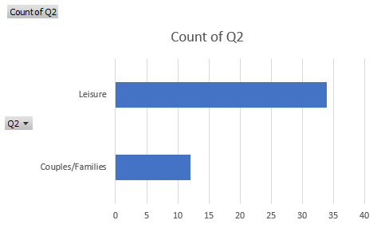
As the researcher, I believe that the limitation to this study is the missed opportunity of interviews up with industry professionals, such as venue staff, that could’ve given the study valuable information on the changes that have been made to safety and security to better the visitor experience. I feel that this has definitely limited my study as I can only use the public’s thoughts and opinions which may not be the most reliable data source. If I could do the study again I would definitely manage my time more wisely to be able to make the most of what would have been available to the study. Another recommendation for improvement would’ve been to do a pilot study of the questionnaire before it went out to the public, to ensure that it was fit for purpose. This would’ve confirmed that the correct questions were being asked; which would’ve then ensured that the correct data was collected.
Research Results and Discussion
Paper Survey
The first research method that I’m going to be analysing is the ‘street survey’ that was handed out to attendees after the Dua Lipa concert on 18th April 2018; in order to find out how they felt about the security measures that were in place and to see whether their visitor experience was positive a one. The paper survey’s questions were brief and concise as it was distributed as a ‘street survey’ after the Dua Lipa show on the 18th April 2018. It was therefore hard to decide which questions to include in order to obtain the best data. During the design of the survey, I had included a ’13-18’ age range option thinking that Dua Lipa has a teenage audience and their thoughts on the visitor experience now would have been useful as the Ariana Grande concert also had a teenage audience. However, I soon realised that it wasn’t ethical to ask under 18 year olds to complete a survey even more so as it’s based on terrorism.
A copy of the survey can be found in the Appendices section. There were 45 respondents in total and I used Microsoft Excel to assist in presenting the data.
The first question was: ‘What is your age range?’
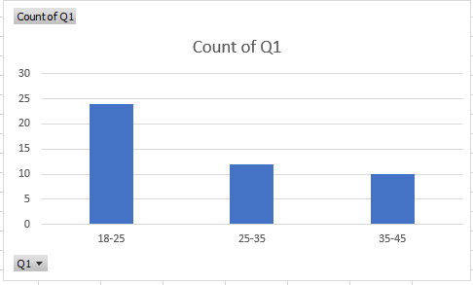
The first question was ‘What is your age range?’ with 23 respondents answering as ’18-25’ year olds, 12 answering as ’25-35’ year olds and 10 answering as ’35-45’ year olds. There were no respondents over the age of 45. This supports the assumption that the majority of the audience were ‘young people’.
The second question was: ‘What motivated you to attend the concert today?’
The answer options were leisure, business, education and couples & families. The only options selected were leisure and couples & families with 33 respondents selecting leisure and 12 respondents selecting couples & families. This illustrates that most attendees at music events are motivated to attend for leisure purposes which would then lead to enjoyment and relaxation.
The third question was ‘How many music events have you attended following the Manchester Arena bombing in May 2017?’
1 | 2 | 3 | 4 | 5+
16 | 20 | 6 | 3 | 0
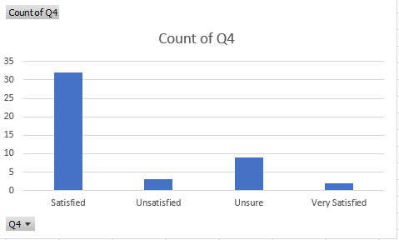
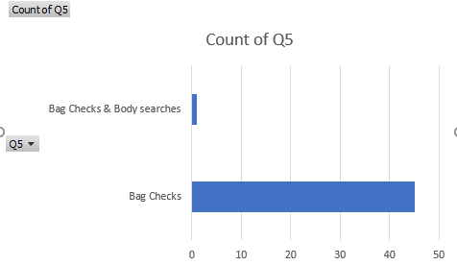
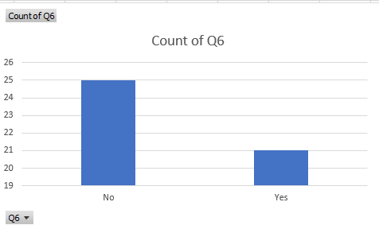
This question was asked with the idea of investigating whether the Manchester Arena bombing had affected the amount of concerts people had been to following the incident.
The most popular choice was 2 music events with 20 respondents choosing this option, 16 respondents choosing 1 music event, 6 respondents choosing 3 music events and the last 3 respondents chose 4 music events.
This tells me that a lot of people are still going to the average amount of two concerts per annum even after the Manchester Arena bombing.
The fourth question was ‘Did you find the security measures at today’s concert to be satisfactory?’
As you can see from the graph, most respondents selected ‘Satisfied’ with the security measures that were in place during the concert with 32 respondents selecting that choice, 3 selected ‘unsatisfied’, 8 selected ‘unsure’ and 2 selected ‘very satisfied’.
As we can see from the graph below, the security measures that were in place were bag checks. The options that were given to the respondents on the survey were bag checks, metal detectors, sniffer dogs, police patrols and body searches. 44 people selected bag checks as the main security measure and 1 respondent selected body searches. This respondent may have experienced a different security measure due to security thinking they needed an extra check due to a suspicion that they were carrying a weapon or so on.
Most respondents were satisfied with the security procedures that were in place.
The fifth question was ‘What security procedures were in place at today’s concert?’
The sixth question was ‘Has your feelings towards attending music events been affected following the Manchester Arena bombing in May 2017?’
25 respondents selected ‘No’ and 21 respondents selected ‘Yes’. This made it almost an equal divide of respondents feeling affected following the Manchester Arena bombing and not feeling affected.
This almost depends on what type of person the respondent is for example if they’re a nervous person who worries a lot and overthinks things, then they would definitely feel affected after a terrorist incident such as the Manchester Arena bombing. If the respondent is the type of person to be unfazed by incidents such as this one where the actions of another person are out of their control, then they wouldn’t be affected by such a terrorist incident and it wouldn’t stop them from going to events and doing what they had done before it had occurred.
The seventh question was if yes, why?
21 respondents out of the 45 selected ‘Yes’ when answering Question 6 therefore, Question 7 only applies to them.
Their answers were as follows:
Less relaxed, more anxious
I feel quite nervous about high profile events now
I’m very aware of what could happen and that makes me nervous
Nervous, on edge, uncertain
I feel nervous when attending events now
Nervous, don’t know what to expect
I don’t want to let terrorists win but they will if the appropriate checks aren’t in place to stop them
A bit scared of what might happen
Nervous but today’s security has changed my feelings.
Nervous
More nervous that I used to be
The thought of terrorism terrifies me
Really nervous
Nervous
The lack of security in venues such as these is worrying
Scared
Feel a little bit more on edge
Nervous
Nervous
Very on edge
Scared

As this question was open-ended, with a ‘comment box’ answer section, the data given was qualitative therefore, I have highlighted the key words that were given which are: nervous, anxious, scared, on-edge, worried.
This tells me that some attendees at music events may not be fully comfortable when attending music events due to the fear that a similar terrorist attack could occur. This is something that event organisers are going to have to keep in mind when planning events as it could be something that stops them attending events altogether.
The eighth question was ‘Is there anything that could be done to improve the spectator experience?’
Some answers were either ‘No’, ‘Nothing’ or ‘Not Applicable’ due to the respondent feeling as though there are no improvements that need to be made to the visitor experience. This was a comment box question and the answers were as follows:
N/A
Body searches on people
More toilets
Police should be here especially when there’s a young audience
Refreshments
More refreshments and more body searches
Body searches on people
More searches and metal detectors
Searches and police patrols
Body searches and metal detectors
No
Metal detectors
N/A
No
No
Body searches
Maybe some metal detectors
Body search and police
No
More police, metal detectors
Nothing
More food options
Nothing
No
Body searches and metal detectors
Body searches
Refreshments
Body searches, police with dogs
No
Nothing
Body searches
Nothing
No
Police
No
Metal detectors
No
Metal detectors
Nothing
No
Police and metal detectors, body searches
Police and searches
Nothing
Nothing
Metal detectors
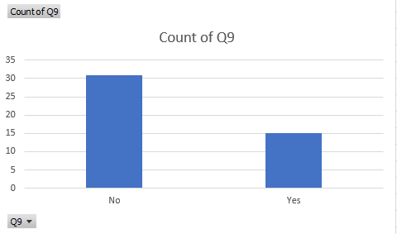
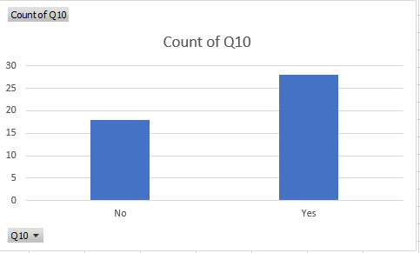
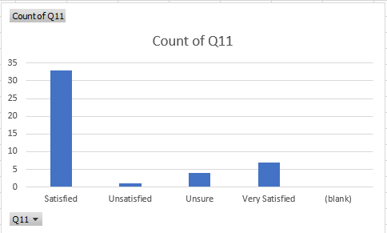
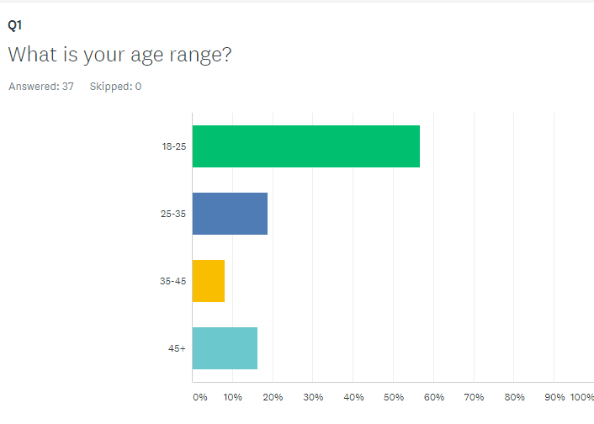
As this question was open-ended, with a ‘comment box’ answer section, the data given was qualitative therefore, I have highlighted the key words that were given which are: body searches, police patrols and metal detectors.
This is something that event organisers and event venues might need to consider in order to improve the visitor experience and to ensure that attendees feel comfortable at their events.
The ninth question was ‘Would you stop attending music events if a similar terrorist incident occurred in the future?’
30 respondents selected ‘No’ as their answer choice for this question and 15 respondents selected ‘Yes’.
Unfortunately, it seems that stopping a lone suicide attacker from detonating bombs may be near impossible as no one can predict when they about to occur however, event organisers can put the appropriate measures in place to contain them and stop them from escalating to life threatening implications.
The tenth question was ‘Do you feel comfortable enough allowing children to attend concerts such as the one held today?
At the Ariana Grande concert in Manchester, there were a lot of under 18 year olds at the concert who were there without their parents for the duration of the event. This question was asked to see whether parents would now feel comfortable allowing their children under the age of 18 to still do that.
27 respondents selected ‘Yes’ and 18 respondents selected ‘No’. This opinion could be altered if parents believed that the event venues were safe and protected enough to allow them to attend music events without them.
The final question was ‘Please rate your visitor experience today on a scale of 1 to 5.
1- Very Unsatisfied 2- Unsatisfied 3- Unsure 4- Satisfied 5- Very satisfied
33 respondents selected ‘satisfied’, 1 respondent selected ‘unsatisfied’. 4 respondents selected ‘unsure’ and 7 respondents selected ‘unsatisfied’.
Out of the respondents I had received data from, the majority of them were satisfied overall with the visitor experience of the concert. This tells me that despite the terrorist incident last year in Manchester, people are still attending concerts and they are still enjoying themselves. Some people are obviously nervous and have fear in the back of their mind but they’re not letting it stop them from enjoying music events.
The second research method that I’ll be analysing is the online survey that was distributed through Facebook. The survey was designed on SurveyMonkey.com which is where the data has also been analysed. There were 37 respondents in total.
The first question was ‘What is your age range?’
21 respondents selected ’18-25’, 7 respondents selected ’25-35’, 3 respondents selected ’35-45’ and 6 respondents selected ‘45+’.
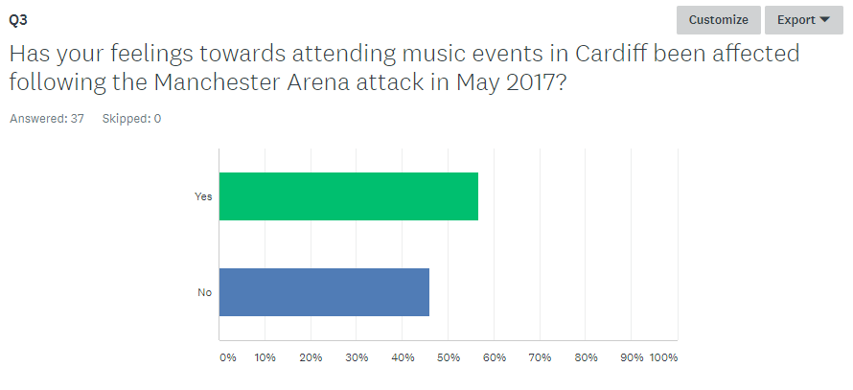
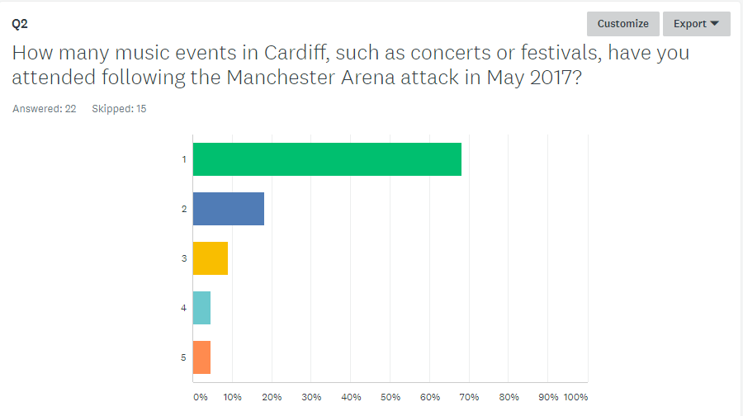
The second question was ‘How many music events in Cardiff, such as concerts or festivals, have you attended following the Manchester Arena attack in May 2017?’
Only 22 respondents answered this question as 10 respondents had skipped it.
15 respondents selected ‘1 event’, 4 respondents selected ‘2 events’, 2 respondents selected ‘3 events’, 1 respondent selected ‘4 events’ and the last respondent selected ‘5 events’.
This tells me that most people are still going to 1-2 music events per year which is still the average amount of music events for people to attend per annum.
The third question was ‘Has your feelings towards attending music events in Cardiff been affected following the Manchester Arena attack in May 2017?’
21 respondents selected ‘Yes’ and 17 respondents selected ‘No’.
Like the paper survey, it’s almost an equal divide between respondents feeling affected following the Manchester Arena bombing and not feeling affected.
As I have previously mentioned, this almost depends on what type of person the respondent is and how they would feel about these types of situations.
The fourth question was ‘If yes, how has your feelings been affected?’
Only 27 respondents answered this question as 10 respondents had skipped it.
Some answers were either ‘Not Affected’ or ‘Not Applicable’ due to the respondent feeling that their feelings have not been affected following the Manchester Arena bombing.
This was a comment box question and the answers were as follows:
-
Have not been affected
N/A
More careful
I feel uneasy when attending events now as if somethings going to happen
Fear
More feelings of anxiety when attending shows
N/A
Scarier to go there. Different feeling
Negatively
Always get a bit dubious going to an event and it’s quite intimidating being body searched when all you want to do is go to a concert
Scared and overthink things
I have never attended a music event but I would be very cautious about attending one in the future in view of the Manchester bombing
I do not feel safe if I go to a big event and am always on edge.
Anxious
Being a capital city, I feel anxious when I'm in an arena that it is going to happen here as well.
N/A
Haven’t been affected
I suspect that it will happen again, only a matter of time
I’m nervous at concerts now
Warier
More cautious
I don’t feel safe anymore
Security was very high and thorough however i felt a bit uneasy towards end of the event ...thinking about Manchester
N/A
I will not go to concerts
It's left me with cause for concern also I have a teenage daughter who would like to attend with her friends, it’s made me question all of our safety.
As this question was open-ended, with a ‘comment box’ answer section, the data given was qualitative therefore, I have highlighted the key words that were given which are: uneasy, anxious, cautious, and on-edge and negatively.
Like the paper survey, this tells me that some attendees at music events may not be fully comfortable when attending music events due to the fear that a similar terrorist attack could occur.
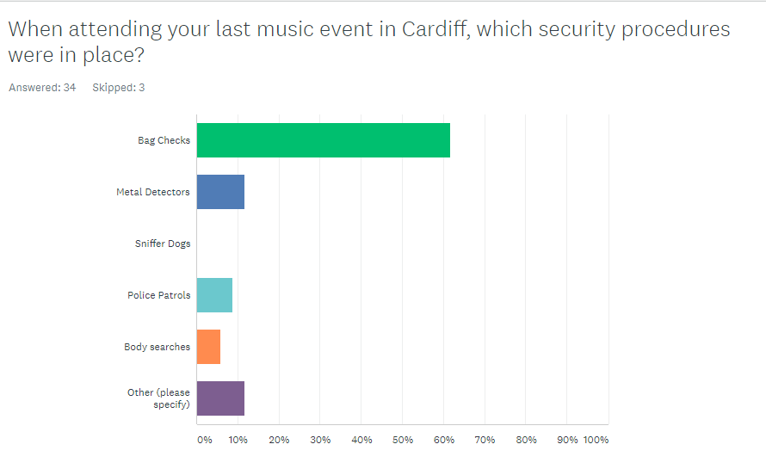
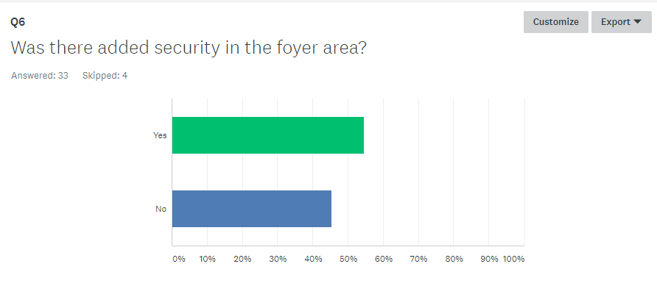
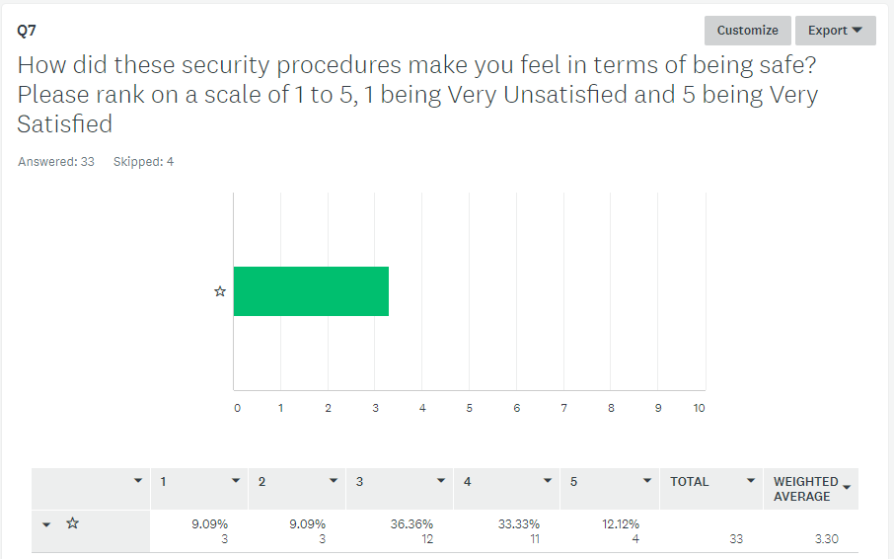
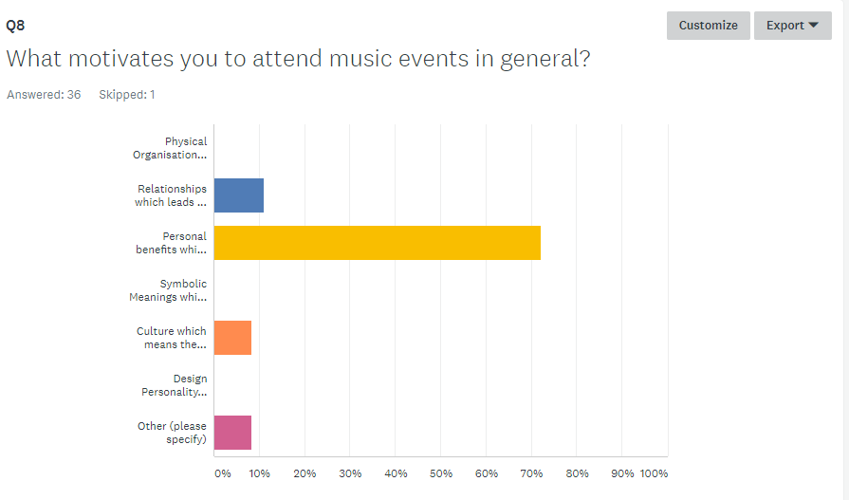
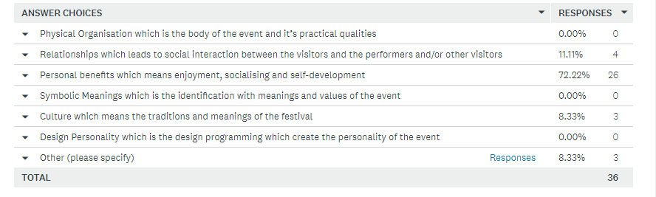
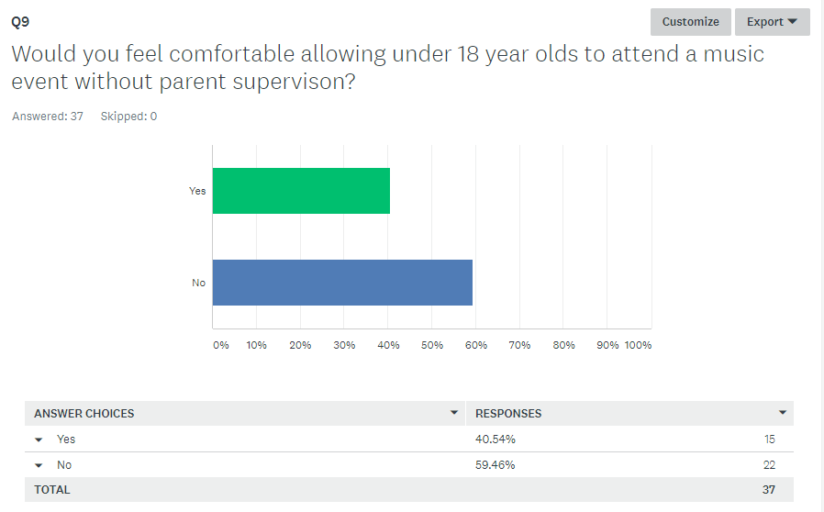
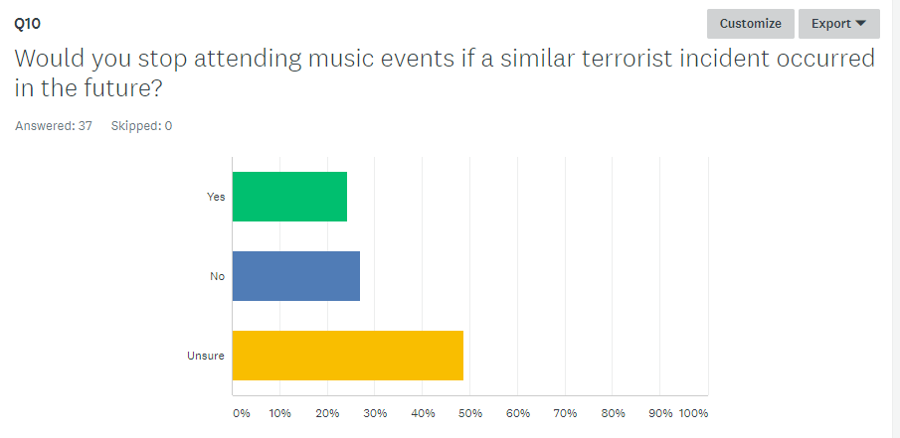
The fifth question was ‘When attending your last music event in Cardiff, which security procedures were in place?’
34 respondents answered this question and 3 respondents skipped it.
The majority of the respondents selected bag checks which seems to the most common security procedure at events in Cardiff which is great as it prevents people from bringing weapons into the venue. Some of the respondents selected metal detectors, police patrols and body searches which is great however, event organisers may need to look at bringing more of these in to every event in order to ensure attendee’s comfortability and enjoyment.
The sixth question was ‘Was there added security in the foyer area?’
33 respondents answered this question and 4 respondents skipped it.
This question was asked as I kept in mind that in the Manchester Arena, there were no security measures in the foyer area which is how the suicide bomber was able to detonate his device in the venue.
18 respondents selected ‘Yes’ and 15 respondents selected ‘No’. This is concerning as this is how the suicide bomber identified a weak spot in security meaning it’s something that has to be addressed for future events.
The seventh question was ‘How did these security procedures make you feel in terms of being safe?’
33 respondents answered this question and 4 respondents skipped it.
The majority of respondents ranked at number 3 which was the neutral ground between Very Unsatisfied and Very Satisfied.
This is something that definitely could be improved as each attendee should be feeling at least satisfied with the security procedures that are in place.
The eighth question was ‘What motivates you to attend music events in general?’
36 respondents answered this question and 1 person skipped it.
This question was based on Crompton, J.L. & McKay, S.L. 1997’s visitor motivations as listed in the literature review. 26 of the respondents selected ‘Personal benefits which means enjoyment, socialising and self-development’. 4 of the respondents chose ‘Relationships which leads to social interaction between the visitors and the performers and/or other visitors’ and 3 respondents chose ‘Other’. This response tells me that most attendees are motivated to attend music events for their own personal benefits in their own leisure time.
The ninth question was ‘Would you feel comfortable allowing under 18 year olds to attend a music event without parent supervision?’
Like the paper survey, this question was asked to see whether parents would now feel comfortable allowing their children under the age of 18 to still do that.
22 respondents selected ‘No’ and 15 respondents selected ‘Yes’.
Finally, the tenth question on the survey was ‘Would you stop attending music events if a similar terrorist incident occurred in the future?’
The majority of respondents selected ‘unsure’ which is worrying as one more terrorist incident in the events sector could potentially deter many people from attending music events in the future.
Conclusion
The following conclusion will link the findings back to the main themes discussed in the literature review.
Objective 1-To investigate what the changes are to the visitor experience at music events in Cardiff.
Objective 2-To investigate how these changes have made visitors feel in the lead up and implementation of the event.
Objective 3-To review how safety and security measures are influencing attendee’s motivations.
Objective 4-To determine what improvements, need to be made, if any, to better the visitor experience for all.
Following the Manchester Arena bombing in May 2017, the Motorpoint Arena in Cardiff, the Welsh capital city, has now implemented new security strategies to ensure they are vigilant at all times. They are in constant contact with local authorities and police to arrange appropriate security and they are now having regular training exercises for new security measures (Motorpointarenacardiff.co.uk).
They also now ask for no bags larger than A4 size to be bought into the arena and for visitors to be patient if things take a little longer than they are used to (Motorpointarenacardiff.co.uk).
Some may argue that these precautions hinder the visitor experience as many don’t expect to be searched as thoroughly as they will be now just to attend a concert. This is supported by a comment to question 4 in the paper survey: ‘Always get a bit dubious going to an event and it’s quite intimidating being body searched when all you want to do is go to a concert.’
Overall, I feel that these changes are needed within the events industry as people need to become more aware on what could happen if the appropriate measures aren’t in place. The changes will ultimately better the visitor experience as most will feel safer knowing that these changes are taking place.
Bibliography
Literature Review
"Boost to City's Live Music Scene." BBC News. N.p., 2018. Web.
Accessed on: 16/04/18
"Cardiff | Destination Management Wales." Businesswales.gov.wales. N.p., 2018. Web.
Accessed on: 22/04/18
"Cardiff Destination Action Plan (DAP) 2012-2014." N.p., 2018. Web.
Accessed on: 22/04/18
"Home - Visit Cardiff." Visitcardiff.com. N.p., 2018. Web.
Accessed on: 22/04/18
"Proud to Be Security: How Roles Changed After 9/11." Securitymagazine.com. N.p., 2010. Web.
Accessed on: 16/04/18
"Safety and Security at Motorpoint Arena Cardiff | Motorpoint Arena Cardiff."
Motorpointarenacardiff.co.uk. N.p., 2018. Web
Accessed on: 20/04/18
"What to Know About the Explosion at Ariana Grande's Manchester Concert." Time.com. N.p., 2017. Web.
Accessed on: 20/04/18
"Why Terrorists Love to Target Concerts." New York Post. N.p., 2017. Web.
Accessed on: 22/04/18
“Mega-Events Power Cardiff’s Tourism Strategy." Financial Times. N.p., 2017. Web.
Accessed on: 22/04/18
Bowdin, G.A.J., Allen, J., O’Toole, W., McDonnell, I. and Harris, R. (2005) Events management. 2nd edn. Amsterdam: Butterworth-Heinemann, Kidlington.
Accessed on: 16/04/18
Baker, Keiligh (2017). "Concert-Goers Slam 'Lax' Security at Ariana Grande Show." Mail Online. N.p., 2017. Web.
Accessed on: 21/04/18
Barry, C. (2015). THE EFFECTS OF GLOBAL TERRORISM ON THE EVENTS INDUSTRY. Available: http://www.confpeople.co.uk/free-venue-finding/conference-venues/the-effects-of-global-terrorism-on-the-events-industry.
Accessed on: 16/04/18
BBC News. (2015). Paris attacks: What happened on the night.
Available: http://www.bbc.co.uk/news/world-europe-34818994
Accessed on: 16/04/18
Bergen, Peter. CNN National Security Analyst. "16 Years After 9/11: The State of The Terrorist Threat." CNN. N.p., 2017. Web.
Accessed on: 20/04/18
BOWDIN, G., ALLEN, J., O‟TOOLE, W., HARRIS, R. & MCDONNELL, I. 2006. Event Management. 2nd ed. Oxford: Elsevier. 510 p.
Accessed on: 16/04/18
Bryn Parry, Anton Stone. Successful Event Management. 2001. Print.
Cited: Berlonghi in McDonnell et al (1999)
Accessed on: 22/04/18
Chalip, L., Green, C., & Hill, B. (2003). Effects of sport media on destination image and intentions to visit. Journal of Sport Management, 17, 214 -234.
Accessed on: 16/04/18
Clarke, Richard A. ‘Against all enemies: Inside America's war on terror. Simon and Schuster, 2008.'
Accessed on: 20/04/18
Coyle, Simon. 2017 "Manchester Terror Attack." Manchestereveningnews.co.uk. N.p., 2017. Web.
Accessed on: 10/05/18
CROMPTON, J.L. & MCKAY, S.L. 1997. Motives of visitors attending festival events. Annals of tourism research, 24(2):425-439
Accessed on: 09/05/18
Dearden, Lisa (2015). Is this the end of al-Qaeda? Bin Laden's network is being destroyed by Isis, loyalists admit.
Available: https://www.independent.co.uk/news/world/middle-east/is-this-the-end-of-al-qaeda-bin-ladens-network-is-being-destroyed-by-isis-loyalists-admit-10312163.html
Accessed on: 09/05/18
Deighton, Katie. (2015). Life after Paris: How the UK event industry is reacting to terror Read more at https://www.campaignlive.co.uk/life-paris-uk-event-industry-reacting-terror. Available: https://www.campaignlive.co.uk/life-paris-uk-event-industry-reacting-terror/%7Bsubjects%7D/article/1373596
Accessed on: 10/05/18
Dodd, Vikram. (2017) "At Least 22 Killed, 59 Injured in Suicide Attack at Manchester Arena." The Guardian. N.p.
Accessed on: 10/05/18
Faulkner, B., Chalip, L., Brown, G., Jago, L., March, R., & Woodside, A. (2000). Monitoring the tourism impacts of the Sydney Olympics. Event Management: An International Journal, 6(3), 231-246.
Accessed on: 01/05/18
Getz, Donald. Event Management & Event Tourism. New York: Cognizant Communication Corp., 2005. Print.
Accessed on: 16/04/18
Getz, Donald. Event Studies. Hoboken: Taylor and Francis, 2013. Print.
Accessed on: 16/04/18
Global Terrorism Database (GTD). University of Maryland.
https://www.start.umd.edu/gtd/
Accessed on: 22/04/18
Goldblatt, JJ. Special Events. New York: Wiley, 2002. Print.
Accessed on: 20/04/18
Gould, Eric D., and Esteban F. Klor. "Does Terrorism Work?" Quarterly Journal of Economics 125, no. 4 (2010).
Accessed on: 20/04/18
Greenberg, Karen J. Rogue Justice: The Making of The Security State. Print.
Accessed on:
Hoffman, Bruce. Inside terrorism. Columbia University Press, 2013.
Accessed on: 22/04/18
Jago L., Chalip L., Brown G., Mules T. and Ali S. (2003) ‘Building events into destination branding: Insights from experts’, Event Management Vol. 8, No. 1: pp. 3–14
Accessed on: 20/04/18
Keneally, Meghan, and Madden, Pete (2017). "Concerts, Other Soft Targets Remain Vulnerable to Attack, Experts Say." ABC News. N.p.
Accessed on: 20/04/18
Knight, Jane Ali, and Alan Fyall. International Perspectives of Festivals and Events. 2008. Print.
Accessed on: 22/04/18
Morgan, Michael. 2008 Event Management: What Makes A Good Festival? Understanding the Event Experience. 2nd ed. 2008. Print.
Accessed on: 05/05/18
Neggaz, Sihem (2017). "5 Greatest Risks to The Security of Your Event | Gardaworld." Garda.com. N.p., 2017. Web.
Accessed on: 22/04/18
Roberts, Adam. "BBC - History - The Changing Faces of Terrorism." Bbc.co.uk. N.p., 2014. Web
Accessed on: 05/05/18
Roser, Max. "Terrorism." Our World in Data. N.p., 2013. Web.
Accessed on: 05/05/18
Sands, Katie. "Armed Police Will Be at Major Music Events in Cardiff And Swansea." WalesOnline.co.uk N.p., 2017
Accessed on: 20/04/18
Schwenkenbecher, A. (2012). Terrorism: A Philosophical Enquiry. [Online] Available at: https://link.springer.com/chapter/10.1057/9781137024220_3
Accessed on: 20/04/18
SILVERS, J. 2004. Professional event co-ordination. Hoboken, N.J.: Wiley. 474 p.
Accessed on: 22/04/18
Tarlow, P. E. (2002). Event risk management and safety. New York, NY: John Wiley & Sons Inc.
Accessed on: 16/04/18
Taylor, Tracy, and Kristine Toohey. Event Management. 4th ed. 2005. Print.
Accessed on: 16/04/18
Telegraph Reporters. (2018). Timeline of vehicle rampage attacks in Europe.
Available: https://www.telegraph.co.uk/cars/news/timeline-vehicle-terror-attacks-europe/
Accessed on: 22/04/18

Methodology
"Understand Qualitative Vs Quantitative Research | Surveymonkey.com" SurveyMonkey. N.p., 2018. Web.
Accessed on: 23/04/18
Matthews, Bob, and Ross, Liz. Research Methods. Harlow: Pearson Education, 2010. Print.
Accessed on: 23/04/18
Bell, Judith. Doing Your Research Project. Maidenhead: McGraw-Hill Open University Press, 2010. Print.
Accessed on: 23/04/18
DeFranzo, Susan. "Which Is More Effective: Paper-Based Surveys or Online Surveys?" SnapSurveys.com N.p., 2018. Web.
Accessed on: 24/04/18
Devault, Gigi. "Learn the Difference Between Primary and Secondary Research." The Balance Small Business. N.p., 2018. Web.
Accessed on: 23/04/18
Dudovskiy, John. "Phenomenology - Research Methodology." Research-Methodology. N.p., 2018. Web.
Accessed on: 24/04/18
Henderson, K.A. Reality Comes Through A Prism: Method Choices in Leisure Research. 1990. Print.
Accessed on: 25/04/18
Joop, J., Hox, and Boeije Hennie, R. Data Collection, Primary Vs. Secondary. 2005. Web.
Accessed on: 25/04/18
Leahy, Jennifer. Using Excel For Analysing Survey Questionnaires. 2018. Web.
Accessed on: 25/04/18
Ltd, White. "Mixed Methods Research." Resourcecentre.foodrisc.org. N.p., 2017. Web.
Accessed on: 25/04/18
Hussey, Jill, and Roger Hussey. Business Research: A Practical Guide for Undergraduate and Postgraduate Students. 4th ed. 1997. Print.
Accessed on: 25/04/18
Press, William. "Simple Random Sample: Definition and Examples." Statistics How To. N.p., 2018. Web.
Accessed on: 25/04/18
Types of Survey Questions — Canada Business Network.com" Canada Business Network. N.p., 2018. Web.
Accessed on: 25/04/18
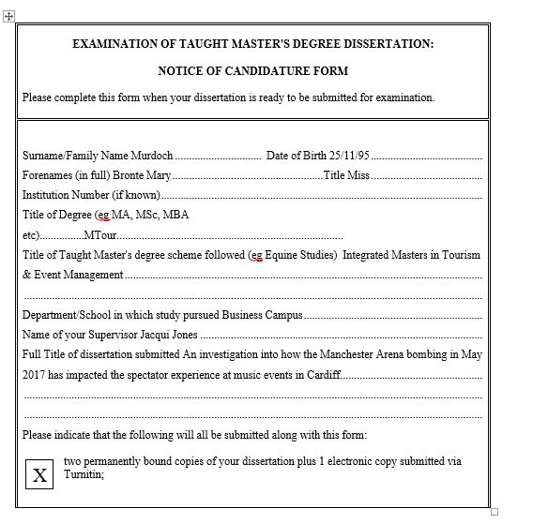
Veal, A.J (1992). Research Methods for Leisure & Tourism. 3rd ed. Harlow: Pearson, 2018. Print.
Accessed on: 25/04/18
General
"People Raised Security Issues with Manchester Arena Weeks Ago – But Were 'Brushed Off' | Metro News."
www.Metro.co.uk. 2017 (Web)
Accessed on: 10/05/18
Appendices
Research Questionnaire
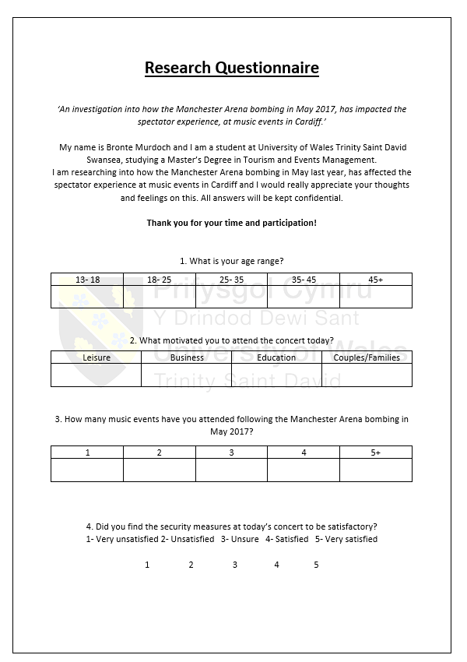
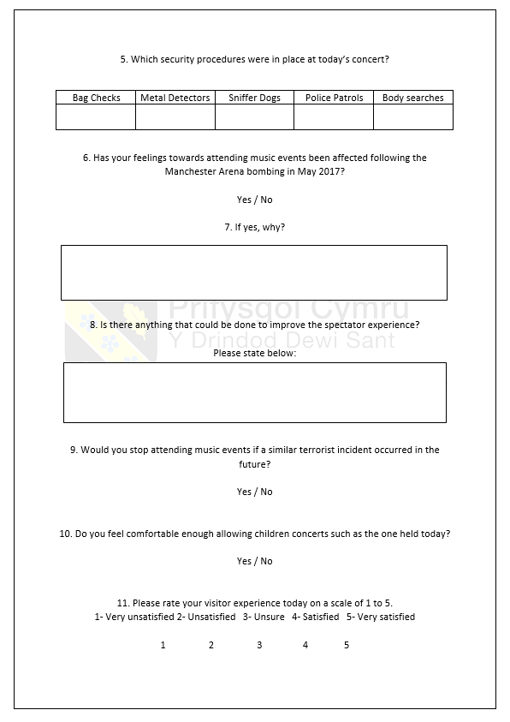
Notice of Candidature Form

