

University of Wales Trinity Saint David
BABM Level 6
Dissertation proposal on the topic
To what extend are the markets efficient?
Student: Georgi Dimitrov, 1917423
Dissertation supervisor – Dr. Taye Osadiya

To what extent are the markets efficient?
Dissertation proposal

The efficient markets hypothesis has been the subject of much academic research, and economists still disagree about how efficient markets are.
The Efficient Market Hypothesis (EMH) theory – introduced by economist Eugene Fama – states that the prevailing asset prices in the market fully reflect all available information. "The proposition is that prices reflect all available information, which means since prices reflect all available information, there is no way to beat the market."
Eugene Fama classified market efficiency into three distinct forms:
*Weak form efficiency* – "the current price of a security already reflects all past prices" (Fama, 1970). In other words, an individual investor cannot predict future stock prices by analysing past prices.
*Semi-strong form efficiency* – "the current price of a security already reflects all publicly available information" (Fama, 1970). It means that an analyst cannot beat the market by analysing publicly-available information.
*Strong form efficiency* – "the current price of a security already reflects all relevant information, both public and private" (Fama, 1970). It is the most potent form of market efficiency, which means that it is impossible to beat the market, no matter what information an individual or an entity has.
Altogether, it states that no technical analysis or information can give us returns higher than the indices average without taking more risk.
One of the main criticisms of the EMH is that it assumes that all investors have equal access to information and that they all process this information in the same way. Richard Thaler However, we know that this is not the case. Some investors have the edge over others, whether it is because they have access to better information or they are better at analyzing it.
Another criticism of the EMH is that it assumes that all investors are rational. However, again, we know that this is not the case in reality. Investors are subject to behavioral biases, which can lead them to make suboptimal investment decisions.
In the age of rapid technological advancement, the market has evolved and became more volatile (Oecd.org, 2019). Some of the questions which we will discuss will be - can an individual investor beat the market? It appears there is not enough academic research on the matter in the recent times. Most market researchers would agree that markets are quite efficient. In other words, they would say that asset prices reflect all available information about those assets. This would mean that it is very difficult, if not impossible, to find "undervalued" stocks or other investments.
However, some researchers argue that markets are not always efficient. Even Fama himself agreed with Thaler in their discussion that the EMH model does not always work.(Chicago Booth Review, 2016)
Fama states that markets are efficient only in the long run. Burton Malkiel confirms this in his work ''Efficient market hypothesis and its critics''. All of them believe that prices may deviate from the true value in the short term.
The purpose of this study is to investigate market efficiency concerning the Eugene Fama theory, along with the views of proponents and opponents like Malkiel, Thaler, Soros, and Schiller. The theory states that markets are efficient and that prices reflect all available information. However, there are ''anecdotes'', as Fama and Thaler refer to them, like the CUBA fund, a case revealing a not-so-efficient market. This study will attempt to determine whether or not this is true by looking at different markets and how they operate. It will also look at the role of market makers and how they affect market efficiency. Finally, the study will conclude with a discussion of the findings and their implications.
Fama's theory is very influential and has helped shape how many investors think about the markets. However, there is still some debate as to whether markets are truly efficient. Some researchers believe they are, while others believe there are still opportunities to find undervalued assets. There are practitioners and theorists like Soros, whose theory of reflexivity on the financial markets helped him generate wealth.
It is up to each individual to decide whether they think the markets are efficient or not. Markets are closely related to the economic crisis, and knowing what the key drivers of the prices are is key to achieving efficiency and reducing risk. Knowing the different arguments and theories would lead to making better-informed decisions. This would also help reduce the risk and increase efficiency.
According to a study, nearly 40% of economics experiments fail when trying to be repeated.(Science.org, 2021) This has to be taken into consideration. In this research, we would not be able to research the effect of High-Frequency Trading strategies or options strategies. The research will be limited to the ideas proposed by the referenced authors.

‌
Several different research philosophies underpin different research approaches.
Positivism is a scientific approach to research that emphasizes the need to test hypotheses through empirical observation. This approach is based on the idea that there is an objective reality that can be studied and measured. Data that is used allowed the result to be clear and valid. It is essential to use this approach because we need to trust the data we are using, and the research must be based on reliable data. This approach will be helpful when examining the different market theories because it would allow us to test our hypotheses about market efficiency through empirical observation.
Objectivism is the belief that social phenomena exist beyond our influence, regardless of whether we are aware of them. It means they have an objective reality independent of our role as an observer. Objectivist epistemology presumes that reality exists independently of and outside the individual mind. Therefore, Objectivist research is beneficial in guaranteeing reliability (consistency of results obtained) and external validity (applicability of the results to other contexts). Objectivism tells us that the efficient-market hypothesis is an ontological proposition—a statement about reality. The EMH is thus a claim about how markets behave. We will investigate the market's efficiency using positivism and objectivism research methods. This should help to analyse different theories critically. Since this is a controversial topic, it is crucial to use both positivism and objectivism to get a complete picture of reality and fully understand the issue.
Quantitative analysis: Most social science research is quantitative, which means it uses data that can be measured and counted. This makes the information accurate. The data is reliable, meaning it can be repeated, and the results will be the same. This type of research often relies on statistical models to understand psychological, social, and economic processes through the study of numerical models. When we analyse the market theories, the quantitative methodology will help us because this is a statistical and mathematical approach to economic analysis.
For the purpose of the study, we are going to use the historical pricing of certain stocks and theories, and we are also going to examine the methodologies and metrics used by some of the elite professional traders, analysts, and investors.
In the research, we will analyse different patterns, models, and backtest experiments; We can also conduct a test in live market conditions of the reviewed patterns and strategy.
The limitation of the study refers to the fact that we will not use surveys, questionnaires, and personal interviews, which may affect the study, as the type and methodology of research do not require it. We are going to look at the market in general. Some of the objects of observation will be the price chart of indices like S&P500 and NASDAQ. We will take our data using publicly available information and software to process it. We will be limited in time to process all available data about patterns that will be mentioned across the research.
The study will be consisted of five chapters.
The first chapter will introduce the topic of the efficient market hypothesis (EMH) and its critics. This chapter will provide an overview of EMH, its key concepts and assumptions, as well as the arguments of its opponents.
The second chapter will be a literature review, in which relevant research on EMH will be discussed and synthesized. This chapter will aim to identify gaps in the current body of knowledge and formulate research questions for the subsequent chapters.
The third chapter will focus on research methodology and design. This chapter will detail the research methods used to answer the questions posed in Chapter 2 and the justification for why these methods were chosen.
The fourth chapter will present the findings of the research conducted in Chapter 3. This chapter will include a discussion of the data collected and how it supports or refutes the hypotheses formulated in Chapter 2.
The fifth and final chapter will analyse, discuss, and conclude the findings of the previous four chapters. This chapter will recommend future areas of research on EMH, as well as reflect on the limitations of the current study.
Some ethical considerations that may arise during this research include protecting participants' privacy if there are any. There will be a need to ensure that all information collected is used only for research purposes and obtain informed consent from all participants and volunteers, if any. Most of the data that will be used is publicly available. Some software used for the research might not be available for public use for free. Additionally, it is vital to know any potential biases that could influence the research results.
It is an important topic, with roots going back to Adam Smith, called behaviourist economist by Ashraf, Camerer, and Loewenstein in their 2005 work. Furthermore, if we consider that the markets are one the best ways so far to allocate resources, we should strive to make it more efficient. We can conclude the same as Thaler - we need better working models. Moreover, through this research, we would try to help the community in its effort to find a way to improve the inefficiencies and bring benefits to stakeholders along the way. Burton Malkiel does more in-depth research on technical analysis. The research will show how the theories differ and their touch points and examine if some patterns or signals are allowing an individual to make profits higher than the average without excessive risk.

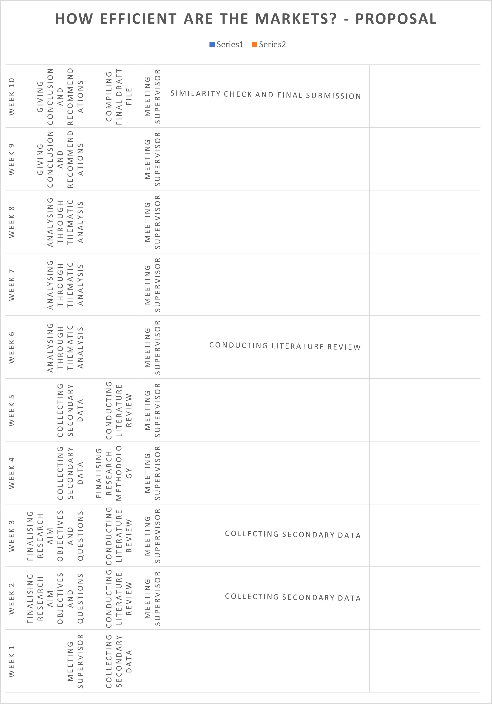

References:
Ashraf, N., Camerer, C.F. and Loewenstein, G. (2005). Adam Smith, Behavioral Economist. Journal of Economic Perspectives, [online] 19(3), pp.131–145. doi:10.1257/089533005774357897.

Chicago Booth Review (2016). Are markets efficient? YouTube. Available at: https://www.youtube.com/watch?v=bM9bYOBuKF4&t=2114s [Accessed 2 Sep. 2022].
Edge.org. (2022). Edge.org. [online] Available at: https://www.edge.org/response-detail/25293 [Accessed 2 Sep. 2022].

Fama, E. F. (1970). Efficient capital markets: A review of theory and empirical work. The journal of finance, 25(2), 383-417.

Garcia, C. (2017). Thaler, the CUBA fund and the efficient markets hypothesis (plus a roundup). [online] @FinancialTimes. Available at: https://www.ft.com/content/d9e9d4be-7f2c-36fc-8f62-9bfb98f32315 [Accessed 2 Sep. 2022].

‌Malkiel, B.G. (2003). The Efficient Market Hypothesis and Its Critics. Journal of Economic Perspectives, [online] 17(1), pp.59–82. doi:10.1257/089533003321164958.

‌Open Society Foundations (2010). George Soros Lecture Series: Financial Markets. YouTube. Available at: https://www.youtube.com/watch?v=RHSEEJDKJho [Accessed 2 Sep. 2022].

‌Saunders, M, Lewis, P & Thornhill, A (2019). Research Methods for Business Students. 8 edn, Pearson, Harlow.

‌Svizzera (2014). Nobel Prize Prof. Robert J. Shiller on Market Efficiency and the Role of Finance in Society. YouTube. Available at: https://www.youtube.com/watch?v=z5hWd2Zoies [Accessed 2 Sep. 2022].

Tiwari, P. (2021). How Fintech Is Changing the Face Of the Stock Market. [online] Entrepreneur. Available at: https://www.entrepreneur.com/article/369803 [Accessed 2 Sep. 2022].

