Con-rod Dynamic Forces Report,

AUDI RS4 B7 4.2 V8

James Smith

1801879

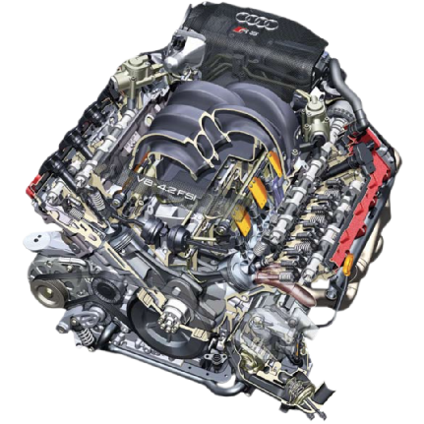

Figure 1: Audi RS4 Engine

Contents:

Title Page.......................................................................................................................Page 1
Contents Page................................................................................................................Page 2
List of Figures.................................................................................................................Page 3
Introduction...................................................................................................................Page 4
Research.........................................................................................................................Page 5
Methodology..................................................................................................................Page 7
Analysis...........................................................................................................................Page 8
Conclusion......................................................................................................................Page 13
References......................................................................................................................Page 14
Figures References…………….......…………………………………………………………………………………Page 15

List of Figures:
Figure 1…...........................................................................................................Audi RS4 Engine
Figure 2............................................................................................................. Audi RS4 Engine
Figure 3………………………………………………………………………….….……………Audi RS4 Advertisement
Figure 4.................................................................................................RS4 Con-rod Dimensions
Figure 5..............................................................................................APR Torque and HP Graph
Figure 6..............................................................................................Velocity Graph (2500 rpm)
Figure 7......................................................................Force and Acceleration Graph (2500 rpm)
Figure 8..............................................................................................Velocity Graph (5000 rpm)
Figure 9......................................................................Force and Acceleration Graph (5000 rpm)
Figure 10............................................................................................Velocity Graph (7500 rpm)
Figure 11....................................................................Force and Acceleration Graph (7500 rpm)
Figure 12........................................................Velocity Graph (7500 rpm) Piston Mass Increased
Figure 13................................Force and Acceleration Graph (7500 rpm) Piston Mass Increased
Figure 14……………………………...……. Force and Acceleration Graph (7500 rpm) Shorter Con-rod
Figure 15……………………………………………………………………...……………………………………Results Table
Introduction

When in use, an engine exerts extreme forces on the connecting rod (con-rod). This report will be discussing these dynamic forces and the effects they impart when acting upon the con-rod. This small-scale report will test and analyse these effects and will start by presenting recent and relevant research in this area. In order to demonstrate the effectiveness of the con-rod, an engine of interest has been chosen specifically because of its history performance and design. After finishing the research, computer programmes and tools will be used to help analyse the engine speeds and forces acting upon components within the engine. The results will then be presented in graphs showing the acceleration, velocity and force, which will contribute to reviewing the performance of the engine. After calculating these results, the findings will be discussed and a conclusion drawn, emphasising how the components of the con-rod can be enhanced by changing dimensions and speeds.

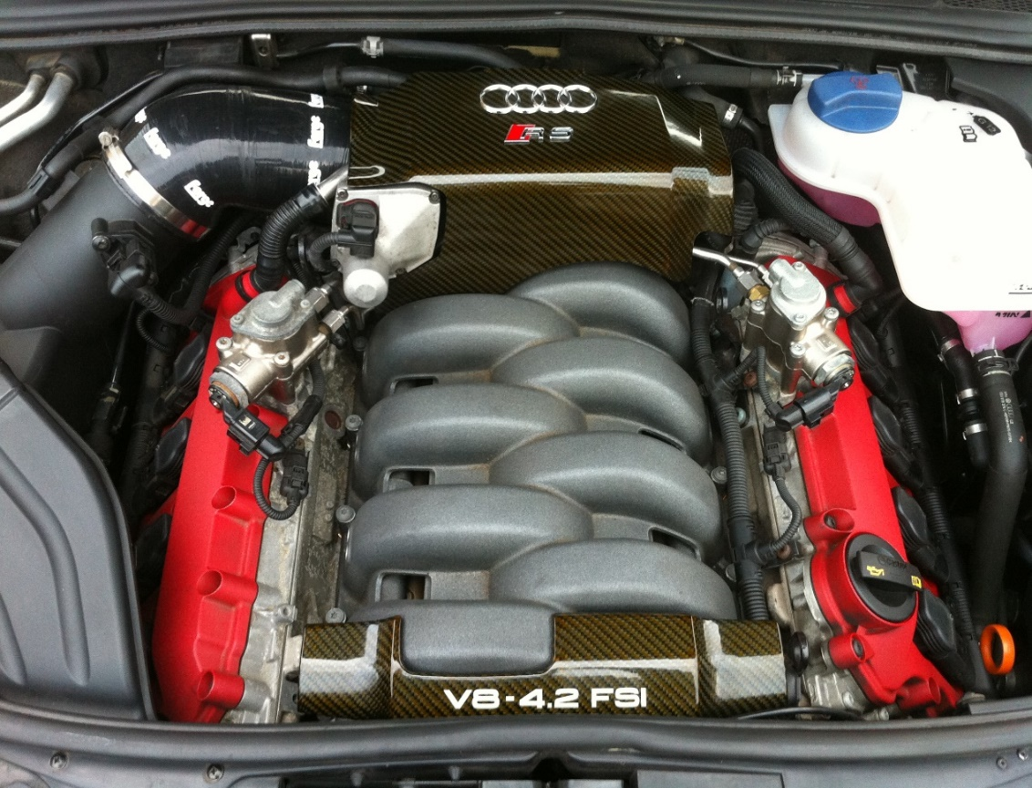
The engine of interest is the Audi RS4 B7 4.2 V8 (2006-2008), this engine will be used in a selection of tests to show the forces that a con-rod is put under when the engine is in use. The B7 engine is going to be tested by changing the engine speed (rpm), piston mass (kg), con-rod length (mm) and crank radius (mm). These measurements are going to be found using the appropriate technical documentation and articles. These tests will present the forces that the con-rod is put under when the minimum and maximum forces are occurring, such as the maximum rpm of the engine and the most effective rpm of the engine for the maximum torque and acceleration in order to increase power output.
Figure 2: Audi RS4 Engine

Research

The B7 Engine has been chosen for the report because as stated in “Wireless News; Jacksonville” (2006), the B7 Audi RS4 was one of the “three finalists in the World Performance category” alongside the Porsche Cayman S and the BMW M5. For the three finalists to be chosen, a variety of experts in the field of performance and environmental design, were selected. These experts helped the 46-member jury determine the top three finalists for all the variations of categories shown in “Wireless News; Jacksonville” (Close-Up Media, Inc. April 2006, p.1).

Graham Johnson (co-chair of the World Car of the Year steering committee) announced these awards and argued that; “Performance, design, and environmental responsibility are all key elements in the success of a vehicle on a global scale” (Johnson, 2006). This statement, and the fact that it is grouped in the top three of the “World Performance category” in 2006 is used here to support the decision to choose the B7 RS4 engine, as the engine of choice to be analysed in this Dynamic Forces report.

The B7 RS4 was also described as a “predatory animal” as stated in the article “Campaign of the month” (Long, 2006). Long also compared it to a “deadly spider that devours other, lesser sports cars”, which presents the B7 RS4 as a beast that has transformed the standard everyday A4 family car into a vicious weekend toy. After reading both these articles, the B7 Audi RS4 seems to be the perfect candidate to perform testing on. Over its lifetime this engine has been highlighted by many articles as the favourite RS4 yet. The report findings will be interested in whether minor adjustments can be made to increase the power output and acceleration timings of the engine.

Before releasing the B7 RS4, Audi wanted to make sure that the new improved model was targeted to the correct market so they created a worldwide marketing campaign to display the improved V8 powered RS4, which was replacing the older B5 2.7 V6 Turbo RS4.

Audi is backing the launch of its RS4, a high-performance version of its A4 model, with a £4m campaign. A TV ad targeting drivers who need a practical vehicle, but are also tempted by something with more power, breaks today (Wednesday). The execution features a Black Widow spider surrounded by what appear to be insects in its web, but turn out to be the remains of old sports cars. The spider moves toward the camera while morphing into the RS4.
(Anonymous, 2005)

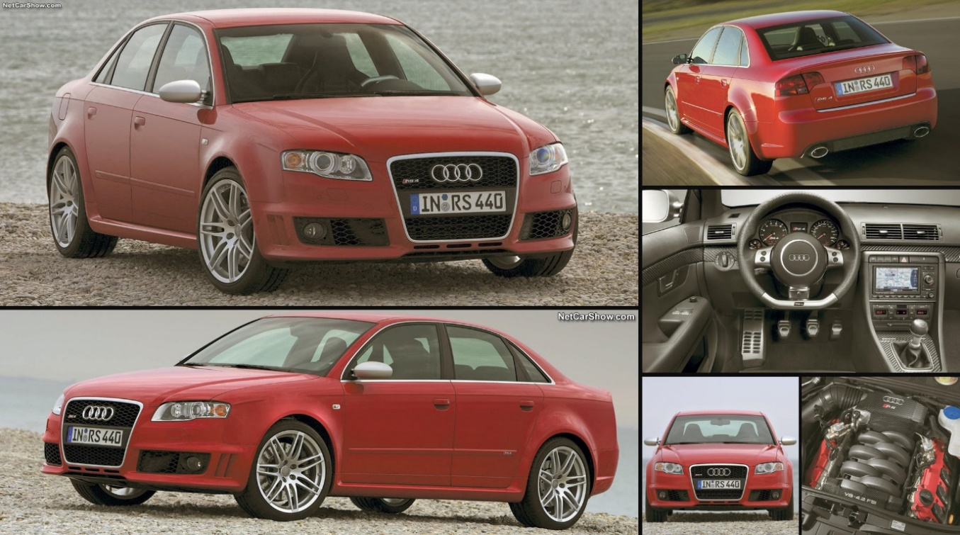
The above comments from the section from “Marketing; London” shows that even before the B7 RS4 was launched there were already high expectations that it would be a game changer for the Audi RS range.
Figure 3: Audi RS4 Advertisement

The figures needed to perform the testing on this engine have been obtained using an internet source as shown in figure four. The dimensions that will be used for the testing are the Crank Radius 28.4mm, the Con-rod Length 154mm and the Piston Mass 0.29kg. Whilst testing, these dimensions are going to be changed, to analyse the forces within the engine to see the different velocities and forces at different revolutions per minutes.
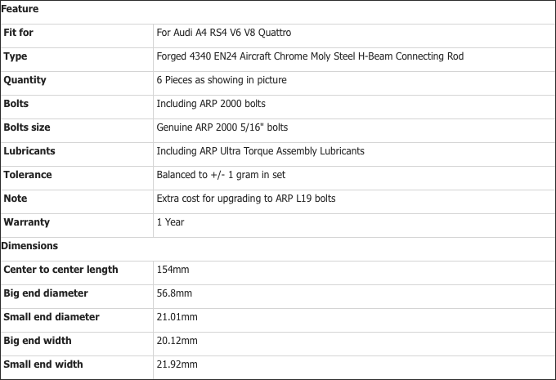
Figure 4: RS4 Con-rod Dimensions

Methodology

The analyses section is going to be carried out using an Excel Spreadsheet with the dimensions and weights filled in, as shown on page 6 in this report. Once the Excel programme is set up with the correct data imputed in, a set of graphs will be generated to show the velocity, force and acceleration of the engine at different rpms, calculated in 0.0002 second intervals. The data imputed into the programme will then be changed slightly to see how the engine performs at different rpms and dimensions. For example; the con-rod length is going to be changed to make it shorter to see how this affects the performance of the engine.
By using this programme, the aim is to see how the performance of the B7 RS4 Engine can change after adapting some of the dimensions and weights used in testing. After adapting the data, one of the outcomes that will hopefully be present is an increase in the force and velocity of the engine after changing the rpm and the con-rod length.
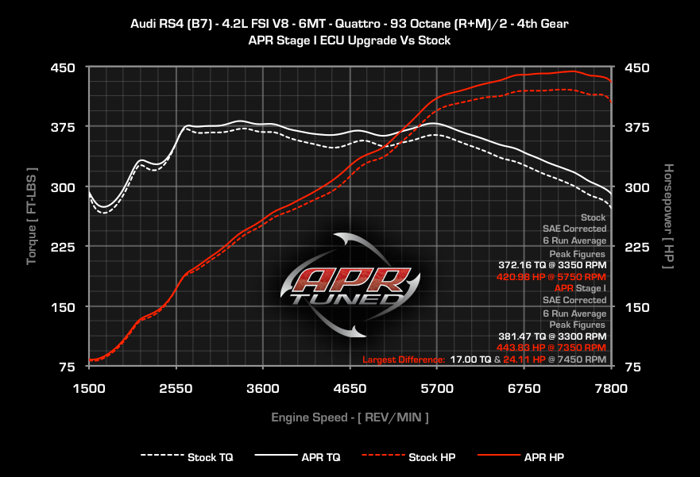
Figure 5: shows the Horse Power and Torque values from 1500 rpm to 7800 rpm. These values have been included so that when testing, tests can be carried out to see whether the stock torque shown in figure 5: is similar to the torque found whilst carrying out the testing section. This will then show whether the programme being used is an efficient and effective way of testing the engine.
Figure 5: APR Torque and HP Graph

Analysis

Before the analysis can start, a test will be carried out to see if Excel is a reliable programme to analyse the RS4 Engine. The test being carried out is the torque value at 3350 rpm, which is then going to be compared to figure 5.

Torque = Force x Radius = 1,309.162 x 0.284 = 371.8nm

The torque produced in figure 5 for a standard RS4 Engine is 372.17nm, the torque that was produced in the test was 371.8nm which shows that this programme is suitable and reliable for testing. The minor difference between the two torques can be down to several variables but the reason in this case, is figure 5 has been produced from an engine dyno so the results will be slightly different.

Carrying out the testing, three different rpms are going to be used; 2500 rpm, 5000 rpm, 7500 rpm. These three rpms are going to be tested, looking at the peak velocity, max force and the max tensile force. Detailed testing is then going to be carried out on the most effective rpm found, by changing the piston mass and con-rod length to see how the velocity and force change.

m/s

Time (s)
Figure 6: Velocity Graph (2500 rpm)

Figure 6: shows the peak velocity of the RS4 Engine at 2500 rpm, this is 7.56 m/s after one revolution of the engine. This result is low due to little rpm being used, causing the forces acting on the con-rod to be lower. Once all rpms have been tested, a conclusion will be obtained to see how effective this rpm is compared to others.

N
m/s²

Time (s)
Figure 7: Force and Acceleration Graph (2500 rpm)

Figure 7: shows the max force and acceleration of the RS4 Engine at 2500 rpm. The max force is 460.35 N, which is a relatively low force because using a low rpm for a large engine, is not an effective way of getting large forces and power. The max tensile force on the con-rod at 2500 rpm is 668.365 N, which is also low because the rpm is too low for the size of the engine to gain more force.

m/s

Time (s)
Figure 8: Velocity Graph (5000 rpm)

Figure 8: shows the peak velocity of the engine at 5000 rpm after one revolution. The peak velocity is 15.11 m/s, this is around double the results from the first test because now the rpm has increased so has the velocity and force.

m/s²
N

Time (s)
Figure 9: Force and Acceleration Graph (5000 rpm)

Figure 9: shows the max force and acceleration of the engine after one revolution. The max force is 1840.96 N, which is around four times the force at 2500 rpm. The force has increased this much because the large V8 is much more effective at producing power at higher rpms. The max tensile force on the con-rod is now 2670.8 N, which has increased as the rpm and velocity have increased.

Time (s)
Figure 10: Velocity Graph (7500 rpm)

Figure 10: shows the peak velocity of the engine at 7500 rpm after one revolution. The peak velocity is 22.61 m/s, this value has increased again and is now over three times more than the velocity at 2500 rpm. After this, the velocity and force will slowly start to decrease as the engine hits the maximum rpm that the engine can handle before damaging.

N
m/s²
Time (s)
Figure 11: Force and Acceleration Graph (7500 rpm)

Figure 11: shows the max force and the max acceleration of the engine at 7500 rpm after one revolution. The max force produced by the engine is 4140.53 N, this is a massive difference compared to the forces produced at 2500 and 5000 rpm. The difference between each force at each rpm has increased because the mass has stayed the same each time, but the rpm has increased, causing the velocity, force and acceleration to increase as well. The max tensile force has subsequently increased to 5999.36 N, because the other forces have increased. In the next set of testing the piston mass and con-rod length is going to be changed, to see how this effects the engine at 7500 rpm.

m/s

Time (s)
Figure 12: Velocity Graph (7500 rpm) Piston Mass Increased

Figure 12: shows the velocity of the engine at 7500 rpm, after the piston mass has been increased from 0.29kg to 0.30kg. The velocity is 22.61m/s, which has stayed the same as when the piston weighed 0.01kg less.

N
m/s²

Figure 13: Force and Acceleration (7500 rpm) Piston Mass increased

Figure 13: shows the max force at 7500 rpm, after increasing the piston mass by 0.01kg. The max force is 4283.3 N, which has increased by over 100 N after increasing the piston mass, which shows this is an effective improvement. The max tensile force on the con-rod has increased to 6206.23 N, so more forces can be applied to the con-rod before damaging.

N
m/s²

Figure 14: Force and Acceleration (7500 rpm) Shorter Con-rod

Figure 14: shows the max force at 7500 rpm, after shortening the con-rod to 145mm. This change has been applied to see the effects on the forces produced. The max force is 4082.8 N, which is 100 N less than the standard force and 200 N less with the increased piston mass. The max tensile force on the con-rod is 6206.23 N, which has massively improved and is now the same as when the piston mass was increased. This means that even though the forces have reduced, the tensile force on the con-rod has increased, as the con-rod has been shortened.

Conclusion
RPM | Max Velocity | Max Force | Max Tensile Force
2500 | 7.56 m/s | 460.35 N | 668.365 N
5000 | 15.11 m/s | 1840.96 N | 2670.8 N
7500 | 22.61 m/s | 4140.53 N | 5999.36 N
7500 (Increased piston mass) | 22.61 m/s | 4283.3 N | 6206.23 N
7500 (Reduced con-rod length) | 22.61 m/s | 4082.8 N | 6206.23 N

Following the testing that has been carried out in the analysis, the conclusion can be drawn that at 7500 rpm, the B7 Audi RS4 Engine is most effective. Figure 15: shows the results recorded from the graphs during testing, these results show that by increasing the rpm, the velocity and force also increase.
Figure 15: Results Table

Although 7500 rpm was the most effective rpm, after increasing the piston mass by 0.01kg the forces graph and the max tensile force increased significantly. This shows that as you increase the piston mass, the force will correspondingly increase. Immediately after increasing the piston mass, another test was carried out by reducing the con-rod length to 145mm from 154mm. This was tested to see whether a shorter con-rod will increase, or reduce the velocity and force acting on the engine. The outcome from this test was noteworthy, because it shows that by reducing the con-rod length, the max tensile force will increase, but the forces will reduce, causing this test to be an improvement from the standard engine but not as effective as increasing the piston mass.

In conclusion, the data obtained shows that at 7500 rpm, the Audi RS4 B7 Engine is most effective. However, by increasing the piston mass, you subsequently increase the force, acceleration and max tensile force that can be applied to the con-rod. These recordings prove that by increasing the piston mass, the engine is therefore more effective, showing that this is the most effective the engine can perform at.

References
Anonymous. (2005), Haymarket Business Publications Ltd. “Marketing; London” [Online] Available: https://search.proquest.com/docview/214975442?accountid=130472 [Accessed 15th November 2018]
Close-Up Media Inc. (2006), “Wireless News; Jacksonville” [Online] Available: https://search.proquest.com/docview/209903888?accountid=130472 [Accessed 12th November 2018]
Johnson, G. (2006), “Wireless News; Jacksonville” [Online] Available: https://search.proquest.com/docview/209903888?accountid=130472 [Accessed 5th November 2018]
Long, D. (2006), “Campaign of the month” [Online] Available: https://search.proquest.com/docview/231165566?accountid=130472 [Accessed 8th November 2018]

Figures references
Figure 1. APR, Audi RS4 Engine [Online] Available: https://www.goapr.com/products/ecu_upgrade_42fsi_rs4.html

Figure 2. Smith, J. (2016), Audi RS4 Engine
Figure 3. Net Car Show, Audi RS4 Advertisement [Online] Available: https://www.netcarshow.com/audi/2006-rs4/#2
Figure 4. Max Peeding Rods [Online] Available: https://www.maxpeedingrods.co.uk/high-performance-audi-rs4-2-7t-4340-en24-chrome-moly-forged-h-beam-connecting-rods-conrod-with-arp-bolts-x6pcs.html?af=pi1
Figure 5. APR, Torque and HP Graph [Online] Available: https://www.goapr.com/products/ecu_upgrade_42fsi_rs4.html

