LCMB7000
Human Resource Management
Assessment 2

Contents
Introduction 3
Company Background: The Yorkshire Soap Company 4
PESTEL analysis of The Yorkshire Soap Company to find its HRM needs. 5
HRM strategies for Change management, Recruitment, and Learning and Development for The Yorkshire Soap Company. 7
Change Management 7
Recruitment 9
Learning and Development 10
How the chosen strategies will make team members valued, appreciated, and develop a sense of belonging to the organization 11
The principles, models and concepts of current HRM and IHRM theories 12
Conclusion 14
References 15

Introduction
Any organization is formed with a workforce that consists of employees who have been assigned formal roles. Managing this workforce is crucial to the success of the organization. Managing consists of five functions, which are planning, organizing, staffing, leading, and controlling. The staffing or personnel management is considered the responsibility of the HRM. Human Resource hires, trains, assesses, and pays the employees. The department also manages labour relations, health and safety, workplace issues and more (Dessler, 2020). To achieve such, HRM must strategies, plotting and executing HR policies and practices that produce expected employee proficiency, engagement, and behaviour.

Company Background: The Yorkshire Soap Company
The Yorkshire Soap Company began its operations in 2005, with directors Marcus P. Doyle and Warren L. Booth experimenting and creating soap formulas. The company was incorporated 27 January 2010 as a private limited company. Its office is registered at 6 Market Street, Hebden Bridge, West Yorkshire (UK Companies House, 2010). The company currently manufactures cosmetics and toiletries in 7 physical locations, and their website (Booth and Doyle, 2011). In 2020, the company generated a 4.5 million GBP. However, the company generated 4.7 million GBP in 2019, and its physical stores have been suffering due to the pandemic, leaving the company unable to properly manage its workforce.

PESTEL analysis of The Yorkshire Soap Company to find its HRM needs.
The Yorkshire Soap Company has been struggling since the advent of the pandemic, with its revenue lowering by 2020. A PESTEL analysis of the company has been provided below in the attempt to determine the HRM needs of the company.

PESTEL | Effect on Company
Political: The government of the UK began to gradually lock down physical stores from March 2020 due to pandemic. The restrictions were gradually lifted over time till September (GOV.UK, 2020). After the rise of infections, the restrictions were put back in place. This continued until July 2021. | The Yorkshire Soap Company has seven physical locations in Beverly, Halifax, Harrogate, Hebden Bridge, Leeds, and York. These outlets suffered greatly in retail and generating revenues within this period, as the stay-at-home orders did not allow customers to come in. However, the online retail of the company increased due the same reason, with a drastic increase in traffic.
Economical: The purchasing power of the consumer base in UK fell as the pandemic halted all commercial operations. In 2021, the purchasing power has shown an increase due to the projected recovery of the economy within months (Trading Economics, 2019). | Due to the drop in purchasing power and intent, the company could not sell its products in 2020.
Social: In 2020, the consumer base was initially reluctant to spend on anything they considered unnecessary. However, by 2021, this shifted to the opposite. 30% of the consumers now believe that the economy will recover, and 47% of them are willing to spend more to reward themselves. Also, 92% will continue to shop online (McKinsey & Company, 2020). | The company sold less products in 2020, which can be considered as luxury products by consumers. However, in 2021 consumers are seeking to reward themselves, increasing chances of sales. Also, the shift to online shopping seems to be permanent, leaving the physical shops as redundant.
Technological: The shift to online shopping had made websites and online marketing mandatory for survival in 2020. The consumer preference has stuck with online shopping in 2021, and this made this trend continue. | The company had a functional and custom designed website before the rise in demand for online shopping, which is in a better state than other prominent competitors. However, the company now needs social media marketing and PPC for exposure.
Environmental: The pandemic has made the global perception of hygienic practices and sanitation shift. Physical outlets are now expected to create and carry out disinfection protocols and do so openly. | This shift only increases the upkeep cost of the physical outlets for the company, making them even less viable. Employees now will be expected to disinfect the shop for public display. This must happen more than deemed necessary, purely for assuaging public fears. The company will have to field additional cleaning and disinfection costs moving forward.
Legal: The health and safety regulations for physical shops was updated by the UK government. The final update is effective from 16 August, and the requirements are risk assessments, disinfection protocols, ventilation, employees and customer distancing and masking, enabling checking in and turning away potentially infected customers (Gov.uk, 2021). | While these regulations now allow the company to operate its physical shops, it raises the price, and lowers the employee efficiency. It also lowers the number of customers that the store can serve at a time.
Table 01: PESTEL analysis of The Yorkshire Soap Company (Author’s Creation).

From the PESTEL analysis of The Yorkshire Soap Company in the UK local market, it is evident that the company needs changes. HRM will need to work on change management, retention of staff, recruitment of staff, learning and development, and compensation. For this report, change management, recruitment, and learning and development will be focused upon.

HRM strategies for Change management, Recruitment, and Learning and Development for The Yorkshire Soap Company.

Change Management
Ironically, change is the only consistent element in the history of companies. Companies that have taken the initiative to adapt to change and exploit it have been able to lead and dominate (Paton and Mccalman, 2014). For The Yorkshire Soap Company, this change comes in form of the advent of the pandemic. This is an external change driver, and it cannot be ignored, nor eliminated. Therefore, the company must rely on virtual retail more than physical and seek to close some of its physical outlets. A TROPICS analysis of the change has been provided below:
TROPICS Analysis | Nature of the Problem
Time Scales: Long term. | Hard
Resources: Ambiguous and variable. | Soft
Objectives: Swapping to virtual retail. | Hard
Perceptions: Online retail is preferable to 92% | Hard
Interest: Limited to HRM. | Hard
Control: Partially with the government, and the directors. | Soft
Source: Outside of the company. | Soft
Table 02: TROPICS analysis of virtual retail change of The Yorkshire Soap Company (Author’s Creation).
The nature of the change is mostly hard, meaning the change can be met with concrete solutions in most stages. The change management can be addressed following the systems approach to change. Here the website can be considered as the hard system, with the subsystems being the production, marketing, packaging, logistics, and maintenance (Paton and Mccalman, 2014). The production department will not need to make any changes, as the product being retailed will remain the same in quality, and projected quantity. The website maintenance will also not require much change, as the website is already functional. The scope of the change then will be the modification of marketing, logistics, and packaging.
In case of marketing, the goal is to change the marketing from physical and typical channels to virtual channels. Marketing will have to make use of social media platforms, YouTube personas and influencers as well as PPC, lead collection and big data. The shift will require new segmentation of the marketing department and new staff.
For logistics, the company will have to build a network with shipping companies such as Evergreen, Shippo, GAC. As the shipping numbers will go up due to online purchase, it is best to convert the staff in the logistics department into passive management of shipping. This can optimize the delivery time and lower cost.
Finally, in the case of packaging, the packing materials now must be made sturdier and more conditional. The other issue would be the design and presentation of the packaging. Lastly, the staff at packaging will have to increase their performance, as more orders will come than before.
These changes can be implemented with a basic ISM or Intervention Strategy Model. The problem initiation phase has begun with the analysis of the change, with the cause of the change and the initiation point of a solution. The PESTEL and TROPICS analysis provides data for the definition phase, and provides the system, the website. The system and its subsystems production, marketing, packaging, logistics, and maintenance are identified as well, and the changes needed are planned. The packaging, logistics and marketing subsystems are identified in the evaluation phase, in the changes needed will be reviewed by an internal management team including the directors, along with external partners of the company (Paton and Mccalman, 2014). The implementation phase will divide the changes in progressive stages and will implement them over time. Finally, the changes made will reach the problem conclusion stage, providing a collective new environment which will affect the system, which is the website or online retail. From definition phase to implementation phase, a feedback loop will be created. This loop will allow refine the changes made and note the issues, adjusting as need be. Finally, to problem initialization to conclusion, a lengthier loop will be made, the goal of which is to make a new environment out of the past one, which will better suit the company’s needs.
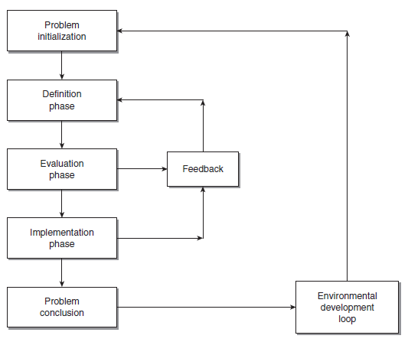
Figure 01: Intervention Strategy Model for The Yorkshire Soap Company (Paton and Mccalman, 2014).

Recruitment
For the shift to the online marketing environment, The Yorkshire Soap Company will need staff for online marketing activities. Typically, the company makes a competency assessment of the position and creates a list of requirements that the ideal employee would have. This is later used for the recruitment as a job list or post. However, the company does not have such a position yet, and cannot identify the specific requirements for the position. This can be solved by looking in competitors who have used online marketing before and assess their position holding employees to understand what skills and experience are needed (Putzier and Baker, 2016). The competency assessment will provide insight that can be used to create a job listing or post. However, the recruitment of such positions ideally should be through channels and methods that test the capability of the candidates. The job would require marketing on social media, YouTube, connecting with influencers, personalities, knowledge of PPC, lead collection and understanding of big data. The staff would be divided for each of these functions, and as such the recruitment should also be fractioned accordingly. Modern and alternate methods such as ATS analysis, job auditions, social media hiring combined with inbound recruitment and moving employees can fill these positions. The company can automate the candidate search process, test the competency, or outright use the latent skills of an employees in this way.

Learning and Development
The Yorkshire Soap Company will also need to train the existing staff and the new. The existing workforce will have to be trained to develop the skill needed for mass online retail and marketing. While the new staff must be acclimated to the workforce environment and people, which will require orientation and on-boarding. The company can provide in-house training using the newly recruited and experienced staff, who can transfer their skills to the others. However, this would not result in rapid transition, nor would the new staff be acquainted enough. Thus, the company will need to provide external training for a select number of employees, who have zeal and commitment to absorb information faster, along with the new staff (Putzier and Baker, 2016). This will help achieve both ends, and the cost of training can be reduced by having the skilled old employees teach the rest of the workforce as they operate. The workplace will be then immediate active and operable after a short delay and see a steady rise in performance.

How the chosen strategies will make team members valued, appreciated, and develop a sense of belonging to the organization
Change management, recruitment, learning, and development are all part of an important function of HRM. All three are component of the HRM talent management strategy, and these three achieve workforce engagement. Change management can provide the necessary stimulation and challenge for the employees to feel active. Change eradicates repetition, and this is a key factor that induces boredom in employees. With change, employees are forced to perform at their best, to think creatively, and contribute. This provides the shift that the employees need to grow and be engaged. Furthermore, the ISM feedback and environmental development loops need careful monitoring to collect data. The company will have to collect the data from the input of the employees, who do not feel reified. Their opinions are collected, and changes are made accordingly (Becker, Huselid and Ulrich, 2011). For recruitment, the hiring specifications, and processes filter in the most suited employees for the positions. This provides the employees with a workplace that the find suitable, with stimulating work in the sectors that they appreciate. And finally, providing learning opportunities that mix the new and the old together allow the on-boarding process to somewhat auto-complete, with relations building swiftly. And as the trained staff teach the others, they find common ground to cooperate. The staff also appreciate the opportunity to learn, as it contributes to their personal and professional growth. Overall, the staff feel valued appreciated and become loyal as they are engaged, experience a good atmosphere and growth.

The principles, models and concepts of current HRM and IHRM theories
HRM practices are the strategic approach which refers to the efficient and effective management of the employees of an organization so that they can maximize organization and employees performance and achieve organizational objectives (Paauwe, 2013). The principles, models and concepts of current HRM theories are given below:
The Harvard Model: This model was developed by Michael Beer in 1984 at Harvard University with the help of several other experts. This model includes some factors such as HRM policies, stakeholder’s interest, situational factors, HRM outcomes etc. This model suggests that there is a significant relationship between stakeholder’s interests and situational factors and these factors affect the HR policies and the HR outcomes are a result of these policies (De Cieri and Kramar et al, 2008). The stakeholders include employees, management, government, shareholders etc. And the situational factors include characteristics of unions, workforce etc. These factors and stakeholders have an impact on the HR practices such as recruitment, training, reward systems. If the HRM policies are done well then it shows positive outcome which is competence, commitments, and cost effectiveness and employee retention. If the organization has a positive outcome, then it can affect societal, individual and organizational effectiveness.
The 5P’s model: This model suggests purpose, principals, people, performance, and processes must be balanced to achieve success. This model defines the purpose as the primary objectives, mission, and vision of the organization. Principals define as the operating protocols of the organization which they use as the lead to achieve its objectives and purpose (Gartner, 2018). Process of 5P’s model includes methods of the operations, systems, architecture etc. Propel refers to the resources and employees who mainly perform tasks by following the processes and principles. The result of all these steps above is the performance which can be measured through appropriate standards. This model suggests that the performance of the organization depends on the performance of the employees and other staff who directly works for the organization by following the principles and purposes of the organization.
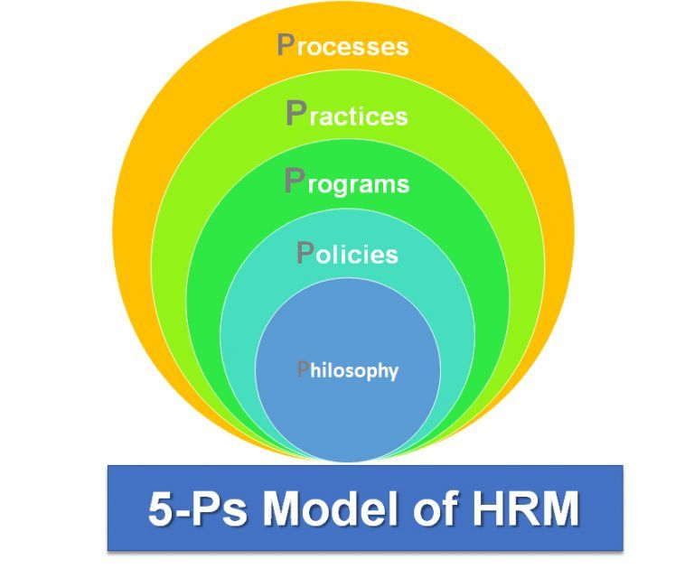
Figure 2: 5P’s model of HRM (Paauwe, 2013)
The guest model: According to this model, the HR manager should adopt many strategies to get good outcomes and this outcome includes financial rewards, behavioural and performance-related rewards etc. This model includes six components which are HR practices, HR strategy, HR outcomes, behavioural outcomes, financial consequences, and performance results. From the discussion, this can be identified that employee performance can shape the financial results, and employee performance depends on the employee behaviours. Employee behaviours depend on employee quality, commitment, flexibility and these factors are the results of the HR practices. HR practices depend on the HR strategies or the organizational strategies. So it is clear that the Guest model is superior to the other models as it clearly shows the input and outcomes of HRM (De Cieri and Kramar, 2008).
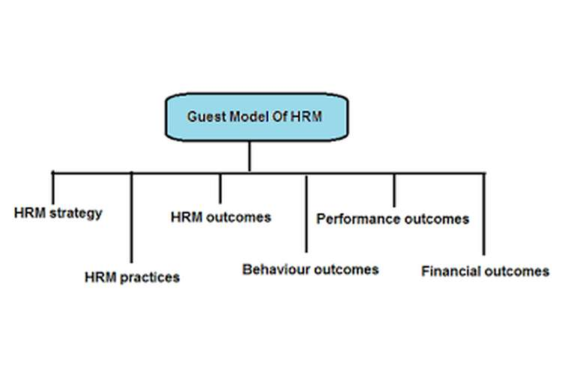
Figure 3: Guest model of HRM (Paauwe, 2013)

Conclusion
Human Resource team needs to adopt different strategies so that they can easily manage the employees and workforce. Through these strategies the HR team can make the employees effective, efficient and motivate them. Such as the change management model is a strategy which helps the employees to adopt the changes easily and efficiently. There are other strategies which helps the HR team to ensure employees retention, employee satisfaction, loyalty, and commitment.

References
Becker, B.E., Huselid, M.A. and Ulrich, D. (2011). The HR Scorecard: Linking people, strategy, and Performance. 11th ed. Boston: Harvard Business School Press.
Booth, W.L. and Doyle, M.P. (2011). Our Story | The Yorkshire Soap Company. [online] yorkshiresoap.co.uk. Available at: https://yorkshiresoap.co.uk/our-story [Accessed 22 Aug. 2021].
De Cieri and Kramar, 2008, Human Resource Management in Australia, McGraw-Hill
Dessler, G. (2020). Human Resource Management. 20th ed. London: Harlow, England Pearson.
Gartner. (2018). Change Management. Retrieved from https://www.gartner.com/en/insights/change-management
GOV.UK (2020). Prime Minister’s statement on coronavirus (COVID-19): 16 March 2020. [online] GOV.UK. Available at: https://www.gov.uk/government/speeches/pm-statement-on-coronavirus-16-march-2020 [Accessed 22 Aug. 2021].
Gov.uk (2021). Shops, branches, and Close Contact Services - Working Safely during Coronavirus (COVID-19) - Guidance - GOV.UK. [online] www.gov.uk. Available at: https://www.gov.uk/guidance/working-safely-during-covid-19/shops-branches-and-close-contact-services [Accessed 22 Aug. 2021].
McKinsey & Company (2020). Consumer Sentiment in the UK during the Coronavirus Crisis | McKinsey. [online] www.mckinsey.com. Available at: https://www.mckinsey.com/business-functions/marketing-and-sales/our-insights/survey-uk-consumer-sentiment-during-the-coronavirus-crisis [Accessed 22 Aug. 2021].
Paauwe, J., Guest, D. and Wright, P., 2013. HRM and performance. Chichester, West Sussex: Wiley.
Paton, R.A. and Mccalman, J. (2014). Change Management: A Guide to Effective Implementation. 6th ed. London: Sage.
Putzier, J. and Baker, D.J. (2016). The Everything HR Kit: A Complete Guide to attracting, Retaining & Motivating high-performance Employees. 6th ed. New York: American Management Association.
Trading Economics (2019). United Kingdom Consumer Spending. [online] Tradingeconomics.com. Available at: https://tradingeconomics.com/united-kingdom/consumer-spending [Accessed 22 Aug. 2021].
UK Companies House (2010). YORKSHIRE SOAP COMPANY LTD - Overview. [online] find-and-update.company-information.service.gov.uk. Available at: https://find-and-update.company-information.service.gov.uk/company/07137624 [Accessed 22 Aug. 2021].

