ACDC5009 – Electromagnetic Radiation
Analysis of Electromagnetic Wave Propagation
Using computational simulation software to create a rectangular waveguide and half-wave dipole antenna, and modelling and predicting the properties of both against theoretical expectations.
Shaun Malone (2030723)
April 2025

Contents
Abstract 1
Introduction and Background 2
Electromagnetic Waveguides 2
Dipole Antennae 3
Method 4
Rectangular Waveguide 4
Half-Wave Dipole Antenna 4
Results 6
Rectangular Waveguide 6
Vacuum Core 6
Teflon Core 8
Half-Wave Dipole Antenna 9
Discussion 10
Rectangular Waveguides 10
Half-Wave Dipole Antenna 11
Conclusions 11
References 12
Appendix 13
Rectangular Waveguide Magnitude and Vector Fields 13
Vacuum Core 13
Teflon Core 13

Abstract
The purpose of this report aimed to use computational software to predict the key properties of fundamental components of modern communication systems, and then used known theoretical formulae to compare the modelled data with the expected results according to existing theory. This involved using a package called ANSYS Electronics to produce two rectangular electromagnetic waveguides of different materials, as well as a half-wave dipole antenna, and passing signals through them to find key properties. For the waveguides, the transverse modes of the system were modelled, as well as the cut-off frequencies. For the antenna, the operating frequency and radiation pattern were found.
Across the simulations, results were obtained to a good degree of accuracy, but often did not achieve a 100% match with theoretical expectations, for a variety of reasons not limited to the accounting of real-world occurrences that theory can often overlook, slight differences in listed material properties compared with theory and conditions given during set-up that may alter the simulation from the real world in order for the program to run.
In all, modelling components using computational software has obvious benefits due to its good degree of accuracy, such as avoiding the need to manufacture prototypes for new systems.

Introduction and Background

Electromagnetic Waveguides
Electromagnetic waveguides are defined as a ‘special category of transmission line’ [1]. Their purpose is to guide electromagnetic waves efficiently along their length. Using waveguides in communication systems helps to prevent signal losses by directing waves along a given length over which losses can be minimised by the make-up of the guide. They can be metallic, which can be broken down further in to rectangular, circular or elliptical; or dielectric – such as optical fibres.
Rectangular waveguides consist of a single core of a given refractive index, often but not always hollow, surrounded by a metallic cladding of a different refractive index. In these systems, signals are transmitted along the guides through the principle of total internal reflection. Rectangular waveguides are high-pass filters, which means that signals must be of a minimum frequency in order to propagate successfully through the waveguide without being refracted out to the cladding. The minimum frequency at which a signal can propagate through any given waveguide is called the cut-off frequency and is given by the formula
$$\frac{c}{2}\left(\sqrt{{\left(\frac{m}{a}\right)}^{2}+{\left(\frac{n}{b}\right)}^{2}}\right)$$
Equation 1: Formula for the cut-off frequency of an electromagnetic waveguide
Where:
- c = velocity of light in the given medium. In a vacuum this would be 3x10⁸m/s.
- m = number of observed half-wavelengths in the guide’s horizontal direction
- n = number of observed half-wavelengths in the guide’s vertical direction
- a = width of the waveguide
- b = height of the waveguide³
The values of m and n relate to the ‘transverse modes’ that can be supported by the waveguide. Rectangular waveguides can support both transverse electric (TE) and transverse magnetic (TM) modes.
Figure 1 shows how the values for ‘a’ and ‘b’ relate to the dimensions of the guide.
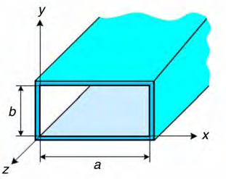
Figure 1: Generic dimensions of a rectangular metal waveguide [2].
TE modes refer to propagation in which the electric field acts transverse to the direction of propagation, but the magnetic field acts in the direction of propagation. TM modes are precisely the opposite. The modes supported by the waveguide are denoted as TX_{mn}, where X can either be E or M, and m and n are the same as in the formula above. The dominant mode of a given electromagnetic waveguide is the mode which accepts the lowest cut-off frequency.

Dipole Antennae
Antennae play a crucial role in communication, acting as the transmitters and receivers of electromagnetic signals, converting signal between electric current and electromagnetic radiation. A single antenna is capable of both transmission and receipt if correctly set-up within a communications system.
Correct antenna design is crucial to achieve the desired outcomes from it and maximise the power of a transmission.
There are several types of antenna, one of the simplest being a half-wave dipole antenna, which consists of a single piece of conductive wire attached to the wider system at its centre. The antenna is named by the fact that the length of the antenna is half of the operational wavelength of the signal, such that
$$L=\frac{λ}{2}$$
Equation 2: Formula for calculating the length of a half-wave dipole antenna.
The operating frequency of the antenna is given by the universal relationship between velocity, frequency and wavelength, such that the frequency, f, is given as
$$f= \frac{c}{λ}$$
Equation 3: Relationship between operating frequency, wavelength and velocity.
Dipole antennae produce distinctive, doughnut-like, radiation patterns, similar to Figure 2, where radiation is omnidirectional except along the axis of the antenna itself, where there is no radiation [3].
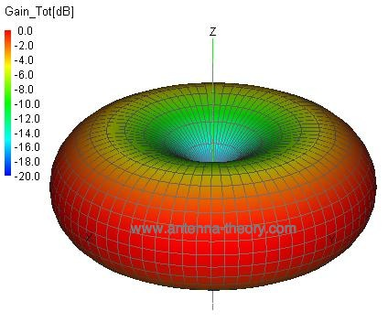
Figure 2: Radiation pattern of a 1-wavelength dipole antenna. The radiation pattern for a half-wave antenna is very similar, with an even smaller null area. [3]

Half-wave dipole antenna are useful because at this particular length there is good impedance matching, where the impedance of the signal input is close to typical impedances of communications systems [4]. This, combined with their multi-axis directionality, makes them useful for applications such as FM radio, where there is a need to transmit a signal outwards in multiple directions from the source with minimised signal losses.

Method

Rectangular Waveguide
For the creation of the rectangular waveguide, the software package ANSYS Electronics. In line with the brief and tutorial provided [5] [6], a rectangular waveguide with perfectly electrically conducting walls and a vacuum core was designed in the software. The values of ‘a’ and ‘b’, as visualised in Figure 1, in mm as per [5], related to the student ID 2030723, where ‘a’ was the first two digits of the number, 20mm, and ‘b’ was equal to half of the third and fourth digits, 15mm. The wavelength was given a standard length of 50mm.
The simulation was set up to run a frequency sweep between 2GHz and 30GHz, which would produce a series of results including a port field display, determining the modes being supported by the waveguide, the cut-off frequencies for each mode, as well as producing a visual representation of the magnitude and vector fields across the guide for all modes.
Once this simulation was complete, then the same process was repeated in line with [6], but instead using a core of Teflon, which, with its different refractive index from vacuum, should produce an entirely different set of results.

Half-Wave Dipole Antenna
In order to create and simulate the operation of a half-wave dipole antenna, the same software was used and, following the brief and tutorial provided [5] [7], a half-wave dipole antenna with a perfectly electrically conducting wire was designed in the software, as shown in Figure 3.
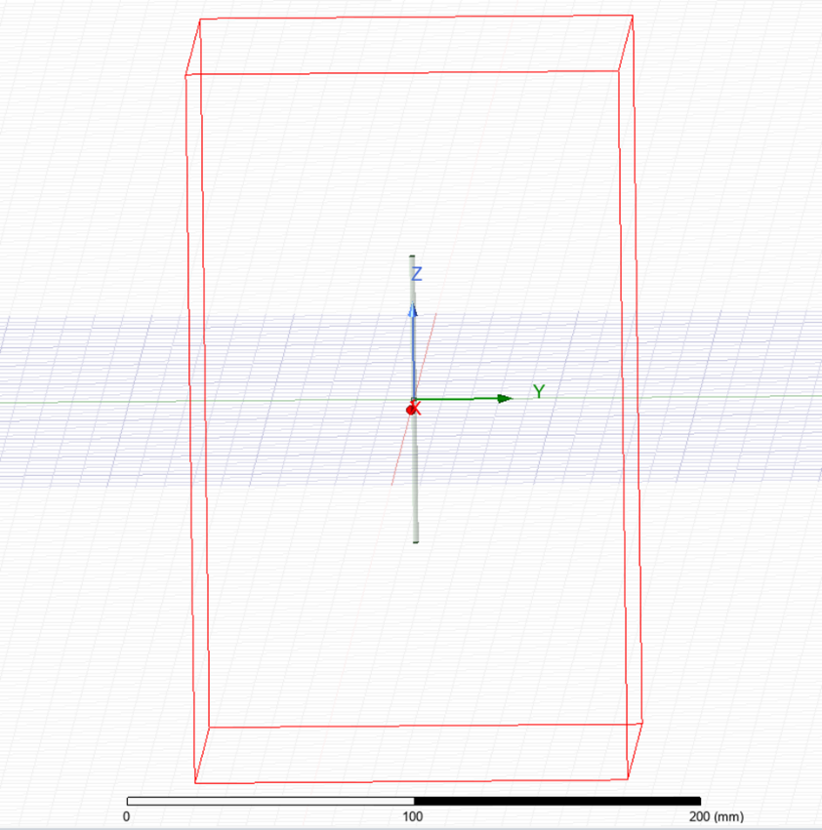
Figure 3: Design of half-wave dipole antenna in ANSYS Electronics.
As dictated in [5], the given operational wavelength of the antenna was to be related to the student number 2030723, such that λ = the first three digits of the ID, and therefore 203mm. The length of the antenna for the simulation was calculated using Equation 2.
The antenna was centred on the origin of the space so as to correctly take the lengths of each side of the antenna around the centre-point. There was a small gap at the centre to mimic the existence of the connection point to the communication system, and the cuboid drawn around the antenna represents the radiation space.
The simulation was run to produce a radiation pattern from the antenna, as well as to find the device’s operating frequency, to compare with theoretical data.

Results

Rectangular Waveguide

Vacuum Core
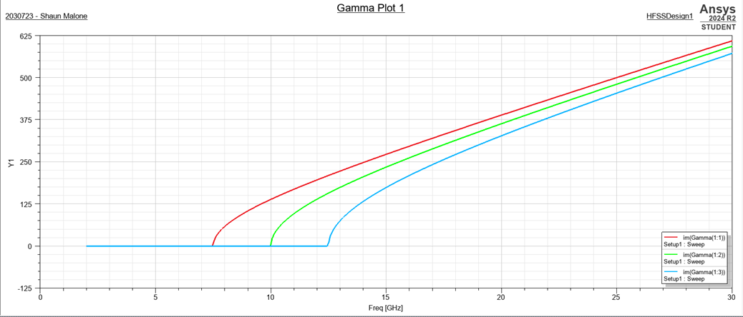
Figure 4: Graph plotting the frequencies in the waveguide. The value along the x-axis where the curve begins is the 'cut-off' frequency for the given mode.
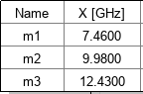
Table 1: Accompaniment to Figure 4 listing the experimental 'cut-off' frequencies for all supported modes.
Figure 4 and Table 1 show the produced data from the frequency sweep of the vacuum filled electromagnetic waveguide. It shows that three modes of propagation where supported within the waveguide, and lists their cut-off frequencies.
In order to determine the relevance or accuracy (or lack of) of the numbers, there was a requirement to understand what precise modes of propagation had been supported by the waveguide.
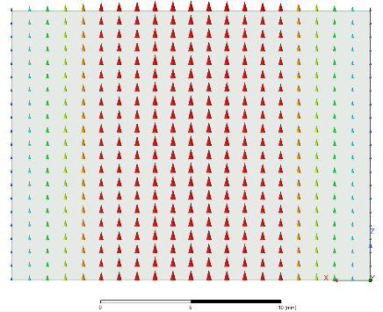  Figure 5: Port field display of mode 1. | 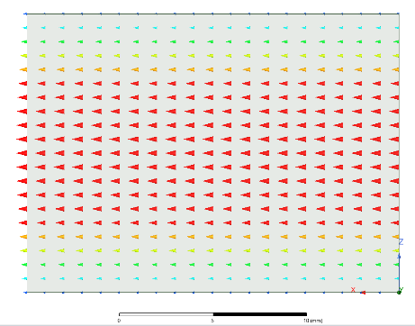  Figure 6: Port field display of mode 2. | 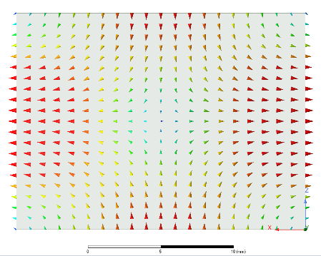  Figure 7: Port field display of mode 3.
Table 2: 'Port field display' for modes 1, 2 and 3, showing a simple visualised view of the direction and magnitudes of the waves throughout the cross-section at the entry port. Enlarged versions are viewable in the appendix.
In order to do this, ‘port field displays’ were generated at both ends of the waveguide. Table 2, showing Figures 5, 6 & 7, displays these views for all three modes.
To determine what types of transverse mode were propagating through the system, the port field displays were compared to existing technical reports to identify similarities. Figure 8 shows the typical visual appearance of a TE and TM mode side by side.
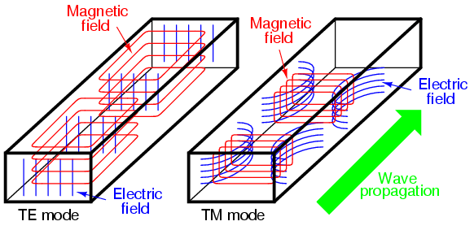
Figure 8: Existing technical report diagram comparing the visual display of a typical TE and TM mode. [8]
On comparison with the produced field displays from the waveguide simulation, it was deduced that modes 1 and 2 are transverse electric modes and mode 3 is a transverse magnetic mode.
Next, the number of half-wavelengths in the horizontal, m, direction, and vertical, n, direction were deduced to confirm the three operational modes within the waveguide.
- For mode 1, m = 1 and n = 0. Mode was determined to be TE₁₀
- For mode 2, m = 0 and n = 1. Mode was determined to be TE₀₁
- For mode 3, m = 1 and n = 1. Mode was determined to be TM₁₁
Using these values for m and n, as well as the known values for a, b and c, the theoretical cut-off frequencies for each mode could be calculated using Equation 1. This gave theoretical cut-off frequencies for all three modes:
- For mode 1, f = 7.5GHz
- For mode 2, f = 10GHz
- For mode 3, f = 12.5GHz
TE₁₀ was found to be the guide’s dominant mode.
As well as capturing the field display just at the port, full views of the electric and magnetic fields, both magnitude and vector, were captured by the software, and are displayed in full in the appendix for reference.

Teflon Core
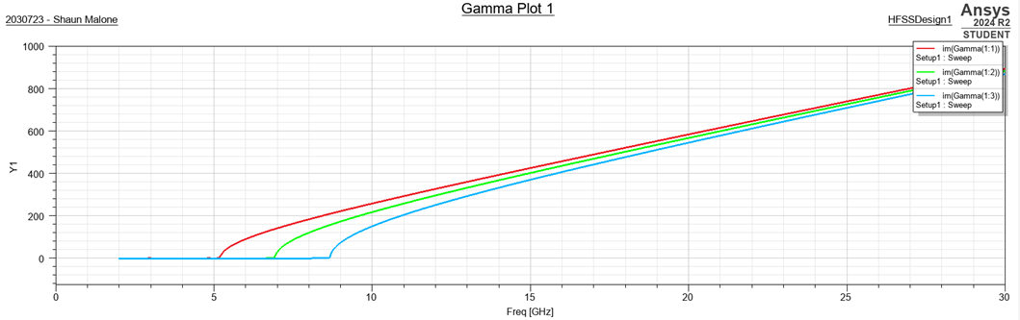
Figure 9: Graph plotting the frequencies in the waveguide. The value along the x-axis where the curve begins is the 'cut-off' frequency for the given mode.
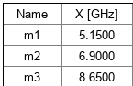
Table 3: Accompaniment to Figure 9 listing the experimental 'cut-off' frequencies for all supported modes.
Figure 9 and Table 3 show the produced data from the frequency sweep of the Teflon filled electromagnetic waveguide. Again, the plot shows that three modes of propagation were supported within the waveguide, and lists their cut-off frequencies, which are noticeably lower in this case than with the vacuum core.
Once again, the port field displays were loaded to determine the modes propagating throughout the waveguide.
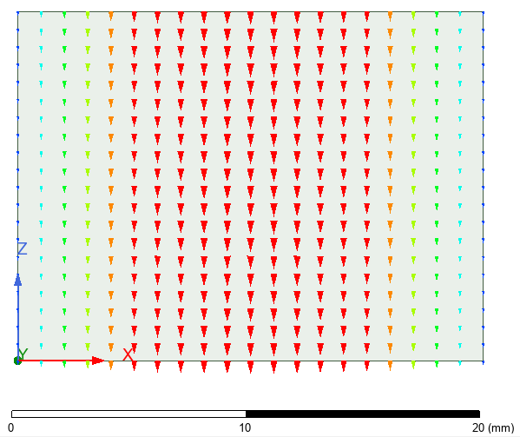  Figure 10: Port field display for mode 1. | 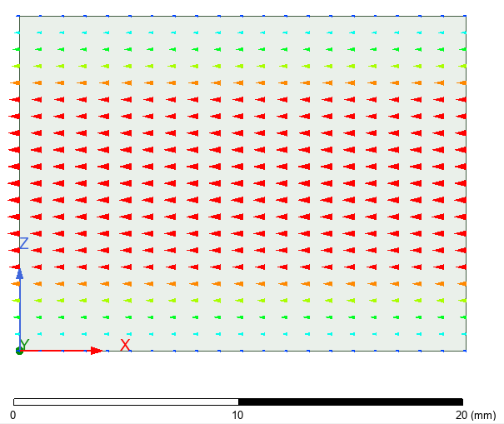  Figure 11: Port field display for mode 2. | 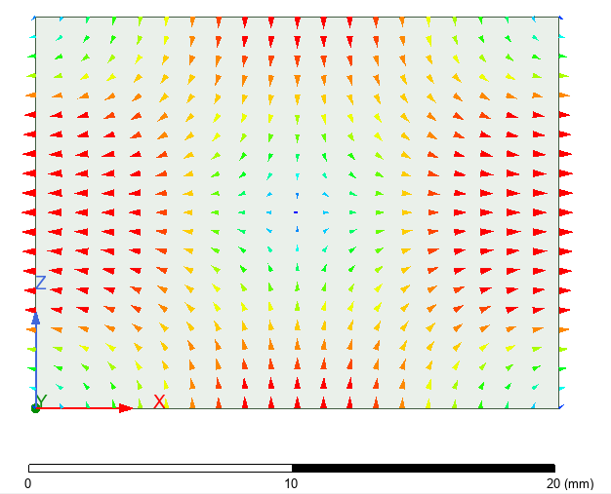  Figure 12: Port field display from mode 3.
Table 4: 'Port field display' for modes 1, 2 and 3, showing a simple visualised view of the direction and magnitudes of the waves throughout the cross-section at the entry port. Enlarged versions are viewable in the appendix
Figures 10, 11 and 12 within Table 4 show minimised versions of the port field displays. On comparison with Figure 8, and once again counting half-wavelengths in the m and n directions, the three modes could be determined. Modes 1 and 2 were once again TE modes, and mode 3 was once again a TM mode.
- For mode 1, m = 1 and n = 0. Mode was determined to be TE₁₀
- For mode 2, m = 0 and n = 1. Mode was determined to be TE₀₁
- For mode 3, m = 1 and n = 1. Mode was determined to be TM₁₁
As the core is not filled with a vacuum, c will not be the regular value of 3x10⁸m/s. To calculate cut-off frequencies, the new value of c needed to be established.
Equation 4 builds on the fact that the ratio between velocity in any medium and a vacuum is governed by the ratio of their permeability and permittivity. The relative permeability and permittivity in a vacuum is 1, and in Teflon the relative permeability and permittivity of Teflon are 2.1 and 1 respectively.
$$\frac{v}{c}=\frac{1}{\sqrt{μ_{r}ε_{r}}}$$
Equation 4: Ratio of velocity of EM radiation in any medium relative to a vacuum.
Using Equation 4 gives it that velocity is equal to$\frac{c}{1.45}$, or 2.069x10⁸m/s, to three decimal places.
With a new value for c, and knowing all other values, Equation 1 was used once again to calculate theoretical cut-off frequency.
- For mode 1, f = 5.175GHz
- For mode 2, f = 6.9GHz
- For mode 3, f = 8.625GHz
TE₁₀ was found to be the guide’s dominant mode.
As well as capturing the field display just at the port, full views of the electric and magnetic fields, both magnitude and vector, were captured by the software, and are displayed in full in the appendix for reference.

Half-Wave Dipole Antenna
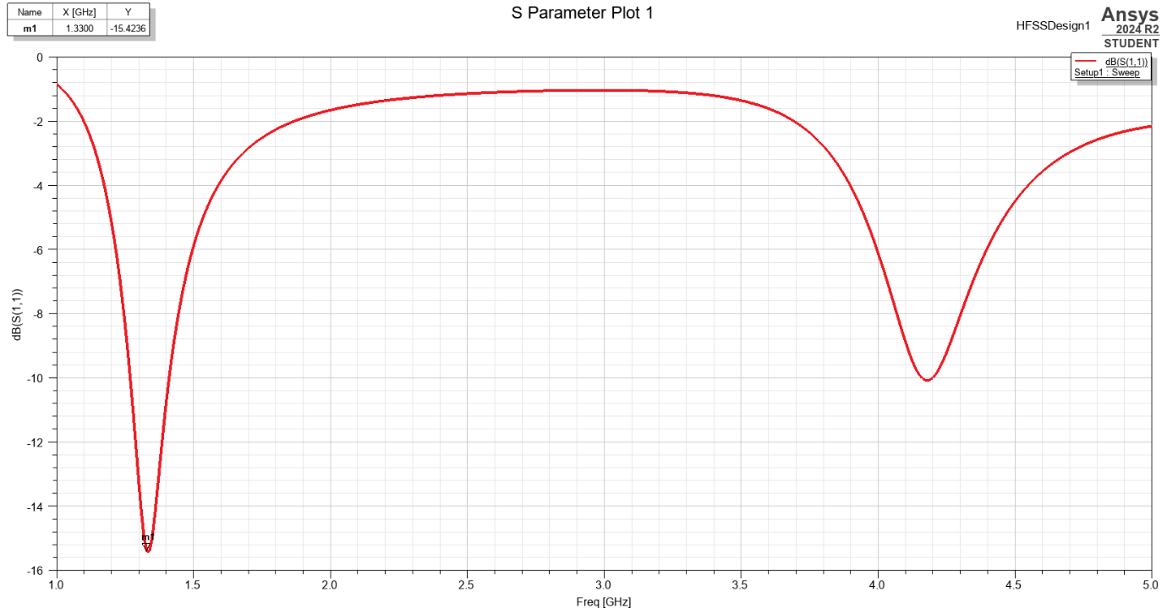
Figure 13: S-Plot graph for a half-wave dipole antenna. The first minimum of the graph represents the value of operating frequency.
Table 5: Table showing the experimental value of the operating frequency of the dipole antenna.
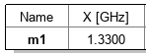
Figure 13 and Table 5 show the experimental value of the operating frequency of the constructed half-wave dipole antenna, given to be 1.33GHz.
Using the relationship described in Equation 3, the theoretical value for the operating frequency can be established, noting again that the operating wavelength of the dipole is 203mm as per the method, and that velocity, c, is 3x10⁸ms⁻¹. Using equation 3 gives a theoretical result for the operating frequency of 1.48GHz (to two decimal places).
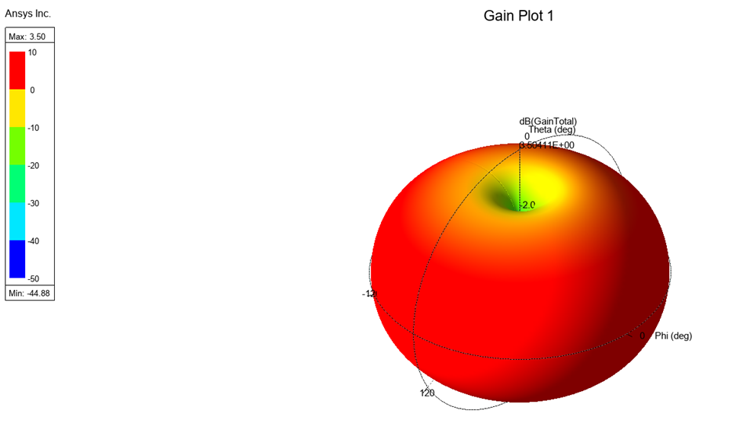
Figure 14: Gain plot demonstrating the radiation pattern of the half-wave dipole antenna.
Figure 14 shows the gathered radiation pattern for the antenna. It shows a multi-directional pattern, radiating in all directions except for that which is along the axis of the antenna itself.

Discussion

Rectangular Waveguides
The results gathered from the rectangular waveguide simulations, relating to the operating frequencies of the three modes within the system, both for the vacuum and the Teflon core waveguides, back-up the existing theory regarding rectangular waveguides. The results for the experimental and theoretical values are almost identical, and any small differences can be easily explained by number rounding taking place during theoretical calculations compared to the simulation. The results go a long way to verifying the existing theory relating to waveguides, how they work and how they can be useful in communication systems.
The results suggest a correct and proper set-up of the model in the system, and highlight the potential for carrying out computational simulation experiments in the digital space where there is opportunity to save time and cost relative to physical experiments and designing and manufacturing prototype waveguides to test.
It would be worth noting, however, that both situations imply perfect materials that obey expected data completely at all times. This is rarely the reality in the real world of manufacture and engineering, where natural resistance and imperfection exists that will alter results to a varying degree depending on the care taken not to introduce them.

Half-Wave Dipole Antenna
In the instance of the half-wave dipole antenna, there was more variance between the expected and obtained result, in respect of the operating frequency. There was a difference of 0.15GHz between the two values, which is not a negligible shift. This is not a discrepancy whose cause can easily be identified. A check of the set-up of the system confirmed that the method had been followed as set-out, and so the causes for such variation are open to discussion. Rounding differences may have led to a small discrepancy, as with the rectangular waveguide results, but a difference of several thousand Hertz cannot be so easily explained.
Possible reasons for the difference stem from the mesh space of the simulation, how the system reads and calculates a mesh, and then the mathematical methods it uses to simulate results across said mesh. It is possible that fine-tuning this mesh and associated calculations carried out across the mesh would yield results closer to the theory, and should be considered for future iterations of the experiment.
One area where existing theory was categorically validated by simulations was in the gain plot. The gain plot obtained for Figure 15 was a very familiar shape, the expected ‘doughnut’ shape of a dipole antenna, where radiation is almost omni-directional, except for along the axis of the antenna itself, where there is no radiation.
The results suggest some tangibility to existing theory, as the two values are not miles apart, and the radiation pattern matched expected results, but do not go the whole way to validating the theory owing to the differences in operating frequency. They serve as a reminder that computational results are only as accurate as the means by which they calculate, and that paying attention to meshing and other properties of the simulation can play a big part in how accurate or truly reflective the obtained results are.

Conclusions
This report aimed to use analytical computer software to create simulated rectangular waveguides and a half-wave dipole antenna, comparing the results with existing theoretical expectations. In the main, the results gathered accurately reflected the existing theory surrounding the subject, particularly in the case of the rectangular waveguides, where the experimental and theoretical results for cut-off frequencies were a near-perfect match. These results validate the use of computational software to conduct experiments that would otherwise require the manufacture of prototypes for evaluation.
There were observed differences, although not huge, between the experimental and theoretical operating frequencies in the half-wave dipole antenna, and this could be because of the way in which the software breaks a large shape down in to a series of smaller shapes in a mesh and does discrete calculations on each, a reminder that small changes to meshes in these sorts of experiments can have notable impacts on results. The gain pattern established by the antenna did however match the expected pattern and shape.
It would be a possible scope for future experiments to work with manually refining the system’s mesh to see if this did bring results closer to the theoretical value.
Word Count: 2699

References

[1] | Y. Roshni, “Waveguides,” Electronics Desk, 2025. [Online]. Available: www.electronicsdesk.com/waveguides. [Accessed 4 April 2025].
[2] | D. Arumugam and D. Engels, “Characterisation of RF propagation in rectangular metal pipes for passive RFID systems,” International Journal of Radio Frequency Identification Technology and Applications, vol. I, no. 4, pp. 345-362, 2007.
[3] | antenna-theory.com, “Dipole Antenna,” Antenna Theory, 2009. [Online]. Available: https://www.antenna-theory.com/antennas/dipole.php. [Accessed 4 April 2025].
[4] | S. V. Prof. Hum, “Half-Wave Dipole,” University of Toronto, [Online]. Available: https://www.waves.utoronto.ca/prof/svhum/ece422/notes/07-halfwave.pdf. [Accessed 4 April 2025].
[5] | S. Dr. Jacob, “ACDC5009 Assignment Brief,” 2025. [Online]. Available: https://moodle.uwtsd.ac.uk/mod/resource/view.php?id=591847. [Accessed 4 April 2025].
[6] | S. Dr. Jacob, “Steps to design rectangle wavguide using HFSS,” 2025. [Online]. Available: https://moodle.uwtsd.ac.uk/mod/resource/view.php?id=591939. [Accessed 19-20 March 2025].
[7] | S. Dr. Jacob, “Steps to design antenna in HFSS,” 2025. [Online]. Available: https://moodle.uwtsd.ac.uk/mod/resource/view.php?id=591938. [Accessed 12-13 March 2025].
[8] | A.-A. Khalid and N. Fawaz, “Zinc Sulfide Waveguide Analysis,” Universal Journal of Electrical and Electronic Engineering, vol. VII, no. 4, pp. 227-233, 2020.
[9] | V. Sudarsan, “Relation of Structure to Electrical and Optical Properties,” in Functional Materials, Mumbai, Elsevier, 2012, pp. 285-322.
[10] | E. Gregersen, “Total Internal Reflection,” Encyclopedia Britannica, 21 February 2025. [Online]. Available: https://www.britannica.com/science/total-internal-reflection. [Accessed 4 April 2025].

Appendix

Rectangular Waveguide Magnitude and Vector Fields

Vacuum Core
 | Scalar Electric Field | Vector Electric Field | Scalar Magnetic Field | Vector Magnetic Field
m1 | 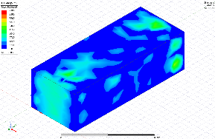 | 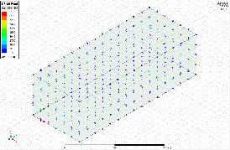 | 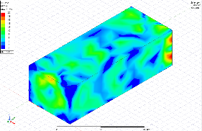 | 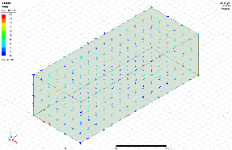
m2 | 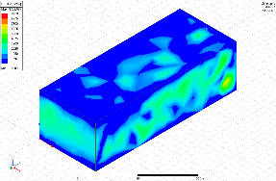 | 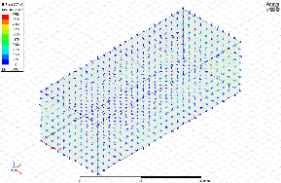 | 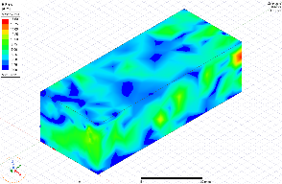 | 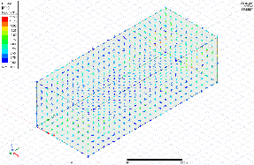
m3 | 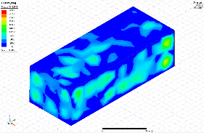 | 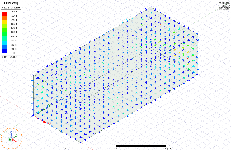 | 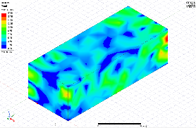 | 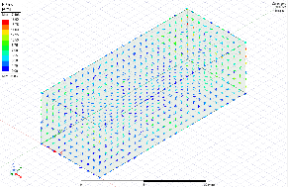

Teflon Core
 | Scalar Electric Field | Vector Electric Field | Scalar Magnetic Field | Vector Magnetic Field
m1 | 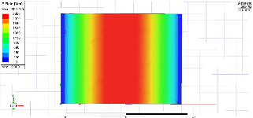 | 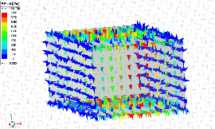 | 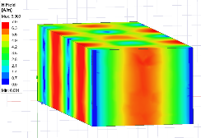 | 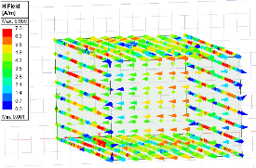
m2 | 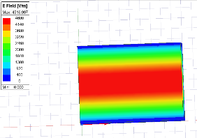 | 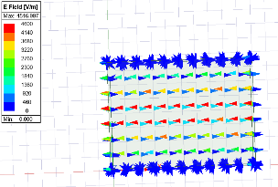 | 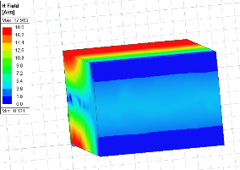 | 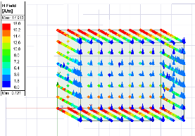
m3 | 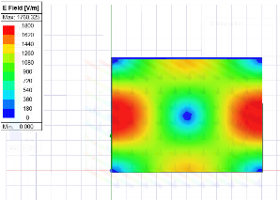 | 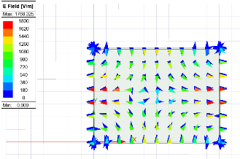 | 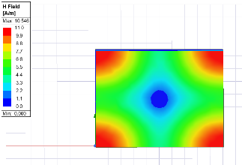 | 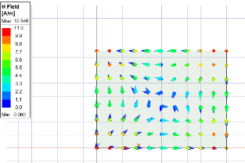

The refractive index, n, of a material is defined as the ratio of the velocity of light in a vacuum relative to the velocity of light passing through that material [9]
Total internal reflection is the complete reflection of a ray of light within a medium such as water or glass from the surrounding surfaces back into the medium. [10]
For rectangular waveguides, a > b.

