Student Name: Ben Rowden
P Number: P124911
BA Course Title: Graphic Design
Word Count: 1911
Tutor: Sarah Tombs and Louise Burston

Module: M5X01599

Within a given time period, select examples of what could be considered high and low cultural artefacts. Discuss these, taking into consideration the surrounding social, political and historical context.

The 60s was an interesting time in the art community. Self-expression became more acceptable among the adolescent population, and there was a chance for something new to be created, without having to abide by the “rules” set by ‘Abstract Expressionism’, and what was expected by society or deemed acceptable as a worthy piece of art.
“This new art was not held back by the monklike asceticism, the purity of feeling so brilliantly presented by Newman and Rothko. It wasn’t fazed by pictures or Pollock and de Kooning, all densely packed and psychologically charged” (Madoff, 1997)

The reason this essay uses the 60s as an example to discuss low culture and high culture art, is because, from a personal viewpoint, the lines were blurred between high and low culture during this time. Artists such as Andy Warhol and Jim Dine were creating pieces inspired by mass society (bright coloured billboards, Brillo Boxes, everyday items, etc.), but at a standard that was considered high culture. On the other end of the spectrum, artists such and Carl André were focussing on Minimalism, using raw materials to build installations, and how it was inspired from working industrial jobs.

The first piece that will be discussed, as an example of this distinction, is a work by Roy Lichtenstein titled ‘BLAM!’, and how it compares to Russ Heath’s original illustration:
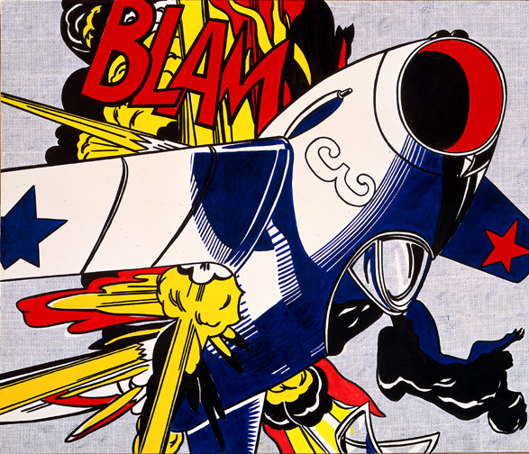
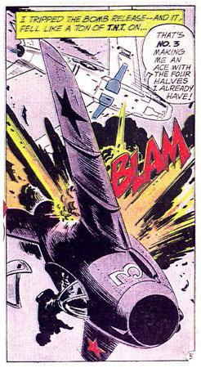
BLAM! – Roy Lichtenstein All-American Men of War – Russ Heath

Based on the comic book All-American Men of War (issue #89), Lichtenstein used the Ben-Day dot technique (which he often used in many of his other works), which was popular among comic books of the era, “In the four process colours (cyan, magenta, yellow and black) to inexpensively create shading and secondary colours such as green, purple, orange and flesh tones.” (Downthetubesnet, 2016).

‘Blam!’ represents the time period in which it was created; the end of the war, the time of peace, and using bright ‘jazzy’ colours that represent the ideals of the ‘American Dream’. It’s an interesting depiction of what came just before (being the second world war) and what was currently happening in the art world at the time (bright colours, interesting shapes). Although it’s based on low culture media (comic books being for the masses) ‘Blam!’ is a standalone piece, created with great skill, and beautifully represents the time in which it was created. Lichtenstein stated, “I'm not interested in the subject matter to try to teach society anything, or to try to better our world in any way.” (Aaronsartprints, 2018), however, it’s not necessarily devoid of meaning, as it’s taken an image that is based on pre-Popart style, and portrayed as a contemporary art style, which in itself would be a ‘sign of the times’ and how even the war can be mass produced and saturated to lose meaning. This sort of insight is evidence of how both Lichtenstein and Heath’s pieces can be separated into both high and low culture statuses. In conclusion, ‘Blam!’ would technically fall into the category of high cultured art.

“Pop is everything art hasn’t been for the last two decades. It’s basically a U-turn back to a representational visual communication, moving at a break-away speed…Pop is a re-enlistment in the world…It is the American Dream, optimistic, generous and naïve.” – Robert Indiana (Wordpress, 2013)

Most art created in the 60s may be considered contradictory, as pop culture (pop art) literally means low culture, yet much of it, is appreciated as high culture. This is due to its potential subtle undertones, and the level of grace in which it was crafted allows it to be appreciated in galleries, and by educated art critics. It truly pushes the boundaries of distinguishing the difference between high and low culture, and Lichtenstein’s work is a brilliant example of this.

‘Because the result was so dry and ‘unemotional’, it was possible to believe that there had been no interpretation at all. His paintings look, at first glance, as mechanically fashioned as their source material…’ (Archer, 2002)

Using someone else’s work, and recreating with your own name attached to it, would be considered controversial to many people. Especially considering the raw emotion and originality of art that came prior to the 60s, such as Cubism and Abstract Expressionism. Even Dadaism, with its nihilistic approach to the art scene and a protest towards the first world war. There was so much meaning behind most famous pieces, it’s easy to disregard ‘Pop Art’ as being on the same level as artists such as Jackson Pollock and Pablo Picasso. However, the art that was being created in the late 50s and 60s was relevant to the mass society, which also symbolised an anti-establishment protest, ‘British Pop artists adopted a similar visual technique (Dada) but focused their attention on the mass imagery of popular culture which they waved as a challenge in the face of the establishment.’ (Mactagart, 2018).

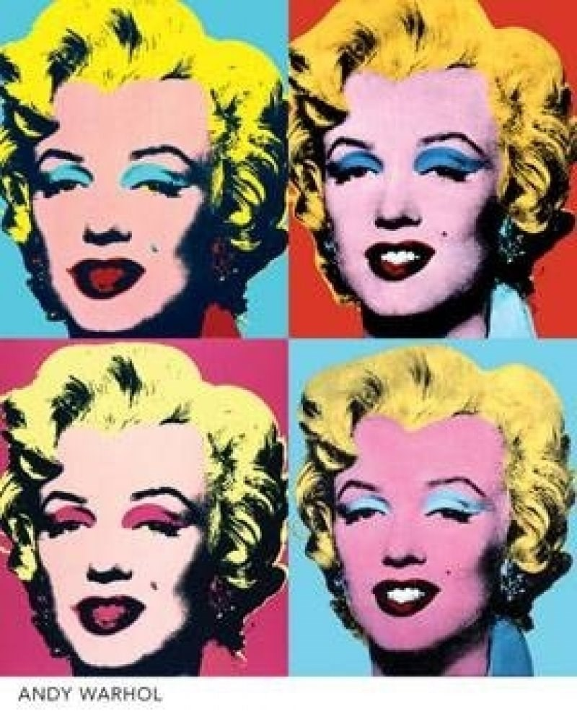
Marilyn Monroe (1962) – Andy Warhol

Andy Warhol’s print of Marilyn Monroe can be viewed as ironic when distinguishing between high and low culture. It’s message of taking a pop icon, and rendering her as a product, is in itself a symbol of pop culture. The image was taken from a publicity still of Monroe for the Film ‘Niagara’ (1953), and was originally screen printed using bright colours on a golden canvas as a tribute to her untimely passing in 1962. It was then repeated a number of times on a single canvas, sometimes using a variation of bright ‘tacky’ colours.

Warhol was famous for this style of art. It was similar to Abstract Expressionism, in the way that it would cover the canvas from corner to corner. However, Warhol focused on using repetition of motifs, such as; soup cans, coke bottles and, celebrity faces; which was a statement of desensitisation. In an interview, Warhol stated ‘It was Christmas or Labor Day – a holiday – and every time you turned on the radio they said something like, “4 million are going to die.” That started it. But when you see a gruesome picture over and over again, it doesn’t really have any effect’ (Archer, 2002).

This statement rings true for most of his work, whereas the more it’s repeated, the less meaning it holds, which is an example of the time. With television and billboards, the repetition of products were everywhere in the public’s daily lives. Warhol merely used this as inspiration, and to send a message to the masses. By fusing the high culture and popular culture into a single art form.

On the other end of the spectrum, during the same time, Minimalism was making its mark in the art community. ‘Think of “Minimalism” as a name not of an artistic but of a historical moment, a brief outbreak of critical thought and invention in the cavalcade of postwar American art.’

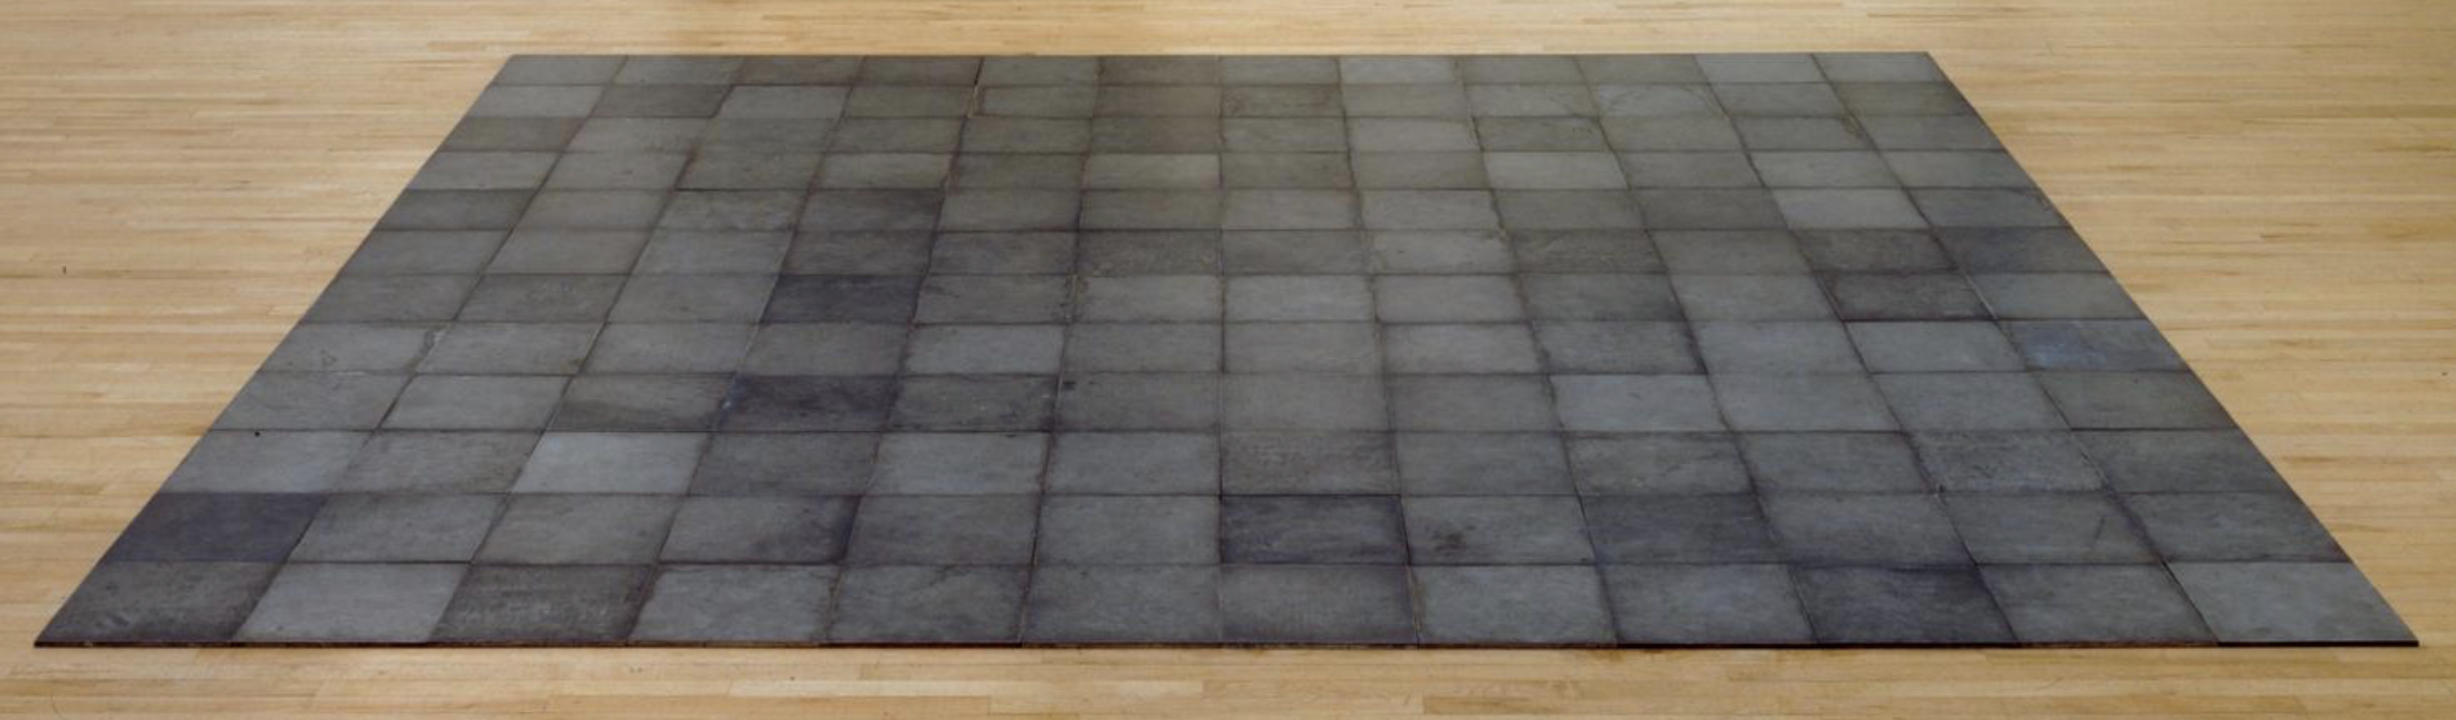
144 Magnesium Plates (1969) - Carl André

In 1957, the Soviet Union launched the first artificial satellite, Sputnik. As a result, an active interest was taken into Russian Constructivism. Its therefore plausible, and no coincidence, that artists in America would incorporate these methods into their own work, and combine it with ‘anti-establishment’ art (that would oppose Abstract Expressionism).

Carl André’s aptly named piece ‘144 Magnesium Plates’, consists of 144 12 inch plates of Magnesium, assembled into a square, then placed on the gallery floor. It is part of a series of other similar works, composed of other metals such as Zinc, Magnesium, Copper, Lead, Aluminium, ‘The materials used in the series are presented in their raw state, without physical alteration by the artist. Visitors are allowed to walk over this and the other sculptures in this series.’ (Tate, 2018). What’s interesting about this, is that we are now introduced to a traditional taboo style of displaying art, in the sense that it interacts with it’s surroundings, and breaks away from the use of a ‘base’:

“According to Jack Burnham, the base functions primarily to support, to distance and dignify, and to isolate the work above it. It physically elevates the sculpture, thereby severing the work of the art’s contact with the ground. Thus, sculpture becomes a thing apart, not sharing the Spector’s space but creating its own space, often delimited by the circumference of the plinth. The experience of sculpture which stands on the floor without the interference of a base is more direct and immediate.” (Colpitt 1990: 35)

It’s as if ‘Popart’ had now been taken a step further, by no longer turning to mass media for inspiration, but sourcing inspiration from a more ‘primitive’ and honest place. In turn, this can be reassuring for the audience, due to its calm aesthetic, which ironically, may have less of a nihilistic message towards the masses, and instead, offers a sense of experimentation. It can also be viewed as a statement of factory workers and labourers being able to artistically express themselves using non-traditional methods, as stated by Clement Greenberg “…a judgment of quality in art is based on “not skill, training, or anything else having to do with execution or performance, but conception alone.” (Archer, 2002).

This form of sculpture art, in Minimalism, has masculine undertones, especially considering the time is was established, and industry in which it was inspired. After some research, it was difficult to find any well-known female sculpture artists in the 60s. It’s easy to romanticise the era as being an exciting time for art, culture and technology, yet It’s easy to forget about a lot of the societal issues of the time, like sexism.

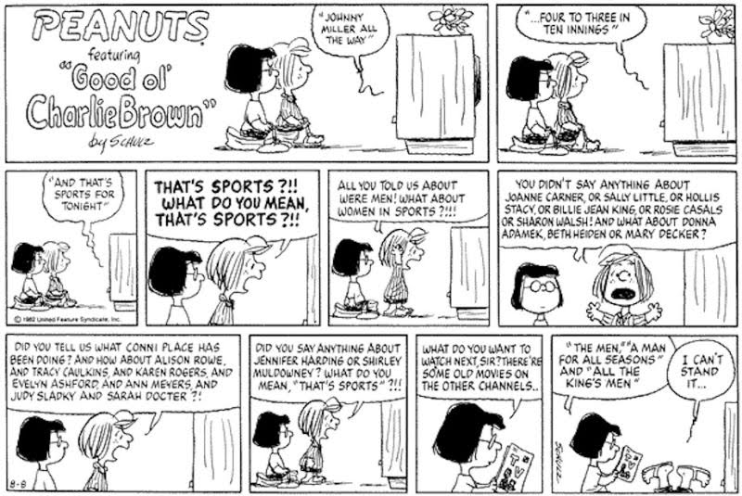
Peanuts (1950 – 2000) - Charles M. Schulz

Charles M. Schulz was very forwarding thinking when it came to social issues, and it shows in his work. During the 50-year run of Peanuts, up until his death in 2000, Schulz would often tackle social issues in a light-hearted, humorous manner, that would be appropriate for newspapers, and easy to digest for the younger audience. It’s interesting to compare a low culture comic strip, like this one, to the high culture examples shown previously. It’s been quoted that Minimalism and some Popart (Liechtenstein, for example) tend to offer no message, and come across as ‘dry and unemotional’, yet a low culture comic strip, such as the one shown above, was bringing to light many of the issues that would go unspoken about. Even John. F. Kennedy’s view on gender equality was slightly skewed "We want to be sure that women are used as effectively as they can to provide a better life for our people, in addition to meeting their primary responsibility, which is in the home." (Mclaughlin, 2018).

The character of Peppermint Patty was created as a way to communicate some of the political issues involving women’s rights, that were relevant to the time (and still to this day)

“Peppermint Patty’s worldliness manifests itself through her particular activism. The strip has been celebrated, in many different venues, for being an understated advocate for second wave feminist issues. There’s something admirable about Peppermint Patty’s insistence and stubbornness despite token support from her peers.” (Kevin Wong, 2018).

Although some of these pieces may have been misinterpreted, the point of this essay was gain a fresh perspective of these works, and to approach the challenge of analysing each piece chosen, in an attempt to discover the intended message, based on the research from the era as a whole. It was also intended to challenge the definition of high and low culture, and the 60s seemed like a prime example to explore these cultural similarities/differences.

Bibliography

Books
Madoff, Steven Henry (1997) Pop Art: A Critical History. University of California Press, Oakland.

Archer, Michael (2002) Art Since 1960. Thames Hudson, London.

Baker, Kenneth (1988) Minimalism. Abbeville Press, New York.

Colpitt, Frances (1990) Minimal Art The Critical Perspective. UMI Research Press, America.

Websites
Wordpresscom, R.T. 2013. Russell Tether Fine Arts Associates, LLC. [Online]. [25 November 2018]. Available from: https://russelltetherfineart.wordpress.com/2013/10/04/jim-dine-finding-humanity-in-pop/

Downthetubesnet, J.F. 2016. Downthetubesnet. [Online]. [25 November 2018]. Available from: https://downthetubes.net/?p=32823

Aaronartprintsorg. 2018. Aaronartprintsorg. [Online]. [25 November 2018]. Available from: https://www.aaronartprints.org/lichtenstein-blam.php

Mactaggart, J.F. 2018. Artyfactorycom. [Online]. [27 November 2018]. Available from: http://www.artyfactory.com/art_appreciation/art_movements/pop_art.htm

Tate. 2018. Tate. [Online]. [12 December 2018]. Available from: https://www.tate.org.uk/art/artworks/andre-144-magnesium-square-t01767

katie mclaughlin, cnn. 2018. CNN. [Online]. [12 December 2018]. Available from: https://www.cnn.com/2014/08/07/living/sixties-women-5-things/index.html

Kevin wong. 2018. How Peanuts Used Peppermint Patty To Talk About Politics. . Kotaku. [Online]. [12 December 2018]. Available from: https://kotaku.com/how-peanuts-used-peppermint-patty-to-talk-about-politic-1789460213

