MARKETING FUNDAMENTALS
CARNIVAL CORPORATION & PLC
Assessment 2 Marketing Fundamentals Analysis and Evaluation
Student name: Sava Mantchev
Student number:2028706
Lecturer name: Tushara Balendran
Module code: LCBB4004
Submission date:06/01/2022

Table of Contents
TABLE OF FIGURES 3
INTRODUCTION 4
PROCESS AND STAGES OF MARKETING 5
EXTERNAL ANALYSIS OF CARNIVAL CORPORATION & PLC POST-COVID-19 PANDEMIC 8
INTERNAL ANALYSIS CARNIVAL CORPORATION & PLC POST COVID-19 PANDEMIC 11
SWOT ANALYSIS OF CARNIVAL CORPORATION & PLC 11
VRIO ANALYSIS OF CARNIVAL CORPORATION & PLC 12
SEGMENTATION, TARGETING AND POSITIONING 14
MARKETING MIX STRATEGIES 16
CONCLUSION 19
REFERENCES 20
APPENDICES 22

TABLE OF FIGURES
Figure 1 - Marketing stages 4
Figure 2 - The market segment of Carnival Corporation & PLC 5
Figure 3 - PESTEL Analysis of Carnival Corporation & PLC 7
Figure 4 – Segmentation 13

INTRODUCTION
Carnival Corporation & PLC is the cruise operator and largest travel leisure organisation. It is a British-American organisation. It was founded in 1972 and later in 2003 established as Carnival Corporation & PLC. According to reports, the net income of the organization in 2020 was US$ 10.23 billion and revenue was US$ 5.59 billion. The numbers of employees at present in the organisation are approximately 150,000.
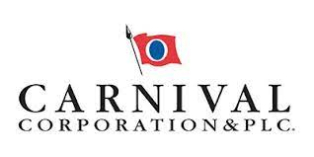
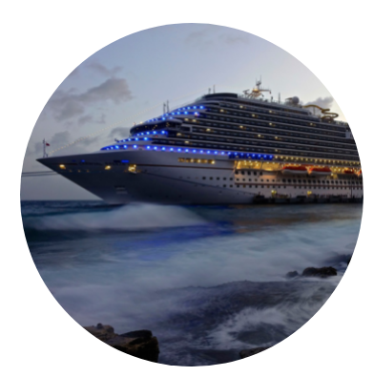
This report will present the understanding and concept of the marketing plan. It will include the processes and stages involved in the marketing, situational analysis which includes external and internal factor analysis of Carnival Corporation & PLC considering the impact of the COVID-19 pandemic on the firm, marketing mix strategies of the Carnival Corporation & PLC and segmentation, targeting and positioning.

PROCESS AND STAGES OF MARKETING
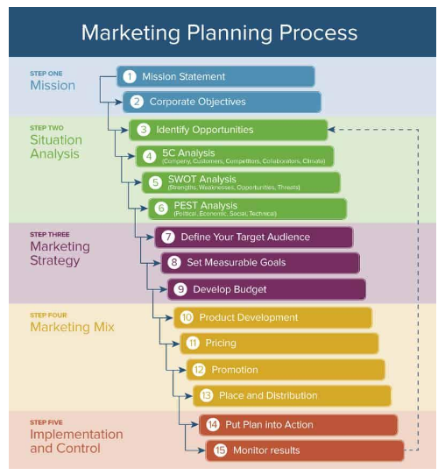
Figure 1 - Marketing stages
(Source- DO, 2021)
Mission: It is the first step includes the organizational mission and goals. It explains why the organization is in this business and how the company will benefit the consumers. The mission of the Carnival Corporation & PLC is to take individuals across the globe on vacation and offer them exceptional experience via many worlds' best Cruise brands that cater for several geographical locations and the standard of living on land or sea. The goal of Carnival Corporation & PLC is to become the topmost number one vacation service provider in the world (Vision, Mission & History | Carnival Corporation & plc, 2021).
Situation analysis: This is the second stage and involves internal and external analysis of the company. It provides the analysis of the external competition to the company and internal resource analysis. For Carnival Corporation & PLC SWOT and VRIO analysis is used as internal analysis tools (Fotiadis et al., 2018). It has analyzed the company has the strength of the strong portfolio of brand, days inventory is high contrast to the competitors as weakness, new trends in the customer behaviour is opportunity and threat of new entries in the market. External analysis has analysed, the political factors Carnival Corporation & PLC needs to analyze before investing in new business or any country are risk of post-COVID-19 protocols of the government of the country, favoured trading parterres, antitrust laws concerning casinos and resorts, industrial safety regulations etc. The rate of interest, foreign exchange rate, infrastructure quality in casinos and resorts etc. are the main economic factors that may impact the business of the company (Carnival Corporation & plc, 2021).
Marketing strategy and planning: It includes defining the target audience and market, setting measurable goals, and identifying and setting the budget of marketing. The market can be segmented by geographic, demographic, behavioural and psychographic ways. The target segment of the Carnival Corporation &PLC is demographic including families, couples and singles.
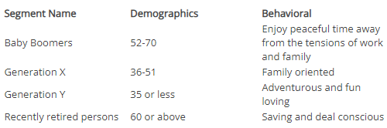
Figure 2 - Market segment of Carnival Corporation & PLC
(Source- Carnival Corporation & plc, 2021)
Marketing mix: It refers to the organisational strategies for marketing the goods and services of the firm. It includes elements like price, place, promotion, people, physical evidence, product and process, generally termed as 7P’s of marketing. Carnival Corporation & PLC’s product strategy is it sells a variety of products and allows its clients to choose the best suited for them. The current pricing strategy of the firm is a competitive based strategy. The place marketing strategy of the company is it sells its products by directly selling and others are through retailers. It uses multiple channels for promotion such as traditional and social media. People in an organization are the workforce involved in various departments of the firm and process strategy makes sure products are always available for the clients. The last physical evidence strategy is distinct packages to attract customers (DO, 2021).
Implementation and control: This is the last stage in which an organization needs to implement all the strategies and the plans to check if it is reliable or not. And if it succeeded organization can move towards new plans for next year (Fotiadis et al., 2018).

EXTERNAL ANALYSIS OF CARNIVAL CORPORATION & PLC POST-COVID-19 PANDEMIC
PESTEL analysis is the tool for external analysis of the environment. It is the detailed determination of the challenges in the operations of the organization. It will assist in providing a detailed analysis of the factors in functioning and operating the business of Carnival Corporation & PLC other than the competitive forces (Oe and Nguyễn, 2021). The external factors are political, economic, technological, social, environmental and legal.
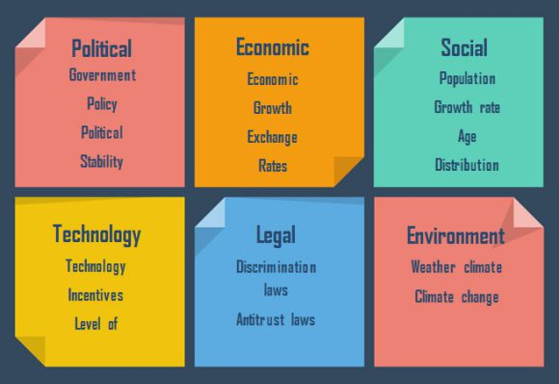
Figure 3 - PESTEL Analysis of Carnival Corporation & PLC
(Source- Pan et al., 2019)
Political factors
This factor plays an essential role in determining the impact on the long term profitability of Carnival Corporation & PLC. As the organisation operates in resorts and casinos in various countries it has different kinds of political risks. The political factors Carnival Corporation & PLC needs to analyze before investing in new business or any country are the risk of post-COVID-19 protocols of the government of the country, favoured trading parterres, antitrust laws in relation to casinos and resorts, taxation, wage regulations, industrial safety regulations etc (Pan et al., 2019).
Environmental factors
Different nations and markets have different regulations and norms regarding the environment. These factors impact the functioning of the organisation. The environmental factors associated with the Carnival Corporation’s business are weather, climate change, air and water pollution laws, etc.
Social factors
The beliefs and attitude of the individuals in the society affects the operations of the company. For example, the shared attitude and beliefs of individuals impact the decision making of the marketers of the Carnival Corporation to understand the views of the clients and market analysis. The management or leaders of the Carnival Corporation & PLC needs to analyse the social factors like skill level of the population, leisure interests, power structure of society etc (Oe and Nguyễn, 2021).
Technological factors
Technological advancement is the biggest factor that impacts the service sector. Travel and tourism organizations are mostly affected by this factor. For example, if the competitors of the Carnival Corporation are more advanced and provide technologically updated services then it is the con for the Carnival Corporation. The organisation not only needs to analyse technological factors but is also required to speed up technology to provide services. Technological factors impacting Carnival organisation are a rate of diffusion in technology, competitor's developments, impact on value chain structure etc (Pan et al., 2019).
Economical factors
The inflation rate, rate of interest, foreign exchange rate, infrastructure quality in casinos and resorts etc. are the main economic factors that may impact the business of Carnival Corporation & PLC. While working in international marketing, it is essential to analyse these factors to analyse the future risks and profit margin estimation.
Legal factors
This refers to the legislation of the country. Many nations are not able to protect the IPR of the organisations. Carnival Corporation & PLC needs to carefully evaluate the legal considerations of the nations before expanding business. The factors that can impact the functioning of the Carnival Corporation & PLC are antitrust laws of resorts and casinos, discrimination regulations and health and safety laws (Oe and Nguyễn, 2021).

INTERNAL ANALYSIS CARNIVAL CORPORATION & PLC POST-COVID-19 PANDEMIC

SWOT ANALYSIS OF CARNIVAL CORPORATION & PLC
SWOT analysis is the tool for analyzing the organization's internal effectiveness to operate the business. It includes the analysis of the advantages of the company over its competitors, areas for improvement, future growth and opportunities and the threats to analyze before expanding and functioning (Williams, 2018).
Strengths | Weaknesses
- Strong portfolio of brand  - Reliable suppliers for organisation  - Good returns on expenditure capital  - Highly skilled human resources  - Innovative products (Chen and Zhao, 2019) | - Days inventory is in high contrast to the competitors  - The high attrition rate in the workforce  - restricted success outside core business
Opportunities | Threats
- Decreasing cost of transportation  - The new expertise provides a chance to Carnival Corporation  - lesser inflation rate  - New trends in the customer behaviour | - No usual supply of inventive products  - scarcity of accomplished human resources in some marketplace  - New entries in the marketplace

SWOT analysis of the Carnival Corporation & PLC shows the organisation has many advantages over its competitors in the market. The analyzed strengths of the organisation are company has a strong portfolio which is the result of services provided from the beginning (Williams, 2018). The organization has a strong base of suppliers and this enables the firm to reduce the burden of raw material suppliers. The organisation is struggling in managing the day’s inventory as the organization’s expenses are high as compared to the competitors. Other areas of improvement for the company are restricted success out of the core business offered by the Carnival Corporation & PLC. It has many opportunities for a post-COVID-19 period such as a decrease in the cost of transportation, advantage and adaptation of new advanced technologies, less inflation rate and new services for the customer preferences after the social media. The identified threats for the Carnival Corporation are new entries in the market and the continuous advancement of technology (Chen and Zhao, 2019).

VRIO ANALYSIS OF CARNIVAL CORPORATION & PLC
VRIO analysis is the analysis of the organization’s resources to analyze whether they are unique or not from the competitors. The resources of Carnival Corporation & PLC are international and domestic presence, opportunities in electronic commerce by using the means of information technology, position of activities with Carnival Customer business strategy, right of entry to cheap capital, allocation and logistics costs competitiveness, the situation among retailers and wholesalers corporation name retail strategy, brand name positioning in contrast to the competitors, product collection and synergy among a variety of product lines (Chen and Zhao, 2019).
Flexibility in supply chain networks: This resource of the Carnival Corporation & PLC is valuable and rare as this is not completely offered by the competitors. The resource is nearly imitable as some of the competitors also has flexible supply chain system and share the suppliers. The organisation fully utilise its resources and its competitive advantage is keeping the business running (Williams, 2018).
The situation among retailers and wholesalers corporation name retail strategy: It is the most valuable resource as the company has strong retailers and wholesalers relationship. This is rare because Carnival Corporation & PLC has dedicated partners of the channel. This is difficult to imitate but not impossible, and organizations over the years successfully used this. The organisation has the advantage of sustainable development (Oe and Nguyễn, 2021).
Marketing Expertise within the Carnival Customer: Carnival Corporation & PLC has competing based differentiation in the related industry and this is not rare because most of the rivals and competitors now know about the marketing expertise of the company. This resource is not imitable because the organisation's pricing strategies are kind of matched with the other competitors. The organisation has leveraged it is in house capability and has a temporary advantage over competitors (Chen and Zhao, 2019).
Financial resources: These resources of the company are valuable but not rare, as every organization has better financial strategies. The financial resources and the liquidity are always available for the competitors. The organisation has a sustained financial position and temporary advantage over competitors (Oe and Nguyễn, 2021).

SEGMENTATION, TARGETING AND POSITIONING
Segmentation refers to dividing the potential market into small groups to satisfy their needs according to the offerings of the company. Targeting means selecting the particular segment of the potential market and offering it the organisation's goods and services. Positioning refers to creating a brand image in the individual's mind or advertising the product and service in a unique way that customers can easily recognize. STP strategy of the Carnival Corporation & PLC is as follows:
Segmentation: The segmentation of the organization can be based on the preferences of the clients. For example, if some passengers want accommodation at destination ports or some do not want that. It includes the geographic segmentation involving the considerations of the region, population and climate and weather. Demographic considering the age, gender, occupation of the target market. Behavioural segmentation considers the patterns of using the services of the organization, and the psychographic considerations like values, beliefs and lifestyle of the population (DO, T., 2021).
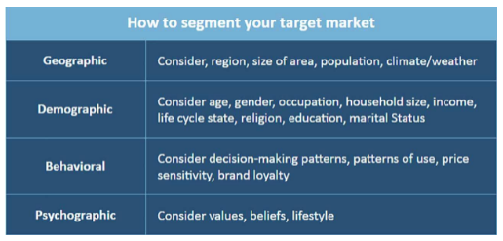
Figure 4 – Segmentation
(Source- DO, T., 2021)
Targeting: The target markets of Carnival Corporation & PLC are the individuals who want to experience a luxurious cruise experience at an affordable price. Therefore the Carnival Corporation & PLC should use different marketing strategies to target the market to increase its market share and to enjoy competitive advantage. The major target to the Carnival Corporation & PLC will be the adults in the age ranging from the 30 to 80.
Positioning: It refers to the advertising of the organistaion’s brand name. Carnival Corporation & PLC is recommended to use social media more for the advertising as the COVID-19 pandemic has resulted in the more use of social media and many individuals these days are updated on social networking sites, therefore the organization will get the advantage of more traffic to the organisation’s page or website (Williams, 2018).

MARKETING MIX STRATEGIES
PRODUCT
Product is the offering of the company to the market like goods and services. The products of the Carnival Corporation & PLC are services of the cruise line. The product strategy of Carnival Corporation & PLC is it offers broad five categories of the separate product line and allows its clients to choose the best suited product for them. It offers high quality products than the competitors. Organisation is recommended to introduce new service to the customer applying the norms of COVID-19 to cover the loss due to pandemic (Thabit and Raewf, 2018).
PRICE
Price is the money customer has to pay to avail the product or services offered by the organization. Carnival Corporation & PLC follows the competitive pricing strategy as the data of competitors are easily available to access. The recommended pricing strategy for the firm is to introduce discount and special vouchers for the customers to experience luxury cruise at affordable price. It will promote the organistaion’s value and revenue and cover the losses of the pandemic of covid-19 (Thabit and Raewf, 2018).
PLACE
Place is the location for selling the goods and services. Carnival Corporation & PLC use two channels for its services through online advertising using social media and traditional channels. Organization is recommended to use the social median its official website more to generate more traffic. The distribution strategy of the Carnival Corporation & PLC is valuable and rare as this are not completely offered by the competitors. The resource is nearly imitable as some of the competitors also has flexible supply chain system and share the suppliers. The organisation fully utilise its resources and competitive advantage is keeping the business running (Oe and Nguyễn, 2021).

PROMOTION
Promotion refers to advertising the organistaion’s products and services to the customers to share the information of the organistaion’s offerings. The Carnival Corporation & PLC’s promotion strategy includes advertising through various channels to promote the company’s goods and services. These channels are both traditional and online such as social media. Carnival Corporation & PLC advertises using social media platforms such as Facebook, Youtube, etc. It is recommended for the organization to hire influencers to promote the luxuries experiences of cruise in less cost (Thabit and Raewf, 2018).
PEOPLE
People refer to the individuals involved in the organization such as the personnel in marketing, selling and accounts department of the firm. People plays an essential role in the marketing department of the Carnival Corporation & PLC, as their main role is the promotion of the company and increase in sales. Other important people involved in the marketing strategy of the Carnival Corporation & PLC are suppliers for the required raw material for the company (Thabit and Raewf, 2018). Carnival Corporation & PLC is recommended to provide the incentives and other benefits to the human resources involved in the company to motivate them to work effectively post COVID-19 pandemic situations.
PHYSICAL EVIDENCE
It refers to the distinguishing the organistaion’s products and services to attract the customers. Carnival Corporation & PLC should apply the strategy completely difference from the competitors to gain the advantage of the physical evidence and experience. Carnival Corporation & PLC has competing based differentiation in the related industry and this is not rare because most of the rivals and competitors now know about the marketing expertise of the company. This resource is not imitable because the organistaion’s pricing strategies are kind of matched with the other competitors. Organisation has leveraged its in house capability and has temporary advantage over competitors (Fotiadis et al., 2018).

PROCESS
It is to make sure the availability of the organistaion’s goods and services to the customer all the time. Carnival Corporation & PLC is selling its services through online and offline booking. It is recommended to enhance the quality and innovation in the offerings (Thabit and Raewf, 2018).

CONCLUSION
This report concludes the concept of marketing plan. It concluded the processes and stages involved in the marketing, situational analysis which includes external and internal factor analysis of Carnival Corporation & PLC considering the impact of the COVID-19 pandemic on the firm. It has analyzed company has strength of strong portfolio of brand, days inventory is high contrast to the competitors as weakness, new trends in the customer behavior is opportunity and threat of new entries in the market. External analysis has analysed, the political factors Carnival Corporation & PLC needs to analyze before investing in new business or any country are risk of post COVID-19 protocols of the government of the country. Technological factors impacting Carnival organisation are rate of diffusion in technology, competitor’s developments, impact on value chain structure etc. Further it concludes marketing mix strategies of the Carnival Corporation & PLC and segmentation, targeting and positioning.

REFERENCES
Brilliant Term Papers. (2021). Marketing Plan about Carnival Corporation & plc - Brilliant Term Papers. [online] Available at: <https://www.brillianttermpapers.org/samples/marketing-plan-about-carnival-corporation-plc/> [Accessed 17 December 2021].
Carnival Corporation & plc. (2021). Corporate Information | Carnival Corporation & plc. [online] Available at: <https://www.carnivalcorp.com/corporate-information> [Accessed 17 December 2021].
Carnival Corporation & plc. (2021). Vision, Mission & History | Carnival Corporation & plc. [online] Available at: <https://www.carnivalcorp.com/corporate-information/mission-and-history> [Accessed 17 December 2021].
Carnivalcorp.com. (2021). [online] Available at: <https://www.carnivalcorp.com/static-files/e71dadff-f1f5-4d72-8281-0d0a500f84b2> [Accessed 17 December 2021].
Chen, F. and Zhao, R. (2019). In what way is the cruise shipping industry possibly affecting the development of the mechanical ventilation fans.
Chernev, A. (2020). The marketing plan handbook. Cerebellum Press.
DO, T. (2021). Marketing Plan. Marketing.
Fotiadis, A., Mombeuil, C. and Valek, N.S. (2018). Designing and implementing a marketing plan. In The Emerald Handbook of Entrepreneurship in Tourism, Travel and Hospitality. Emerald Publishing Limited.
Joy, M.M., (2021). THE NATION’S COMMUNICATIONS AND REPUTATION ON MANAGEMENT STRATEGIES 1999 TO 2019: A SWOT ANALYSIS APPROACH. International Journal of Sustainable Development, p.103.
Koc, E. and Ayyildiz, A.Y. (2021). Culture’s Influence on the Design and Delivery of the Marketing Mix Elements in Tourism and Hospitality. Sustainability, 13(21), p.11630.
Oe, H. and Nguyễn, H. (2021). Opportunities, challenges, and the future of cruise ship tourism: beyond COVID-19 with ubiquitous information sharing and decision-making. International Journal of Management and Decision Making, 20(3), pp.221-240.
Pan, W., Chen, L. and Zhan, W. (2019). PESTEL analysis of construction productivity enhancement strategies: A case study of three economies. Journal of Management in Engineering, 35(1), p.05018013.
Schmillen, M. (2020). Dérive: 2021-2025 Business Plan and SWOT Analysis.
Thabit, T. and Raewf, M. (2018). The evaluation of marketing mix elements: A case study. International Journal of Social Sciences & Educational Studies, 4(4).
Williams, K. (2018). A SWOT Analysis of the Lodging and Tourism Industry in New Orleans.

APPENDICES
APPENDIX- I

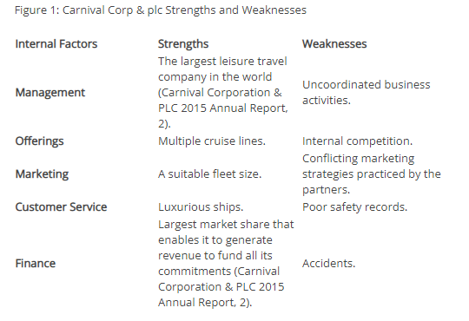
(Source- Marketing Plan about Carnival Corporation & plc - Brilliant Term Papers, 2021)

APPENDIX- II

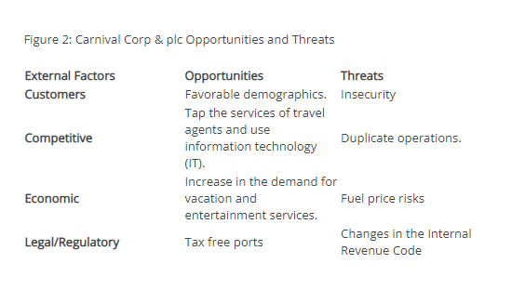
(Source- Marketing Plan about Carnival Corporation & plc - Brilliant Term Papers, 2021)

APPENDIX- III

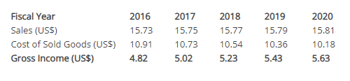
(Source- Marketing Plan about Carnival Corporation & plc - Brilliant Term Papers, 2021)

