HP
TESCO REPORT
Katarzyna Kolowrocka 1805961
NAME OF HOST:
UWTSD NEWPORT
MODULE CODE: BMSK 4001

05.04.2019

Executive summary

The food retail sector represents the largest industry in the UK, providing employment for over three million people in various areas, such as production, manufacturing, transportation and trading ( Wood, 2017).The purpose of this report is to identify and analyse Tesco’s problems and examine aspects of its nature, scope and impact. The report provides an analytical insight into TESCO, with the emphasis on an internal and external factors, affecting the business in the form of a SWOT analysis, then followed by a PESTEL - external environment analysis. This report also contains a study of the company’s stakeholders and the future strategic recommendations, which are provided at the end of the report. The paper is supported with details of the overall business description including Tesco’s development history.
Contents

Executive summary 1
1.0 Terms of reference 2
2.0 Procedure 2
3.0 Findings 2
3.1 An overview of Tesco 2
3.2 Previous attempts to resolve problems by Tesco. 3
3.3 Nature, scope, and impact of the current Tesco’s problems. 3
3.4 INDUSTRY ANALYSIS 7
3.4.1 SWOT ANALYSIS 7
3.4.2 PESTLE ANALYSIS 9
3.4.3 STAKEHOLDERS ANALYSIS 12
4.0 CONCLUSION 16
5.0 RECOMMANDATION 17
6.0 ACKNOWLEDGEMENT 18
7.0 APPENDIX 1 18

Terms of reference

This report has been written by Katarzyna Kolwrocka, it was requested by Laura James on 19/02/2019 for submission on 05/04/2019. The purpose of this report is to examine students analytical knowledge of solving problems, connected to the retail industry based on TESCO example.

Procedure

This report has been created on the basis of a literature review. The information to answer research question involved collecting data from range of sources, such as: books, journals and articles, but primarily websites.
Examples of theory and models, which have been studied during this course, have been used, along with lecture notes

Findings

3.1 An overview of Tesco

Tesco is the UK’s long established grocery retailer and one of the world’s leading food distributer. The company was founded by Jack Cohen in 1919, who’s mission was to ‘put affordable food in the reach of everybody’ (Clark, 2014). Tesco has maintained a strong position in the UK’s market through well targeted product range and outstanding innovation. Tesco had to consider that the major customers shopping in supermarkets, therefore in addition to their food selection, Tesco developed a range of non- food products and services, such as electrical and motor goods, furniture, clothing, petrol, software, mobile phones, insurance. (Dawson, 2006) The “price war” amongst supermarkets began in the 80’s, which caused a reduction in prices. In the beginning of 2000, Tesco offered their customers online services and now leads in the online grocery retailing (businessteacher.org.uk).

3.2 Previous attempts to resolve problems by Tesco.

On the path to the success Tesco struggled with huge amount of challenges. One of the problem was and still is the competition. When the recession began in 2008 and customers turned towards budget supermarkets, TESCO responded quickly with its own range of "discounter" style products and a new slogan – "Britain's biggest discounter".
Where lots of others businesses struggled since the financial crash of 2007/08 and the subsequent recession period, Tesco delivered a 10% increase in profits and declared that they were even stronger than before the crisis. Finch J.(2010).
German retailers, with their bottom prices, earned social acceptance as a popular place to shop. Tesco has responded to this price war with over £200m price cuts. (2018, https://www.theguardian.com)
The next big problem, which TESCO addressed was food waste problem.Tesco was the first supermarket to reveal information to the public. In UK’s stores, had generated nearly 57.000 tonnes of food waste. (Swaffield, J., at al, 2018). In this form, management wanted to communicate that they monitor wastage and that they care about natural environment. This premium retailer resolved food waste problem in its stores by donating any unsold food to local charities and community groups across the Britain (Hoad, 2017).

3.3 Nature, scope, and impact of the current Tesco’s problems.

The slogan "Every little Helps" encompasses all the positive policies that Tesco implemented for customers and becoming the UK’s biggest retailer, however, they made many mistakes.

The retailer faced many problems (https://bstrategyhub.com) such as:
- Numerous of scandals which has an impacted on current performance
- Brexit,
- Poor operational performance in certain markets (Polish, Thailand),
- Competition,
- Financial errors.
For the purpose of this report, the researcher chose two current problems Tesco is facing.
The nature of the first problem is demonstrated by a damaged reputation following the horsemeat scandal in 2013. Tesco’s beef burgers contained horse and pork related DNA. This scandal have had a huge impact on the business as pork meat is a taboo food in the Jewish and Muslim society. (Pratley, 2013).This situation negatively affected consumers perception on the company and resulted in a deterioration in sales. CEO is trying to rebuild profit from the period before the scandal and implemented a cut cost strategy as a solution for the company problems. Approximately a thousand jobs have been affected by this decision as an unprofitable fresh food counters in 90 stores have been closed down (www.theguardian.com). Tesco Direct also has been closed down and involved additional 500 jobs loses ( 2018, www.bbc.co.uk).
The SCOPE of the problem reached many individuals such as: employees, unions, suppliers, local communities, shareholders and management.
IMPACT This situation lowered morale among employees as they became uncertain and insecure. Lack of motivation lead to bad customer service. The cost cutting strategy involved increasing pressure on suppliers. The company was delaying payment to suppliers to boost profit. Tesco’s cost cutting strategy lead they search for cheaper suppliers abroad. (Hoad, 2017).

Using the 5 WHY’s model below, allow to understand what the problem is and develop actions to resolve it.

Figure 1 Five WHY’s model
1. Why?
Uncertain, unhappy staff
Employee losing jobs
Tesco closing down fresh food counters

2. Why?

3. Why?
4. Why?
Cost cut strategy
5. Why?
Profit not recovered after horse meat scandal in 2013
Food supply chain

Another nature of the TESCO’s problems is intense competition in the grocery sector. (Food report, 2018)
Brexit referendum and uncertain economic situation are the main reasons that customers changed their preferences and opted for the cheaper retailers. The German retailers are growing. With their bottom prices, they have acquired socially acceptance and started to be a more popular (https://www.bbc.co.uk).
Tesco’s position as the UK’s number 1 supermarket is endangered due to Sainsbury and Asda’s potential merger. (Food report, 2018 )The Asda’s promise of "everyday low prices", and Sainsbury's with its "value and values" possessed customers, while Tesco losing theirs, as shoppers accused the company at not being the best at price nor quality.
In 2018 management made a decision to close Tesco Direct as it could not compete with the on-line giant Amazon.
The SCOPE of this problem mainly affected shareholders, as the competitive rivals have eroded the profit margins for the business. Suppliers, Managers, Employees are also affected.
The IMPACT
The bargaining power of the UK's grocery retail chains, put pressure on suppliers as they have to provide cheaper products with even better quality.
Tesco share price fell more than 9% due to the decline in operating profits. That is acclaimed as the worst performance for the company since the Brexit Referendum. Shareholders were unsatisfied as the share price in 2017 was below peak affecting returns. (https://www.learnmarketing.net)
Tesco loss of a huge amount of loyal customers have had an impact on the company and placed pressure on the management, resulting in a change their business strategy.
The cause - and - effect diagram (Yazdani, A 2012, p 653) was provided by Ishi Kava. That powerful decision making tool, identifies different causes of problem.

Figure 2 Isikawa diagram – cause and effect the potential loss of customers
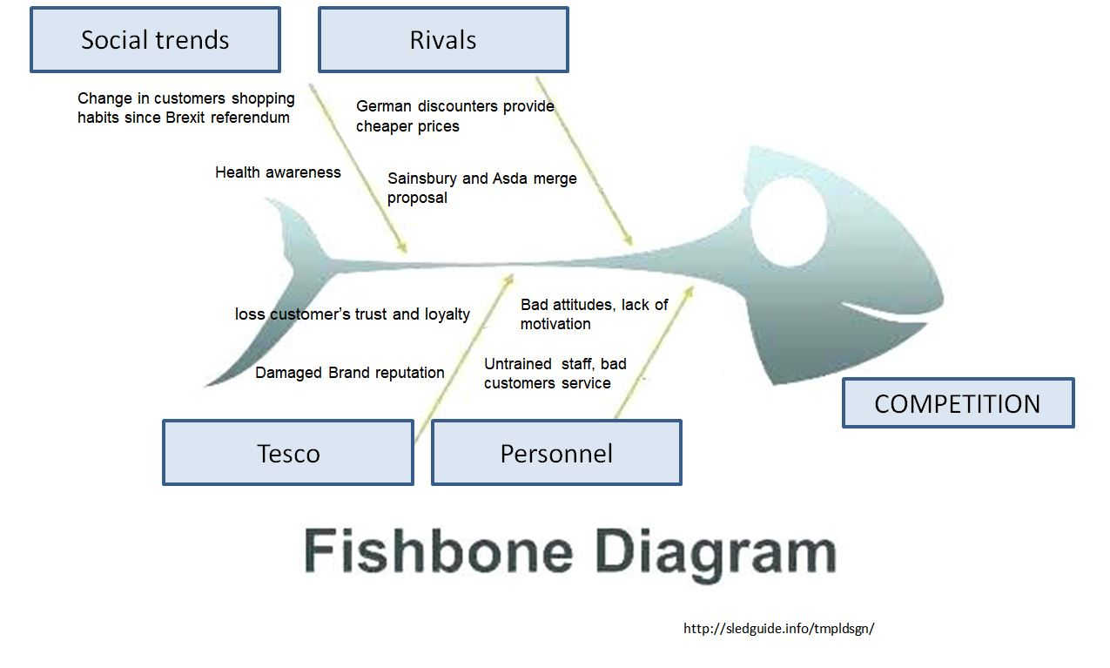

3.4 INDUSTRY ANALYSIS

External and Internal analysis will help to understand Tesco as a retailer and its current situation on the market.

3.4.1 SWOT ANALYSIS

The SWOT analysis considers important internal and external factors impacting on the retail chain. The full SWOT analysis of Tesco is presented in Appendix 1. Despite numerous scandals, Tesco still has very strong market position and remains the UK’s number one retailer. Tesco could compete effectively with its rivals and improve its position by concentrating on strengths and eliminating weaknesses, by gaining benefit from opportunities and finding strategies to reduce the potential impact of threats.
100 years of experience have helped Tesco to learn how to resolve problems. The retailer has managed to keep its market leading position, gaining customers’ trust and loyalty through reliable quality and using with innovative approaches and techniques. Tesco has secured further social acceptance through involvement in charitable actions. (Christmas, Easter, Charity food collections ). (Hoad, 2017). The retailer is simplifying product ranges and is cutting costs in its fight back against the discounters. As an international retail giant, it can use economies of scale and cheaper suppliers outside the home market. Another of Tesco’s strengths is their use of advanced technology, which helps to keep operational costs low whilst enhancing customer service levels. Another opportunity coming from technology usage is online shopping and a same day delivery service. (businessteacher.org.uk)
Tesco has gone far beyond just advertising the fact that it meets customer needs. Over the past 20 years, Tesco has launched more than 100 useful initiatives, which include mother-and-baby changing facilities, the promise to limit checkout queues to 'one in front’. (Hoad, 2019)
Unfortunately, on the way to the success, the giant supermarket has been involved in many scandals, resulting in damage to its reputation and customers trust. The problem lay more in customer opinion of the brand rather than quality, since in blind taste tests, Tesco’s food outscored its competitors.
Knowing that, Tesco’s priority is now to focus on customers’ perception and regain social acceptance back. Tesco seek an opportunity to gather families together and provide a personalised service experience. For example, in 2018, Tesco launched food recipe suggestions: 'Food love stories'. This inspires not only quality meal ideas, but also involves emotions (“Helen's 'homecoming' lamb, Nana's 'magic' soup”) (Hoad, 2017).
At the moment Tesco controls more than a quarter of the UK grocery market (www.theguardian.com), although its number one position is threatened by the Asda-Sainsbury's proposed merger and German discounters aggressively gaining market share. Tesco has the opportunity to grow business and position, and fight back against the competition, since introducing their own discounter chain, Jacks, and merging with Booker group.
Another threat to the business is Brexit, if an acceptable trade deal is not agreed with the EU. Currently, the increased costs of importing goods from Europe resulting from a ‘hard Brexit’ are unknown (www.theguardian.com). A higher inflation rate and a weakening of the pound, are already causing price rises at an operational and trading level, resulting in Tesco’s CEO cooperating closely with suppliers to ensure that the effect on customers is minimised. (Food Report, 2018)

3.4.2 PESTLE ANALYSIS

For the purpose of this report, it is necessary to consider the external environment impacting on the retail chain. Three PESTLE factors have been selected for deeper analysis of those dimensions, based on social, technological and economic aspects.
SOCIAL
Kotler, P., (2010, at al, p.163) suggest that the consumer’s opinion about a company can rapidly change if levels of quality, pricing and service are not maintained.
Following the Brexit referendum, customer behaviour has changed and they have started looking for cheaper options and products. More customers buy less or switch to cheaper own-label products as price rises exceed wage increases. (Wood, 2017)
Demographic changes, such as aging population, increase in female workers, as well as busier lifestyles have caused a decrease in home food preparation and led to an increase in sales of convenience food products and ready – made meals. (Clarke, 2003). The fact that people have less time and older generations are using the Internet, have brought about an increasing trend in online shopping. (ttps://www.theguardian.2019).
According to the food report forecasts ( 2018), rising health consciousness among British customers, will increase sales of fresh fruits, vegetables and dairy products. Customers will refrain from buying goods with high sugar, fat and salt content. Consumption of meat will drop (reduce) as more individuals as vegetarianism becomes more popular. Tesco should adapt to these trends and meet customer expectations by accommodating the demand for organic, healthier, quality products.

TECHNOLOGY ANALYSIS
According to the Food & Drink Report (2018), the British customer, is amongst the most technically advanced, which helps online sales. Tesco has made huge investments in advanced technology.
Tesco has turned itself into the biggest online retailer. The grocery online site is used by an impressive 100,000 consumers per day use the grocery online site. (https://www.bbc.co.uk)
It is essential for TESCO to innovate, continuously improve products and services and make processes as easy as possible. Advanced systems that control stock and deliveries and record and analyse business transactions are essential for the company’s success.
The use of technology helps to reduce labour costs and keep prices on at competitive levels.
Tesco has invested in advanced technologies to improve the shopping experience and support day-to-day operations. Today’s consumers value speed and are gaining confidence in helping themselves at the check-out , (Quelch, ) therefore Tesco uses technology for self - checkout machines and mobile payment apps. Other examples of technology usage are a stock control system, the automatic counting of products through a barcode system, intelligent scales and electronic shelf labelling.
The Clubcard, Tesco’s secret weapon over its rivals, rewards consumers. That is another positive use of technology as the system analyses the shopping habits of cardholders and tailors specified offers to them. (https://www.theguardian.com/business/2010)
The Internet and Extranet allows Tesco to create an efficient information system between itself and its business partners. The company has introduced an Extranet, to its major suppliers, to give them easy access to the sales data of products on promotion. The introduction of new products will be faster, as suppliers will be able to find specifications for new lines electronically. Tesco will be able to influence the way its suppliers work and improve their efficiency. It has been estimated that the system has saved Tesco 30 % of joint annual promotional costs (Charlesworth, 2017).
ECONOMIC ANALYSIS
The uncertain and difficult economic situation has resulted in the retail industry to be put under pressure. (https://www.theguardian.com/business)
Rising inflation since the vote and the depreciation of the pound, increased the costs of imported goods, operational costs for traders and prices for clients. (https://www.bbc.co.uk). According to the research (Wood, 2017) inflation also meant that British families now have to spend about £27 more for the same basket of products.
Food price inflation in Tesco’s stores was just 1.4%. In tough economy economic conditions, the CEO has stayed true to the commitment “Every little helps”, working in partnership with suppliers to maintain low price. The CEO is promising to protect customer from inflation and is reducing the full impact of price rises to the customer. (Wood, 2017)
Furthermore, pressure on pricing strategy is being caused by rising labour and unprocessed material costs. This reduces company profits and leads to changes in its supplier network, to obtain lower prices on raw materials. (https://businessteacher.org.uk)
Tax on sugary drinks, introduced in 2018 is another hit for the retail industry, which already suffers as a result of the increasing health-awareness trend. (food report, 2018).

3.4.3 STAKEHOLDERS ANALYSIS

Tesco has many stakeholders and is focused on delivering value to each of them. Stakeholders have impacted on Tesco’s past performance and further business strategy.
The diagram below illustrates the company’s primary and secondary stakeholders.
Figure 3 Tesco’s stakeholders
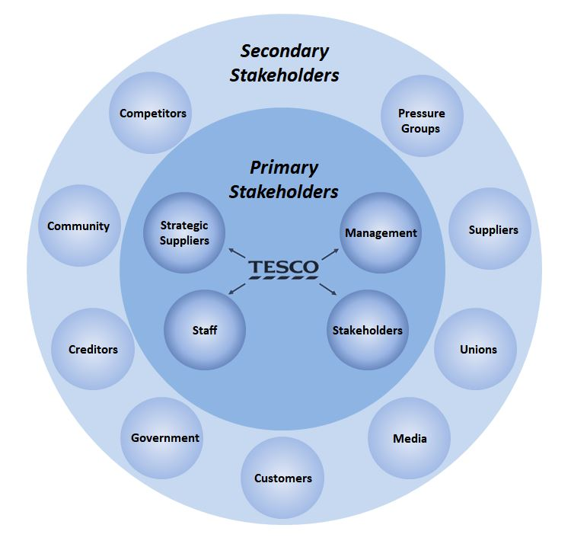
Customers have had a huge impact on Tesco’s current problems and strategy. Tesco was one of Britain's most trusted brands, but a series of reputational challenges damaged that faith. Tesco’s customers turned towards cheaper competitors.
Government regulations have put pressure on the retail chain. To adhere to new regulations Tesco needs to make adjustments to its structure, policies and strategies for dealing with the extra cost. (https://businessteacher.org.uk)
Insecure and dissatisfied employees have had a huge impact on customers service (Hoad, 2017). Tesco has started to put emphasis on training staff, as they often know little about a their products
Scandal with the horse-meat DNA in burgers started from the suppliers.
Media negative reporting damaged reputation.
Shareholders impacted on Tesco’s business. Two of Tesco’s biggest investors were against the £3.7bn controversial acquisition of Booker which distracted from the financial recovery of the company (food report, 2018). This triggered the resignation of catering group Compass director. (Wood, 2017)
Tesco started solving the problem of growing competition, a little too late. Strong traders such as Amazon, Aldi, pushed Tesco to cut cost and simplify products to stay competitive. (https://www.theguardian.com). This caused lower profit margins for Tesco.
The diagram below provides an illustration of a Tesco Stakeholder Analysis.
Figure 4 A stakeholder analysis
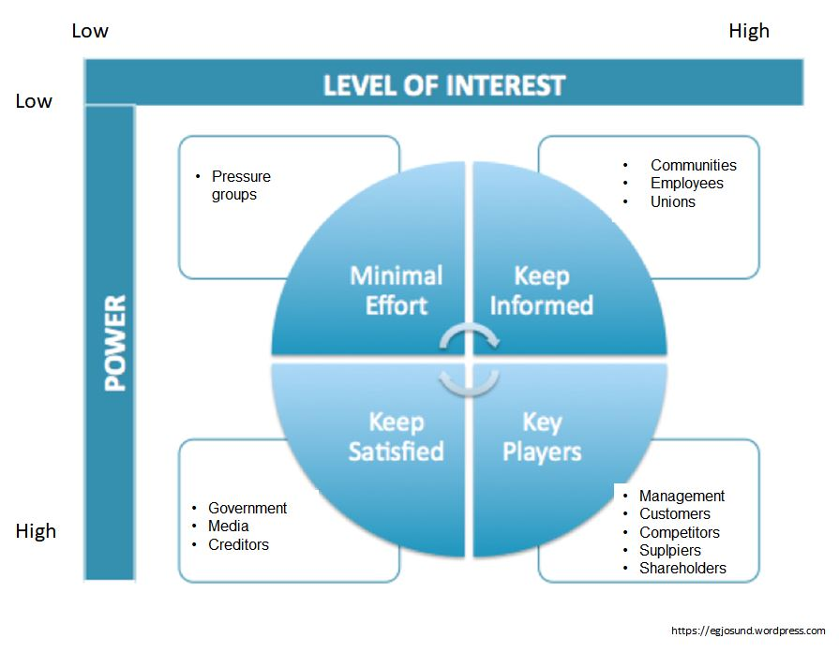
Tesco’s new strategy to improve its business, strengthen its position should be focused in developing customers service, investing in employees and restoring relationships with suppliers to bring back trust, pride and loyalty. (Hoad, 2017)

Customers can recommend Tesco and start to be loyal to the business.
An employee, when satisfied with the work, can recommend the organisation as a place to work and shop. Tesco started to put emphasis on improving staff performance which can help to provide excellent customer service.
With stores in so many towns, it is essential for Tesco to provide a help to local communities. The retailer reduced food waste in its stores by donating food to local charities. This way Tesco gains respect and rebuilds the trust of locals (Hoad, 2017).
Suppliers provide all the goods which the company can sell to make a profit and be successful.
Government can give permission to open new stores in strategic places. The government care about Tesco’s success as Tesco is an important employer in the UK. As the largest retailer it has a huge impact on the economy. Tesco has more than 743K employees worldwide and has been reported as the largest opportunity builder in Europe.
Tesco’s analysts suggest that the management cost cutting strategy saved Tesco up to £170m annually. (https://www.theguardian.com)
Competition has positive aspects for the company and customers. This motivates management to improve the services and products, constantly looking for development and new solutions.
Media could destroy or help company’s image. Tesco has developed a new media strategy, placing clients at the heart of the business (Hoad, 2017). Tesco using media could boost advertising activities to gain more consumers than its rivals.
- CONCLUSION
The report provides all the crucial elements of the company analysis and examined some aspects of solving problems. The current trading situation, lack of customers trust in the business, unhappy employees and suppliers are issue need to be addressed and resolved straight away. Tesco faced numerous external challenges, competitive environment and stakeholder pressures. (https://businessteacher.org.uk)
Rivals led to price wars and eroded the retailer's profit margin when TESCO should have been focused on other ways of gaining competitive advantage. (https://businessteacher.org.uk)
The retailer started losing market share in the UK, because of German retailers growing stronger and the Sainsbury- Asda plan to merger. The uncertain economy and increased product prices, have reduces what clients can buy.
Tesco set a new brand purpose - a 'reset' for the entire organisation - to drive change from the inside out, increasing customer trust - 'Serving Britain's shoppers a little better every day (Hoad, 2017).
Today’s successful companies are strongly customer focused (Kotler, P. ,2010,p. 28)
Dealing with challenges have shown Tesco that the most important thing is to focus on customers rather than running the business. (Hoad, 2017)

5.0 RECOMMANDATION
Tesco need to rethink their business strategy, if they wish to compete with rivals.
To rebuild customers trust, Tesco needs to return to serving people, not just running shops. The company needs to be the customer champion again, once more providing a workplace which colleagues could be proud of and regaining the trust of suppliers (Hoad, 2017).The answer to Tesco's future lay in its past. At its successful time, Tesco was a consumer – focused company. It can be noticed that when Tesco started be involved in many social activities, customer’s trust increased.
Tesco should build a new online system to help elderly people to care for themselves. Knowing fact that population is aging, Tesco should consider to simplifying their online website. Although online shopping is a great help for elderly people, majority of them struggle with the system – and without family support they are not able to place the order, as is too complicated. Tesco should create simplified website pages with basic products range, such as milk, bread and other daily essentials and introduce a dedicated phone help line; online shop assistant or web chat.
Research shows that customers want not only quality food but also easy ways to put a good meal on the table. This requires better understanding of their motivation: their time, cooking skill and financial possibilities (HOAD, 2017).

6.0 ACKNOWLEDGEMENT

The researcher like to acknowledge the important role of Beth Downing and Laura James in the outstanding support of writing this report, who have contributed to the content through comments and editorial input.

7.0 APPENDIX 1

Strengths (https://bstrategyhub.com)
- Great Britain’s leading grocery retailer by annual sales and market share –Tesco has highest sales and revenue., its operating profits rose 28%. Food report
- Leading market share –currently at 28.1%
- Strong position on the market maintained through 100 years of experience
- Europe’s largest private employer – Tesco provides more than 743K jobs opportunities worldwide. It has been announced as the largest opportunity builder in whole Europe.
- Advanced technology usage
- Effective supply chain network
Weaknesses https://bstrategyhub.com
- Damaged brand trust and reputation – numerous of scandal have had huge impact on Tesco business, and customers trust https://www.theguardian.com/business
- Unsecure and unsatisfied employees with another round potential job losses
- Decrease in operating profits – End of 2018, the share prices of Tesco fell more than 9% due to the decline in operating profits. That is acclaimed as the worst performance for the company since the Brexit Referendum.
- Low-cost strategy – Although Tesco is the price leader in the UK market, its low-cost strategy and price war with budget supermarkets reduced Tesco’s profit margins.
Opportunities https://bstrategyhub.com
- Launching Jack’s discounter stores – A new chain allowed company to grow and efficiently compete with cheaper rivals.
- Online shopping – The retailer growing and developing its online shopping business. Since 2017 providing same-day delivery services
- The merger with wholesaler Booker strengthened Tesco’s position
- Rebuilding trust strategy introduced by chief executive (Hoad, 2017)
- Cost cutting strategy - Tesco’s analysts (experts, researchers) suggest that the latest cost cuts strategy annually saved Tesco up to £170m. https://www.theguardian.com/business

Threats (https://bstrategyhub.com)

- Brexit Referendum – difficult and uncertain economic climate, demonstrates that retailers are under the pressure https://www.theguardian.com/business
- Low cost competition – The rise in the popularity of budget supermarkets, such as Aldi and Lidl, and the subsequent price war in UK retail will continue to affect Tesco
- Rising growth and performance of Tesco’s competitors. Germans discounters (Aldi and Lidl) are taking an increasing share of the market. Tesco’s leading position has been threaten by the proposal merger of Asda and Sainsbury’s. https://www.theguardian.com/business/2019
- Economic crisis and credit crunches – Government regulations, legal and tax matters, credit crunches, and economic instability affecting the operational efficiency and performance of Tesco stores.
- Increasing Inflation, the depreciation of the pound, which is pushing prices of goods up
- Prominent shareholders of Tesco have criticised the Booker acquisition as a distraction from the more important turnaround strategy. food report (2019)

References:
Charlesworth, A. (2017), Tesco ties seven suppliers to Extranet to track sales https://www.v3.co.uk/v3-uk/news/1980739/tesco-ties-seven-suppliers-extranet-track-sales accessed 29/03/2019
Clark, T, Chan, S.P., (2014), A history of Tesco: The rise of Britain's biggest supermarket, Telegraph https://www.telegraph.co.uk/finance/markets/2788089/A-history-of-Tesco-The-rise-of-Britains-biggest-supermarket.html 2019/ accessed 17/03/2019

Dawson, J, Larke, R., Mukoyama M, (2006), Strategic Issues in International Retailing, Kobe, University Marketing and Distribution Sciences.

Eley, J. (2018), in Financial times- https://www.ft.com/content/a0863b1c-c6d0-11e8-ba8f-ee390057b8c9c 2019/ accessed 05/03/2018
Finch J.(2010), Tesco beats the recession to unveil record profits again
https://www.theguardian.com/business/2010/apr/25/tesco-record-profits-terry-leahy 2018/ accessed 8/03/2019

Butler, S. (2019), Tesco confirms 9,000 jobs at risk as it axes fresh food counters
https://www.theguardian.com/business/2019/jan/28/tesco-jobs-fresh-food-counters-supermarket--staff 2019/ accessed 05/03/2019
Hoad, A. (2017), Making Tesco great again, Teddington, Cambridge University Press

https://pestleanalysis.com/pestle-analysis-tesco 2019/ accessed 25/03/2019
https://www.bbc.co.uk/news/business-44211616 2019/ accessed 25/03/2019
https://www.bbc.co.uk/news/business-43722494 2019/ accessed 25/03/2019
http://sledguide.info/tmpldsgn 2019/ accessed 28/03/2019
https://bstrategyhub.com/tesco-swot-analysis-2019swot-analysis-of-tesco/
https://businessteacher.org.uk/swot/tesco.php 2019/ accessed 17/03/2019
https://www.theguardian.com/business/2014/jul/21/five-probems-tesco-dave-lewis/ 2018; accessed 05/03/2019
https://egjosund.wordpress.com/2013/02/06/how-to-rebuild-stakeholder-confidence-in-the-tesco-brand/ 2019/ accessed 04/04/2019
Kotler, P., Amstrong, G. (2010), Principles of Marketing (13th Edition), London, Pearson Education
Paton, N. (2015), Top Employers UK: Tesco: open all hours: The benefits of having staff work from home, London, Guardian News & Media Limited.
Ruddic, G., (2016), From Green Shield Stamps via Tesco and now Sainsbury's?, The Guardian
https://www.theguardian.com/business/2016/jan/05/argos-story-green-shield-stamps-tesco-sainsburys 2019/ accessed 29/03/2019
Swaffield, J., Evans, D., Welch, D. (2018), Profit, reputation and ‘doing the right thing’: Convention theory and the problem of food waste in the UK retail sector, Vol.89, Geoforum https://doi.org/10.1016/j.geoforum.2018/ accessed 17/03/2019
Quelch J, Cannon-Bonventre K, “Better Marketing at the point of purchase https://hbr.org/1983/11/better-marketing-at-the-point-of-purchase 2019 / accessed 28/03/2019
United Kingdom, Food and Drink Report (2018), Market Line, London, Fitch Solution

Wood, Z., ( 2017), Tesco says price rises are last resort as UK growth hits seven-year high, The Guardian, www.theguardian.com/business/2017/jun/16/tesco-price-rises-uk-growth-inflation-pound-brexit 2019, accessed 29/03/2019.
Yazdani, A., Tavakkoli-Moghaddam, R. (2012), International Journal of Advanced Manufacturing Technology, London.

Bibliography:
Amstrong, A., ( 2017), 'I want to run a responsible firm and that's what I'm doing' Tesco boss Dave Lewis is on a mission to transform the store's reputation as the bully boy of retail, London, Telegraph Group, p. 31
Winnett, R. (2012) ‘Supermarkets Face Large Fines for Abusing Farmers’, The Telegraph

