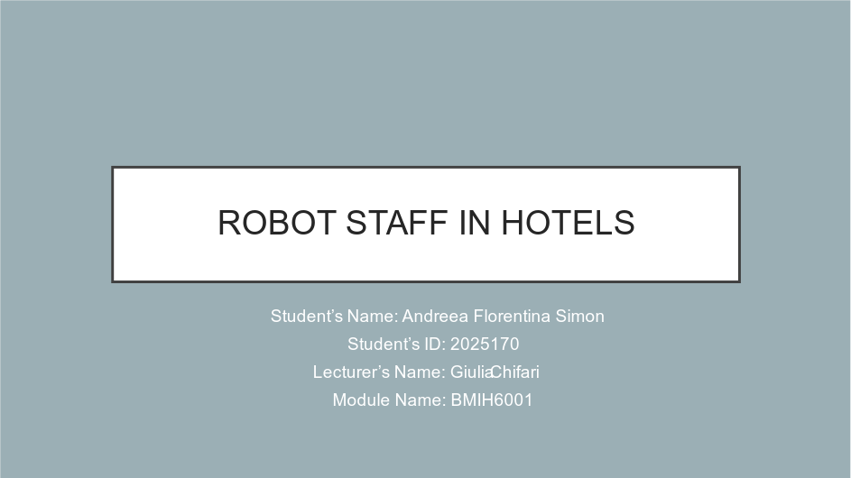

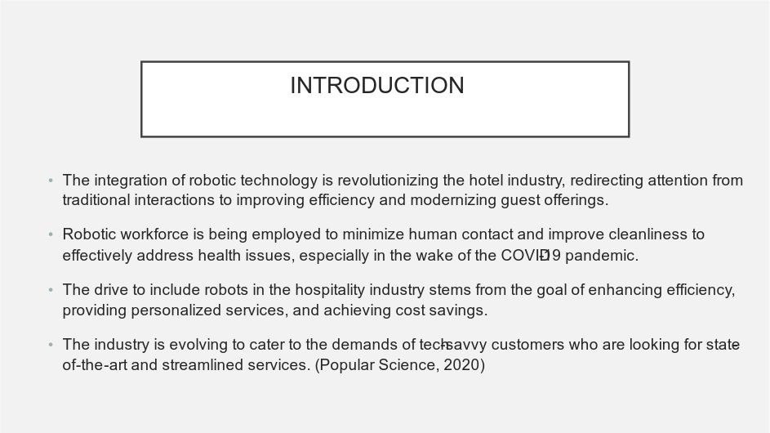
The hospitality industry is experiencing a transformative shift by integrating robotic employees, moving beyond traditional personal interactions. This evolution enhances both operational efficiency and guest experiences. Post-COVID-19 health and safety concerns have accelerated the adoption of robots to reduce physical contact and improve cleanliness. This shift is driven by the need for higher productivity, personalized services, and cost savings, made possible by advancements in AI and robotics. Today’s tech-savvy consumers demand innovative and efficient experiences, compelling the hospitality sector to continually innovate and adapt to meet evolving preferences and operational challenges.

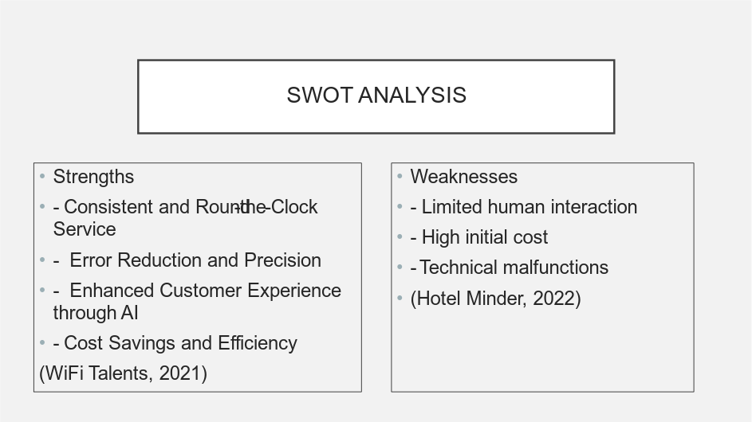
Robots in hotels provide consistent, round-the-clock service, ensuring uninterrupted guest supports bd also, excel in error reduction and precision, enhancing service accuracy. Utilizing AI, robots offer a personalized customer experience. Additionally, they drive cost savings and efficiency by automating repetitive tasks, reducing labor costs, and improving operational productivity. While robots offer many benefits, they also have their own vulnerabilities such as limited interaction with others can greatly affect the satisfaction of our guests and the significant upfront costs involved in implementing robotic systems can pose a considerable financial hurdle. Furthermore, technical issues may arise that could disrupt operations and require costly repairs, potentially affecting the dependability of the service.
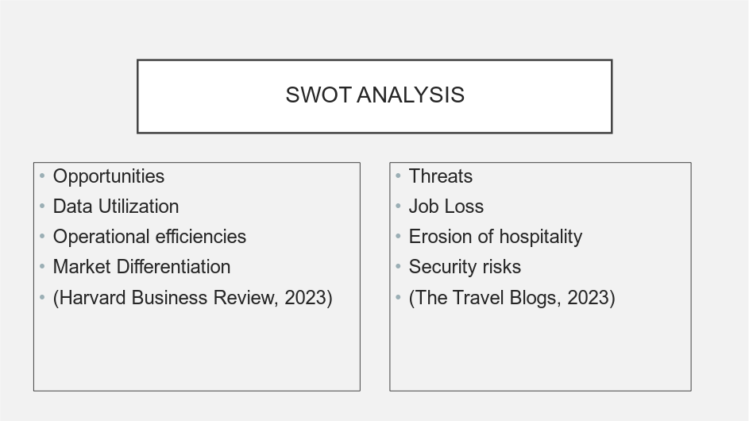
The integration of robotic staff in hotels presents a wide range of possibilities and by harnessing data, we can offer tailored services that enhance guest satisfaction. Robots improve operational efficiencies, enabling human personnel to focus on more complex interactions. Furthermore, they set themselves apart in the market by incorporating cutting-edge technologies but also, there are significant risks involved as when people lose their jobs, it can sometimes lead to conflicts between workers and management, as well as negative opinions or attitudes. Some guests may feel disconnected due to the gradual decline of traditional principles of hospitality while the financial costs associated with purchasing and maintaining robots can pose a significant challenge, especially for smaller hotels. In addition, our increasing reliance on technology has made us more susceptible to cybersecurity threats, making data breaches a major concern and ensuring a successful integration necessitates astute management of both the potential benefits and risks.

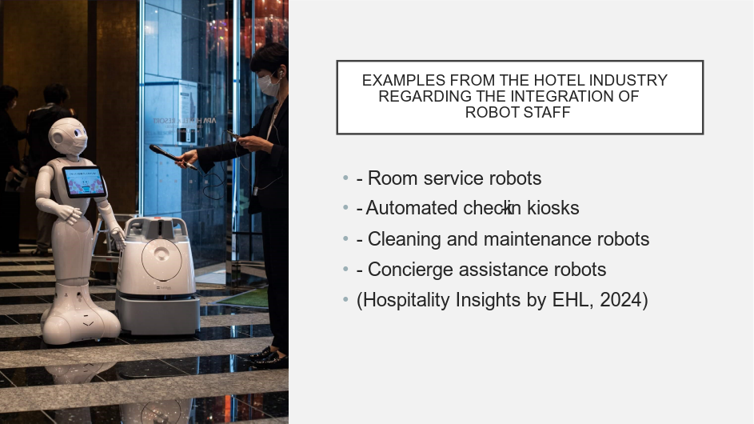
Robots are increasingly being integrated into the hotel sector to enhance client experiences and streamline operations and for instance, robots used in room service deliver meals and amenities directly to guest rooms, providing quick and contactless assistance. Automated check-in kiosks streamline the check-in process, reducing wait times and allowing guests to quickly access their rooms while cleaning and maintenance robots are crucial for ensuring optimal cleanliness and upkeep, which are of utmost importance for visitor satisfaction and hygiene, especially in times of health crises. Concierge robots enhance the client experience by offering personalized and efficient assistance, providing information, directions, and recommendations and these examples showcase how robotic staff can completely transform hotel operations, boosting efficiency and elevating the guest experience.

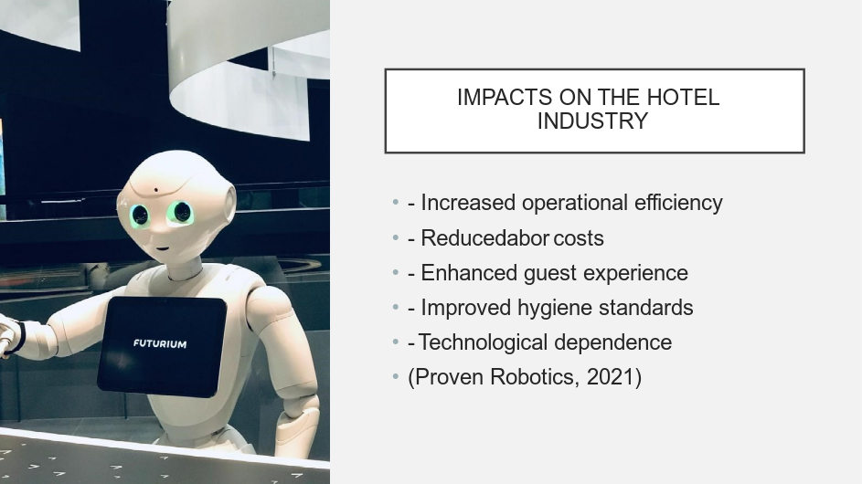
The presence of robot staff in the hotel business has significant impacts as at first, operational efficiency is improved by using robots to handle repetitive tasks, allowing human workers to focus on more complex responsibilities. This leads to reduced labour costs, as certain roles necessitate a smaller workforce and robots enhance the guest experience by providing prompt and personalized services. Efficient cleaning and maintenance play a crucial role in maintaining high hygiene standards, especially during health crises, to prioritize the safety of guest and also, there is also a strong dependence on technology in hotels, as they increasingly rely on sophisticated technologies for their daily operations. Maintaining a balanced and seamless integration of robotic personnel is essential for successfully incorporating them into the hotel industry.

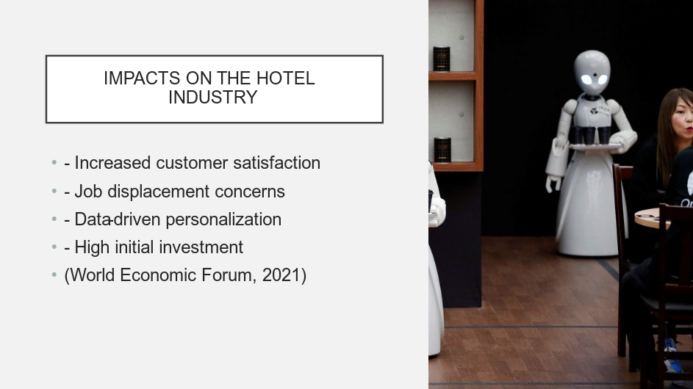
The introduction of robot staff in the hotel business has various impacts as robots excel at providing top-notch customer satisfaction through their unwavering commitment to delivering consistent, efficient service and personalized experiences. However, the replacement of certain tasks traditionally performed by humans with robots raises concerns about job displacement, potentially leading to labour disputes and negative perceptions as they use guest data to customize services, thereby enhancing the overall guest experience which is another consequence of data-driven personalization. However, a potential downside is the significant initial investment required to acquire and incorporate robotic technology, which could pose a financial hurdle for some hotels and understanding and managing these effects is crucial for successfully integrating robot employees while striking a balance between technological benefits and workforce considerations.

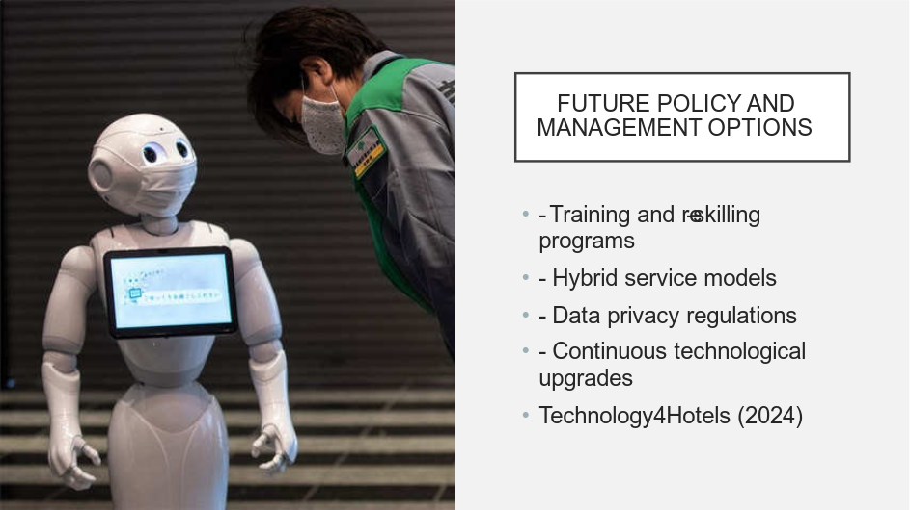
In the future, there are various policy and management strategies that can be implemented to seamlessly integrate robot staff into the hotel sector whole training and re-skilling initiatives play a vital role in helping current employees adapt to new roles and technologies, which helps ease concerns about job displacement. Combining human and robotic workers in hybrid service models allows for a seamless blend of technology and personalized human interaction, resulting in a harmonious and effective approach and by implementing strict data privacy regulations, we can ensure the protection of guest information collected by robots. This helps to maintain trust and comply with legal requirements whole technological advancements are crucial to keep robotic systems up to date and operating at their optimal level, ensuring their relevance and effectiveness as these choices will help hotels effectively navigate the ever-changing landscape of robotic integration.

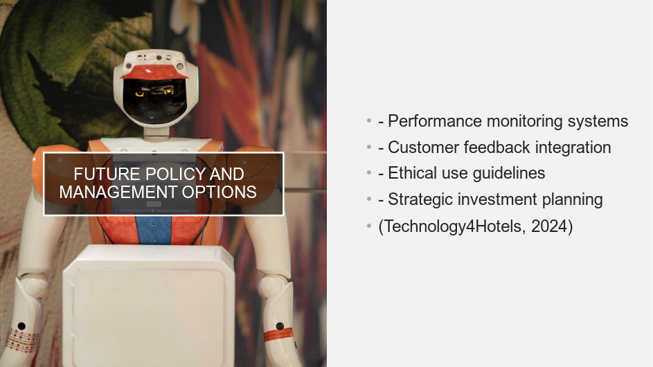
To effectively manage the future integration of robotic employees in hotels, it is crucial to thoroughly assess different legislative options whose performance monitoring tools are crucial for maintaining a high level of service and meeting operational standards in a robotic workforce. By incorporating customer feedback, hotels can continuously improve robotic interactions by incorporating visitor insights and preferences and by implementing ethical usage protocols, we ensure the responsible deployment of robots, prioritizing guest privacy and safety. Efficiently managing the financial aspects of deploying and maintaining robotic technologies necessitates careful investment planning to ensure long-term and cost-efficient adoption and these policies strive to optimize the benefits of utilizing robotic staff in hotels while also addressing any potential challenges.

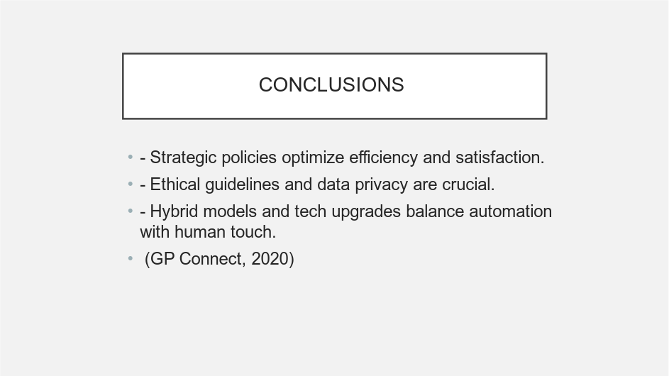
In summary, the integration of robotic employees in the hotel sector presents a mix of opportunities and challenges and strategies, like closely monitoring performance and seamlessly integrating customer feedback, are essential for maximizing productivity and ensuring visitor satisfaction. In addition, it is crucial to recognize ethical considerations and comply with data protection laws to maintain trust and ensure responsible use of technology while finally, through continuous investment in technical advancements and the utilization of hybrid service models, a seamless blend of automated benefits and the personal touch of human connection can be achieved and these strategies will help the hotel business adapt to the evolving landscape of robotic integration.




