Student ID: 2431100
Student Name: Jemima Adams

Introduction to Health & Social Care
Portfolio – Two Tasks
Module code: LCH4003
Lecturer: Shepheard Ziko

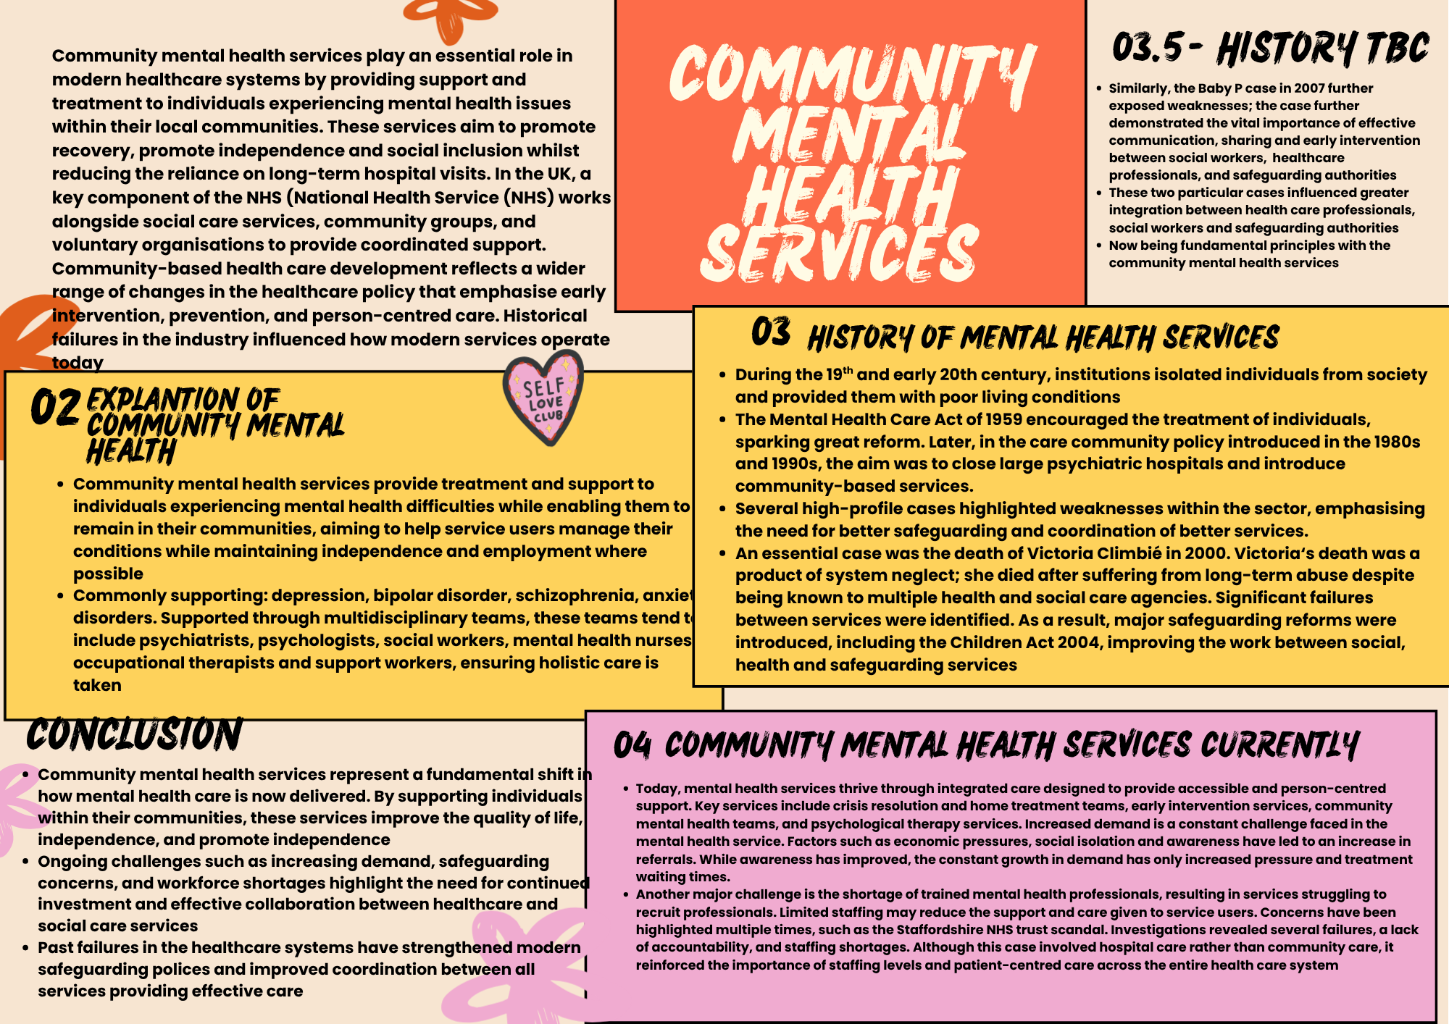

Ambulance Services
This essay explores the historical development of ambulance services, discusses their importance in improving the quality of life for services and evaluates how they operate within contemporary healthcare systems. Modern healthcare systems are made up of essential components, with ambulance services being one of them, providing emergency medical care and rapid transportation for individuals experiencing injury or serious illness. These services are critical in saving lives, improving outcomes and ensuring access to urgent healthcare.
Historical Development of Ambulance Services
The origins of organised ambulance services can be traced back to the late 18th century during the Napoleonic wars. The “concept of flying ambulances” significantly improved survival rates, designed to transport soldiers rapidly from the battlefield to receive medical treatment and is widely recognised as the foundation of modern emergency medical services, designed by French military surgeon Dominique Jean Larrery
In the United Kingdom, the development of civilian ambulance services began in the late 19th century. Organisations such as St John Ambulance played an important role in providing first aid training and emergency medical support. These voluntary services later contributed to the development of more structured emergency response systems.
Ambulance provision became integrated within the national healthcare system, ensuring that emergency medical care was accessible to all members of the public. The establishment of the National Health Service (NHS) IN 1948 marked a significant milestone in health promotion and the professionalisation of ambulance services. Ambulance provision became integrated within the national healthcare system, ensuring that emergency medical services were accessible to all members of the public.
Over time, ambulance services evolved from basic transportation providers into highly skilled emergency medical teams equipped with specialised training and advanced technology.
Current Functioning Of Ambulance Services
Modern ambulance services are highly organised emergency response systems that operate within integrated healthcare networks. In the UK, ambulance services respond to emergency calls made through the 999 and 11 systems and deliver rapid pre-hospital care.
Emergency and paramedics medical technicians are trained to assess patients, provide immediate treatment, and stabilise individuals before transporting them to hospital where necessary.
Equipment such as oxygen therapy, advanced monitoring systems and defibrillators allow paramedics to perform life-saving interventions at the scene of an emergency.
In addition to emergency response, ambulance services provide community-based healthcare interventions. For example, paramedics may assess patients at home and refer them to appropriate healthcare services rather than transporting them unnecessarily to the hospital.
Ambulance services also face constant pressures, rising demand has contributed to increased response times in certain areas. Healthcare failures pose as lessons such as the mid Staffordshire hospital scandal emphasise the importance of maintaining high standards of transparency, accountability and patient care within all healthcare services, this includes response systems.
Importance in Enhancing the quality of life
Rapid emergency responses can be the difference between life and death during medical emergencies such as cardiac arrest, severe trauma and strokes. Ambulance services significantly contribute to improving patient outcomes and quality of life.
Early medical intervention is essential and can prevent long-term complications, increase survival rates and reduce disability. For example, rapid defibrillation provided by paramedics has been shown to significantly improve survival chances for individuals experiencing cardiac arrest.

Ambulance services continue to support vulnerable populations, those with limited access to healthcare facilities, elderly individuals and people living in rural areas. By providing immediate medical care and transportation to appropriate healthcare services, ambulances help ensure that individuals receive timely treatment regardless of their location.
Furthermore, there has been an increased contribution from modern-day ambulance services and their preventative action to help identify patients who may require additional community support services.
Conclusion
From the origins of military medicine to becoming a fundamental part of the modern healthcare system, ambulance services have significantly developed. Through advanced medical care, rapid emergency responses, and coordination with wider healthcare services, ambulance professionals play a vital role in protecting public health.
Despite increasing pressures on healthcare systems, ambulance services continue to improve patient outcomes and enhance quality of life through timely medical intervention and access to emergency care.

