BMSW4002 Effective Teamwork and Communication

Assessment 1

Table of Contents
1. Introduction 3
2. Communication models 4
2.1. The Shannon-Weaver Model of Information Transmission 4
2.2 Schramm's Communication Model 5
2.3 Model of Berlo's Communication 7
3. Communication Skills 8
3.1 Verbal 8
3.2 Nonverbal expressions 8
3.3 Listening 9
3.3.1 Active listen 9
3.3.2 Listening empathically 9
4. Conclusion 11
Reference List 12

Introduction
It is possible to communicate effectively with another or more people when one delivers information while at the same time making oneself and the message understandable to another or more people. When it comes to carrying out one's administrative duties, it's impossible to ignore the importance of communication (Klewes et al., 2018). Companies need their employees to strengthen their communication skills in the workplace if they want to increase output and achieve their goals. It's important for the government to share information to keep businesses running properly, but they've been having trouble doing so.

Communication models
A model is a methodical depiction of a structure that can be used to portray an idealised or abstract version of something. Models are abstract structures that pare down to the essentials by ignoring irrelevant information (Muyeen, 2017). Explanations of communication can be found in a variety of models.

2.1. The Shannon-Weaver Model of Information Transmission
With the intention of clarifying how communication works, the most popular model is Shannon- Weaver's (Gillespie and Schiffman, 2018). In 1948, a scientist and mathematician collaborated to develop this concept.
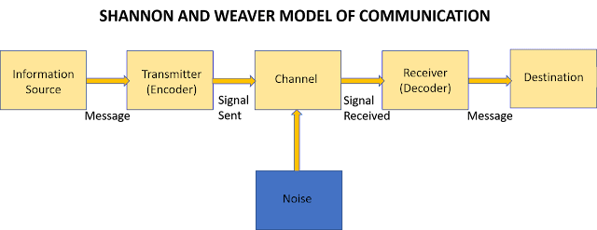
Figure 1: Shannon-Weaver theory of information transfer (source: Internet)
Sender: The individual who is responsible for the creation of a particular message is referred to as the sender in this paradigm. The onus of deciding which communication method to use rests squarely on the sender.
Encoder: The term "encoder" refers to the sender who, using a piece of equipment, transforms the message into either signals or binary data (Al-Fedaghi, 2012). It's possible that this is a reference to the machine in question.
Channel: The term "channel" refers to the medium through which information is transmitted.
Decoder: The receiver converts incoming messages back into signals after having received signals or binary data as input.
Destination: Those who receive messages and those who send them are called "receivers" and "senders," respectively, in the field of communication studies. After receiving the communication, the recipient gives some kind of response.
Relevance to the Case:
Due to background noise and the location of the receiver, Pedro was unable to understand Maria's call while he was working on the construction site. Since this model is useful in facilitating long-distance communication utilising various hardware devices, the case study of Maria and Pedro can be considered in the context of discussing this paradigm. Keeping the right entropy (the limit of uncertainty), redundancy, and uniqueness of information balance is crucial for avoiding this. Many devices are linked together to carry out communication as this model is founded on the value of hard effort and respect. The greater the amount of background noise, the higher the demand for redundancy in order to maintain clear and concise communication (Cobley and Schulz, 2013).

2.2 Schramm's Communication Model
Wilbur Schramm provided a framework for clear expression in his book, The Process and Effects of Mass Communication. The Schramm model, which represents the three essential components of any communication system—a sender, a receiver, and a message—is widely known (Pavenkov and Rubtcova, 2021). In a perfect world, a message would be encrypted at its origin, sent over a specific channel, and then decrypted at its final destination. The idea of transmitter and receiver having the same orientation is introduced from this model. The primary idea behind this approach places an emphasis on the two parties involved in the transaction exchanging information based on their respective levels of experience and knowledge. Effective and efficient communication is greatly enhanced when the sender and the recipient share a common background of life experiences (Vandome, 2012). Schramm didn't make a distinction between technical and non-technical communication, but he did advance the basic concept of communication to a more sophisticated one.
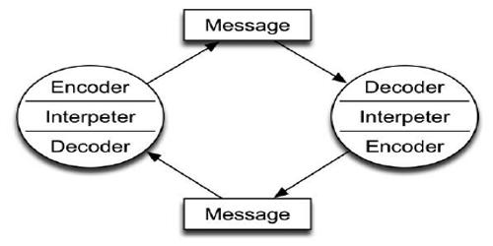
Figure 2: Berlo's paradigm of communication (Elkins et al., 2012)
Schramm's Model and Its Distinctive Features
While conceptually similar to Shannon and Weaver's model, this one frames communication in terms of the individuals doing the talking, rather than the information being exchanged. This model differs significantly from others in that it repeats itself at regular intervals (Elkins et al., 2012). Taking a traditional approach, this model replicates the flow of communication down to its most fundamental building blocks. The elements are like giant switchboards that constantly reroute and redirect a never-ending stream of data, making this phenomenon truly infinite in scope. Accordingly, there is a two-way street of information that needs to be deciphered.
Since the villagers were more well-educated than the professor, they were unable to assist him in his work since they did not grasp the meaning of the words he used. As a consequence of this, they were incapable of comprehending what the instructor was attempting to convey. The professor should have asked for assistance in simple terms, as he was well aware that the villagers did not have a high level of education. It is helpful to explain the problem using Schramm's Model of Communication. One of the key tenets of this paradigm is the importance of shared knowledge or experience amongst communicators. It will be difficult to carry out a successful communication process if the individuals involved are dissimilar to one another in terms of the many factors (Vandome, 2012).

2.3 Model of Berlo's Communication
Berlo gave a comprehensive model of communication in 1960. Because it is constructed in 4 stages—from source to message to the receiver to channel—this model is also known as the SMRC model (Stead, 2017). It is a step-by-step process that follows a linear format, and each stage of this model has been thoughtfully developed. In this approach, bitstream, data, and information are not discrete entities but rather are located within the code itself.
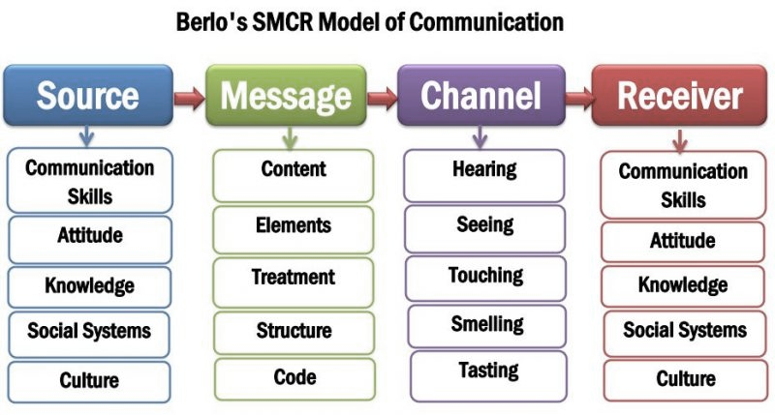
Figure 3: Berlo's paradigm of communication (newsmoor.com)
The source: The source in this paradigm represents the sender, the person or thing that initiates the transmission of a message without including any specified details for the recipient. It's important to note that the criteria for this component take into account a variety of aspects. Communication competence, sender and receiver attitude, information, social structure, and cultural norms are all contributors.
Message: The information that the sender employs in order to interact with the receiver is referred to by this model's second component, which is referred to as "the information." The content of communication consists of the full body of the message. A structure has been used to organise the message, and it can be sent via text, audio, video, or visual modes.
Channel: It's the channel through which the intended message can be communicated. The five channels depicted in the following model are all important components of the communication process (Tiainen et al., 2007). Sensations such as sound, sight, taste, touch, and smell are examples of channels.
Receiver: The model concludes with the receiver as its final component. They are the final target of the message the sender is trying to convey.

Communication Skills
Communication is sending and receiving information using a medium. A sender, a message, and a receiver are the three essential components of any communication process (McQuail, 2017). There are many factors that can influence how successfully data is transmitted from source to recipient. In order to keep communication flowing smoothly, it's crucial to pay attention to the whole process, rather than just the content of the message. Verbal and nonverbal communication are common types.

3.1 Verbal
One of the most effective forms of communication, it is also the most widespread and easily learned. Information is exchanged between people in this process mostly through the use of spoken language. Two-way verbal communication includes both oral and written forms.
Oral: When two people in the same physical location exchange information by speaking to one another, or when they use a medium like a phone, video chat, or voice chat, this is called oral communication.
Writing: As a means of conveying ideas and information, writing is similar to vocal forms of communication. However, the degree of formality used in written versus oral communication is a key distinction between the two. Verbal exchanges are typically more relaxed than written ones.

3.2 Nonverbal expressions
Body language is a non-verbal mode of communication that makes use of things like gestures, posture, eye contact, and facial expression in place of spoken language (Owings et al., 2013). The ability to observe and evaluate a variety of physical actions is crucial to understanding nonverbal communication. It's useful for explaining things like how someone is feeling or what they're going through, what kind of information they prefer to receive, and how to approach a group so that they can grasp the situation's gist.

3.3 Listening
The capacity to listen attentively and understand what is being said is a crucial skill in every conversation. A key component of any successful relationship is the ability to listen to one another. An individual's ability to listen determines how well they are able to gather information, comprehend the situation, and take away valuable lessons. As soon as there is a misunderstanding between the parties, communication is lost.

3.3.1 Active listen
When a person actively listens, they pay attention, using all of their senses, to what the speaker is saying (Gearhart and Maben, 2021).
Eye contact: Making direct eye contact with the speaker is a sign of full attention and participation in the conversation at hand.
Mirroring: Focusing on the speaker's intended audience and the topic at hand is reflected in the practise of "mirroring." To accomplish this, mimic the speaker's facial expression and gestures and show that you agree with them.
Preventing Distracting Actions: However, a good listener will refrain from doing anything that can be considered distracting, such as fiddling with their hair or picking at their nails.
Giving Responses: If the listener still has any questions or concerns, speaker can ask them a different question to clear things out (Jahromi et al., 2016).

3.3.2 Listening empathically
Empathic listening and clarifying questions for establishing context are hallmarks of empathetic listening, which can help develop and strengthen relationships with others (Miller, 2018). In order for the listener to comprehend the context and establish an intellectual and emotional connection with the speaker, it is crucial for communication to include this crucial element. It takes a lot of patience to develop the crucial ability to listen, as this entails not making assumptions about what the speaker is going to transmit next but rather listening attentively and trying to grasp what they are saying, even if you disagree with what they are saying. Part of this method involves interrupting the speaker with brief comments meant to keep them motivated to keep talking. Without openly criticising the facts or making arguments, the listener can ask questions to help explain the information being presented. It is necessary to pay close attention and use specific methods throughout this procedure (Gearhart and Maben, 2021).
The case of multitasker Max
Max got himself into a sticky predicament since there wasn't enough empathic listening going on. Even though Max is an event organiser, he avoided asking clients about their needs and avoided summarising or repeating the facts they supplied to clarify the problem over the phone. Instead of paying attention as Tamara explained the need for a shift in the program's timing, he simply nodded and agreed.
As a direct consequence of this, he failed to remember to postpone the programme. Avoiding this problem can be accomplished through active listening and asking questions to clarify and comprehend the caller's demands. If Max is able to sustain effective communication when taking the call by focusing on the needs of the current customer and listening to and remembering what they are, then he will be able to do so in the future as well. Max was very open about the fact that he was struggling to manage the entire job process, therefore Tamara's actions in this regard were inappropriate. She ought not confine their conversations to her problems but should inquire after Max's well-being as well. Given her awareness of Max's math struggles, she should be more patient and proactive in her efforts to elicit his cooperation in studying the program's requirements. Tamara and Max both lacked the ability to listen with empathy in this situation.

4. Conclusion
A thorough comprehension of the communication process can be provided to the individual with the aid of communication models. Different communication models, such as the Shannon-weaver model, the Schramm model, and the Berlo model, are discussed in detail and illustrated with relevant examples. There's no denying the significance of various modes of communication in facilitating efficient knowledge transfer. Listening is just as crucial as talking when it comes to effective communication. Keeping the lines of communication open requires attentive and empathic listening.

Reference List
Al-Fedaghi, S. (2012) “A conceptual foundation for the Shannon-weaver model of communication,” International journal of soft computing, 7(1), pp. 12–19. doi: 10.3923/ijscomp.2012.12.19.
Cobley, P. and Schulz, P. J. (eds.) (2013) Theories and models of communication. 1st ed. Berlin, Germany: De Gruyter Mouton.
Elkins, A. et al. (2012) “Predicting Users’ Perceived Trust in Embodied Conversational Agents Using Vocal Dynamics.” Available at: https://www.researchgate.net/publication/254051534_Predicting_Users%27_Perceived_Trust_in_Embodied_Conversational_Agents_Using_Vocal_Dynamics (Accessed: August 17, 2022).
Gearhart, C. C. and Maben, S. K. (2021) “Active and empathic listening in social media: What do stakeholders really expect,” International journal of listening, 35(3), pp. 166–187.
Gillespie, D. J. and Schiffman, R. (2018) “A critique of the Shannon-weaver theory of communication and its implications for nursing,” Research and theory for nursing practice, 32(2), pp. 216–225. doi: 10.1891/1541-6577.32.2.216.
Jahromi, V. K. (2016) “Active listening: The key of successful communication in hospital managers,” Electronic physician, 8, pp. 2123–2128.
Klewes, J., Popp, D. and Rost-Hein, M. (eds.) (2018) Out-thinking organizational communications: The impact of digital transformation. Cham, Switzerland: Springer International Publishing.
McQuail, D. (2017) Communications. 2nd ed. London, England: Routledge.
Miller, W. R. (2018) Listening well: The art of empathic understanding. Wipf & Stock.
Muyeen, S. (2017) “Communication,” Communication. Stevenage, Herfordshire.
Owings, D. H., Beecher, M. D. and Thompson, N. S. (2013) Communication. Edited by D. H. Owings, M. D. Beecher, and N. S. Thompson. New York, NY: Springer.

Pavenkov, O. and Rubtcova, M. (2021) “Lasswell and Osgood-Schramm models of mass communication.” Available at: https://papers.ssrn.com/abstract=3983485 (Accessed: August 17, 2022).
Stead, B. A. (2017) “Berlo’s communication process model as applied to the behavioral theories of Maslow, Herzberg, and McGregor,” Academy of Management journal, 15(3), pp. 389–394. doi: 10.5465/254868.
Tiainen, T. et al. (2007) Proceedings of 30th systems research Scandinavia, Core.ac.uk. Available at: https://core.ac.uk/download/pdf/250105068.pdf#page=1137 (Accessed: August 17, 2022).
Vandome, N. (2012) Effective communications in easy steps: Get the right message across at work. Southam, England: In Easy Steps.

