Name :- Reeyalkumar Patel
Student ID :- 2244445
Subject name :- international business
Subject code :- 7014

INTERNATIONAL BUSINESS
Table of Content
Introduction 2
Background Analysis 2
Internationalisation Strategies 4
Company's Internationalisation Approach 8
Impact of PESTLE factors on the company's decision-making process 10
Integration of Contextual Factors and Internationalisation Strategy 14
Recommendations for the Company 17
Conclusion 18
References 19

Introduction
International business encompasses the cross-border exchanges of services, goods, and resources between the home country and other host countries. International business allows companies to extend business to large markets and reach a global customer base while increasing the scope of business growth. Purpose of the present study is to analyse the internationalisation strategies of AstraZeneca while taking business from the home country the UK to India. The report includes analysing the internationalisation strategies of AstraZeneca along with a detailed discussion of the company's background, and international business approaches. Implications of business strategies in host countries have been discussed in the context of business environment, related decision-making, and foreign subsidiaries.

Background Analysis
AstraZeneca Plc is a science-led biopharmaceutical business that offers patients innovative respiratory and immunology medicines. Its headquarters is located in Cambridge, the United Kingdom. In 1913, Astra was developed in Sweden as the former pharmaceutical organisation. AstraZeneca was developed in 1999 through the merger of the British Zeneca Group and Swedish Astra AB (Astrazeneca, 2023). After emerging as AstraZeneca, the company entered into biotechnology through the acquisition of CAT, Arrow, KuDOS, and MedImmune in 2005-2007. Increasing company innovation has led AstraZeneca to acquire the rights to the respiratory division of “Spanish Pharmaceutical company Almirall” in 2014. Thus, AstraZeneca has become one of the largest and competitive bio-pharmaceutical companies in the world.
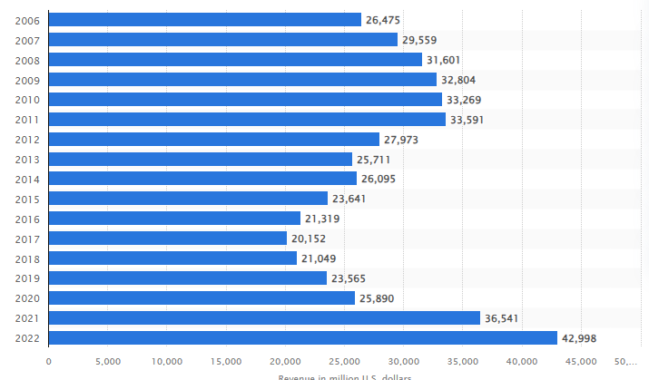
Figure 1: Revenue of AstraZeneca
(Source: Statista, 2023)
AstraZeneca’s medicine product portfolio includes a wide range of medicines including oncology, infection, gastrointestinal, respiratory, neuroscience, and cardiovascular disease. Consistent providence of effective medication has led the company to retain its business growth in consecutive years. Figure 1 indicates that AstraZeneca has generated about 43 billion U.S. dollars in 2022 which has increased from 36.5 billion U.S. dollars in 2021 (Statista, 2023). Mission of AstraZeneca is “to transform the lives of people affected by rare diseases through the development and delivery of innovative medicines” to more people all over the world. Company’s research and development and commercial functions are essential for discovering new medicines across the therapy areas. In terms of serving a large customer base, the company has started to internationalise its business in several countries. This biopharmaceutical company has started to globalise business by developing research & development activities, product manufacturing sites in several countries.
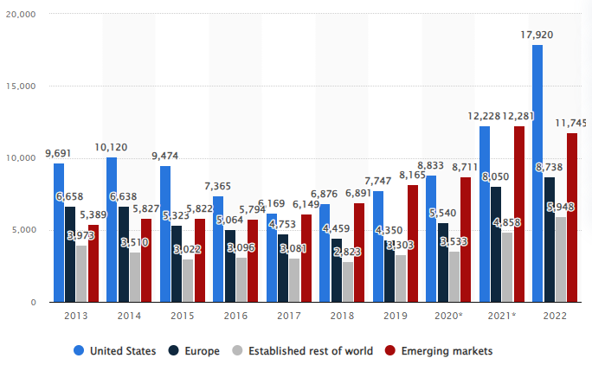
Figure 2: Revenue of AstraZeneca in global regions
(Source: Statista, 2023)
Presently, AstraZeneca operates in over 180 countries across the world. Figure 2 indicates that AstraZeneca has gained 18 billion U.S. dollars in the U.S. market, 8 billion in Europe, and 5.9 billion in other established markets (Statista, 2023). The statistics imply that the company has successfully done its business internationalisation by operating different business actions. In its home country UK, the company operates its R & D by developing the “Discovery Centre (DISC)” in Cambridge. Presently, £1.1 billion is invested in the home country’s R&D centre for installing primary laboratory equipment and for employing 2,200 research scientists (Astrazeneca, 2022). In the present case study, the company is analysed on its business expansion to the host country India. The internationalisation journey of the company started in 1979 when AstraZeneca India was established in Bengaluru, Karnataka. In this host country, “AstraZeneca India Limited (AZPIL)” operates sales, manufacturing, marketing, and other business activities.
All AstraZeneca units in India work together as a science-led pharmaceutical company while supporting the business purpose of delivering life-changing medicines to patients. In the host country India, AZIPL has hosted “Global Business Service”, “Global Medicine Development”, and “Global Technology Centre” in recent years. “Global Technology Centre” of AstraZeneca was established in Chennai, and about 2400 employees are engaged in India to deliver innovative medicine solutions using advanced technologies (AstraZeneca.in, 2023). In addition, the company has proposed to operate marketing and sales operations in various host countries. The organisation has also established a research and development centre in Bangalore in 2017 to support the company’s global medicine portfolio. This Bangalore team of 90 employees, supports a wide range of therapy areas including cardiovascular, respiratory, oncology, and other metabolic disease (AstraZeneca.in, 2023). Host countries’ operations are equally important along with the home country’s business operations for the successful internationalisation of business.

Internationalisation Strategies
Critical analysis of the core characteristics of the internationalisation strategies of ethnocentric, polycentric and geocentric
The core component of the international business is the entire commercial transactions consisting of the sale, investment along with the transportation. The main motivation to adopt the international business strategies is associated with the sales expansion, risk reduction and resource acquisition (“IB - Week 1 - International-Business-and-Globalisation”, 16). The management department of the multinational companies efficiently utilise the ethnocentric, polycentric as well as geocentric approach for expanding the entire operational activities across the world. The ethnocentric approach of internationalisation is based on the home country and recruitment of the people from the home country. In the ethnocentric strategy, the core positions of an organisation are strategically filled with the employees of the home country (Lee et al. 2022). The management authority efficiently engages to market the products and services internationally by following the manner of the home country.
Strategies | Core features
Ethnocentric | - Home-country oriented approach  - All employees recruited from the home country  - Entire decision made by the organisational manager of the home country  - Subsidiaries contain little autonomy
Polycentric | - Host country oriented strategy  - Recruitment procedure includes the employees of the host country  - Increased morale of the host country staff  - Host country nationals occupy the management positions
Geocentric | - Global recruitment approach  - Standardisation of the marketing mix based on the global needs  - Requires for the more effective collaborative approach between the company and subsidiaries  - Application of the international management experiences
Table 1: Core characteristics of the ethnocentric, polycentric and geocentric internationalisation strategy
(Source: Created by Author)
The polycentric internationalisation strategy is related to the recruitment of the employees from the host country. Polycentrism could be also termed as the recruitment method that is effective for maintaining excellent communication with the requirements of the global based customers. The lower cost of the training and workshop, increased morale of the host country employees and improved opportunities of the host country are the core features of the polycentrism (Paniagua and Rayamajhee, 2022). Additionally, adoption of the polycentrism approach could help the potential subsidiaries to better understand the local needs. Additionally, the polycentric values efficiently differentiate the cultural assimilation across the business dynamics across the host countries. Moreover, the main features of the polycentric strategy consist of the prosperous career opportunities of the host country, effective productivity and efficient morality of the employee.
The geocentric strategy of internationalisation is associated with the recruitment method of the best employees from different regions of the world. More precisely, an organisational manager with the geocentric approach believes in recruiting the talents and observing the world from a global perspective. According to Alugbuo et al. (2022), the implementation of the geocentric strategy plays an efficient role to increase the operational efficiency of the multinational company by recruiting global talent. In geocentrism, an organisation seeks to standardise the products, service also with the strategies across the world. The organisational manager with the geocentric perspective so efficiently engages to standardise the marketing mix for serving the people with the best quality products and services. The geocentric strategy is based on understanding the potential needs of the global customers in an efficient way.
Contrast of the internationalisation approach for understanding the impaction in the global expansion
The ethnocentric strategy of internationalisation is effective to maintain better coordination, efficient communication and decrease the operational costs. However, the adoption of the ethnocentric approach can create the cultural insensitivity, social myopia along with the resistance for the implementation of the potential change in the business environment. Contextually, Shults et al. (2022) critically analysed that, the fragmented corporate culture as well as issues in the subsidiary companies could be preventive for the global expansion of an organisation. The adoption of ethnocentrism can negatively affect the motivation for the global expansion of an organisational manager due to sourcing the employees only from the home country. The tendency for recruiting only from the home country can prevent the organisation from accessing the potential opportunities in a significant way that creates barriers for global expansion.
Ethnocentric strategy | Polycentric strategy | Geocentric strategy
- Recruitment only from the home country  - Missed opportunities for recruiting the best employees  - Lead to the cultural clashes  - Create resistance to implement change  - Delay the global expansion procedure | - Employee engagement from the host country  - Better understanding of the local necessities  - Problem with the language barrier  - Decisive power to the potential subsidiaries  - Comparatively efficient than ethnocentrism towards the global expansion | - Source the global talent  - Efficiently utilise the available resources and opportunities fully  - Transfer the best practices across the subsidiaries  - Comparatively effective to ensure the global expansion rather than polycentrism and ethnocentrism
Table 2: Comparison among the ethnocentric, polycentric and geocentric internationalisation strategy
(Source: Created by Author)
The adoption of the polycentric internationalisation strategy is effective to increase the potential career opportunities for the country nationals of the host country. More precisely, the polycentric approach of internationalisation is based on sourcing the tales from the host country of an organisation. On the contrary, the adoption of the polycentric strategy of internationalisation can be responsible for the emergence of conflict between the managers of the home country and host country (ILIC and DERBAL, 2022). Moreover, the polycentric strategy can remarkably contribute to the global expansion by supporting the companies for establishing the local presence within the individual foreign market environment. The core approach of recruiting and promoting the employees from the host country can be effective to ensure the internationalisation procedure.
The geocentric strategy of internationalisation is associated with global recruitment, identification of the requirements of the global customers and straightening the competitions. However, the higher costs of the operation, complexities as well as highly centralised control of the staffing can affect the global expansion (Diab, 2022). The adoption of the geocentric strategy efficiently allows an organisational manager to improve the performance quality by integrating the best talents across the entire world. Additionally, the management authority with the motivation of global expansion can utilise the potential human resources efficiently and establish a strong cultural network in a structured manner.

Company's Internationalisation Approach
Approach taken by AstraZeneca
Organisations generally take internationalisation approaches by operating the commercial transactions of Investments, manufacturing, sales, and marketing between two or more countries. With the business goal of consistent growth, AstraZeneca has also adopted a particular internationalisation strategy in an effective manner. One of the crucial business globalisation strategies is the hiring of employees to get better business outcomes. AstraZeneca has hired and worked with about 1200 employees in India (Astrazeneca, 2023). Company has preferred to look out for superlative talent in India who can serve patients with great standards. The main focus of AstraZeneca during internationalisation is to hire skilled and talented workers irrespective of location who can leverage science and innovation to create value for the patients.
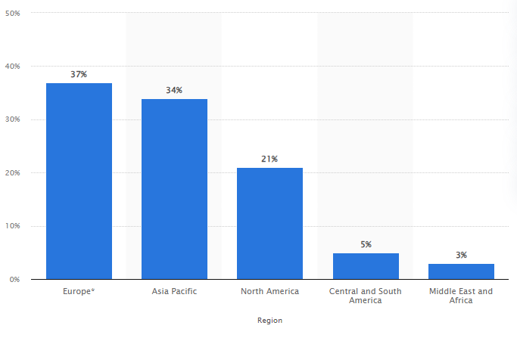
Figure 3: Employees in AstraZeneca by regions
(Source: Statista, 2023)
This approach to employee hiring is also applied in other host countries. As per the information of AstraZeneca's annual report, the company has hired over 22,500 employees globally through external and internal hiring (AstraZeneca, 2023). Company has prioritised career and leadership capacity development of workers by increasing workers’ global engagement rate. This employee staffing strategy indicates AstraZeneca’s internationalisation strategy to be geocentric. In the geocentric approach, the organisation seeks to employ the best man who can contribute in an independent manner and solve business problems efficiently (Derghan, 2022). The geocentric approach has led AstraZeneca to ensure the company's growth in terms of innovation, and profitability. Figure 3 indicates that AstraZeneca can control its business success with 37% of employees in the Europe region, 34% in the Asia Pacific region, 21% in the North America region, and 5% workers in Central and South America (Statista, 2023). Therefore, the geocentric approach is effective for continuing international business successfully for AstraZeneca.
Critical analysis of the Geocentric approach for AstraZeneca
The Geocentric approach, adopted by AstraZeneca has allowed the hiring of the most suitable and skilled employees in the organisation with respect to nationality and location. This approach has directly impacted internationalisation strategy to a certain extent which is discussed below.
Standardisation of business in AstraZeneca
Geocentric business approach is advantageous as it allows for recruiting the most skilled and competent workers for doing a job. This approach generally recognises that talent is global which is to create a diverse and inclusive workforce while ensuring business standardisation (Gupta and Sharma, 2023). Skilled employees across the world, have enough knowledge about standard norms of treatment, medication, and therapy which would not have been possible by the workers of a particular country. Company has been able to deliver standardised medication and treatment services in India by engaging skilled employees in “Global Innovation and Technology Centre” (GITC) (Astrazeneca.in, 2023). The organisation has included IT specialists, Pharmaceutical experts, and market-leading IT experts from all over the world in terms of developing global-standard services for the Indian Market. The geocentric approach has been crucial to start over the latest technology usage in the Indian market including “XR/VR Capabilities”, “Data and analytics”, “Hyper-Automation”, “Visualisation”, and other advanced technologies. Global standardisation of healthcare technology has been essential for getting a better place in the Indian Market for AstraZeneca.
Market entry mode
The particular market entry mode adopted by AstraZeneca, has been a crucial aspect of its internationalisation approach. Geocentric approach has directed companies to hire skilled employees who have ensured business expansion by starting new heal healthcare practices in new locations. AstraZeneca has applied the “partnership strategy” of market entry mode for expanding its business in India. Through partnership strategy, organisations can enter a new market with businesses that have already established channels to individual customers of the location (Vaskelainen et al. 2022). AstraZeneca has positively established its standardised healthcare service system by having partnerships with many Indian organisations. For instance, AstraZeneca has developed a partnership with Indian company “Tricog” which is a medical technology manufacturer and has started a new “Project HeartBeat”. With skilled employees all over the world, AstraZeneca has manufactured the InstaECG machine, a revolutionary ECGs solution in remote treatment (Astrazeneca, 2023). This internationalisation business strategy of partnership has brought great success to AstraZeneca where the company has been able to serve AI-based healthcare solutions to the top 60 Indian territories.
National cultural drivers behind the internationalisation approach
The cultural aspects of Indian employees and consumers are not fulfilled by the geocentric approach. Different national cultures of different employees create disagreement about information sharing, and taking lead responsibilities (IB - Week 6 - Strategies for-International-Business, Slide 22). Cultural aspects of Indian consumers are quite different from Western countries, and European countries where employees from other regions cannot understand the specific cultural demands. As a result of implementing a geocentric approach, the company may not influence Indian customers by offering their culture-related values and demands through healthcare technologies.

Impact of PESTLE factors on the company's decision-making process
PESTLE framework for India
Factor | Evaluation
Political | - The Indian “Foreign Trade Policy” depends on export promotion and collaboration (Epw, 2023).  - The “Political Stability Index” of India is -0.62 (Theglobaleconomy, 2023).
Economical | - The revenue of the Indian pharmaceutical company is estimated to grow by nearly 11.66 billion U.S. dollars by 2023 (Statista, 2023).  - The current inflation rate is approximately 4.95% in India (Statista, 2023).
Social | - Approximately 46% of the elderly Indian prefer to be facilitated by the dedicated healthcare facilities (Statista, 2023).  - A cost-effective healthcare service is the core requirement of the Indian.
Technological | - The Indian healthcare system is incorporating cost-effective technologies.  - Robotic surgery, artificial intelligence and telemedicine are advancing Indian healthcare (Indiatimes, 2023).
Legal | - The India government restricted the working time of the labourers in a flexible way (Lawyered, 2023).  - The pharmaceutical products can be imported by the trading ownership of the India government.
Environmental | - The “National Environmental Policy” is supportive of environmental wellbeing.  - The “National Resource Efficiency” of the India government is effective for resource conservation.
Table 3: PESTLE framework for India
(Source: Created by Author)
Analysis of the PESTLE framework
The “Foreign Trade Policy” of the India government is based on effective collaboration as well as exporting the promotional strategy in an effective way. Additionally, the negative political score could affect the new market within India. Additionally, the increasing pattern of the revenue in the pharmaceutical industry is indicating the prosperous situation for the development of the new organisation in India.
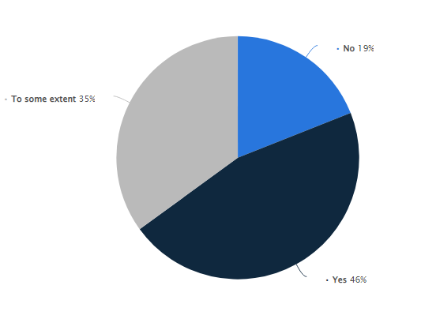
Figure 4: Awareness of the elderly Indian people towards the healthcare services
(Source: Statista, 2023)
The social perspective can be the motivational factor for the expansion of the new organisation within India. Moreover, approximately 19% of employees critically reported the inefficiency of the healthcare facilities in life (Statista, 2023). This situation can act as the motivating factor for expanding the new business within the pharmaceutical industry of India. Additionally, the advancement of the healthcare sector with the incorporation of efficient technologies can be efficient for the development of the performance of the Indian healthcare sector. The cost effectiveness of the healthcare system as well as ensuring the flexible labour law of the Indian government could be effective to maintain the consistency in the performance of the new firm.
Impact of the PESTLE factors on the decision making process of AstraZeneca and the foreign subsidiaries
The political, social, economical and social factors could affect the decision making procedure of the management department of AstraZeneca. The collaboration and export promotion-oriented “Foreign Trade Policy” of the Indian government could significantly attract the operation manager of AstraZeneca to expand globally. However, the negative score of the political stability can create the barrier to enter into the Indian pharmaceutical industry. Additionally, the political stability, confidence level of the consumer and intensity of the FDI level can be effective for making the potential decision regarding the business expansion in an effective way (Ekhart and Breese, 2022). Similarly, the growing pattern of the revenue of the Indian pharmaceutical industry could also motivate the organisational manager of AstraZeneca for expanding the pharmaceutical sector. However, the contemporary emerging inflation situation can demotivated AstraZeneca to expand the business operation within the Indian market.
The preference of the Indian elderly people for the effective healthcare facilities can affect the decision making procedure of AstraZeneca to redesign the existing products and services in an efficient way. Additionally, the management authority can implement the cost effectiveness approach within the entire operation by the development of the detailed PESTLE framework. The technological advancement plays a supportive role to integrate the entire operational complexity and create the strategic solutions in a rapid manner (Battisti et al. 2022). For instance, the implementation of the advanced robotic system, telemedicine and artificial intelligence would be effective to maintain the operational efficiency of the Indian pharmaceutical company. Additionally, the entire decision making procedure of AstraZeneca will be motivated by the flexible labour law of the Indian government that is configured with the restricted working hours. More precisely, an efficient trading ownership can be a motivational factor for AstraZeneca to expand in the Indian pharmaceutical industry.
Addressing procedure of the PESTLE factor by AstraZeneca to address internationalisation
The organisational manager of AstraZeneca is essentially needed to conduct the detailed risk analysis, consult with the local partners and assess the political system to drive the political factors to internationalise. Additionally, AstraZeneca could critically analyse the political environment by assessing the approach of the India government for improving the pharmaceutical industry. The addressing of the political factor can be effective for internationalisation due to consist of the international agreement for the trade (Shayery et al. 2022). The management department of AstraZeneca could address the economic factor through analysing the contemporary exchange rate, labour costs as well as income patterns and the employment trends. Additionally, the organisational manager of AstraZeneca is essentially responsible to identify the current financial stability, project the growth and interest rate in a systematic way. Concurrently, the executive board of AstraZeneca is essentially responsible to assess the unemployment rates along with the intense competition for the job opportunities for managing the economic uncertainty during the global expansion session.
The management authority of AstraZeneca is committed to adopt the potential practices like adopting the “social franchising model” and combining the social mind-set to address the social factors for internationalisation. Similarly, the managing authority of AstraZeneca is critically responsible for representing the “support programs” to foster the innovative environment of the planned business entry strategies. The addressing of the advanced technologies is also effective to maintain the consistency for driving the internationalisation (Vélez‐Ocampo and Gonzalez‐Perez, 2022). The management department of AstraZeneca can also create operational efficiency through creating the growing efficiency of the entire technological system in a systematic way. Additionally, the integration of the information intensity in the operational activity would be a supportive factor for AstraZeneca for expanding the business operation in the Indian pharmaceutical unit. Additionally, the address of the legal compliance and environmental factors will be effective for driving the internationalisation.

Integration of Contextual Factors and Internationalisation Strategy
The PESTLE analysis of the Indian business environment has illustrated fundamental aspects which are essential for influencing AstraZeneca’s international business strategies. Opportunities and threats of the Indian market have impacted AstraZeneca’s business practices in certain ways which are discussed below in its implementation of business strategy, international strategy, and value chain of the company.
International business strategy of AstraZeneca
Indian customers’ demands, social situation, and political situation have directly impacted AstraZeneca’s international business strategy in the host country. Companies generally adopt four types of international strategies including “Global strategy”, “Transnational strategy”, “multi-domestic strategy”, and “International strategy” (IB - Week 6 - Strategies for-International-Business, Slide 28). Organisations generally apply this strategy on the basis of national responsiveness and global integration.
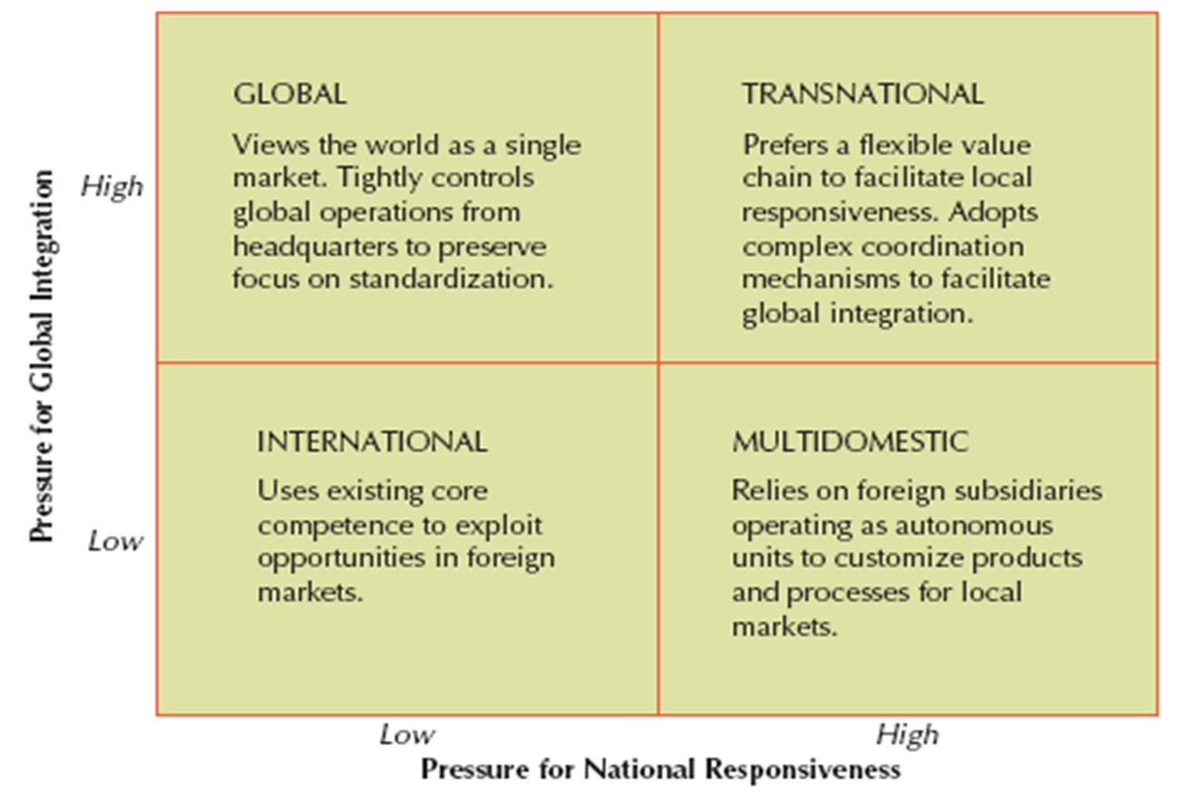
Figure 5: International strategies
(Source: IB - Week 6 - Strategies for-International-Business, Slide 28)
AstraZeneca has combined both local expectations of the Indian market and international trends of healthcare medicines for providing a standard service in the host market. The PESTLE analysis has identified Indian society to have more health-seeking behaviour in terms of building the best lifestyle. In terms of local responsiveness, AstraZeneca has developed different healthcare programmes in India. For instance, the company has developed a partnership with “Plan International India” and “Dr A.V. Baliga Memorial Trust” for different Indian citizen-focused initiatives of livelihood promotion, child protection, sanitation, HIV prevention, and other healthcare initiatives (Astrazeneca, 2023). In addition to local responsiveness, this biopharmaceutical organisation has integrated world-class healthcare solutions by establishing the “India-Sweden Healthcare Innovation Centre”. The latest AI-based solution is integrated by AstraZeneca for improving early-stage detection of lung cancer which is a globally recognised treatment process (Astrazeneca, 2023). Integration of local and global treatment aspects is highly crucial enough that has helped companies to diagnose Indian patients in the right ways.
The international business pattern of AstraZeneca indicates that the company is very crucial about both local and global aspects of healthcare. This strategy implies AstraZeneca’s Transnational strategy implication in the Indian market. In a transnational business strategy, the company prefers to facilitate local responsiveness while adopting Complex coordination mechanisms of global practices (IB - Week 6 - Strategies for-International-Business, Slide 28). This particular international strategy of transnational approach drives many benefits as it pushes managers to respond to coordinating processes, configuring resources, and changing social demands of a particular business location. In 2023, the revenue of “AstraZeneca Pharma India Ltd” has grown to 10.03 billion from 8.06 billion by increasing net revenue by 61.19% (Ft, 2023). Business records indicate the company's financial growth in India which is assessed to be the positive effect of the transnational strategy adopted by AstraZeneca.
International strategic goals of AstraZeneca
Another business aspect of AstraZeneca in India to create value through setting strategic goals in different host countries. An organisation can create value for customers by adopting two basic strategies; “Low-Cost Leadership Strategy”, and “Differentiation Strategy”. The business activities of AstraZeneca in India, directed the company to adopt “Low-Cost Leadership Strategy” after being influenced by India’s social structure. While applying “Low-Cost leadership”, firms sell products at either below-average industry prices to capture market share or at average prices to earn profit (Week 6 - Strategies-for-International-Business, Slide 15). AstraZeneca has also focused on reducing products and service prices in India in respect to the social aspect of Indian customers.
The PESTLE analysis has indicated that Indian customers generally prefer cost-effective and low-cost services due to the economic situation of the country. The Pharmaceutical market in India is forecasted to grow at CAGR of 9% between 2022 to 2025 (Astrazeneca, 2023). Some of the social factors that have also driven the company's strategic goals are ageing demographics, need for affordability, better awareness of wellness, preventive care, and healthcare delivery infrastructure. These factors have been crucial to direct AstraZeneca to offer cost-effective service delivery by applying “low-cost leadership”. For instance, recently AstraZeneca has provided cost-effective Covishield to the mass Indian population during India’s omicron Outbreak (Du et al. 2023). This international strategy goal has led the company to be one of the popular pharmaceutical companies in India while ensuring enough growth.
Value of chain in AstraZeneca
The business strategy of value creation of AstraZeneca is closely related to India’s technological, economical, and political aspects. Environmental scenario of India indicates, gradual development of country in using advanced healthcare and other technologies. These technologies have helped AstraZeneca to ensure continuous connection between healthcare professionals, patients, and other stakeholders. Indian Government has developed technological infrastructure that has eventually impacted on company’s proliferation of technologies (Astrazeneca, 2023). As a result of this situation, AstraZeneca has been able to provide enhanced treatment solutions to the Indian patients. Another vital aspect of AstraZeneca in value creation is its proactive supply chain. Company’s resilient manufacturing operations, robust inventory management, and supply chain, and efficient distribution network have enabled to operate the business successfully.
Sustainable product delivery and service providence is a crucial value that AstraZeneca provides to Indian customers. This unique aspect of sustainability has differentiated company’s approach in comparison to other pharmaceutical company for customers. The company has prioritised clean energy with the aim of tackling climate crisis. Company has taken initiatives to protect environment by decarbonising healthcare, controlling environmental impacts, and investing in nature to a great extent. Company has also delivered value to about 44.63 million people by engaging them in healthcare programmes (Astrazeneca, 2023). These business initiatives have increased the overall brand value of company in global marketplace as well as providing the advantages of adopted international strategies, specifically in India. Furthermore, the company needs to take certain steps to elevate the international business process which are recommended below.

Recommendations for the Company
Deploying digital marketing strategy
AstraZeneca is recommended to apply digital marketing strategy during the expansion of business in new market. Digital marketing leads company to use online Technology for promoting services and products. this strategy involves producing materials and services to be distributed across online channels for gaining more attention to the business. AstraZeneca can promote its advanced healthcare technology and sustainable healthcare services through the online channels such as website, email, blog, social media, video and audio streaming. As per the view of Pereira et al. (2023), organisation can create a greater consumer involvement with the brand while making the relationship more engaging through the digital marketing strategy.AstraZeneca needs to develop the tools and capabilities of digital marketing in terms of getting the advantages of more brand value. The company can learn about different business procedures, foreign environment, key players, new techniques of the international market and can use the information to create digital marketing content. This particular strategy will help AstraZeneca to retain more success from business internationalisation by overcoming cultural differences and segmented market of new location.
Targeting particular customer group
AstraZeneca is recommended to segment and target specific customer groups before entering in a new market for business expansion. Targeting a particular consumer segment, helps a company to determine product quality and service approaches which are to be offered in new market. Abbasi (2023) has mention that, targeting customers using sophisticated algorithms, is essential to provide a more personalised and richer customer experience. Target market is also effective for company in creating communication and marketing strategies to appeal the potential customers. selecting the most relevant consumer group can help the organisation to create services and products that ultimately focuses on the requirement of potential customer group. AstraZeneca can conduct detailed market research and identify industry trends of a particular market in terms of identifying potential customer base as per the offered products.
Compliance with regulations and legislation
AstraZeneca is suggested to have enough compliance with the regulations of countries before expanding business in different countries. The company needs to consider data Protection Act, data security legislation of countries while planning the internationalisation strategy in other countries. every country has their own data security policies that the companies are obliged to consider strictly. Olukoya (2022) has mentioned that the company needs to develop a framework for verifying compliance with regulations and laws relevant to information security to be ethical in business. Regulatory compliance Strategies and processes provide guidance for the companies as they drive to attend to their business aims. compliance is also essential for reducing the likeliness of law sweets, penalties, science, and closure of the business for not considering regulatory instructions. Moreover, this recommendation will be essential to AstraZeneca for executing the business with high sustainability and ethical approach in the international marketplace.

Conclusion
It can be concluded that the international strategy adopted by AstraZeneca has been effective for consistent business growth in the Indian market. The business aim of serving a large customer group has directed AstraZeneca to adopt a Polycentric international approach. Company’s transnational strategy has directed to be locally responsible and globally standardised to a great extent. Environmental analysis of India has directed the market to be quite favourable for AstraZeneca’s business. The company has generated high-level value in terms of the good supply chain, innovation, technology, and healthcare prevalence in the Indian Market. Company is recommended to adopt digital marketing and compliance for better results of internationalisation.

References
Abbasi, N., (2023). Business strategies for the internationalisation of the fashion industry in Finland.
Alugbuo, C.C., Ikwumezie, A. and Ugochukwu, C.O., (2022). Managerial Approaches and Organizational Performance of Multinational Enterprises in Nigeria. Central Asian Journal of Innovations on Tourism Management and Finance, 3(6), pp.76-88.
Astrazeneca, (2022), Annual Report, https://www.astrazeneca.com/content/dam/az/Investor_Relations/annual-report-2022/pdf/AstraZeneca_AR_2022.pdf, [Accessed on: 10/11/2023]
Astrazeneca, (2023), AstraZeneca, Available at: https://www.astrazeneca.in/content/dam/az-in/pdf/2022/investor-relations/Annual%20Report%202021-22.pdf, [Accessed on: 10/11/2023]
Astrazeneca, (2023), Careers, Available at: https://careers.astrazeneca.com/india, [Accessed on: 10/11/2023]
Astrazeneca, (2023), Impact beyond India, Available at: https://www.astrazeneca.com/media-centre/articles/2022/India-health-innovation-hub-transforming-lives-worldwide.html, [Accessed on: 10/11/2023]
Astrazeneca, (2023), Our history, Available at: https://www.astrazeneca.ch/en/about-us/our-history.html, [Accessed on: 10/11/2023]
Astrazeneca, (2023), Sustainability at AstraZeneca, Available at: https://www.astrazeneca.com/sustainability.html, [Accessed on: 10/11/2023]
Astrazeneca, (2023), Young Health Programme India (phases 1 & 2), Available at: https://www.yhp.astrazeneca.com/programmes/india.html, [Accessed on: 10/11/2023]
Astrazeneca.in, (2023), About us, Available at: https://www.astrazeneca.in/about-us.html, [Accessed on: 10/11/2023]
Astrazeneca.in, (2023), AstraZeneca’s Global Technology Centre in India increases its focus on driving innovation – repositioning itself as a Global Innovation and Technology Centre, Available at: https://www.astrazeneca.in/media/press-releases/2022/astrazenecas-global-technology-centre-in-india-increases-its-focus-on-driving-innovation-repositioning-itself-as-a-global-innovation-and-technology-centre.html, [Accessed on: 10/11/2023]
Battisti, S., Agarwal, N. and Brem, A., (2022). Creating new tech entrepreneurs with digital platforms: Meta-organizations for shared value in data-driven retail ecosystems. Technological Forecasting and Social Change, 175, p.121392.
Derghan, M., (2022). Management Of Best Practices in Multinational Companies: Starbuck’s Best Practices in The Lebanese Market. Technium Business and Management, 2(3), pp.116-123.
Diab, O., (2022). The EPG Model in Multinational Companies: The Case of Mazaya. Management Studies and Economic Systems, 7(1/2), pp.17-24.
Du, Z., Wang, L., Bai, Y., Feng, S., Ramachandran, S., Lim, W.W., Lau, E.H., Malani, A. and Cowling, B.J., (2023). Cost effectiveness of fractional doses of COVID-19 vaccine boosters in India. Med, 4(3), pp.182-190.
Ekhart, G. and Breese, R., (2022). The influence of government upon multinational company manufacturing location decisions. European Management Review.
Epw (2023). The Foreign Trade Policy 2023. Available at: https://www.epw.in/journal/2023/40/commentary/foreign-trade-policy-2023.html#:~:text=India's%20Foreign%20Trade%20Policy%20(FTP,(Press%20Information%20Bureau%202023). (Accessed on: 10 November, 2023)
Ft, (2023), About the company, https://markets.ft.com/data/equities/tearsheet/profile?s=ASTRAZEN:NSI, [Accessed on: 10/11/2023]
Gupta, K. and Sharma, M.A., (2023). Global Talent Acquisition: Strategies and Best Practices for Staffing and Recruitment in A Globalized World. MANGLAM PUBLICATIONS, p.177.
ILIC, D.K. and DERBAL, A., (2022). EXPAT MANAGEMENT: EXPLORING EXPATRIATE ADJUSTMENT IN INTERNATIONAL ASSIGNMENTS. Research on Economics and Administration and Social Sciences, p.265.
Indiatimes (2023). Advancing medical technology innovation and changing the face of healthcare in India. Available at: https://timesofindia.indiatimes.com/blogs/voices/advancing-medical-technology-innovation-and-changing-the-face-of-healthcare-in-india/ (Accessed on: 10 November, 2023)
Lawyered (2023). Major Labour Laws Amendment in India. Available at:https://www.lawyered.in/legal-disrupt/articles/major-labour-laws-amendment-india/#:~:text=However%2C%20the%20new%20labour%20laws,per%20quarter%20for%20all%20industries. (Accessed on: 10 November, 2023)
Lee, H.J., Yoshikawa, K. and Harzing, A.W., (2022). Cultures and Institutions: Dispositional and contextual explanations for country-of-origin effects in MNC ‘ethnocentric’staffing practices. Organization Studies, 43(4), pp.497-519.
Olukoya, O., (2022). Assessing frameworks for eliciting privacy & security requirements from laws and regulations. Computers & Security, 117, p.102697.
Paniagua, P. and Rayamajhee, V., (2022). A polycentric approach for pandemic governance: Nested externalities and co-production challenges. Journal of Institutional Economics, 18(4), pp.537-552.
Pereira, L., Tovstolyak, Y., Costa, R.L.D., Dias, Á. and Gonçalves, R., (2023). Internationalisation business strategy via e-commerce. International Journal of Business and Systems Research, 17(2), pp.225-250.
Shayery, A.J., Zayed, N.M., Islam, K.M.A., Hossain, M.F., Nitsenko, V.S. and Imran, M.A., (2022). THE IMPACT OF INTERNATIONALIZATION TO IMPROVE AND ENSURE QUALITY EDUCATION: A CASE STUDY OF DAFFODIL INTERNATIONAL UNIVERSITY (BANGLADESH). Natsional'nyi Hirnychyi Universytet. Naukovyi Visnyk, (6), pp.160-169.
Shults, L.M., (2023). Reason-based deference or ethnocentric inclusivity? Avery Kolers, Richard Rorty, and the motivational force of global solidarity. Journal of Global Ethics, 19(1), pp.6-21.
Statista (2023). Awareness about dedicated healthcare facilities for elderly people India 2023. Available at: https://www.statista.com/statistics/1302750/india-awareness-about-dedicated-healthcare-facilities-for-elderly/ (Accessed on: 10 November, 2023)
Statista (2023). India: Inflation rate from 1987 to 2028. Available at: https://www.statista.com/statistics/271322/inflation-rate-in-india/ (Accessed on: 10 November, 2023)
Statista (2023). Pharmaceuticals - India. Available at: https://www.statista.com/outlook/hmo/pharmaceuticals/india#:~:text=Revenue%20in%20the%20Pharmaceuticals%20market,US%241.76bn%20in%202023. (Accessed on: 10 November, 2023)
Statista, (2023), AstraZeneca's revenue from 2006 to 2022, Available at: https://www.statista.com/statistics/266542/revenue-of-astrazeneca-since-2006/, [Accessed on: 10/11/2023]
Statista, (2023), AstraZeneca's revenue from 2013 to 2022, by region, https://www.statista.com/statistics/266550/revenue-of-astrazeneca-by-region-since-2006/, [Accessed on: 10/11/2023]
Statista, (2023), Distribution of employees at AstraZeneca in 2022, by region, Available at: https://www.statista.com/statistics/266558/astrazenecas-employee-distribution-by-region-since-2008/
Theglobaleconomy (2023). India: Political stability. Available at: https://www.theglobaleconomy.com/India/wb_political_stability/#:~:text=Political%20stability%20index%20(%2D2.5%20weak;%202.5%20strong)&text=The%20average%20value%20for%20India,193%20countries%20is%20%2D0.07%20points. (Accessed on: 10 November, 2023)
Vaskelainen, T., Münzel, K., Boon, W. and Frenken, K., (2022). Servitisation on consumer markets: entry and strategy in Dutch private lease markets. Innovation, 24(1), pp.231-250.
Velez‐Ocampo, J. and Gonzalez‐Perez, M.A., (2022). Internationalization and capability building in emerging markets: What comes after success?. European Management Review, 19(3), pp.370-390.

