Utilising the Entrecomp Framework, critically evaluate your own creativity and enterprise and consider how you might be able to develop the creative and enterprising skills of primary learners through your own pedagogy.
Creativity is an essential skill for learners to develop how to communicate and express original ideas and feelings (Fisher and Williams, 2004). Robinson (2013) defines creativity as process of developing ideas and having them be valued by others. Within the current world, creative thinking has huge value, as creativity supports learners to grow their personal talents and abilities to make meaning. Costa and Kallick (2008) defined behaviours and attributes of a creative person, which are known as the sixteen habits of mind (appendix one). These attributes have not been just collected from musicians, mathematicians or scientists, they have been collected from all walks of life. Teachers can use these attributes as a creative checklist to see if children are being inventive when they explain an answer related to a creative question or in their work.
Enterprising skills closely links to creativity as they both have connections and similar aspects which develop learners to become high achievers in life. Enterprising learners will be prosperous in eight skills which are; creative skills, problem-solving skills, good listening and understanding skills, collaboration skills, good leadership and presenting skills as well as being positive and aiming high in everything they undertake (Enabling Enterprise, 2015). This is an achievable goal for teachers to aim for, as every learner should leave school confident and creative individuals ready to succeed in life. European Commission (2016) released the, “Entrecomp Framework,” to build bridges with education and work life through three areas and competences (appendix two). The framework areas closely connect to the enterprising skills to make sure education generates lifelong learners.
The framework is believed to be flexible and can be adapted to support different inspirational contexts. The idea behind the framework is to provide learners with time to process their creative ideas, while the teacher generates the framework skills to enhance the learning taking place. This is useful as these skills can be adapted to use within the developing curriculum with areas of learning such as, the literacy and numeracy framework and digital competency framework. Donaldson (2015) states within the report of, “Successful Futures,” that he wants children to be enterprising and creative contributors for them to flourish within the fast-developing, future Welsh society. This relates to what the European Commission (2016) wants to achieve too, by promoting work skills for learners. Donaldson (2015) recognises how important developing creative and enterprising learners are, as it is one of the four main purposes (appendix three) within the evolving curriculum. Therefore, this would mean that the Entrecomp framework would be useful to partner to achieve a better, successful education for all.
Kirsty Williams (WG, 2017) explains in the, “National Mission,” that every child should be aiming high and achieve their goals, while becoming resilient and imaginative individuals also. Therefore, for children to reach their full potential, teachers will need to be creative with lessons, while teaching children creative and enterprising skills. This links closely to the entrecomp framework (2016) as the skills the framework wants to develop are, critical thinking, problem-solving and learning to learn. These skills are needed to create the future Welsh society fairer and better well-being for all, and this is evidenced in the Welsh government document (2015), “Well-being future generations (Wales) act.” The aim of the framework is to develop social inclusion, personal development and active citizenship for all. To achieve the set goals in the well-being document children will have to be taught the above skills, to make Wales a fairer society in the future by using the framework.
On the contrary, the entrecomp framework has not been used in real setting such as education systems, therefore, we do not know if it will be effective or work. The framework may lead education to use more business leadership skills, rather than creative skills. Education is to teach children about various skills and knowledge from a wide range of subjects, not just business skills. The framework explains that they can measure how creative individuals are by using different levels to identify where you are, and how you can move forward to become more creative. As the framework has not been tested, the levels may not work. Therefore, if teachers want a tool to measure their creativity from a reliable source, they should use Torrance’s (1963) creativity tests which measured creativity accurately and successfully through testing for fluency, flexibility, originality, elaboration and resistance. This would be reliable as there is evidence that the test works effectively, consequently, there would be no need for the Entrecomp framework to be used or tested. Although, if the framework is yet to be tested, it could be vital for schools to use in the future to develop curriculum links such as the literacy, numeracy framework and digital competency framework, as it could be extremely effective once professionals are taught how to use the framework. Before disapproving the framework, perhaps professionals should test the framework and measure its effectiveness through a month of lesson reflections to understand the effectiveness on learners’ abilities and needs.
Teaching the creativity process has been diverse in many ways. Baer and Kaufman (2006) believe teaching creativity is amendable to teach. Guilford (Parnes, 1963) implied that creativity can be fostered like behaviour can be nurtured. Michael Gove (Grigg, 2015) believed that before children can express themselves and their ideas, they will need to acquire basic knowledge and understanding of creativity. Robinson (2013) argues that creativity is not a linear process, he believes it is a personal process that develops and flourishes while being educated at school. For this reason, creativity should not be seen just for talented learners or subject related elements like art or music, everyone has creative skills. This can be a challenge for teachers as it might be difficult for teachers to overcome negative attitudes towards creativity from the children. Therefore, teachers need to build children’s confidence that they are all good in creative skills, otherwise they will lead a life where they will think negatively about their enterprising and creative skills, hence they could believe that they are deskilled in future society. Creative programmes such as De Bono’s (1985) six thinking hats can be used to generate diverse ideas to solve problems through divergent thinking.
Creativity within in the old curriculum was a secondary importance as teachers needed to meet intense set curriculum targets, which did not give teachers time to teach creative lessons or be creative (Grigg, 2015). The old curriculum focused less on enterprising skills like problem-solving which can be used in real-life, and more focus on standardised teaching strategies with no creative involvement. For children to develop their full potential, teachers will need to understand the importance that creativity is not on the opposite end to literacy, numeracy lessons. In the new curriculum, this has changed as creativity can be found across every subject within Foundation Phase (FP) and Key Stage Two (KS2) subjects (appendix four). Enterprising skills and creativity can be used in a cross-curricular approach which is beneficial for teachers to teach the whole curriculum areas creatively (Barnes, 2011). Also, teachers can build on previous creativity skills daily from the curriculum, by allowing children to explore their natural curiosity to develop imagination through promoting thinking skills. Teachers can teach creativity as a process, rather than a subject this way (Wyes, 2013).
Creativity can be criticised within education as teachers need to teach innovative practices while progressing multiple intelligences (Armstrong, 2000), as well as developing higher order thinking (Fryer, 2003). Secondly, another challenge is to create a learning environment that supports enthusiastic creative behaviour (Torrance, 1995). Enterprising and creativity skills can be attained if the learning environment is an inviting, inclusive atmosphere to develop innovative learners and inspire creativity (DeWitt, 2011). A stimulating learning environment will allow children to mature their creativity skills independently through first-hand experiences or, by working collaboratively with peers. Outdoor environments and learning walks allow imagination to flow and research suggests that walking boosts divergent thinking. Outdoor learning environments can also motivate as children can explore their senses in open spaces (Gilchrist and Emmerson, 2016). Adding provision to the learning environment will create wonder and awe to motivate learners to freely think also. This will create challenges for teachers as it can be difficult to achieve an inspiring learning environment. Rearranging furniture frequently permits children to recognise that classrooms should be active to resemble how thought processes work, nevertheless, moving furniture is one aspect to develop creativity.
Pupil-voice should be used so that learners can express themselves about the learning environment with arrangement of the classroom to develop respectful relationships with peers and the teacher. If teachers ask what the children need to become high achieving learners, teachers will overcome challenges about the learning environment. Children understand what they need from creative spaces therefore, their point of view about the learning environment is vital. This will raise standards in achievement, attainment and pupil well-being. Developing creative learners in learning environments will allow children to progress in life skills such as problem-solving and other skills (Duffy, 1998). These skills provide experiences for children which lead to vital reflections for development of original ideas. These experiences can be shared with different characters in society like artists, mathematicians or musicians to develop their knowledge and connections with the community.
The writer’s own creativity skills have been measured through the entrecomp framework in two competences of; creativity (ideas and opportunities section) and self-awareness and self-efficiency (resources section). Firstly, to measure the writer’s own creativity, she tried to understand where creativity can be found to be able to assess her own creativity successfully. Amabile (1983) believed creativity can be found at ordinary everyday situations to higher levels of creativity in inventions, paintings or scientific discoveries. This proves that every individual has the desire and can be creative. Amabile (1983) explained that there are three influences on creativity which are; domain relevant skills, creativity-relevant skills which are cognitive and personal processes to develop thinking and lastly, task motivation and enjoyment to engage within creativity. This is known as, “the componential model of creativity.” After understanding these components of creativity, the writer reflected upon her own creative thinking such as when she created ideas of how to use a shoe in different ways, at a task in university (appendix five). The writer understands that imagining different valuable uses of a shoe is not a science discovery, yet it is an everyday creativity task that boosted the writer’s creativity skills. At the time, the writer did not feel that she was immensely creative, yet some of her ideas were original, which is evidence that she used her divergent thinking.
After looking at entrecomp framework levels, the writer based herself at intermediate level three, as in the section of developing ideas, the writer did explore the different solutions of how to use a shoe in different contexts effectively, and she understood the design value of the basic function from the shoe. Therefore, to develop the writer’s creativity thinking further onto the level four, she will need to test the value of the shoe methods to test how effect and valuable the ideas were. This could be done through using the writer’s convergent thinking, to have only one best fit idea for the shoe. Diversely, this would mean that the writers creativity skills will be decreased as convergent thinking dulls creativity and imagination, the writer needs to overcome her functional fixedness in order to be creative (Craft, 2000). Although, if divergent and convergent learning are connected, this will progress the writer’s problem-solving skills through creating many imaginative solutions that work. The level three was awarded by understanding how creative the writer is through her thinking and imagination skills. This does not mean she is a level three for her creative teaching. Supposedly, to create good creative lessons, the writer would have to be on a good level of understanding through her own creative thinking to plan effective lessons.
To prove the writer has good skills to teach creativity, she will provide evidence through an example lesson in KS2. The lesson was taught to year five pupils, where they had to create body movements to express feelings and emotions through no communication. The lesson was taught to deepen their knowledge within history, while developing different types of learners needs through body-kinaesthetic, interpersonal and intrapersonal intelligences (Gardner, 1985). Before the lesson was planned, the writer made sure that this lesson was never taught to the children so, that they would imagine creative emotion movements through new, original ideas. The lesson involved the children having scenarios from World War Two (WW2), where they used their creative movements to show how they felt within situations such as, leaving their mother to go to a safer environment via a long train ride to the countryside. They imagined original movements independently then collaborated in groups to show their creative movements. An example of this was a child used their body to arch downwards to create a sad smile, while using one arm straight in the air to visualise a tear. This is evidence that the child was using an element of divergent thinking through the aspect of complexity of their ideas.
The children valued every child’s original ideas of the different scenarios, as they knew every child would act differently to each problem, as everyone thinks differently. This type of learning is developing heutagogy teaching (Hase and Kenyon, 2000), as the writer is using a holistic teaching approach to allow children to explore while creating discussions about information they want to learn about. This type of teaching is effective for creativity, as the children are self-leading their learning by contributing to the lesson through interaction with others. However, this type of learning was not personalised to suit thirty different learning needs, although heutagogy learning is essential to create children who are determined to seek knowledge and to become life-long learners, which European Commissions (2016) wants to provide in their framework. The writer found this lesson thought-provoking while innovative, as the children were engaged by learning about well-being feelings and applying them to real-life situations, which happened hundred years ago. The valuable outcome of this lesson was allowing children to explore their divergent thinking skills (Runco, 1991), while developing historical knowledge through questions and thinking time to process the information (Black and Wiliam, 1998). Some children connected this lesson to how refugees would feel, and this connected the children to modern day society. This developed the children’s diverger learning style (Kolb, 1994) as all children were learning about real-life experiences and discussing the problems in detail, through self-chosen action (McAuliffe, et al, 2008). The children were developing their own critical thinking skills in a respectful, controlled environment to allow learner performance grow, as well as students learning from each other (Rogers et al, 2013). The children were developing innovative, problem-solving skills within this discussion (Blaschke, 2012) as they were reflecting (Savery and Duffy, 1995) and expressing true emotions how they would feel in past-history like WW2 and modern-day history.
Lastly, the writer will measure her self-awareness and self-efficiency using the entrecomp framework. To measure this accurately, she will be using her arc from the history lesson to analyse what level she will be. Reflections provide evidence for self-awareness and self-efficiency, as they show personal development to improve personal targets. The writer reflects constantly as she strives for her best, not just to improve her own development, but to also make sure that children are provided with lessons that reach their full potential. The writer believes that her reflection (appendix six) supported her to understand how self-efficient and aware she is. Before understanding what creativity really intended, the writer was not confident in teaching creative lessons as she did not think she was not skilled enough in creative related subjects, like art or music.
This is a challenge as the writer needed to develop a positive ethos with an open attitude towards creative ideas and behaviours, also, developing a humanistic approach to value independent thinking (Chen, 2008). At the start of teaching for creativity, the writer had no confidence as she needed to have an accepting approach to challenges and failed attempts of creative lessons, instead of thinking she was not creative through errors. The writer needed to be more reflective in order to achieve this challenge and to be an inspirational teacher. A lack of professional voice (Callan, 2008) will reflect onto the students. Non-creative behaviour is learnt as discussed previously, so the writer needed to be positive to reflect positive creative behaviour for children to learn positively (Land-Ainsworth and Jarman, 1993).
The writer believes she is on level three and four intermediate level, as her reflection included own targets to strive for improvement, which shows the writers commitment to fulfil her goals to be the best teacher (appendix seven). The lesson was taught to four groups over four days, therefore, the writer knew how to improve the lessons for the next group through creating more value of the lesson. This provided learners with better opportunities to achieve their creative needs. The writer’s confidence grew to teach this creative history lesson also, and this is documented in the reflection. She knew that the children were developing vital knowledge and understanding about children from WW2, as well as progressing in key enterprising and creative skills. As the writer repeated this lesson four times with different ability groups, her creativity confidence grew stronger, and she was self-aware about this, as she started creating her own historical scenarios and questions by using her own creative initiative to develop the children’s divergent thinking. This is evidence for the writer’s self-efficiency of her creative mind by judging her own strengths and weaknesses (Bohm, 1998).
One of the challenges in developing enterprising and creative learners, is developing their creative minds through different ways of thinking. This can be a challenge for teachers as all children are motivated by different types of questions to develop the skill of problem-solving. For example, lower ability children benefit from knowledge and comprehension questions to raise confidence from teacher praise if correct and higher ability children develop deeper knowledge from difficult open and closed questions (Woolfolk, 2008). Hayes (1998) stated that novice teachers would not understand the difference between differentiating questions, consequently this could be a challenge for teachers. Sharp (2004) advices teachers how to promote creativity through open-ended questions, praising unexpected answers and modelling creative thinking and behaviour. On the other hand, teachers will benefit from enterprising and creative lessons as they will produce better relationships with children through connecting learning in engaging and exhilarating lessons (N.A.C.C.C.E, 1999). The writer believes her reflections support learners to motivate their creativity as she has evidenced how she used high-order thinking questions to stimulate the children in the history lesson. To reach an overall level four, the writer would need to compensate her weaknesses by building upon more strengths, while inspiring more learners to develop their creative weaknesses into strengths, through positive attitudes with more problem-solving and decision-making tasks.
In conclusion, the writer believes the entrecomp framework could be useful to utilise teachers and learner’s skills, as there are many aspects ranging from different creativity aspects. This means it could be used effectively to move children forward in their creativity to support them to have positive futures. If creativity was made vital in the old curriculum, perhaps there would already be more talented artists, mathematicians and scientists to enhance their creative capacities for a fairer and successful society. Overall, creativity is an essential part to develop important work-related skills and thinking skills. William Plomer (Grigg, 2015) described, “creativity is the power to connect the seemingly unconnected.” This is an influential quote to remember that all teachers can provide every learner with creativity to connect all areas of learning and connect all pupils to society.

Appendices.
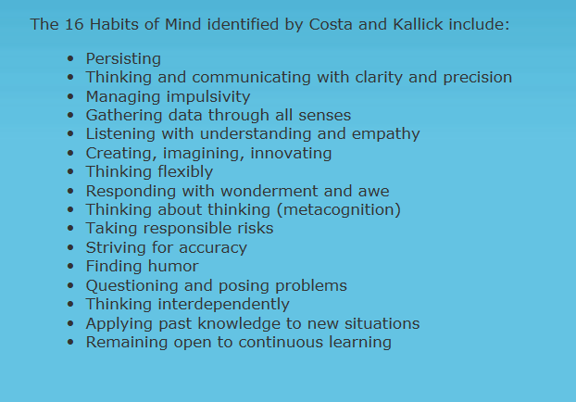
Appendix One:

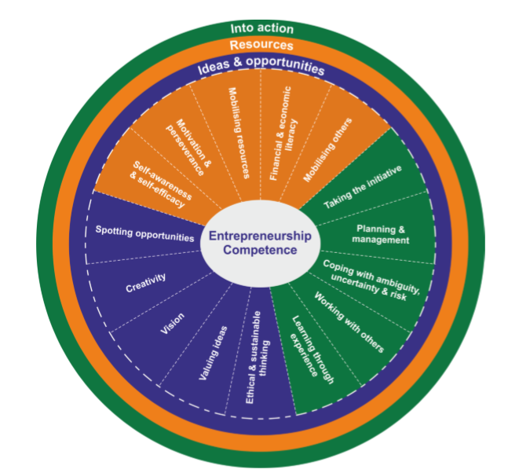
Appendix Two:

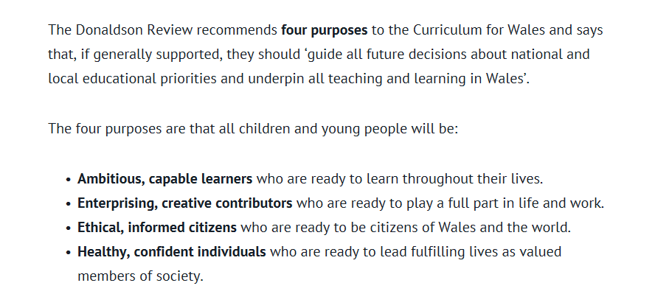
Appendix Three:

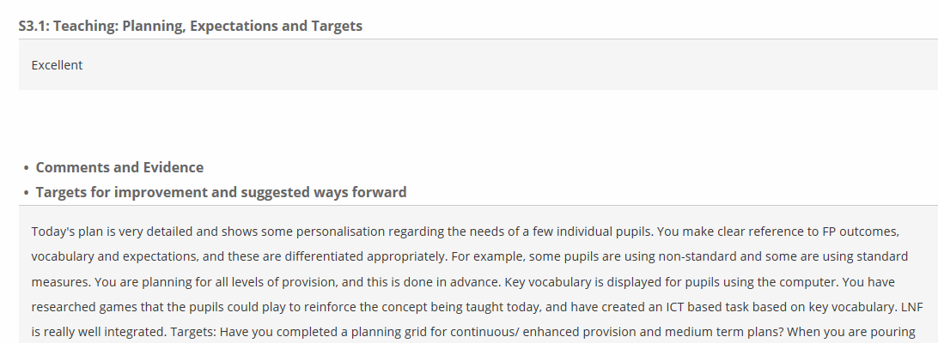
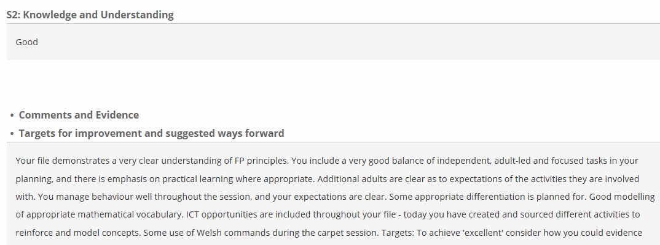
Appendix four:

These are two mentor reports from this year’s teaching practice. These reports are evidence that I am good at cross-curricular planning, including planning for creativity and engaging with the LNF and DCF. I consider this as evidence for my own creativity and teaching for creativity. Cross-curricular planning is needed to reach children’s full potential in their learning.

Appendix five:

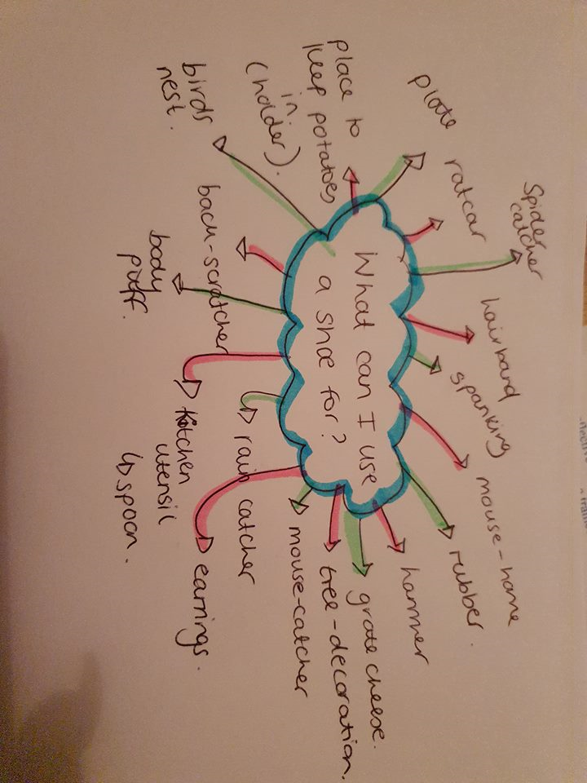



Appendix six:
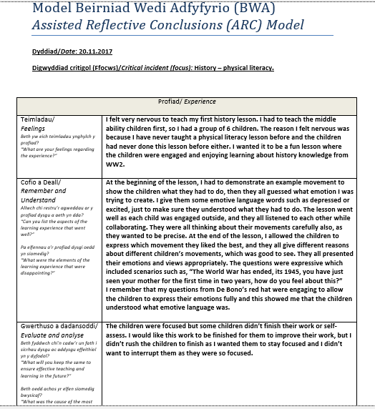



This reflective arc shows the beginning of the week, where my confidence was not strong. I was nervous because it was in my second week of teaching practice and I was still trying to get to know the children properly so that my lessons could suit individual needs. I planned this lesson as I wanted to explore history scenarios in a different way, rather than the children being sat in a classroom listening to a PowerPoint about the scenarios. This would not have raised creativity or history knowledge. The lesson was planned for active learning so that all children were engaged. This arc shows the first group I taught. The lesson went well but I knew myself, that I could make improvements to engage the learners further as well as developing myself into a better professional.
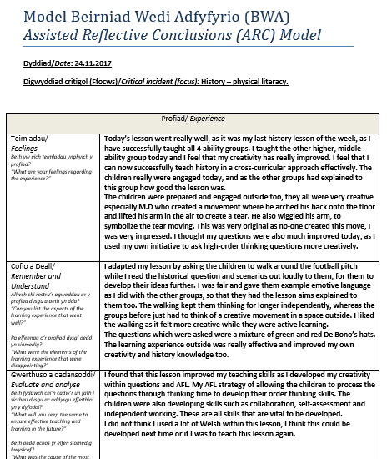

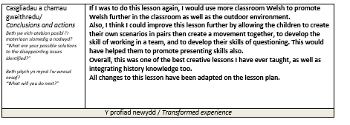

This was my last reflective arc from this lesson. Here, I have shown my development through this reflective arc explaining how I improved the original lesson, as well as still reflecting on other aspects to make sure I am allowing children to strive for their best, to raise attainment and to also be an outstanding teacher. There is always something to improve, and even the little changes have vital importance for a teacher. This lesson went well due to my own reflective experience, and I believe this is good evidence to show my self-awareness and efficiency as a trainee teacher.

Appendix seven:
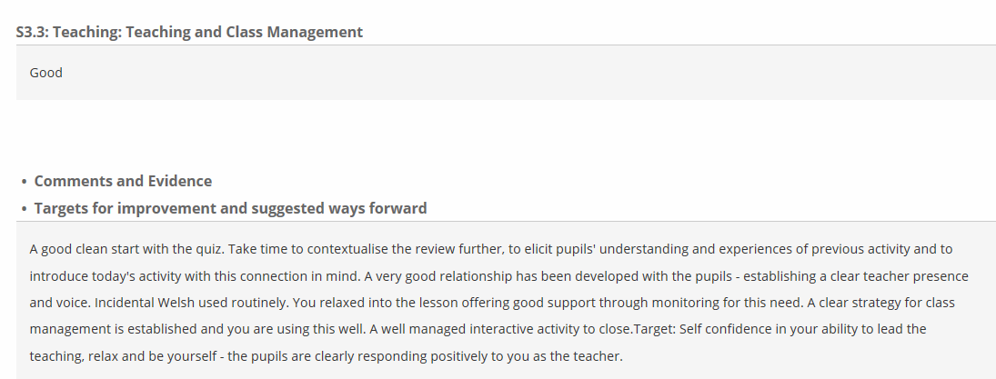

I believe this mentor review shows how I strive for my best to become a good teacher through constant reflections (this was from 2017). This is evidence how I am good at connecting and engaging with the children. Even though is a class-management report, I think this is evidence how I have used all areas of my teaching including creativity well.

Bibliography
Amabile, T. M. (1983). Social Psychology of Creativity: A Componential Conceptualization. Journal of Personality and Social Psychology. Available at: http://www.hbs.edu/faculty/Publication%20Files/12-096.pdf [accessed on 18.01.2019].
Armstrong, T. (2000). Multiple intelligences in the classroom. Alexandria, VA: Association for Supervision and Curriculum Development.
Barnes, J. (2011) Cross-curricular learning 3-14 (3rd edition) London: SAGE.
Baer, J., & Kaufman, J. C. (2006). Creativity research in English-speaking countries. In J. C. Kaufman, & R. J. Sternberg, The international handbook of creativity. New York, NY: Cambridge University Press.
Black, P. and Wiliam, D. (1998) Inside the Black Box: Raising Achievement through Classroom Assessment, London: King’s College.
Blaschke, L. M. (2012) Heutagogy and Lifelong Learning: A Review of Heutagogical Practice and Self-determined Learning, The International Review of Research in Open and Distance Learning. Available at: http://www.irrodl.org/index.php/irrodl/article/view/1076/2113 [accessed on: 15.01.2019].
Bohm, D. (1998) On Creativity, Edited by Nichol. L, London: Routledge.
Callan, S. (2008) ‘Ongoing research journal for investigation student experience. Beyond the Statement of Requirement: reflective practice and the continuing of professional development of Foundation Degree, “graduates”’. Sited in: Reed, M., and Canning, N. (2010) Reflective Practice in the Early Years, London: SAGE Publication.
Chen, L. (2008) Theories and Practices of Teaching for Creative Thinking. Taipei: Psychological Publishing.
Costa, A., Kallick, B. (2008) Learning and Leading with Habits of Mind, Virginia: ASCD.
Craft, A. (2000) Creativity Across the Primary Curriculum: Framing and Developing Practice. London: Routledge.
DeBono, E. (1985) Six Thinking Hats: An Essential Approach to Business Management, New York: Little, Brown and Company.
DeWitt, P. (2011) Creative Learning Environment, Editorial Projects in Education. Arlington Road, Bethesda. Available at: http://blogs.edweek.org/edweek/finding_common_ground/2011/11/creative_learning_environment.html [accessed on: 15.01.2019].
Donaldson, G. (2015) Successful Futures, Independent Review of Curriculum and Assessment Arrangements in Wales, Available at: https://gov.wales/docs/dcells/publications/150225-successful-futures-en.pdf [accessed on: 30.12.2018].
Duffy, B. (1998) Supporting Creativity and Imagination in the Early Years, Buckingham: Open University Press.
Enabling Enterprise. (2015) The Enterprise Skills, Skills Builder Partnership: Enabling Enterprise. Available at: http://enablingenterprise.org/about/skills [accessed on: 04.01.2019].
European Commission. (2016) EntreComp: The Entrepreneurship Competence Framework, Joint Research Centre: European Union. Available at: http://publications.jrc.ec.europa.eu/repository/bitstream/JRC101581/lfna27939enn.pdf [accessed on: 29.12.2018].
Fisher, R., and Williams, M. (2004) Unlocking Creativity – A Teacher’s Guide to Creativity Across the Curriculum, London: David Fulton.
Fryer, M. (2003) Creativity across the curriculum: A review and analysis of programmes designed to develop creativity. London: Qualifications & Curriculum Authority.
Gardner, H. (1985) Frames of Mind: The Theory of Multiple Intelligences, New York: Basic Books.
Gilchrist, M. and Emmerson, C. (2016) Transforming Outdoor Learning in Schools; Lessons from the Natural Connections Project, Department for Education, Plymouth University: England. Available at: https://www.plymouth.ac.uk/uploads/production/document/path/7/7634/Transforming_Outdoor_Learning_in_Schools_SCN.pdf [accessed on: 03.01.2019].
Grigg, R. (2015) How to Become an Outstanding Primary School Teacher (2nd ed), Abingdon: Routledge.
Hase, S., and Kenyon, C. (2000) From Andragogy to Heutagogy, Ultibase Articles.
Hayes, D. (1998) Effective Verbal Communication, London: Hodder & Stoughton.
Kolb, D. (1994) Experimental Learning: Experience as the Source of Learning and Development, Englewood Cliffs, NJ: Prentice-Hall.
Land-Ainsworth, T, G., and Jarman, B. (1993) Break-Point and Beyond: Mastering the Future – Today, Business and Economics, HarperBusiness: University of California.
McAuliffe, M.B, et al. (2008) “Does Pedagogy Still Rule?” 19th Annual Conference of Australian Association for Engineer Education, 7-10 December 2008, Central Queensland University, Yeppoon. Available at: https://www.sciencedirect.com/science/article/pii/S1877042812053785 [accessed on: 15.01.2019].
N.A.C.C.C.E. (1999) All our futures: creativity, culture and education, London: DfEE.
Parnes, S. J. (1963). Education and Creativity. In P. E. Vernon (Ed.) (1970), Creativity: Selected readings. Middlesex: Penguin Books Ltd.
Robinson, K. (2013) ‘To Encourage Creativity, Mr. Gove, You Must First Understand What it is’, The Guardian, 17 May. Available at: https://www.theguardian.com/commentisfree/2013/may/17/to-encourage-creativity-mr-gove-understand [accessed on 30.12.2018].
Rogers, C. R., Lyon, H. C., and Tausch, R. (2013) On Becoming an Effective Teacher: Person-Centred Teaching, Psychology, Philosophy, and Dialogues with Carl R. Rogers and Harold Lyon. London: Routledge.
Runco, A, M. (1991) Divergent Thinking, Creativity Research Series, Education: Ablex Publishing Corporation.
Savery, J. R., and Duffy, T. M. (1995) Problem-Based Learning: An Instructional Model and its Constructivist Framework, Educational Technology.
Sharp, C. (2004) ‘Developing young children’s creativity: What can we learn from research?’, Topic, 32: 5-12. [Sited in Grigg, 2015].
Torrance, E. P. (1963) Education and the Creative Potential, Minneapolis, MN: The University of Minnesota Press.
Torrance, E. P. (1995). Why Fly: A Philosophy of Creativity. Norwood, NJ: Ablex Publishing Corporation.
Welsh Government. (2015) Well-Being Future Generations (Wales) Act, Cardiff: Welsh Government. Available at: https://gov.wales/topics/people-and-communities/people/future-generations-act/?lang=en [accessed on: 29.12.2018].
Welsh Government. (2017) Education in Wales: Our National Mission, The Educational Directorate, Cardiff: Welsh Government. Available on: https://beta.gov.wales/sites/default/files/publications/2018-03/education-in-wales-our-national-mission.pdf [accessed on: 29.12.2018].
Woolfolk, A., Hughes, M., and Walkup, V. (2008) Psychology in Education, Harlow: Pearson.
Wyse, D. (2013) ‘Creativity,’ in Wyse, D., et al (eds) Creating the Curriculum, Abingdon: Routledge, 117- 28.

