

Module Code: LCLM6003
Module Title: Leading and Implementing Change(LIC)
Assignment Title: A Strategic Change Plan
Lecturer's Name: Stephen Malone
Student Name: Beniamin Avram
Student ID: 2131588

Executive Summary
Leading and implementing changes is a constructive process of guiding a firm through various aspects. The report has highlighted the various strategic issues of the company with the help of Lewis’s 3-stage model and Kotter’s 8-step model. These explanations have also demonstrated the role of leaders in managing the changes in the organisation with the help of a democratic leadership style. The report has focused on the strategic change plan of Jaguar Land Rover Automotive PLC. Additionally, the ways in which the changes in both the external and internal environments have created an impact on the company have been examined. A change management plan has been developed for the respected firm.

Table of Contents
Introduction 4
Overview of the organisation 4
Outline of the report 4
Analysing the history of the Jaguar Land Rover Automotive PLC and examining both its external and internal environment 6
Outlining the history of the organisation 6
Examining the changes in the internal environment that have created an impact on Jaguar Land Rover Automotive PLC 6
Understanding the changes in the external environment that had an impact on the organisation 7
Evolution of the change management model along with the strategic changes within JLR 10
Explanation of the strategic issues of the organisation 10
Kotter’s 8-Step Change Model 10
Lewin’s 3-Stage change management model 12
Role of the leadership by applying the leadership style and the impact of the organisational culture on the change management 14
Role of the leadership in managing the strategic issues 14
Change management program impact on the organisation 15
Developing a suitable change management plan for Jaguar Land Rover Automotive PLC 16
Establishing a change management plan for the organisation 16
Conclusion 22
References 23

Introduction

Overview of the organisation
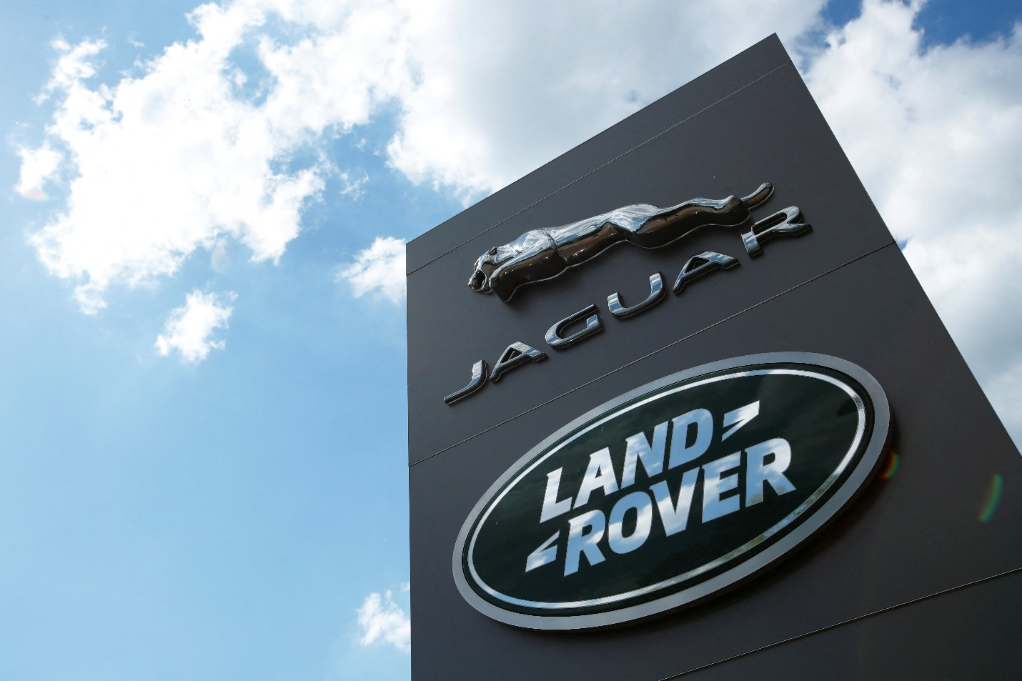
Figure: Overview of the JLR
Source: (JLR, 2026)
Jaguar Land Rover Automotive PLC (JLR) is a well-known vehicle manufacturer company known for its high-standard cars. The organisation was founded in 2008 when Tata Motors bought it from Ford as a luxury British subsidiary. Jaguar market focuses on coupes and sporty sedans, while Land Rover prioritises rugged SUVs (JLR, 2026). Both brands are known for their advanced technology and stylish designs, which influence people. JLR is committed to innovation and sustainability and performing on hybrid and electric vehicles to decrease environmental impact. The goals of Jaguar Land Rover are to deliver exceptional driving experiences and balance its brand reputation for performance and luxury with its loyal global presence. The JLR continues to adapt and evolve to customer preferences and market trends to maintain the brand reputation equally for the long-term.

Outline of the report
This elaboration will shed light on the current history of the company based on its external and internal environment, including Online shopping, AI utilisation and digital disruptions. The strategic changes in JLR will also be demonstrated with the help of relevant change management models. The leadership role in this organisation, based on the accurate leadership style, will also be highlighted.

Analysing the history of the Jaguar Land Rover Automotive PLC and examining both its external and internal environment

Outlining the history of the organisation
The recent history of JLR is defined by its Reimagine, which is a transformation strategy launched in 2021. Through this approach, the company is planning to shift towards electric first and digitally advanced modern luxury manufacturer. The main goal was to strengthen the profit margin thus lowering the overall carbon emissions by 2039 (JLR, 2022). During 2022, the company faced significant losses resulting in around £412 million due to severe shortages of semiconductors. Moreover, the revenue rate of the organisation has increased by 27% to £29 billion and profit before tax reached around £2.2 billion in 2023-2024 thus upgrading the performance (JLR, 2024a). Apart from this, the organisation in 2025 experienced a major cyberattack which has forced the firm to shut down its plants across Britain and other regions. This has resulted in a £559 million loss in the first quarter of 2026 significantly affecting the overall operations and brand image (JLR, 2025).

Examining the changes in the internal environment that have created an impact on Jaguar Land Rover Automotive PLC
SWOT Analysis
Strengths  a. JLR continues to maintain a strong brand identity and loyalty due to its rich and iconic models including Range Defender and Range Rover. Besides this, the company is shifting towards a modern luxury approach focusing on the software and digital-enabled platforms and electric vehicles.  B. JLR is partnering with Tata Communications to implement ML, AI and real-time analytics to improve the resilience of the supply chain and visibility of the supply chain (JLR, 2025). The company operates interconnected and advanced smart factories that increase the efficiency of manufacturing. | Weakness  a. Incorporating the digital and advanced tools in the production has created systemic vulnerabilities. The company experienced a major cyberattack in 2025 which showed that a single breach can cause severe loss in operations as well as shut down operations globally for weeks.  b. The organisation is significantly dependent on the older IT systems in certain manufacturing processes which poses a significant security risk. Besides this, it also requires a high operational cost to maintain the systems. Moreover, JLR focuses on Just in Time manufacturing which is efficient but becomes a major vulnerability when the digital systems are compromised.
Opportunities  a. JLR is harnessing ML methods, AI-powered and data analytical tools to improve the visibility and transparency of the supply chain operations (JLR, 2025). The innovators are focusing on developing new solutions to upgrade the accuracy of the supply chain. This can help the world to eradicate illegal mining practices, deforestation and forced labour.  b. The organisation is currently shifting to the D2C consumer online selling which can allow the organisation to control the profit margin rate as well as help to collect data as per the preferences of the users. Moreover, the firm is focusing on new electric platforms such as MLA, EMA in order to enter into premium and new segments. | Threats  a. JLR has been the high-profile target and is currently facing the ongoing risks of the ransom-seeking hackers. This can significantly disrupt the operations of the supply chain in the future.  b. The organisation is also facing the data security risks which have raised serious privacy concerns among consumers. This cyberattack has led to data breaches as the hackers gained access to the personal data of consumers and other financial information of the company (Derrick, 2025).

Understanding the changes in the external environment that had an impact on the organisation
PESTLE Analysis
Political | JLR has faced significant challenges due to the sharp rise in US tariffs. Due to this, the retail sales fell by 25.1% at 79600 cars which significantly lowered the production rate. This attack has forced the organisation to halt its production at the factories of Brazil, Slovakia and the UK resulting in a net loss of around £500 million (Kollewe, 2026).
Economic | The sales rate of the company has fallen by 43.3% to 59200 vehicles in the quarter of December. Moreover, the operations of more than 5000 organisations across Britain have been severely impacted due to the cyberattack in 2025. This has caused an estimated £1.9 billion in economic damage and the factories have been shut which halted the production for over a month (Jolly, 2025).
Social | The consumer behaviour of the UK is currently shifting towards e-commerce shopping due to which they are seeking to purchase the products online. This increases the demand of consumers for the modern luxury, digital-first buying experience. However, the company has faced an online backlash over its teaser trailer highlighting the risks of changing the identity of the brand. Despite the disruptions caused by the cyberattack the demand for the Range Rover, Defender and Range Rover Sport models remains high.
Technological | The global operations of JLR have been severely disrupted due to the major cyberattack. This has caused nearly £2 billion of economic damage to the company creating a history in the UK. This attack has forced the company shut down its production across all the plants affecting more than 5000 businesses. Moreover, the organisation has partnered with Tata Communications to use AI-driven real-time data for enhancing the efficiency of the supply chain. However, the cyberattack has targeted the IT system of JLR leading to the disruption of operations and shutdown of the manufacturing plants (Collins, 2025).
Legal | JLR experienced a major cyberattack in 2025 which caused the leakage of data and raised security and privacy concerns. The hackers have got unauthorised access to the internal SAP systems which allowed them to access the sensitive personal data, payroll and financial information (Derrick, 2025). Thus, the firm needs to strictly comply with the NIS regulations and the Data Protection Act and UK GDPR.
Environmental | JLR has committed to achieving net-zero carbon across the products and operations of the supply chain emissions by 2039 as a part of its Reimagine strategy. The company will cut down the average vehicle emissions by 54% and GHG emissions across its operations by 46% by 2030 (JLR, 2022). Moreover, the organisation is currently developing the hydrogen fuel cell technology to decarbonise its manufacturing plants and is also focusing on reducing the waste across its operations.

Evolution of the change management model along with the strategic changes within JLR

Explanation of the strategic issues of the organisation
Marketing competition
JLR experiences various issues, like increasing competition in the current industry and declining sales market (Leggett, 2024). This company also faces challenges in the infrastructure and new technologies adaptation that include charging networks and battery production. Furthermore, Jaguar Land Rover also requires an environmentally conscious customer base which helps them to maintain the sustainable practice.
Supply chain management
Another important issue for Jaguar Land Rover is related to controlling the global supply chain management effectively. This automotive firm is heavily dependent on a complex supplier network for materials and parts (Upton & Dawkins, 2025). Disruptions such as geopolitical tensions or the COVID-19 pandemic can remarkably impact their production. The various strategic change management helps this organisation to steady flow and permits them to reach production targets.

Kotter’s 8-Step Change Model
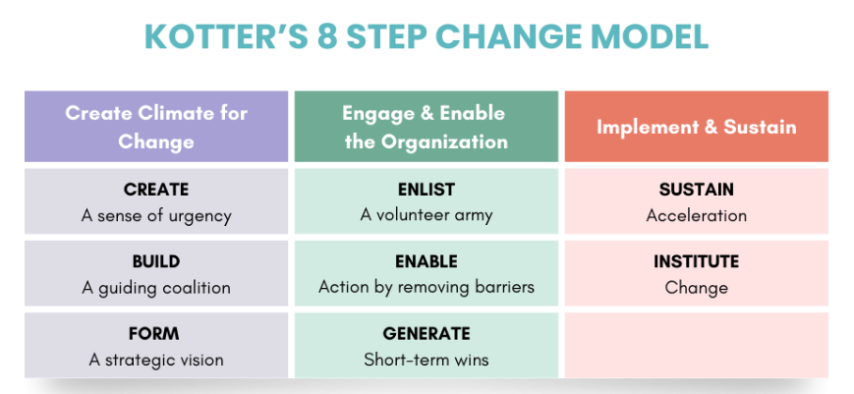
Figure: Kotter’s 8-Step Change Model
Source: (Jones, 2025)
Create Urgency
The transformation initiated by making individuals feel the requirement for change while sharing facts that highlight the reason for change is crucial. This helps all the people to understand the cause behind the transformation and the needs (Jones, 2025). JLR is prioritising the risks of not adapting with the advanced market trends like the transformation required in electric vehicles, which may produce obstacles in their progress.
Build a powerful coalition
Collecting a team of influential individuals who help with the change, and the group should include the key stakeholders and leaders who can lead the shift forward collaboratively. These approaches help the JLR to balance the current trend in the market while maintaining the brand reputation. Jaguar Land Rover built a concrete group to drive the transformation process by including key stakeholders and leaders (JLR, 2023). This decision followed the current stage, where it emphasises developing a sense of urgency and creating a guiding coalition.
Create a vision for change
Develop a fair vision that elaborates on how the transformation will provide the outcome. This vision should be easy and simple to determine and guide all in the right pathways. JLR invested in advanced technology and established a new electric model to boost production effectively.
Communicate the vision
Emphasising the clear vision with all people who are involved in this change management process. Additionally, utilising several methods like emails, posters, and meetings to confirm that every individual understands the vision. The organisation communicated the cruciality of sustainability and innovation to staff and made them conscious that change was necessary for the growth and survival of the company (James & Hughes, 2025). JLR makes sure that all workers understand the change management protocol and their responsibilities to meet the goal.
Empower action
The factors that may create issues in progression need to be addressed and removed from the process. Providing important resources and help to support them in the case of success, along with this, also influences people to try new ideas. JLR delivers the relevant resources to the employees for understanding the cruciality of changes that help them to reach the goal of the company.
Create quick wins
The celebration of little progress always helps to motivate and influence people to serve their role in their work effectively. Understanding these wins increases morals and reflects that the transformation is working, encouraging all to keep going. JLR prioritises small wins where all the celebration of little progress after launching any new products, which fosters the workforce to sustain momentum (JLR, 2024b).
Build on the change
The stage mainly emphasises the celebration of the small wins, which help to manage bigger issues and challenges. These approaches keep fostering more developments and ensure that the shift becomes a part of the organisational culture. JLR strengthens new marketing strategies and confirms team alignment to identify the changes and celebrate the progression.
Anchor the changes
Creating the change management by combining it into all day practices and strengthening the new values and behaviours to confirm they maintain all of this for the long-term. JLR adaptation and continuous feedback were created to keep the change on track and confirm the organisation remained competitive in the advanced automotive industry (JLR, 2024b).

Lewin’s 3-Stage change management model
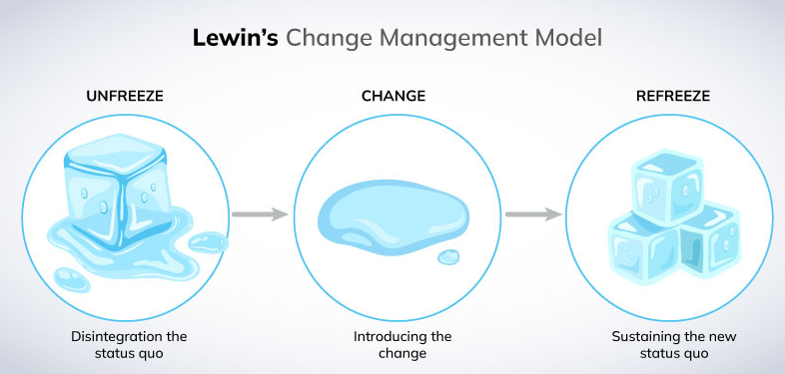
Figure: Lewin’s 3-Stage model of
Source: (Miller, 2022)
Unfreezing
Jaguar Land Rover recognised the requirement for change because of supply chain issues and market competition. This company initiated by assessing their present situation, gathering inputs from stakeholders and staff and identifying the weaknesses (Miller, 2022). These supports creating awareness about the problem the company experiences and makes a steady flow of their business. JLR prepares all the staff for the upcoming adaptation and confirms that the group is ready to adjust to the new strategies by communicating the cause of the transformation.
Changing
JLR applies a new mechanism to indicate supply chain issues and competition at this stage. This might adjust with the advanced technologies, increase production mechanisms and develop supplier relationships (Solow and Perry, 2023). Training programs are established to equip staff with important knowledge and advanced skills. This organisation fosters groups to manage the new practices and methods, and confirms a streamlined transition by encouraging an ethics of innovation.
Refreezing
JLR is prioritising stabilising the new exercises after implementing the transformation in their organisation. This firm continuously monitors the progress and collects feedback to confirm that the changes are productive (Miller, 2022). Jaguar Land Rover supports staff feel confident in the new pathways by strengthening, celebrating achievement and progressive strategies. This solidifies the transformation within the firm culture, creating it easier to experience future challenges and balance a competitive edge in the industry.

Role of the leadership by applying the leadership style and the impact of the organisational culture on the change management

Role of the leadership in managing the strategic issues
Inclusive decision-making
The leadership style in the JLR adapted democratic initiatives by including staff in the decision-making mechanism (Cherry, 2025). This style forces group members to share their opinions and ideas and encourages a sense of ownership and involvement in the goal of the firm. The leader needs to confirm that all staff feel heard and valued by making forums for feedback and discussion. Staff were more likely to support the transformation when they felt they were allowed to share their opinion, which ultimately supported the organisation in negotiating with the challenges productively.
Teamwork and Collaboration
The democratic leadership style at Jaguar Land Rover elaborates that collaboration among various departments is important for an effective work culture. The leader fostered cross-functional groups to work collaboratively on the project and break down silos, which rapidly hindered the success. This teamwork permitted a more holistic understanding of complications and facilitated faster problem-solving (Morales-Huamán et al., 2023). JLR can tackle the diverse perspective by leading to improved performance and innovative solutions by encouraging collaboration and teamwork. Leadership of JLR makes sure that all voices are delivered to the transformational process, leading to more productive implication of strategies by encouraging a collaborative culture. This initiative not just developed relationships among staff but also developed entire productivity as groups performed towards common objectives.
Trust and empowerment
Leader in the JLR authorised their staff by trusting them to take approaches and make decisions within their roles. This empowerment was important during the change management as it fostered workers to take ownership of their responsibilities and delivered positivity to the company (Kahl et al., 2023). Owners should promote people to step up and lead approaches which supported in controlling change by encouraging an environment of trust. Workers felt more self-efficacious in their abilities and consisting to raised engagement and a concrete commitment to the vision of the company. This belief also supported in decreasing resistance to transformation as staff were more willing to adjust when they felt supported.
Adaptation and Feedback
An important aspect of democratic leadership was the emphasis on constant review at JLR. The leader proactively sought input from staff about the transformation being applied and permitted for adaptation based on the practical data. This adjustment was important in confirming that the change met the requirements of both the workforce and the firm (Morales-Huamán et al., 2023). The leadership management of JLR should demonstrate an involvement in responsiveness and improvement, which supports creating resilient ethics. This initiative not just facilitates the streamlined transition but also strengthens the idea that ownership is a shared responsibility.

Change management program impact on the organisation
Positive Impact
The culture of Jaguar Land Rover promotes teamwork, which boosts collaboration among staff and fosters effective work. This specific effort consists of innovations and advanced resolutions during the change management (Bell and Reed, 2022). Team members embrace transformation, support one another and share ideas when they feel heard, valued and allowed in the decision-making. This collaboration can drive progressive implementation of new mechanisms and protocols that make change streamlined and more productive. A trustworthy culture empowered staff to take approaches and invest in change management productively. This promotes a sense of leadership and accountability when the owner trusts their group. Workers are more willing to adjust to transformation when they realise their input is important. This empowerment can consist of a boost in engagement and motivation that results in a more prevalent workforce that can negotiate challenges productively.
Negative Impact
Inclusive decision-making can slow down the transformation mechanism in the organisation, where involving many opinions can lead to lengthy explanations and delays in meeting the aims (Chernyi and Uotila, 2024). This can be challenging in a fast-paced culture where faster adaptation is important for progression. Collaborative work is important, but it can also lead to issues in the groupthink where workers might hesitate to raise their voices. This can make resistance to important changes when people feel pressured to obey the norms. Open feedback is crucial, when the culture of an organisation never fosters this, it might hinder the identification of issues during the change management.

Developing a suitable change management plan for Jaguar Land Rover Automotive PLC

Establishing a change management plan for the organisation
The change management plan for the JLR is mainly designed around its Reimagine Strategy. This aims to transform the company into an electric-first sustainable luxurious brand by 2030 and to achieve net-zero emissions by 2039.
Objectives
To launch the first three generations of all-electric Jaguar models successfully ensuring 100% of Jaguar sales are pure electric within 1 year.
To organise training sessions for the production and retail employees in EV technology and new diagnostic skills within the next 2 years.
To reduce the GHG and carbon emissions across its entire operations including its supply chain and minimise the waste by 20% within the next 3 years.
Financial plan
Investment Areas | Cost in £
EV Platform & Architecture Development | 9000
Vehicle Programs & R&D | 12000
Digital Tech & AI | 8000
Sustainability & Circular Economy | 6000
People Skills & Training | 7000
Total | 42000

Analysis
The total amount required to develop the change management plan for JLR to transform fully into electric first and sustainable luxurious brand is estimated at around £42000. A huge financial capital of around £12000 will be required for R&D and Vehicle programs. Moreover, the highest amount will also be required in the EV platform and Digital technologies. Besides this, the lowest amount will be needed in the People Skills and training as well as in sustainability.
Communication plan
Objective 1
Phase | Target Audience | Key Messages | Channels | Timeline
The Foundation | Financial Media, Dealers and Existing Owners | Focus on Copy Nothing Philosophy which will influence originality and creativity thus positioning the new electric portfolio. | Investor Relations and Direct Email (Matsumoto, and Miller, 2025). | 2026
The Reveal | Media, Influencers and Luxury Buyers | Unveiling the 4-door GT, redefining Modern Luxury. | Digital launch, high end Automobile shows, Miami Art Week. | 2026
The Launch | ESG Investors and New Luxury Demographic | Delete Ordinary 3 new Evs, 700 km range, 3 motor performance. | Digital Ecosystem, Brand Stores in Cities and Experiential Events. | 2027-2028
The Shift | All Stakeholders | 100% Electrified Portfolio. | Social Media Campaign, Global Press Release and Dealer Network (Thomas and Duffett, 2025). | 2027-2028

Objective 2
Phase | Target Audience | Key Messages | Channels | Timeline and Frequency
Prep & Buy in | Managers, Staff and HR | The Future is Electric. Introducing the 2-year upskilling initiative to stay competitive | Email from Leadership, Town Halls and Intranet FAQ. | 1-3 months, once, with the ongoing FAQ access.
Diagnostic Skills | Service Staff/Retail Sales | Empowering EV sales and Service. Training on charging infrastructure, EV basics and customer queries. | E- learning modules, Mobile Application and Webinars (Nabatchikova, 2026). | 4-12 months, with monthly workshops.
Tech & Assembly | Production/Assembly Line | Precision in Production, Training on Motor Controller, Battery Pack and Safety protocols. | Hands-on demos, Safety Posters, In-person workshops. | 6-18 months weekly sessions
Reinforcement | Trained Staff | Continuous Improvement. Sharing success stories, applying new skills and troubleshooting. | Recognition applications, Internal Newsletter and Team huddles (Boogaard, 2025). | 12-24 months monthly feedback loops
Evaluation | Managers, HR | Measuring Success. Reviewing the impact of training on sales rate and efficiency. | Performance dashboards, Surveys, and focus groups. | 20-24 months quarterly review meetings

Objective 3
Phase | Target Audience | Key Messages | Channels | Goal and Timeline
Foundation & Alignment | Key Suppliers, Board and Employees | Building a Greener Future: Our 3 Year Waste & Emission Targets | Supplier Launch Letter, Intranet and Townhalls. | To build awareness and secure leadership commitment.
Operational Kick-Off | Procurement Teams and Operational Staff | Small Changes, Big Impact: Reducing Waste &Energy | Internal Newsletters, Green Teams and Workshops (Boogaard, 2025). | To manage the waste efficiently and adopt the renewable energy sources within 6-12 months.
Supply Chain Engagement | Logistic Partners, Key Suppliers | Collaborating for a Low-Carbon Value Chain | Supplier Surveys, Webinars and Sustainability Summits. | Engage top suppliers on Scope 3 data and reduction targets within 12-24 months.
Transparency & Progress | Customers, Investors and Public | Transparency in Action: 2- Year Progress Update. | PR Campaigns. Social Media, Annual Sustainability Report (Christodoulou and Berg, 2026). | To build trust and avoid greenwashing within 24-36 months.
Goal Organisation | All Stakeholders | Goal Achieved: Our Journey Towards Net Zero Continues. | Special Report, Public Relations, CEO Video Message. | To celebrate success and set future targets within 30-36 months.

Evaluation plan
Objective 1
The evaluation plan to support the transformation of Jaguar into 100% electric and sustainable luxury brand focuses on evidence based approach to monitor the launch of its three new models. Here, the KPIs will be used to track down the ways in which the internal combustion engines are transformed to EVs which will include some primary metrics. This method will also focus on the operational success where the financial stability will be assessed. This will be examined by tracking down the rate of profit margin per unit rather than pure volume. Here, the sales data will be monitored monthly via CRM or SAP to check the 100% EV sales rate (Antwi, and Avickson, 2024). The potential delays resulting from the disruptions of the supply chain and from cyberattacks will be tracked. This will ensure that the goal of the Reimagine strategy to become a premium, sustainable and net-zero carbon business is met by the end of the decade.
Objective 2
A multi-level framework based on the Kirkpatrick Model will be used to evaluate the success of the two-year training program for the employees on EV technology (Giatman, 2025). During phase 1, assessment surveys will be conducted during the first three months to determine the specific skill gaps. Following this, the pre-tests will be carried out to address the existing knowledge gaps. During phase 2, the training attendance rates and the number of participants who completed the course will be tracked. The satisfaction rates of the participants through the surveys after each session will be measured to understand the engagement rate. Post training assessments including the hands-on simulation and quizzes for diagnostic skills will be conducted in phase 3. Moreover, 6-12 months after post-training the long-term changes in the behaviour during phase 4 will be noticed by the manager and 360-degree feedback will be provided. Finally, an ROI analysis will be carried out to compare the financial benefits of improved productivity against the training cost.
Objective 3
The evaluation plan to minimise the GHG and carbon emissions across all its operations will be incorporated on the basis of the principles of the Circular Economy and the GHG Protocol (Sassanelli et al., 2026). A baseline carbon inventory will be established in the first year and a comprehensive waste audit will be conducted. This will help to measure the overall amount of waste generated and track the current emissions rate. Following this, KPIs will be used to measure the performance rate predicting the intensity of carbon per unit of production as well as identifying the total percentage of carbon emissions reduced. The total amount of waste diverted from landfills through the recycling methods will also be monitored. Incorporating supplier sustainability codes of conduct along with optimising transport logistics and shifting to renewable energy thus optimising the transport logistics will be audited for checking the effectiveness.

Conclusion
Leading and implementing the change in the firm is important for success and growth. Transformation comes from dynamic, various resources like new technology, integral challenges, and market demands. A clear vision is crucial for effective lead change in the organisation, which helps maintain the competitive edge for the long-term. Leaders need to communicate this vision to all the workers and confirm that all understand the cause behind the change. Team members support the transformation when they feel included in the decision-making. Understanding and prioritising the staff opinion helps to evaluate the progression in the firm. Delivering resources and helping staff to adapt to new mechanisms or systems that support reaching the aim of the company faster. Regularly monitoring the changes is vital for identifying the challenges of the change. This report has demonstrated the internal environment of JLR with the help of SWOT analysis and the external environment by the PESTLE model. The strategic change issues of the organisation have also been evaluated with the help of Kotter’s steps and Lewis’s 3-stage model. The role of leadership in managing the challenges by using the democratic leadership style has also been demonstrated.

References
Antwi, B.O. and Avickson, E.K. (2024) ‘Integrating SAP, AI, and data analytics for advanced enterprise management.’ International Journal of Research Publication and Reviews, 5(10), pp.621-636.
Bell, K. and Reed, M. (2022) ‘The tree of participation: a new model for inclusive decision-making.’ Community Development Journal, 57(4), pp.595-614.
Boogaard, K. (2025) Employee recognition ideas: The ultimate guide. [Online] Available at: https://www.cultureamp.com/blog/employee-recognition-ideas (Accessed 26 February 2026).
Chernyi, A. and Uotila, J. (2024) ‘Prioritization of organizational stakeholders: A managerial decision-making perspective.’ Journal of Business Research, 185, p.114882.
Cherry, K. (2025) Is Democratic Leadership the Best Style of Leadership?. [Online] Available at: https://www.verywellmind.com/what-is-democratic-leadership-2795315 (Accessed 26 February 2026).
Christodoulou, C. and Berg, A.S. (2026) ‘Responsible design and use of social media technology: A reflective case study on raising awareness towards social sustainability.’ Journal of Responsible Technology, p.100158.
Collins, L. (2025) How Has JLR’s Supply Chain Been Affected by Cyber Attacks?. [Online] Available at: https://supplychaindigital.com/news/the-impact-of-major-cyber-attack-on-jlrs-production-lines (Accessed 24 February 2026).
Derrick, M. (2025) Jaguar Land Rover Confirms Data Theft in Major Cyber Attack. [Online] Available at: https://cybermagazine.com/news/jaguar-land-rover-confirms-data-theft-in-cyber-attack (Accessed 24 February 2026).
Giatman, M. (2025) ‘Training evaluation using kirkpatrick evaluation model for well intervention pressure control training.’ Jurnal Penelitian Pendidikan IPA, 11(3), pp.143-152.
James, E. & Hughes, C. (2025) 'Labour must step up to help JLR supply chain'. [Online] Available at: https://www.bbc.com/news/articles/c36kjx8w793o (Accessed 25 February 2026).
JLR (2023) Jaguar Land Rover partners with Tata Technologies to accelerate the digital transformation of its industrial operations. [Online] Available at: https://www.jlr.com/news/2023/03/jaguar-land-rover-partners-tata-technologies-accelerate-digital-transformation-its (Accessed 25 February 2026).
JLR. (2022) JAGUAR LAND ROVER INVITES SUPPLIERS TO ALIGN TO 2030 SUSTAINABILITY COMMITMENTS. [Online] Available at: https://media.jaguarlandrover.com/news/2022/09/jaguar-land-rover-invites-suppliers-align-2030-sustainability-commitments#:~:text=We%20also%20have%20vehicle%20plants,within%20the%20wider%20Tata%20Group (Accessed 24 February 2026).
JLR. (2024a) JLR DELIVERS STRONG FINANCIAL RESULTS WITH RECORD REVENUES FOR THE YEAR ENDING 31 MARCH 2024. [Online] Available at: https://media.jaguarlandrover.com/news/2024/05/jlr-delivers-strong-financial-results-record-revenues-year-ending-31-march-2024 (Accessed 24 February 2026).
JLR. (2024b) JLR STRENGTHENS EXECUTIVE LEADERSHIP TEAM WITH APPOINTMENTS FOR NEXT PHASE OF ITS REIMAGINE TRANSFORMATION. [Online] Available at: https://www.jlr.com/news/2024/10/jlr-strengthens-executive-leadership-team-appointments-next-phase-its-reimagine (Accessed 25 February 2026).
JLR. (2025) JLR INVITES THE BRIGHTEST INNOVATORS TO SHAPE THE FUTURE OF AUTOMOTIVE SUPPLY CHAINS. [Online] Available at: https://media.jaguarlandrover.com/news/2025/03/jlr-invites-brightest-innovators-shape-future-automotive-supply-chains#:~:text=Innovators%2C%20who%20have%20until%2025,unlock%20unprecedented%20visibility%20and%20resilience (Accessed 24 February 2026).
JLR. (2025) JLR PERFORMANCE IMPACTED IN CHALLENGING QUARTER. [Online] Available at: https://media.jaguarlandrover.com/news/2025/11/jlr-performance-impacted-challenging-quarter (Accessed 24 February 2026).
JLR. (2026) About Us. [Online] Available at: https://www.jlr.com/overview (Accessed 23 February 2026).
Jolly, J. (2025) Jaguar Land Rover hack has cost UK economy £1.9bn, experts say. [Online] Available at: https://www.theguardian.com/business/2025/oct/22/jaguar-land-rover-hack-has-cost-uk-economy-19bn-most-costly-cyber-attack-britain (Accessed 24 February 2026).
Jones, J. (2025) Kotter’s 8-Step Change Management Model. [Online] Available at: https://www.waywedo.com/blog/kotters-8-step-change-model/ (Accessed 25 February 2026).
Kahl, J., de Klerk, S. and Whiteoak, J. (2023) ‘Managing empowerment: adjusting organisational units' autonomy to achieve corporate agility.’ Journal of Organizational Effectiveness: People and Performance, 10(4), pp.527-545.
Kollewe, J. (2026) Jaguar Land Rover sales slump sharply amid US tariffs and cyber-attack. [Online] Available at: https://www.theguardian.com/business/2026/jan/06/jaguar-land-rover-sales-us-tariffs-cyber-attack-shares-tata-motors#:~:text=Julia%20Kollewe,%E2%80%9CDo%20you%20sell%20cars?%E2%80%9D (Accessed 24 February 2026).
Leggett, T. (2024) How Jaguar lost its way - long before that polarising advert. [Online] Available at: https://www.bbc.com/news/articles/cd60v8zj678o (Accessed 25 February 2026).
Matsumoto, D.A. and Miller, G.S. (2025) Managers’ channels of communication. In Handbook on the Financial Reporting Environment (pp. 157-178). Edward Elgar Publishing.
Miller, K. (2022) A Practical Explanation of Lewin’s Change Management Model. [Online] Available at: https://crowjack.com/blog/strategy/change-management-models/lewins-model (Accessed 25 February 2026).
Morales-Huamán, H.I., Medina-Valderrama, C.J., Valencia-Arias, A., Vasquez-Coronado, M.H., Valencia, J. and Delgado-Caramutti, J. (2023) ‘Organizational culture and teamwork: A bibliometric perspective on public and private organizations.’ Sustainability, 15(18), p.13966.
Nabatchikova, O. (2026) How E-Learning Modules Solve Your Biggest Training Challenges: From Onboarding to Upskilling. [Online] Available at: https://anyforsoft.com/blog/e-learning-modules/ (Accessed 26 February 2026).
Sassanelli, C., Tornese, F., Bressanelli, G. and Jabbour, C.J.C. (2026) ‘Redesigning industrial systems supporting a systemic shift towards a Sustainable Circular Economy for achieving Net-Zero.’ Computers & Industrial Engineering, p.111930.
Solow, M. and Perry, T.E. (2023) ‘Change management and health care culture.’ Anesthesiology Clinics, 41(4), pp.693-705.
Thomas, S. and Duffett, R.G. (2025) ‘Using social media as a marketing communication strategy: perspectives from health-related non-profit organizations.’ Journal of Nonprofit & Public Sector Marketing, 37(3), pp.373-397.
Upton, P. & Dawkins, A. (2025) 'Impact on JLR supply chain might last months'. [Online] Available at: https://www.bbc.com/news/articles/c77dmyeze40o (Accessed 25 February 2026).

