Introduction
An expectation of the module ‘the Principles of Practice and Progress’ is to create a ten minute video presentation and a supporting file. The content of both the presentation and file requires engagement with literature and theory in order to provide evidence of wider reading. Research should be made regarding policy, theory and practice. In relation to knowledge and understanding, there should be demonstration of the understanding of themes relating to progression, transition, well-being, whole school approaches and inclusion, which have been drawn upon in lectures. The supporting file should show evidence of the assignment process, from the original idea to the recording of the video presentation. In regard to cognitive and intellectual skills, the intended intervention should be discussed and introduced. Recommendations should be convincing and supported by evidence. The impact of the intervention should also be considered and discussed. Practical skills should also be demonstrated, with the video being suitably presentable for a formal audience involving governors and staff members. While recording the presentation, it will be expected that a clear voice is used, with a suitable tone. The work presented, such as the file, should be well organised. In relation to transferable skills for life and professional practice, it is required to carefully select relevant data and language used should be relatively formal. The audience should be considered throughout.
Rationale
According to Cooper (2001), around 10-20% of children in England and Wales are affected by social, emotional and behavioural difficulties (SEBD). In order to reduce the impact that SEBD has on children’s education, I propose that we develop a nurture facility for children who are disadvantaged by these needs. This links to our School Development Plan (SDP) as our fourth priority is to develop students’ well-being, with the success criteria being to increase pupils’ engagement, attitudes to learning and well being by reducing behaviour incidents. We also aim to adopt a whole school nurturing and inclusive ethos. Appendix 1 shows the SDP. Tackling the impact of SEBD on pupils is crucial, since we are aware that 38% of pupils attending our school are affected by additional learning needs (ALN). We understand that it is our responsibility to ensure that these pupils are included in the school environment and to make sure that all students have the same opportunities to succeed. According to Sloan et al. (2016), nurture groups can be extremely beneficial to students who are disadvantaged with SEBD, since they can help to move barriers to learning.
According to the CCEA (2014), behaviour and emotional well-being are a result of both our biological features and our environment. Taking this into consideration, it is important to note that children’s behaviour often has a reason. Although most children arrive at school ready to learn, not all children are due to negative home environments. Even though children’s biological features cannot be altered, the environment that they are placed in can be to a certain extent. The CCEA (2014) outline that children’s unmet needs can cause young people to behave in a way that can be harmful to their contentment, quoting that ‘the reasons why these needs are unmet can be many and varied, from difficult home circumstances through to a gifted and talented learner remaining unchallenged’ (CCEA, 2014, p.16). In order to ensure that students’ needs are met and that children are ready to learn, a nurture group could provide a positive environment. Through using a positive approach, children will feel ‘secure and ready to develop socially and emotionally’ (CCEA, 2014, p.19).
Maslow (1943) outlined that human needs are arranged in a hierarchy and are categorised according to basic needs, psychological needs and self-fulfilment needs, in order for human beings to achieve their full potential, basic needs such as physiological needs and safety needs need to be met, as well as belongingness and love needs and esteem needs. These bottom four layers of Maslow’s pyramid of needs are also known as ‘deficiency needs’ (Maslow, 1943). If human-beings do not have their deficiency needs met, it can cause feelings of unrest and anxiety, providing a reason as to why children with SEBD often have behaviour needs. Maslow’s pyramid is ‘a good starting point for professionals considering learners at risk of SEBD. Each level of need should be considered in turn’ (CCEA, 2014, p.16).
A current commitment of the Welsh Government is to ensure the well-being of all pupils. As outlined by Kirsty Williams, the Cabinet Secretary for Education, while delivering the new Welsh curriculum, one of the four key enabling objectives will be to focus on ‘strong and inclusive schools committed to excellence, equity and well-being’ (WG, 2017, p.3). The Welsh Government (2017) also outline that they are committed to the well-being and success of all pupils, no matter their personal circumstance or background.
To ensure that the well-being needs of all students are met, a nurture facility in our school could prove to be extremely useful to children who may not be ready to learn. Nurture groups were created by Marjorie Boxall in 1969 in London, she identified that children with SEBD could not progress in mainstream education due to attachment issues and missed nurturing experiences (nurtureuk, no date a). This notion is strongly linked to Bowlby’s attachment theory, which contends that children obtain age-appropriate behaviour through interactions with different people (nurtureuk, no date a). According to McLeod (2017), Bowlby believed that a person’s behaviour is strongly linked to early childhood experiences. Bowlby (1951) mentions that a child should receive continuous attachment to their primary caregiver for the first two years of their life, if this is missed then a child will suffer the consequences of maternal deprivation. Bowlby (1951) continues to mention that the long-term consequences of this may result in the affected child acting impulsively and showing very little remorse for bad behaviour. When discussing the link between Bowlby’s attachment theory, nurtureuk (no date, a) outlined that ‘if a child’s early experiences were characterised by missing or distorted nurturing, it can lead to stunted social, emotional and cognitive development’ (nurtureuk, no date, a, p.12). Nurtureuk (no date, a) proceed to mention that these lacking experiences can be reduced with the help of nurturing adults.
In order to tackle this, a short-term nurture group facility will be highly beneficial in our school. Every afternoon, key stage two pupils who are affected by SEBD will visit the nurture room in our school in order to reach our success criteria, as seen in the school development plan, of increasing pupil’s engagement, attitudes to learning and well-being by reducing behaviour and anxiety incidents. This intervention will hopefully begin in September 2020. Although we shall be piloting our intervention with key stage two pupils, over time children from foundation phase will also have a nurture group facility, depending on the success in key stage two. The nurture group will be aimed at children with SEBD who are not ready to be a part of their mainstream class full-time, after two or three terms, the students will hopefully be ready to be immersed in mainstream classes full time.
In order to build self-esteem for children disadvantaged by SEBD, our nurture facility will involve listening and communication activities. ‘In a nurture group/school everything is verbalised with an emphasis on the adults engaging with the children in reciprocal shared activities e.g. play/meals/reading/talking about events and feeling. Children respond to being valued and thought of as individuals, so in practice this involves noticing and praising small achievements; nothing is hurried in nurture groups’ ‘Welsh Government, 2010, p.2).
In order to run our nurture group facility, it is crucial that we have two fully trained staff members, who have nurturing qualities. According to the Welsh Government (2010) how the staff members interact with students is vital to the success of nurture groups. It will be crucial for the staff who are responsible for running our nurture group facility to undergo training. Two members of staff will attend the ‘Theory and Practice of Nurture Groups’ course in Cardiff on the 11th or 12th of February and the 12th of March, the cost of this will be £718.80 for each staff member, totalling £1437.60 (nurtureuk, no date, d). According to the nurtureuk (no date, a), the majority of nurture groups cost less than £10,000 to run. Staff members who are involved in running the nurture group facility will be given advice and practical support from the Behaviour Support Service, which is run for schools in Swansea, for professionals working with children with SEBD (Swansea Council, 2019). As shown by a recent survey of nurture groups in schools, ‘the most popular option in terms of funding for nurture group provision is annually via the Pupil Development Grant, followed by Local Authority funding and then by individual school funding streams, Government funding or a combination of these different sources’ (The Nurture Group Network, no date, p.3). Since our school is in a deprived area, with 43% of our students being eligible for free school meals (FSM), our school is eligible for funding from the Pupil Development Grant (PDG). See Appendix 2 for the school context. Most of our students affected with SEBD come from disadvantaged home backgrounds. According to the Welsh Government (2014), Mount Stuart School, a school with a similar context to ours, with 31% of pupils being eligible for FSM, utilise part of their PDG for their nurture group facility.
Overview of general themes
The Welsh Government’s Education in Wales Action Plan 2017-2021 (2017) outline the commitment in Wales to wellbeing and personal success of all students and outline that no student should be put at a disadvantage due to their personal childhood experiences and that wellbeing is crucial to an education system that is successful. Children should be given the opportunity to reach their full potential regardless. Kirsty Williams (2017) mentions in the action plan that the aim is for all children to receive a good quality education whilst being happy and safe. Children should be treated fairly and benefit from ‘high levels of wellbeing’ (WG, 2017, p.3). The Welsh Government (2017) also recognise that in order to ensure that the implementation of the new curriculum is a success, there should be a focus on four key enabling objectives, the third of which is ‘strong inclusive schools committed to excellence, equity and well-being' (WG, 2017, p.23). Whilst expanding on the third enabling objective, it is noted that all children should be physically and emotionally ready to learn in an environment which is safe. There is a major link between the third enabling objective and the fact that children with social, emotional and behavioural difficulties (SEBD) are not always ready to learn. According to Kevin Kibble, the CEO of The Nurture Group Network, although most children start school with confidence, ‘some do not respond to teachers or teaching methods, leaving them disengaged with their surroundings’ (nurtureuk, no date, a, p.14). One of Donaldson’s four purposes for the new curriculum is for all children and young people to be ‘healthy confident individuals who are building their mental and emotional well-being by developing confidence, resilience and empathy’ (Donaldson, 2015, p.30).
THE CCEA (2014), outline that the way a child with SEBD acts is due to their environment, as well as their biological make-up. If children have needs that are not met, this may cause them to act in a way which is not ‘socially acceptable’, such as being withdrawn. The CCEA (2014) further mention that home circumstances can be a possible reason as to why students’ needs are sometimes not met. This is linked to Maslow’s Hierarchy of Needs, the CCEA (2014) expand on this, mentioning that the lower four tiers of the hierarchy needs have to be met in order to reach the top tier, which is self-actualisation. If the lower four needs of physiological, security and safety, love and belonging and self-esteem are not met, children may struggle to reach their full potential. McLeod (2018) also writes about Maslow’s pyramid, outlining that for Maslow, physiological needs are most important as they motivate human behaviour. These needs include food, water and sleep. If they are not met, then humans’ cannot function properly.
Cooper (2001) outlines in an article written for Barnardo’s, that children who are affected by SEBD often have challenging or withdrawn behaviour, which means it is a challenge to teach them in a mainstream education facility, around 10 and 20% of children in schools experience SEBD to some degree which can hinder their development socially and educationally. Although, Cooper (2001) writes with a focus on what works in education for children with SEBD outside of the mainstream classroom, a key quote that he mentions is that ‘every child has the right to expect that professionals intervening in their lives will do so on the basis of the best available knowledge’ (Cooper, 2001, p.1). Although, the focus of my intervention is providing a nurture group facility for children with SEBD outside of their mainstream classroom, though they are still a part of it, it is essential that these vulnerable children receive the best education possible.
In relation to nurture groups, the Welsh Assembly Government (2010) in ‘Nurture groups: a handbook for schools’ provides information regarding what features classic nurture groups entail, how to set up a nurture group, how to run a nurture group and provide examples of successful nurture groups around Wales. The handbook outlines the six basic principles of nurture groups, one principle is that: ‘children’s learning is understood developmentally, the classroom offers a safe base, nurture is important for the development of self-esteem, language is understood as a vital means of communication, all behaviour is communication and that transitions are significant in the lives of children’ (WAG, 2010, p.2-3). The Welsh Assembly Government (2010) outline that a nurture group is a small class, with less than twelve students and two members of staff, with training in Nurture theory and practice. The handbook also outlines the effectiveness of nurture groups in regard to meeting the needs of children with SEBD and mentions there are currently over 1,300 nurture groups in the UK.
The Welsh Assembly Government (2010), discusses that nurture groups were started in the 1970s in London as a response to children with SEBD being excluded from mainstream education. In the 1990s, they mention that there was a ‘growing emphasis on the inclusion of all pupils in mainstream schools’ and that pupils with SEBD ‘present the greatest challenge to inclusion’ (WAG, 2010, p.7). Nurtureuk (no date, b) also state that nurture groups were created by psychologist Marjorie Boxall as a response to children starting school with severe SEBD in London. The solution to this was not to place children in a special school, but to place them into a nurture group where they felt valued. Nurtureuk (no date, b) state the importance on not stigmatising nurture groups and the importance on the whole school being educated on the importance of the groups. An example is provided where the ‘reputation of the groups was so high that other children wanted to join and most schools devised ways for allowing this, such as invitations for tea, or sharing story-time' (Nurtureuk, no date, b, p.2).
Nurtureuk (no date, a) also mention that nurture groups involve less than twelve students and that the aim is to replace early nurturing experiences, they highlight effectiveness by mentioning that being a part of a nurture group can improve attendance, create a love of school and increase students’ self-esteem. The document outlines the importance of routine in nurture groups and that they should be ‘explicit and predictable’ (nurtureuk, no date, p.2). An important quote mentioned is that ‘SEBD aren’t transient problems students will grow out of’ (nurtureuk, no date, p.6), indicating that something needs to be put in place to help minimise the impact of these problems. Advice is given on how to start your own nurture group, for example, sending out letters to parents, deciding on suitable staff members, arranging visits to local nurture group, whilst also discussing the cost (nurtureuk, no date, b, p.9-10). Discussion also involves John Bowlby’s (1965) attachment theory, which ‘underpins the effectiveness of nurture groups’ (nurtureuk, no date, b, p.11).
Evaluation
In evaluating, through creating the ten minute presentation and completing the supporting file, my knowledge regarding well-being and the importance of an inclusive school environment has grown. This knowledge will be extremely beneficial in terms of my professional practice and will certainly have provided me with transferable skills that can be used whilst teaching.
In relation to the 2009 QTS Standards, which define standards that trainee teachers and qualified teachers are expected to reach, this module has benefitted my understanding of ‘S3.3 Teaching and Class Management’ (Welsh Government, 2009, p.9). Within S3.3, this module has increased my confidence regarding ‘S3.3.14’, which states that trainees and teachers should ‘recognise and respond effectively to social inclusion and equal opportunities issues as they arise in the classroom, including by challenging stereotyped views’ (Welsh Government, 2009, p.11). Since my intervention proposal focussed on running an in-school nurture group facility for children with social, emotional and behavioural difficulties (SEBD), this showed that these vulnerable children did not have to be excluded from mainstream schools and that they could be included as part of a whole school inclusive environment. All children should be given equal opportunities in the classroom. I will adopt this into my teaching practice. Planning my intervention has also increased my knowledge to the fact that SEBD can often cause a barrier to learning, often due to personal circumstances. However, it is crucial that teachers work their hardest to ensure that their full potential is reached. This relates to ‘S1 Professional Values and Practice’ (Welsh Government, 2009, p.5). S1.1 in particular mentions that teachers should ‘understand the diverse learning needs of learners and endeavour to provide the best possible education for them to maximise their potential, whatever their individual aspirations, personal circumstances or cultural, linguistic, religious and ethnic backgrounds’ (Welsh Government, 2009, p.5). It should be noted that these standards are already ten years old. However, Donaldson (2015) proposes that in Wales’ new curriculum, which will be implemented from 2022, there will be an emphasis on the well-being of all pupils.
A strength of my intervention is that it is in line with the Welsh Government’s commitment to the ‘success and well-being of every learner, regardless of personal circumstance’ (Welsh Government, 2017, p.2). A further strength of my intervention is that it highlights the importance of positive influences and environments on children’s well-being. The proposed nurture facility ensures that children with SEBD have both. However, a weakness is that it will only be available for Key Stage Two pupils at present. Although there is a future plan to ensure that the facility will be available for Foundation Phase pupils, younger pupils who may need urgent help could miss out on a valuable experience.

Bibliography
- Bowlby, J, (1965) Child care and the Growth of Love (2nd edition) Middlesex: Penguin
- Bowlby, J. (1951). Maternal care and mental health. World Health Organization Monograph.
- CCEA. (2014) Guidance on Identifying and Supporting Learners with Social, Emotional and Behavioural Difficulties. A CCEA Publication. Available at: http://ccea.org.uk/sites/default/files/docs/curriculum/guidelines_general_strategies/sebd-guidance_identify_and_support.pdf (Accessed: 5th November 2019).
- Cooper, P. (2001) We can work it out. What works in education pupils with social, emotional and behavioural difficulties outside mainstream classrooms? – Summary. Available at: https://b.barnardos.org.uk/sebdeduc.pdf (Accessed: 1st November 2019).
- Donaldson, G. (2015) Successful Futures. Crown Copyright. Available at: http://gov.wales/docs/dcells/publications/150317-successful-futures-en.pdf (Accessed: 30th October 2019).
- Estyn. (2015) Establishing behaviour groups. Available at: https://www.estyn.gov.wales/effective-practice/establishing-behaviour-groups (Accessed: 27th October 2019).
- Estyn. (2017) A report on Burlais Primary School. Available at: https://www.estyn.gov.wales/sites/www.estyn.gov.wales/files/documents/Burlais%20Primary%20School.pdf (Accessed: 22nd October 2019).
- Estyn. (2018) An inclusive and nurturing environment for all children. Available at: https://www.estyn.gov.wales/effective-practice/inclusive-and-nurturing-environment-all-children (Accessed: 27th October 2019).
- Estyn. (2019) Developing pupils’ skills through nurturing. Available at: https://www.estyn.gov.wales/effective-practice/developing-pupils-skills-through-nurturing (Accessed: 28th October 2019).
- Maslow, A. H. (1943). A theory of human motivation. Psychological Review, 50(4), 370-96.
- McLeod, S. (2017) Bowlby’s Attachment Theory. Available at: https://www.simplypsychology.org/bowlby.html (Accessed: 28th October 2019).
- McLeod, S. (2018) Maslow’s Hierarchy of Needs. Available at: https://www.simplypsychology.org/maslow.html (Accessed: 4th November 2019).
- Netherbrook Primary School. (2019) Nurture Group Policy. Available at: https://www.netherbrook.dudley.sch.uk/pdfs/policy-nurturegroup.pdf (Accessed: 5th November 2019).
- Nurtureuk. (no date, a) Nurture Groups. Available at: https://www.nurtureuk.org/sites/default/files/ngn_-_nurture_groups-2017-05web.pdf (Accessed: 27th October 2019).
- Nurtureuk. (no date, b) History. Available at: https://www.nurtureuk.org/what-we-do/history (Accessed: 3rd November 2019).
- Nurtureuk. (no date, c) What is a nurture group?. Available at: https://www.nurtureuk.org/nurture/what-nurture-group (Accessed: 4th November 2019).
- Nurtureuk. (no date, d) Cardiff. Available at: https://www.nurtureuk.org/civievents/306 (Accessed: 5th November 2019).
- Rhayader Primary School. (2018) School Development Plan. Available at: http://www.rhayader.powys.sch.uk/school-development-plan/ (Accessed: 22nd October 2019).
- Sloan, S., Winter, K., Lynn, F., Gildea, A. & Connolly, P. (2016) The impact and cost effectiveness of Nurture Groups in Primary Schools in Northern Ireland. Belfast: Centre for Evidence and Social Innovation, Queen’s University Belfast.
- Swansea Council. (2019) Behaviour emotional and social difficulties. Available at: https://www.swansea.gov.uk/article/46238/Behaviour-emotional-and-social-difficulties (Accessed: 8th November 2019).
- The Boxall Profile. (2018) Welcome to the Boxall Profile Online assessment tool for social emotional and behavioural difficulties for children and young people. Available at: https://boxallprofile.org/#more (Accessed: 31st October 2019).
- The Nurture Group Network. (no date) Nurture groups in Wales: A briefing from the Nurture Group Network. Available at: https://www.nurtureuk.org/sites/default/files/briefing_from_thenurturegroupnetwork_wales.pdf (Accessed: 30th October 2019).
- Welsh Assembly Government. (2010) Nurture Groups: A handbook for schools. Crown Copyright. Available at: https://gov.wales/sites/default/files/publications/2018-12/nurture-groups-a-handbook-for-schools.pdf (Accessed: 20th October 2019).
- Welsh Government. (2009) QUALIFIED TEACHER STATUS STANDARDS WALES 2009. Available at: https://gov.wales/sites/default/files/publications/2019-07/2009-25.pdf?fbclid=IwAR3A5HQQRJYXPPXJIxm4o0qhTqYIwk1eFySCDC0XQFYFN2WZ0-crC68zR5Q (Accessed: 12th November 2019).
- Welsh Government. (2014) Guidance for using the Pupil Development Grant. What really works?. Crown Copyright. Available at: https://gov.wales/sites/default/files/publications/2018-11/what-really-works.pdf (Accessed: 10th November 2019).
- Welsh Government. (2016) Inclusion and pupil support. Crown Copyright. Available at: https://gov.wales/sites/default/files/publications/2018-05/guidance-inclusion-and-pupil-support_0.pdf (Accessed: 3rd November 2019).
- Welsh Government. (2017) Education in Wales: Our National Mission. Crown Copyright. Available at: https://gov.wales/sites/default/files/publications/2018-03/education-in-wales-our-national-mission.pdf (Accessed: 25th October 2019).
- William Reynolds Primary School. (2019) Nurture Group Award. Available at: http://williamreynoldsprimary.org/nurture-group-award/ (Accessed: 26th October 2019).

Appendix
Appendix 1- School Development Plan
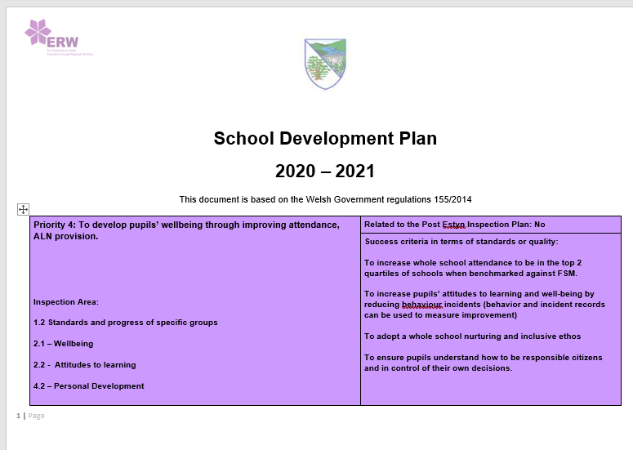
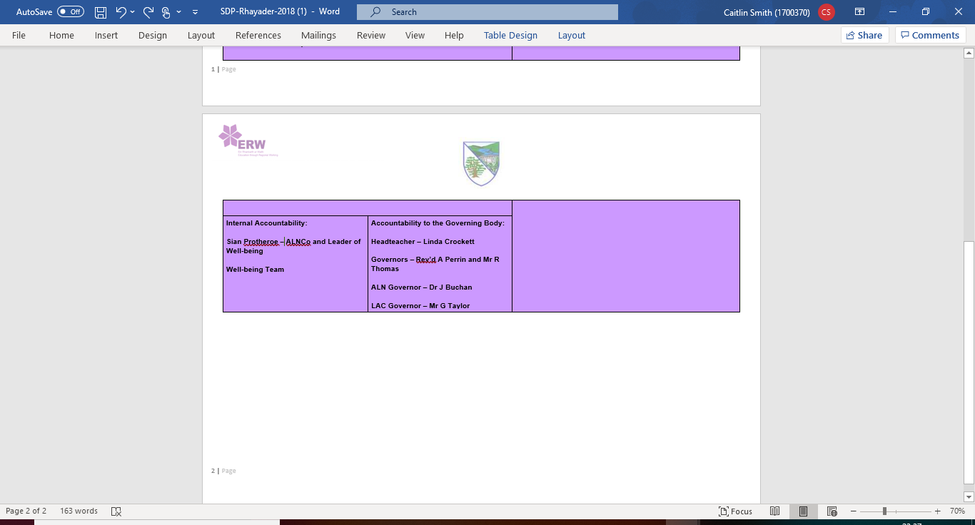

Appendix 2- School Context
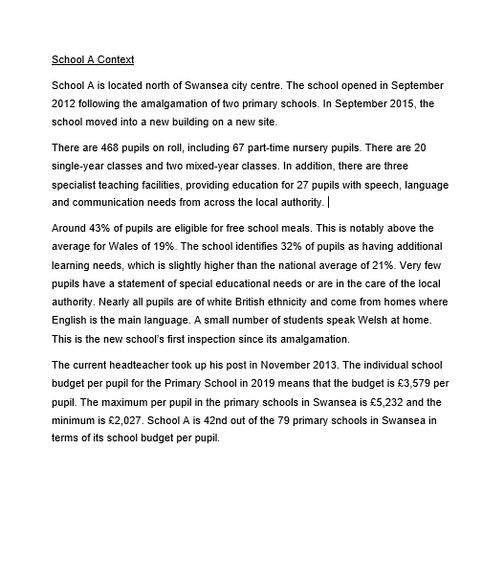
Appendix 3- Letter to parents
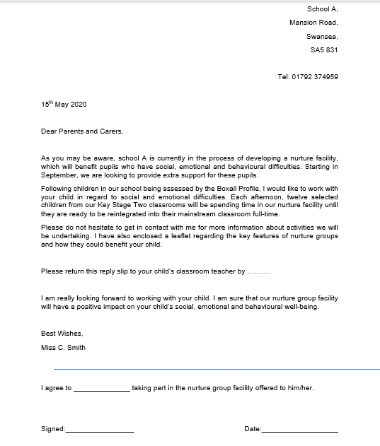

Appendix 4- Intervention Script
Prynhawn da and welcome. My name is Caitlin Smith and I am currently a newly qualified teacher (NQT) at our school. I would like to take the time to thank you all for being here and for giving me the opportunity to propose my intervention, regarding planning and running a nurture group facility in our school. To ensure the success of this intervention, it is extremely important that the governors, senior management team and the staff at our school understand the purpose and importance of nurture groups and how they will be beneficial for a group of pupils in our school. I hope that you will find my talk of some interest and that I will provide some useful points and evidence.
Following being graded as ‘adequate’ in our recent 2017 Estyn inspection, wellbeing is something that we need to focus on as a school. Our school development plan for next year, prioritises that we develop pupils’ wellbeing, with our success criteria focussing on increasing pupils’ engagement, attitudes towards learning and wellbeing by reducing behaviour incidents. We are also aiming to adopting a whole school nurturing and inclusive ethos. Appendix 1 shows the SDP. Our school identifies 32% of pupils as having an additional learning need, which is well above the national average of 21%. See Appendix 2 for the school context. Particularly, our school has many pupils who are affected by social, emotional and behavioural difficulties (SEBD). These difficulties can cause barriers to learning and are not something that children will grow out of (nurtureuk, no date, a). Something needs to be put in place for all children to reach their potential, this is something that the Welsh Government (2017) place emphasis upon. It is our responsibility to ensure that all pupils’ have the same opportunities to succeed. Pupils with more challenging behaviour may ‘benefit from a period of support in a nurture group, or through being taught anger management, or positive leadership skills’ (WG, 2016, p.70).
Nurture groups are an in-school, teacher-led intervention of groups of less than twelve students, aimed at replacing missing or distorted early nurturing experiences. The twelve children chosen to be a part of our nurture facility will be affected with SEBD. Nurture groups were created by Marjorie Boxall as a response to the fact that many pupils were entering primary schools severe social, emotional and behavioural difficulties. The difficulties presented by most of these children were a result of impoverished early nurturing, meaning that they were not able to make trusting relationships with adults or respond appropriately to other children’ (nurtureuk, no date, b). The children were not ready to meet the social demands of school, which damaged their ‘already fragile self-confidence and self-esteem’ (nurtureuk, no date, b).
We will select pupils who will partake in our nurture facility using the Boxall Profile, ‘which is an invaluable resource for the assessment of children and young people’s social, emotional and behavioural development’ (The Boxall Profile, 2018). The assessment is a ‘two-part checklist, which will be completed by members of staff that know the child best. The profile helps with ‘early identification and assessment, target intervention and setting and tracking progress’ (The Boxall Profile, 2018). Through setting individual targets, positive behaviour and skills can be reinforced. The Boxall Profile will help to identify areas where the child may need support.
As part of our nurture intervention, children will start their day in their mainstream class but attend the nurture group in the afternoon. Once registered, the targeted children will be taken to the in-school nurture facility, which is a ‘hybrid of home and school’ (nurtureuk, no date a, p.3). The targeted children will still share their break and lunch times with pupils from their mainstream class and will regularly return to it. Children who attend our nurture facility will be informed of the daily routine well in advance. One of the six important principles which underpin the ethos of a nurture group is that ‘transitions are significant in the lives of children’ (WAG, 2010, p.3). The transition between different sessions, classes and different adults can be stressful for vulnerable children and it is important that our nurture group will provide a ‘safe and predictable structured environment’ (WAG, 2010, p.1).
Each day, pupils in our nurture facility will discuss their feelings, there will be an emphasis on staff modelling positive relationships and the development of language and communication skills (WAG, 2010, p.1). Following this, the students will attend curriculum-based sessions in small groups, with individual support where needed (Estyn, 2015). A year five pupil from a similar area, mentioned that afternoon sessions were helpful stating that ‘if I have a bad morning, the relaxation helps me to get the bad stuff out of my mind so that I can get on with the rest of the day’ (Estyn, 2015). At the start of the day, the children will place a name card on a chart, indicating how they are feeling. If a child has had a bad start to the day the nurture staff can anticipate how the child is going to act that day. We will help children to understand that it is normal to feel upset and teach them how to deal with emotions correctly. It is important for students to feel comfortable talking to a trusted adult in the group without judgement.

Activities that will be undertaken by pupils in our nurture group facility will include ‘news sharing, nurture breakfasts and regular curriculum tasks’ (nurtureuk, no date a, p.3). Sharing these nurturing activities will be beneficial for students’ wellbeing since children respond to being valued and thought of as individuals. Children will be recognised for their hard work. Praise postcards will be sent home to parents/carers to inform them of their child’s success and progress. In order to reduce behaviour, which is a part of our success criteria, staff in the nurture facility will encourage good behaviour through positive reinforcement and reward (Estyn, 2015).

Our nurture room will be set up to be warm and welcoming to foster a sense of belonging that the pupils may be lacking. Our nurture room will include a den, a quiet corner where children can relax and a sensory zone. A year four pupil from a similar school, mentioned that the Dark Den helped to calm them down.

In order to run a successful nurture facility, it is crucial that we have two good, well-trained staff members. In our nurture facility this will be a teacher and a teaching assistant. When choosing the staff members, we should be confident that the staff members will be able to ‘create effective learning environments, use positive behaviour management, have the respect of other staff members and parents, set realistic demands and state them explicitly, secure motivation and concentration and have the support from mainstream staff for the school for planning’ (Welsh Government, 2010, p.11). To prepare staff for the intervention, it will be important to arrange a visit to a local nurture group to see how it is run.

Prior to setting up our nurture group facility, it is crucial to inform parents or guardians how the facility would benefit them. Also prior to children joining the nurture group, parents should be provided with material to read about the nurture facility (Welsh Government, 2010). Appendix 3 shows a letter written to parents. Gaining consent from the selected pupils’ parents is essential in determining whether our facility goes ahead. We will regularly invite parents to join in nurture group activities and to take their feedback on board. ‘Children and young people who experience higher levels of parental involvement and a closer relationship with their parents/carers are less likely to exhibit behavioural problems’ (Welsh Government, 2016, p.11).

If the nurture approach is adopted in our school, it will start in September 2020. Whilst starting up our nurture group facility, our focus will be on key stage two pupils. However, if the intervention is successful, it can be implemented in the Foundation Phase, in September 2021, promoting a whole school nurturing approach. The twelve selected children will attend the nurture group facility for a few terms, until it is felt that they are ready to be reintegrated into their mainstream classrooms full-time.

Nurture groups will not only have an impact on the selected children, but on the mainstream classes that they are a part of too. One way that we will measure the overall impact that our nurture group has had is through the successful reintegration of the children to their mainstream classrooms. Children who may not have been able to engage which teachers and students beforehand, will hopefully be able to after being a part of the nurture facility. Their attitudes towards learning will have improved. We will also keep track on behaviour incidents, if they have reduced this will indicate that the nurture facility made a positive change to social, emotional and behavioural skills. As a bonus, studies have found a significant advantage in academic progress for pupils who attended nurture groups. From background reading, it is evident that staff have seen the positive impact of their nurture group facility, as they provided children with a positive start to the day and a place to relax when children struggled with their emotions.
It is crucial that our two staff members are fully trained. Two members of staff will attend the ‘Theory and Practice of Nurture Groups’ course in Cardiff on the 11th or 12th of February and the 12th of March, the cost of this will be £718.80 for each staff member, totalling £1437.60 (nurtureuk, c). The cost of utilising the Boxall profile will be £150 for our school. This includes unlimited assessments and learning plans and accounts for up to ten staff members. Most nurture groups cost less than £10,000 to establish (nurtureuk, no date a, p.10).

