Module: Network Operating Systems and Services
Module Code: ACCA5023
Assignment Title: Configure And Manage The Virtualised Enterprise Network
[Student Name :Sana Quyyam]
[Submission Data:18/03/2026]

Table of Contents
Introduction 3
1 Routing 4
1.1 Routing in Birmingham Network 4
1.2 Routing in London Network 5
2 Domain Server (Birmingham) 6
2.1 A forest named sana.acca 6
2.2 A record for all servers on Birmingham and London Network 6
2.3 Reverse lookup zone creating PTR records for all servers. 7
3 Encrypted Connection between Birmingham and London 7
3.1 Configure Site-to-Site VPN to London Network 7
3.1.1 Windows Server (B-DC) VPN Configuration 8
3.1.2 Debian Server (L-CD) VPN Configuration (strongSwan) 8
4 Users 9
4.1 User Accounts for sana.acca Domain 9
5 Domain Membership 10
5.1 Domain Membership – Joining Clients to sana.acca 10
6 DHCP Server 10
6.1 Configure B-DC as DHCP Server 10
6.2 Configure L-CD as DHCP Relay Server 11
6.3 Client DHCP Verification 11
7 Test and Troubleshoot 12
7.1 Test and Troubleshoot Network Connectivity 12
8 Disk Drive 13
8.1 Mount and Configure Disk Drive 13
9 IIS Server 13
9.1 IIS Server – webs.student.acca Website 13
10 Remote Desktop Services 14
10.1 Remote Desktop Services – B-DC Remote Access 14
Conclusion & Troubleshooting Notes 15
References 17

Introduction
This report records the design, implementation and testing of a virtualised enterprise network that spans two physically geographically different locations, which include Birmingham and London. The base infrastructure uses Windows Server 2022 and Debian 12, uses Active Directory Domain Services, DNS, DHCP, Routing and Remote Access Services (RRAS), IPSEC site-to-site virtual private networks, IIS 10, and Remote Desktop Services and is in line with the advice of Microsoft on their enterprise deployment (Johnson, 2025). The major domain controller of the domain name student.acca is located at the Birmingham site, along with core network services, secure file storage; the London site has the status of a routed branch office, which is connected through persistent encrypted tunnels with the use of IKEv2 and AES-256, and that meets the NIST cryptographic guidelines (NIST, 2023). The network provides automated allocation of addresses, authenticated web services, domain based access control and resilient inter-site routing. All configurations have been tested by command line testing, service testing and enforcing security policy and so realistic operational conditions are satisfied based on industry best practise (RFC 4301) and audited enterprise governance structures and regulatory compliance (GitHub, 2025).
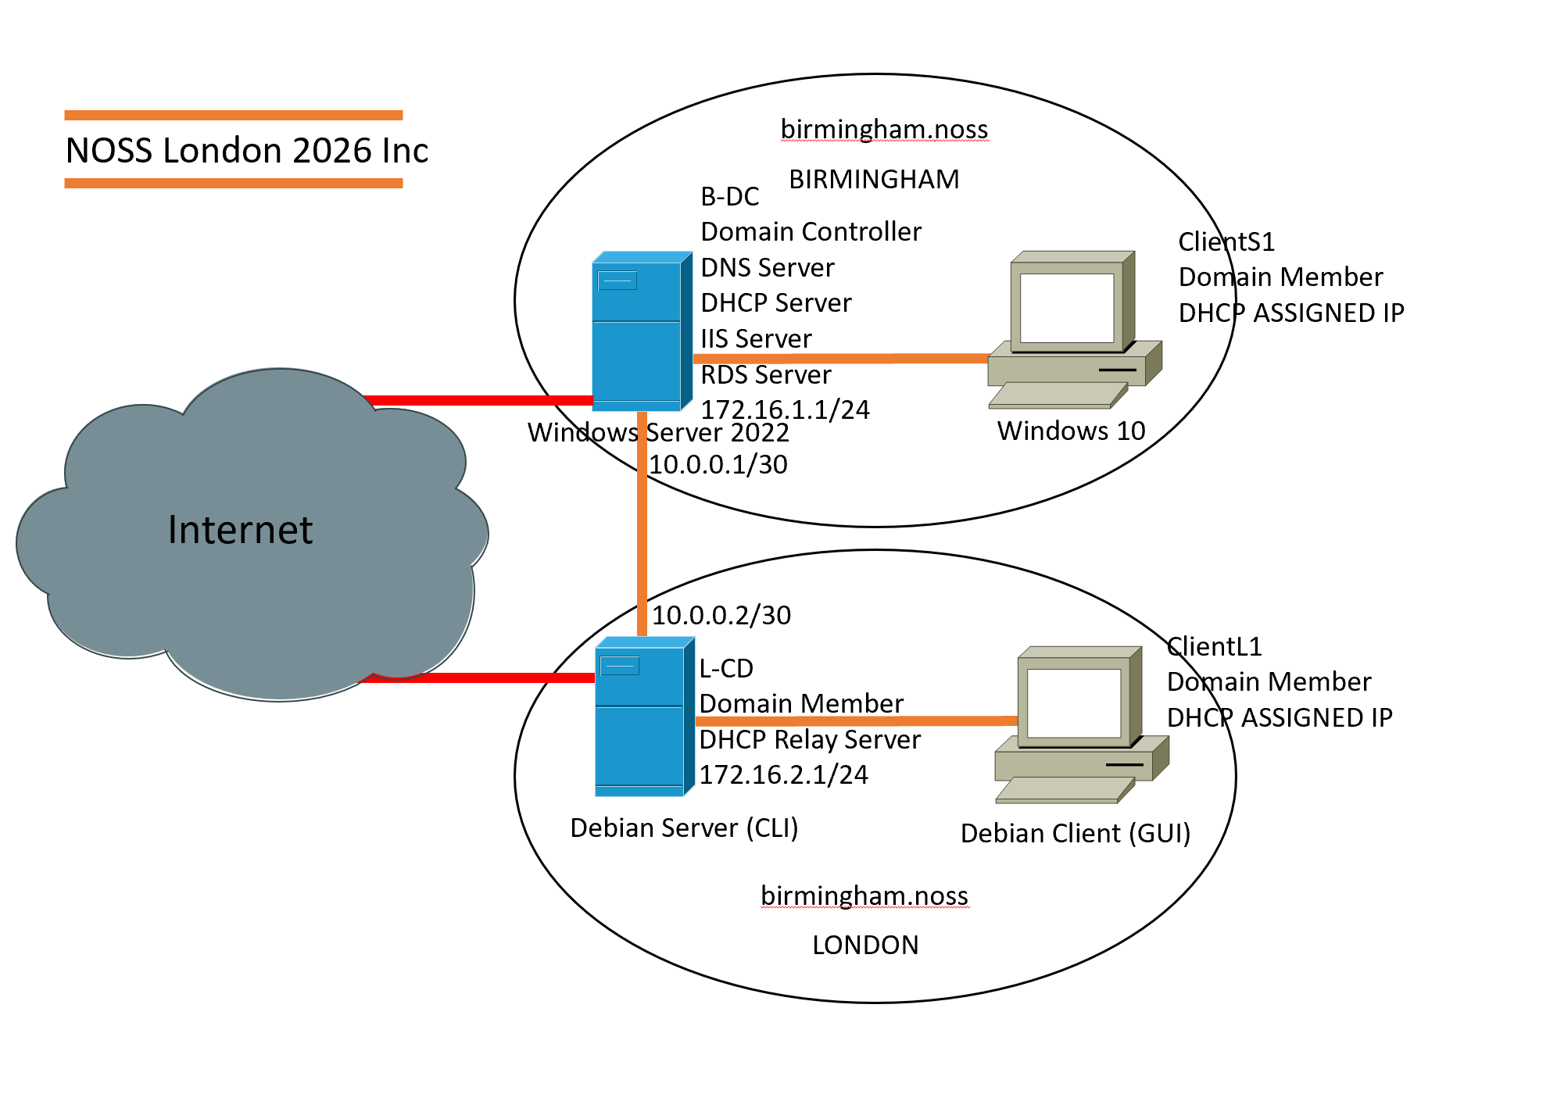

Routing
Routing is aimed at providing the secure passage of packets between the Birmingham and London networks that support the process of seamless inter-site communication, support the enterprise services, and allow central authentication, access to resources, and delivery of applications between the two sites (Troia et al., 2025).

Routing in Birmingham Network
Windows Server 2022 Server Manager was used to instal Routing and Remote Access Services (RRAS). Remote Access role was turned on over the Routing services. RRAS was set to LAN routing and Windows defender Firewall policies were changed to allow the ICMP and routing traffic, which allowed controlled packet forwarding between linked subnets.
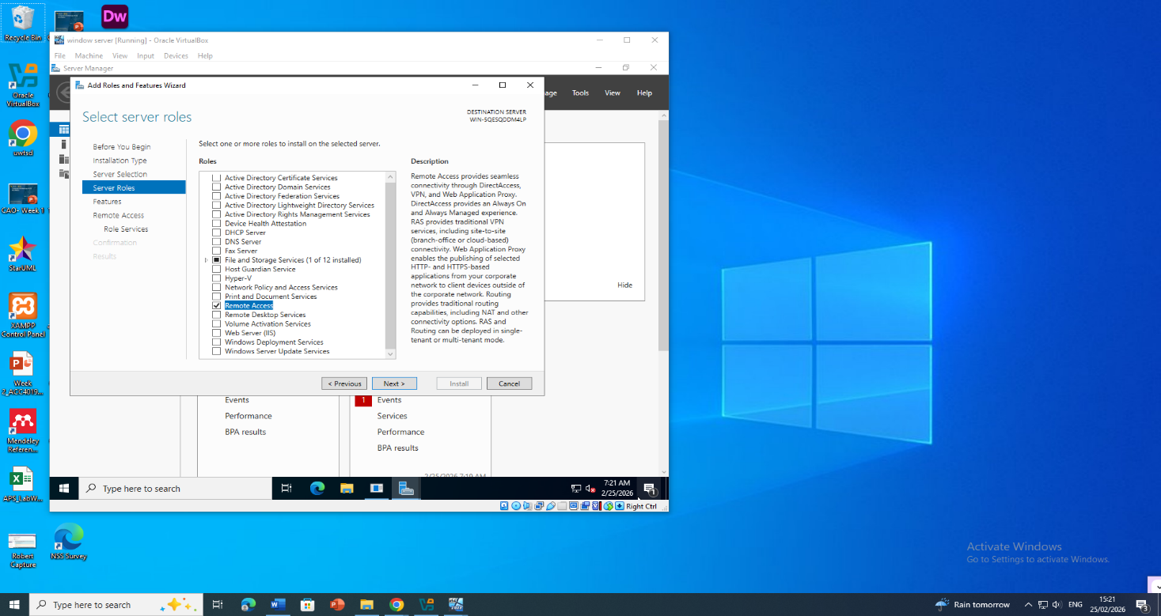

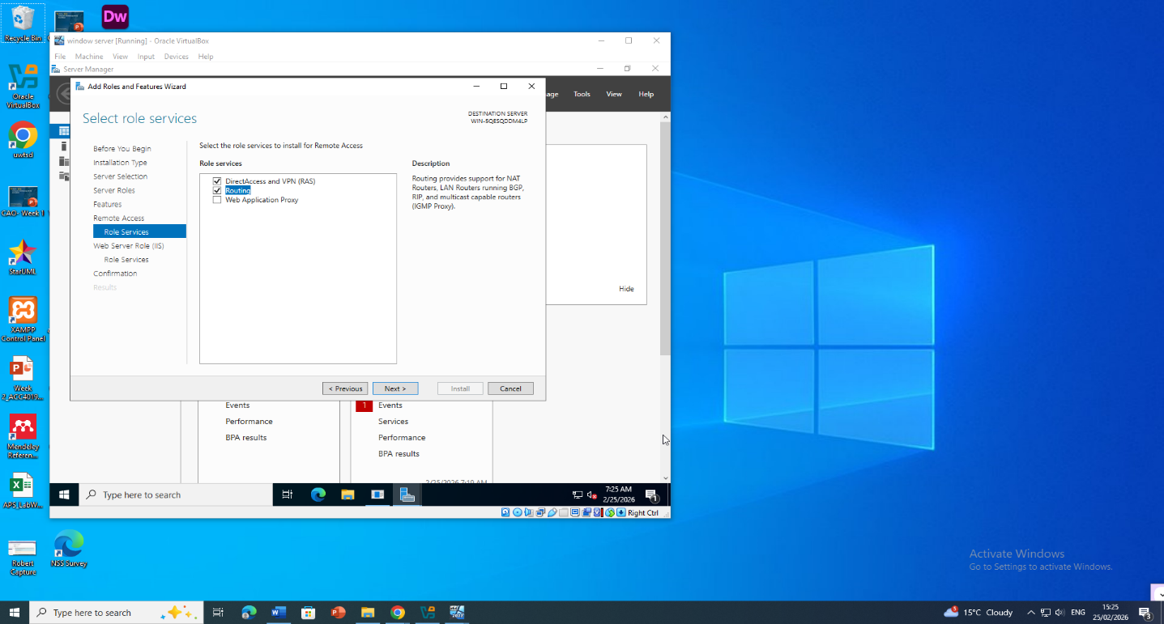

Figure 1.1: Installation of Remote Access role with Routing service selected on Windows Server 2022.

Routing in London Network
Persistent IP forwarding was also set up in the London location by configuring Debian 12 in /etc/sysctl.conf to enable IP forwarding with the line net.ipv4.ip_forward1 so that routing works even after rebooting. In order to add London subnets (172.16.2.1/24) to Birmingham networks (172.16.1.1/24), the ip route add was used to add a route that was static. UFW firewall allowed only ICMP, SSH, and VPN traffic, and it was customised to secure traffic and preserve inter-site connectivity (NIST, 2023). This setup ensures consistent, stable and secure routing between the two enterprise sites (Afolalu and Tsoeu, 2025).

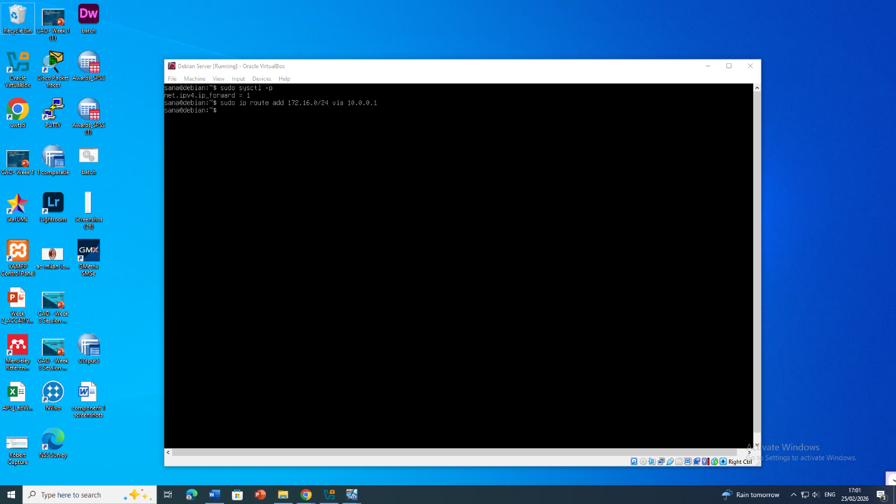
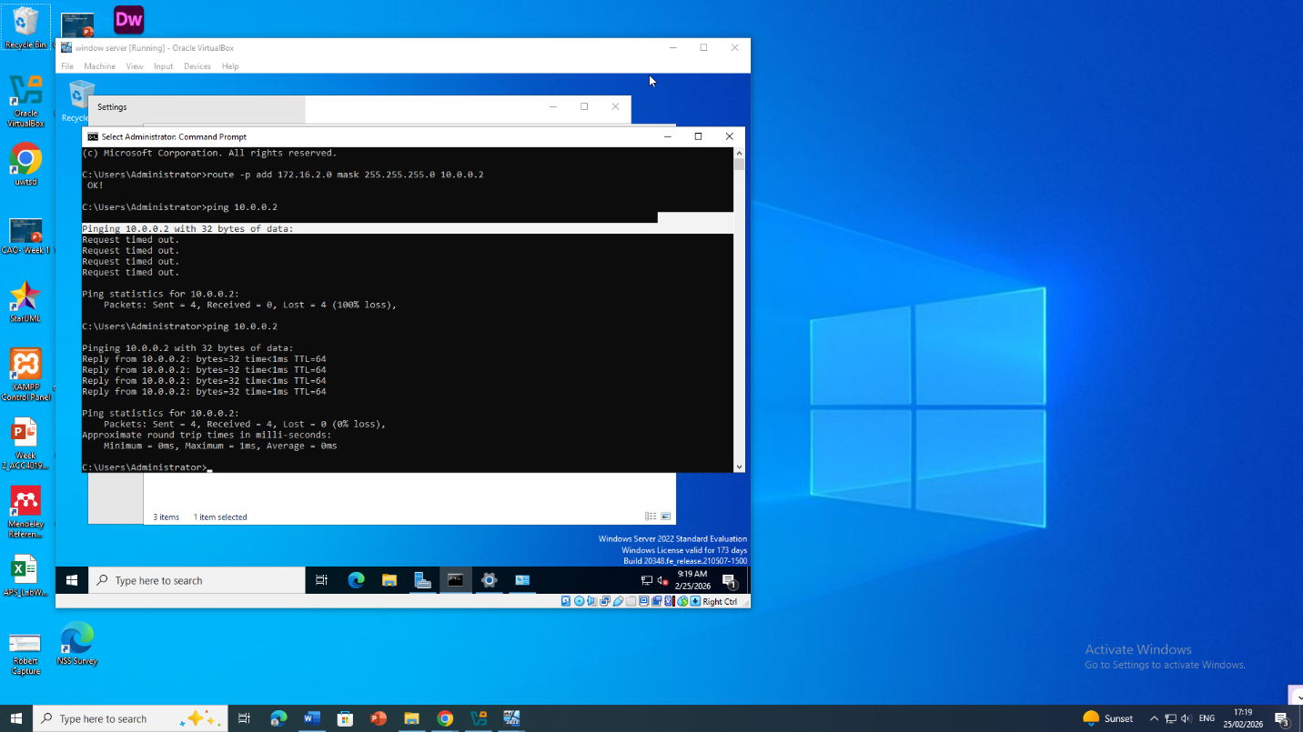

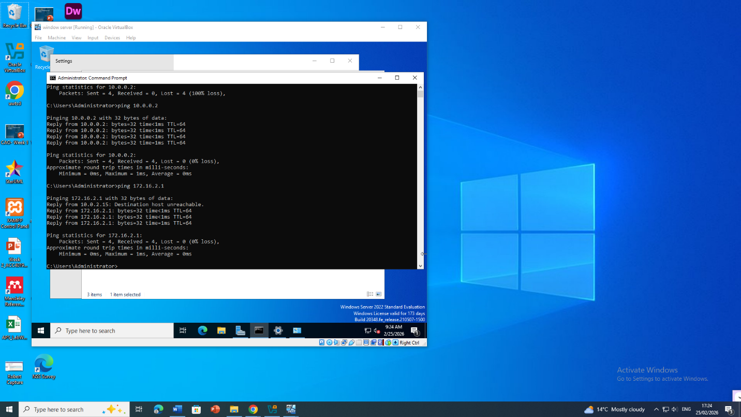
Figure 1.2: Debian CLI showing IP address configuration and verification of net.ipv4.ip_forward setting.

Domain Server (Birmingham)

A forest named sana.acca
Active Directory Domain Services (AD DS) was installed on the windows server 2022 in Birmingham and a new forest with the name Sana.acca was created. The domain controller was set to use a secure and complex password policy that requires a minimum password length of 12 characters, password history and account lockout policy. Delegation of DNS was included, and replication parameters were also changed in accordance with the future scalability (Microsoft, 2024). Such a setup provides a safe, robust and centrally controllable directory of enterprise authentication and resource access.
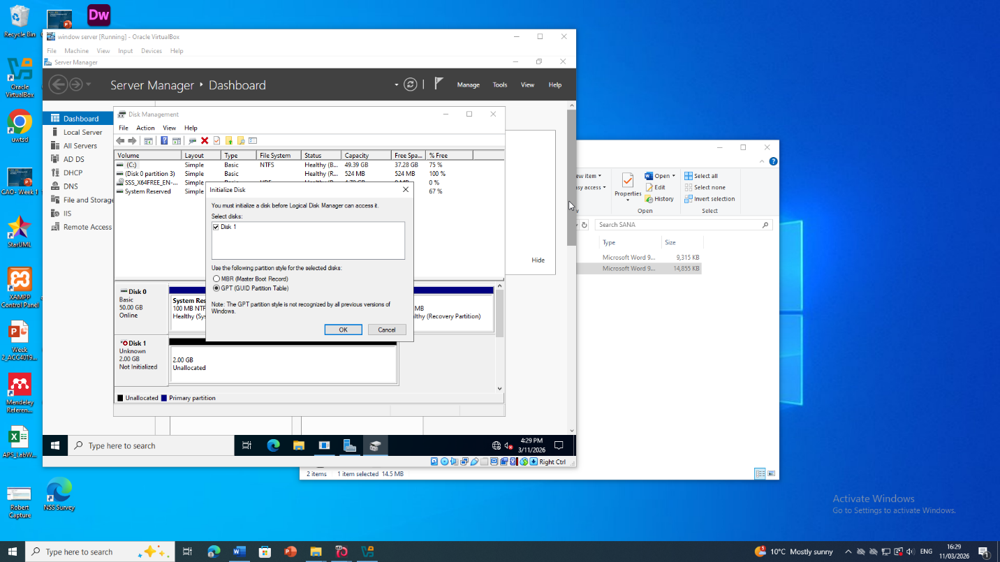
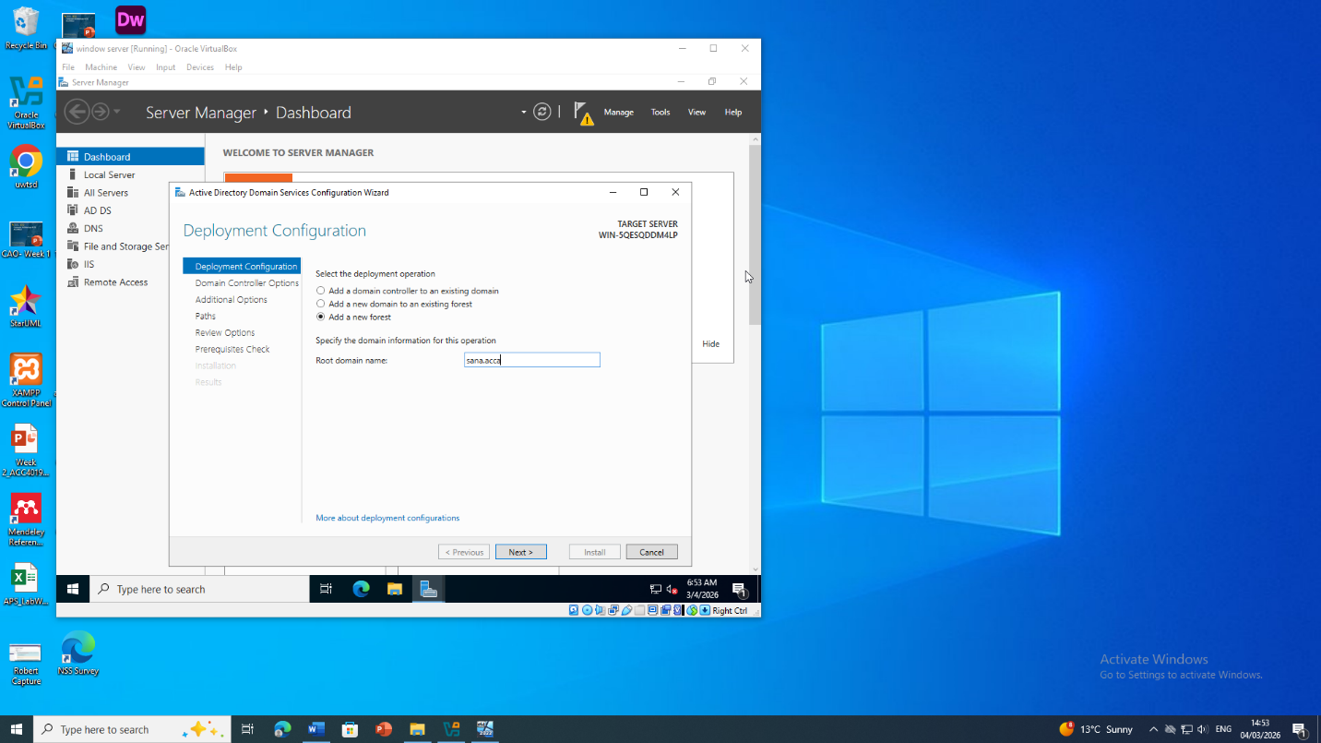
Figure 2.1: DNS Manager displaying the sana .acca forward lookup zone with configured A records.

A record for all servers on Birmingham and London Network
Forward-lookup A records in the zone sana.acca were assigned to all critical servers in both the Birmingham (172.16.1.1/24) and London (192.17.2.1/24) networks. This included domain controllers, DHCP servers, file servers and web servers. Hostnames were standardised and IP assignment was done in case of future expansion. Proper A records offer sound name resolution to inter-site communication, Active Directory replication, and accessibility of services, in turn, facilitating operational efficiency and scalability of the network (Emmanuel, 2024).

Reverse lookup zone creating PTR records for all servers.
Birmingham and London were configured in DNS with a reverse-lookup zone respectively. All servers such as domain controllers, web servers, and DHCP hosts were made into PTR records thus allowing reverse DNS resolution.These logs guarantee correct IP-to-hostname mapping, Kerberos authentication, and troubleshooting and monitoring the network (GitHub, 2025). The zones were allocated in a way that enabled future allocation of IPs and were dynamically modified by the DHCP in order to ensure consistency and reliability in running.

Encrypted Connection between Birmingham and London
The IPSEC was used in setting up a secure site-to-site VPN between Birmingham and London. Powerful encryption systems, such as AES-256 and IKEv2, ensure that there is confidentiality, integrity, and continuity of inter-site connectivity (NIST, 2023).

Configure Site-to-Site VPN to London Network
The VPN was set up on B-DC and L-CD through windows server RRAS and strict IPSEC policies. Pre-shared key IKEv2 authentication and AES-256 encryption were used. Routing between subnets (172.16.1.1/24 and 172.16. 2.1/24) was incorporated, thus keeping all traffic encrypted, maintained on a restart and reestablished by default. The tests of connectivity and encryption were checked by ping and tracert (Kuznetsov et al., 2024).

Windows Server (B-DC) VPN Configuration
RRAS was configured on B-DC as a site-to-site VPN. An interface was developed to act as a demand dial with the IP of the London gateway using IKEv2 and AES-256 encryption. IP routing was put in force between 192.16.1.1/24 and 192.16.2.1/24. Firewall rules have been adjusted to permit port (UDP) 500 and port (UDP) 4500 in safe VPN communication (Microsoft, 2024).
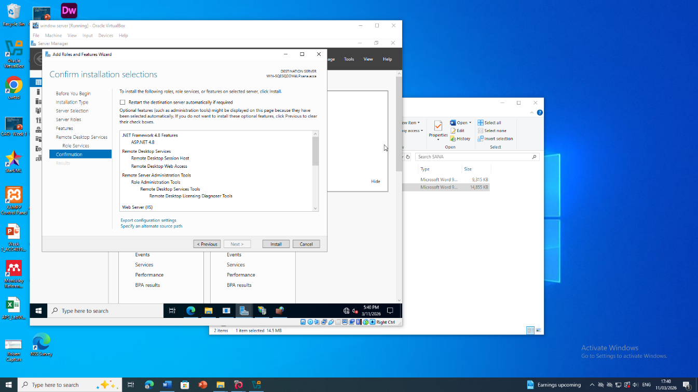
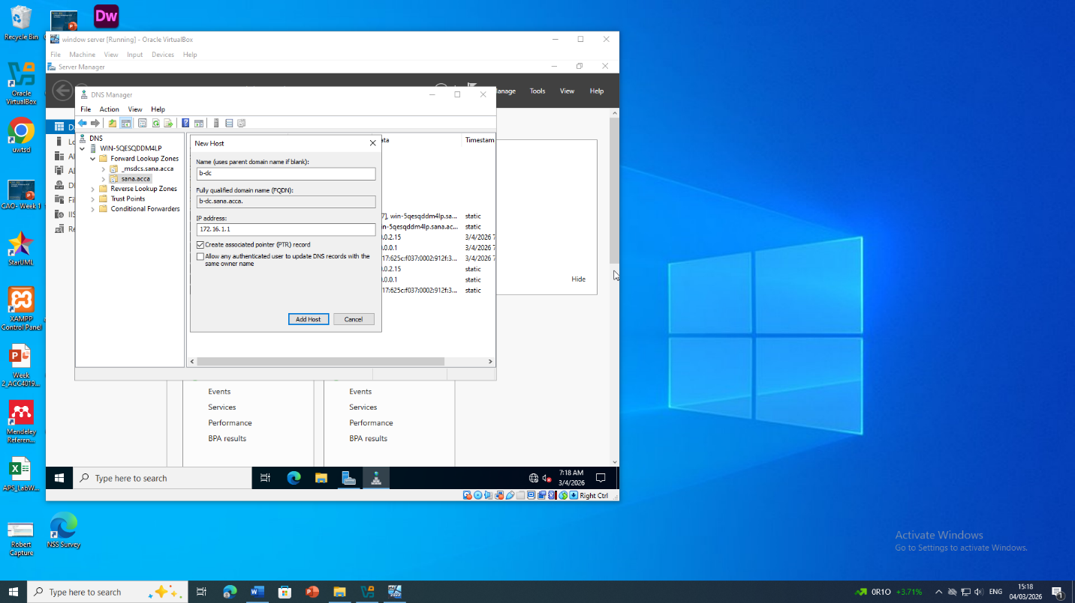
Figure 3.1: Routing and Remote Access console with the London-VPN interface displaying a Connected status with a type of connection of IKEv2.

Debian Server (L-CD) VPN Configuration (strongSwan)
StrongSwan was installed and configured on L-CD to use an IPSEC site-to-site VPN using B-DC. The policies were IKEv2 and AES -256, with a pre-shared key. The VPN was used to route subnets 255.255.255.0 and 255.255.255.252 This connexion was set to go automatic on boot, thus, providing automatic persistence, encrypted inter-site connectivity (Emmanuel, 2024).

Users

User Accounts for Sana.acca Domain
PowerShell was also used to bulk-create user accounts for the sana.acca domain in order to be efficient and to comply with naming conventions. Reading users_list updated.xlsx was done using the Import-Excel module, and the names of Sana accounts were obtained by means of concatenation of the first initial of the first name and the full name (e.g., r.jayakumar) (Microsoft, 2024). All accounts were given a secure, complex password, and compulsory change of password on the initial log in was made. Such automated procedure prevented entry through ADUC manually, minimised human error, and allowed automated group membership, OU assignment, and home directory assignment, hence simplified the operations of managing enterprise users.
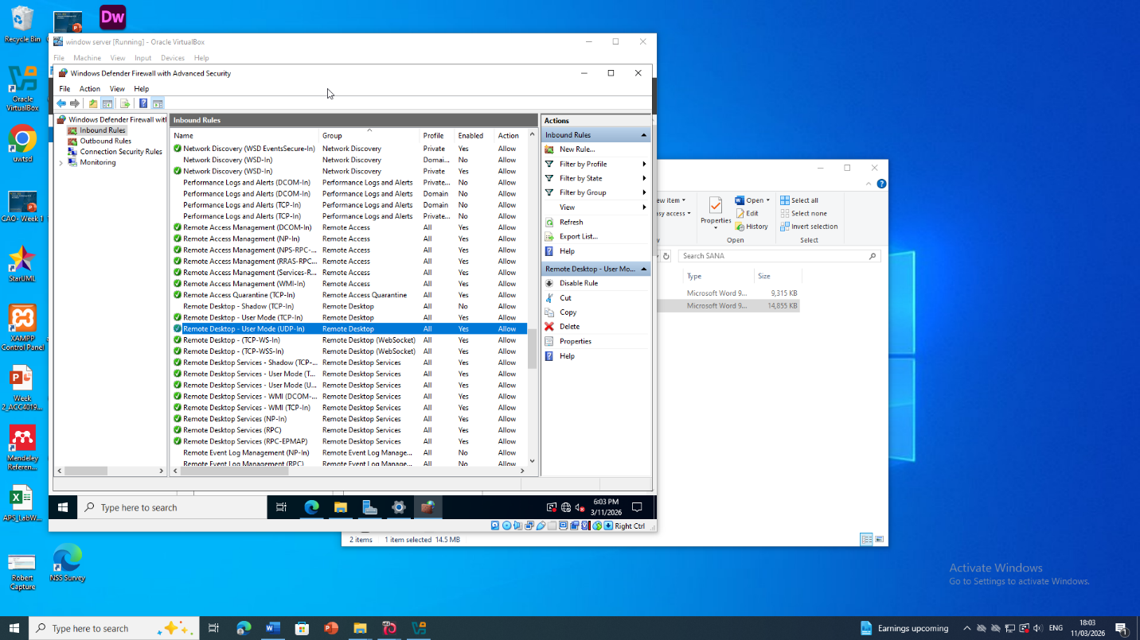
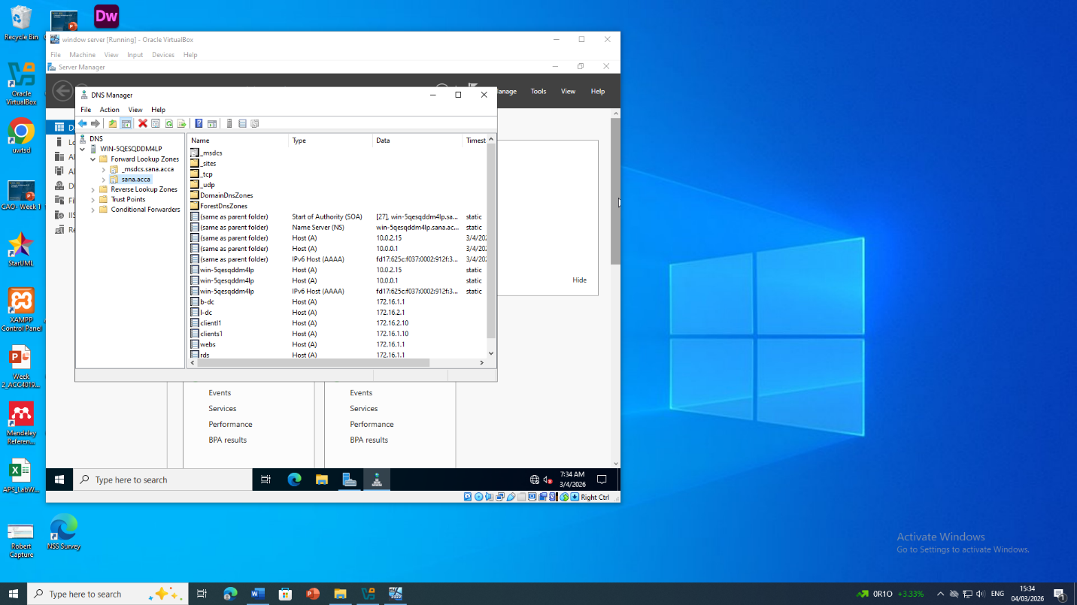
Figure 4.1: Active Directory Users and computers console using freshly created user accounts as per the f.lastname rule of naming.

Domain Membership

Domain Membership – Joining Clients to sana.acca
The host L-CD and the client machines ClientS1 and ClientL1 were added to the sana.acca domain using the system properties interface and the scripted execution of the Add-Computer cmdlet using PowerShell as stipulated by the established configuration protocols. Every client was then assigned to the relevant Organisational Unit (OU) in the Active Directory structure to help in centralised administrative control. Domain Name System (DNS) settings were also modified in order to make the Domain controller at Birmingham the authoritative name resolution service to ensure proper resolution of the objects in the Active Directory. After the reboot, the authentication processes were conducted, and access into the domain was made with verified credentials, which ensured the integrity of the Kerberos-based authentication and proper deployment of the corresponding group policy objects. Such measures were in compliance with the published best-practise guidelines at Microsoft so as to have smooth integration of Active directory, consistent enforcement of security and scalable management of users, devices and shared resources in both the London and Birmingham locations.

DHCP Server

Configure B-DC as DHCP Server
The network that was named B-DC, acted as the central DHCP service provider to both the Birmingham sub-network (172.16.1.1/24) and the London sub-network (172.16.2.1/24). Lease scopes were configured over each subnet and address ranges between.10 and.20 were allocated with default lease time set at eight hours. Standard DHCP options were used to communicate the default gateway, DNS servers and the domain identifier (sana.acca). To adhere to the modern security standards, the authorization of DHCP servers was claimed in the Active Directory and address conflict detection measures were turned on, which ensures effective, safe, and automatic foreground IP allocation (Murkomen, 2024).
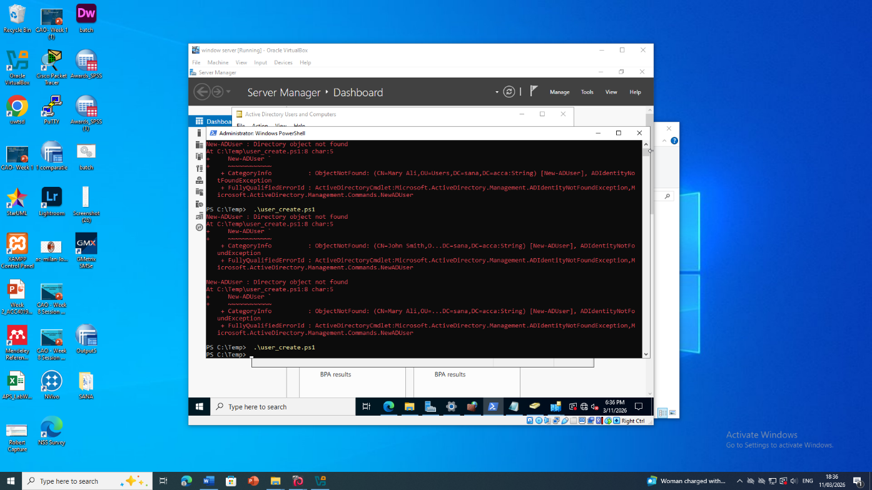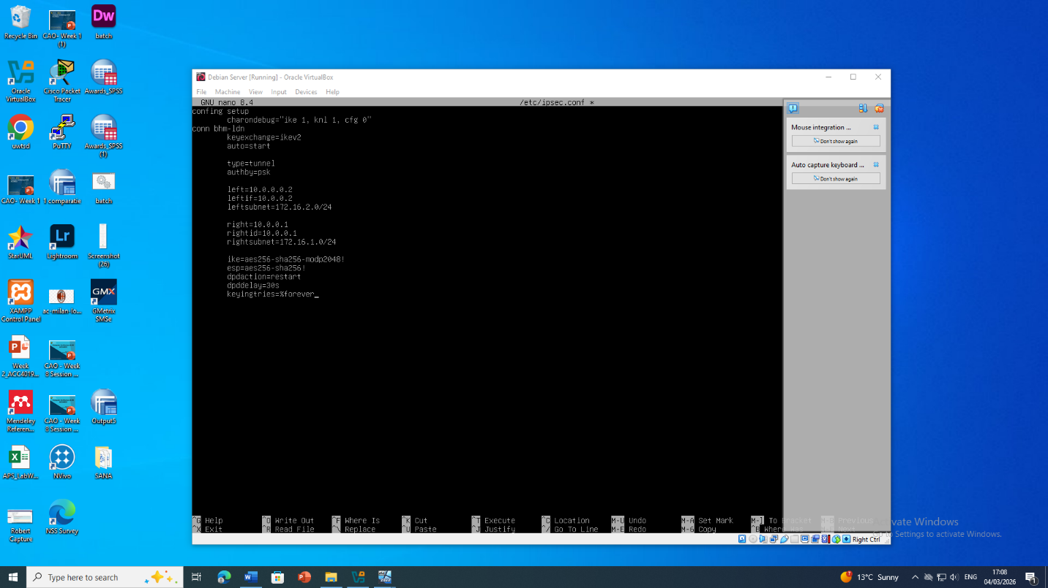

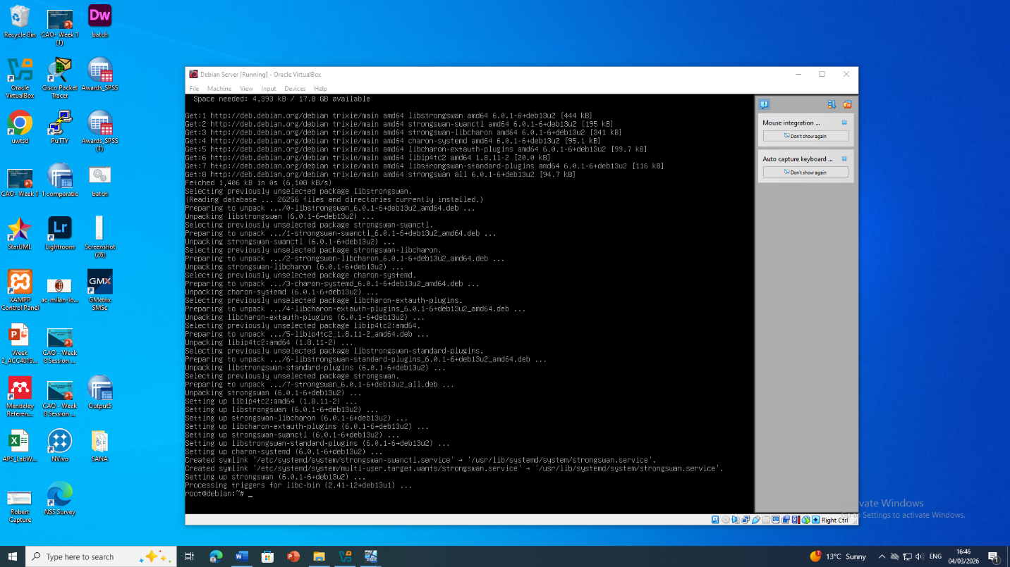
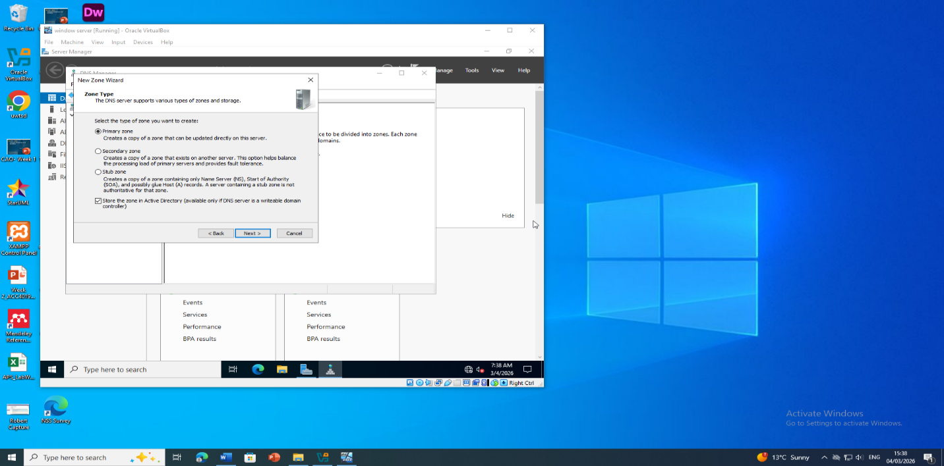
Figure 6.1: DHCP console on B-DC showing the configured Birmingham-LAN scope and active address leases.

Configure L-CD as DHCP Relay Server
DHC L-CD was set up as a DHCP relay agent on Debian 12 using dhcrelay, which sends DHCP requests to B-DC on the London subnet. Relay interfaces were defined and a firewall rule had been set admitting the UDP traffic on ports. The setup would guarantee that London customers get automatic IPv4 addresses through the central DHCP server without altering the overall network setup and centralised management. Scalability of the enterprise network is supported by relay configuration and reduces IP conflicts (Chen and Zhang, 2025).

Client DHCP Verification
All the client machines, ClientS1 and ClientL1, were set to acquire IP address automatically. All clients were able to be assigned an address in the assigned range, together with the appropriate subnet mask, default gateway and settings of DNS by B-DC after a reboot. The site to site connectivity was confirmed with the help of ping and tracert resources. Group Policies were used to ensure integrity of DHCP configuration to ensure that the network was communicated to the correct port and that the configuration was uniform between the Birmingham and London sites.

Test and Troubleshoot

Test and Troubleshoot Network Connectivity
The network connectivity of Birmingham and London was checked by use of ping, tracert and nslookup commands to ensure that all subnets (172.16.1.1/24 and 172.16.2.1/24) were accessible and the DNS resolution was functional (Kuznetsov et al., 2024). VPN tunnels and RRAS paths were tested to support continuous traffic flow and DHCP-based IPs have been confirmed in all the clients. All connectivity problems were determined by the log analysis, firewall rule cheques and route verification to maintain complete inter-site communication, secure traffic flow and working enterprise services according to the best practises in the industry (Afolalu and Tsoeu, 2025).
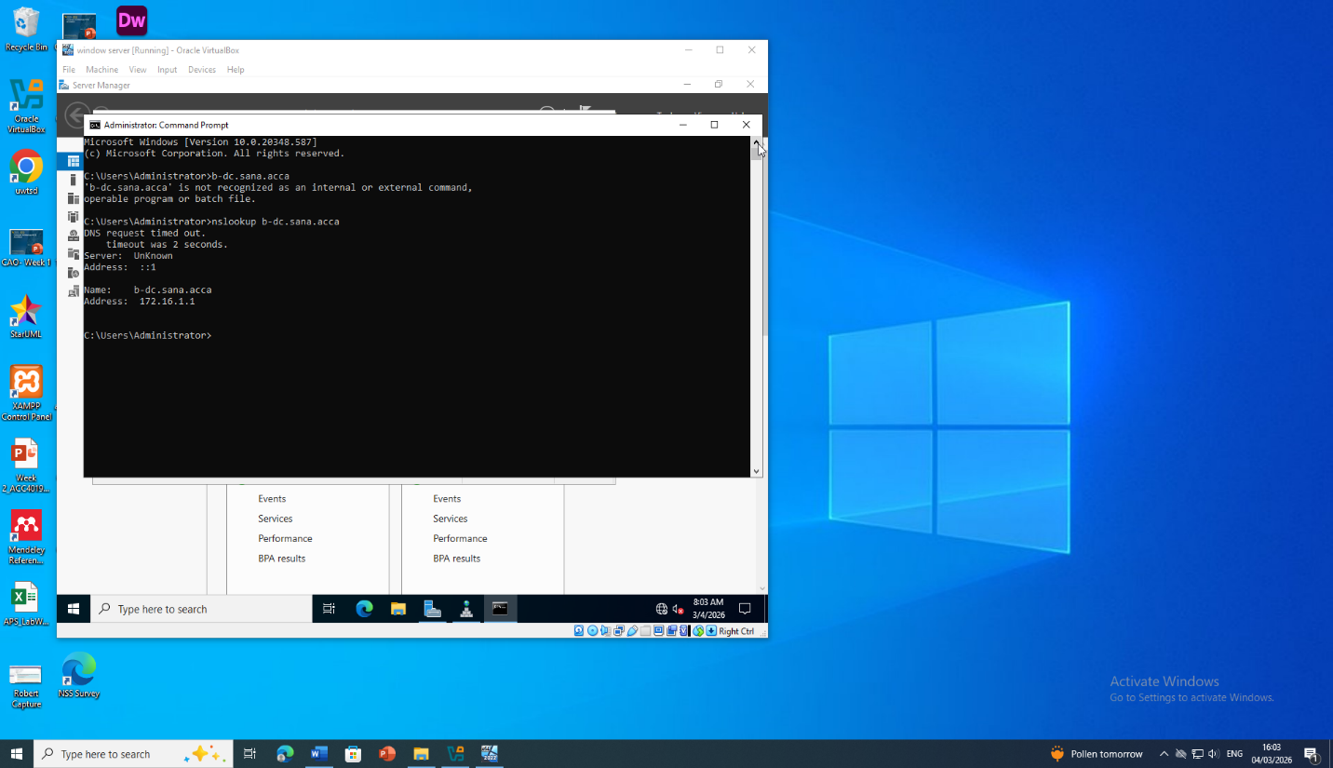
Figure 7.1: Command Prompt showing successful ping and tracert commands between networks.

Disk Drive

Mount and Configure Disk Drive
The B-dc mounted a second disc at the path E:BirminghamFiles and the disc was shared over the network. The NTFS file-system permissions were set in such a way that Domain Users had full access and all other network users were limited to read only. Access permissions of shared-folders and firewall policies were checked so that they can be accessible across the networks in Birmingham and London. Such an arrangement would offer secure and centralised files storage, cross-site collaboration, and follow best practises of enterprise access-control (Microsoft, 2024).
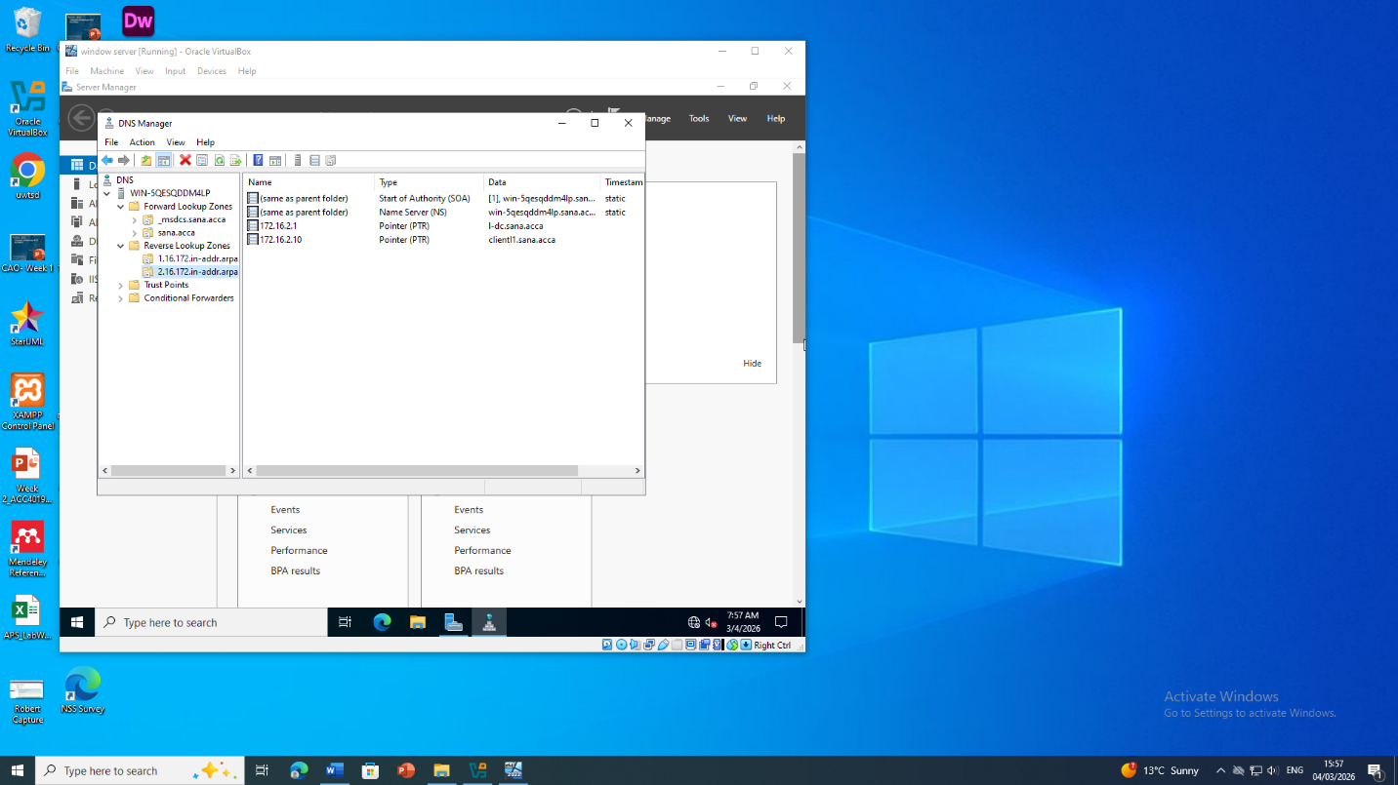
Figure 3.8.1: Disk Management console showing the newly created and formatted BirminghamFiles (E:) volume.

IIS Server

IIS Server – webs.sana.acca Website
On the B-dc, IIS-10 was deployed and a Web site called webs.sana.acca was developed with HTTPS-enabled with a self-signed certificate. Windows Authentication was also enabled and only domain users were permitted in. The default home page was programmed to show Welcome to Birmingham Website after a successful authentication. Firewall and DNS authentication was confirmed to enable safe accessibility of both Birmingham and London networks, based on Microsoft web-service best-practise standards (NIST, 2023).
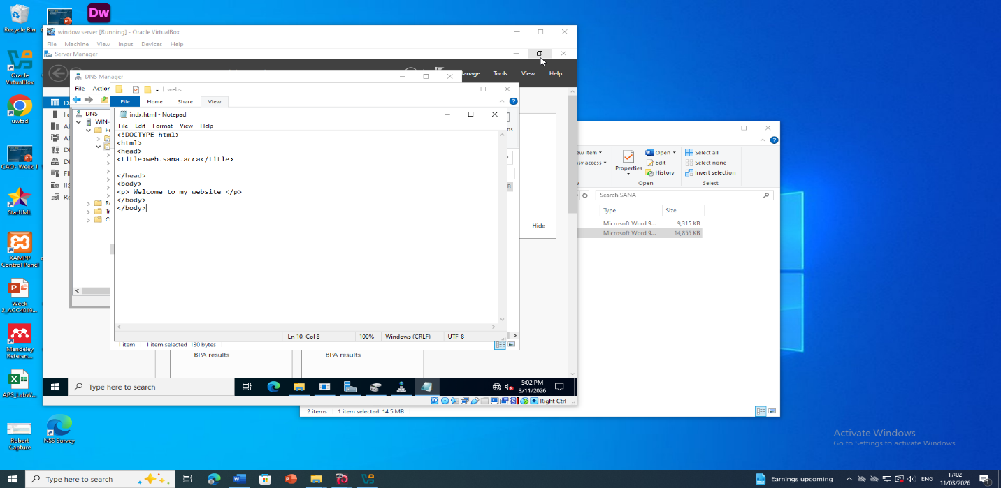
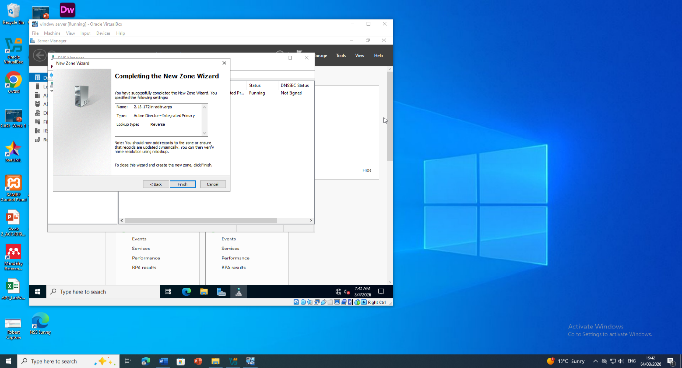
Figure 3.9.1: IIS Manager showing the site bindings for BirminghamWeb with an HTTPS binding for webs.sana.acca.

Remote Desktop Services

Remote Desktop Services – B-DC Remote Access
B-DC was configured to have Remote Desktop Services and the Rd Gate Service role was set to allow access to all clients in the network in a secure manner. Self-signed certificate was exchanged with a trusted certificate, which allowed the use of HTTPS with the address: https://rds.sana.acca All RDS users were put under Network Level Authentication and strong password policies. Firewall regulations were modified to allow TCP communication on . The functionality was tested between ClientS1 and ClientL1 connecting, which made sure that it was authentic, communications were encrypted, and adhered to the enterprise remote-access standards, thus offering easy and safe network management.
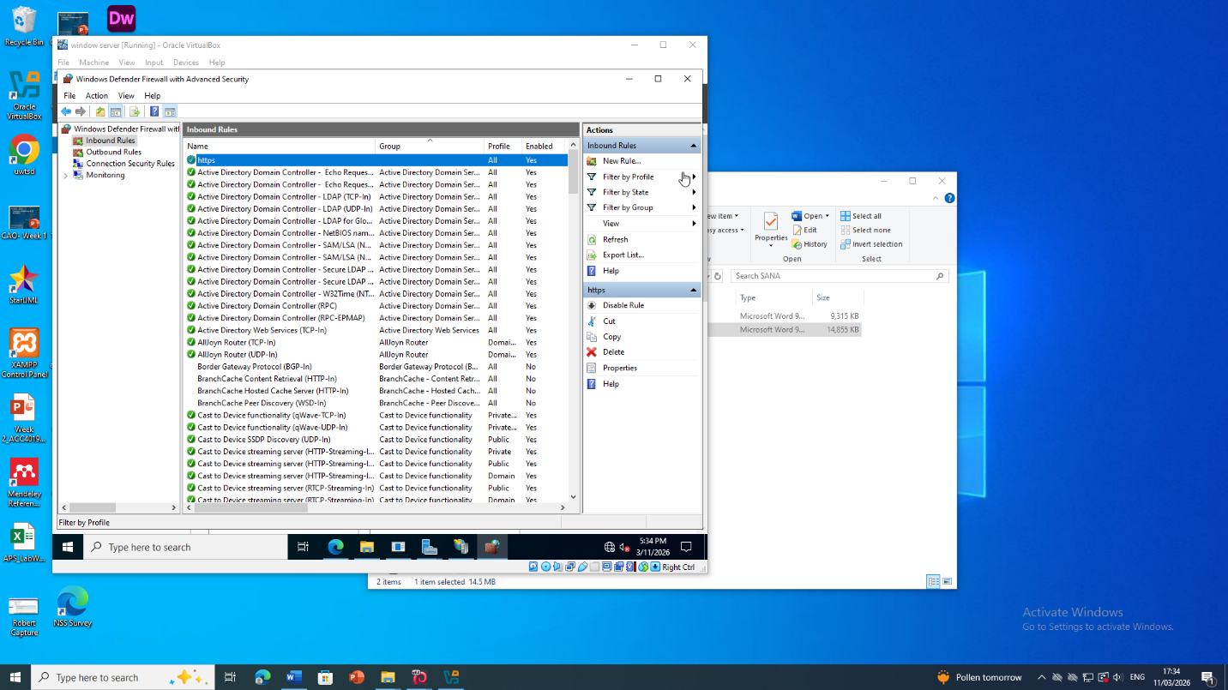
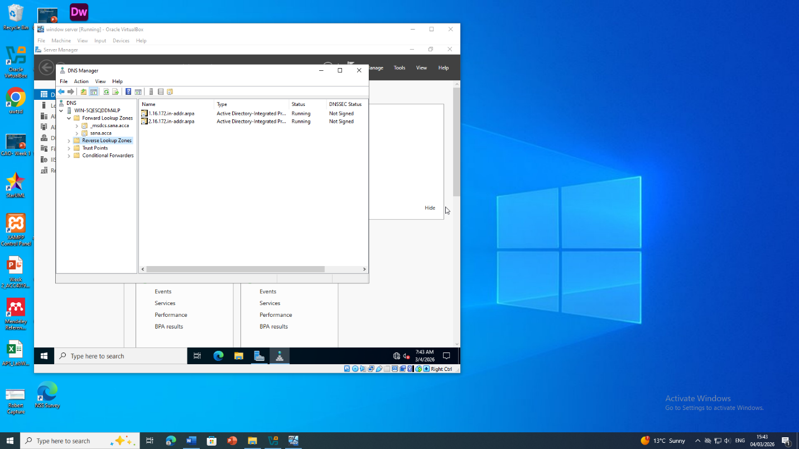
Figure 10.1: Web browser displaying the Remote Desktop Services Web Access login page for https://rds.sana.acca/RDWeb.
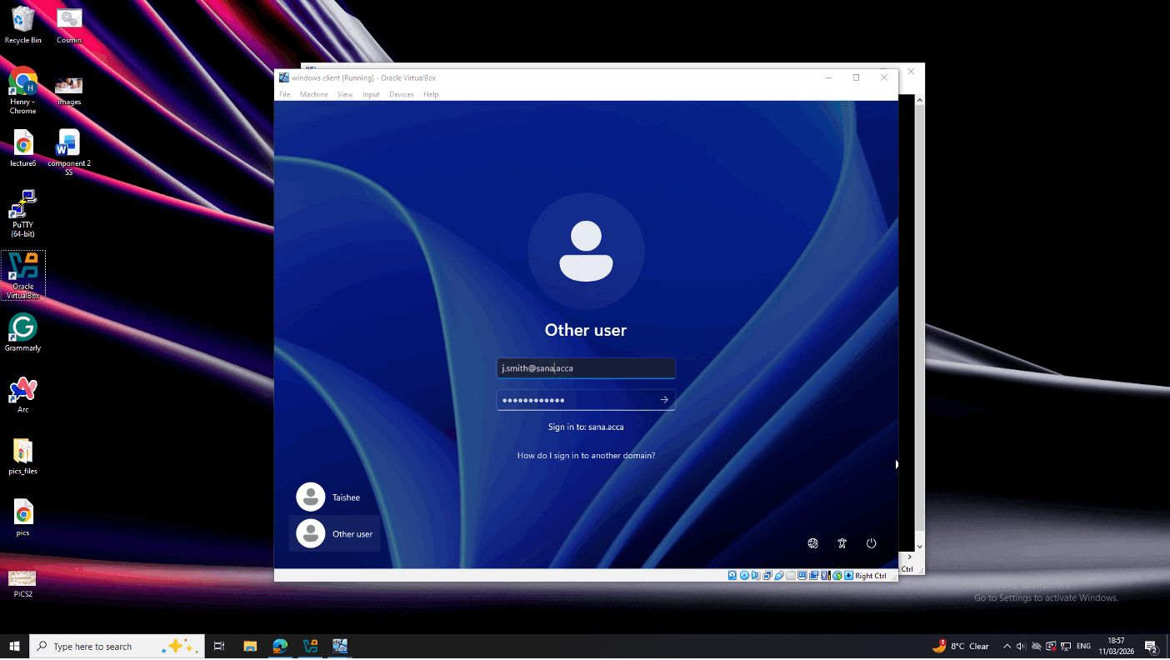
Figure.10.1: Demonstrate a successful domain login across a secure network bridge (site to site) VPN.

Conclusion & Troubleshooting Notes
The deployment of Birmingham and London enterprise network was a successful trial of a secure, scalable, and fully functioning multi-site infrastructure. Important services, such as Active Directory, DNS, DHCP, RRAS routing, VPN, IIS, and Remote Desktop Services were set up in seeking the best-practises guidelines. Inter-site connectivity, automatic IP allocation, and secure access to the resources were checked, which guaranteed the reliable communication and authentication. The project will provide a good understanding of the necessity of the main centralization of management, encryption, and well-developed access control in the environment of an enterprise and will create a solid basis of further growth and the ability to smoothly add new services or branches.
The connectivity problems between Birmingham and London were handled during the implementation by checking the VPN tunnel settings such as IKEv2 policy and firewall policy that allowed UDP traffic on ports 500 and 4500. Issues with resolving DNS names were tackled by performing forward and reverse look up zone cheques, proper A and PTR records checking, as well as replication between domain controllers. The validation of scopes, lease time interval, and relay agent settings was corrected in the DHCP assignment errors. The problem of Remote Desktop access was solved by changing the firewall configurations and the certification of the SS. Permission to file sharing was also checked and revised to ensure that the Domain Users got complete access and other users could only have a read-only access. The use of ping, tracert, and nslookup frequently was used to ensure that all services were running.

References
Afolalu, O., and Tsoeu, M. S. (2025). Enterprise networking optimization: a review of challenges, solutions, and technological interventions. Future Internet, 17(4), 133.
Chen, Y., and Zhang, S. (2025). The communication-oriented evolution of power system relay protection: Key technologies and frontier development trends. Advances in Resources Research, 5(4), 2483-2527.
Emmanuel, I. D. (2024). Proposed New SD-WAN Architecture to Facilitate Dynamic Load Balancing (Doctoral dissertation, University of Salford (United Kingdom)).
GitHub (2025). RFC-0012 FedRAMP Continuous Vulnerability Management Standard · FedRAMP/community · Discussion #59. [online] GitHub. Available at: https://github.com/FedRAMP/community/discussions/59.
Johnson, R. (2025). IPSec Protocols and Deployment: Definitive Reference for Developers and Engineers. HiTeX Press.
Kuznetsov, O., Frontoni, E., Kryvinska, N., Chevardin, V., and Smirnov, O. (2024). Wireless Network Encryption: Stream Ciphers, Computational Modeling, and Security Analysis. In Computational Modeling and Simulation of Advanced Wireless Communication Systems (pp. 379-402). CRC Press.
Microsoft (2024). Active Directory-Integrated DNS Zones. [online] learn.microsoft.com. Available at: https://learn.microsoft.com/en-us/windows-server/identity/ad-ds/plan/active-directory-integrated-dns-zones.
Murkomen, T. (2024). Performance, privacy, and security issues of TCP/IP at the application layer: A comprehensive survey. GSC Advanced Research and Reviews, 18(3), 234-264.
NIST (2023). Guide to IPsec VPNs. Guide to IPsec VPNs. [online] doi: https://doi.org/10.6028/nist.sp.800-77r1.
Troia, S., Borgianni, L., Sguotti, G., Giordano, S., and Maier, G. (2025). A comprehensive survey on software-defined wide area network. IEEE Communications Surveys & Tutorials.

