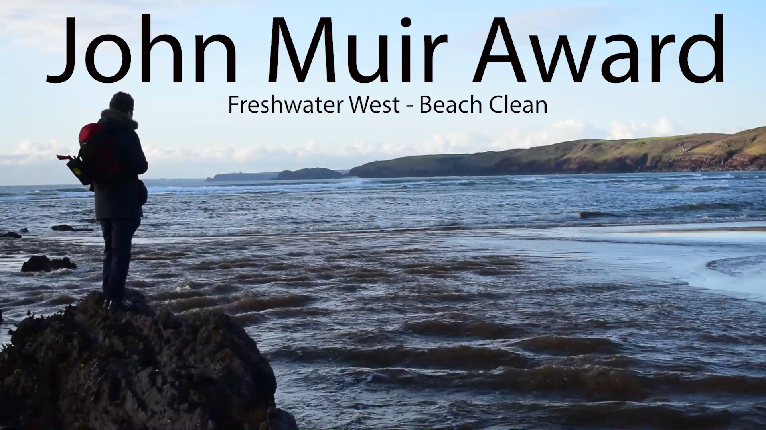

Below is the link to my John Muir Video. Due to file size I had to use my YouTube as a platform so I uploaded this as unlisted so only people with the direct link can find it. In the video I cover all 4 elements of the award via media content.


https://youtu.be/mkeAmZkEZNU

