
Project Management

Portfolio on British Columbia massive flood reconstruction of infrastructures Project

Module Code: LCLM5003

Name: Ottavio Altana

Student ID: 2331607

Lecturer: Xavier Matieni

December 2025

Table of contents

Part A: poster presentation 1
Part B: reflection on feeback using gibbs reflection style 2
Description 2
Feelings 2
Evaluation 2
Analysis 2
Conclusion 3
Action plan 3
Part C: project management plan 4
Introduction 4
Project description 4
Scope 5
Work breakdown structure 6
Quadd chart 7
Gantt chart 9
Stakeholders 9
Allocation of resources 11
Risk analysis 12
Conclusion 13
References 14

Part A: Poster Presentation

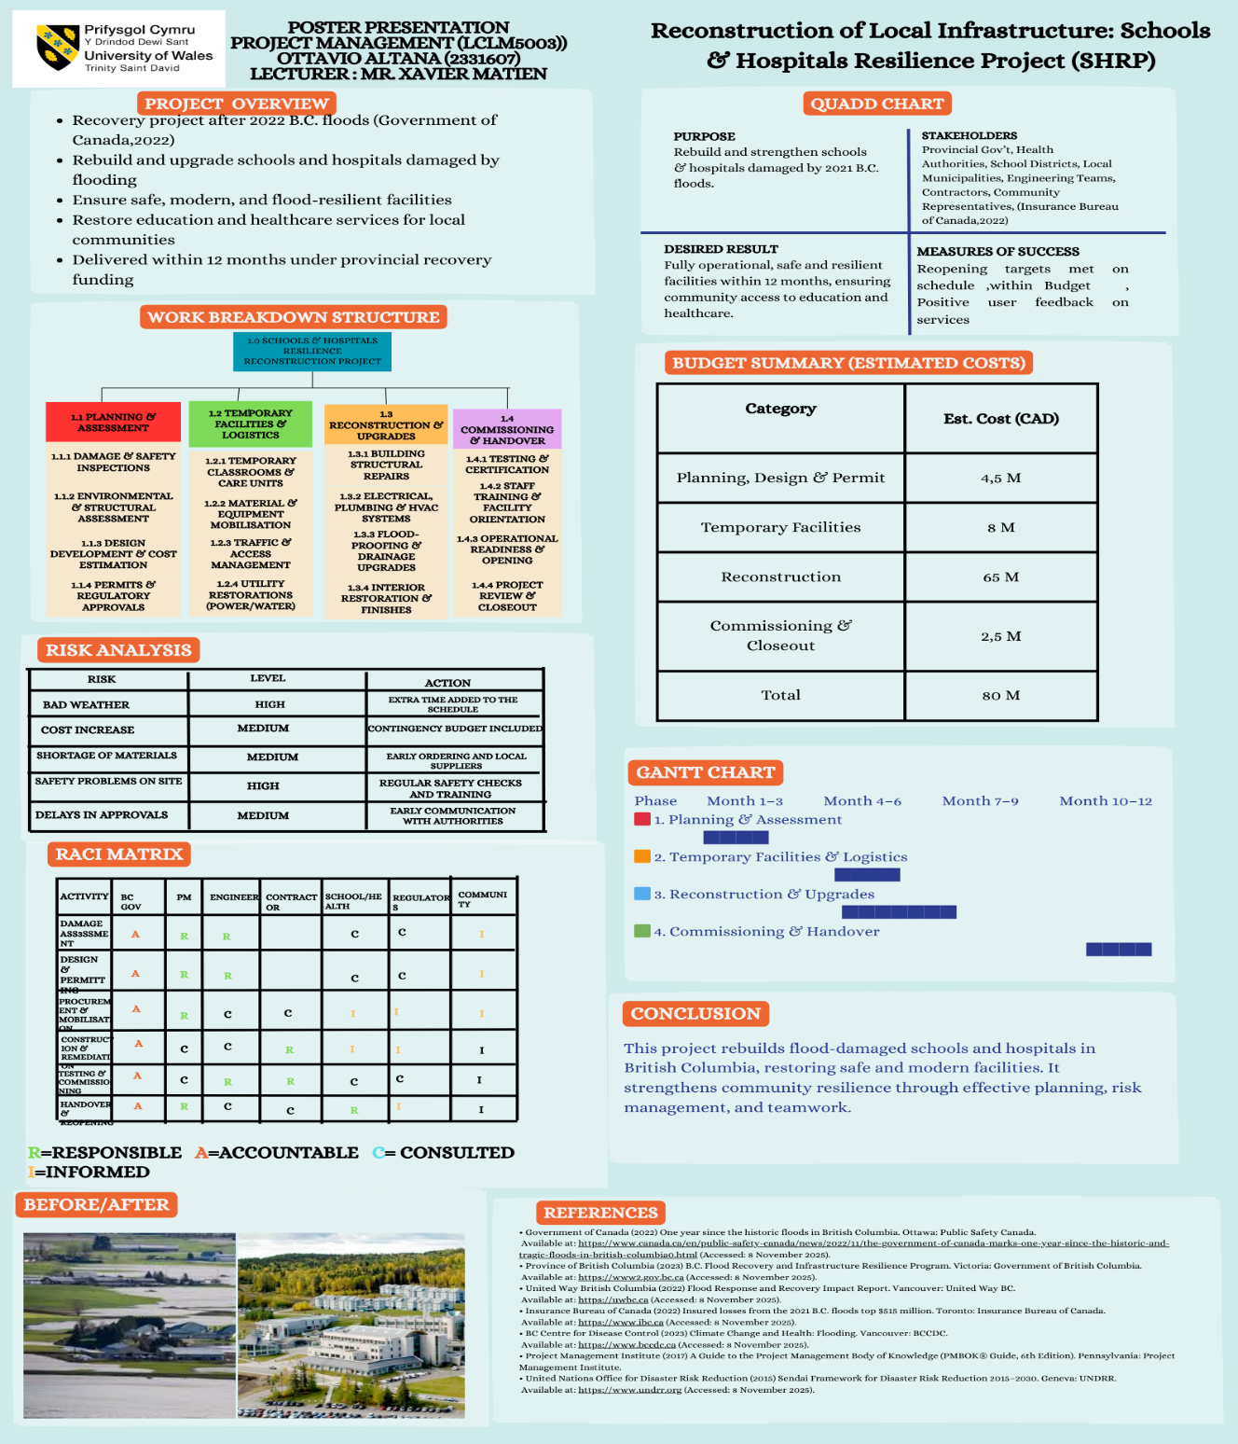

Part B: Reflection on Feeback using Gibbs Reflection Style

Description
The poster presentation for my project, Reconstruction of Local Infrastructure: Schools and Hospitals Resilience Project (SHRP), was a valuable experience that allowed me to demonstrate my understanding of project management principles in a real scenario. Presenting to my Lecturer and classmates helped me improve my communication skills and gain practical insight into how others interpret my work. The feedback I received was constructive and has guided me in refining my final project management plan.

Feelings
At the beginning of the presentation, I felt nervous and a bit overwhelmed. I usually feel stressed when I must speak in front of other people. I was worried that I might forget what I wanted to say. After a few minutes, I have started to speak more comfortably. I realised that I knew my project well, which helped my confidence. At the end, I felt relieved and quite proud of myself for managing to present without reading everything from notes.

Evaluation
I think the presentation went quite well overall. The poster helped me talk through the project and made it easier to explain each part in my own words. I felt comfortable speaking, and I believe my delivery was clear and understandable.
However, when reflecting afterwards, I realised that I missed the risk analysis section in the poster. This is something important for a project plan, and I should have included from the beginning. So even though the presentation felt good, I can see that I need to make sure I cover all sections fully next time.

Analysis
Looking back, I understand that nerves affected the way I started speaking. Once I relaxed, I could present better because I understood my topic. This shows me that preparation is important and makes me feel more confident. The weaker parts, like missing an important part, show that I need to improve for future presentations and pay attention to the work description, doing so I will not miss any part.

Conclusion
From this experience, I learned that I can present well if I am familiar with my topic. I also learned that I need to be calm at the start and take my time to explain things. The only feedback I received from the lecturer was that I missed the risk analysis part, and I admitted that I have forgotten to include that part. Overall, I think the presentation went well and made me more confident for future assessments.

Action Plan
Next time, I will practise to speak more calmly and clearly, so I will not panic. For the final written project, I will add more detail to sections such as risk management, stakeholder involvement. I will also make sure my explanations are clearer and more developed than on the poster.

Part C: Project Management Plan

Introduction
In November 2021, British Columbia experienced one of the most damaging flooding events in its history. The severe weather caused widespread landslides, bridge failures and infrastructure disruption, forcing closures of roads, services and essential public facilities (Government of Canada, 2022). Schools and hospitals were among the structures affected, leading to interruptions in healthcare, education and community support.
This Project Management Plan introduces the Schools and Hospitals Resilience Project (SHRP), which aims to repair and strengthen damaged facilities so that they can return to safe and fully functioning operation. The plan applies recognised project management tools such as scheduling, stakeholder engagement, risk mitigation and Work Breakdown Structure to organise and deliver a 12-month reconstruction programme.
The purpose of this report is to show how structured project planning can support recovery efforts and enhance resilience to future events. By defining project scope, roles, resources and monitoring approaches, this plan offers a framework to guide delivery and support successful rebuilding outcomes.

Project Description
The Schools and Hospitals Resilience Project (SHRP) focus on repairing and improving public facilities that were damaged during the 2021 flooding event in British Columbia. Many schools and hospitals were forced to close, relocate services or operate at reduced capacity due to structural damage, safety concerns and access issues. These closures affected thousands of residents who rely on these buildings for essential services. The project aims to restore these facilities so that communities can return to normal operation.
The SHRP will run over 12 months and includes four main phases: assessment and planning, temporary service arrangements, reconstruction and upgrades, and commissioning and handover. Its objective is not only to repair buildings but also to enhance their resilience so that they are better prepared for future flooding or extreme weather events. This aligns with post-disaster recovery priorities highlighted in provincial recovery guidance (Province of British Columbia, 2023).
The project includes several key activities. First, engineering assessments will be conducted to determine the extent of damage. Next, temporary classrooms and health units will be set up to ensure continuity of services while reconstruction takes place. The core phase involves structural repairs, upgrading utilities, installing flood-resistant features and improving safety systems. The final stage involves testing, training staff and reopening the facilities to the public.
The expected outcomes of the project are fully operational schools and hospitals that meet safety and resilience standards, reduced disruption to essential services, and improved community confidence in public infrastructure. The project will deliver physical outcomes (repaired buildings) as well as social benefits, including faster recovery, stronger infrastructure and safer environments for students, patients and workers.
Overall, the SHRP is designed as a structured response to flood damage, using project management methods to coordinate planning, execution, communication and risk control. It demonstrates how recovery can be organised in a systematic way to achieve long-term community resilience.

Scope
The scope of the Schools and Hospitals Resilience Project (SHRP) defines what the project will deliver and sets the boundaries for its activities. This project is entirely focused on restoring and strengthening damaged schools and hospitals in affected areas of British Columbia. The main aim is to return these facilities to safe, functional operation while also improving their resilience against future flooding.
The work within scope includes carrying out detailed inspections to assess the level of damage, designing appropriate reconstruction solutions and coordinating approval processes with relevant authorities. The project also covers temporary arrangements to ensure that educational and healthcare services can continue while repair work is underway. The core activities involve rebuilding structures, replacing damaged systems, installing flood-resistant features and improving safety standards within these buildings. The final part of the scope includes testing the upgraded facilities, training staff and formally reopening them for use.
The project does not extend to facilities outside the affected schools and hospitals, nor does it aim to build entirely new institutions. Keeping the focus limited helps to ensure that available time, funding and resources remain concentrated on restoring the most essential public service buildings.
The main outcomes expected from this scope are schools and hospitals that are operational again, contain resilience improvements and meet updated safety standards. Success will be measured through timely reopening, the ability of facilities to function normally and positive community response. These goals align with the recovery priorities observed in flood response efforts in British Columbia (United Way British Columbia, 2022).
Overall, this scope ensures that the SHRP remains clearly targeted and controlled, supporting effective planning, execution and monitoring throughout the project.

Work Breakdown Structure
A Work Breakdown Structure (WBS) is a planning tool used to divide a project into smaller and more manageable parts. It allows project teams to see how tasks are organised, who is responsible and how different activities connect. For this project, the WBS is shaped around four main phases that reflect how the reconstruction process will move from planning to delivery.
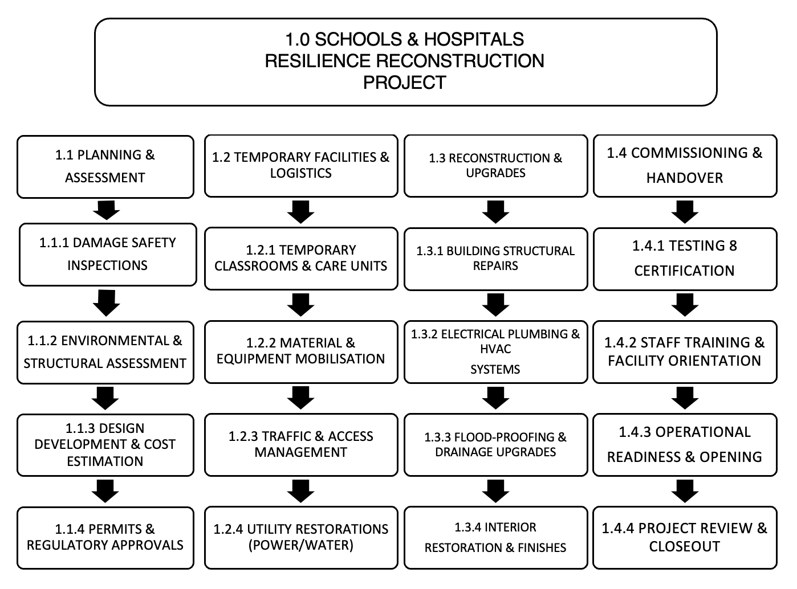
The first phase is Planning and Assessment. During this stage, damage inspections are completed, design work is prepared and required permits are requested. This phase also involves defining timelines and establishing the project organisation structure. It ensures that the team has accurate information to make the right decisions before construction begins.
The second phase is Temporary Facilities and Logistics. Because schools and hospitals must continue serving the community, temporary classrooms and health units will be arranged while repairs are underway. This keeps essential services running and minimises disruption for residents who depend on education and healthcare. This approach is often promoted in post-disaster infrastructure recovery to support continuity (Province of British Columbia, 2023).
The third phase is Reconstruction and Upgrades, which is the main delivery stage. It includes structural repairs, installation of resilience features, replacement of damaged systems and internal improvements. This is the longest phase because it deals with the physical rebuilding of the facilities.
The final phase is Commissioning and Handover. At this point, buildings are tested to ensure safety and functionality. Staff are trained on new systems, documentation is finalised and the facilities are formally reopened to the public.
Overall, the Work Breakdown Structure gives the SHRP project a clear structure. It helps the team manage time, monitor progress and divide responsibilities appropriately, which increases the chance of delivering a successful recovery programme.

Quadd Chart
The quad chart is a simple tool that shows the main parts of a project in four boxes. It helps people quickly understand what the project is about, who is involved, what results are expected and how success will be measured. It is useful because it makes information easy to see and explain

PURPOSE  Rebuild and strengthen schools & hospitals damaged by 2022 British Columbia floods. | STAKEHOLDERS  Provincial Gov., Health Authorities, School Districts, Local Municipalities, Engineering Teams, Contractors, Community Representatives.
DESIRED RESULT  Fully operational, safe and resilient facilities within 12 months, ensuring community access to education and healthcare. | MEASURE OF SUCCESS  Reopening targets met on schedule, within Budget, Positive user feedback on services.
The quad chart for this project summarises the most important information needed to understand the Schools and Hospitals Resilience Project (SHRP). It captures four areas: purpose, stakeholders, expected results and measures of success. This visual helps explain the project clearly and supports communication with people who may not have time to read full documents.
The purpose of the SHRP is to rebuild and improve damaged schools and hospitals in British Columbia so that essential services such as education and healthcare can return to normal. This work is important because the 2021 floods disrupted local communities and highlighted weaknesses in public infrastructure (Government of Canada, 2022).
The second part of the quad chart shows key stakeholders, including provincial authorities responsible for funding, engineering teams designing the repairs, contractors carrying out construction and local school and health managers who will use the facilities once they reopen. These groups need to work together to ensure the project succeeds.
The third section outlines the expected results, which include safe, operational buildings, continuity of services through temporary arrangements and resilience improvements to reduce future disruption. The final part presents measures of success, such as reopening schools and hospitals within the 12-month timeframe, positive service feedback and evidence that buildings can better withstand future flooding.
By presenting these four elements side by side, the quad chart gives a quick overview of the project and supports decision-making by showing what matters most (PMI, 2017). It is therefore a useful communication tool for this recovery project.

Gantt Chart
A Gantt Chart is used to schedule project activities over time. It shows when each phase will begin and end and helps track progress throughout the project. For this project, the Gantt Chart covers a 12-month period, which matches the expected duration for restoring the selected schools and hospitals.

The first three months are focused on planning and assessments, where inspections, design work and permits are carried out. The next period, between months two and five, includes preparation of temporary facilities, such as portable classrooms and temporary health units, to make sure services continue during reconstruction. The main construction work takes place from around month four to month ten and includes repairs, upgrades and installation of resilience features. The final three months of the project involve commissioning and handover, including safety testing, staff training and reopening.
Using a Gantt Chart helps the project team visualise the timeline, identify dependencies and monitor delays. It also supports communication because stakeholders can quickly see when main activities occur, which is important for government and local authorities involved in recovery planning (Province of British Columbia, 2023). Overall, the Gantt Chart is a practical tool for controlling time and making sure the project stays on track.

Stakeholders
Stakeholder involvement is an important part of this project because many groups are connected to the rebuilding and reopening of schools and hospitals. The main stakeholders include the provincial government, engineering and design teams, construction contractors, school districts, health authorities, local communities and regulatory bodies responsible for inspections and safety standards.
The provincial government is responsible for funding and oversight, making sure the project meets recovery goals. Engineering teams carry out assessments and design the repairs, while contractors complete construction activities on site. School districts and health authorities are directly involved because they are the end users of the buildings. They help with planning temporary services and preparing for reopening. Local communities are also important because they rely on the facilities and want updates on progress. Finally, regulatory authorities approve permits and check that the work meets safety rules.
To support effective involvement, communication will take place throughout the project. This includes meetings, reports, updates and consultation sessions. Each stakeholder has a specific role and level of responsibility, which is shown through tools like the RACI matrix used in the poster. This helps avoid confusion by showing who is responsible, who makes decisions and who needs to be informed.
ACTIVITY | BC GOV | PM | ENGINEER | CONTRACTOR | SCHOOL  HEALTH | REGULATORS | COMMUNITY
DAMAGE ASSESSMENT | A | R | R |  | C | C | I
DESIGN & PERMITTING | A | R | R |  | C | C | I
PROCURAMENT & MOBILISATION | A | R | C | C | I | I | I
CONSTRUCTION & REMEDIATION | A | C | C | R | I | I | I
TESTING & COMMISSIONING | A | C | R | R | C | C | I
HANDOVER & REOPENING | A | R | C | C | R | I | I

Good stakeholder management increases project success because it improves coordination, reduces misunderstandings and supports decision-making. This is especially important in recovery projects, where services must continue and communities expect visible progress (United Way British Columbia, 2022).
Overall, involving stakeholders actively ensures that the rebuilt schools and hospitals meet user needs, comply with rules and reopen smoothly when work is complete.

Allocation of Resources
Resource allocation is important because it helps the project use people, money and materials in the best way. For the SHRP project, resources must be organised carefully to make sure schools and hospitals are repaired within the planned time and budget.
Human resources include engineering teams who inspect and design repairs, project managers who coordinate planning, and construction workers who complete rebuilding work. There are also support staff such as procurement officers, administrators and specialist trainers who help prepare the facilities for reopening. Each group has different skills, and their work is scheduled based on project needs.
Financial resources come from funding allocated by the provincial government and recovery programmes. The budget must cover assessments, temporary facilities, construction, equipment, testing and training. A contingency amount is usually included to cover unexpected costs, especially in recovery projects where damage levels may change (Insurance Bureau of Canada, 2022).
Material resources include construction supplies, equipment, safety systems and temporary units like portable classrooms or health units.
Resource allocation is done according to the project timeline. More resources are used during the main reconstruction stage, while fewer are required during planning and commissioning. Good communication and supervision help ensure that resources are not wasted and are used where they are most needed.
Overall, managing resources effectively helps keep the SHRP project on schedule and within budget. It also ensures that the repaired schools and hospitals meet safety and quality standards when they are ready to reopen.
In the poster, an estimated budget of 80 million CAD was proposed for this project. The distribution includes approximately 4.5 million for planning and design, 8 million for temporary facilities, 65 million for reconstruction works and 2.5 million for commissioning and close-out activities. These estimates illustrate how costs increase as the project moves into more labour-intensive phases. Even though these figures were assumed for the purpose of the poster, they demonstrate how budget allocation supports resource planning and how financial planning helps guide decisions throughout the project lifecycle.

Risk Analysis
Risk analysis is important because projects often face uncertainty, especially in recovery situations where damage levels and site conditions may change. The SHRP project includes several risks that could affect time, cost, quality or safety. Identifying these risks helps the team prepare responses and reduce negative impacts.
One major risk delay from weather conditions. Because this project deals with flood-affected areas, ongoing rainfall or storms could slow down reconstruction work. To reduce this risk, the project schedule includes buffer time and flexible work planning periods.
Another risk is cost escalation, where materials or labour become more expensive than first expected. This is common in disaster recovery because urgent demand increases prices (Insurance Bureau of Canada, 2022). The project budget includes contingency funds to help manage this risk.
A third risk relates to stakeholder coordination. If communication is weak, decisions may be delayed, or misunderstandings might occur. To manage this, regular meetings and reporting will take place to keep everyone informed.
Safety risks are also important. Construction work in damaged areas can expose workers to hazards such as unstable structures or contaminated spaces. The project will reduce this risk through safety training, inspections and protective equipment.
Another risk is failing to meet service continuity goals. If temporary classrooms or health units are not set up on time, community services may be disrupted. To manage this, temporary facilities are planned early in the schedule and have dedicated budget support.
Overall, risk analysis helps guide decisions and resource planning for SHRP. It ensures that risks are monitored, contingency strategies are in place, and the rebuilding process remains controlled. Effective risk management supports the project aim of reopening schools and hospitals safely and on schedule, helping communities recover more quickly.

Conclusion
The Schools and Hospitals Resilience Project (SHRP) provide a structured plan for rebuilding essential public facilities damaged by the 2021 flooding in British Columbia. Using project management tools such as the Work Breakdown Structure, Gantt Chart, stakeholder analysis and risk management, the project shows how recovery work can be organised clearly and delivered within a planned timeframe.
The project aims to restore safe access to education and healthcare services while also improving resilience so that future flooding causes less disruption. The 12-month schedule, supported by allocated resources and a dedicated budget, demonstrates a realistic way for communities to return to normal. Although some elements were presented through simplified estimates for assignment purposes, they reflect the types of planning decisions needed in real projects.

References
- Government of Canada (2022) One year since the historic floods in British Columbia. Ottawa: Public Safety Canada. Available at: https://www.canada.ca/ (Accessed: 10 December 2025).
- Province of British Columbia (2023) B.C. Flood Recovery and Infrastructure Resilience Program. Victoria: Government of British Columbia. Available at: https://www2.gov.bc.ca (Accessed: 11 December 2025).
- United Way British Columbia (2022) Flood Response and Recovery Impact Report. Vancouver: United Way British Columbia. Available at: https://uwbc.ca (Accessed: 10 December 2025).
- Insurance Bureau of Canada (2022) Insured losses from the 2021 B.C. floods top $515 million. Toronto: Insurance Bureau of Canada. Available at: https://www.ibc.ca (Accessed: 11 December 2025).
- Project Management Institute (2017) A Guide to the Project Management Body of Knowledge (PMBOK® Guide, 6th Edition). Pennsylvania: Project Management Institute.
- United Nations Office for Disaster Risk Reduction (2015) Sendai Framework for Disaster Risk Reduction 2015–2030. Geneva: UNDRR. Available at: https://www.undrr.org (Accessed: 11 December 2025).

