FESTO Cyber Physical Production System – Goods Dispatch Process Automation Development

Level 5 Manufacturing, Design & Technology Assignment
Module – ACMA5002

Student – Paul Corry

Word Count - 3769

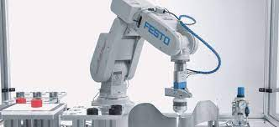

Table of Contents

Assignment Introduction 3
Why use industrial robotics? 3
Designed gripper arm 3
Failure Mode and Effects Analysis Tool Used (FMEA) 4
The 5 “Why’s” 5
5 Whys Tool Used for the designed gripper 5
Ishikawa Modelling 6
Ishikawa Diagram used for the Designed Gripper 7
Gripper Assembly Design 8
Individual Gripper Parts 9
Gripper Jaw Part 1 9
Gripper Jaw Part 2 10
Gripper Piston Rod 10
Gripper Piston Housing 10
Gripper Jaw Grips (x2) 10
Gripper Attached to Robot Arm 11
Evaluating non-essential and essential parts: 12
Manufacturability 12
Recyclability and Disassembly Focus on the Deigned Gripper 12
Material Selection of the Designed Gripper 13
Maintainability 13
Bulk Manufacture 13
Design for assembly (DFA) 14
Quality Function Deployment (QFD) Considerations of Designed Gripper 15
Quantification of a Lucas Handling index 15
Design for manufacture (DFM) 16
Why is the design for manufacturing so important? 17
Evaluation 18
Conclusion 19
References 20
Web Sites Used / Visited 21

Assignment Introduction
The objective of this assignment is to design a suitable robot gripper as well, as an end effector using a CAD type software design program such as Solid-Works. The gripper will be attached to a “Cobot” (collaborative robot) to unload a finished and assembled mobile phone from a dispatch station of the CP Lab and then subsequently loaded onto the AGV (autonomous guided vehicle) in order, for these fully assembled mobile phones to be transported to inventory. The Cobot, produced by automation manufactures Festo, will be integrated within its cyber production facility. The CP factory is an industrial production line which, can be comprised of various individual stations that are all fully integrated with each other which, serve a particular automated function within a manufacturing organisation.

Why use industrial robotics?
Robotics in today’s industrial/manufacturing age paves the way for new technologies as well as, new opportunities. Robotics such as “articulated-arm robots” can move, palletise, and assemble types of work pieces in many high technological modern production industries (Appleton, E. and Williams, D.J., 2012).

Designed gripper arm
In simplest terms, a robotic gripper arms are types of devices that enable robots to pick-up and move objects and in this instance, combined with a collaborative Cobot which, are vital to automated industries (Colgate, J.E., et al, 1996).

The designed gripper detailed in this assignment which, will be used by the robot will be subjected to full evaluation using appropriate methodology design tools and principle such as, “design for Assembly” (DFA) and design for manufacture (DFM) type techniques.

Failure Mode and Effects Analysis Tool Used (FMEA)
Prior to the Gripper design, a tool known as a Failure Modes and Effects Analysis (FMEA) was created as a proactive method for the evaluation of such a process. This tool is designed to identify how it may fail and, to identify the parts of the process which, may need change. The objective of FMEA is to basically improve the design or indeed, the design process. As a tool, FMEA’s can now be considered as one of the most effective tool for predicting problems of the part being produced. According to Mikulak, R.J. et al, (2017), an added benefit can also provide a more structured approach to track, evaluate, and can also be used to updating process or design process developments. The most significant part of the FMEA process is to detect whether, or not a particular process or, indeed in this case an assembled part is to evaluate, detect and mitigate any sort of potential failures of any kind. From the scoring, it was evident that measures/recommended actions must be put in place. These measures/recommendations then reduced the RPN (risk priority number) to a satisfactory value (<100) making this assembly a robust production item. As seen in (fig 1) below, the FMEA in this instance denotes the completed process (Mikulak, R.J. et al, 2017).
(fig 1)
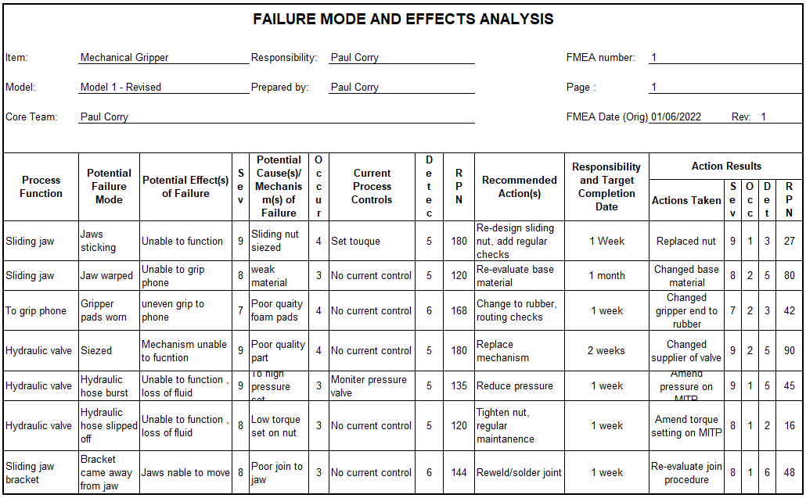

The 5 “Why’s”
From the results of the FMEA evaluation tool, a problem-solving technique which, aims to solve problems by repeatedly questioning “why” was applied to this designed gripper. Ideology of this tool (five whys) explores the cause and effect of a particular problem which was picked-up from the FMEA process. The goal of this technique is to determine a defect or indeed a problem with repeated “why” questions. This strategy as identified as per (fig 2) & (fig 3) can lead to the root cause of a problem or defect. Idea of this process is that when a countermeasure is identified it is followed through in order, to prevent the effect from reoccurring. This root analysis tool, which is used as part of SIX Sigma, aim to solve problems as mentioned, uses the following techniques. As mentioned, the see below actions that can be taken to improve the reliability of the gripper (Serrat, O., 2017).
- Define
- Measure
- Analyze
- Improve
- Control

5 Whys Tool Used for the designed gripper
(fig 2)
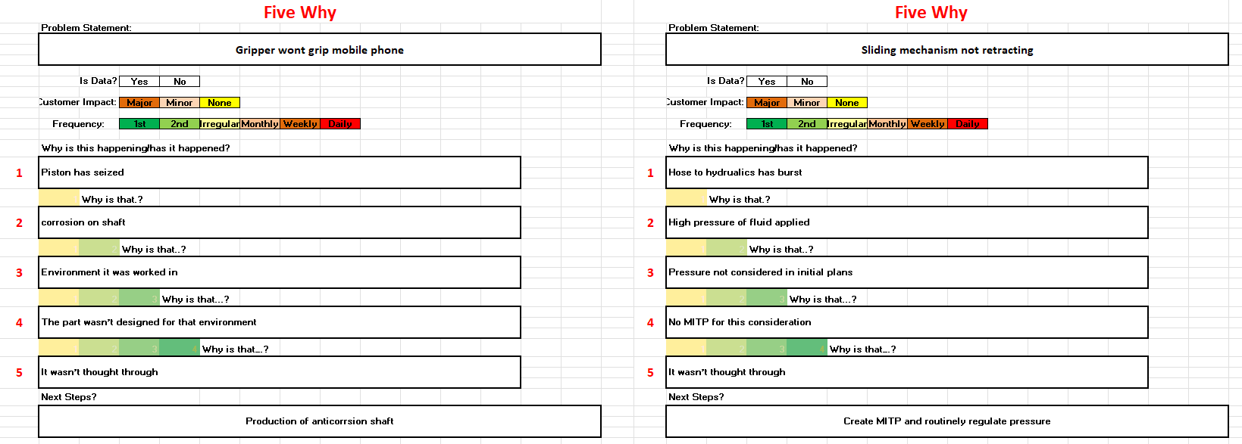
(fig 3)
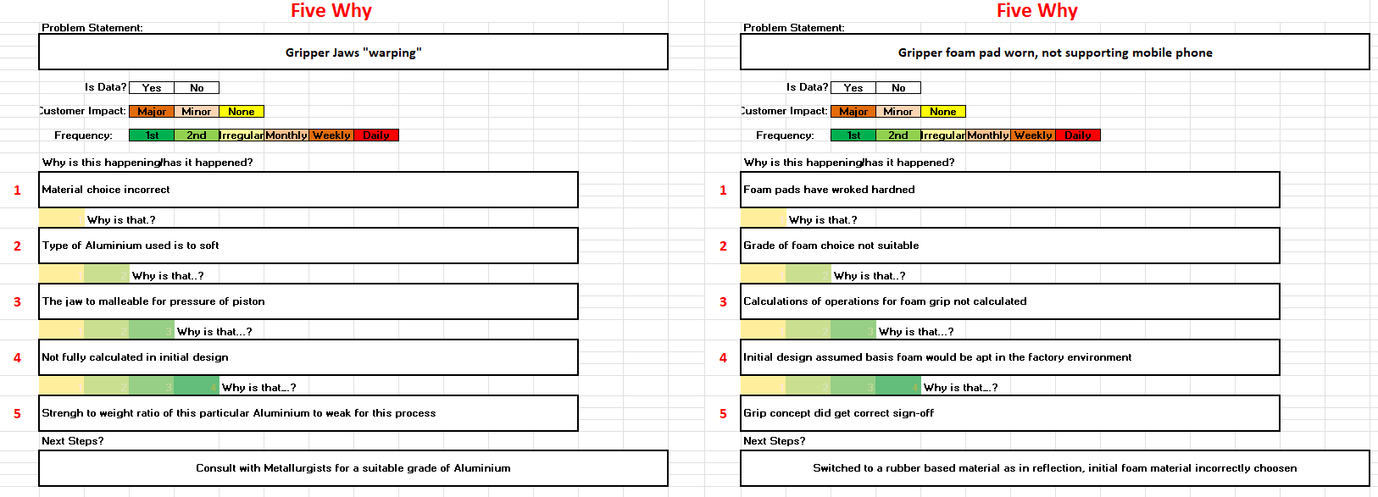
From the “5” Whys evaluation of the gripper, areas for improvements can now be actioned

Ishikawa Modelling
In combination with the 5 Why’s concept, another type of tool namely “Ishikawa Diagram can be used with an aim to explore potential causes that can result in a single defect or indeed failure. According to Radziwill, N., (2017), this cause and analysis method also known as a “Fishbone” diagram was created by Professor Kaoro Ishikawa in the 1960’s consists of four basic steps which when used can be used to drill down to the root cause. The four steps usually consist of:
- Identification of the problem
- Work out the factors involved in the problem
- Identify the possible cause
- Analyze the diagram
By drawing-up a cause-and-effect diagram such as this, information can be observed by showing all the links that exists between the event as well as their potential or indeed actual causes. This then provides the means of generating any ideas in regard, to why the particular problem and the effects of the cause. This allows the designers to “broaden” their thinking and therefore enable them to see the overall visual picture of the problem. After all the steps have been taken on the Ishikawa one can then ask, “why does this happen”. As shown in (fig 4), the potential problem of the gripper was analyzed (Coccia, M., 2018).

Ishikawa Diagram used for the Designed Gripper
(fig 4)
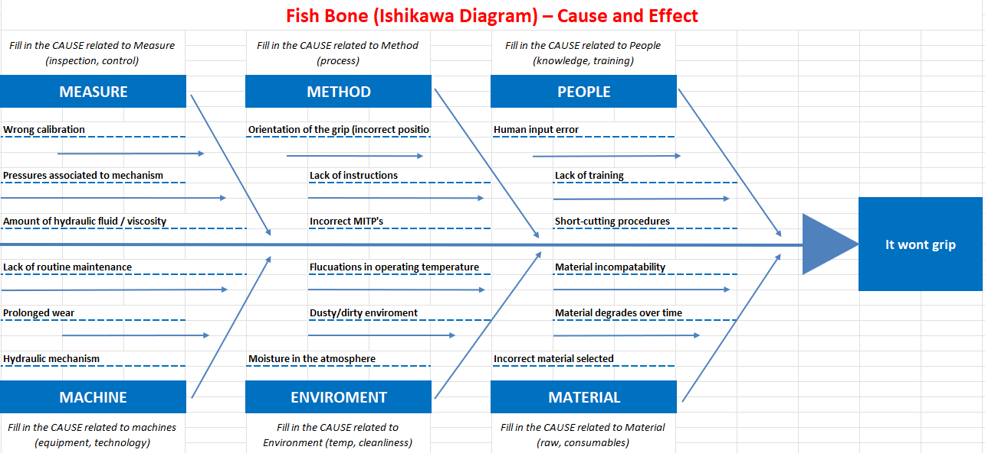

Gripper Assembly Design
The gripper and gripper assembly were designed using the available manufacturing tools was designed using Solidworks which is a modelling software program, that can used to develop fast and accurate designs including 2D and 3D drawings and assemblies of complex parts. According to Mattson, J,E (2013), Solidworks can cost, (using cost estimation tools) and can also be used for prototyping, planning and project management. See below (fig 5) the gripper assembly. There were many considerations given to how the gripper would grip and move the intended mobile phone device. Early ideas and thoughts were given to using a sucker device which, would simply lift the produced mobile phone. However, at this point of the mobile manufacturing process, it was decided that the cover lid of the phone would detach therefore, alternative method chosen would consist of a simplistic hydraulic or pneumatic piston whereby, the mobile phone would be picked-up/lifted by clamping the sides. However, it is important to note that although the gripper was designed by using Solidworks for lifting the mobile phone from mobile phone dispatch station, this pick-up station can also be modified so a further improvement design to the gripper could be undertaken.
(fig 5) as seen below represents the gripper assembly “without” the robot attachment bracket for reasons to show the inserted piston housing mechanism.
(fig 5)
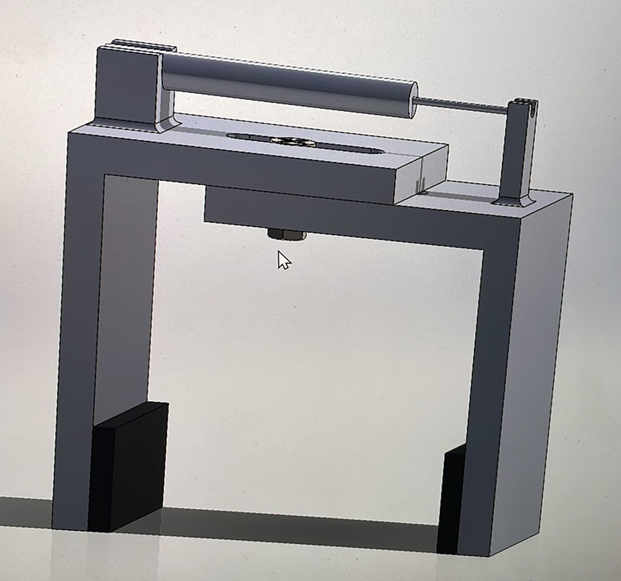
Please note:
The “initial” gripper design body concept was a team effort as agreed, consisting of myself & Ian Lewis
The image below in (fig 6), shows the gripper assemble complete with the attachment which, connects to the robot arm.

(fig 6)
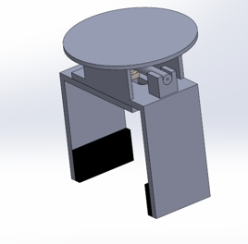

Individual Gripper Parts
The assembled gripper basically consists of several parts

- Gripper jaw part 1, see (fig 7)
- Gripper jaw part 2, see (fig 8)
- Gripper piston rod, see (fig 9)
- Gripper piston housing, see (fig 10)
- Gripper jaw grips (x2), see (fig 11)

Gripper Jaw Part 1
(fig 7)
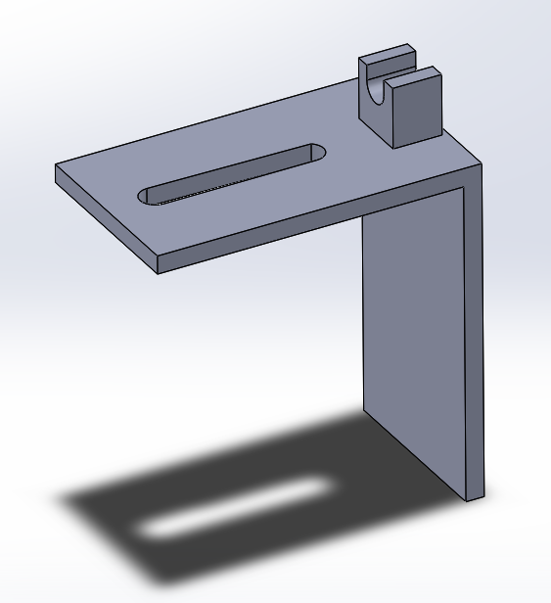

Gripper Jaw Part 2
(fig 8)
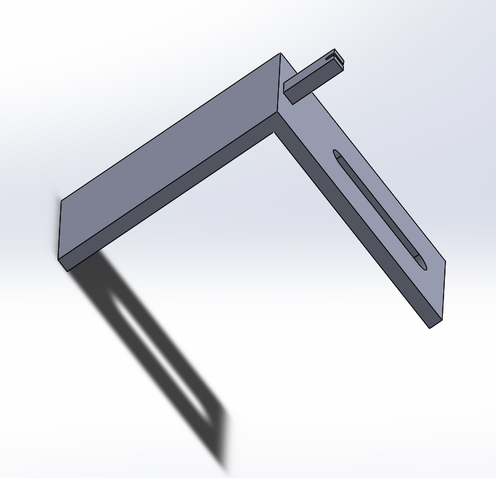

Gripper Piston Rod
(fig 9)
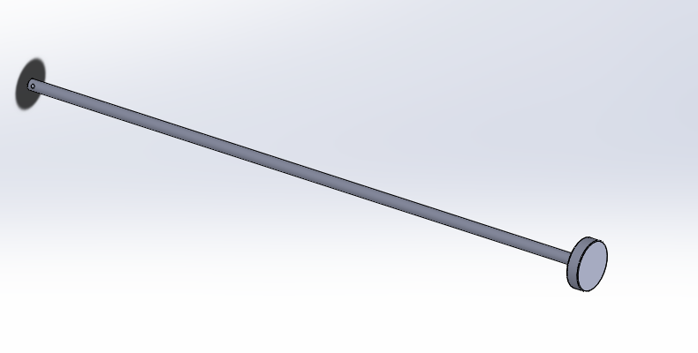

Gripper Piston Housing
(fig 10)
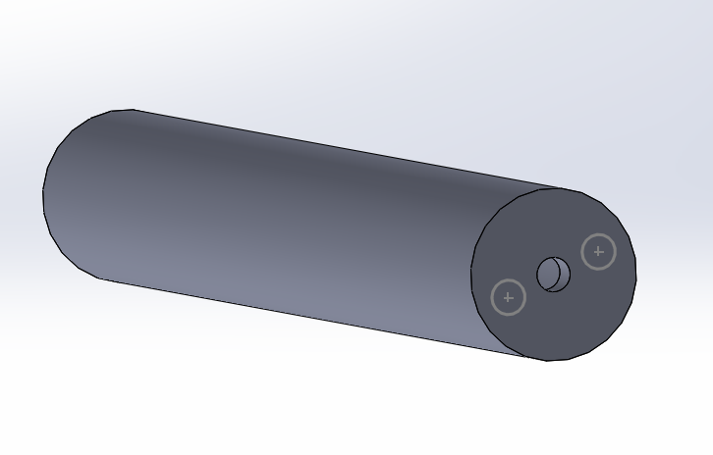

Gripper Jaw Grips (x2)
(fig 11)
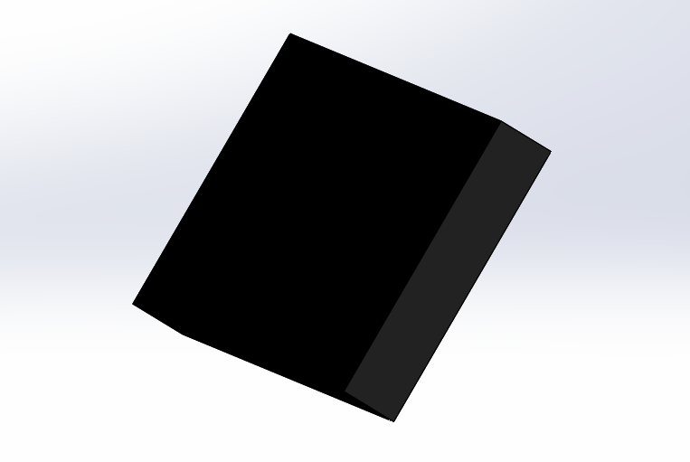

Gripper Attached to Robot Arm
Images below as shown in (fig 12) & (fig 13) shows the grippers assembly attached to the robot arm. However, it’s important to note the relative size between the gripper and the gripper assembly.

(fig 12)
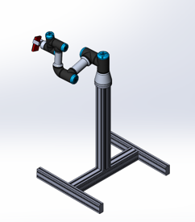

(fig 13)


Evaluating non-essential and essential parts:
The designed gripper when in the design stage had considerations for reducing the number of individual parts which, simplifies the assembly stage. This again gave early opportunity to reduce production and assembly costs. Another consideration in this instance is for the gripper to use less material without compromise to the longevity of the part

Manufacturability
Using the production tools mentioned in this assignment there have been many considerations of how the individual parts could have been manufactured. Such as, castings, pressing or indeed machining from block material. However, in regards, to the design’s flexibility using a die casting method would give many advantages such as the design finish with fast and good dimensional stability. Would also require minimal finished machining especially is machined using CNC. This would increase cycle time that would reduce a large percentage of the overhead cost that are associated. Most of the costs which, are associated to die casting is within the design and, also the tools and dies (Venkatachalam, A,R et al, 1993).

Recyclability and Disassembly Focus on the Deigned Gripper
In regards, to design for recyclability focus aim would be to use the same material wherever possible in the intended design. For sure reducing the need for separate materials can reduce operations as most of the parts can be all recycled together. A quicker recycling which, will be more cost effective when the part come to the end of its life cycle. According to Reck, B.K & Graedel, T.E (2012), Metals can infinitely be recycled However, in principle the recycling process can be sometime inefficient.

Material Selection of the Designed Gripper
Aluminium can be used as the basis of most of the parts. Aluminium gives good strength to weight ratio. This would satisfy all the demands of this moving part of the gripper application. As Aluminium being a relatively “light” type of material may mean that reduced costs of transporting and would have less energy associated to remelt than let’s say for instance types of Steel. Using Aluminium can reduce the need of disposal as it continues to circulate which, reduces the need for additional mining resulting in less costs. According to the “Aluminium Institute” it costs approximately 95% less energy to recycle than to produce new virgin material. Aluminium also retains its properties when the material is recycled (Hirsch, J., et al, 2008).

Maintainability
By standardizing the intended parts wherever possible may extend the product life of the part. Using same size fasteners for example simplifies the need of sourcing various part from many suppliers and as mentioned, the base material choice of the main components. Fasteners, pins etc can be fully interchangeable therefore, reduces the need for higher inventory of non-similar parts as well as the need for individual specialized tools required at the assembly stage

Bulk Manufacture
Considerations of other manufacturing routes were given in the design infancy stage. Methods such as investment casting were considered however, higher production costs would be associated then using this method. Parts would have to go through many processes such as, from the wax molds - to the autoclaves and then the fettling stage whereby additional cost would be associated. Fettled part would also then be finished machined to size therefore, this production method was illuminated. By using the die casting method, quick turn-around time with minimal machining costs appears to be the most suitable choice in this instance.

Design for assembly (DFA)
DFA (design for assembly) can also be considered an effective methodology tool in order, to reduce production costs which, can be used in any type of engineering. From a simplistic perspective, rules which, can be neglected or perhaps missed in the original design process of any type of product that may have some sort of assembly can be rectified and reconsidered when using the DFA model. However, the most effective use of this designing tool method is when it’s used at the initial stage of any design process. Many companies now consider this approach as they are effective especially, in the training of designers although, using this method can time consuming and can also become quite tedious. It is important to note however that DFA must have consideration such as, tooling costs, life cycles and service needs for example. As seen below in (fig 14) below, this fishbone style promotes engineers to identify the assembly difficulties and come up with effective rectifications in quantification sequence in the design infancy stage. www.studylib.net

(fig 14)
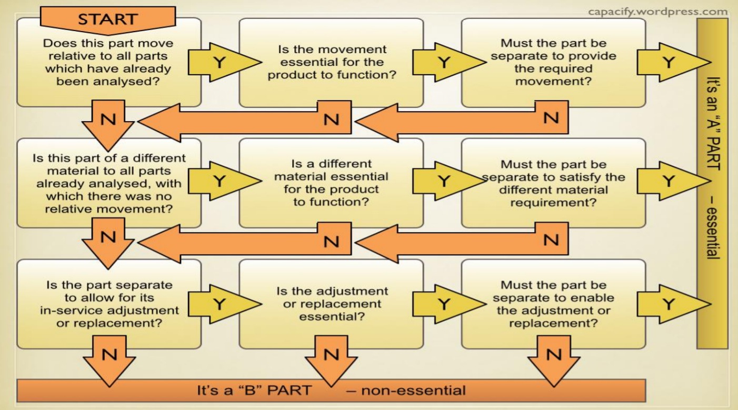

Quality Function Deployment (QFD) Considerations of Designed Gripper
A lean technique tool QFD in reflection, may have also been considered in order to improve the gripper requirement further. QFD is a process whereby, various sets of tools are used to define the customers requirement. As mentioned, QFD can be considered as a “LEAN” technique which, is often used my professionals practicing Six Sigma. According to (Sahney, S., et al, 2004), QFD can be considered a valuable tool which, aids in regards, to designing products or processes that are often based upon customer requirements. Benefits of using such a tool can include the following:
- Reduced start-up times
- Systematic way for obtaining the required information
- Fewer/reduced engineering changes
- Aids teamwork with consensus decisions

Quantification of a Lucas Handling index
Other design tools such as the Lucas method which, although not used in this assignment was developed in the early 1980’s could be used to develop and evaluate the part or assembly being produced in this instance. Consideration in regards, to each of the handling and insertion motions may be given to the components within an assembly. Data is compiled based on a point scale which, when analyzed, gives the relative measurement of the assembly difficulty from a quantification perspective (Leaney, P.G. and Wittenberg, G., 1992).
The components are divided into two separate groups. What’s deemed “to” be essential and also deemed “not” to be essential. The efficiency from a functional perspective can then be calculated by the following equation:
A / (A+B) x 100%. (Typically, for initial designs a targeted number of 60% is required)
A = being the essential components
B = being the non-essential components
Tables for the manual handling dexterity quantification are used to determine the assembly complexity. This handling index quantifies the handling difficulties that apply to the individual parts required. The last part of the Lucas method is to calculate to cost of the manufactured component or assembly. This cost may influence the choice of the material considered and the process by which, the individual part is produced by. www.designsociety.org

Design for assembly (DFA) can also be termed as a method to facilitate and, to potentially reduce the numbers of assembly operations of components which, are needed of the finish product.

Design for manufacture (DFM)
Design for manufacture (DFM) is a critical process in regards, to the product development cycle. It can involve the design of the product optimization for it’s manufacturing process. Can also involve the merging of the design requirements with the production method of the particular product being produced.

The design process comprises of:
- Design
- Process
- The material
- Inspection / testing
- The environment
The design for manufacture may consider the reduction of complexity of the required manufacturing operations as well, as the cost of raw materials which, can reduce the overall cost of production.

Why is the design for manufacturing so important?
According to Barton, J.A, et al, (2001), approximately 70% of all manufacturing costs can be obtained from the design decisions such as material used and, also the manufacturing process itself. The balance of 30% could be made-up from the decisions such as, tool selection and process planning for example.
The design of manufacturing or indeed, the design for manufacturability can be considered as the optimization of the desired part in order, to produce it cheaper and more easily. Design for manufacture involves the “efficiency” of the intended design which, occurs during the production design stage when, it is in its infancy stage thus less expensive therefore, to reduce manufacturing costs. This also allows the identification of errors or discrepancies in this early stage.

Advantages or benefits using this tool include the following:
- Quicker time from production to the marketplace
- Products produced using the tool DFM can have reduced production costs
- The product development process is shorter
- Removes or indeed catches mistakes that are made
- The final product can consist of a high quality

However, it is important to note that the time taken using DFM will naturally depend on the manufacturing complexity and the operational process as well as the parts used
As well as the gripper which, was designed in this instance further examples using DFM can be illustrated:
- DFM can be used in foundries such as castings (investment or spin) where it can able the process in order, to minimize defects such as porosity and, also optimize shape geometry
- Components can be produced with “snap” fits which can save money in production which in turn, reduces material and production costs

Evaluation
The main objective of the assignment task was to design a “suitable” gripper which could be used in production with a collaborative robot in a fast-paced mobile phone production line. The designed gripper was given many considerations at all parts of the manufacturing design proposals and processes. Consideration was given to the fact that the designed part must meet the physical expected needs of the assembly as well as the considerations of the life cycle, practicability, functionality of the gripper. The gripper, however, must be totally robust as any down time in any such fast paced industry whereby this particular part is to be used would be extremely costly. Using the design tools certainly would make the design or indeed any design more economical and most importantly at the design stage, producing the part to be more effective and retain reliability when in service.

Questions can be asked whether or not, the quality of the design met expectations such as:
- Did the design or assembly fulfill its purpose?
- Was the part produced cost effective?
- Are the individual components sustainable?
- Did part satisfy the customer needs?

Again, basic questions with potential issues could be ironed out at the design infancy stage rather than later downstream when in full production whereby costs associated to rectify or redesign of components at this point would incur extra expenditure to put right which, would undoubtedly add financial pressure and respectability to the manufacturer of the supplied part.

In reflection, if the gripper had to be re-designed, maybe the choice would focus on the mobile dispatch station area too. My modifying this area, a more refined and robust gripper could be designed with few design concerns.

Conclusion
The gripper design which, was designed using Solidworks was considered based upon these particular tools mentioned with manufacturability, assembly environmental all included. The overall objective was to design the robot gripper individual parts in order, to simplify the manufacturing assembly process and also the working part functionality without the need of incurring additional unnecessary production costs. Traditional tools that may have been used may also have focused on quality. However, modern design principles also give high consideration on environmental issues which, include life cycles, waste that is favorable for sustainability.

Overall, the designed gripper was designed with focus on the simplification side. Part of the gripper created would be all produced with the same type of grade Aluminium which, as mentioned has good strength to weight ratio. The simplistic overall design and assembly aids the manufacturing process. Ideology here is to manufacture and assemble a gripper with minimal moving parts which, can be operated either pneumatically or hydraulically. Tools used to design the gripper parts aided the process by reducing the quantity of non-essential parts. Environmental factors were explored and given serious consideration to the choice of the material used in the design of this gripper by focusing on the same grade of material which, in turn aids the product life cycle of the gripper. By using the design tools, process selection was considered which, would retain/maintain the overall functionality of the assembled part. As mentioned, the design stage can be considered as the most critical stage of this type of engineering. Using a QFD or a Lucas Handling Index could have added more reliability to the designed gripper. However, without using such tools, raw materials or assembly processes for example maybe overlooked which, could prove costly to the organization.

References
Appleton, E. and Williams, D.J., 2012. Industrial robot applications. Springer Science & Business Media.
Barton, J.A., Love, D.M. and Taylor, G.D., 2001. Design determines 70% of cost. A review of implications for design evaluation. Journal of Engineering Design, 12(1), pp.47-58.
Coccia, M., 2018. The Fishbone diagram to identify, systematize and analyze the sources of general purpose Technologies. Journal of Social and Administrative Sciences, 4(4), pp.291-303.
Colgate, J.E., Edward, J., Peshkin, M.A. and Wannasuphoprasit, W., 1996. Cobots: Robots for collaboration with human operators.
Hirsch, J., Skrotzki, B. and Gottstein, G. eds., 2008. Aluminium alloys: the physical and mechanical properties (Vol. 1). John Wiley & Sons.
Leaney, P.G. and Wittenberg, G., 1992. Design for assembling: The evaluation methods of Hitachi, Boothroyd and Lucas. Assembly Automation.
Matsson, J.E., 2013. An Introduction to SolidWorks Flow Simulation 2013. SDC publications.
Mikulak, R.J., McDermott, R. and Beauregard, M., 2017. The basics of FMEA. CRC press.
Radziwill, N., 2017. Creating ishikawa (fishbone) diagrams with R. Software Quality Professional, 20(1), pp.47-48.
Reck, B.K. and Graedel, T.E., 2012. Challenges in metal recycling. Science, 337(6095), pp.690-695.
Sahney, S., Banwet, D.K. and Karunes, S., 2004. A SERVQUAL and QFD approach to total quality education: A student perspective. International Journal of productivity and performance management.
Serrat, O., 2017. The five whys technique. In Knowledge solutions (pp. 307-310). Springer, Singapore.
Venkatachalam, A.R., Mellichamp, J.M. and Miller, D.M., 1993. A knowledge-based approach to design for manufacturability. Journal of Intelligent Manufacturing, 4(5), pp.355-366.

Web Sites Used / Visited

www.designsociety.org
www.studylib.net
https://asq.org/quality-resources/fmea
https://opexlearning.com/resources/27867-2/27867/
https://www.universal-robots.com/

