

Islamic Finance

Student Name: Dean Chilcott

Student ID: 1403144

Contents

Background 3
Islamic Finance in Practice 3
Advantages and Disadvantages of Islamic Finance 4
Analysis of Islamic Finance 5
Recommendations 6

Background

Islamic Finance practises are guided by Shari’ah Law and based around the teachings of the Qur’an, the Sunnah, this meaning the practices and sayings of the prophet Muhammad. Islamic financial institutions therefore follow practises such as Interest free transactions, Good and services that are illegal from the Islamic point of view cannot be produced or consumed, activities or transactions involving speculation must be avoided, known as gharar, and Zakat, the compulsory Islamic tax must be paid.

The main principles of Islamic finance are that wealth must be generated from legitimate trade and asset-based investments, meaning the use of money for the purposes of making money is forbidden, the investment must also have an ethical benefit to the wider society and not solely a return, the risk must be shared by the individual and institution and all harmful activities referred to as” Haram” Must be avoided. (Cook, January 2005)

Islamic Finance originated in the early 1960’s in Egypt, the Mit-Ghamr Islamic Savings Associations mobilised the savings of Muslim investors, providing returns that did not deviate from the laws of the Shariah (Hussain, 2015)

The Bank of London and the Middle East suggests that Islamic finance main principles are focuses on the avoidance of harmful activities such as charging interest, further to these institutions must ensure that ambiguity, referred to as Gharar, or gambling and speculation known as Maysair is minimised in transactions, to ensure compliance with Sharia Law there must be no investment in Alcohol, pork, pornography or gambling. (Warwick-Ching, 2010)

Islamic Finance in Practice

Islamic Finance prohibits interest and so the Islamic Finance business model is founded on the basis of shared risk, the customer and the financial institution share the risk of potential investments and divide any dividend between them.

Islamic finance is made up of the following categories;

Ijara- a leasing arrangement under which a financial institution buys an item for a customer and then leases this over a pre-determined period to them

Ijara-wa-Iqtina- another leasing arrangement with an option to buy at the end for the customer

Mudaraba- a specialised investment by an expert under which the customer and the bank share any profit, customers risk losing money if the investment is unsuccessful, although the bank will not charge handling fees unless a profit is achieved.

Murabaha- a form of credit enabling a customer to make a purchase without the need to take out an interest-bearing loan, the bank buys the item and sells it on to the customer on a deferred basis.

Musharake- an investment partnership in which profit-sharing terms are established on advance and losses are fixed at the amount invested.

Sukuk- Similar to a bond (Warwick-Ching, 2010)

Advantages and Disadvantages of Islamic Finance

A key advantage of Islamic over conventional finance is that the Islamic finance industry has experience incredible growth over the past decade, growing at a rate of 10-12%, this success is attributed to the following advantages over conventional finance;

The Islamic finance industry promotes financial justice, this is at the very core of the Islamic model, this kind of banking creates a balance for the profit or loss between and individual and a financial institute, the output of a business venture is shared equally between the entrepreneur and the financer.

Financial Inclusion is another benefit of this kind of finance, Muslims refrain from banking in a conventional manner as this is based on paying and receiving interest which is prohibited, Islamic banking removes these barriers and allows Muslims to make use of a banking system.

Islamic Finance reduces the impact of harmful products or practises, this means that investments are approached with caution and the decision making process differs from that of a conventional system, business that appear to pose a high risk are usual not invested in, this can be attributed to the reason that the global 2008 financial crisis had minimal impact upon the Islamic finance industry, due to the audits and analysis under taken by Islamic finance institutes this lessens the occurrence of risk and promotes financial stability by avoiding over debting the banks.

Islamic Finance also has a heightened focus on ethical and moral values, this promotes socially desirable investments rather than changing exclusively profit, this system better supports the individual, the institution and the community at large promoting responsible behaviour and a better corporate social responsibility from organisations. (Aims Education, 2018)

Islamic finance is not without its draw potential drawbacks, the following can be regarded as disadvantages to the Islamic business model;

As institutions that operate under Islamic finance are governed by Shari’a Law, there is no central authority in order to deem what is compliant as this is bases upon religious teachings and so understanding of what is permissible under this system varies among different jurisdictions.

Due to the huge growth within the industry more complex banking products are now available and the banks are not harmonised as regulatory standards differ so vastly when compared to the conventional system that is highly regulated by a measurable body, for example the sale of debt is allowed in Malaysian Islamic financial institutes, however, prohibited by other Islamic banks. (Changeboard Team, 2017)

Further to this Islamic Laws also introduce an element of risk to business as it places a limit on products such as conventional insurance, meaning that in a period of loss the business could be more harshly affected than under a conventional finance approach. (Exportiamo, 2016)

Analysis of Islamic Finance

Focusing of the global financial crisis of 2008 the western conventional banking system was devastated by this crash, the Islamic economy and financial system remained unscathed, Muslims attribute this to the fact that the Islamic banking model is anchored on honourable values such as credibility and transparency allowing the system to support security and safety in any financial transactions.
Furthermore, this is also attributed to the importance placed upon institutions by Shari’ah law when avoiding financial transactions that involve unsubstantiated risk or uncertainty (gharar) or unfairness and taking other people's money unjustly. (Othman, 2012)

A crisis of such a magnitude as the subprime mortgage scandal brining about the financial crash would not be plausible under Islamic financial markets as it is against their principles to sell debt against debt and so as a result the global financial crisis would not have occurred under the principles of Islamic finance (al-Haddad and el-Diwany, 2008).

Islamic finance could be regarded as a means to financial institutions avoiding the peaks and troughs that have occurred in the financial markets; taking into consideration the continued growth of the Islamic Model, due to its responsible and carefully considered practises to avoid over debting the Islamic Finance market has grown and is expected to experience further growth, its success as a model is detailed below.

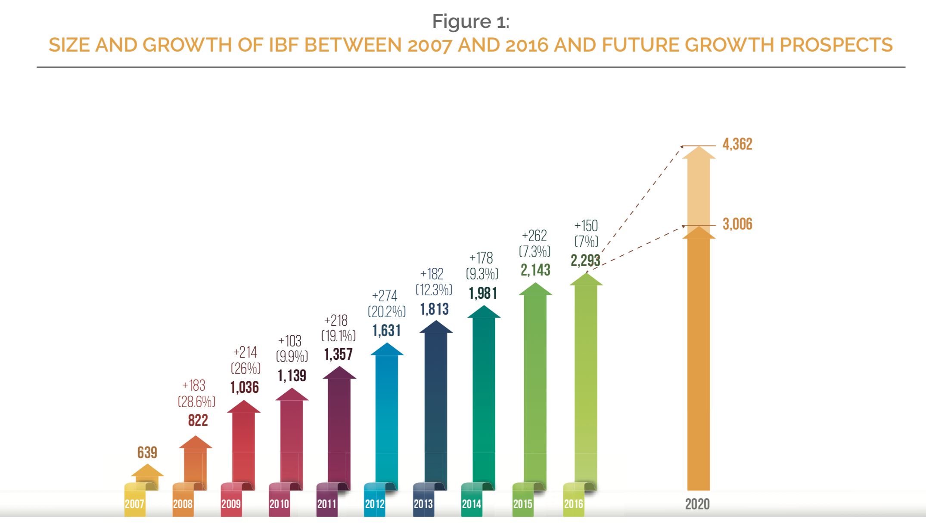

Islamic Finance experienced its third consecutive year of single digit growth – 7.0% growth in 2016, compared with 7.3% in 2015 and 9.3% in 2014. (Dubai Islamic Bank, 2017)

Recommendations

Make 3 recommendations as to whether Islamic finance is the way forward for International banks

Bibliography
Aims Education, 2018. www.aims.education. [Online]
Available at: http://www.aims.education/islamic-finance-blog/advantages-of-islamic-banking-and-finance/
[Accessed 9th December 2018].
Changeboard Team, 2017. The challenges facing Islamic banking. Changeboard, 31 July, p. 1.
Cook, B. J., January 2005. Islamic Banking and Finance inTheory and Practice: The Experienceof Malaysia and Bahrain. The American Journal of Islamic Social Sciences , 22(2), p. 70.
Dubai Islamic Bank, 2017. GLOBAL ISLAMIC FINANCE REPORT , Dubai: Dubai Islamic Bank.
Exportiamo, 2016. Exportiamo.it. [Online]
Available at: http://www.exportiamo.it/aree-tematiche/12877/islamic-commercial-law-limits-advantages-and-disadvantages/
[Accessed 9th December 2018].
Hussain, M., 2015. An Overview Of Islamic Finance. IMF Working Paper, Volume WP/15/120, p. 4.
Othman, R., 2012. Islamic Banking: The Firewall Against The Global Financial Crisis. Journal of Applied Business Research, (1)(28), pp. 9-14.
Warwick-Ching, L., 2010. Beginners’ Guide to Islamic Finance. Financial Times, 14 July.

Al-Haddad, H. and Tarek el-Diwany (2008). “Boom, Bust, Crunch: Is There an Islamic Solution?” http://www.islamic-finance.com/item153_f.htm - date accessed: 28 May 2010.

