UNIVERSITY OF WALES TRINITY SAINT DAVID

Problem Solving and Decision Making (BMSW4004)

Student: Daniel Ionut Manea – 1817998

Lecturer: Suneth Fernando

Contents
Title 4
Introduction 4
Background and specific scenarios 5
Related literature 6
SWOT analysis 6
Strengths 7
Multiculturalism 7
Multilingual people 7
Weaknesses 7
Miscommunication 7
Decreased productivity 7
Avoiding communication 7
Opportunities 8
Creating partnership with teaching organisations 8
Making teams that speak the same language 8
Threats 8
People refusing to try to learn because of comfort 8
PMI 8
Fishbone analysis 9
People 9
Low level of English 9
Logistics 9
IT System frequent issues 9
Management 10
Quick communication / lack of explaining 10
No bottom up communication 10
Training 10
Lack of defined training methods 10
Solutions 10
Evaluating proposed solutions 10
English lessons and quarterly testing at work 11
Plus 11
Minus 11
Interesting 11
Teams that speak the same language 12
Plus 12
Minus 12
Interesting 12
Plan implementation 13
Communication plan for stakeholders 14
Reviewing and monitoring plan 14
Conclusion 15
References 16

Title
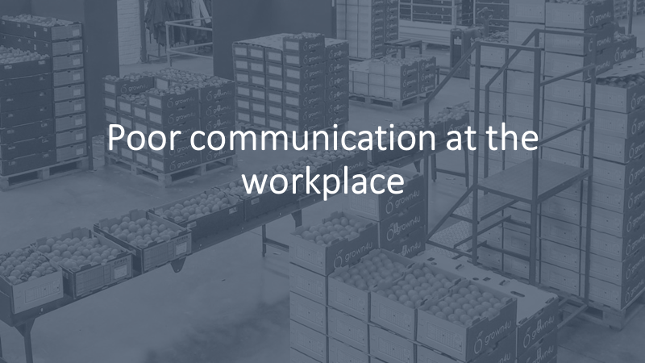

Introduction
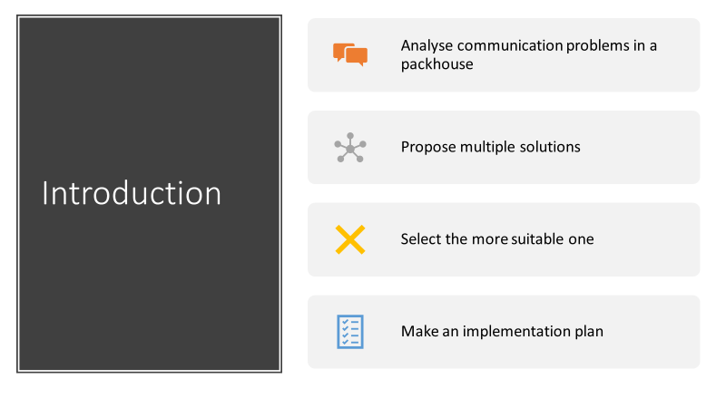

In this presentation I will expose, analyse and propose solutions for the one problem faced in the packhouse I am working on. One solution will be chosen and implemented.
The problem is a big number of miscommunications due to the low level of English on a big percentage of employees.
In order to make sure that this presentation is accurate, and data driven, several tools will be used for analysis and for problem solving.

Background and specific scenarios
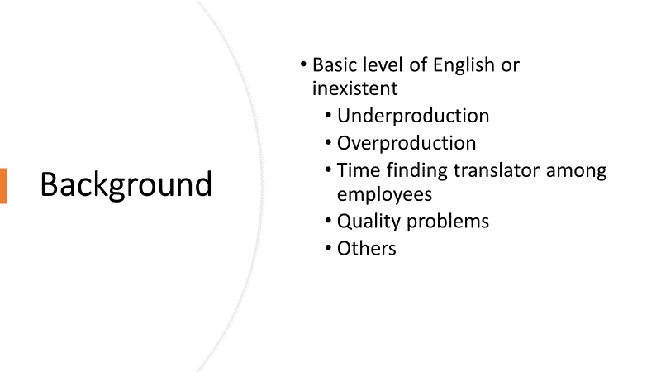
This miscommunication problems happen because most of the employees are not English natives, some of them being in the United Kingdom for several months only and didn’t have a considerable exposure to English in their countries of origin. Later I will expose how this can also be an advantage that could drive productivity, in the same time as improving English.
The main problems that occur because of miscommunications are production problems such as overproduction, increased time on finding a translator among other employees to explain what needs to be done, quality problems and many others that are less frequent.
This is a problem that is mostly found in packhouses, and that is because a fair amount of unqualified people is required, this leading to minimum wage payments depending on the position.
A packhouse is the place where fruit and vegetables are packed before being distributed.

Related literature
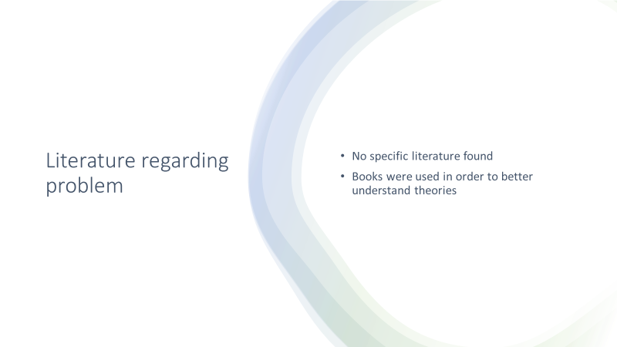
After several hours of research, no relevant book or study was found that approached this specific problem, but several books were used to understand better the tools used, to have a more complete idea about what communication is, and to understand better how to create a presentation.

SWOT analysis

SWOT Analysis is a tool used to analyse internal (strengths and weaknesses) and external factors (opportunities and threats). Strengths and Opportunities can be classified as what makes it favourable to achieve the goal proposed and Weaknesses and Threats are the opposite of that.
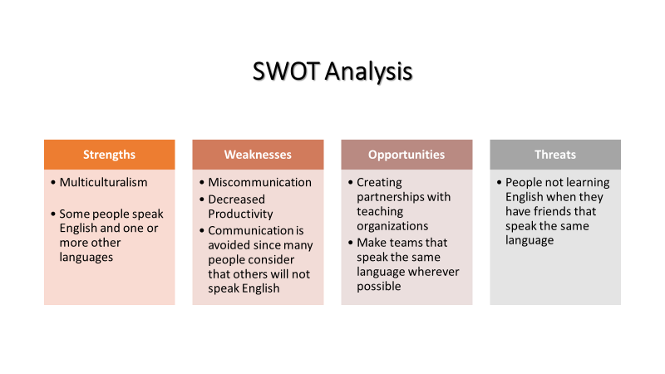

Strengths

Multiculturalism
Multiculturalism is one of the strengths because it increases acceptance between employees, so the workplace doesn’t become hostile or unaccepting for new people from different countries or cultures.

Multilingual people
Some people at the workplace are able to speak several languages and this is a strength because they can be a bridge for the people that don’t yet speak English.

Weaknesses

Miscommunication
Miscommunication happens often and it can lead to production issues or to decreased productivity

Decreased productivity
It has a huge influence in the organisation’s profitability given the fact that if one person doesn’t work or makes a mistake that needs to stop production in order to be fixed, usually at least 5 more people will have to stop their work as well, which means that a considerable number of people are payed but don’t bring profit.

Avoiding communication
Since people don’t know if they will be able to communicate to the employees, most of the times communication is reduced to the bare minimum and simplified as much as possible. This is not a problem when the people are still learning English and they need an easy to understand message, but it is a problem for the people that speak well, because they feel ignored.

Opportunities

Creating partnership with teaching organisations
By creating partnerships with teaching organisations, we could offer the possibility to the employees to learn English. This could be either online or at the company.

Making teams that speak the same language
Although it happens naturally to a certain degree, if we focused on making teams of people that speak the same language, and make sure that the team leader speaks English, the team leader could act as a translator for the employees as well.

Threats

People refusing to try to learn because of comfort
If people have friends or family with which they can speak all the time, the motivation of learning English could not be very high, and give this, some other incentives for learning English should be provided.

PMI
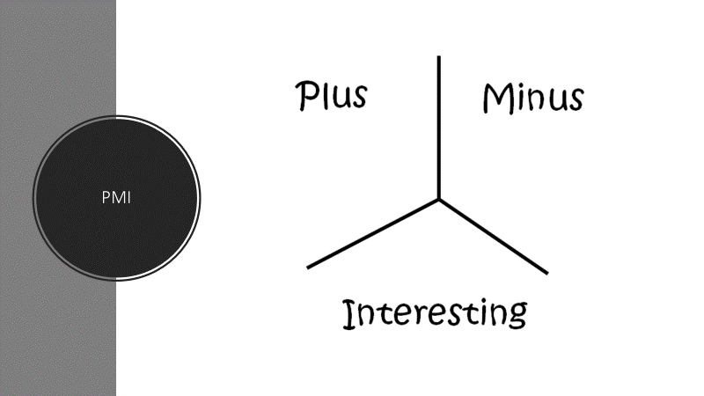
The PMI tool will be used in order to analyse every solution suggested. This slide is meant to explain what this tool is before implementing it.
PMI stands from Plus, Minus and Interesting. On each category we will put reasons or facts and each of them will get a mark. In order to choose something, plus should be more than minus and interesting.

Fishbone analysis
Fishbone diagram is a cause and effect analysis tool that is meant to identify the rood cause of a problem.
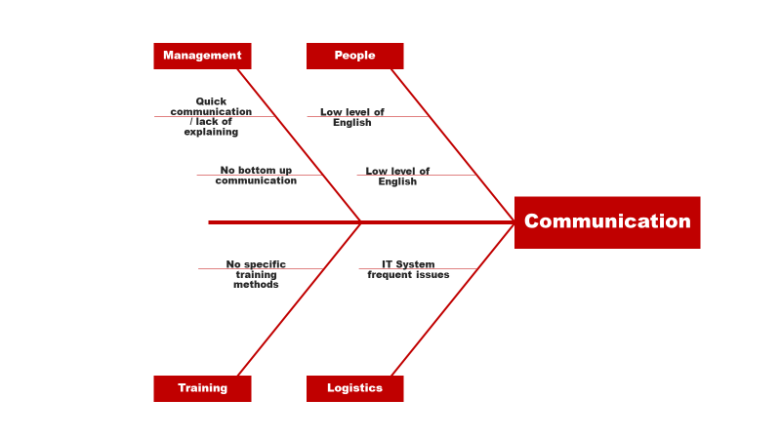

The root causes of the communication problem that were identified are: People, Logistics, Management and Training.

People

Low level of English
The low level of English affects communication because most conversations are kept simple and quick in most scenarios. There is also quite common to have to use gestures in order to explain what is meant to be done.

Logistics

IT System frequent issues
Due to the frequent issues in the IT System, through which information is transmitted to team leaders, sometimes the information expected is different from the one received and employees get confused regarding what is expected from them when they are told to do something and after that they have to do something else or produce a different quantity.

Management

Quick communication / lack of explaining
Communication from management to team leaders and employees is quick if not automatized, this leading to frequent misunderstandings and fails in production

No bottom up communication
Communication from employees to managers is very limited and there are no implemented strategies for employees to be able to communicate with managers. There are no meeting, briefs, or one to one or coaching sessions in which employees can talk directly regarding problems or suggestions.

Training

Lack of defined training methods
There are no training methods that were proved to work, when someone is trained for a new position, he/she is trained by someone that works on that position or above, but there is no check list of what should be covered, so sometimes information is missed.

Solutions

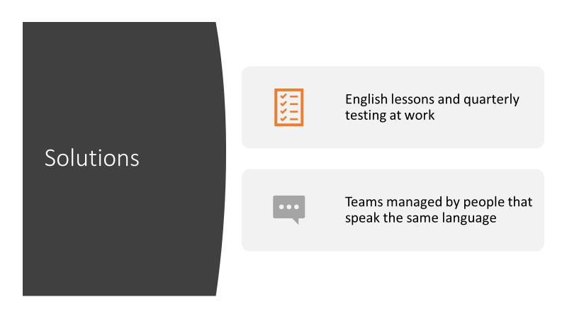
These are the solutions found. They will be explained in more detail in the next slide.

Evaluating proposed solutions

The evaluation is done with the help of the PMI method (Plus, Minus, Interesting).

English lessons and quarterly testing at work
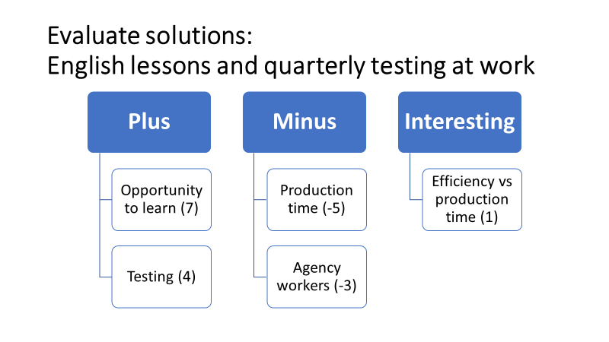

Plus
Chance to offer more benefits to the workers that could improve both the working experience and their day to day life.
Possibility to track progress from a quarter to the next one.
Possibility to see the average English level and base a communication plan on it.

Minus
Production time would be decreased since the courses would take place during the working days, one hour every week.
People working for agencies with zero-hour contracts would not be able to attend all offline courses since they have a variable schedule.

Interesting
It will be interesting to track if production will be decreased in the days people will have the learning hour, and if that hour can be recovered in the same week. Given the fact that efficiency should be improved, the difference long time should not be major.

Teams that speak the same language
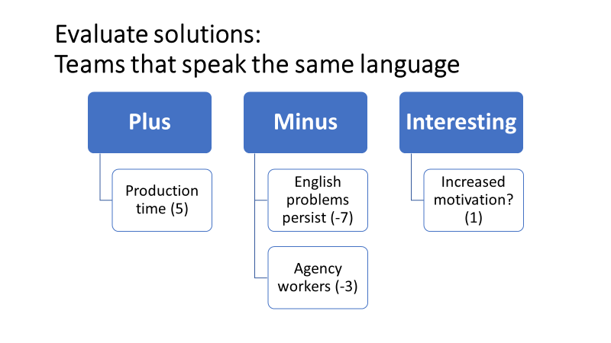

Plus
The production time should be slightly increased since the team leaders can communicate with no barriers with their employees.

Minus
The English problems are not solved, so if they need to work on a different team, the same problem will happen again. For this same reason employees are going to be limited on not taking any higher positions.
Agency workers are not always on the same team and they are not called to work every day, this meaning that it might be hard to fill all teams with people speaking the same language.

Interesting
It would be interesting to see what would happen to the motivation of people. Probably it will increase in the beginning due to the fact that people would be able to communicate, and it is a known fact that when people can talk at work and they are listened, their motivation increases, as said by Eunson (2007).

Plan implementation
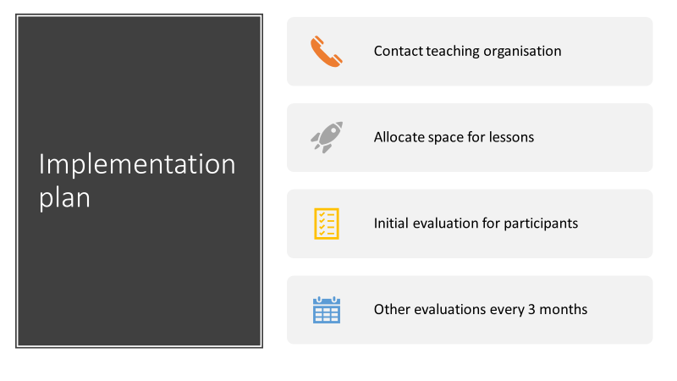

Find company or organisation to implement English courses. The company must be experienced in teaching English as a second language to be as efficient as possible since the sooner people learn, the faster productivity should increase.
Allocate place for lessons. The place has to respect health and safety regulations and be appropriate for teaching and learning in order to maximise results
Every person taking part will have an initial test to see what their English level is. Every 3 months, they will be tested again. After 6 months they should be one level higher. The people responsible for this will be our HR department and the contact person from the teaching organisation.
Goals:
- Help every employee get to at least a medium level of English (B2 or more)
- Improve communication at the workplace
Milestones:
- One level more every six months
Allocated resources
- Money for teachers
- Study location
- Printed materials to take home
- Online resources

Communication plan for stakeholders
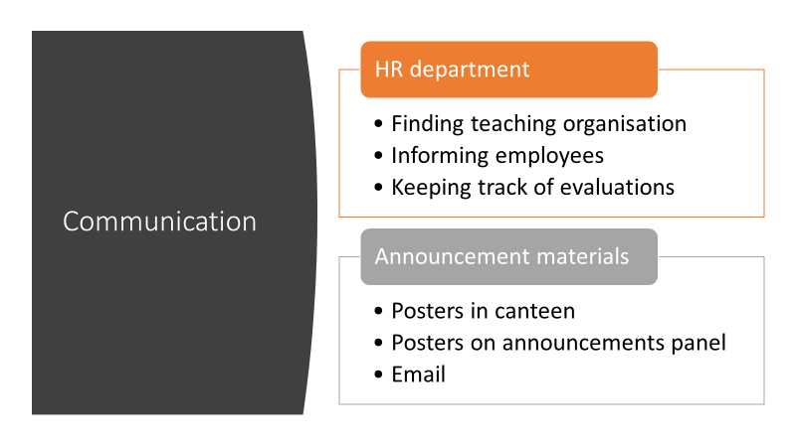
The only major stakeholders for this project will be the teaching provider and the employees. The project will be mainly implemented by the HR department.
Teaching organisation: The communication will be assured by our HR department.
Employees: Responsible will be the HR department and the team leaders of each line.
The changes will be announced by posters in the canteen and announcements panel, as well as by e-mail.

Reviewing and monitoring plan
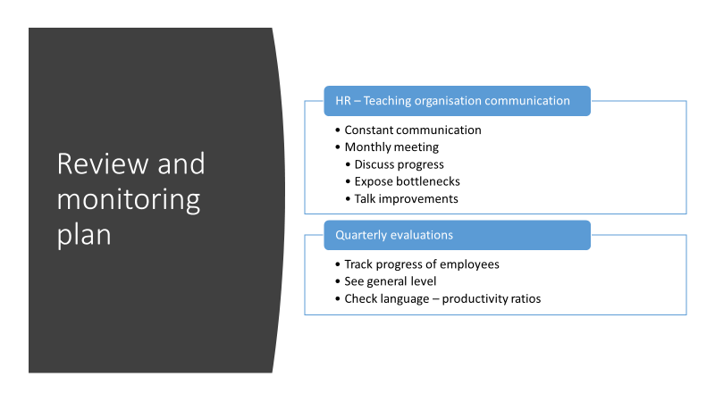
In order to assure that the plan is creating positive results, we will first make sure that our HR team will be in constant communication with the teaching organisation, they will have at least one obligatory monthly meeting to discuss progress and bottlenecks, and discuss what can be improved for better results.
There will also be quarterly evaluations on which the progress of English employees posses will be tracked, the general level of English in the organisation will be analysed, and most importantly, a level of English - productivity ratio will be checked.
This English – productivity ratio will determine if this plan is appropriate to increase productivity.

Conclusion
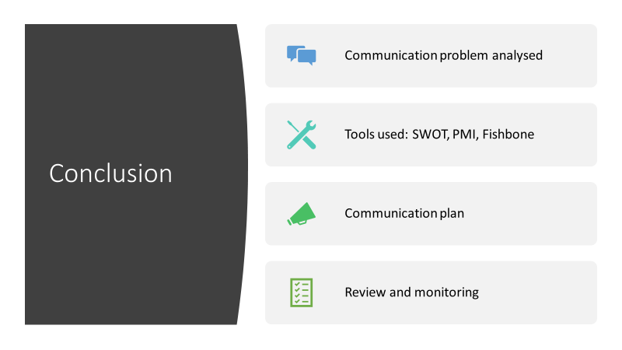
In this presentation we have discussed about how a communications problem in a packhouse, caused mainly by a low level of English, can be solved.
In order to do this, we used several tools such as SWOT analysis, PMI, and Fishbone (or Ishikawa diagram), a solution has been chosen and an implementation plan, communication plan and reviewing and monitoring plan has been provided

References
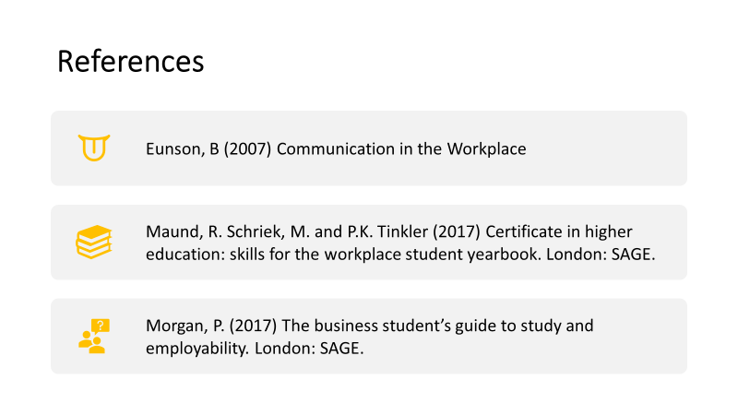
- Eunson, B (2007) Communication in the Workplace
- Maund, R. Schriek, M. and P.K. Tinkler (2017) Certificate in higher education: skills for the workplace student yearbook. London: SAGE.
- Morgan, P. (2017) The business student’s guide to study and employability. London: SAGE.

