Shafia Bibi 1711966
LECTURER | ABDULLAH AL MAMUN
EMERGENT LEADERSHIP SKILLS IN THE WORKPLACE
MODULE CODE: BMSW6101_BIRM

TABLE OF CONTENTS

PART 1: CASE STUDY ANALYSIS 2
Introduction 3
Exploring Leadership Traits 4
Gender Stereotypes and Challenges Faced by Female Leaders 7
Long-Term Solutions to Gender Discrimination 8
Transformational Leadership and Organisational Performance 11
Conclusion 12
PART 2: REFLECTIVE REPORT 13
REFERENCES 17
APPENDIX 22

PART 1: CASE STUDY ANALYSIS

Introduction

An attempt has been made to emphasize the importance of women in leadership using approaches and traits, and the challenges they may face. To be an effective leader, they need to have knowledge and understanding in the relevant field, and a confidence that will gain them respect. Depending on the level of leadership skills, people can use their skills in different organisations and with different scales of people. They must be honest, trustworthy, and approachable. It is important to have cultural and situational awareness so support can be provided. When a leader understands all this, they can be fair and provide adequate support.

Exploring Leadership Traits

Leadership can be seen as an approach or a theory. There are many approaches to leadership, which include trait approach, behaviour approach, situational approach, relational approach, new leadership approach and emergent leadership approach.

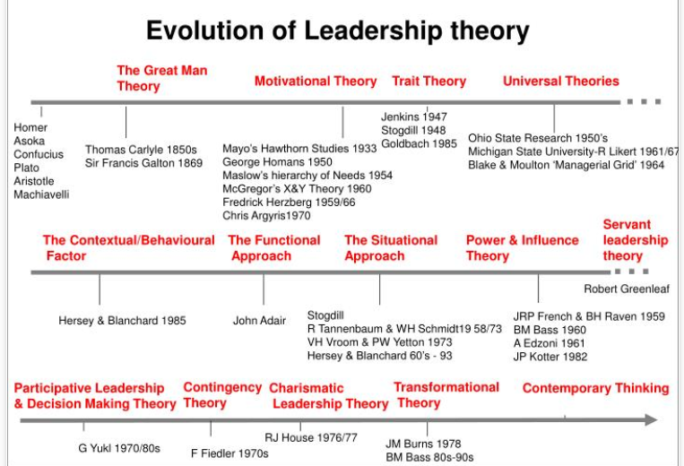

Fig. 1 (Source: Saidi, 2020).

This timeline shows how theory has changed overtime. The accuracy of dates is questionable, as a research conducted into this suggests otherwise. This can be used as a guide to identify various types of leadership, which shows how attitudes have changed. The case study that this assignment analyses, discusses mainly traits and transformational theory. Ursula Burns had certain qualities and characteristics which enabled her to progress further into her career. Her outspokenness and inspiring character led her to recognition and a visionary leader.
Maccoby (1979) stressed that in order for businesses to succeed, they need to have a higher level of leadership than ever before (cited by Landis, Hill and Harvey, 2014, p. 98). Leadership can be described in a number of ways. It can be a trait, ability, skill, behaviour, relationship, or an influence process, which Burns had displayed in the case study. Yuki (2010), cited in Alagoa (2014, pp. 5-7), suggests the three main leadership processes that are most vital are in their characteristics. This can be observed in their traits, skills and behaviours. Traits and skills encourage adaptability and better relationships. (Saurel, 2019). Behaviours can be divided into two categories: task orientation and relationship orientation. Task orientated leaders are task driven, whereas relationship orientated leaders are more people driven.

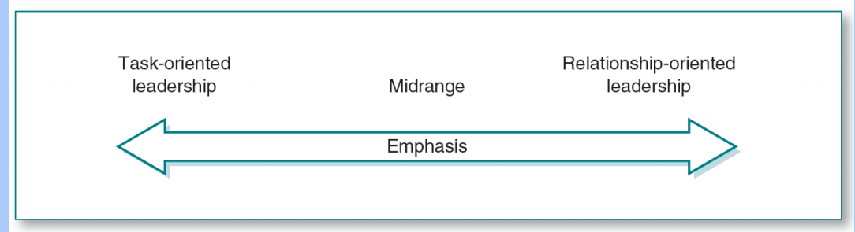
Fig. 2 (Source: Messersmith, 2015).

A balance between task and relationship is very important for effective leadership. This would demonstrate knowledge and competency and followers would have more confidence in the leader. It is evident in the case study that Burns had great concerns for her people, but she also ensured jobs were being complete. This puts her in midrange.
Leaders around the world are mostly of male leaders. Women leaders are increasing, however relatively low. Women leaders are often in their role for no longer than 5 consecutive years (Geiger and Kent, 2017). They also suggest, according to the World Economic Forum, research conducted between 2014 and 2017 shows 70 nations have had female leaders as head of government or state, between 1966 and 2017. The research also suggests countries such as Bangladesh, India, Ireland and Iceland have had female president or prime ministers leading for 20 to 23 years. So why is it that other countries are failing to promote female leadership and why are female leaders being replaced? Perhaps they do not have the necessity skills? Or maybe they do not have the characteristics it takes to be an effective leader?
Looking at the case study, it suggests Ursula Burns was a charismatic leader. A person with this type of characteristic has extraordinary powers and results with the person being treated as a leader, as described by Max Weber, a German sociologist, and the founder of charismatic authority (Coggins, 2020). Good leaders have a unique charm to them. They have an inborn quality to attract followers and create a special bond. They are good role models and have the intelligence to inspire people. However, this can have a negative impact on people too. People may not like this attitude, which can seem intimidating. A charismatic leader is more people oriented rather than task oriented. This was evident in Burns, as the case study suggests she spent most of her time inspiring other females to progress their careers. Burns was determined to include people from different backgrounds. Her care and support for others, her knowledge, and the courage to take risks are appealing.
Burns also demonstrated high levels of confidence, emotional intelligence, and a strong work ethics. Jordon Peterson, a Canadian psychologist and professor, clearly states that intelligence and conscientiousness predicts success in the workplace (Primed, 2018). Her integrity is a quality that stands out from the rest of the crowd. She is very much aware of herself and of her environment. Ursula Burns fought for what is right and was not afraid to take risks. This showed confidence.
Confidence gives people assurance and helps them to understand each other better. When people are less confident, putting themselves in an awkward situation could improve their confidence. This will also gain them respect. Good listening and speaking skills are essential for this. Burns went head-to-head with the executive, questioning him as to why there was a lack of workers from different ethnic backgrounds. Gina Bullard, a former Chemical Dependency Counsellor states confrontation can have multiple meanings and can be explosive (Quora, 2020), however in Burns’ case, her confrontation with the executive led to her being recognised and promoted to a higher level in the workplace, as this displayed her integrity. (Sometimes dishonest people get leadership roles because they are good speakers but that is betraying its people).
Burns leads by example. She was open-minded, flexible, and an empathetic leader. According to the case study, she looks for people who have great empathy. March 2019, when the terrorist attack took place in New Zealand, Jacinda Arden paid a visit to the victims. She displayed a lot of empathy for her followers and this in turn gained her recognition from the whole nation. She was applauded for her bravery and her leading skills. However, some critics say showing empathy makes her a weak leader (Salvaire, 2019). It is possible that they are from a minority group who feel empathy is weakness as they have experienced such disadvantages. Maybe in their experience, they have seen over-managed or under-performing empathetic leaders which is why they are associating empathy with weakness. Burns had great sociability skills and was very ambitious. She was able to establish positive relationships. Some leaders prefer to be on their own. Her determination is what makes her likeable, however some may argue that too much determination can have side effects. Spending too much time on leading people can lead to neglect of other important things such as family. Burns was able to engage with people from different backgrounds and had a lot of patience. She displayed cultural and situational awareness.

Gender Stereotypes and Challenges Faced by Female Leaders

Ursula Burns faced a lot of discrimination in her career, with majority of it concerning her age. People thought she is too young to have the responsibilities that she has had. Burns started her career at the age of 22years, which enabled her to explore her interests, abilities and talents. She did not let anything stop her from achieving her vision. According to Doh (2017), early education can strongly influence career choices, shape behaviour and the approach of leadership roles and interaction.
Greta Thunberg, a Swedish teenager inspired an international movement to fight climate change. She has the ability to lead and inspire millions of people to take part in protests around the world, only at the age of 17 years. As well as all the positivity and support Thunberg has received from climate activists, scientists, world leaders and the Pope, Thunberg has also received criticism from the likes of US President Donald Trump and Russian President Vladimir Putin, telling her to work on anger management and study further before preaching to others (BBC News, 2020). After Brazil’s President Jair Bolsonaro ridiculed Thunberg and called her a “brat”, Thunberg’s response was that they are terrified of young people bringing change (Helmore, 2019). It can be said that Thunberg is also experiencing some age discrimination. They are not taking her seriously due to her being a teenager.
Burns experienced gender discrimination. It is not uncommon for people to believe women have more child-bearing responsibilities or go on maternity or seek part-time jobs only. Unfortunately Burns was on the receiving end of this stereotype. There is a stigma against women, that men are better leaders than women. Men have more power, confidence, and are more competitive, whereas women are more emotional and sensitive, hence making them weaker than men. This becomes a barrier for women and minority groups from achieving their full potential, which is called a “glass ceiling”, the invisible barrier. This concept was first popularized in 1986 in an article discussing corporate hierarchy (Kagan, 2019). It could be said that gender discrimination started from the Great Man Theory. Men dominate leadership positions because men are “better leaders”. Or perhaps the educational choices of women deny them from becoming leaders. Maybe they do not have self-belief. According to statistics, more than 42% of women experience gender discrimination at work. This could come under the form of pay gaps, being treated unfairly, microaggressions, less support, no opportunity for promotion and isolation (Reiners, 2020). Maybe if roles were reversed and when it all started women were the ones to go to work whilst the men stayed home and looked after the family. Then maybe today women would dominate leadership positions and they would be seen as the stronger gender.
Mother Teresa was another woman of high integrity, however there is still criticism that she was doing jobs for her personal satisfaction (Biography.com, 2020). She was also criticized for opposing to contraception and abortion (Carter, 2016). However, most of the US laws banning or restricting access to abortions have been voted by male politicians (Prasad, 2019). A female lawmaker recognised that a matter concerning women is being made official entirely by men. Where is the female input in this? Prasad suggests, Alabama’s lawmakers are made up of 85% men, with only 4 women in the senate.
This shows Mother Teresa being a female was not heard, however the male politicians are fighting hard to be heard. “These people don’t care about protecting human rights. It’s about controlling women”, argued Delaney Burlingame, a young activist (Prasad, 2019). However, there are some men that say women should decide what they do with their bodies, but women turn around and say that is simply pressure.

Long-Term Solutions to Gender Discrimination

The issues around gender discrimination can be reduced by shifting old rules and expectations (Carbajal, 2018). Females can be guarded against discrimination by removing stigma against women, such as they should be at home, and by closing the gender pay gap, so to provide gender equality and equity. A combination of equality and equity can bring true fairness of opportunity and level of support (Daisy, 2019). It is crucial to provide extra support to those who may require it, to meet different levels of need. On the other hand, giving people more support than they need would only put others at a disadvantage as crucial time and assistance may be missed. It is important to consider peoples abilities, not everyone will have the same level of knowledge, understanding or experience. Also, everyone should be entitled to a chance at the very least.
Education is also another means to prevent or reduce gender discrimination, required by today’s society. People should be made aware of current rules and regulations around gender discrimination, which should help educate people. They should also be given practical training around the matter, so that they can understand it better and are not simply forced to comply with it. The 2010 to 2015 government policy on equality states that they prevent various types of discrimination, and support and protect the rights of women by helping them to reach their full potential, helping businesses get the full benefits of women’s skills, and by ensuring women’s voices and interests are heard (Gov.UK, 2015) . This shows discrimination is a serious matter and there are laws to prevent this. Not every case will be solved, however there are measures that can be taken.
Leaders should also have the training so they can too be aware of potential discrimination and know the correct actions to take. Segal (2015), editor of HR Magazine, suggests alongside education, more women should be hired and promoted, as this can send out a powerful message. Minimum job requirements should not be so high that they exclude women. This means more work / life balance and flexible shifts should be considered. Support from male leaders can also be significant to women, as this would demonstrate trust and compassion, and create a better workforce.
There are a lot of vital information in the infographic below, which can help one to remember the importance of education. The information is clear that women’s education plays a significant role in society, especially if she wants to climb the corporate ladder. It also mentions how education can help reduce stereotype in men.

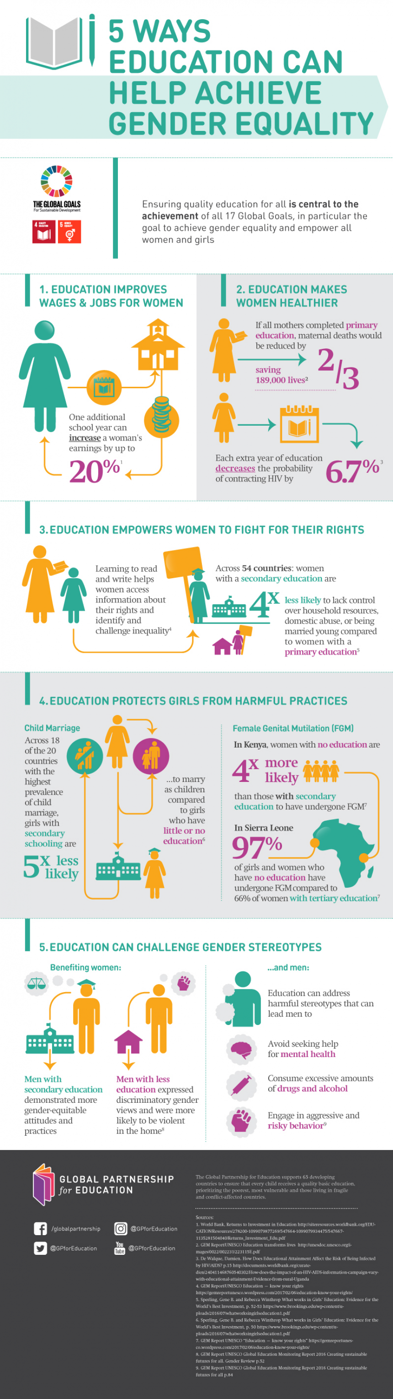

Fig. 3 (Source: Global Partnership for Education, 2018).

Transformational Leadership and Organisational Performance

Transformational leaders are able to recognise a need for change. They have clear values, vision, and a mission. Leaders stimulate the mind of followers, helping them to find new ways for problem solving and decision making. Not only can they identify the skills and qualities of followers, but a leader can also identify their emotional needs. Emotional intelligence plays a massive part in transformational leadership too. This would create high-performance groups and the ability to manage change. Also, more creativity will be discovered. There are two types of transformational leaders: authentic and socialized. Authentic leaders bring ideas and attention for followers benefit, whereas the dark side known as pseudo-transformational leader, means the leaders are manipulating followers for self-satisfaction, with the followers ability to do critical thinking reduced (Groves, 2013).This type of leader is dishonest and only cares about themselves.
Quain (2018) suggests, transformational leaders are able to inspire their team to think outside the box and change strategies to increase productivity. The key to a successful business is an eager leader and a motivated follower. An example of this is Reed Hastings, who had a clear vision. He worked in the software industry and developed Netflix, which exceeded Blockbuster. Jeff Bezos is another famous transformational leader, the founder of Amazon. Amazon dominates various industries, which include food and electronics.
Ursula Burns was able to attract her followers through motivation, inspiration and her bravery. She is able to take risks. This is what a transformational leader does and according to Sarros, Cooper and Santora (2015), transformational leaderships leads to employees feeling valued and a sense of self-satisfaction, which in turn would benefit the business as followers would be making more effort. Burns was also able to form a culture and displayed some ethical leadership skills within her workplace by helping women to focus on their future goals and differentiating between right and wrong. She found herself in a confrontation with her leader, which showed great concern for people of different backgrounds. This demonstrated great awareness and importance of having other ethnic groups in the involvement of the business and how they could be an asset. She is authentic, can co-operate well with others and speaks the language everyone can understand. These skills make a leader more approachable and likeable, and the atmosphere is more positive.

Conclusion

It is essential to have a clear vision in which one can share with their followers. This would facilitate clear paths for strategies and embodying change. It would ensure the bigger picture is understood and gain knowledge on how to implement ideas through innovation. It is the responsibility of top management to create the vision, whereas the middle management to carry them out, whilst effectively leading the team, re-interpreting and adjusting where necessary. Delegating skills are critical here as this would allow others to improve themselves, as well as building more trust and effective communication. In addition, this would keep followers motivated and enable them to feel valued for their actions. The best way to learn something is through education. Qualities of a person can be enhanced through appropriate training and education, enhancing ones leading skills. Characteristics can help identify a person’s leadership style. It is beneficial to learn what traits work best with different types of people.

PART 2: REFLECTIVE REPORT
My Knowledge and Understanding of Leadership
This report reflects my knowledge and understanding of leadership, which is a process that can be changed to meet certain needs and influences others to achieve a common goal (Rouse, 2020). Leadership has many responsibilities. Defining leadership is a complex and elusive problem, suggested by Bryman (2013, pp. ix - 1) as there are a variety of definitions and to make matters worse, there are no mutual agreed one.
In my opinion, leadership is a visionary. A person that can see the wider picture and help inspire their followers to share this vision. They have powerful influential skills and are great communicators with high levels of intelligence. I take a lot of inspiration from one of my previous managers, who led by example. She was modest and trustworthy, and always approachable. My current manager, he is more focused on accomplishing tasks. Perhaps this is why there has been so many problems in the workplace.
Leadership can be described as an approach or a theory. Douglas McGregor had 2 theories. Theory X and Theory Y. Theory X is where people dislike work and need direction, whereas Theory Y, people like work and like to lead others. They are self-motivated and they accept responsibility. I believe both theories to be true, however in this time of my life I feel I am somewhere in between the two. After doing a leadership questionnaire (please refer to appendix), I strongly believe that leadership is a skill and influence process. This means that leadership can be studied and learnt, and that the influence process is between leaders and followers, where they meet to achieve a common goal.
There are positive and negative factors about being a leader. The positive side is that great leaders have a clear vision. They are committed, have a positive energy, confidence in what they are doing, a great sense of humour, courageous, creative, honest, trustable, and have patience. Good leaders are able to identify the problem and focus on the future. The negative side of it is that underperforming leaders attack the person and focus on the past. They may lack of flexibility, can sometimes be seen as self-centred, unable to empathize, not an optimist, lack of integrity, accountability and patience.
There is similarity of traits that all great leaders possess: intelligence, confidence, charisma, determination, sociability, and integrity. Some of this can be evident in historical leaders such as George Washington and Oprah Winfrey, and current leaders such as Jacinda Ardern. I believe the three most important leadership traits to have are communication, influential powers, and intelligence. The leader should be able to adjust to different styles of communication for better interaction. A good leader should be able to motivate and inspire their followers to achieve their goal, and this should be evident in business results. Intelligence is required to assess any situation and goal, to see if they fit well with plans.
There are three different types of leadership styles: authoritarian, democratic, and laissez-faire. Authoritarian is where a leader dictates, directs and controls all activities. Democratic leadership is where all participants are involved in activities. Laissez-faire is where leaders have little input in activities. Followers are able to decide their actions. After doing a leadership style questionnaire, I have come to realise that I am a democratic leader. A democratic leader creates a sense of value and recognition. This does not surprise me as I believe followers should be involved in decision making processes. This encourages communication, trust and brings quicker results, although this requires more effort and it may not always be right. I feel people are happier within their roles and this encourages creativity and solutions. However, effective leaders can switch leadership styles for different situations. In a group of inexperienced staff, being the only member with knowledge and expertise, a person may change to an authoritarian leadership style. They would need to give followers more guidance and determine how and when tasks will be complete. Authoritarian works best when there is no time or less knowledge amongst members.
There are two dimensions of leadership behaviour. Task and Relationship. Task oriented leaders are driven by goal. They want to see results. They are good planners. Relationship oriented leaders are more focused on the current situation. One of their core values is trust. It can be said that relationship orientated leaders have more respect and concern for people. This leads to the workplace having a better atmosphere. After doing a behaviour questionnaire, I have found out that I am relationship oriented, only by one point. This does not surprise me, as I always consider task and the people. Both are very important to me. A good leader will be able to balance the two and adapt to different needs. Having said that, it really depends on the situation. For example, when I was a room leader, I was more focused on the tasks rather than individuals. I did not make myself fully aware of people’s feelings. I just wanted to complete every job. I was more task orientated. As I reflect on this module, I now realise how important it is to balance the two.
There are many different types of leadership, some that have already been mentioned above. Other leadership theories that have not been touched upon may include: Charismatic Leadership, Participative Leadership, Social Leadership, Situational Leadership, Path-Goal Leadership, Servant Leadership, Authentic Leadership, and Implicit Leadership (Coggins, 2020).
Primal Leadership is another type of leadership that has not been discussed but linked to own research conducted. Emotional intelligence is the key in Primal Leadership. It focuses on people’s emotions before anything else. Emotional contagion means emotions may spread like viruses, however not all travel at the same pace. The key to a successful leadership is how it is done. Leaders should assess followers emotional state and make adjustments, before striving to motivate them (Goleman, Boyatzis and Mckee, 2013, pp. 3-10). If followers display any unwanted emotions, these can be addressed so better work can be produced. Their book also suggests another leadership style: The Resonant Leader. This type of leader connects with the followers, shows empathy and talks from personal experiences first, to engage with their followers and show them their true feelings. This would build trust. The opposite of that type of leader is called a Dissonant Leader. This could lead to followers feeling excluded and create a toxic relationship. It is crucial to understand relationships and qualities.

REFERENCES

- Alagoa, H. (2014) Leadership Approaches for Effective Organizational Change. [e-book] pp. 5-7. Available at: https://www.academia.edu/9909576/LEADERSHIP_APPROACHES_FOR_EFFECTIVE_ORGANIZATIONAL_CHANGE (Accessed: 16 July 2020).

- BBC News. (2020) ‘Greta Thunberg: What Does the Teenage Climate Change Activist Want?’ BBC News, 28th February. Available at: https://www.bbc.co.uk/news/world-europe-49918719 (Accessed: 18 July 2020).

- Biography.com. (2020) Mother Teresa Biography (1910-1997). Available at: https://www.biography.com/religious-figure/mother-teresa (Accessed: 20 July 2020).

- Bryman, A. (2013) Leadership and Organizations. Oxon: Routledge, pp. ix – 1.

- Carbajal, J. (2018) ‘Patriarchal Culture's Influence on Women’s Leadership Ascendancy.’ The Journal of Faith, Education and Community, [online] 2(1), p.3. Available at: https://scholarworks.sfasu.edu/cgi/viewcontent.cgi?article=1011&context=jfec (Accessed: 18 July 2020).

- Carter, J. (2016) 9 Things You Should Know About Mother Teresa. Available at: https://www.thegospelcoalition.org/article/9-things-you-should-know-about-mother-teresa/ (Accessed: 20 July 2020).

- Coggins, E. (2020) The History of Leadership Studies and Evolution of Leadership Theories. Available at: https://toughnickel.com/business/The-History-of-Leadership-Studies-and-Evolution-of-Leadership-Theories (Accessed: 17 July 2020).

- Daisy. (2019) Equality and Equity [blog]. 29 March. Available at: https://social-change.co.uk/blog/2019-03-29-equality-and-equity (Accessed: 19 July 2020).

- Doh, J. P. (2017) ‘Can Leadership Be Taught? Perspectives from Management Educators.’ Academy of Management Learning & Education, [online] 2(1). Available at: https://journals.aom.org/doi/full/10.5465/amle.2003.9324025 (Accessed: 16 July 2020).

- Geiger, A. and Kent, L. (2017) Number of Women Leaders Around the World Has Grown, But They Are Still A Small Group. Available at: https://www.pewresearch.org/fact-tank/2017/03/08/women-leaders-around-the-world/ (Accessed: 17 July 2020).

- Global Partnership for Education. (2018) 5 Ways Education Can Help Achieve Gender Equality. Available at: https://www.globalpartnership.org/news/infographic/5-ways-education-can-help-achieve-gender-equality (Accessed: 19 July 2020).

- Goleman, D., Boyatzis, R. and Mckee, A. (2013) Primal Leadership: Unleashing the Power of Emotional Intelligence. Boston: Harvard Business Review Press, pp.3-20.

- GOV.UK. (2015) Policy Paper. 2010 to 2015 Government Policy: Equality. Available at: https://www.gov.uk/government/publications/2010-to-2015-government-policy-equality/2010-to-2015-government-policy-equality (Accessed: 19 July 2020).

- Groves, K. (2013) ‘Examining Leader–Follower Congruence of Social Responsibility Values in Transformational Leadership.’ Journal of Leadership & Organizational Studies, [online] 21(3), pp.227-243. Available at: https://journals.sagepub.com/doi/full/10.1177/1548051813498420 (Accessed: 20 July 2020).

- Helmore, E. (2019) ‘Greta Thunberg: “I Wouldn’t Have Wasted My Time” Speaking to Trump’, The Guardian, 30th December. Available at: https://www.theguardian.com/environment/2019/dec/30/greta-thunberg-trump-climate-change-un-summit (Accessed: 18 July 2020).

- Kagan, J. (2019) What is The Glass Ceiling? Available at: https://www.investopedia.com/terms/g/glass-ceiling.asp (Accessed: 18 July 2020).

- Kolzow, D. (2014) LEADING FROM WITHIN: Building Organizational Leadership Capacity. [e-book] p.20. Available at: https://www.iedconline.org/clientuploads/Downloads/edrp/Leading_from_Within.pdf (Accessed: 17 July 2020).

- Landis, E., Hill, D. and Harvey, M. (2014) A Synthesis of Leadership Theories and Styles. Journal of Management Policy and Practice, 15(2), p.98.

- Messersmith, D. A. (2015) Being the Leader Your Followers Need. [Presentation] Available at: https://uaad.unl.edu/btlyfn_handout.pdf (Accessed: 17 July 2020).

- Prasad, R. (2019) ‘Alabama Abortion Plan: Should Men Have A Say in The Debate?’ BBC News, 18th May. Available at: https://www.bbc.co.uk/news/world-us-canada-48262238 (Accessed: 20 July 2020).

- Primed. (2018) The Traits That Predict Success According to Psychology (And Jordon Peterson). [Video] Available at: https://www.youtube.com/watch?v=3ikrOyhiGf8 (Accessed: 17 July 2020).

- Quora (2020) Why Is Confrontation Not Healthy in A Positive Relationship? Available at: https://www.quora.com/Why-is-confrontation-not-healthy-in-a-positive-relationship (Accessed: 17 July 2020).

- Reiners, B. (2020) What is The Glass Ceiling and How Do We Break It? Available at: https://builtin.com/diversity-inclusion/glass-ceiling (Accessed: 18 July 2020).

- Rouse, M. (2020) What Is Leadership? Available at: https://searchcio.techtarget.com/definition/leadership (Accessed: 16 July 2020).

- Sagepub. (n.d.) Conceptualising Leadership Questionnaire. Available at: edge.sagepub.com/system/files/questionnaire_ch01_0.pdf (Accessed: 22 July 2020).

- Saidi, F. (2020) 4-6. Leadership Paradigms. Available at: https://www.slideserve.com/fayola/4-6-leadership-paradigms (Accessed: 19 July 2020).

- Salvaire, A. (2019) Jacinda Ardern: 'It Takes Strength to Be an Empathetic Leader.’ Available at: https://www.shiftbalance.org/jacinda-ardern-it-takes-strength-to-be-an-empathetic-leader/ (Accessed: 9 July 2020).

- Sarros, J., Cooper, B. and Santora, J. (2015) ‘Building a Climate for Innovation Through Transformational Leadership and Organizational Culture’, Journal of Leadership & Organizational Studies, 15(2), pp.145-158. Available at: https://journals.sagepub.com/doi/pdf/10.1177/1548051808324100 (Accessed: 20 July 2020).

- Saurel, S. (2019) 10 Personality Traits More Important Than Any Other Skill. Available at: https://medium.com/the-helm/10-personality-traits-most-important-than-any-other-skill-e45b3ab14a9c (Accessed: 17 July 2020).

- Segal, J. A. (2015) 10 Tips to Fight Gender Discrimination. Available at: https://www.shrm.org/hr-today/news/hr-magazine/Pages/010215-gender-discrimination.aspx (Accessed: 19 July 2020).

- Quain, S. (2018) Transformational Leadership Example in business. Available at: https://smallbusiness.chron.com/transformational-leadership-examples-business-20730.html (Accessed: 22 July 2020).

APPENDIX

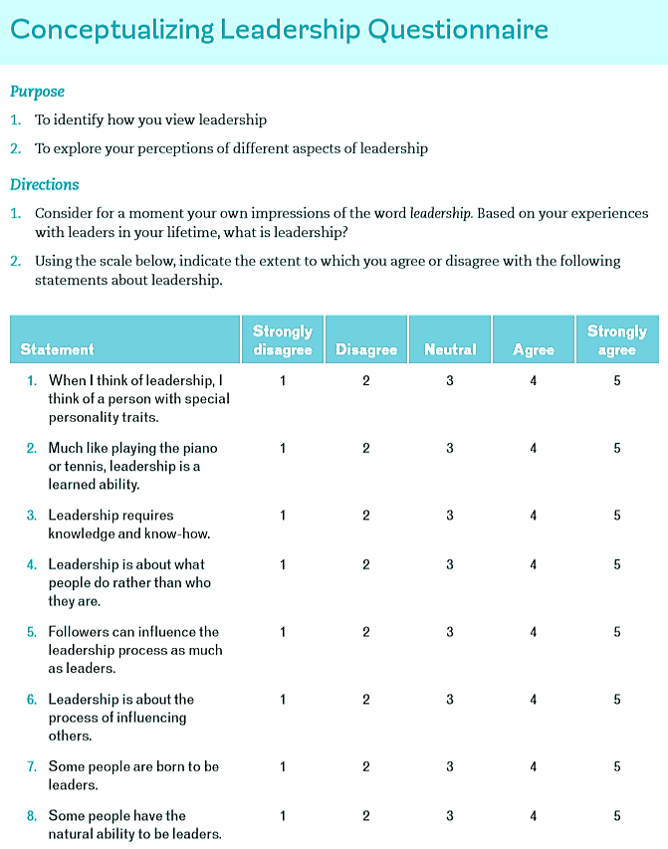

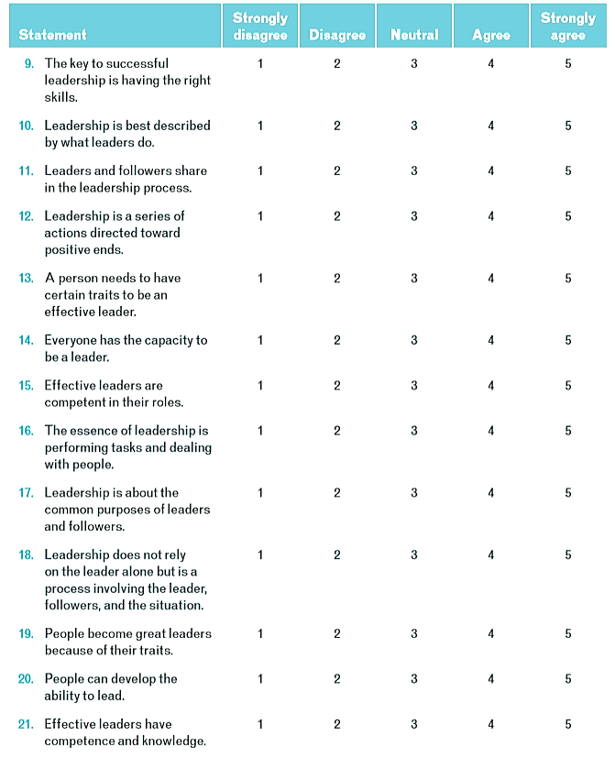

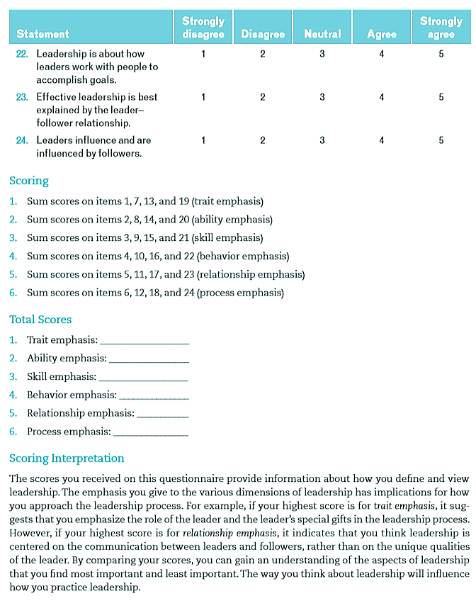
Source: Sagepub, (n.d.).

