Early years practitioner’s handbook;
A guide to transitions.



(Google images)

Contents

Introduction Page 3-4
Role of the adult Page 5-6
Needs of a child Page 6-7
Environment Page 8-9
Partnership Page 9-10
Interventions Page 10-12
Proposed outcomes Page 12
Reference List Page 13-15

Introduction

This handbook will be providing information and guidance on specifically the transitions from childcare setting to nursery. Children experience many different transitions throughout their first years of life. This handbook will be providing theories and evidence on the needs of a child, the role of an adult, partnerships and interventions, also providing evidence on how a keyworker and the adult play a massive part in a child’s transition from childcare to nursery.

What is transition?
Transition is when a child moves to a new home, a new school or a new childcare setting for the first time. Also, when a baby transitions onto solid foods, goes from crawling to walking and non-verbal to verbal. According to Clarke (2020) Children may be impacted emotionally through a range of personal experiences throughout their life. These may include parents separating, bereavement, entering or leaving care. As children age and develop they experience transitions that may affect them in some shape or form. According to Clarke (2020) Many of these transitions and events are common to most children and can usually be anticipated or expected, whilst others may be unpredicted or unexpected. It is important for child practitioners to remember that transition is a progress and although some children adapt quickly other’s may not. Reflection on transitions allows practitioners to link emotional wellbeing and behaviour together, this normally gives them idea on how well a child is coping, because how a chid cope with ‘change’ will arise from how well they have responded Robinson (2008) There are four development areas that transition can affect these include physical, emotional, intellectual and phycological. According to Supporting Transitions (No Date) “Children’s reactions to transition and the strategies they use to cope are often related to their development stage”. An infant may experience separation anxiety and cry uncontrollably when a familiar caregiver is absent.

Physical transitions include new home or care setting, a new school and or participating in a new activity
Intellectual transitions include moving to a higher educational setting such nursery to primary education.

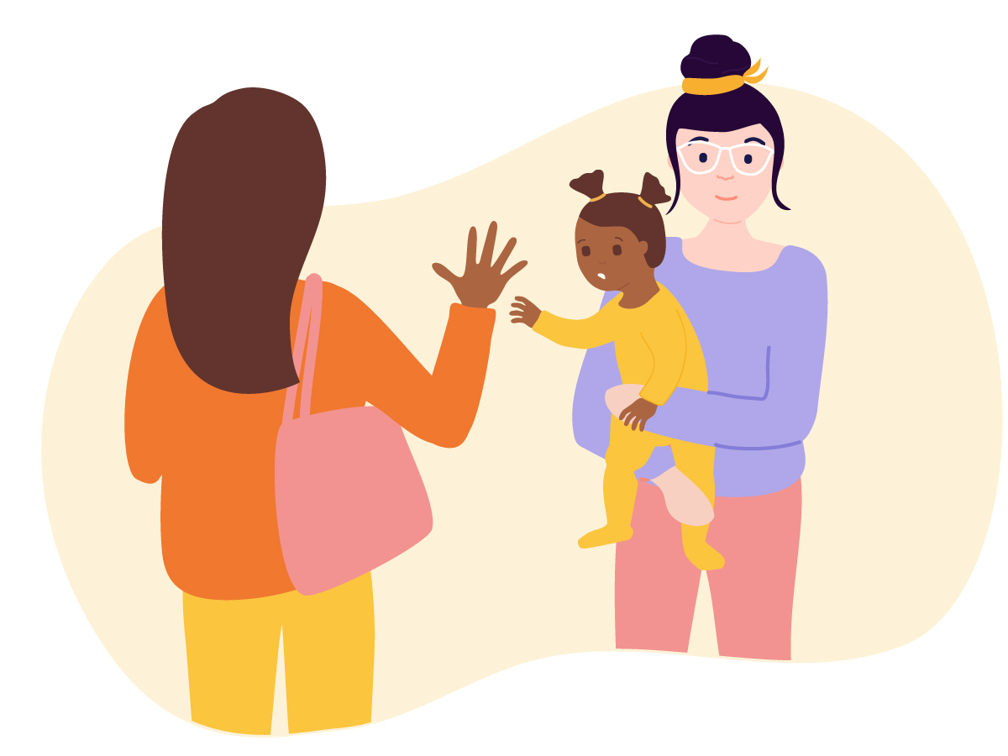
Google images.

Role of the adult
A parent’s main role in transition is vitally important since they are the most important and comfortable individual in their child’s life. A parent knows their child the best and providing support during a transition will not only help the child feel more comfortable but also to ensure the child they are safe. When a child transitions into nursery from childcare they start to form relationships with individuals they don’t know, its important for the primary key worker to understand the child’s needs and make them feel safe in their new surroundings. The role of the parent and of the keyworker is that they should always be kept in communication throughout the child’s transition into their new surroundings, this proves that the transition will run more smoothly, and the child will feel more comfortable and adapt well. According to IRIS, (2019) “Effective, regular communication is at the heart of any personal or professional relationship. This will make all the difference to a parent of a child in an Early Years setting. It will reassure, inform and build long term parental engagement.”

Role of the primary keyworker
When a child transitions into nursery from childcare they start to form relationships with individuals they don’t know, it’s important for the primary key worker to understand the child’s needs and make them feel safe in their new surroundings.
It’s vital to plan handovers between practitioners and the main key workers to ensure that children’s needs are met, and new attachments are strengthened. Without this we develop the risk of children losing confidence in their new setting, the child may appear to be lost and uncomfortable which can lead to a regression in knowledge and understanding and loss becoming social with their peers. (Patel, A., No date)

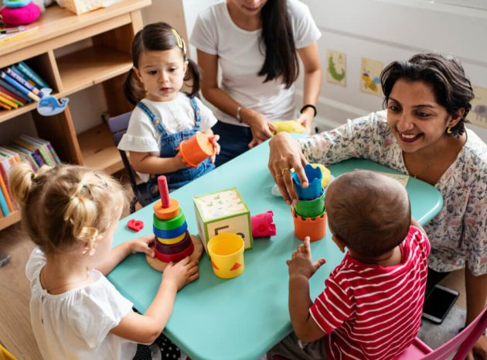
Role of the setting manager
The role of a setting manager is to provide management to the nursery and leadership to the key workers in order to make sure everything is in order and every child is being cared for. They will be providing high standards within the nursery and the environment and experiences offered to the children. Along with this they also will be providing the environment is kept up to date with health and safety standards, making individuals in the setting aware of any emergency procedures. In any setting safeguarding is a vital element in the daily practice, providing that all individuals in their setting are well cared for and protected. It’s important to remember safeguarding doesn’t stop once the child leaves the setting, the. Key practitioners and especially a setting manager is responsible for making sure the child is protected from maltreatment, preventing the impaired of a child’s health and development, taking action to ensure the child has the best outcome, and protecting children who are suffering from harm or being harmed at home. “A safeguarding partner in relation to a local authority is defined under the Children Act 2004 (as amended by the Children and Social Work Act, 2017) as:
Google images
- The local authority
- A clinical commissioning group for an area any part of which falls within the local authority area
- The chief officer of police for an area any part of which falls within the local authority area.
The three safeguarding partners should agree on ways to co-ordinate their safeguarding services; act as a strategic leadership group in supporting and engaging others; and implement local and national learning including from serious child safeguarding incidents”. Ndna (2020)

Role modelling
For most children their role models are their parents or primary care givers. Children look up to their role models to imitate their behaviour, relationships and how to make difficult decisions. According to (bebe care, no date) “modelling appropriate behaviour for your children is as important as it is to talk to them about it. The importance of role models in child development is crucial and helps shape their resolution skills and how they behave socially”. From the moment a child is born they learn every skill, word, facial reaction, emotional reaction from their parent or main caregivers. Children are strong observers of their surroundings so its vitally important to remember how you act as parent has a significant effect on the child.

Needs of a child
The needs of a child are to understand that each induvial comes from a different background and has different needs. It’s important to realise that not every child is the same which is why providing them with understanding and safeness is vital. Understanding their needs, likes and dislikes is a big role to participate in. Each setting the child experiences home, childminders house, nursery or school is described as a microsystem and each of these has a role to play in the child’s development, if a child is from a loving and caring home having constant reassurance from parents/caregivers they become more open, happier than to a child who doesn’t come from a loving home and not having the same love from a parent (Brooker, 2008)
To understand a child’s needs and wants its important to be communicating as often as possible as communication is fundamental to a child’s development and the foundation to a healthy relationship with the child, this is essential for the child as it helps them thrive in play and social interaction. Effective communication builds understanding and trust. It allows the child to become more open to talking to their parents or caregivers, when you and parents or carers understand and trust each other, you’ll all be better able to work together to support children’s wellbeing and development (Raising children, 2021).
Children need consistency in their life from their parent or main care giver, a consistent approach has proved that it helps the child in behaviour and understanding, it sets boundaries and limits but also shows love and care. Studies show that families with very few boundaries or rules are more likely to have children who behave poorly around others, or don’t consider their own safety. (Grose, M 2017).
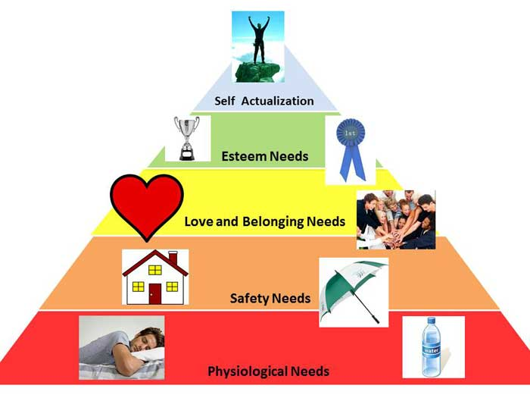

Supporting children in their transition will help us better understand their emotional well-being. “Children, just like adults, experience feelings as they anticipate or react to transitions and show them in their behaviours”. (Supporting transitions, No date). The quality of experiences a child goes through in their early years of life, either being positive or negative shapes how their brain develops. Having negative life experiences at such a young age begin to infect a part of the brain, it interferes with how the child can cope with emotions and frustration. “Studies have shown that individuals who were exposed to adverse experiences in their childhood were more at risk for health and social conditions later in life. Adverse childhood experiences are described as: stressful or traumatic situations, including, abuse, parental abandonment, substance abuse by parents, poverty and exposure to crime” (Savage, No date)
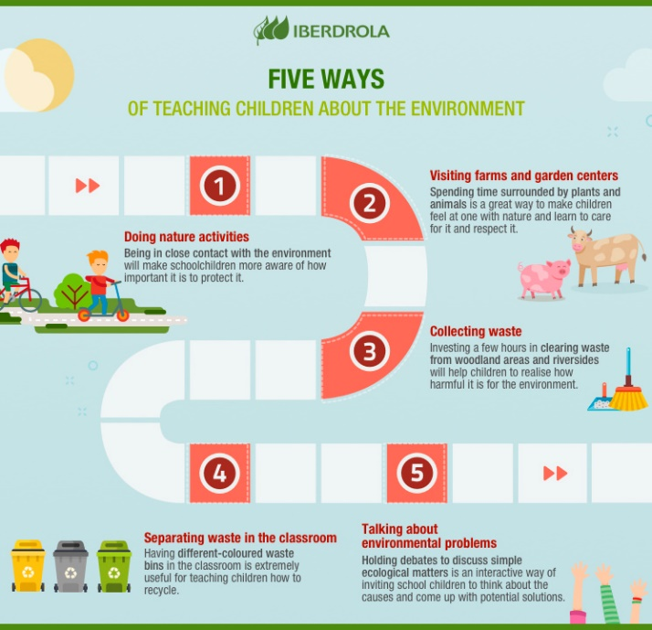
Environment
Environment in children’s transitions play a key role part, encoring a safe and comfortable environment enables children to feel more relaxed and safer. When children feel safe and secure this encourages them to explore more in play and social settings. “The emotional environment is an invisible measure of ‘feelings’ – sometimes it can have a ‘feel-good’ factor where the children, staff and parents feel positive, and at others it can have a ‘not-so-good’ feel about it when children, staff or parent are down or unhappy” (Early years, No date) An environment is more than just a new setting it’s a space that contains the emotions of children, it’s also the staff who work in the environment and the parents who drop the children off there. According to (Devereux and Miller, 2003) “A high- quality and loving environment or setting is a stable one where children have love, security and lots of appreciate stimulation”
What is a rich environment and why do we push towards this? A rich environment is where the quality of a children’s education setting is at the highest satisfactory needs, its comfortable interesting and safe for the child. We must remember children spent a lot of time at their nursery setting so most become a second home for them where they eat and play and often sleep. According to (Devereux and Miller, 2003) “Those who provide education work hard to compensate for the disadvantages of both genetic and environmental deprivation that children encounter at home, ensuring the child is provided with the best opportunities in life”
As for indoor space for environment there needs to be flexible planning to accommodate each child’s needs. As discussed before each child is different so planning actives for the days every child needs to be thought of. Its important for these settings to include sensory activities and ones to help their motor skills. These include Drawing with felt pens, Painting, building blocks, Reading, playing dress up and having smaller more trickier activities such as jigsaws. “The school of thought is known as environmental determinant which supports the view that the environment and what it is contains is the greatest determinant of behaviour” (Bruce, 2006)

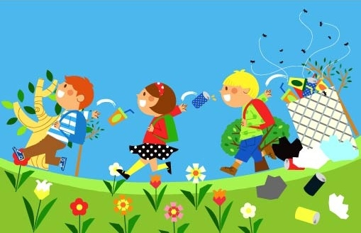
Outdoor environments, children adapt to the outdoors well as they find this a sense of freedom from the classroom. Ideally every childcare setting should have access to an outdoor area, being outdoors gives children a sense of responsibility and to be able to move around with restrictions. “Being outdoors supports confidence and allows opportunities for big scale play, problem-solving and creativity in the company of other children.” (Early years, No date). “The Early Years Foundation Stage (EYFS) Curriculum, which covers children aged birth to the end of the reception year, became statutory in September 2008 and places strong emphasis on the importance and value of daily outdoor experiences for children’s learning and development” (Lotc, No date)

Partnership Working
Partnership working is important as each parent is kept up to date on their child’s learning and how well they are developing in their nursery setting. Nursery’s may make changes to their learning curriculum or their learning practices to which parents should be informed on. Not only is it important for the key practitioners to advise parents on any changes in their setting its important for parents to inform the child’s teachers on any changes or challenges their child is struggling with. “Partnership working can be for single events, or on a more long-term basis such as working together to benefit children and families who attend more than one setting” (Early education, No date)

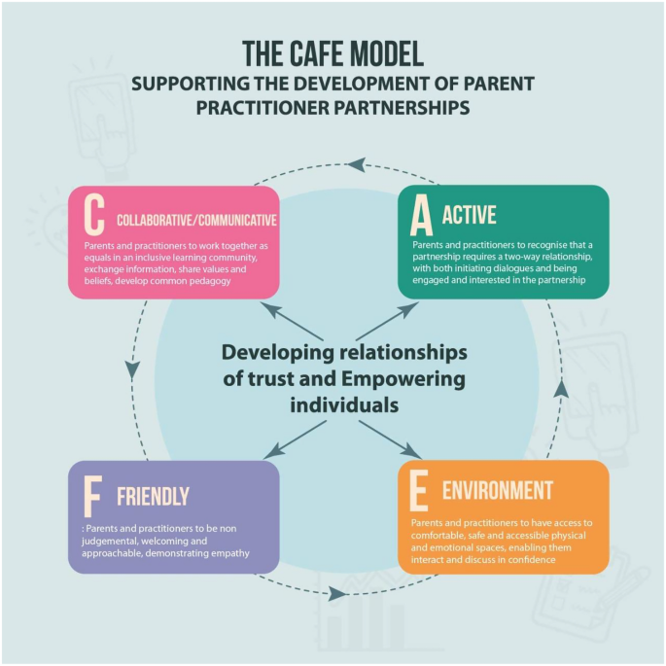
Possible partners
-Parents-
-Social workers
-School or childcare centres
- Other settings

Working in partnership with parents and carers is central to the early years foundation stage (EYFS). The relationship might begin with them visiting your setting. This will help inform you how to sensitively settle the child. (Gov, No date)
Setting up an opportunity to communicate between key practitioner and parent allows a 2-way street of information to be shared. Observations from both the parent and key practitioner can be shared to one another allowing and reconstruing a plan of action if needed. Top tip: Be flexible in your approach to communication with parents. Think about how you might need to adapt to suit different parents, for example those with English as an additional language or a specific learning need. Also, make sure it’s the right time to share information without having to rush off. (Pacey, 2021)
Ways to involve parents
-Home visits
-Home phone calls
-volunteering
- Daily chats
- Community projects
- Documentation of observations
Interventions
Early intervention means providing support to children and young people. While proving support key practitioners will be building relationships with the parents or care givers of the children who are soon to join their nursery setting. Working together with a trained practitioner gives parents the sense of safeness for their child.
Welcome pack
Before children join the nursery, the parents will be offered a welcome pack. This welcome pack will go into detail on what their setting offers. Along with providing all the relatable forms needed to be signed and filled in by parents/care givers, the forms will be in relation to information on the child, if the child has any dietary needs/educational needs/extra support. Each pack includes a book with the school’s logo on their and some colouring books, so the child feels some comfort and belonging.
Settling into the nursery
Each setting will have their own settling in policy when it comes to children going to a nursery setting for the first time. Each child is normally invited to the setting 2-4 weeks before their start date. This allows each child to have a look around and get comfortable with the area, it allows the key practitioners to formally introduce themselves and to provide a one-to-one welcome. This provides the child to feel more comfort on their first day as they would have been shown around before starting and know their key practitioners beforehand.
“Try to start establishing this connection before your child starts at the setting. If a child is starting a setting, it’s useful for you to have a point of contact for any questions, home visits (when appropriate), and to arrange settling in sessions” (Pacey, 2021)

Handovers
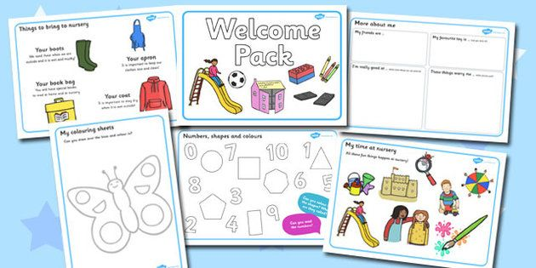
At the end of each day the key practitioners will give a hand over to the parents this includes information about the day, so how well the child has done academically, if there have been any problems, if the child has eaten and drank and just normal day to day observations.
Stay and play

At the end of the academic first year, parents will be invited to stay for a play session with the children, this allows parents to see how well their child has adapted to the new surrounding and how well their development needs have improved. This allows parents to be involved and gives them a sense of comfortability.

Proposed outcomes

Each child that attends a new transition will develop at their own rate and time. Not every transition is the same for every child, some may not feel comfortable and safe for a few weeks while others will settle in almost immediately. The key practitioners will know when a transition has been successful once the child starts to show an understanding of their new surroundings, a relationship build with their key practitioners and peers. A child will show how emotionally secure, happy and confident they have become.
The study, by researchers at the London School of Economics and Oxford University, found children are more stimulated at nursery due to the interaction with new children and adults, which helps their development. Martin (2018)

References

Bebe Care (no date) ‘the importance of role models in child development’ available at: https://www.bebecare.me/social-development/parents-as-role-models/ (Accessed 22nd November 2021)
Brooker,L. (2008) ‘supporting transitions in the early years’ Milton Keynes : Mcgraw-hill education.
Bruce,T.(2003) ‘Early childhood’ Published: London. Sage publications LTD

Clarke, V. (2020) Different Types of Transitions in Child Development https://www.twinkl.co.uk/blog/different-types-of-transitions-in-child-development (Accessed, 18th November 2021)
Devereux,J. And Miller,L. (2003) ‘Working with children in the early years’ London; David Fulton Publishers LTD
Devereux,J. And Miller,L. (2003) ‘working with children in the early years’ London; David Fulton Publishers LTD
Early education (No date) ‘Working in partnership’ Available at: https://www.early-education.org.uk/working-partnership (Accessed 23rd November 2021)
Early years matters ( No date) ‘Emotional Environment’ Available at : https://www.earlyyearsmatters.co.uk/our-services/school-and-nursery-improvement-partner/enabling-environments/emotional-environment/ (Accessed 23rd November 2021)
Gov (No date) ‘Working in partnership with parents and carers’ Available at : https://help-for-early-years-providers.education.gov.uk/get-help-to-improve-your-practice/working-in-partnership-with-parents-and-carers (Accessed 23rd November 2021)
Grose. M. (2017) ‘How consistency improves a child’s behaviour’ Available at : https://www.parentingideas.com.au/blog/how-consistency-improves-kids-behaviour/ (Accessed 22nd November 2021)
IRIS (2019) ‘early years communicating with parents is the key to success’ available at: https://www.iris.co.uk/blog/early-years-communicating-parents-key-success/ (Accessed 22nd November 2021)
Lotc.Org (No date) ‘Benefits of early years of learning outside of the classroom’ Available at : https://www.lotc.org.uk/wp-content/uploads/2010/12/Benefits-for-Early-Years-LOtC-Final-5AUG09.pdf Accessed (23rd November 2021)
Ndna (2020) ’safe guarding and child protection in nursery’s’ Available at: Safeguarding and child protection in nurseries | England Knowledge Hub | NDNA (Accessed 23rd November 2021)
Pacey, (2021) ‘Working in partnership with parents’ Available at: https://www.pacey.org.uk/working-in-childcare/spotlight-on/partnerships-with-parents/ (Accessed 23rd November 2021)
Pacey, (2021) ‘Helping your child settle in’ Available at: https://www.pacey.org.uk/parents/working-with-your-childcarer/helping-your-child-settle-in/ (Accessed 23rd November 2021)
Raising children, (2021) ‘effective communication with parents and carers: for the professionals. Available at: https://raisingchildren.net.au/for-professionals/working-with-parents/communicating-with-parents/communication-with-parents (Accessed 22nd November 2021)
Robinson,M. (2008) ‘child development from birth to eight’ Berkshire: Open university press.

Savage, L. (No date) ‘Negative childhood experiences and health conditions’ Available at: https://thecenterforchilddevelopment.com/negative-childhood-experiences-and-health-conditions/ (Accessed 23rd November 2021)
Supporting transitions (No date) ‘Using child development as a guide’ Available at : https://web.partnership.vcu.edu/projectseedva/downloadables/supporting-transitions-brief-one.pdf (Accessed 23rd November 2021)
Supporting Transitions (No date) Supporting transitions using child development as a guide https://web.partnership.vcu.edu/projectseedva/downloadables/supporting-transitions-brief-one.pdf (Accessed 18th November 2021)
Supporting transitions (No date) ‘Using child development as a guide’ Available at : https://web.partnership.vcu.edu/projectseedva/downloadables/supporting-transitions-brief-one.pdf (Accessed 23rd November 2021)
Teach early years (No date) ‘supporting transitions in the early years’ available at: https://www.teachearlyyears.com/a-unique-child/view/supporting-transitions-in-the-early-years (Accessed 22nd November 2021)
Effective communication with parents and carers: for professionals
SHARE

