

WORK CLASS PHOTO
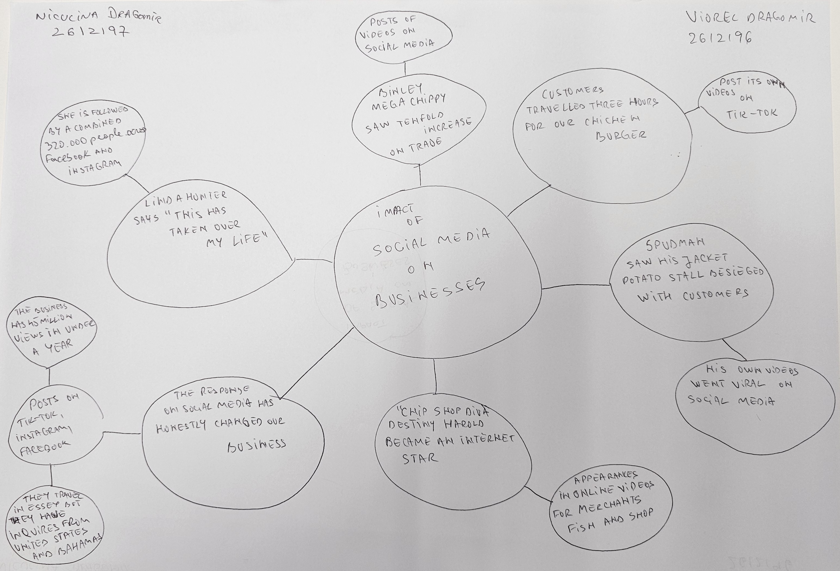

- What is the main idea of the whole text?

The main idea of this text is to show real life scenarios and how social media can grow and promote businesses.

- What is one key point that supports the main idea, and which specific example from the text shows this?
When positive feedback comes from customers themselves it can bring out an even bigger customer base, an example of this would be the HonyWood sandwich shop. This shop started tucked away on an industrial estate in Basildon and is now having their customers drive 3 hours for their famous chicken sandwiches.

- What is a different key point that supports the main idea, and which specific example from the text shows this?
Another key point that would support the main idea would be Linda Hunter also known as Lindy Loo , she runs an online clothing business in Epping , she started her business during the pandemic and after her grandson advised her to create a social media post it resulted in her now having a combined 320,000 people across Facebook and Instagram.

- Which part of the text do you think is most important, and why?
The most important part of the text would be to be up to date with any social media trends as this can result in a business expanding and becoming more popular.

Reflection:
- What did you find difficult in this task (including in-class components), and why was it difficult?
The thing I found difficult during this task would be choosing which business has had the most growth.

- What helped you with this difficulty, and how did it help you?
I chose the one that I found had the most expansion and growth in their customer base and the ones that started out as a small, less known business which then grew into a bigger one.

