
University Of Wales Trinity Saint David

Module Title: Dissertation Proposal

Module Code: LCMB7020

Course: MBA Marketing

Research Proposal: Assessing the impact of Social media marketing on consumer buying behaviour in the UK aviation industry

Supervisor: Amitave Banik
Student Name: Shemeka L Williams
Student Number: 1913883

Contents
1. Introduction 3
1.1 Justification of the Research 3
1.2 Aims 4
1.3 Research Objectives 4
1.4 Research Questions 4
2. Literature Review 4
2.1 Consumer Buying Behaviour 4
2.2 Social Media Marketing 5
2.3 Social Marketing and UK Aviation Industry 6
3. Research Methodology 6
3.1 Research Philosophy 6
3.2 Research Choice 7
3.3 Research Approach 7
3.4 Research strategy and Data collection 7
3.5 Time Horizon 8
3.6 Data Analysis 8
3.7 Relevancy of captured data Ethical consideration 8
3.8 Research limitation 8
4. Time Prospects of Study 9
5. Conclusion 9
6. References 10

Introduction
This research proposal will discuss the research study's aims and objectives. Moreover, it will state the justification for doing research along with attention to focus on specific areas. It will explain the concepts from scholarly articles to state the impact of Social media marketing on consumer buying behaviour in the UK aviation industry. Social media is becoming an effective marketing tool in modern times, and for the aviation industry, it can help achieve high sales targets. This proposal will plan to draw the findings of proposed research questions through primary research data analysis.
  - Justification of the Research
In the modern world, social media has changed the course of life and people are now interacting efficiently with each other and sharing information using different social media platforms (Bigne et al., 2018). The statistics showed that till 2020, there were around 3.6 billion social media users on different platforms, including Facebook, Instagram, YouTube, Twitter and others (Atherton, 2023). The analysis showed that day by day, the number of social media users is increasing, and they are becoming members of the global community, which is linked with each other and able to share their interests and activities (Berthon et al., 2018). Along with it, social media provided multiple benefits to businesses. The firms are getting specific support from social media by connecting with the targeted customers and enhancing sales.
Furthermore, the rapid growth of the online shopping industry is motivating firms to use e-commerce websites for sales. In the era of COVID-19 and after that, the firms realised the significance of online stores to attract customers who cannot visit physical stores for multiple reasons (Afaq et al., 2023). Social media platforms are helping to grow online businesses by attracting more customers and providing new ways to share products (Santos and Silva, 2019). The major marketing and advertisements for online sales are done through social media platforms. The success of the firms is associated with high product purchases, which directly supports earning high profits.
The aviation industry in the UK is serving the needs of customers. It is the third largest aviation network in the world, which supports creating one million jobs through contributing to GDP with £ 22 billion (Heyes et al., 2023). The growth of the aviation industry relates to customers, including passengers, non-passengers and suppliers of services (Koch and Tritscher, 2017). Through social media, the aviation industry is implementing modern marketing strategies, which help provide customers with information about discounts and seasonal offers (Amaugo, 2022).

The analysis of the reports showed that social media is impacting the purchase of businesses (Gitto and Mancuso, 2019). There are multiple factors, including perceived purchase easiness, product usefulness, brand trust and word of mouth, which influence the purchase decisions of customers in online platforms (Karaağaoğlu and Çiçek, 2019). They motivate customers to buy more products by paying a suitable amount and getting the items while staying home. This research study will assess the impact of social media marketing on consumer buying behaviour in the UK aviation industry.
  - Aims
This study aims to assess the impact of social media marketing on consumer buying behaviour in the UK aviation industry.
My attention of doing research is it help the aviation industry to look at the possible ways of using social media for the sake of marketing and promotion to increase sales and earn more profit. The findings will help to make future decisions about focusing on effective usage of social media marketing to attract more customers and influence their buying behaviour.
  - Research Objectives
- To critically analyse the link between social media tools and techniques, and consumer buying behaviour.
- To investigate the tools of social media tools including Facebook Ads Manager, LinkedIn Campaign manager, Instagram and Youtube Ads Manager which can positively and negatively impact the buying behaviour of customers.
- To investigate the impact of social media marketing tools and techniques on the UK aviation industry.
- To recommend social media marketing strategies for the sake of impacting consumer buying behaviours in the UK aviation industry.
  - Research Questions
- How is social media linked with consumer buying behaviour?
- What are the tools of social media including Facebook Ads Manager, LinkedIn Campaign manager, Instagram and Youtube Ads Manager for the UK aviation industry?
- What is the impact of social media marketing on the UK aviation industry?
- What are the recommendations for effective social media marketing strategies to impact consumer buying behaviours in the UK aviation industry?
- Literature Review
  - Consumer Buying Behaviour
According to Seo et al. (202the consumers are the important stakeholders of businesses because they provide opportunities to earn more profit. They impact the supply and demand requirements of products and services for the companies to redefine objectives. Bigne et al. (2018) argued that firms can run businesses while developing a good connection with consumers to enhance the purchase of products. Connecting with the consumers is possible by delivering the brand message through modern digital media (Santos and Silva, 2019). The studies showed that the delivery of right and valid information is important to earn the loyalty of consumers (Atherton, 2023). Moreover, the ethical considerations in the marketing of services and purchase satisfaction can support getting the consumers for life.
However, the issues are expected in case of poor reach of products and services to customers. Zelenka and Hruška (2018) proposed that firms that do not focus on using modern techniques for selling products and services cannot meet the sales targeting. Through the right and required information sharing, the companies can impact buying behaviour. The analysis of data from the study by Gitto and Mancuso (2019) showed that the consumer wants to buy products that help to enhance ease of life while maintaining social identity.
  - Social Media Marketing
Social media supports in development of productive social interactions and the sharing of information. Santos and Silva (2019) stated that online communities create ease in linking with people and businesses. The research of Seo et al. (2020) proved that social media has created multiple benefits for businesses, impacting all departments, including human resources, marketing, sales, manufacturing and packaging. Now, the companies are sunning the promotional campaign on a seasonal basis after analysing the interest of consumers on social media (Gitto and Mancuso, 2019). The information about the consumers is analysed by using data analysis tools, which supports making productive marketing decisions.
On the other hand, Berthon et al. (2018) argued that, unlike the old times, now, consumers can get the right information about the products and services of businesses through social media. Moreover, they can develop an interest in the real trends in the industry. Bigne et al. (2018) noted that social media is impacting the buying behaviour of consumers. People from different countries can search for the required products and services on social media platforms by using the internet. Karaağaoğlu and Çiçek (2019) narrated that the old marketing methods are not supportive of modern businesses to achieve high-profit margins. In the 21st century, consumers are looking towards brands with positive online reviews of old consumers for the sake of making purchase decisions.
  - Social Marketing and the UK Aviation Industry
The UK aviation industry is helping the country achieve multiple benefits, including economic development, employment support, investment and skill acquisition (Amaugo, 2022). Koch and Tritscher (2017) proposed that the UK aviation industry is the leading network in the world and has a major contribution to GDP and job creation for local and foreign nationals. The government is focused on long-term economic planning, which is possible through meeting the productivity gap. To maintain a competitive position in the global industry, the connection with the consumers is important (Atherton, 2023). Social media marketing is helping the aviation industry to share the main objectives and success stories with consumers.
Moreover, Zelenka and Hruška (2018) stated that it links consumers with the aviation industry to decide the promotional plans and discount programs according to the requirements. Karaağaoğlu and Çiçek (2019) noted that as the size of the UK aviation industry is growing, the expenses are increasing, which can be managed by enhancing the service delivery level. Not only for local tourists but also for foreign tourists, the social media platforms are supportive of getting ideas about flight tickets, facilities, cargo charges and promotion deals.
The advantages of using social media for the aviation industry are multiple in the form of increasing consumer engagement, brand building, business promotion, real-time information sharing, cost-cutting advertisement plans, and data analytics for supply chain decision-making (Zelenka and Hruška, 2018). However, they can achieve this after focusing on research and development about modern social media marketing tools, including messenger bots, SEO content and graphical supports. Heyes et al. (2023) stated that true sentiments and preferences of consumers can reach to aviation industry through social media platforms, which will help in strategy planning.
- Research Methodology
The research methodology helps to implement the research objectives. The research onion is proposed by Saunders et al. (2016) that assist in organizing the research and developing the design by meeting the demands of all the stages.
  - Research Philosophy
The research philosophy is helpful in understanding the belief that supports data collection and analysis for the sake of completing the research study (Ahmad and Salim, 2023). There are three research philosophies: interpretivism, positivism and pragmatism (Younus and Zaidan, 2022). This research study will use positivism to implement the belief that knowledge can be extracted by objectively observing social phenomena to reveal the nature of functions (McDermott, 2023). It will support finding the impact of social media on consumer buying behaviours in the UK aviation industry.
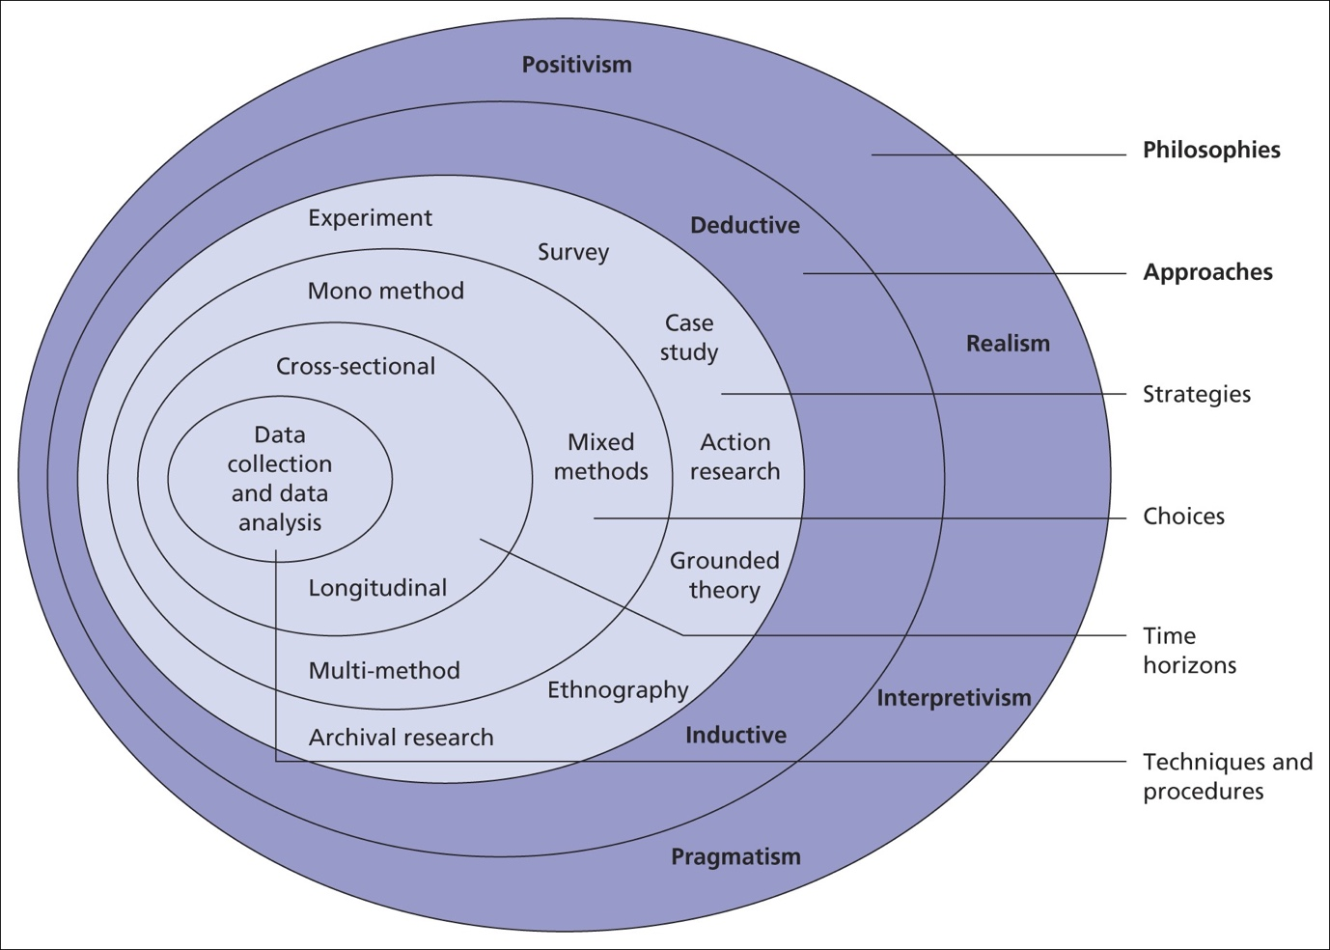
Figure 1: Research Onion (Source: (Saunders et al., 2016))
  - Research Approach
The research approach states the path, which indicates the stages involved in designing the objectives of research to end on the interpretation of findings (Mohammed et al., 2022). Two types of research approaches are mainly used in research studies in the form of inductive research and deductive research, which are linked with the aspects and requirements of research (Younus and Zaidan, 2022). This research study is based on a deductive approach to focus on data analysis for the sake of stating the facts by using already existing theoretical ideas instead of developing of new theory.
  - Research Strategy

The research strategy is the plan to complete the research study by using a specific method of data collection (Ahmad and Salim, 2023). The research strategies are multiple in the form of case studies, interviews, surveys, experiments, and action research. This research study will focus on using the survey strategy in which the close-ended questions will be used to extract the social media marketing impact on buying behaviours from 150 consumers of the UK aviation industry.
This research study will be based on quantitative research because it will utilise numeric data to understand the impact of social media on the buying behaviour of consumers (Bibi et al., 2022). It is effective to get and narrate accurate results from the selected sample population. However, it has some issues because it is time-consuming and complex as it needs the involvement of participants to share their personal experiences about social media and buying behaviours related to the UK aviation industry (McDermott, 2023).
This research study is based on a cross-sectional time horizon in which the data collection and analysis will not be repeated after the given time to compare the findings.
  - Data collection and Data Analysis
The survey method is selected for the collection of data. The sample size of the participants is kept small to reduce the investment of time and other resources. The survey strategy is supportive of getting the required data, most simply by asking suitable questions to the targeted sample population.
The data analysis stage helps to indicate the method which will support in extraction of results to justify the objectives of the study (McDermott, 2023). This research study will use SPSS correlation and regression analysis to analyse the quantitative data of the survey method. The benefits of selecting these data analysis techniques are multiple because they help to investigate data deeply and predict the outcomes for the future after defining the correlation between variables (Dineva, 2023).
  - Relevancy of captured Data Ethical Consideration
The ethical considerations are important to state the moral value of the study (Dineva, 2023). This research study will take the consent of participants before involving them in the research processes. Moreover, the data will be kept in secret place. The information will be recursed by implementing GDRP data protection requirements (Mohammed et al., 2022). Furthermore, the personal identity of the participants will be hidden to eliminate the possible risks to their lives.

  - Research Limitation
The research study has limitations as the small sample size is being used to extract the impact of social media marketing on consumer buying behaviours. Moreover, the time is limited to complete the major sections of research work. Only a few questions are included in the survey, which is insufficient to complete the wide topic of social media marketing usage in the UK aviation industry.
- Time Prospects of Study
Milestones | Weeks
 | 1 | 2 | 3 | 4 | 5 | 6 | 7 | 8 | 9 | 10 | 11 | 12 | 13 | 14 | 15 | 14
Selection of Topic
Background Research
Aims and Objectives of Research
Selection of Scholarly Articles
Selection of Research Methodology and Proposal Design
Completion of Introduction Chapter
Completion of Literature Review Chapter
Completion of Methodology Chapter
Data Collection and Data Analysis
Completion of Results Chapter
Completion of Conclusion and Recommendation
Proofreading and Editing
Final Submission

- Conclusion
The research study will be used to make future decisions for the UK aviation industry. The stakeholders will use the data to take productive measures for high customer engagement and profit earning. In the future, the research study should be extended by using more participants from different countries of the world who are consumers of the UK aviation industry.

- References
Amaugo, A., 2022. Examining the Culture of Women in Aviation Leadership: A Case of UK Airports. In Women, Work and Transport (Vol. 16, pp. 189-206). Emerald Publishing Limited.
Ahmad, A. and Salim, S., 2023. Exploring Viewership Patterns and Engagement Levels of Malayalam Political Satire Shows' Audience: A Quantitative Survey & SPSS Analysis. Global Media Journal, 21(63), pp.1-9.
Atherton, J., 2023. Social media strategy: A practical guide to social media marketing and customer engagement. Kogan Page Publishers.
Afaq, A., Gaur, L., Singh, G. and Dhir, A., 2023. COVID-19: transforming air passengers’ behaviour and reshaping their expectations towards the airline industry. Tourism Recreation Research, 48(5), pp.800-808.
Bibi, H., Khan, S. and Shabir, M., 2022. A Critique Of Research Paradigms And Their Implications For Qualitative, Quantitative And Mixed Research Methods. Webology, 19(2).
Bigne, E., Andreu, L., Hernandez, B. and Ruiz, C., 2018. The impact of social media and offline influences on consumer behaviour. An analysis of the low-cost airline industry. Current Issues in Tourism, 21(9), pp.1014-1032.
Berthon, P.R., Pitt, L.F., Plangger, K. and Shapiro, D., 2012. Marketing meets Web 2.0, social media, and creative consumers: Implications for international marketing strategy. Business Horizons, 55(3), pp.261-271.
Dineva, D., 2023. Mixed methods research Part 2: Designing an online experimental survey from prior qualitative research and using one-way ANOVA in SPSS for data analysis. SAGE Research Methods: Business.
Gitto, S. and Mancuso, P., 2019. Brand perceptions of airports using social networks. Journal of Air Transport Management, 75, pp.153-163.
Karaağaoğlu, N. and Çiçek, M., 2019. An evaluation of digital marketing applications in airline sector. Journal of Human Sciences, 16(2), pp.606-619.
Koch, S. and Tritscher, F., 2017. Social media in the airline industry: acceptance of social seating. Journal of Hospitality and Tourism Technology, 8(2), pp.256-279.
McDermott, R., 2023. On the scientific study of small samples: Challenges confronting quantitative and qualitative methodologies. The Leadership Quarterly, 34(3).
Mohammed, A., de Sousa Jabbour, A.B.L., Koh, L., Hubbard, N., Jabbour, C.J.C. and Al Ahmed, T., 2022. The sourcing decision-making process in the era of digitalisation: A new quantitative methodology. Transportation Research Part E: Logistics and Transportation Review, 168.
Seo, E.J., Park, J.W. and Choi, Y.J., 2020. The effect of social media usage characteristics on e-WOM, trust, and brand equity: Focusing on users of airline social media. Sustainability, 12(4).
Saunders, M., Lewis, P. and Thornhill, A., 2016. Research methods for business students (7th New ed). Research methods for business students.
Younus, A.M. and Zaidan, M.N., 2022. The influence of quantitative research in business & information technology: An appropriate research methodology philosophical reflection. American Journal of Interdisciplinary Research and Development, 4, pp.61-79.
Zelenka, J. and Hruška, J., 2018. Ways and effectiveness of social media utilisation by airlines. Tourism: An International Interdisciplinary Journal, 66(2), pp.227-238.

