Matthew Greg Johnson (2012415)

Stress and Dynamics Assignment
Analysis and Simulation of a Centrifugal Clutch

Table of contents
Introduction Page 2
History Page 3
Parts and Diagram Page 4
Operating conditions Page 4
Typical Applications Page 4
Materials Page 5
Advantages and Disadvantages of centrifugal clutches Page 5
Why Electromagnetic clutches are used in automation Page 6
Conclusion Page 6

Introduction
Centrifugal friction clutches (CFC’s) are small motors used in household items.
CFC’s transmit motion by engaging a plate which is driven in one direction to a stationary driven plate by bring the two plates into contact with each other. The contact between the rotating drive plate and stationary plate causes friction and the transfer of energy (kinetically and heat). Centrifugal friction clutches come in four main types conical, radially expanding, contracting band and friction disk clutches.

This document will focus on radially expanding, in this case the clutch has shoes which are forced outward against an enclosing drum which are connected to the shaft through levers. As the shaft begins to rotate it causes the shoes to gradually move outwards eventually contacting the drum.

This document will cover the development, structure, material, advantages, applications, operating condition and where CFC clutches would be unsuitable, and electromagnetic clutches would be more beneficial.

History

CFCs have been used for different machinery in the last 200 years, they have been used in locomotive trains, motor bikes and cars according to their respective patents. Patents of centrifugal clutches being used in the 1800s would coincide with the industrial revolution and boom of the locomotive industry in Britain. (Institution of Civil Engineers , 1858)
The next patent is for the motor bike in 1898, this coincided with use of motor bike in WW1 and movement of communication in WW2. The design doesn’t include the use of shoes moving outwards but does use weighted circular object which slowly pushes against a drum as centrifugal forces increase. (USA Washington D.C. Patent No. 598 314, 1898)

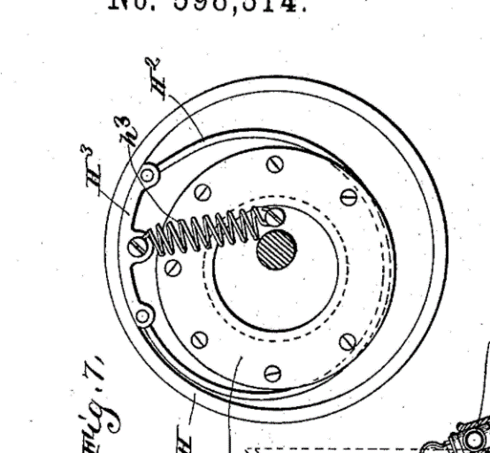

The source is a car magazine called Mecanno magazine, the design was patented in 1934 used first in the Armstrong Siddeley. (magazine, 1934)The article describes how the electric motors need to reach their maximum power and allowing for enough RPM before transmitting to the wheels.

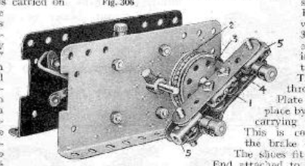

Parts and Diagram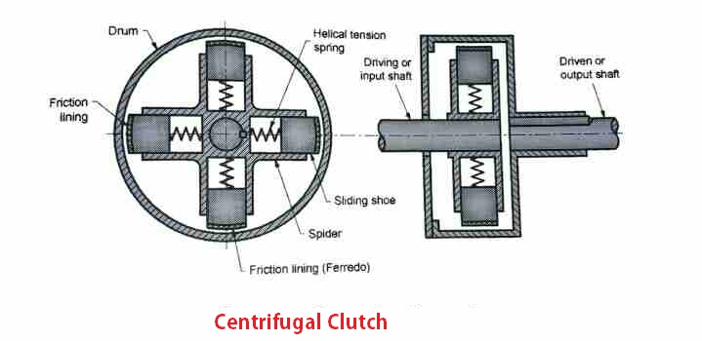
(Autoprotips.com, 2014)

Centrifugal clutches these days as previously mentioned are constructed as seen in the image with a drum, friction lining, spider, shoes, springs and a drive shaft. The size of the motor and weight of the shoes determines its power, whilst the beginning operating speed is determined by the strength of the spring. (Bacon, 1977)

Operating Conditions

As the driving shaft spins the shoes move outwards due to the centrifugal force they gain. The centrifugal force must overcome the force of the spring, the spring allows the correct RPM before the shoes touch the drum. If the correct speeds is not reached the clutch could stall.
The motor must reach a certain RPM before the shoes make contact with the drum, this is an advantage of clutches, it allows for the correct power before applying the load.
As the shoes touch the drum it is the very tips known as friction lining which make contact. Friction linings are important as the determine the torque which is transmitted to the drum. (Engineering choice, 2018)

Typical applications

CFCs are primarily used for small motors such as vehicles, lawn mowers, other automotive uses, fans and motor pumps. There are some situations where CFC’s are unsuitable for use. There are characteristics which need to be considered, such as in low-speed engines, the low speed causes slippage. Slippage causes more friction and heats the drum ultimately leading to a loss of power. The maximum speed attainable for the motor is dependent on the clutch size. Smaller clutches provide a high speed, this is due to the centrifugal force required to lock it into place.
However, this lowers the amount of torque which the motor can apply. CFCs are used for motors which require a wide speed range, the clutch only activates once a certain speed is reached. It will only reach its rated capacity as the clutch will slip protecting the driven equipment and the motor. (Learnmechanical, 2017)

Materials

The friction lining allows for different material usage dependent on the application of the CFC, however, friction lining must be heat resistant and structurally strong to undergo the intense conditions in the clutch. Friction lining used to be made of Asbestos before it was banned in most countries due to the health and safety concerns. The more recent materials are Kevlar, organic and ceramic (and more) which are used in clutches. Kevlar is used in automotive industry due to its longevity and smooth appliance; this makes it ideal in cars. Whereas ceramics are ideal for racing, this is due to them withstand high temperatures and strength but can not be used for a prolonged period, ceramic friction linings are made from copper, iron, tin bronze, silicon dioxide, and/or graphite. Organic clutches are made with phenolic resins mixed with metallic powder or metal oxides which act as friction modifiers. Organic material is used for applications which are designed for short time use such as towing, hauling, and street performance applications. They're temperature-resistant, strong, and durable but still smooth. (Phoenix friction, 2020)

Advantages and Disadvantages of centrifugal clutches
There are several advantages and disadvantages of CFC’s:

- Automatic – the CFC’s by using the previously discussed process engage and disengage from the drum, they need no external control mechanism.
- Lower costs – Centrifugal clutches are cheap compared to other clutches, this is due to fewer parts being involved in the operation of the clutch.
- Low maintenance – due to their simple design, lack of external control system, so there is no electrical or hydrolics knowledge to be known to repair.
- Lower chance of engine damage – due to the gradual engagement of the shoes to the drum, comparatively to the hydraulic and electrical engagements, CFC’s provide a smooth and shockless acceleration
- Engagement speed control – the engagement of the centrifugal clutch occurs progressively as the friction increases so does torque.this ensures a much longer lifespan and more energy saving on startup

However some of the negatives of clutches include:

- Loss of power due to friction and slipping.
- This type of clutch not appropriate for the high amount of torque, the shoes will slip at the heavy loaded condition.
- They engage at full or near-full power, shoes get heated very quickly may cause overheating.

(Learnmechanical, 2017)

The pros of centrifugal clutches heavily outweighs the cons, there are applications which CFC’s are well perfect for which was mentioned earlier.

Why Electromagnetic clutches are used in automation

Electromagnetic clutches are used in conveyor drives copy machines and they are also in packing machinery food processing, printing factory automation. Electromagnetic clutches use as the name implies a magnet which engages and disengages the clutch, this is useful for the previously listed operations as it allows for automatic machines to engage the clutch when an input is provided. This could be a material sensor or proximity sensor, which indicates when to engage or disengage. The advantages are that electromagnetic clutches engage automatically, and they have an easy operation. The disadvantages are there is a risk of over heating due to the heat generated by electromagnetic actuators. (Shafi, 2021)

Conclusion

To conclude centrifugal friction clutches are useful for manual operations and medium machines such as cars, mowers, fans etc, they are simple, and easily maintainable. They have a wide range of uses and are very practicable due to their simple design. They are however not viable every time and other clutches are more suited to different situation.

References

References
Autoprotips.com. (2014, January 30). Centrifugal Clutches. Retrieved from Autopro tips: https://i1.wp.com/www.autoprotips.com/wp-content/uploads/2019/03/Centrifugal-Clutch-line-diagram.jpg?ssl=1
Bacon, D. H. (1977). Mechanical technology. In D. H. Bacon, Mechanical Technologies (pp. 195 - 201). Oxford: Martins the Printer . Retrieved from https://www.mechstudies.com/centrifugal-clutches-parts-types-working/#Drum
Crowdus, W. A. (1898). USA Washington D.C. Patent No. 598 314.
Engineering choice. (2018, July 15). Centrifugal Clutch: Definition, Parts And Working. Retrieved from Engineering choice: https://www.engineeringchoice.com/centrifugal-clutch/#:~:text=%20Parts%20of%20Centrifugal%20Clutch%20%201%20Shoes.,lining.%20It%20helps%20hold%20the%20inside...%20More%20
Institution of Civil Engineers . (1858). Minutes of Proceedings . London: Institution of Civil Engineers.
Learnmechanical. (2017, September 30). Centrifugal Clutch: Definition, Parts, Working Principle, Advantages, Disadvantages, and Applications . Retrieved from Learn mechanical: https://learnmechanical.com/centrifugal-clutch/#Different_Parts_of_Centrifugal_Clutch
magazine, T. M. (1934, may 02). Retrieved from Meccano magazine: http://www.nzmeccano.com/MMCache/3403.p49.r90.jpg
Phoenix friction. (2020, Febuary 07). Clutch Friction Materials Explained - Organic, Kevlar, Ceramic. Retrieved from Phoenix Friction: https://www.phoenixfriction.com/t-clutch-materials-explained.aspx
Shafi, M. (2021, 01 16). Electromagnetic Clutch: Components, Working Principle, Advantages, Disadvantages, Applications. Retrieved from Mechanical E notes: https://mechanicalenotes.com/electromagnetic-clutch/
Questions

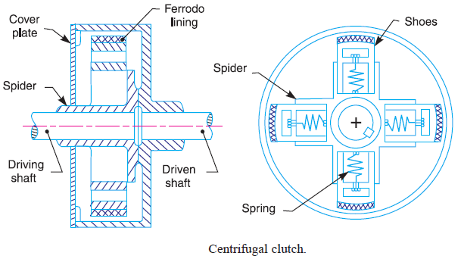

Consider the centrifugal clutch above that comprises of four ‘shoes’ symmetrically attached to the ‘spider’. Each shoe with its friction lining has a mass of 275 grams and is attached by means of a linear mechanical spring with a stiffness value of 7.5 kN/m. The coefficient of friction of the material attached to the shoes is 0.35. The centre of mass of each of the shoes is at a radius of 95 mm from the shaft centres in the rest position shown above and has a clearance distance of 9 mm to the outer drum. The outer drum has a wall thickness of 4 mm.

- What is the diameter of the outer drum?

95mm from the centre of the clutch to the centre of mass for the shoe.
We assume that the centre of gravity of the shoe is the friction lining material.

The distance from the friction lining to the drum is 9mm

The thickness of the drum is 4mm

95mm + 9mm + 4mm = 108mm

This is the radius of the drum; the radius must be doubled to give the diameter.

104 x 2 = 216mm

The diameter of the drum is 216mm
- Determine the engagement speed of the centrifugal clutch. You should provide your answer in RPM (revolutions per minute) and rounded to the nearest whole value of RPM.
Spring stiffness = 7500 N/m (K)
Distance = 0.009m (X)
Force = K * X
Force per shoe= 67.5
67.5 * 4 = 270 N (for all shoes)
Using N = M * W² * r
W = $√\frac{N}{M*r}$
W= $√\frac{270}{1.1*0.104}$

W = 48.58 Rad/s

Or 464 RPM

- Calculate the radial force acting on the clutch face when the driving shaft is rotating at a speed of 550 RPM.
550 RPM or 57.6 rad/s
Mass of shoes = 1.1kg
Radius = 0.104 mm

F_{c} = M * A
F_{c} = M * V² / r
F_{c} = M * (w² * r²) /r
F_{c} = M * W² * R
F_{c} = 1.1 * 57.6² *0.104
F_{c} = 0.3796 kN/m

- At the driving shaft speed of 550 RPM, what will be the value of torque transmitted to the driven shaft?

Centrifugal force = 379.55 N/m

The centrifugal force must overcome the spring force

The spring force = (7500 * 0.009) * 4 = 270 N/m (multiplied by 4 for each shoe)

379.55 – 270 = 109.55 N/m

Using the friction coefficient to calculate the torque transmitted

109.55 * 0.35 = 38.34 N/m

- Using either MatLab or MS Excel, calculate and plot on a suitable graph the transmitted torque at the driven shaft against driving shaft speed, from 450 RPM to 700 RPM in increments of 25 RPM.

- Undertake the same analysis as in point 5 above but adopt a coefficient of friction of 0.3 and 0.4. Discuss the effect of changing the coefficient of friction of the shoe material on the torque transmitted when comparing the three values of coefficient of friction.

Explain what is happening in the graph, talk round the information which has been worked out.
The graphs shows that the high friction coefficient allows for better torque transmission from the shaft to the drum. Whereas the lower friction does not transmit the friction as well. The graph would not start at minus torque transmitted it would begin at 0 from where the shoes touch the drum at 464RPM. The graphs show a curve which levels off, this is likely as there is high pressure against the drum. More friction there is the less likely the shoe and drum will slip past each other creating slip.

- For the maximum possible transmitted torque determined from either point 5 or 6 above, and given that the mass of the drum is 750 grams and can be considered as a solid disc, what is the angular acceleration of the drum to achieve the maximum possible torque?

Torque = 0.137889131 kN/m
Radius = 0.104m
Mass = 0.75 kg
K= $\frac{R}{\sqrt{2}}$
$\frac{0.104}{\sqrt{2}}$ = 0.073528
Moment of inertia I = mk²
I = 0.75 * 0.073528²
I = 0.004054775
T = Iα
T / I = α
0.137 / 0.004054775 = α
α = 34.00660402

- At the maximum rotational speed of 700 RPM, for a single clutch shoe of effective dimensions 50 mm by 20 mm, what will be the direct stress experienced by the drum? Why at this speed would the stress situation not be considered as a complex stress model?

50mm or 0.05m
20mm or 0.02m
0.05*0.02 = 0.001mm^2
Torque = 0.1379 N/m
0.1379 * 0.001 = 137.9 N/m^2 for one shoe
137.9 * 4 = 551.6 N/m^2

