Marlon Bushell
1814775

BMSW 5101
Developing workplace critical thinking
Ernest Ovia
How individuals’ beliefs, attitudes, and values impact on workplace behaviour.

Table of Contents

1.0 Introduction 2

2.0 The impact of beliefs on workplace behaviour 2

3.0 Maslows Hierarchy of Needs Theory 3
3.1 Biological and Physiological needs 4
3.2 Safety Needs 5
3.3 Belongingness and Love Needs 5
3.4 Esteem Needs 7
3.5 Self-Actualisation 7

4.0 Analysis 7

5.0 Self-Reflection 9
6.0 References 10

Introduction
Our beliefs, attitudes, values, and behaviours affect us all in every aspect of our daily life. This can range from our religious beliefs to our own personal beliefs or opinions. All of the above are interlinked because our beliefs can sometimes define our values and ultimately this will affect our attitude and behaviour. The purpose of this report is to critically evaluate the impact that beliefs and values have on workplace behaviour and to assess the modern-day effectiveness of management theories.

The impact of beliefs and values on workplace behaviour
The first part of this report is to determine how an individuals’ beliefs and values may have an impact on workplace behaviour. In order to do this, I am going to look at some of the different beliefs and values that individuals may have and how they can affect their attitude and their ability to work to the best of their abilities.
There are many reasons as to how beliefs, attitudes, and values impact workplace behaviours. Some examples may include an employee who is working in the meat processing industry where a new product is introduced that is against their beliefs. This could cause the employee to feel upset which may result in them being unwilling to work or have any part in the process. In more serious cases they may even consider resigning from their role.
If they decided to stay, then this would undoubtedly have an impact on their productivity as well as their mental wellbeing. This could contribute towards stress due to the fear of having no other option but to work in an environment that they are not comfortable in. It may also be that they have financial commitments and the fear of not being able to fulfil their obligations outweighs their beliefs.
This may then ultimately have an impact on a person’s attitude. It can start to affect things such as attention to detail resulting in substandard workmanship, it may also affect their punctuality because they may have a lack of interest in the job and in cases where the financial implications were less relevant, the individual may not care whether or not they were terminated. Another area that may be affected by this is their attendance which could also be part of the behaviour and the attitude of no longer caring.
This change may also have implications on the employee’s mental health and can affect things such as their self-worth and self-esteem. This can result in having an unhappy worker which can affect productivity.
An individual’s values may also affect their workplace behaviour. Values can strongly influence employees conduct within the workplace and shared values are often the basis for workplace relationships. As a result of this if values are not shared it may result in conflict within the workplace.
Within an organisation it is important for them to outline their values because it highlights what they expect from their employees. By doing so it can also attract employees who share similar beliefs and values. The impact of this would be that they are more likely to retain committed staff as they are both working towards the same values and values drive behaviour. Another advantage to outlining values is that if they are clear, as previously mentioned, employees will know what is expected of them and they may act quickly in order to resolve problems if they arise.
Within an organisation there is likely to many people who have different beliefs and values and whilst this level of diversity may bring its challenges, it is important to remember that they have no right to expect others to change their beliefs and values just because they don’t comply with what the organisation believes . Everybody is entitled to their own beliefs, values, and opinions.
Maslows Hierarchy of Needs Theory
The next part of this report relates to management theories and their modern-day effectiveness within the workplace. The management theory that I am going to focus on is Maslows Hierarchy of Needs Theory which is a five-tier based theory that focuses on human needs.
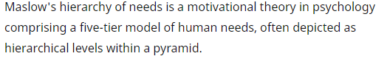
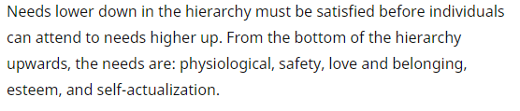
https://www.simplypsychology.org/maslow.html

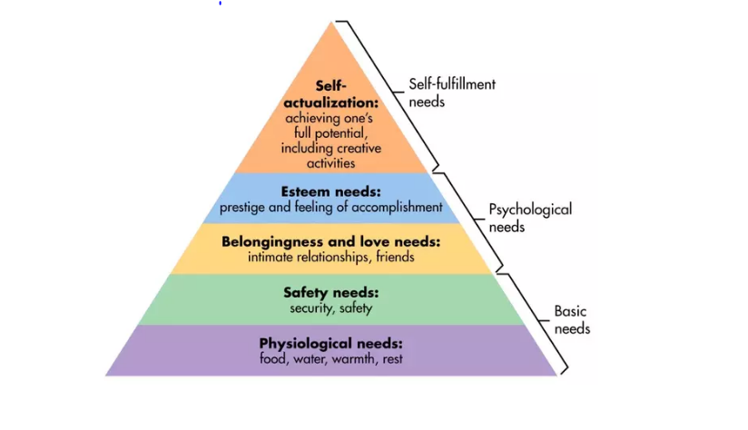
According to Maslows theory, if the need of individual is satisfied then this would increase productivity and staff morale.
Maslow was able to identify the needs of each individual by analysing the issues around their work and personal life. Once he had identified them, he then devised the five steps of motivation as detailed below.
Biological & Physiological Needs – Maslow was able to determine that these needs consisted of some of the most basic needs such as food and water. He believed that by ensuring employees had access to these basic needs it would enhance their performance. By allowing sufficient times for breaks during working hours or providing food and water he believed that it also contributed to their productivity because if an employee was unable to take a break, which resulted in them not eating enough, they would potentially find it extremely difficult to focus on the task in hand as they will only be thinking about food.
Food studies suggest that in order to concentrate an individual needs sustenance. If this need is not met it can also have an effect on their emotional status, which in modern day terminology this is referred to as ‘hangry’. I would describe this terminology as, anger fuelled by hunger; hunger causing a negative change in emotional state.

feeling irritable or irrationally angry as a result of being hungry.
https://www.dictionary.com/browse/hangry

Another basic needs that Maslow believed was important was to ensure that employees were having sufficient sleep. This meant that employers would need to take this into consideration when setting shift patterns etc. An employee may be worrying about things such as whether or not they will be forced to work longer hours in order to meet the company’s expectations. It is important for the organisation to take this into consideration because a tired employee is more likely to make mistakes as they will not be fully rested and engaged in the task they have been set.
Safety Needs – Maslow believed that employees have the right to work in a safe environment, if these needs are not met then an employee may become distressed at work and become worried about attending because they do not feel safe in their working environment. Again, this can cause them to make mistakes as they will potentially be more worried about their well-being than the task they have been set.
Another important thing to remember when considering the working conditions is whether or not they comply with the current health and safety regulations. It is also important for organisations to ensure that they have the appropriate liability insurance in place as well. This not only protects the organisation but it will also give the employees some reassurance to know that the organisation that they are working for takes the safety of their employees seriously and that they are in a safe working environment which has regular health and safety inspections.
Safety needs can also relate to feeling secure, again this can be applied in both a working environment and in your personal life. If we look at this in relation to your personal life, then if an individual is in a secure and stable relationship and has financial security then this is highly likely to affect their emotional state. This could be because they will not be worrying about these particular issues so they will most likely feel stress-free and happier within themselves and if this is the case, then in terms of their working environment they are likely to be more focused and productive because potentially they will have fewer distractions. With regards to feeling secure within a working environment, if an employee feels as though they have job security then this increases their level of commitment as they may feel as though they are performing to a high standard and this can also make them feel valued.
Belongingness & Love Needs – The sense of belonging has a positive impact on an individual. This can be both personally and socially. As a result of this, Maslow determined that if an employee feels accepted then they are more likely to be happy in their environment which ultimately means they are more likely to perform better and produce higher results. Equally, if an employee feels excluded, then this would undoubtedly affect their performance because they may not feel confident enough to approach colleagues if they are unsure of something. An example of an employee feeling a sense of belonging to an organisation is by becoming a member of a trade union which is dedicated to the interests of its members. This will allow them to interact with employees from all departments within the organisation and will also help in making them feel as though they are a valued employee.
https://www.unison.org.uk/about/what-we-do/about-trade-unions/
In addition to this organisations can encourage employees to engage with each other and build relationships. This can be done in the form of organising team building activities which will allow employees to get to know each other and help to form bonds and relationships outside of their working hours.
This need can also relate to family commitments. As most employees have families or dependents, it is beneficial for all if organisations put measures in place to account for when things don’t go to plan such as babysitters letting you down, the closure of nurseries and schools or any other unforeseen circumstances. An arrangement that could be considered is the option of flexitime to account for childcare. This would effectively allow the employee to make up for any hours lost without the concern that their job was on the line. This would not only be beneficial to the employee but also to the organisation because it would increase the variety of staff that they could employ within their organisation.
Another thing that could affect family commitments is an employee’s rate of pay. This could have an impact because if an employee does not earn enough money to take care of their family without working overtime then it would result in them spending less quality time with their family and this may cause problems at home. By ensuring an employee earns enough to take care of their financial commitments and have a little extra to survive is not only allowing them to spend more time with their family but is also another step towards satisfying this need.
Maslow believed that this need was important because it helped to motivate behaviour.
After physiological and safety needs have been fulfilled, the third level of human needs is social and involves feelings of belongingness. The need for interpersonal relationships motivates behavior
https://www.simplypsychology.org/maslow.html

Esteem Needs – Maslow determined that as humans we have a need and desire to feel good about ourselves. In addition to this we also need to feel valued by others. If we feel valued this implies that we feel a level of importance so are therefore more likely to produce positive results. According to simply psychology (2020) Maslow indicated that the need for respect or reputation is more important for young children and teenagers and precedes real self-esteem and dignity. This would indicate that they believe that how other people see them and the level of respect that they are given is more important than how they see and feel about themselves.
Self-Actualisation – This need relates to the feeling of self-contentment and the belief that we are achieving exactly what we are meant to. Maslow described this particular needs as an individual using the full extent of their capabilities.
"It may be loosely described as the full use and exploitation of talents, capabilities, potentialities, etc. Such people seem to be fulfilling themselves and to be doing the best that they are capable of doing. They are people who have developed or are developing to the full stature of which they capable."
https://www.verywellmind.com/what-is-maslows-hierarchy-of-needs-4136760

Self-actualisation is also the highest tier in Maslows theory and as result of this According to Thought Co, (2020) Maslow defined it as a very rare achievement.

Analysis
After analysing Maslow’s Hierarchy of Needs Theory, I was able to identify the potential benefits to adopting Maslows theory within the workplace and what impact this would have on the workforce. In addition to this I will also able to identify the potential implications and negative effects that it would have on workplace behaviour.
It is clear to see that Maslow believed that by taking care of these basic needs such as pay and safe working conditions, the individual is also more likely to be committed to the organisation. It also relieves the stress from the individual worrying about whether or not they are earning enough money to take care of their family and be able to pay their bills.
I believe Maslows theory to be successful because he was able to identify that by taking care of the most basic of needs of an individual that this would affect their productivity. He was then able to come up with an action plan in order to meet this need. I have provided examples throughout this report of how this can impact workplace behaviour.
In an ideal world by applying Maslows theory within an organisation there should be no reason for conflict and all employees would be happy, motivated, and committed. This would be because all the beliefs and values of the employees would be met. However, in todays society as I have already explained everybody has and is entitled to their own beliefs and values and as a result of this working within an organisation you are more likely to come across someone who disagrees with your own.
There are six causes of organizational conflict; these are task interdependence, differences between values and beliefs, the absence of/or ambiguous rules, resource scarcity, ineffective communication, and incompatible goals.
https://link.springer.com/referenceworkentry/10.1007%2F978-3-319-31816-5_3077-1#:~:text=There%20are%20six%20causes%20of,ineffective%20communication%2C%20and%20incompatible%20goals.
In this case the benefit of adopting Maslows Hierarchy of Needs Theory would be that the organisation was making an effort to meeting the most basic needs which is important and vital to all individuals but also if they listen to and understand what their employees want and or need then there may be similarities in what they believe and by implementing this theory they are more likely to be able to meet most of, if not all of their needs.
An additional benefit to adopting Maslows theory in the workplace today is that it will attract and encourage committed staff to organisations because they will feel valued and as though their needs are being met. It can also give them a feeling of self-worth and as a result of this they are more likely to feel part of a team and valid within the organisation which meets the esteem need in Maslows theory.
In today’s society the belief that teenagers have, that how other people see them is more important than how they see or feel about themselves is quite concerning because not only does this have an impact on their self-esteem and self-confidence, they also have different attitudes and beliefs which potentially cannot be met by using Maslows theory. This is because in modern-day society they now demand respect but are less likely to show respect. Whilst Maslows theory created a psychology of the five steps of motivation which is commonly used today I do not believe that this will successfully meet the needs of the younger generation of today as they become adults. This is because if organisations continue to adopt Maslows theory then it may have an impact on their recruitment figures in years to come because due to the different beliefs and values that young children and teenagers have today, when they are at working age they may not be able to abide by rules and structure. This could result in either a high turnover of unproductive staff for an organisation or simply by them not applying for jobs at all which will ultimately affect the economy.
To summarise whilst Maslows Hierarchy of Needs Theory has been successful in the past and continues to be so in today’s society I do believe that due to the changes in attitudes and beliefs of the younger generation that organisations may need to revise it slightly in order to be able to successfully meet their needs in the future.

Self-reflection
The final part of this report is going to be a brief description on how my own personal critical thinking has developed based on my learning of this module. Firstly, I now believe that I have a greater understanding of what is meant by critical thinking. Prior to this module I do believe that I did analyse things in everyday life but I feel that I am now able to do this in a more effective way by focusing on the point and what evidence there is to support it as opposed to thinking purely based around the ‘what ifs’ and then basing my answer or conclusion more around my opinions and feelings, which is how I analysed things prior to learning this module. I also feel as though I have a good overall understanding of everything that we have learnt within this module and I have enjoyed learning about Maslows Hierarchy of Needs Theory. By evaluating this in detail it was able to give me an insight into what my own beliefs and values are and how I apply them in both everyday life and within my working environment. It also made me consider whether or not these beliefs and values have ever affected my own attitude towards work and if so, how I was able to overcome this. It also made me think in greater detail about what tier in Maslow’s theory that I would consider myself to be at and whether or not all of my basic needs are currently being met. I will continue to apply what I have learnt in this module in my everyday life.

References

https://www.dictionary.com/browse/hangry
(Accessed 15th July 2020)

https://www.simplypsychology.org/maslow.html
(Accessed 22nd July 2020)

https://link.springer.com/referenceworkentry/10.1007%2F978-3-319-31816-5_3077-1#:~:text=There%20are%20six%20causes%20of,ineffective%20communication%2C%20and%20incompatible%20goals.
(Accessed 23rd July 2020)

https://www.thoughtco.com/maslows-hierarchy-of-needs-4582571
(Accessed 15th July 2020)

https://www.unison.org.uk/about/what-we-do/about-trade-unions/
(Accessed 22nd July 2020)

https://www.verywellmind.com/what-is-maslows-hierarchy-of-needs-4136760
(Accessed 21st July 2020)

