Task3: Network connectivity (10 marks)

Using ping command, verify end-to-end connectivity:
From PC-1, ping PC-2 & LP-A. Is it successful? yes

From PC-1 ping default gateway. Is it successful? yes
Bellow screenshot for both above tasks
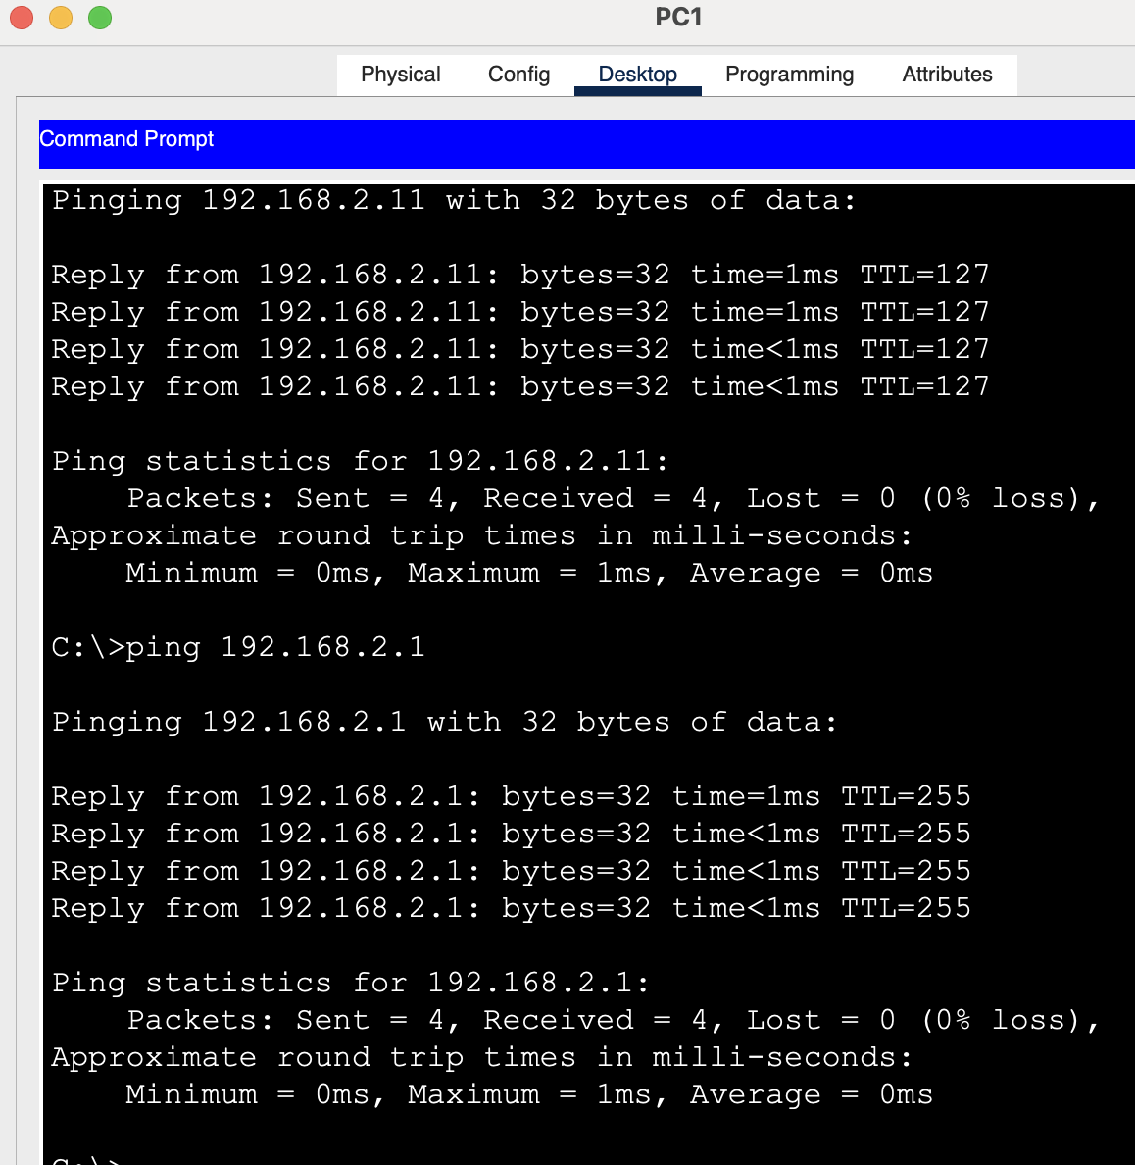
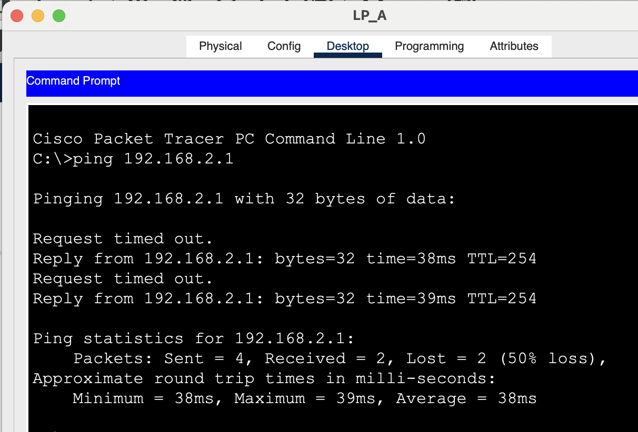
From PC-2, ping 172.16.0.1. Is it successful? yes
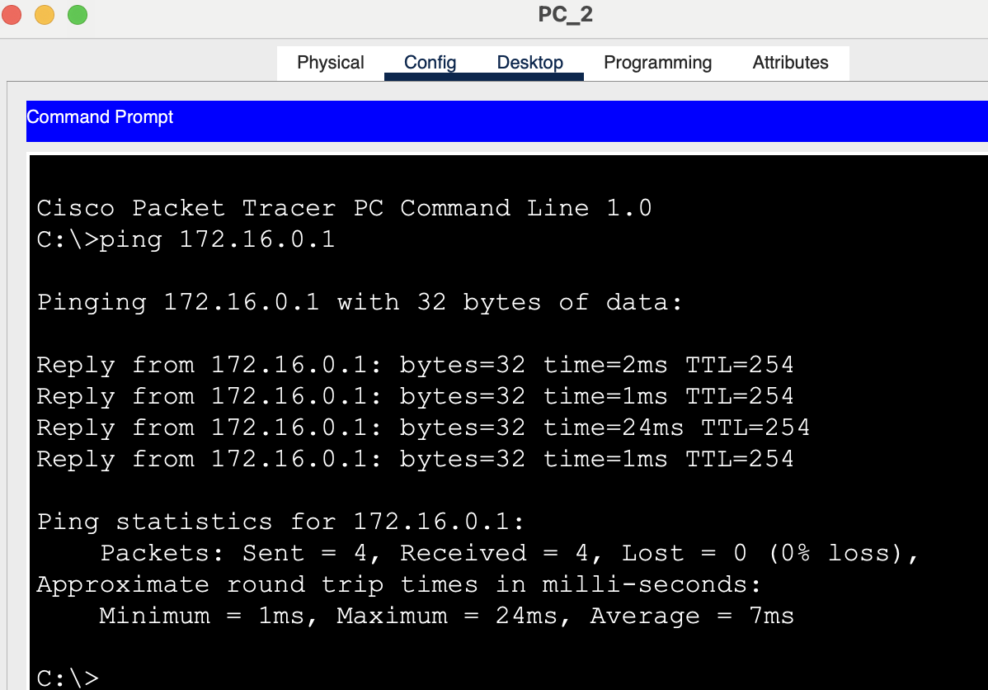
From PC-1, ping 172.16.0.254. Is it successful? yes
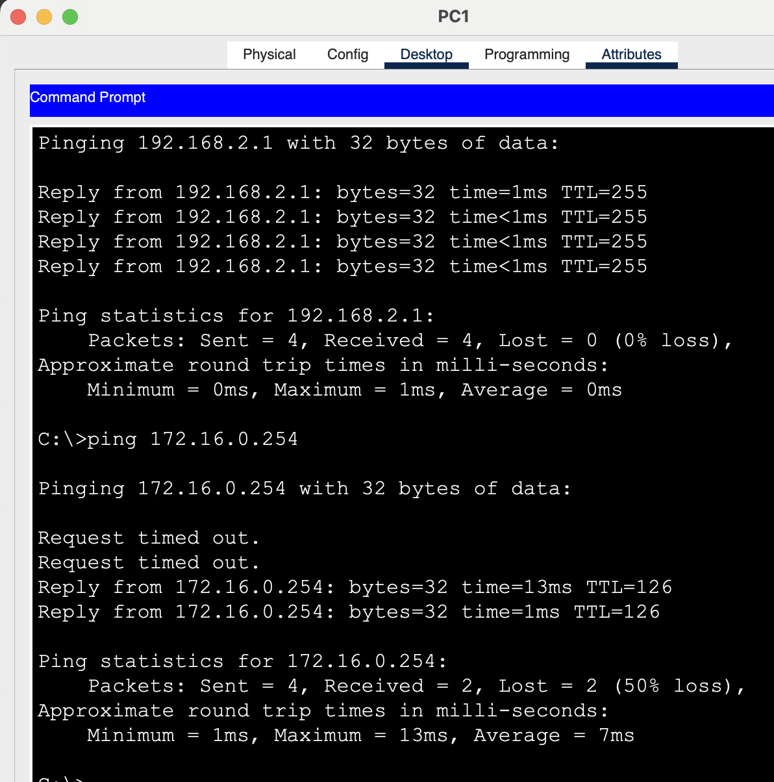

Verify HSRP is working as expected
Issue the shutdown command on R1 G0/1, and then re-issue the following commands to verify that HSRP is working as expected:
From PC-2, ping 172.16.0.1. Ping should not be successful yes
From PC-2, ping default gateway. Is it successful? yes
From PC-2, ping 209.165.200.225. Is it successful? yes

