Postgraduate/Distance Learning
Assignment coversheet & feedback form

THIS SHEET MUST BE THE FIRST PAGE OF THE ASSIGNMENT YOU ARE SUBMITTING (DO NOT SEND AS A SEPARATE FILE)

For completion by the student:
Student Name: Ruth-heather Collins

Student University Email: 2237968@student.uwtsd.ac.uk
Module code: HPCA7015  Module title: Foundations in Cultural Astronomy and Astrology | Student ID number:  2237968 |  |  | Educational support needs:  No
Assignment title: Essay Based on a Sky Journal

Assignment due date: 30th November 2023
This assignment is for the 1st 2nd 3rd 4th 5th 6th module of the degree
I confirm that this is my original work and that I have adhered to the University policy on plagiarism.
Signed ………………Ruth-heather Collins……………………………………………
Email submission: if you are submitting this form via email, please tick this box □
(as a substitute for your signature) to confirm that you agree to the above declaration.
Assignment Mark
1st Marker’s Provisional mark
2nd Marker’s/Moderator’s provisional mark
External Examiner’s mark (if relevant)
Final Mark

NB. All marks are provisional until confirmed by the Final Examination Board.

For completion by Marker 1:
Comments:

Marker’s signature: |  |  | Date:
For completion by Marker 2/Moderator:

Comments:

Marker’s Signature: |  | Date:
External Examiner’s comments (if relevant)

External Examiner’s Signature: |  | Date:

Essay Based on a Sky Journal
Word Count 1,923

As I am quite a pragmatic person, when I read the essay brief before commencing my sky journal, I expected that after a few weeks of recording I would end up with a very practical and analytic data collection for the month of November 2023. To my surprise then when I contemplated this quote, ‘Be clearly aware of the stars and infinity on high. Then life seems almost enchanted after all.’ by the artist, Vincent Van Gogh (1853-1890CE) in relation to my sky journal, I was pleasantly surprised to find tangential links and ascribed meanings not just within the data but also that permeated through and became quite an emotional and evocative piece of diary writing. Because of the subsequent poignancy of the imagery and emotional responses of the journal entries, consequentially, this essay shall endeavour to briefly outline not just the individual days’ recordings but also the ephemeral connections that are related to the observations of the passing days or nights between the 31st of October until 27th of November 2023.

When deciding to record which period for my sky journal, I specifically chose to commence on Halloween night, or Samhain, the Celtic Pagan seasonal festival marking the end of harvest and entry into winter or the “darker half” of the year.

“The basic Irish division of the year was into two parts, the summer half beginning at Bealtaine [sic] (May 1st) and the winter half at Samhain (November 1st) …The festivals properly began at sunset on the day before the actual date, evincing the Celtic tendency to regard the night as preceding the day”.

Halloween is a “big deal” where we live and although there are many Americanized traditions, there is also an element of Irish Celtic traditions associated with Samhain. In 2022, on the 31st, my family and I helped at a Viking re-enactment village (Ballydugan Medieval Settlement) where we dressed in dark linen and wool tunics and wore masks some depicting animal faces other spiritual beings whose presence as the veil between worlds at Samhain is said to be thinnest at that time of the year. As children and adults arrived at the settlement for a special evening festival and night market, they had to walk through a row of underworld guardsmen to enter the suitably decorated village. As Samhain celebrations commence on the 31st of October, due to the Celtic belief in the night being the beginning of the day, it subsequently coincides with “All Hallow’s Eve” aka Halloween and there is often a section of pagan and neo pagan crossover between the two holidays.

Van Gogh’s quote (see above), can be interpreted to suggest a link towards a shared duality between the sky, as seen through celestial bodies and spirituality as well as the absorption and evocation of magic through enchantment. This twin representation of Samhain as Halloween and an ascribing of the season to pagan beliefs and supernatural (sky) mysticism can also be seen in the second verse of the poem “Samhain”, by Annie Finch:

Now when dying grasses veil
Earth from the sky in one last pale
Wave, as autumn dies to bring
Winter back, and then the spring
We who die, ourselves can peel
Back another kind of veil

In previous Halloween nights of the last few years, that is in 2020 and 2021, trick or treating and other October harvest festivals, Halloween celebrations and Samhain gatherings had been curtailed, impacted, and outright cancelled due to the Covid-19 pandemic in Northern Ireland and 2022 was the first year to be celebrated in recent history. As stated above, that year our family had taken part in the celebrations at Ballydugan Medieval Settlement and although we were invited back to the village again this year, we decided to forego that in favour of trick or treating with friends in the town as it had been four years since my youngest had celebrated.

In Northern Ireland, and particularly County Down where I live, Halloween this year was particularly wet and blustery as we waited for Storm Ciaran to make land fall. There were yellow weather warning and people were advised to not drive if possible, however the local children still trick or treated, although many came earlier in the night, before the expected rains beginning around eight o’clock and the town’s Halloween celebrations in the main square were not as robust as other years. Local traditions are for the children to sing a folk song at the doors as opposed to just stating “trick or treat, (smell my feet, give me something good to eat)”, they often learn it in school, although in other countries it is known as a Christmas song, sung in the round:

Halloween’s coming and the goose is getting fat,
Would you please put a penny in the old man’s cap,
If you haven’t a penny, a ha’penny will do,
If you haven’t got that, God bless you.

At seven thirty in the evening as I was walking around with my child trick or treating, I made notes on my phone about my first observations for the sky journal, which I later transferred into a notebook to have a tactile recording of the entries. We missed the heavy rains by a few minutes as they began after we came into the house, post trick or treating but my first observation on the 31st of October, was that although the sky was pregnant with rainclouds, and it had been spitting lightly while my child went from house to house. The moon was atmospheric in that it was not visible behind the storm clouds but that the clouds held a yellow tinge that was very suitable to the “spooky” holiday and hinted at the anticipation of a wild and chaotic evening and new beginning to the Celtic “new year”.

The emotional connection between ‘the stars and infinity on high’ and spirituality continued in my observations for the next night, 1st of November although this entry did particularly show my pragmatic nature in cohesion whilst also embracing the evocative nature of the night sky in conjunction with my other senses:

6.13pm, the night is clear and cold with a nip to the air that suggests snow and the oncoming presence of winter approaching. I have checked online, and moonrise is supposed to be happening at 6.24pm at the direction of 37° NE (northeast) with an 87.4% illumination. 6.24pm – 6.34pm, the moon still is not visible from my front garden, which would normally give the best viewpoint early in the moonrise. There is more cloud cover moving in, however Jupiter is visible and bright as well as the star Arcturus and two planes with their taillights showing are shining overhead as they move through the night sky.

On the evening of the 1st of November 2023, after I had made my evening recordings of the celestial bodies, the heavens opened as Storm Ciaran made land fall in Northern Ireland. The storm decimated the town of Downpatrick by flooding the main street and cutting off key infrastructure such as the bus station, the local further and higher education college and approximately eighty per cent of shops and businesses, including the largest supermarket, Asda on the Ballydugan Road. Nearly a month on and two banks, multiple small businesses, discount shops and the supermarket still have not reopened, with the Asda closing because of structural damage to the roof and some businesses choosing to either relocate or not to reopen at all, such as B&M.

As I work an assistant retail manager in a charity shop, and I was scheduled to work the following day on Thursday the 2nd of November, I walked down Market Street in Downpatrick to the flooding that was two shops away from our store. People were milling about, some were placing sandbags and others were just in shock at the surrealism of the situation, but almost everyone was looking to the skies and acutely aware of the detrimental effect of further rainfall. Luckily, we were able to shore up the doors with sandbags and ragged towels at entrances before high tide forced the Quoile River to burst its banks and the flood waters reached the shops’ front door by 4pm. That evening my journal entry focused upon Jupiter again being highly visible and the moon moving into the new moon phase, while being a crisp and clear night. The next few evenings continued my observations of mainly Jupiter as it sits in the sky and how often it was the only visible planetary body as the moon went into its darker phase, although Arcturus, Vega and certain constellations would also be visible during some of the evenings, Jupiter remained a constant bright “star” that was often the easiest to find in the early evenings in the east or southeast.

Correlation between the observation of stars and the infinite and enchantment or magic continued through the month, during the middle of November where the moon was showing its dark side and then as Storm Debbie also hit County Down Jupiter would remain still visible with my observation for the 14th of November being:

Jupiter is not just Holst’s (1874-1934) Bringer of Jollity, but tonight is appearing like a cross, with the bottom of the cruciform tapering to a point and sitting below the constellation of Aries. In the opposite direction, the constellation Cygnus is barely visible but still identifiable with the star Vega shining brightly under the wing.

By commencing my sky journal on the last day of October, to coincide with Halloween, I aimed to complete it in just under a lunar cycle at the start of the “Beaver Moon”, which is also known as the “Full Fost Moon” on the 27th of November. A third name for the last full moon before the winter solstice is the “Mourning Moon.” There is an apocryphal pagan or neo pagan tradition that suggests this moon is a time to reflect and set goals while discarding things that no longer serve a purpose. Both Samhain and the Mourning Moon have characteristics and traditions that can be interpreted as cyclic, historically reoccurring, and repetitive in nature, which is why they served in good stead to bookmark the start and end of the sky journal, with Van Gogh’s quote advising the recipient of his letter to reflect upon the relevance of an infinite universe above in order to seek wonder (enchantment) in this world; “as above, so below”.

To conclude, this essay has shown an approach to abstract thought in the observations of my sky journal as a primary source as it regards the Van Gogh quote, ‘Be clearly aware of the stars and infinity on high. Then life seems almost enchanted after all.’

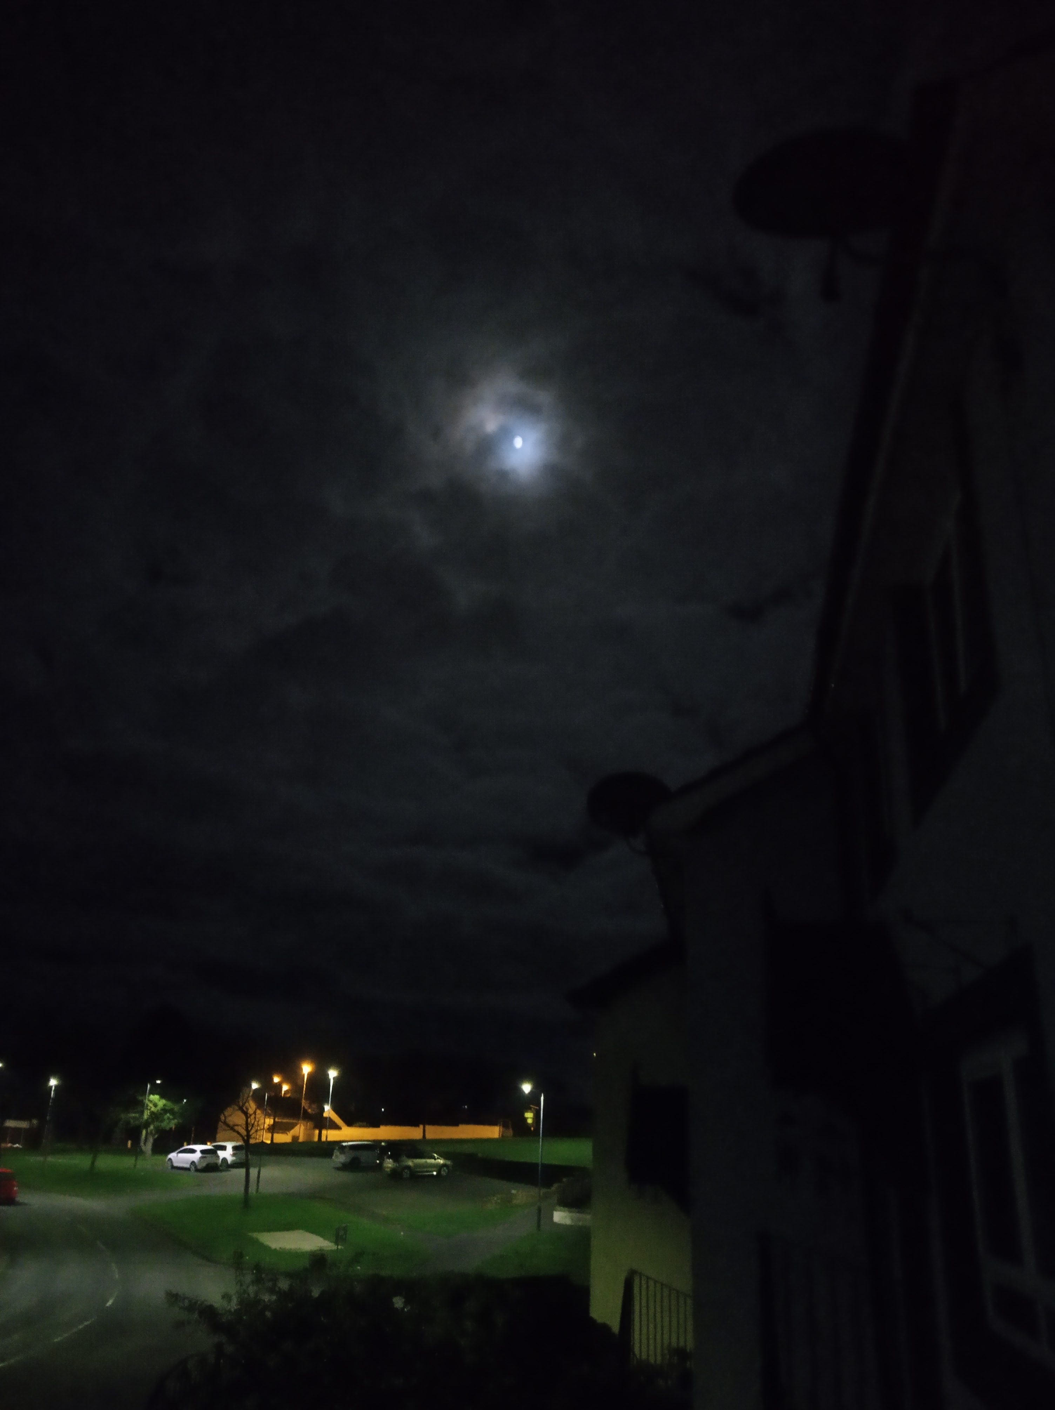

The Mourning Moon, Downpatrick, Co. Down, 27th of November 2023

References:

- Gogh, V. van, and Ronald de Leeuw. The Letters of Vincent Van Gogh. London: Penguin Books, 1997, p.392
- Dáithí Ó hÓgáin. Myth Legend and Romance: An Encyclopaedia of the Irish Folk Tradition. Prentice Hall Press 1991, p. 402
- Finch, A. “Samhain.” The Kenyon Review 18, no. 3/4 (1996): 40–41. http://www.jstor.org/stable/4337396 [accessed 29th November 2023]
- Vaughan Williams Memorial Library, Christmas is Coming https://www.vwml.org/record/RoudFS/S374113 [accessed 29th November 2023]
- Collins, R. (2023) Sky Journal October 31st – November 27th
- BBC NI, Downpatrick Flooding has Ripped Heart Out of Town https://www.bbc.co.uk/news/uk-northern-ireland-67295669 [accessed 29th November 2023]
- Holst, G. The Planets: Jupiter, Bringer of Jollity composed 1914-1917
- Steele, R. & D. W. Singer (1928) “The Emerald Table” Proceedings of the Royal Society of Medicine

Image:

The Mourning Moon, Downpatrick, Co. Down, 27th of November 2023

Gogh, Vincent van, and Ronald de Leeuw. The Letters of Vincent Van Gogh, 1997, p.392.
Dáithí Ó hÓgáin. Myth Legend and Romance: An Encyclopaedia of the Irish Folk Tradition, 1991, p. 402
Annie Finch, “Samhain.” The Kenyon Review 18, no. 3/4 (1996) pp. 40-1
Vaughan Williams Memorial Library, Roud number 12897
Ruth-heather Collins, Sky Journal Wednesday, 1st of November 2023.
BBC NI, Downpatrick Flooding has Ripped the Heart Out of Town, 2nd of November 2023
Gustav Holst, The Planets: Jupiter, Bringer of Jollity composed 1914-1917
Ruth-heather Collins, Sky Journal Wednesday, 14th of November 2023.
Robert Steele and Dorothea Waley Singer 1928 p. 42/486 (English), p. 48/492 (Latin) The Emerald Tablet
Gogh, Vincent van, and Ronald de Leeuw. The Letters of Vincent Van Gogh, 1997, p.392.

