Changemakers: Building Your Personal Brand for Sustainable Employment
(ACCA5035)

Promotional Portfolio: Logo Design and Application

Michael Dawe (2206831)
Contents
Logo Design and Iterations (TASK C): 3
Logo on 3D assets in Fortnite (TASK D): 7
Bibliography: 10

Logo Design and Iterations (TASK C):
Final design:
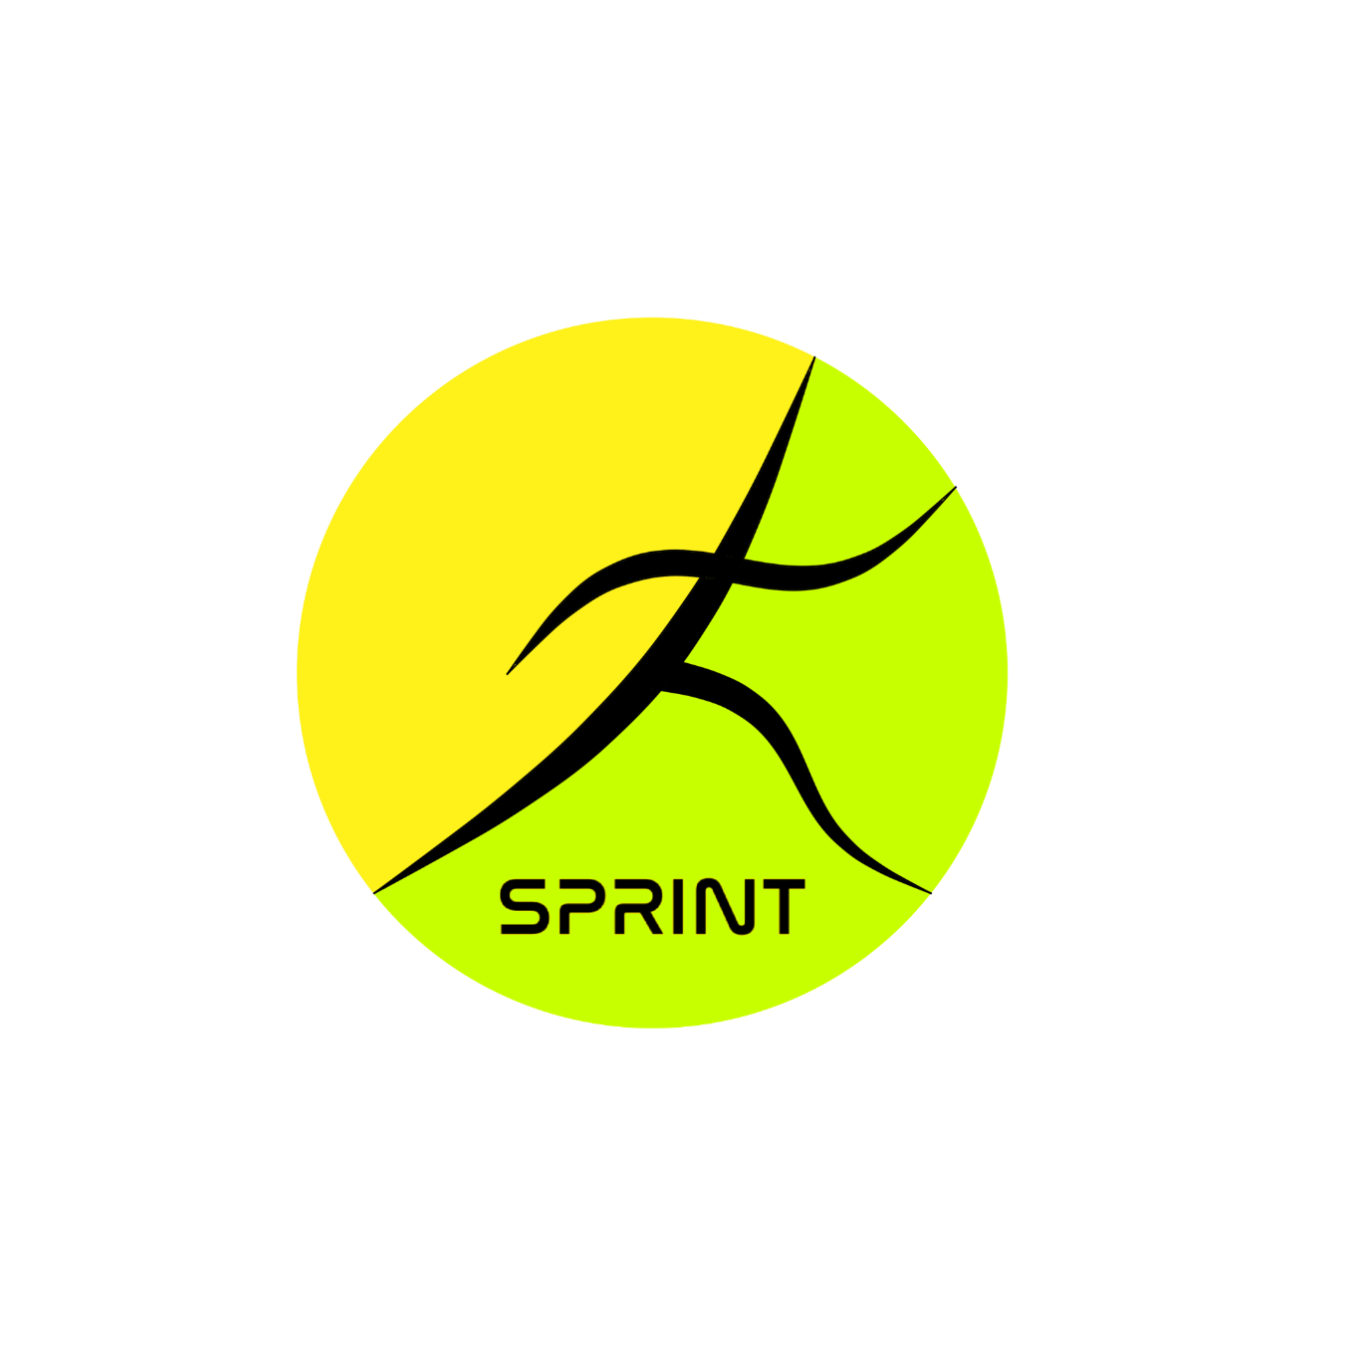

First idea, ‘infinite energy’: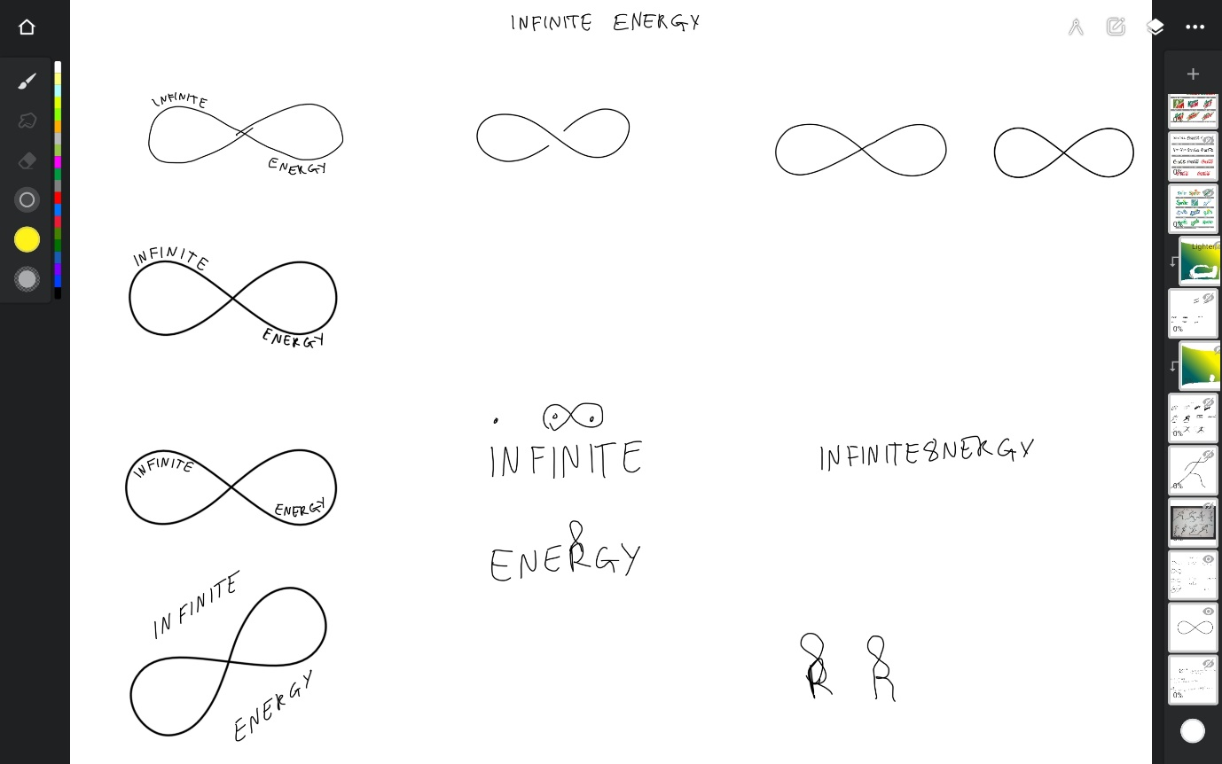
Second idea, ‘sprint’: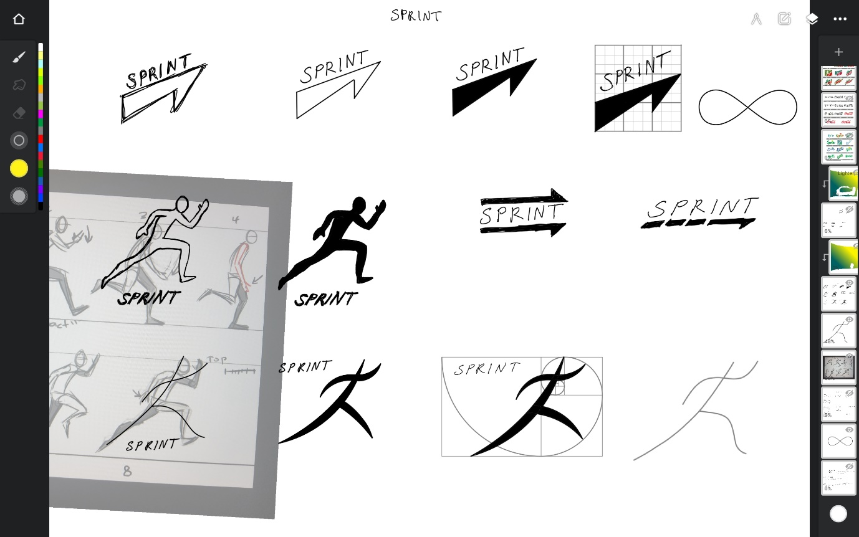

Adding various fonts: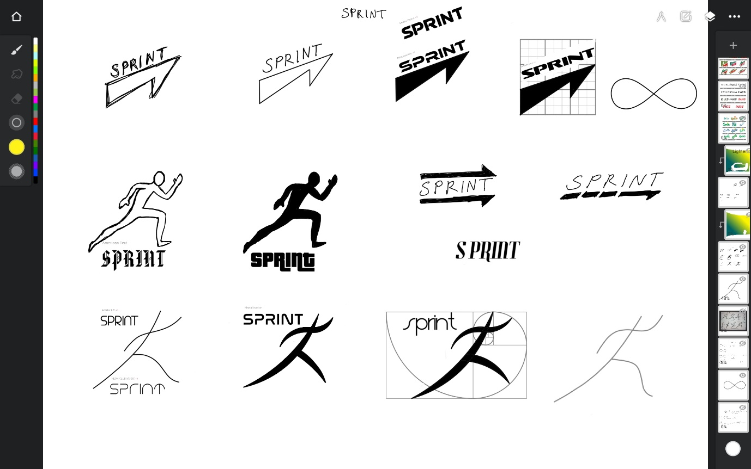
Adding colour: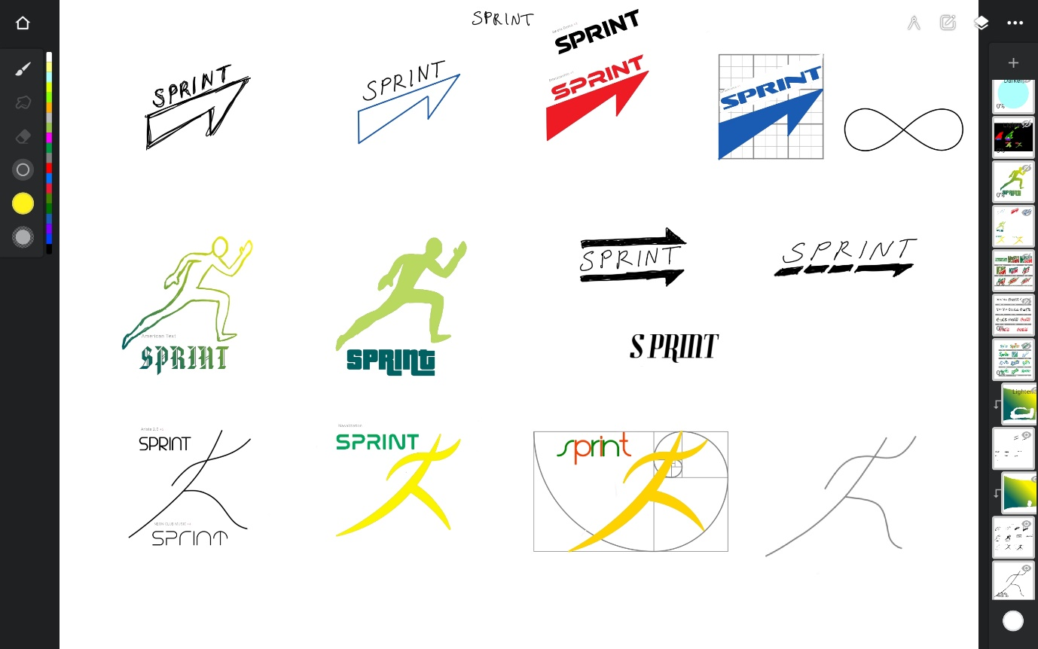
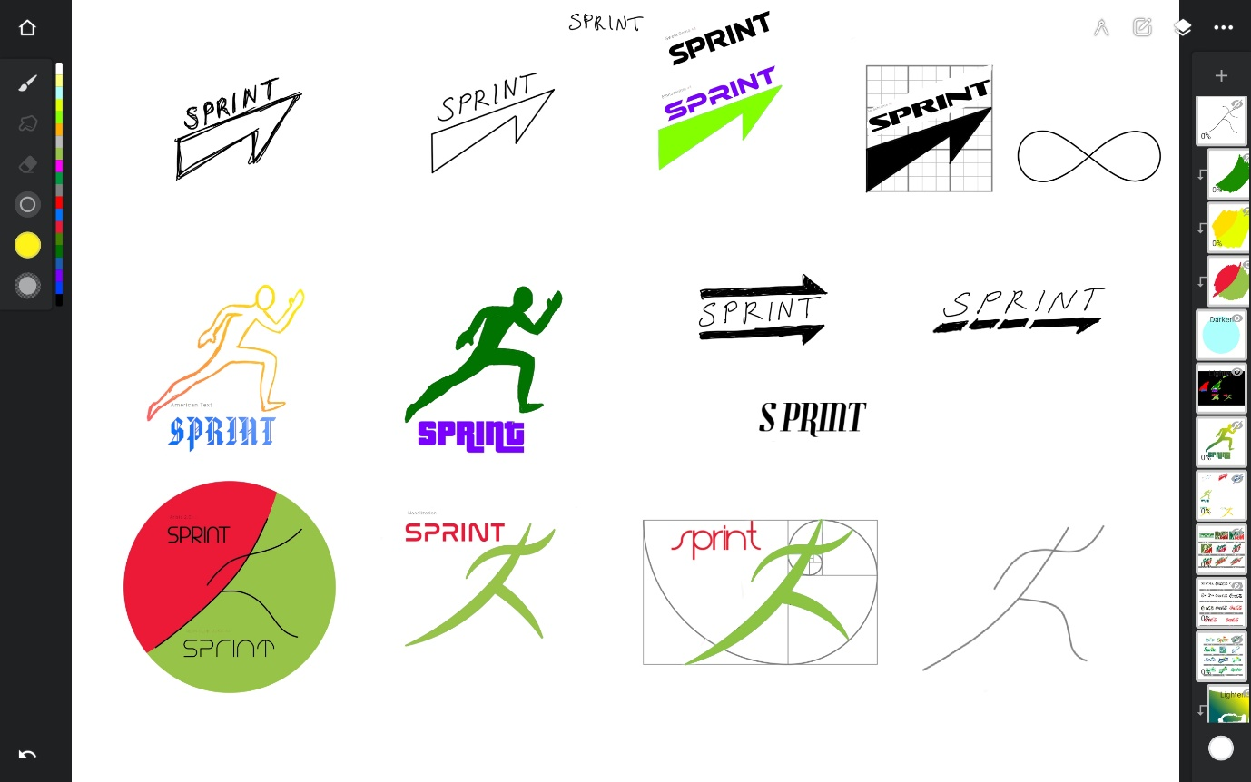

Logo on 3D assets in Fortnite (TASK D):
Billboard featuring the main version of the logo and a modified version on a drink can, where the colours have been extended to form the background of the whole label (in game):
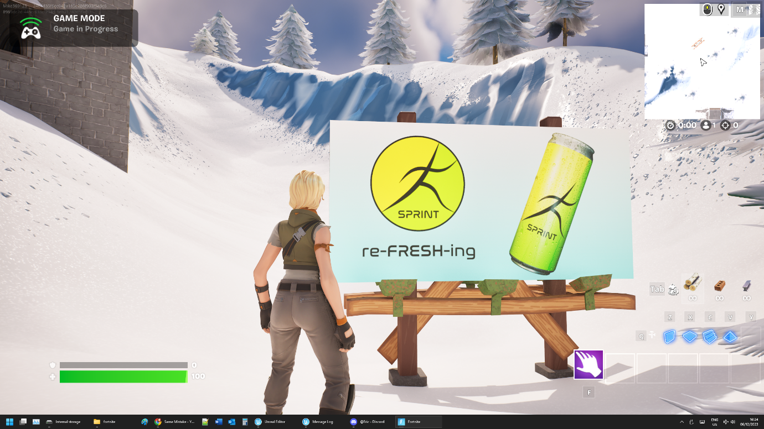
Billboard showing emissive texture to simulate the effect of the floodlights (in editor because I didn’t want to wait for night in game):
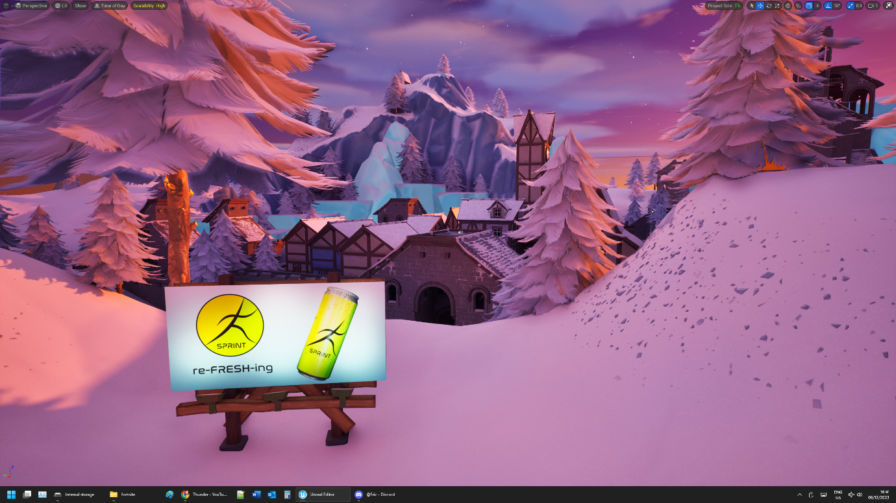

Poster featuring the black and white (black shape on transparent background) version of the logo, and the drink cans (in game):
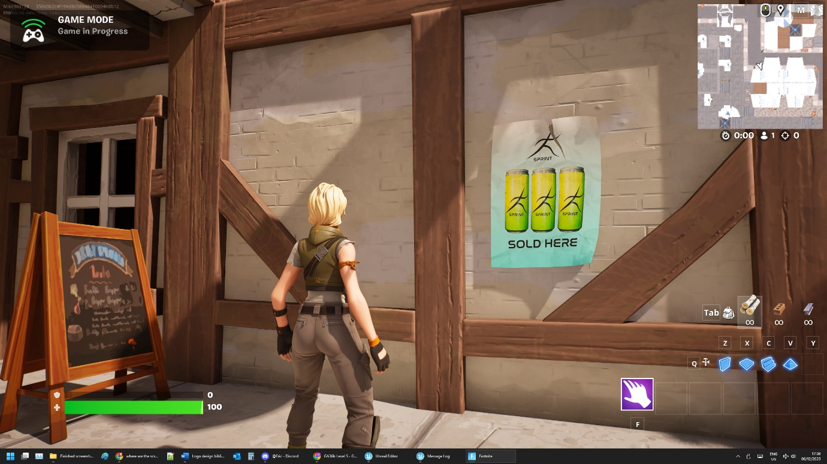
Poster at night (in editor):
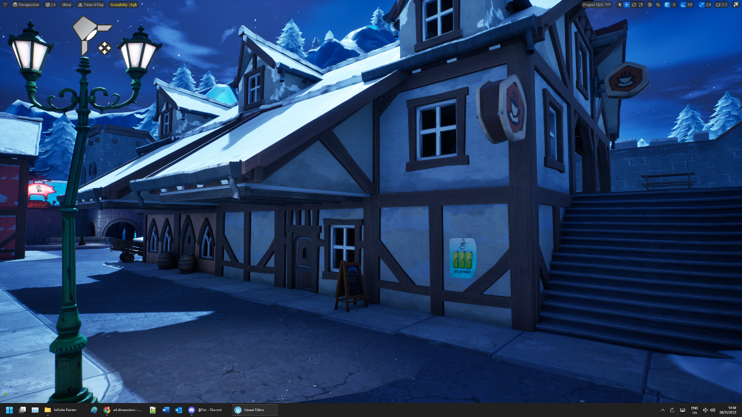

Graffiti using a colour that is not related to the brand, to show that just the shape is recognizable (in game):
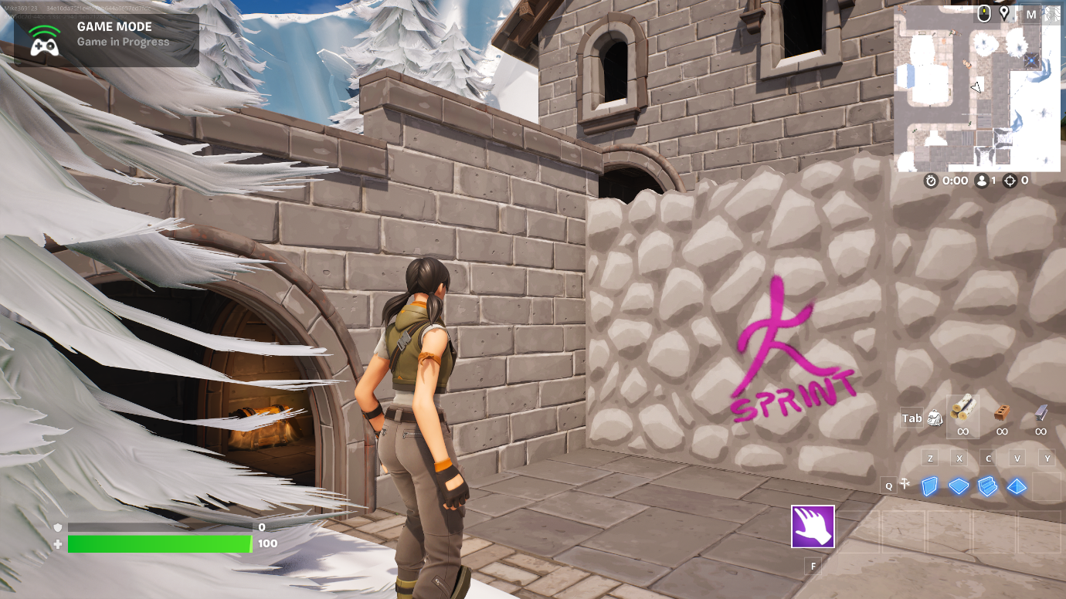
Graffiti (in editor at sunset with light from a streetlamp):
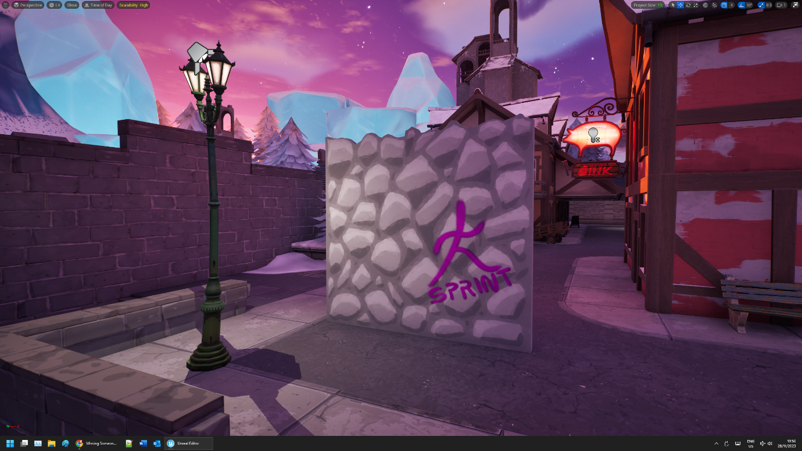

Bibliography:
“Sprite logo,” 1000 Logos The Famous logos and Popular company logos in the World Sprite Logo Comments, 20-Jun-2023. [Online]. Available: https://1000logos.net/sprite-logo/. [Accessed: 08-Dec-2023]
“Coca-Cola Logo,” 1000 Logos The Famous logos and Popular company logos in the World CocaCola Logo Comments, 05-Oct-2023. [Online]. Available: https://1000logos.net/coca-cola-logo/. [Accessed: 08-Dec-2023]
“Mountain Dew Logo,” 1000 Logos The Famous logos and Popular company logos in the World Mountain Dew Logo Comments, 13-Aug-2022. [Online]. Available: https://1000logos.net/mountain-dew-logo/. [Accessed: 08-Dec-2023]
“7UP logo,” 1000 Logos The Famous logos and Popular company logos in the World 7Up Logo Comments, 21-Feb-2023. [Online]. Available: https://1000logos.net/7up-logo/. [Accessed: 08-Dec-2023]
“Pepsi logo,” 1000 Logos The Famous logos and Popular company logos in the World Pepsi Logo Comments, 06-Apr-2023. [Online]. Available: https://1000logos.net/pepsi-logo/. [Accessed: 08-Dec-2023]
“Monster Energy Logo,” 1000 Logos The Famous logos and Popular company logos in the World Monster Energy Logo Comments, 02-Nov-2022. [Online]. Available: https://1000logos.net/logo-monster-energy/. [Accessed: 08-Dec-2023]
Vimeo, “TVPaint - Sprint Cycle: Animation sketches, animation reference, body mechanics animation,” Pinterest, 12-Nov-2015. [Online]. Available: https://www.pinterest.co.uk/pin/499477414902852391/. [Accessed: 08-Dec-2023]
https://2.bp.blogspot.com/_lAMFfvtm_sk/S7vGCN3EmZI/AAAAAAAAAUk/_r7aqiPsyBw/s1600/hotfuzzrun.png
P. Pheenix, “Kiandra run cycle frames by animative on deviantart: Animation reference, animation tutorial, animation sketches,” Pinterest, 05-Mar-2017. [Online]. Available: https://www.pinterest.co.uk/pin/kiandra-run-cycle-frames-by-animative-on-deviantart--21744010681624921/. [Accessed: 08-Dec-2023]
R. Larabie, “Pricedown font · 1001 fonts,” 1001 Fonts. [Online]. Available: https://www.1001fonts.com/pricedown-font.html. [Accessed: 08-Dec-2023]
R. Larabie, “Ethnocentric font family · 1001 fonts,” 1001 Fonts. [Online]. Available: https://www.1001fonts.com/ethnocentric-font.html. [Accessed: 08-Dec-2023]
The League of Moveable Type, “Chunkfive Font Family · 1001 fonts,” 1001 Fonts. [Online]. Available: https://www.1001fonts.com/chunkfive-font.html. [Accessed: 08-Dec-2023]
StudioTypo, “Swera demo font family · 1001 fonts,” 1001 Fonts. [Online]. Available: https://www.1001fonts.com/swera-demo-font.html. [Accessed: 08-Dec-2023]
R. Larabie, “Sofachrome Font Family · 1001 fonts,” 1001 Fonts. [Online]. Available: https://www.1001fonts.com/sofachrome-font.html. [Accessed: 08-Dec-2023]
Typographer Mediengestaltung, “American text font · 1001 fonts,” 1001 Fonts. [Online]. Available: https://www.1001fonts.com/american-text-font.html. [Accessed: 08-Dec-2023]
Zetafonts, “Arista 2.0 font family · 1001 fonts,” 1001 Fonts. [Online]. Available: https://www.1001fonts.com/z-arista-font.html. [Accessed: 08-Dec-2023]
TypoGraphicDesign, “Neon Club Music Font Family · 1001 fonts,” 1001 Fonts. [Online]. Available: https://www.1001fonts.com/neon-club-music-font.html. [Accessed: 08-Dec-2023]
R. Larabie, “Nasalization Font · 1001 fonts,” 1001 Fonts. [Online]. Available: https://www.1001fonts.com/nasalization-free-font.html. [Accessed: 08-Dec-2023]
aqrtypeface, “Nazeefa font · 1001 fonts,” 1001 Fonts. [Online]. Available: https://www.1001fonts.com/nazeefa-font.html. [Accessed: 08-Dec-2023]
Y. Pauliukevich, “Download metal cans with water drops, soda or energy drink for free,” Vecteezy, 10-Dec-2022. [Online]. Available: https://www.vecteezy.com/vector-art/15485829-metal-cans-with-water-drops-soda-or-energy-drink. [Accessed: 08-Dec-2023]
P. Guglielmetti, “Rainy-day hair tips from a celeb stylist (plus, a little frizz experiment),” Glamour, 26-Jun-2009. [Online]. Available: https://www.glamour.com/story/rainyday-hair-tips-from-a-cele. [Accessed: 08-Dec-2023]
S. Maage, “Photo by Simon Maage on unsplash,” A close up of a piece of white paper photo – Paper texture Image on Unsplash, 06-Feb-2023. [Online]. Available: https://unsplash.com/photos/a-close-up-of-a-piece-of-white-paper-nW3XR5c1aCg. [Accessed: 08-Dec-2023]
Fortnite, Version ++Fortnite+Release-28.00-CL-29915848-Windows, [Software], North Caroline: Epic Games Inc, 2023.
Unreal Editor for Fortnite, Version ++Fortnite+Release-28.00-CL-29915848-Windows, [Software], North Caroline: Epic Games Inc, 2023.
Maya, Version 2023.3, [Software], California: Autodesk, 2023.
Infinite Painter, Version 7.0.45, Washington: Infinite Studio LLC, 2023, [App] Available: https://play.google.com/store/apps/details?id=com.brakefield.painter [Accessed: 09-
Dec-2023]

