MODULE NAME | Digital Skills for Personal and Professional Growth(BMSW4008)
Assignment Title | Evidence of Learning (E-Portfolio)
Student Name | ALI AHMED SULIMAN (2326008)
Lecturer Name | Philippa Fitzgerald
Submission deadline | Friday 27th February 2026 23.59pm

AI Statement:

Module Name: Digital Skills for Personal and Professional Growth
Module Code: BMSW4008
Assignment Title: E-Portfolio
Student Name: Ali Ahmed Suliman
Student Number:2326008
Lecturer: Philippa Fitzgerald
Deadline: Friday 27th February 2026 23.59pm
Wordcount: 1925 words
AI Acknowledgement:
I confirm that I have not presented any AI generated materials as my own work.
I confirm that I have copies of my drafts, notes, and other resources I used, which I may be asked to provide in evidence.
I confirm that I have use a tool like Microsoft Editor, Bing Chat or specific elements of Grammarly, to check for grammar, spelling and readability.

Table of Contents
Task 1: Market Research and Website Development Project 4
Introduction 4
Authoritative Analysis of Statistics. 4
Demographic Analysis 5
Purchase Behaviour 5
Pricing Attitudes and Preferences and Sustainability Attitudes. 6
Correlation Analysis 7
Application of the website and Marketing Strategy. 7
Conclusion 12
Task 2: Financial Projection Using Microsoft Excel and the Importance of Excel in the Digital Era 13
Introduction 13
Formulas and Structure with a Spreadsheet. 13
Financial Visualization 14
The applicability of Excel in the Digital Age. 14
Conclusion 15
Task 3: GlowNest Skincare – Final Advert Script 16
Task 4: Presentation 17
References 22

List of Figures

Figure 1: Overview of Descriptive Statistics 4
Figure 2: Age Distribution of the respondents 5
Figure 3: Purchase Frequency by gender 6
Figure 4: Correlation Matrix 7
Figure 5: Website Home Page of GlowNest 8
Figure 6: GlowNest Online Product Page. 8
Figure 7: Canva Poster Sustainable Beauty Matters 9
Figure 8: Instagram Poster of Glow Nest Vitamin C Brightening Serum 10
Figure 9: Infographic Poster 11
Figure 10: Bar Chart -Monthly income/Monthly expenses (Jan -Dec) 14

Task 1: Market Research and Website Development Project

Introduction
In this report, the creation of the proposed natural skincare brand, GlowNest Skincare, in the UK is presented because of the major market research. The questionnaire was structured as a questionnaire, and it contained ten questions and was constructed using Google Forms that generated 30 responses. The statistical data was analysed by exporting the data that had been collected into Microsoft Excel. This was meant to investigate demographic features, purchase behaviour, price and sustainability attitudes sensitivity in order to undertake strategic business decisions (NIQ, 2023). Therefore, GlowNest will take the low-cost, vegan, and sustainable skincare product that aligns with the current needs of the market.

Authoritative Analysis of Statistics.
To compute descriptive statistics and summarise such variables of the survey as the importance rating and purchase behaviour, Excel was used. Descriptive trends like standard deviation and mean were decoded. The descriptive findings indicate that the mean scores of the importance of being natural ingredients and eco-friendly packaging are high, and this is a good consumer attitude towards sustainability. The advantage of statistical summarisation lies in improved comprehensibility of the information and in the possibility of making evidence-based decisions (Kumar, 2023).
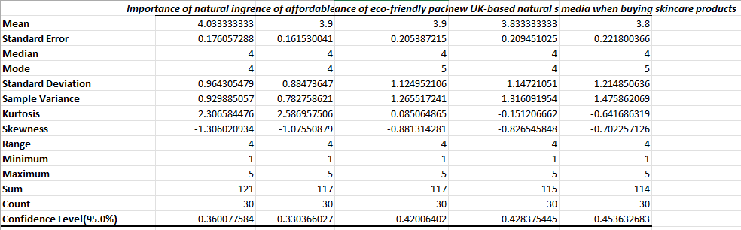
Figure 1: Overview of Descriptive Statistics
Sustainability-related issues are shown to be central in the consumer evaluation processes are demonstrated by the accuracy of the answers.

Demographic Analysis
As can be observed in the figure above, 40 per cent of the participants belong to the 25-30 age bracket, followed by 33 per cent belonging to the age of 18-24. Smaller shares are less than 18 and above 30. This confirms the information that the basic intended market of GlowNest is young adults. Sustainable and natural skincare products are of more interest to the young consumer (Hakulinen, 2025).
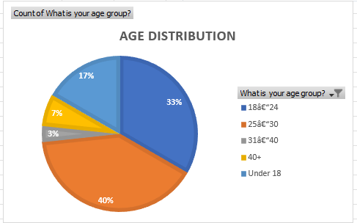
Figure 2: Age Distribution of the respondents
It is also well distributed among the age groups, which means that this brand can pursue an inclusive strategy and focus on targeting young consumers who are digitally active and position the brand as the main orientation.

Purchase Behaviour
The purchase frequency pivot chart indicates that most of the respondents buy the skincare products after two or three months, then periodically buy them. Such allocation of genders presents similarities in behaviour and confirms that it is not gender-specific when it comes to consuming skincare. The shift in customer preference is indicative of the increased interest in skin care by the demographics (Patil et al., 2024).

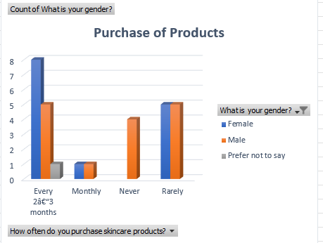
Figure 3: Purchase Frequency by gender
Furthermore, online buying channels are most preferred as the outcome of the surveys. The further evolution of the digital retail in the beauty industry of the UK validates this trend (Euromonitor International, 2024). There had also been high ratings of social media, which proved the relevance of the digital engagement strategies. The purchase intention of green cosmetics is highly influenced by exposure to the internet and social media (Limbu and Ahamed, 2023).

Pricing Attitudes and Preferences and Sustainability Attitudes.
Among the lessons was the lesson on the sensitivity of prices. A large proportion of the respondents like the products that are less than £10 or the ones whose prices are between 10 and £ 20. Even in the markets that are sustainability-oriented, reasonable cost is of the essence. Economic accessibility is often influenced by the measure, which determines the feature of ethical consumption (Jani et al., 2026).
The opinion poll also showed that a majority of the respondents (80 per cent) trust in natural ingredients. Consumers are associated with plant-based formulations and are becoming more inclined to these products in terms of health and efficiency (Adam et al., 2025). In addition, 70 per cent of them placed environmentally friendly packaging. The long-run brand credibility and competition will be assisted by the sustainable packaging (Szalaiova and Vidrinskas, 2023). Circular economy is being increasingly used in the cosmetics industry (Mondello et al., 2024).
These findings confirm that GlowNest ought to synthesise low-cost and environmental friendliness.

Correlation Analysis
A correlation analysis was conducted in Excel, whereby the relationship between key variables was tested. The correlation table depicts that the two variables, the importance of natural ingredients and the importance of eco-friendly packaging, have a positive correlation. This means that the respondents also attach a lot of importance to the plant-based formulations, therefore, having sustainable packaging solutions.
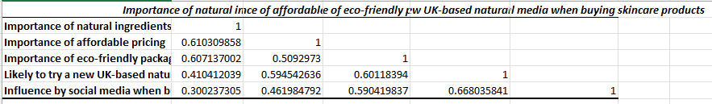
Figure 4: Correlation Matrix
The observed relationship is inclined towards integrated sustainability positioning. Consumer attitudes continue to strengthen both the UK market of natural beauty products (Mintel, 2025). Therefore, consistency of the brand is achieved through aligning the product formulation strategy with the packaging strategy.

Application of the website and Marketing Strategy.
The direct contribution to the work of the results of the research was reflected in the creation of the site of the business, GlowNest Wix. The location is dedicated to clean design, natural ingredients, low prices, and sustainability messages. It was achieved through the assistance of elaborated principles of digital marketing planning (Chaffey, 2023).
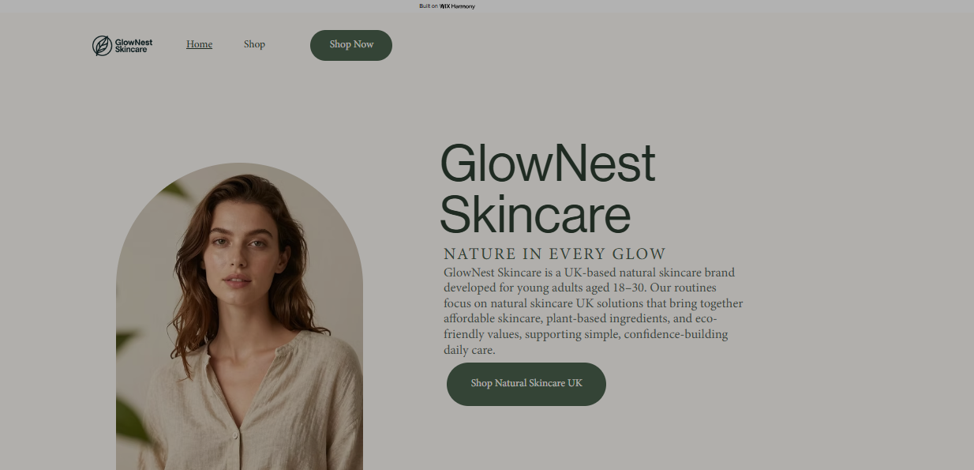
Figure 5: Web Site Home Page of GlowNest
The e-commerce platform informs about the fact that people would prefer online avenues of shopping.
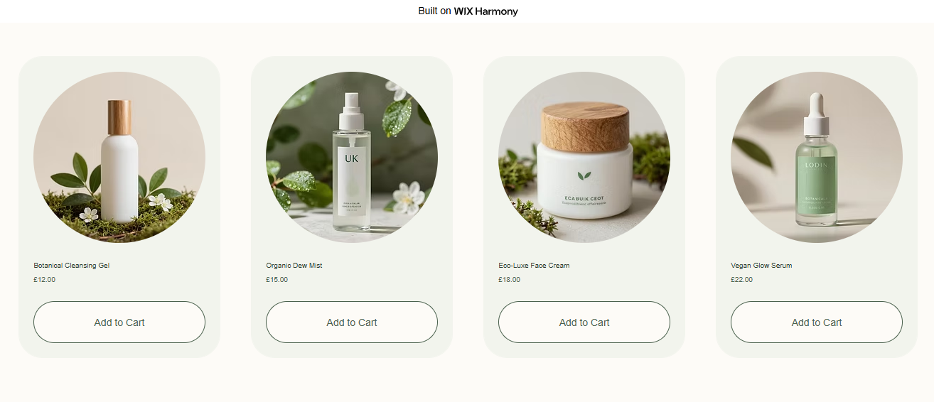
Figure 6: GlowNest Online Product Page.
There was also a development of a Canva marketing grounded on the findings of research. Sustainability-oriented messages improve eco-concerned positioning.
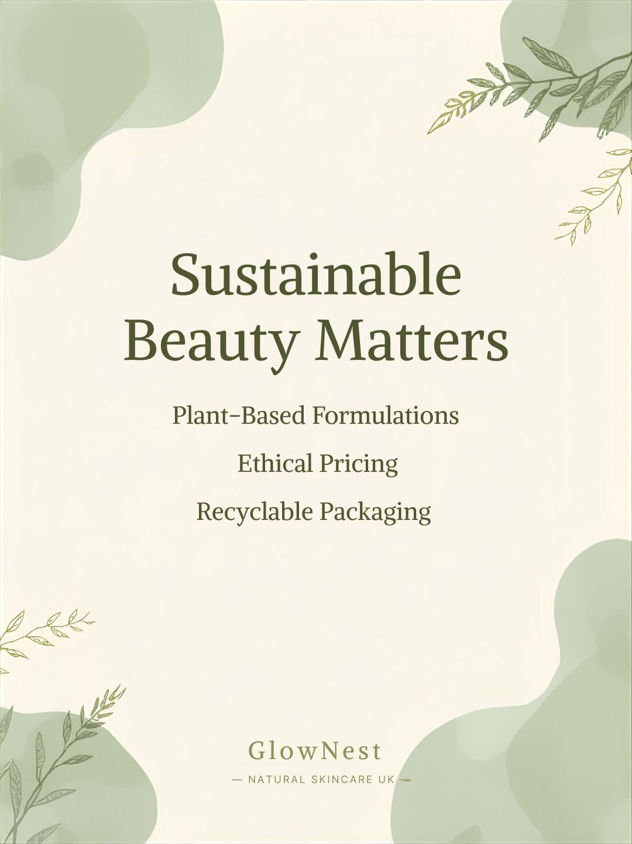
Figure 7: Canva Poster Sustainable Beauty Matters
The information in the promotion focuses on the product and highlights the plant-based products and low prices.
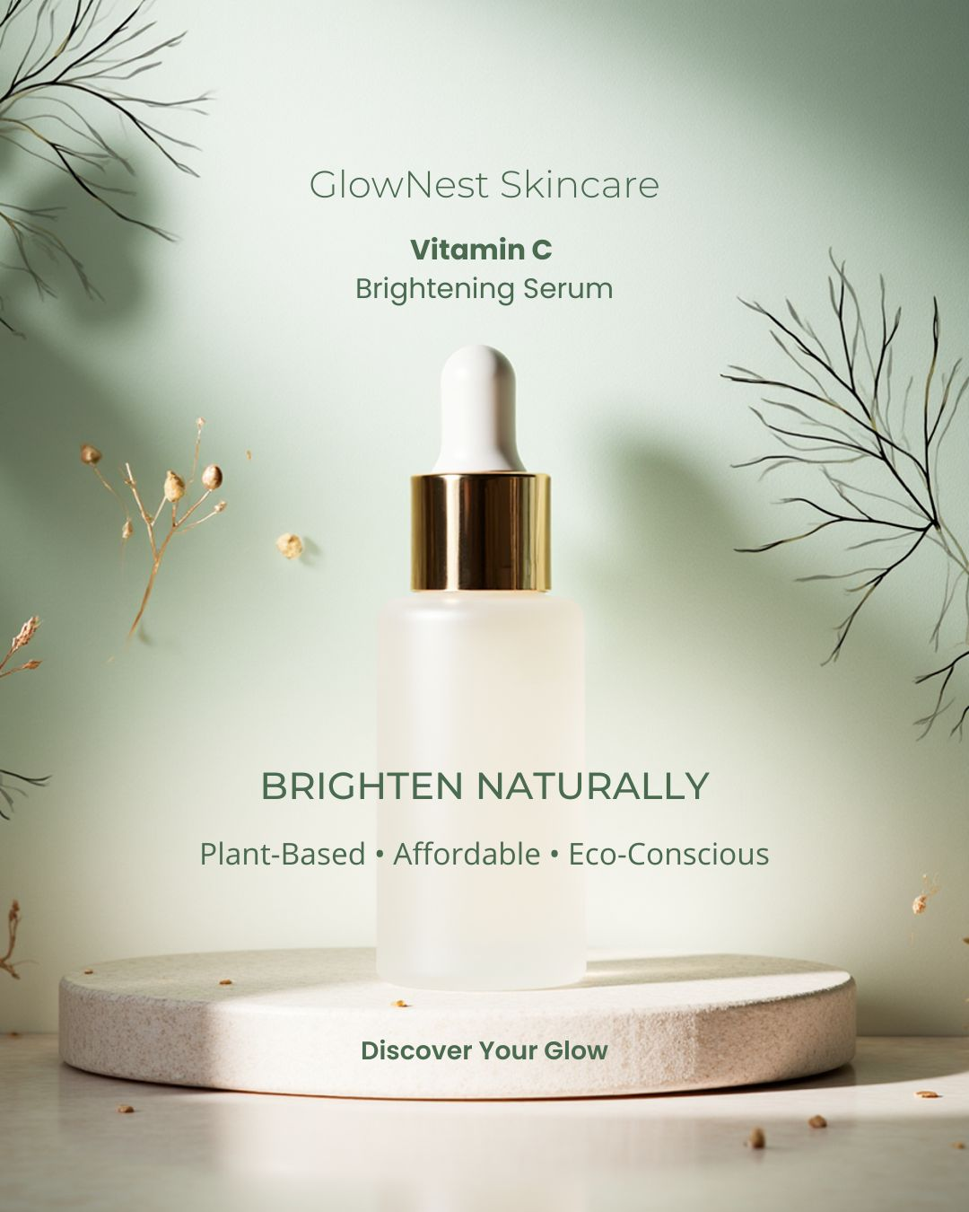
Figure 8: Instagram Poster of Glow Nest Vitamin C Brightening Serum
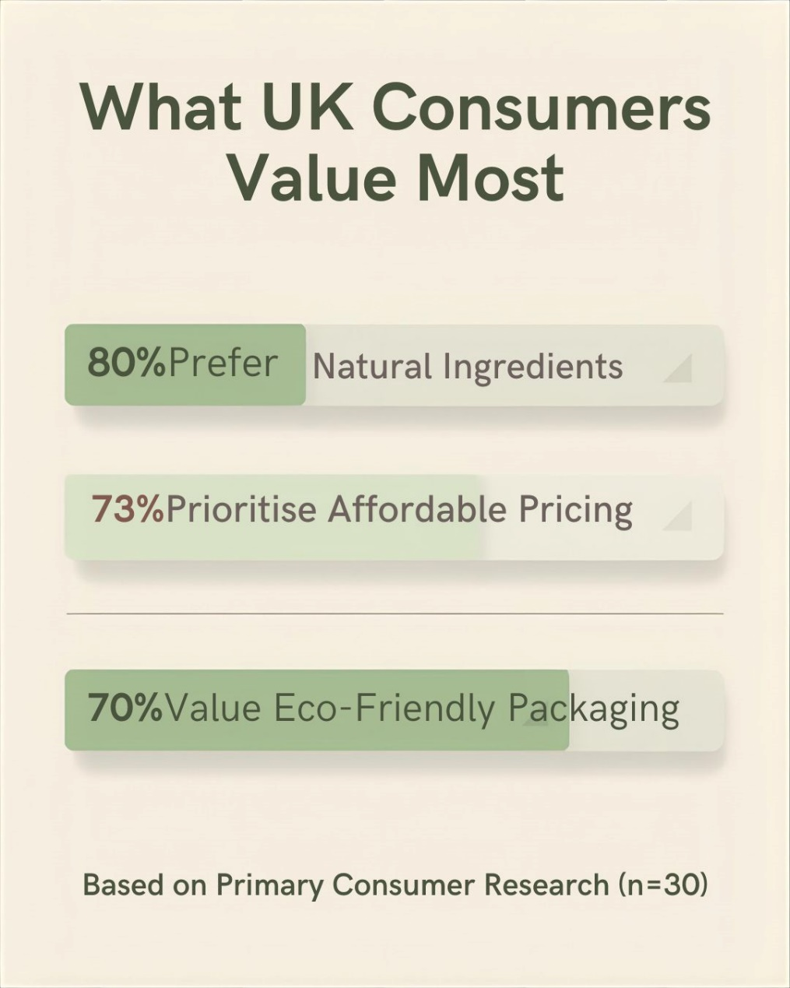
Figure 9: Infographic Poster
Based on the findings of the surveys as an instrument to create their websites and marketing graphics, GlowNest can demonstrate how primary data can be translated into a business strategy to be adopted.

Conclusion
The first analysis indicates that the consumers have a high demand for natural contents, environmental packaging, low costs and the convenience of shopping online. Descriptive statistics results depict that the sustainability attitudes are congruent, and correlation analysis justifies the association between preference for plant-based formulation and packaging responsibility.
The general demographics of the target market are young adults. Trends of purchase frequency show that it is a recurrent demand that has a positive influence on the viability of the business in the long run. Analysis of the data using Excel, the website creation and the marketing tools demonstrate a clear improvement between the data and the strategic implementation.
Generally speaking, GlowNest Skincare is placed strategically to satisfy the current trends and consumer demands in the UK in sustainable beauty.

Task 2: Financial Projection Using Microsoft Excel and the Importance of Excel in the Digital Era

Introduction
In the contemporary digital business environment, financial forecasting and the use of data to make business decisions are crucial as far as the sustainability of enterprises is concerned. Microsoft Excel has remained one of the most used spreadsheet programs to prepare the budget, financial model and performance analysis. Excel continues to be the foundation of the basis of the analytical tool in the procedures of the digital transformations (Cera, 2023).
A financial projection of one year has been prepared in this assignment for one of the start-ups of Natural skincare, GlowNest Skincare, a start-up based in the UK. This spreadsheet has been founded on the approximations of monthly revenue, costs and profit to demonstrate that Excel may assist in the methodical budgeting of money in small enterprises.

Formulas and Structure with a Spreadsheet.
The spreadsheet was configured with the monthly column header, which consisted of January to December. The rows have been divided into Income, Expenses and Profit/Loss to enable rational financial monitoring.
The section Income included the Product Sales and Promotional Revenue, and then the Total Income. Expenses were then added with Raw Materials and Packaging, followed by Website Hosting, Marketing (Instagram Advertising), and Miscellaneous Costs and then the final category showed the Total Expenses. This systematic categorisation is aligned with the principles of financial management of entrepreneurs since it is required to have a clear understanding of who can sustain through business by having costs to survive (Burns, 2022).
Basic Excel formulas were applied in creating automated calculations.
- Total Income was determined as; =SUM(B2:B3)
- Calculating the total Expenses: =SUM(B6:B10).
- Profit/Loss = B4 -B11.
An automated formula is used to minimise human error, and the accuracy of analysis is increased. The Excel computation capability enables the company to make financial adjustments in real time in case they might be certain adjustments in the sales figures or costs.
To simplify the data to comprehend it, we used the currency formatting (£) and bold font was applied under the headers and colour coding was applied to indicate that it was the income (green), or the expenses (red).

Financial Visualization
To enable comparison of the performance, the bar chart was created to compare the Total Income and the Total Expenses per month.
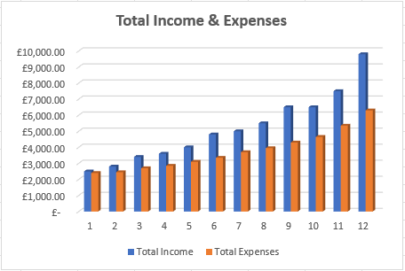
Figure 10: Bar Chart -Monthly income/Monthly expenses (Jan -Dec)
The comparison in graphs makes it easy to determine the profitable and the low-performing months. The information visualisation also enhances the aspect of the manager in making decisions, as the numerical data can be transformed into understandable data (Al Maruf et al., 2022). These visual tools are necessary in monitoring growth patterns and performance in the case of small companies.

The applicability of Excel in the Digital Age.
Microsoft Excel can be said to be highly applicable in the digital era due to its availability, plasticity, and analytical ability. Since organisations are transitioning to more sophisticated digital systems, Excel is often selected as the first destination of digital transformation work (Gontcharov, 2023). The manner in which it has evolved not only as a simple spreadsheet utility but as a versatile analytics tool is very representative of how it can bring in flexibility in the contemporary business environment (Cera, 2023).
Enterprises that are small, like GlowNest Skincare, can afford to utilise Excel as their tool of financial management. Spreadsheet software is commonly used by many entrepreneurs to create budgets and prognosis and invest in advanced accounting software (Burns, 2022). It is particularly applicable to start-ups that have minimal finances and have utilised Excel because of its accessibility.
Besides that, financial planning must be consistent with the marketing strategy. The models of digital marketing are oriented toward the goals and performance monitoring that can be measured (Chaffey, 2023). Excel could be applied to determine whether the marketing budget, which consists of Instagram advertisements, has the capacity to generate the projected revenue for GlowNest.
The UK market also has a growing need to use beauty products at competitive prices, according to the consumer research. By exceeding the revenue forecasts in Excel, GlowNest will be in a position of analyzing the price strategy as competitive and at the same time profitable. In addition to that, internet marketing and company positioning are essential in fostering the buying behaviour in skincare markets (Malakiano and Susila, 2025). Marketing returns on investment can be evaluated by means of using Excel and comparing the cost of promotion to the gains in income.
In its turn, Excel facilitates data literacy, business financial openness, and alignment (Kumar, 2023).

Conclusion
The financial projection spreadsheet shows that Microsoft Excel may be applied in managing formal management of financial matters in small businesses. Precision, business acumen and understanding are enhanced in Excel by formula automation, professional formatting and data visualisation.
Excel is a significant business tool in the digital era, although it is low-priced, has analytical power and is flexible. Excel is a strategic management tool in the case of GlowNest Skincare, which enhances both the growth and expansion of the business in a sustainable way and informs decision-making.

References
Task 1:
Adam, A.B., Paul, S., Fred, A.E., Joy, E.O., Mamudu, S.B., Abubakar, D. and Abubakar, M.Y. (2025). ‘Natural Products for Skincare: A Review of Benefits, Mechanisms, and Innovations’, Journal of Medicinal and Medical Chemistry,1(4), pp.143-154. https://www.jmedchem.com/article_223489_cb93acb2d45f9920ab2b4896a5dbf78b.pdf
Euromonitor International (2024). ‘Dupes’, TikTok and natural ingredients boosting UK beauty and personal care sales: Euromonitor International. [online] Euromonitor. Available at: https://www.euromonitor.com/press/press-releases/august-2024/dupes-tiktok-and-natural-ingredients-boosting-uk-beauty-and-personal-care-sales-euromonitor-international (Accessed 27 Feb. 2026).
Hakulinen, I. (2025). 'Active ingredients–Trends among consumers: a theoretical study about skincare active ingredient use and current trends among Generation Z consumers. https://www.theseus.fi/bitstream/handle/10024/882078/Hakulinen_Iida.pdf?sequence=2
https://www.mdpi.com/2071-1050/15/15/11881
Jani, N.L., Balakrishnan, B.K. and Wibowo, S.F. (2026). Responsible Consumption in the Eco-Friendly Skincare Market. InGreen To Gold: Marketing Strategies for a Sustainable Future(pp 575-594). Cham: Springer Nature Switzerland.https://www.researchgate.net/profile/Sundeep-Kumar-20/publication/400341370_Exploring_the_Level_of_Sustainability_Awareness_among_Consumers_in_the_Indian_Fast-Fashion_Clothing_IndustryA_Consumer_Perspective/links/69803ae142f94d1212a5c267/Exploring-the-Level-of-Sustainability-Awareness-among-Consumers-in-the-Indian-Fast-Fashion-Clothing-IndustryA-Consumer-Perspective.pdf#page=572
Limbu, Y.B. and Ahamed, A.J. (2023). What influences green cosmetics purchase intention and behavior? A systematic review and future research agenda. Sustainability,15(15), pp.1-15.
Mintel Store. (2025). UK Attitudes towards Natural and Organic BPC Consumer Report 2025 | Mintel Store. [online] Available at: https://store.mintel.com/report/uk-attitudes-towards-natural-and-organic-bpc-market-report (Accessed 27 Feb. 2026).
Mondello, A., Salomone, R. and Mondello, G. (2024). ‘Exploring circular economy in the cosmetic industry: Insights from a literature review’, Environmental Impact Assessment Review,105, pp. 1-14. https://www.sciencedirect.com/science/article/pii/S0195925524000301
NIQ. (2023). Trends in Sustainable Beauty 2023. [online] Available at: https://nielseniq.com/global/en/insights/analysis/2023/trends-in-sustainable-beauty-2023/ (Accessed 27 Feb. 2026).
Patil, M.P.R., Deshmukh, M.Y., Kulkarni, M.A., Ingawale, V.S., Gund, M.P., BVDU, I. and Suryawanshi, S., CHANGING CONSUMER PREFERENCES FOR SKIN CARE PRODUCT.JOURNAL OF EDUCATION: RABINDRA BHARATI UNIVERSITY ISSN, pp.0972-7175. https://www.researchgate.net/profile/Pratima-Gund/publication/374674985_CHANGING_CONSUMER_PREFERENCES_FOR_SKIN_CARE_PRODUCT/links/6529048306bdd619c48be19d/CHANGING-CONSUMER-PREFERENCES-FOR-SKIN-CARE-PRODUCT.pdf
Szalaiova, D. and Vidrinskas, M. (2023). More Than Skin Deep: An Investigation of Consumer Behavior Toward Green Skincare Products in the European Context. https://www.diva-portal.org/smash/get/diva2:1766260/FULLTEXT01.pdf
Task 2:
Al Maruf, A., Paul, R., Imam, M.H. and Babar, Z. (2022). A Systematic Review of The Role Of SQL And Excel In Data-Driven Business Decision-Making For Aspiring Analysts.American Journal of Scholarly Research and Innovation,1(01), pp.249-269. https://researchinnovationjournal.com/index.php/AJSRI/article/download/46/35
Burns, P. (2022). Entrepreneurship and small business. Bloomsbury Publishing. https://www.academia.edu/download/57487418/enterprensuirship_and_small_business_start-up__growth_and_maturity.pdf
Cera, S. (2023). The Power of Technology: A Look Back at Microsoft Excel and the Evolution Towards Modern Tech. [online] Medium. Available at: https://medium.com/@sergicera/the-power-of-technology-a-look-back-at-microsoft-excel-and-the-evolution-towards-modern-tech-bfa920ed669b (Accessed 27 Feb. 2026).
‌Chaffey, D. (2023).SOSTAC marketing planning model guide | Smart Insights. [online] Smart Insights. Available at: https://www.smartinsights.com/digital-marketing-strategy/sostac-model/ (Accessed 27 Feb. 2026).
Gontcharov, D. (2023).Excel as a Starting Point of Digital Transformation. [online] Medium. Available at: https://www.smartinsights.com/digital-marketing-strategy/sostac-model/ (Accessed 27 Feb. 2026).
‌Kumar, M.D. (2023). A study on importance of microsoft excel data analysis statistical tools in research works.Journal of Management & Educational Research Innovation,1(3), pp.25-33. https://www.jomeri.org/index.php/jomeri/article/download/12/14
Malakiano, G. and Susila, I. (2025). The influence of digital marketing, brand awareness, and product quality on purchase decisions for Something skincare products.Indonesian Interdisciplinary Journal of Sharia Economics (IIJSE),8(1), pp.1626-1643. https://e-journal.uac.ac.id/index.php/iijse/article/download/6120/2345
Taks 4:
Ajayi, S.A., Olaniyi, O.O., Oladoyinbo, T.O., Ajayi, N.D. and Olaniyi, F.G. (2024). ‘Sustainable sourcing of organic skincare ingredients: A critical analysis of ethical concerns and environmental implications’, Asian Journal of Advanced Research and Reports, 18(1), pp.65-91. https://papers.ssrn.com/sol3/Delivery.cfm?abstractid=4691856
Amelia, R. (2024). Green marketing and its influence on green consumption, environmental knowledge, brand coolness, and purchase intention of environmentally friendly skincare brands. Indonesian Development of Economics and Administration Journal, 2(3), pp.386-400.
https://www.ojs.ideanusa.com/index.php/idea/article/download/188/155
Dlamini, S. and Mahowa, V. (2024). Investigating factors that influence the purchase behaviour of green cosmetic products. Cleaner and Responsible Consumption, 13, pp. 1-9.
https://www.sciencedirect.com/science/article/pii/S2666784324000238
Kohinur, K., Hutabarat, P., Simanullang, L., Simanullang, A.T.W., Simanjutak, B.P. and Tambunan, T.S., 2026. The Influence of Green Marketing on Consumer Buying Interest in Skincare Products. Journal of Economic Resilience and Sustainable Development, 2(1), pp.234-246. https://journal.publigopress.com/index.php/jerad/article/download/75/42
‌

