Matthew Edward Kilgariff
University of Wales: Trinity Saint David | 1705241
project initiation document
Sustainable Business Project: BMSP 6005

PROJECT INITIATION DOCUMENT
- Purpose of the Project Initiation Document.
The purpose of the project is to investigate the feasibility of an online platform in which physical retailers offer up a space in their facility to small independent businesses and start-ups.
- Project Justification.
Independent shops have struggled to compete against larger corporations and more recently online stores. The story in Wales is no different. The Head of the Welsh Retail Consortium, Sarah Morris explained; "Business rates are at a 20-year high and higher in Wales than in England and Scotland" (Gwilym, E. (2019).
Carmarthenshire has a higher self-employment rate than the Welsh average (Nomisweb.co.uk. (2019) with 62% of Carmarthenshire’s shops being independent (BBC News. (2019). This means that any threats on the independent shopping sector will have a significant impact on the economy of Carmarthenshire.
This project sets out to suggest an online platform with the potential to provide a sustainable income source to both;
- Independent shops – with permission to sublet.
- Startup companies - who would benefit from customer exposure in a physical location.
"The challenge to attract customers is too big for any one retailer. In order to survive, independent retailers need to work together – it is something they can do and should do.” – Tim Lewis founder of MyHigh.st.
Instead of competing, independent retailers who are not in direct competition can achieve more as a collective force. Collaboration in office spaces is already a popular and often leads to saving on rent and utilities, exposure from a wider range of customers, networking and joint marketing opportunities (Aldred, T. (2019).

- Background.
Entrepreneurship has the potential to boost economic growth and create new job opportunities although many start-ups do not run for long enough to create benefits (Tanas, J., & Audretsch, D. (2011). UK was ranked third in the world for new company creation but unfortunately did not even make the top ten when it came to businesses that become established (OECD. (2019). 60% of sole traders in the UK do not survive more than three years of trading (Cribb, J., Miller, H., & Pope, T. (2019). However, Royal Bank of Scotland estimated that even if only one percent extra scale up successfully this could potentially lead to the UK’s collective payroll increasing by 288,000 (Clawson, T. (2017).
Wales has a significantly lower rate of early stage entrepreneurial activity than the rest of the UK as highlighted in figure 1 (Bonner, K., Hart, M., & Heery, L. (2017).

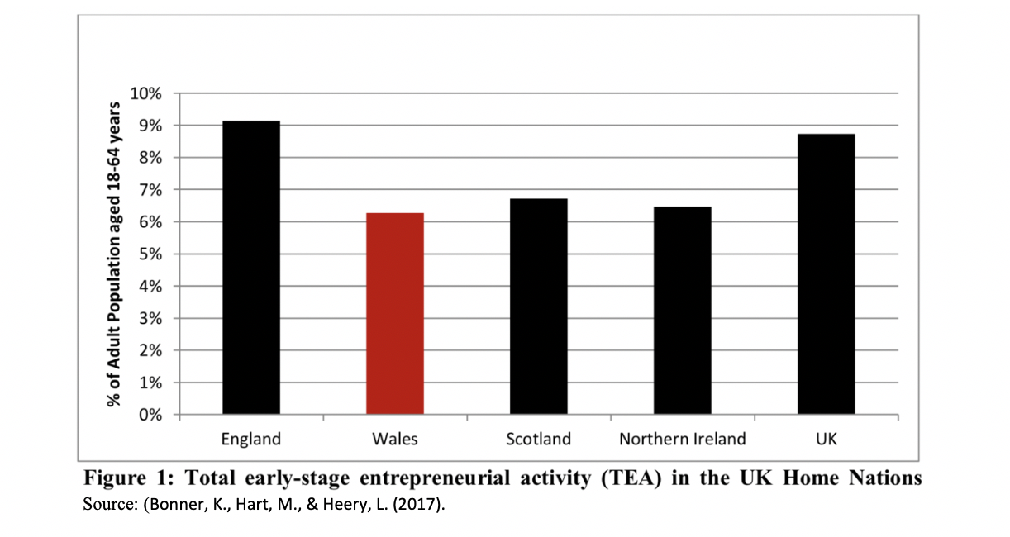

- The Current Market.
There are competitors ,see below;
- Appear Here. (2019),
- We Are Pop Up. (2019),
- Pop Up Shops. (2019).
However the orientation of these sites is focused on short time pop up shops. ‘We Are Pop Ups’ and ‘Appear Here ‘do have a section of the website devoted to renting areas of shops but they are mainly based in London and have no presence in Wales.

- Project Definition.
The project aims to;
- Outline a potential online platform to encourage entrepreneurship: considering data gathered from relevant organisations.
- Promote business collaboration.
- Fill empty retail spaces and re-energise the high street.
- Create sustainable income streams for small businesses/ start-ups.

- Project Objectives.
Objectives will be defined with reference to a SMART framework (Specific, Measurable, Achievable, Realistic and Time Bound) (Lawlor, K. (2012). The project objectives are;
- To determine what information needs capturing in order to design the feasibility study for the project.
- Investigate competition and potential entrepreneurial gateway.
- To interview at least 10 proprietors of local independent shops to gain primary data on their needs.
- To survey at least 10 future self-employed students to find information on potential usage of the platform.
- Research the process of creating the platform/ website.
- To evaluate the prototype platform with a local business and a student sample.

- Project Team.
I will be the consultant on this project. As a consultant ,my role will include identifying areas of weakness and providing recommended solutions (Newton, R. (2010). I have an understanding of the local business environment having previously run a retail business in the area. My time studying undergraduate Business in University of Wales: Trinity Saint David has provided a firm foundation of business knowledge and I have had further business experience as an intern.
The researcher’s academic supervisor will be noted at all stages of the study to ensure that the university’s standards are being met.

Figure 2 below highlights key stakeholders and outlines their roles within the project.
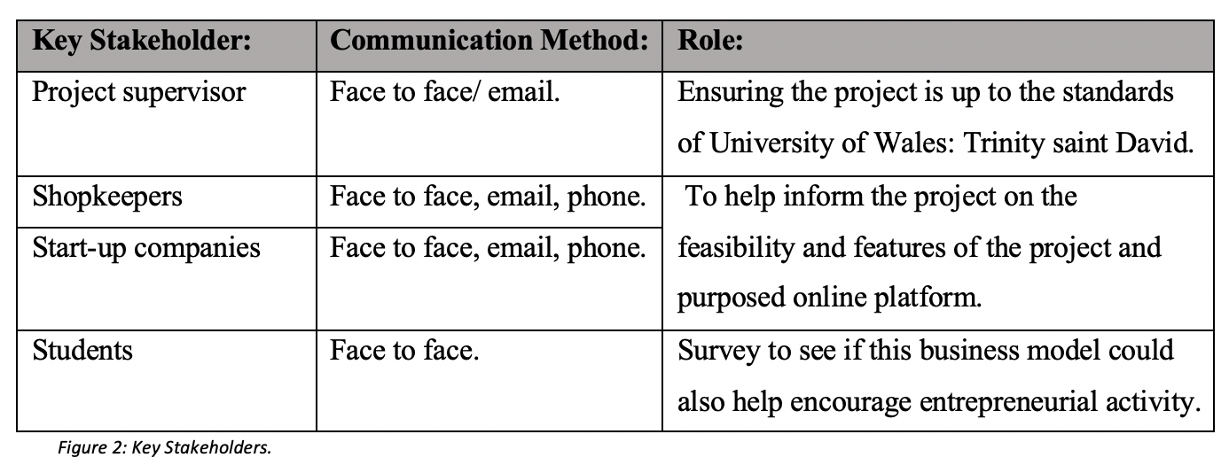

- Costing.
200 hours has been assigned to the project by the Module Handbook. Consultancy fees vary based on experience, region, client and expected outcomes (Consultancy UK. (2019). Fiverr.com (2019) states that freelance consultants’ range in price from £8 - £50 an hour. Therefore a £10 hourly rate would be acceptable at my current level of experience. Estimation of costing in figure 3 below.

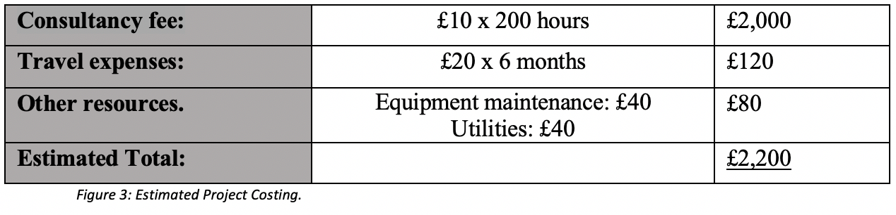

- Project Plan.
Figure 4 outlines the stages needed to fulfil the project. Please refer to Appendix A for full project scheduling.

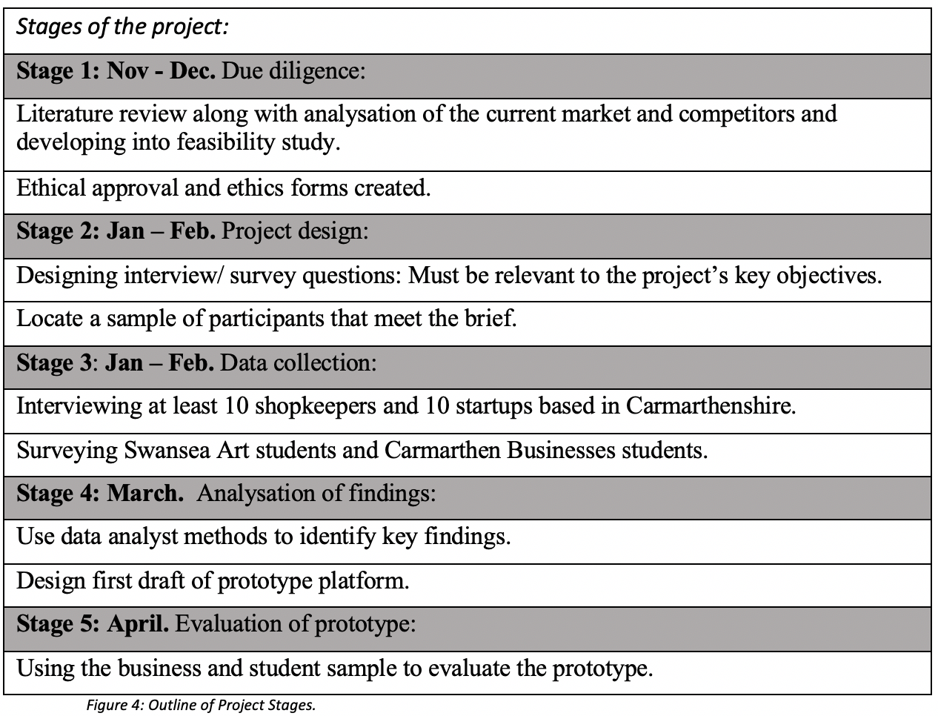

- Methodology.
A mix of qualitative and quantitative research methods will be used for the project. Action research method will allow the researcher to refine their actions (Sagor, R. (2000).
Convenience sampling will be the method to find the shopkeepers and startups because the sample group within the area is small.
Both structured interviews and questionnaires will be used to collect data. This combination will provide both detailed and general information (Moustakas, C. (1994).
The survey will be bilingual and available online as well as in physical print. Voice recording will be used during the interviewing process to aid in transcribing.
The data will be evaluated and pages of the website designed to the specifications of the parties involved.

- Quality, Risks and Ethics.
An ethics form will be completed prior to any primary research to provide details of the project to the participants and to protect the researcher, the participants and University of Wales: Trinity Saint David. This is essential because a lack of ethical approval can affect funding, publication and the validity of results (Gregory, I. (2003).

Potential risks include businesses giving time and the project failing on its deliverables. Also, not being able to attract a large enough sample as there is no immediate benefit to participants.

- Limitations
Limitations of this project include;
- The researcher may not have the technical skills to create a working prototype.
- Participants may not in-vision a clear image of the final deliverable prototype.

- Considering Elements of the Platform.
Appendix B outlines some elements of the platform that will need considering.
This will be extended within the full study. Details of the full resource will be determined through the participants discussions.

- Benefit to the Organisations Involved.
Figure 5 refers to some of the potential benefits to the organisations involved within the project. Full list will be available within the feasibility study.

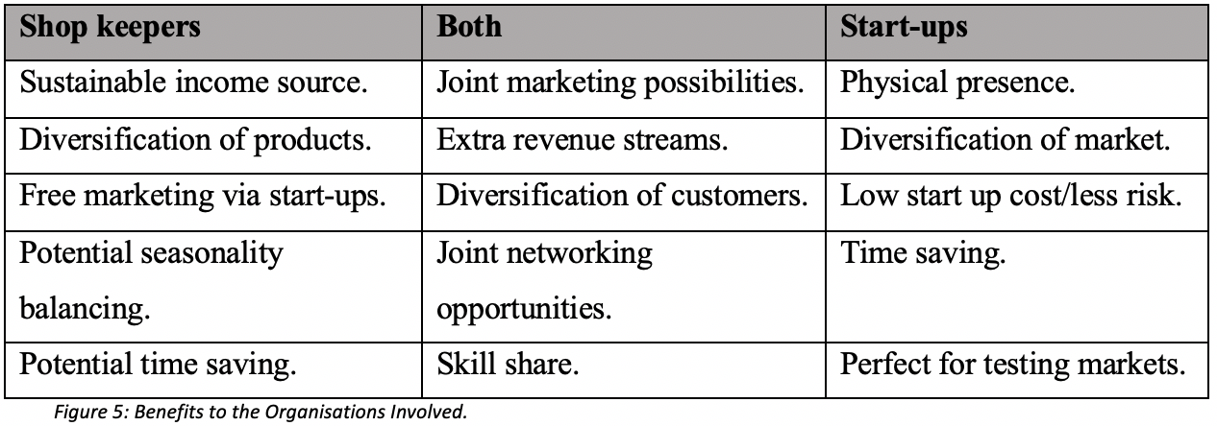

References:
Aldred, T. (2019). What are the benefits of shared office space for SMEs?. https://www.telegraph.co.uk/connect/small-business/business-networks/benefits-of-sharing-office-space/

Appear Here. (2019). Pop Up Shops for Rent, Retail Space, Venues.

https://www.appearhere.co.uk/

BBC News. (2019). Chain shop closures outweigh new stores opening. at: https://www.bbc.co.uk/news/uk-wales-49648242.

Bonner, K., Hart, M., & Heery, L. (2017). Global Entrepreneurial Monitor: Wales. https://gov.wales/sites/default/files/publications/2019-05/global-entrepreneurship-monitor-gem-uk-wales-report-2017.pdf

Clawson, T. (2017). The Size Conundrum - Why Are UK Startups Failing To Scale?. https://www.forbes.com/sites/trevorclawson/2017/05/15/the-size-conundrum-why-are-uk-startups-failing-to-scale/#9d891b23b591

Consultancy UK. (2019). Fees & rates. https://www.consultancy.uk/consulting-industry/fees-rates

Cribb, J., Miller, H., & Pope, T. (2019). One-fifth of self-employed sole traders don’t survive one year, and the majority don’t survive five. https://www.ifs.org.uk/publications/14243

Fiverr. (2019). Business Consultants. https://www.fiverr.com/search/gigs?query=business%20consultant

Gregory, I. (2003). Ethics and research (pp. 1-4). London: Continuum.

Gwilym, E. (2019). Campaigners want more help for high streets. https://www.bbc.co.uk/news/uk-wales-49937323

Lawlor, K. (2012). Smart Goals: How the application of smart goals can contribute to achievement of student learning outcomes. Developments in Business Simulation and Experimental Learning, Vol 39. Pg. 259 – 267.

Moustakas, C. (1994). Phenomenological research methods. London: Sage.

Newton, R. (2010). The Management Consultant: Mastering the Art of Consultancy. Harlow: Pearson.

Nomisweb.co.uk. (2019). Carmarthenshire Labour Market Statics. https://www.nomisweb.co.uk/reports/lmp/la/1946157392/printable.aspx

OECD. (2019). Organisation of Economic Cooperation and Development. http://www.oecd.org/industry/business-stats/

Pop Up Shops. (2019). Rent a Space, launch your idea. https://www.popupshops.com

Sagor, R. (2000). Guiding School Improvement with Action Research. Alexandria: ASCD.

Tanas, J., & Audretsch, D. (2011). Entrepreneurship in Transitional Ecomony. International Entrepreneurship and Management Journal. 7: 431. https://doi.org/10.1007/s11365-011-0189-9

We Are Pop Up. (2019). We Are Pop Up Home. https://www.wearepopup.com/search/spaces/?tenancy=shared

Appendix:

Appendix A: Gant chart timetabling the project.

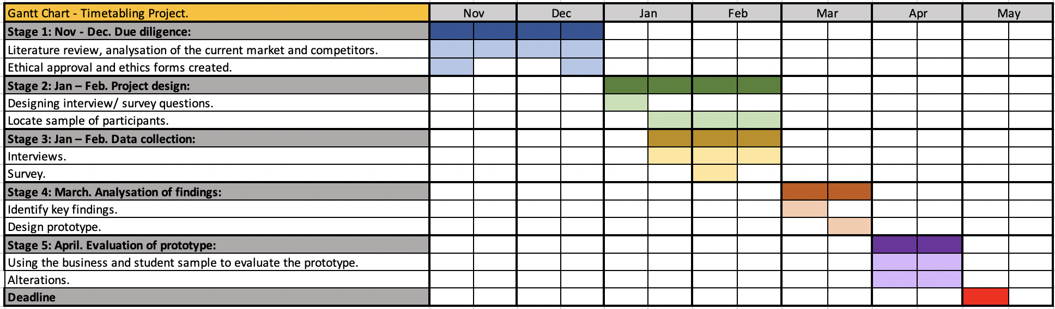

Appendix B: Elements of the platform to be considered.

Payment Options: | Matching Businesses on: | Expectations:
Fixed rate | Industry | Availability
Percentage commission | Ethics | Updating of Stock
Time/skills exchange | Customers | Reliability
Combination of the above | Location | Marketing

