ETHICALITY IN INTERNATIONAL BUSINESS

Module: Global Ethics
Module code: BMBM6008

Student ID: 2207918
Student Name: Vimal Maddichetti
Executive Summary
This is a study that will examine the essence of business ethics and how differences in countries and their internal aspects can create ethical tension in the companies. The study has compared the cultural reflection of China, Japan, and the UK on its businesses. Moreover, real-life cases have made it evident that it is impossible to trade in a global marketplace without compromising ethical principles. It has also been found that the ethically right thing to do would be to abide by all of the laws and regulations in order to make a profit and make a good reputation in public. Further, it is also stated that religion, politics, and culture should be considered and given equal importance by modern businesses in order to make a profit. Finally, in order to save the environment and its people from wrong ethical treatment the businesses should give up on their greed for wealth and focus on ethical morality.

Table of Contents
1. Introduction 4
1.1 Purpose of the Report 4
1.2 Scope and Relevance of the Study 4
1.3 Overview of the Report 4
2. Analysis 5
2.1 Theoretical Framework of Business Ethics 5
2.2 Cultural Influences on Business Ethics 6
2.3 Ethical Challenges in the Global Marketplace 8
2.4 Constraints Imposed by Cultural, Political, and Social Environments 10
2.5 Recommendations 12
3. Conclusion 13
Reference list 15

1. Introduction

1.1 Purpose of the Report
The purpose of the report is to analyse the ethical differences in business across the world, specifically between Asia and Europe and how the differences in their values lead to ethical tension and can cause problems in business.

1.2 Scope and Relevance of the Study
The scope of the study is that it will establish a relationship between how the different cultural values make a huge difference in the ethicality of the same business with changing countries. This will establish a foreground for the research of how the “cultural, political, and social” environments are the primary constraints for establishing the ethics of a business. Ethical tensions will be the primary subject of discussion in this report with mediating factors such as business ethics, cultural dimensions, political and social factors, environmental concerns, and primary CSR related to ethics. These will also be the relevant topics of discussion in the study. The report will study this topic along with support from real-life business examples from all over the world.

1.3 Overview of the Report
The structure of the report will comprise five primary sub points. Firstly, an overview of business ethics will be given and perspectives from various scholars will be discussed. Further, the influence of culture will be discussed in the report. Following this, the ethical challenges that a business might face will be discussed. Moreover, how “cultural, political, and social” factors impact ethicality in different countries will be analysed. Lastly, recommendations for improvement will be provided.

2. Analysis

2.1 Theoretical Framework of Business Ethics
The most simplified definition of business ethics is that it is a set of principles that guide the behaviour and decisions of a company. As stated in the book by Weiss (2021), business ethics refers to the organised and methodical ways of decision-making based on values, rather than depending on distorted perceptions, external pressures, or the quickest and easiest options that may prove more harmful. The author has also identified various layers to the levels of business ethics which is shown in Figure 1.
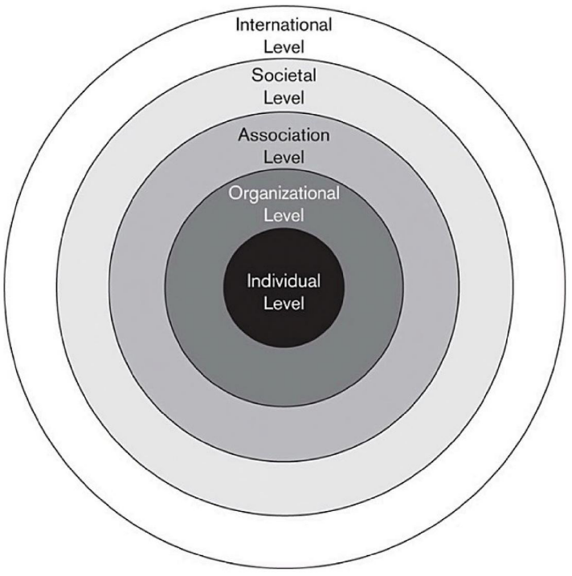
Figure 1: Levels of business ethics
(Source: Weiss, 2021)
In the book, the author also discusses why ethics matters in business. It was established that following business ethics led to the prevention of capital loss for the company along with the prevention of damaged reputation, employee productivity, creativity, and customer loyalty (Weiss, 2021). Similarly, it was also found in the study by Hidayati and Zainurrafiqi (2021) that the ethical behaviour of a company also positively impacts customer satisfaction leading to positive customer loyalty.
Ethical tension is referred to as events in the workplace that give rise to morally troubling questions about practitioners' “uncertainty, distress, or dilemmas”. In ethics literature, there are three primary types of ethical tensions which include “ethical dilemmas”, “ethical distress”, and “ethical uncertainty” (Tengblad and Oudhuis, 2024). The ethical tension is caused when the cultural differences and the sole idea of what ethics is are different in between countries. As stated by Mahbubani the geopolitical tension between the USA and China is also a result of core cultural and ethical differences. For instance, the economic growth of the Chinese community is interconnected with their hard-working ethics and culture whereas for the Westerners it is more about self-confidence and individualism (Rifai, 2022).

2.2 Cultural Influences on Business Ethics
Culture really influences the ethical working of a business since it determines the values of the people running the business. According to Hofstede's different cultural dimensions, the representation of the culture of the areas is very different.
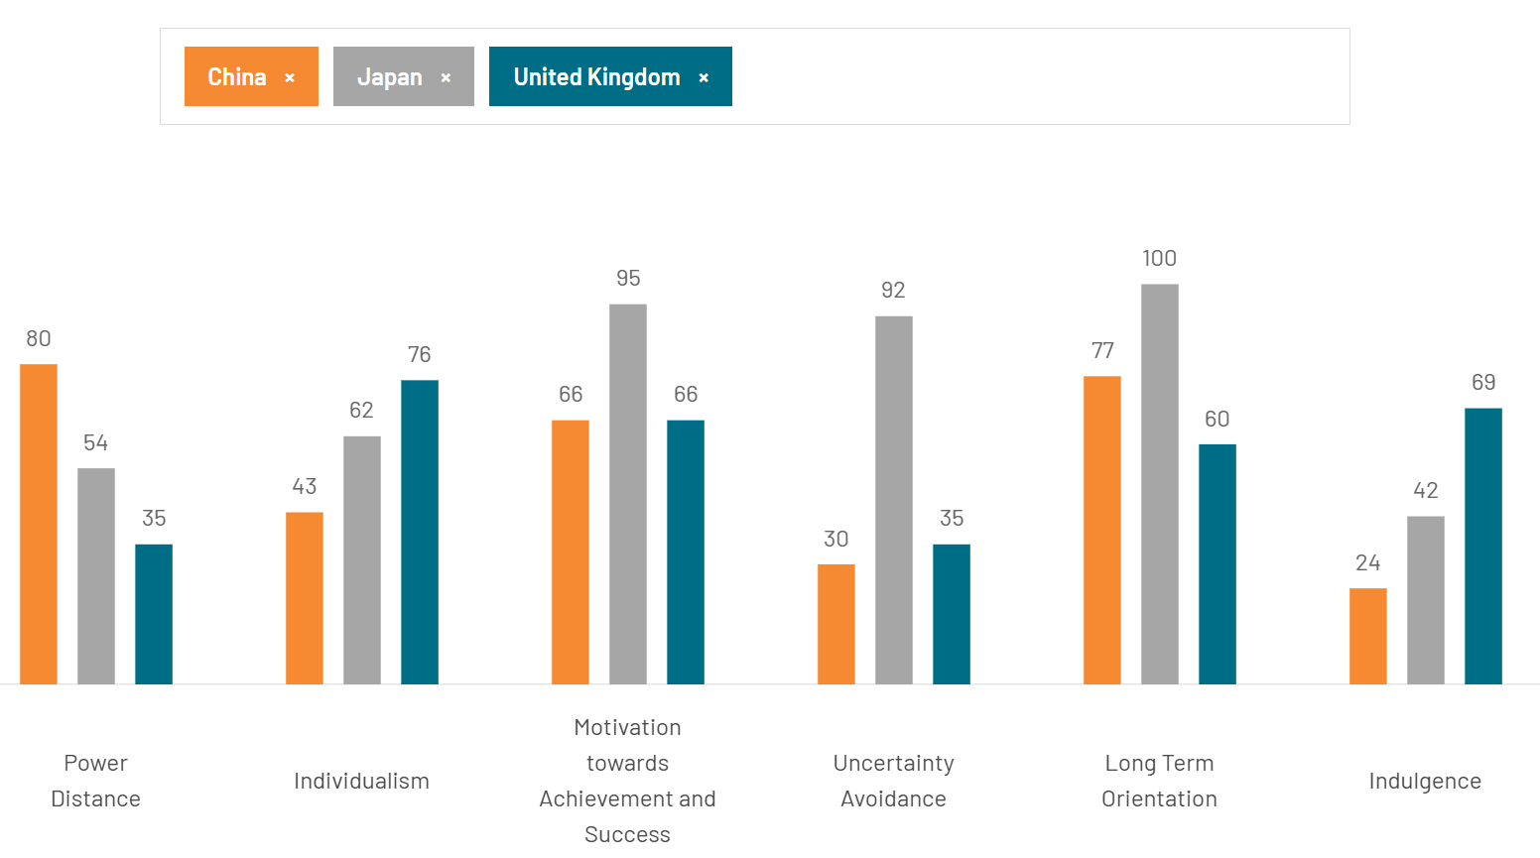
Figure 2: Cultural comparison of China, Japan, and the UK
(Source: The Culture Factor Group, 2023)
As shown in Figure 2, the comparison between the cultural dimensions of China, Japan, and the UK shows that the way culture has influenced each country is very different. For instance, considering the factor of motivation towards achieving success, both the countries of China and the UK are at a score of 66; however, Japan is at 95 which means Japan will do anything to achieve success and might be more in favour of the “Utilitarianism” for its ethics whereas the UK might go for “Rights-based ethics” and China might be more leaning towards “Deontology”. One example of a rights-based ethical business is the NHS from the UK as it provides completely tax-funded services to its population (Timmins, 2023). On the other hand, no company follows any ethical theory solely.
Further, the Asian countries put prime emphasis on the factors of collectivism, long-term orientation, and hierarchy (power distance) whereas the Western countries put emphasis on individualism, risk-taking, and indulgence. For instance, Fuyao a Chinese company focuses primarily on collectivism whereas Amazon is a company that gives importance to individualism. This cultural difference and clash were promptly visible when Fuyao tried to open a subsidiary in the US (Scheiber and Bradsher, 2017).

2.3 Ethical Challenges in the Global Marketplace
There are various factors that determine the ethics of each individual and those individuals then handle the business of many companies reflecting their cultural upbringing and regional beliefs and values in the ethics of the company. Sometimes these ethics can be difficult to club into right or wrong; however, they have a clear wrong outcome. Some of these real-life cases of ethical challenges have been highlighted below.
Bribery and corruption: This is an underlying thing that has been present in the world for a long time. It is when some people use illegal means for the gain of their company or self. In recent times this has increased and morality has almost left the corporate world. An example of this was seen in China when the former “Bank of China” boss was arrested for “bribery charges” (Cai, 2023). Moreover, as China tries to weed out cooperation from its financial industry it finds out that this is a more underlying thing than it appears to the naked eye. Therefore, ethical tension is created between the ones who want to comply with the rightful law and the ones who are ready to do anything for capital gain.
Labour practices and human rights: The violation of labour practices and human rights has been seen in some of the Japanese companies such as “Sony, Panasonic, and Daikin”. This was due to the delayed salary payments to its “Klang-based supplier Kawaguchi Manufacturing Sdn Bhd.”. Moreover, not just these companies it was also reported that recently some of the Bangladeshi employees of the Japanese companies were unpaid for nearly six months (Thomas, 2024). This violated the ethics of following the legal regulations of human and employee rights and thus, created tension among the workers. It is evident that here the companies chose the output of the capital revenue over the output of keeping up with the regulations of human rights.
Environmental sustainability: Tesla is a company that has prided itself on establishing its whole brand on environmental sustainability. Thus, the protection of the environment must come first for the company (Tesla, 2023). However, it was recently reported that the Tesla factory at Fremont has faced “legal and regulatory actions” over environmental issues and violations of environmental sustainability. Moreover, this was not the first time that the company has faced allegations and been convicted for the violation of environmental pollution. In 2022, the company was made to pay a settlement of $275,000 to the “U.S. Environmental Protection Agency” for violating the “Clean Air Act” in the same plant. There was a case in 2021 as well (Baron, 2024). Thus, this brings out the primary question of whether Tesla really is ethically doing right despite its actions benefiting the company in terms of its revenue of “96.8 billion U.S. dollars” in 2023 (Carlier, 2024). The failure of the company to keep up with its environmental CSR is really an aspect of ethical tension created in the company. There is also proof that Tesla’s “green” is not so real (Banal, 2021).
These cases make it more evident that it is impossible to trade in a global marketplace without compromising ethical principles. With the world becoming more capitalist it becomes evident in its working and treatment of the “planet and people” the two factors of maintaining the CSR.

2.4 Constraints Imposed by Cultural, Political, and Social Environments
The cultural political and social environment of a country also impacts the business ethics of the country. With the culture impacting decision-making, political systems impact the business ethics, and social expectations impacting the consumer behaviour all of it is very much present in the world globally. It has been analysed and found in the study by Yan et al. (2021) that the “Confucian culture”, an ancient Chinese culture impacts the research and development (R&D) investment decisions of the company. Moreover, the culture also impacts the behaviour of the market and the risk of innovation in a company in China. Similarly, according to the study by Liu (2021), the creative industry of China and the UK is impacted by the cultural values that are promoted by government policies as well. On the other hand, it has also been found that in the animation industry of Japan culture plays a vital role. As per the study by Ceylan-Dadakoğlu et al. (2022), the produced animes from the Japanese animation industry have reflected Japanese culture in a very strong sense and have taught the world so much more about the culture in Japan. Therefore, culture should be considered by modern businesses in order to be close to their roots and increase profit as well.
Furthermore, as per the article by Chen et al. (2022), it has been stated that the impact of politics on Chinese companies is much more than any other emerging business market in the world. On the other hand, it has also been identified that the government of the UK and the political system of the country have impacted businesses in various ways by establishing laws such as environmental laws that a business needs to abide by in order to be ethically correct. For instance, with banning the use of single-use plastic all of the companies in the UK have stopped using them and have also included the ban in its environmental ethics that needs to be followed. This was also seen in other European companies such as Bluewater which have called for an instant ban on “single-use plastic bottle” sales after finding out how it is harming the water bodies (Bluewater, 2024). In contrast to this Unilever was found to be secretly being against the ban of “plastic sachets” while being in favour of it in the public (Matt, 2022). This shows how even after the establishment of a law by the government of the country the companies are fighting to not follow it and be influenced by it. Therefore, the ethically right thing to do would be to abide by all of the laws and regulations in order to make a profit and make a good reputation in public.
Social expectations do impact the ethics on which a business works. It has been stated by Changar and Atan (2021), that the public's social expectations regarding corporate social responsibility (CSR) were also established by the “Committee for Economic Development (CED)” in the 1970s, which recognised that companies' primary goal is to constructively serve societal needs. For instance, the demand for sustainable products in the UK is increasing. Around 55% of the consumers state that they make choices that are sustainable for the betterment of society (Briggs, 2023). Therefore, reflecting the demands of society the companies in the UK have also changed. The retail market in the UK has grown to 9.2% in 2019 from 2.9 in 1999 (Phoenix Textiles, 2023). On the other hand, this is a bit complicated for China. As per the study by Parsaet al. (2021), in order to meet shifting regional societal expectations and make sure that businesses continue to be responsive to those of global stakeholders, the government of China uses “social organisations” and “social intermediaries” to mediate and facilitate corporate social responsibility (CSR) and its reporting. Thus, the government there shifts the societal expectation of the country on the basis of how the other stakeholders’ countries are reacting; thus, creating similarity between the expectations of the society and the stakeholders making it easy for the companies to meet the ethical demands. This method can be used to dissolve the ethical tension created in the country due to the differing expectations.
Therefore, it has become very evident that religion, politics, and culture should be considered by modern businesses in order to make a profit. Moreover, other considerations such as society, people, and the planet are equally important for a business in order to be successful and ethically relevant.

2.5 Recommendations
It is true that human activities have created a climate emergency, and businesses should also care about it in order to save the environment. This should also be reflected in the ethical standards set by companies all over Asia, Europe, and the rest of the world. To enable this companies should abide by the government-set rules and laws in reality and get rid of corruption and bribery from the business industry. This is a very deep-rooted problem and it needs special attention and dedication of the world in order to mitigate it.
It has been found and stated by many that human greed for wealth and levelling up has led to the destruction of the environment and the humble aspect of humanity that is responsible for upholding ethics. As per Monbiot (2021), we must oppose the search for wealth and level down, rather than concentrating on “micro consumerist bollocks” like throwing away our plastic coffee cups. Therefore, it is recommended that the capitalist nature of businesses should be avoided at all costs and importance should be given to all of the aspects of the ethical responsibility of a company such as people, planet, and then profit.
Lately, all of the diverse regions and their culture should be given importance since diversity is responsible for innovation and appropriate representation of all cultures in a company will lead the environment of the company to be acceptable to everyone and equalise all in the organisation leading to the upholding to ethically correct human rights. In creating these changes ethical tension will inevitably arise and the companies must overcome them by holding a morally right ground and having a non-essentialist perspective.

3. Conclusion
It can be concluded that the ethics that businesses all over the world uphold are lacking in the protection of their people and environment, despite sometimes being capable of doing so. This is just due to the capitalist nature of the businesses which is degrading and ripping them off the ethically right path. The culture, politics, regions, and society all of them impact the businesses. Therefore, collectively all of humanity and businesses should choose the path to be ethically right by being moral and considerate of the people and planet.

Reference list
Banal, T., 2021. How Green Is Tesla, Really?. [online]. Available at: https://www.forbes.com/sites/timabansal/2021/05/13/how-green-is-tesla-really/ (Accessed 8 January 2024)
Baron, E., 2024. Tesla has faced these legal and regulatory actions over environmental issues at its Fremont factory. [online]. Available at: https://www.mercurynews.com/2024/06/26/tesla-has-faced-these-legal-and-regulatory-actions-over-environmental-issues-at-its-fremont-factory/ (Accessed 8 January 2024)
Bluewater, 2024. Bluewater Calls For Single-Use Plastic Water Bottles To Be Banned As New Study Find Wide Contamination Of Water By ‘Forever Chemicals’. [online]. Available at: https://www.mynewsdesk.com/bluewater/news/bluewater-calls-for-single-use-plastic-water-bottles-to-be-banned-as-new-study-find-wide-contamination-of-water-by-forever-chemicals-489521 (Accessed 8 January 2024)
Briggs, F., 2023. Sustainability is more important to 61% of UK consumers than it was two years ago. [online]. Available at: https://retailtimes.co.uk/sustainability-is-more-important-to-61-of-uk-consumers-than-it-was-two-years-ago/#:~:text=55%25%20of%20UK%20consumers%20say,5%20years%20ago%20(16%25) (Accessed 8 January 2024)
Cai, D., 2023. Former Bank of China boss arrested on bribery charges. [online]. Available at: https://www.bbc.com/news/world-asia-china-67119687 (Accessed 8 January 2024)
Carlier, M., 2024. Tesla revenue 2008-2023. [online]. Available at: https://www.statista.com/statistics/272120/revenue-of-tesla/ (Accessed 8 January 2024)
Ceylan-Dadakoğlu, S., Özdemir, A., Dadakoğlu, B. and Özdemir, G., 2022. Student Views on Root Values in Manga and Anime: A Case Study. Journal of Individual Differences in Education, 4(1), pp. 1-24. DOI: 10.47156/jide.1117656
Changar, M. and Atan, T., 2021. The role of transformational and transactional leadership approaches on environmental and ethical aspects of CSR. Sustainability, 13(3), p.1411. DOI: https://doi.org/10.3390/su13031411
Chen, S., Mao, H. and Sun, J., 2022. Low-carbon city construction and corporate carbon reduction performance: evidence from a quasi-natural experiment in China. Journal of Business Ethics, 180(1), pp.125-143. https://doi.org/10.1007/s10551-021-04886-1
Hidayati, N. and Zainurrafiqi, Z., 2021. Empirical study of customer satisfaction and customer loyalty: The role of innovation capability and ethical behavior. Assyarikah: Journal of Islamic Economic Business, 1(1), pp.1-20. DOI: http://dx.doi.org/10.28944/assyarikah.v1i1.212
Liu, Z., 2021. The impact of government policy on macro dynamic innovation of the creative industries: Studies of the UK’s and China’s animation sectors. Journal of Open Innovation: Technology, Market, and Complexity, 7(3), p.168. DOI: https://doi.org/10.3390/joitmc7030168
Matt, O., 2022. Unilever secretly fought ban on plastic sachets it branded ‘evil’. [online]. Available at: https://www.telegraph.co.uk/business/2022/06/22/unilever-secretly-fought-ban-plastic-sachets-branded-evil/ (Accessed 8 January 2024)
Monbiot, G., 2021. Capitalism is killing the planet. the Guardian, 30. Availabel at: https://climateblog.uk/Capitalism%20is%20killing%20the%20planet%20-%20George%20Monbiot%20-%20The%20Guardian%20-%2030%20October%202021.pdf (Accessed 8 January 2024)
Parsa, S., Dai, N., Belal, A., Li, T. and Tang, G., 2021. Corporate social responsibility reporting in China: Political, social and corporate influences. Accounting and Business Research, 51(1), pp.36-64. https://doi.org/10.1080/00014788.2020.1780110
Phoenix Textiles, 2023. Sustainability In The Homewares Market: Meeting Consumer Demand In The UK. [online]. Available at: https://phoenox.co.uk/blogs/updates-inspiration/sustainability-in-the-homewares-market-meeting-consumer-demand-in-the-uk#:~:text=in%20the%20UK.-,Companies%20and%20trade%20bodies%20are%20recognising%20the%20importance%20of%20sustainability,increasing%20demand%20for%20sustainable%20products. (Accessed 8 January 2024)
Rifai, D.S.L., 2022. A Deconstruction of Kishore Mahbubani’s Reconciliatory Thought on the Geopolitical Conflict between the USA and China, pp. 1-22. DOI: https://dx.doi.org/10.2139/ssrn.4019156
Scheiber, N. and Bradsher, K., 2017. Culture Clash at a Chinese-Owned Plant in Ohio. [online]. Available at: https://www.nytimes.com/2017/06/10/business/economy/ohio-factory-jobs-china.html (Accessed 7 January 2024)
Tengblad, S. and Oudhuis, M., 2024. Ethical Tensions in Municipality Management. Scandinavian Journal of Public Administration, 28(2), pp.58-75. DOI: https://doi.org/10.58235/sjpa.2023.12805
Tesla, 2023. Impact Report 2023. [online]. Available at: https://www.tesla.com/impact (Accessed 8 January 2024)
The Culture Factor Group, 2023. Country Comparison tool. [online]. Available at: https://www.theculturefactor.com/country-comparison-tool?countries=china%2Cjapan%2Cunited+kingdom (Accessed 7 January 2024)
Thomas, J., 2024. Japanese electronics giants probe M’sian supplier after delayed salary payments [online]. Available at: https://www.business-humanrights.org/en/latest-news/japanese-electronics-giants-probe-msian-supplier-after-delayed-salary-payments/ (Accessed 8 January 2024)
Timmins, N., 2023. Funding health care in England. INSIGHT. Available at: https://www.instituteforgovernment.org.uk/sites/default/files/2023-09/funding-health-care-england.pdf (Accessed 7 January 2024)
Weiss, J.W., 2021. Business ethics: A stakeholder and issues management approach. 7th edn. Oakland: Berrett-Koehler Publishers.
Yan, Y., Xu, X. and Lai, J., 2021. Does Confucian culture influence corporate R&D investment? Evidence from Chinese private firms. Finance Research Letters, 40, p.101719. DOI: https://doi.org/10.1016/j.frl.2020.101719

