
Network and Cyber Security Essentials (ACCA4024)
Cody John
Applied Computing HND
Lecturer: Clive Prosser
Analysis the Networks and Discuss its Security Postures Report

Table of Contents
Table of Contents 1
1. Introduction 3
2. Challenges and Opportunities in Cybersecurity 4
3. Utilization of Nmap and Wireshark during Reconnaissance Stage 7
4. Cyber-Attacks and Migrations Strategies 9
4.1. How does malware such as WannaCry & TeleRAT Operate 9
4.2. Strategies defending against Whaling and Pharming 10
5. Design a Topology 12
14
6. What technologies can be implemented to enhance network security 15
7. References 16
8. Appendices 18

1. Introduction
Understanding the principles of cybersecurity can come with benefits and challenges. Cybercriminals are becoming a missive problem in the industry as they invest a great amount of time to plan malicious attacks in constructive stages, this can be referenced as the “cyber kill chain”. This can be compiled of strategic resonance in which attackers will gather classified information to investigate weaknesses. Weaponization can also assist as cybercriminals will ascertain useful tools to execute an attack, these tools will exploit the weakness found in the target. Delivery of the attack can then provide the criminal with private data that they can use for their personal gain to apply corporate damage, delay services, blackmail/ransom, or fraud. To make sure that there is no trace. The cybercriminal will eliminate their traces so that engineers cannot link the origin of the attack. These are a few of what can happen if a cybercriminal found weaknesses business. Thankfully there are multiple options to prevent such attacks.

2. Challenges and Opportunities in Cybersecurity
When diving into the complex understanding of cybersecurity it can be challenging as
It takes a great effort to manage, maintain and operate in this time, as technology progresses so does it needs. To assist in keeping integrity to all users, developers create security standards. Such standards are the NIST Cybersecurity Framework v1, which provides an arsenal of tools to businesses and organizations which guides management, protection, and awareness against malicious attacks and preventing reconnaissance for cybercriminals. A survey was conducted in 2016 to see how reliable the NIST framework was, about 70% of respondents felt that NIST cybersecurity framework was the best practice for maintaining compliance with standards such as PCI DSS which is a protective standard for credit card security [1].

When observing the opportunities of using NIST Cybersecurity framework there are five main functions that are critically used for the effectiveness and integrity of the framework [2]. Such standards are:

2.1. Identify
Identifying the potential risks is a key benefactor in the framework as organizational understanding can reduce the risk of systems being compromised, personal data, associated resources, and other private information. Comprehending risks such as identifying the business environment and role in their infrastructure, identifying potential variabilities in associated resources with risk assessments, or identifying the rules and procedures by government schemes and laws, that can be applied for suspected illegal cybercrime activity to business.

2.2. Protect
Outlining protective procedures are crucial and efficient in safeguarding sensitive data. It ensures that there is a layer of reinforced security to limit or stop potential cybersecurity attacks. There are plenty of examples on how to protect the infrastructure of your data, such as controlling staff privileges and awareness to accessibility including physical and remote access, maintaining protective standards to systems, networks, and other assets so that they meet with regulatory business policies and agreements. Establishing data protections that can be applied through risk assessments so that sensitive data is kept concealed.

2.3. Detect
Detection of suspected breaches helps identify the occurrence of cybersecurity attacks.
Alerting the presence of breach can assure that a fast and efficient response is to occur during an event. The best way to prevent such attacks it to apply the following options, such as ensuring that all abnormalities and breaches are detected, and what they risk to the system, implementing stricter monitoring capabilities to demonstrate the effectiveness of protective procedures.

2.4. Respond
Acting towards detected cybersecurity incidents is a key benefactor in reducing the impact of a cybersecurity threat. The respond function supports many uses to contain and eliminate a threat. Such as by communicating to stakeholders, investigators, and Cybersecurity technicians so that during an attack the cybercriminal cannot inflict more damage to the infrastructure. Analysis of effective response including forensic assessments to determine the impact, and to incorporating an improvement plan from occurring or previous events.

2.5. Recover
The Recover function determines suitable actions to uphold resilience plans and to recover any corrupted data, services, systems and assets from a cybersecurity incident. It facilitates the restoration of corrupted data to its normal operations. For example, ensuring that a recovery plan is set to an organization so that when an attempt occurs systems and other utilities are restored and backed up to prevent loss, both internal and external communications are made so that everyone associated is informed that recovery is being made.

3. Utilization of Nmap and Wireshark during Reconnaissance Stage
When defending against cybercriminals is always important to acknowledge that there is an assortment of tools that can be used to prevent an attack in its first stages, cybercriminals use a strategy known as the “cyber kill chain”. Using tools such as Wireshark and Nmap can be useful in identifying and capturing data and traffic flowing in a network.

Wireshark is a packet analyzer that captures incoming packets going through a network. The collected data is used for troubleshooting and investigations in case of a cyber-attack or faulty systems. However, during the reconnaissance stage, a cybercriminal can exploit this tool by capturing sensitive data, such as login credentials, or other confidential information transferred over the network. With this insight, cybercriminals can gather valuable information to locate weaker targets, so that an attack is executed correctly. This is an example I used on the official Wireshark wiki of Wireshark detecting a virus attacking a DSN port, caused by remoteshell riding [3]:
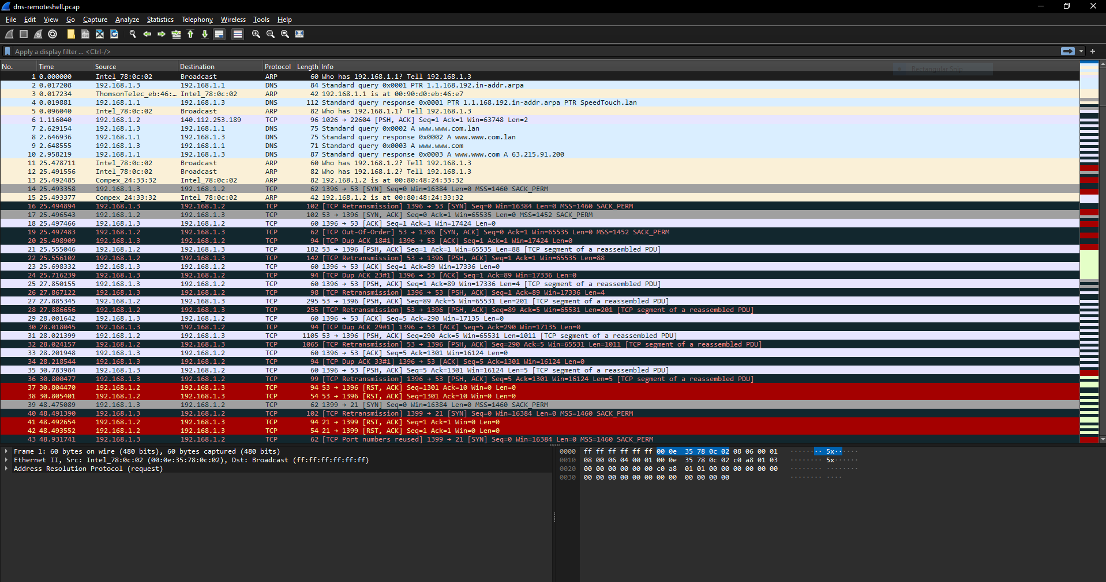

Nmap, on the other hand, is a versatile networking scanning tool that can help cybercriminals collect the foundations of a network topology, discover active users and identify open ports and services. This initially allows cybercriminals to infiltrate a target’s infrastructure so that confidential data can be viewed and accessed. For instance, an open port might indicate a potential entry point for exploitation. Hears an example of Nmap discovering what Operating System the subject is using [4]:
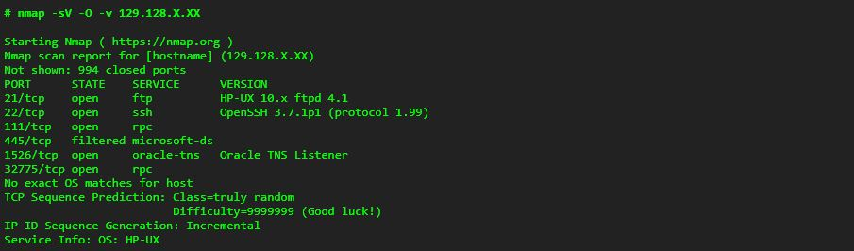

4. Cyber-Attacks and Migrations Strategies

4.1. How does malware such as WannaCry & TeleRAT Operate
In today’s society we have to be cautious about what websites we visit and download from. Websites that are known for containing malware or other illegal data should not be visited. There is a wide range of dangerous malware planted on the internet, such as WannaCry and TeleRAT.

WannaCry is a notorious ransomware crypto worm, that started to emerge in May 2017. It exploits weaknesses in the Windows operating system and barges through networks, encrypting files, and gaining personal or confidential data. It demands payments through either cryptocurrency or Bitcoin. The ransomware was able to use an exploit called EternalBlue which was an intelligence gathering tool used by the United States National Security Agency (NSA). Once a system was infected the ransomware would spread through to other connected systems and networks. An example of how to defend against WannaCry ransomware is to implement a patch update, to ensure that all vulnerabilities are properly addressed and prevented for the malware to further exploit it. Alternatively applying appropriate endpoint protection can also prevent attacks. Deploying advanced endpoint protection can prevent malware infections from spreading further into dedicated systems.

TeleRAT is a type of remote access trojan that disguises itself as a legitimate application for people to download. However, it contains malware that analyses sensitive information that when obtained can be used as blackmail, or demand payments. The program was mainly targeted for android users that take advantage of a type of command line code called telegram, that sends and receives data from a victim’s system. TeleRAT can then access a wide range of information such as SMS messuages, GPS tracking, deletes files, takes pictures and call people. Fortunately, there are ways to prevent these attacks. Enable device lock features such as hard to guess passwords or PIN’s, fingerprints, to make sure that cybercriminals cannot steal or access unauthorized documents. Avoid clicking on suspicious links, especially emails and SMS messuages as cybercriminals use phishing techniques as a way of convincing people to download malicious software [3].

4.2. Strategies defending against Whaling and Pharming
When browsing the web, it is good to consider what you’re visiting and downloading is legit and safe. Cybercriminals often use Whaling and Pharming as a way of stealing data, accessing confidential documents, and unauthorized access to administrative tools.

Whaling is a type of phishing attack that targets high-profile individuals who hold high organizational power, such as executives, head managers, and shareholders. In a whaling attack, cybercriminals typically display themselves as a legitimate member, or associate within the organization by tricking individuals into divulging sensitive information, that can be login credentials, financial data, and access to resources. There is a multitude of tactics that cybercriminals use, such as email spoofing which attackers come across as a trusted source in the organization. Impersonation of high-end associates that fools employes so that information can be sent quickly, and much more. To mitigate against Whaling attacks organizations should implement comprehensive cybersecurity measures, that include employe awareness, suspicious emails, multi-factor authentication to systems and physical locations, and a robust policy toward handling and storage of sensitive information.

Pharming is also malicious software that aims to direct traffic from a normal trusted website to a fraudulent one that tricks the user into thinking it’s legitimate. Unlike other types of phishing attacks, Pharming manipulates the DNS (Domain Name System) and other redirects to lure users to the fake website. Pharming uses a networks infrastructure such as tampering with routers or DHCP servers, injecting malware or manipulating DNS servers to associate a legitimate domain name with a different Ip address, redirecting the user to the fraudulent website. The ultimate goal is to receive sensitive and personal information on a target, so that the cybercriminal can inflict more damage. However, there are plenty of ways to prevent being subjected to fraudulent websites, such as implementing security to DNS servers and networks so that cybercriminals cannot penetrate the extra layer of security. By implementing security extensions, organizations can mitigate the risks in the future. Utilizing Host-based firewalls and monitoring can also lower the risks of an attack, as all devices will have a firewall to prevent internal attacks that cannot spread through the network. Additionally, monitoring will also add another layer of protection as if abnormalities are detected, cyber engineers can quickly act so an attack is prevented.

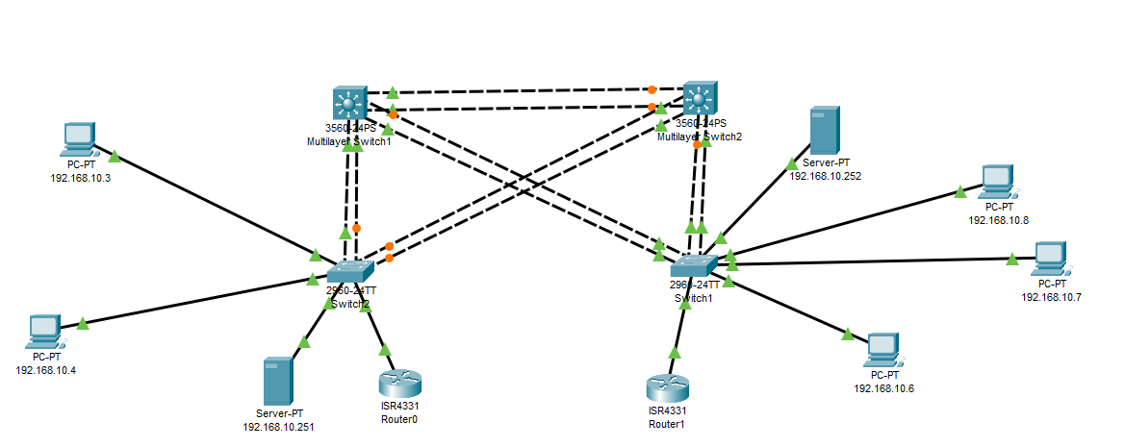
5. Design a Topology

Figure 1 – A crossover topology of two departments, Sales and Accounting.

I have created a cross-over topology that consists of two different departments, Accounts and Sales. As specified, I have eliminated any single point of failure by introducing level 3 switches to the topology, and by crossing the connections over to each department’s switches. Using technologies like Spanning Tree Protocol (STP) creates reliable paths to prevent a wide downtime for the topology. Additionally using level 3 switches to cross over is the best option as observed level 2 switches operate at the data link OSI layer, which more so handles MAC addresses, which is ideal for local networks. However, level 3 switches operate at the network OSI layer, which can perform routing based on IP addresses. This can make them valuable in some scenarios where inner-subnet communication is necessary. Adding to this idea, Trunking is also important to this topology, as it creates a point-to-point link between one or more switches to broadcast data across a network. For instance, incorporating VLAN’s can significantly help a network that operates in separate areas.

Figure 2 – I have assigned ports 1 – 4 to enable trunking mode.

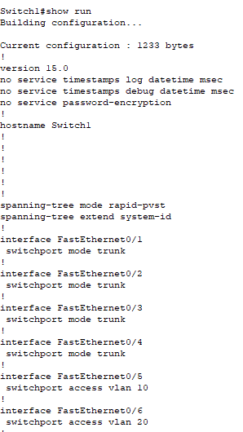
Figure 3 – I used the run command to confirm the configuration of the switch.

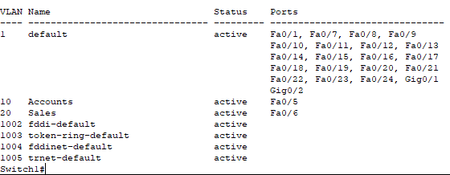
Figure 4 – I have assigned FastEthernet0/5 for Accounts and FastEthernet0/6 to Sales

Figure 5 – Using Switchport trunk to ensure compatibility across interconnected devices.

6. What technologies can be implemented to enhance network security
To enhance a networks security, there are multiple combinations of both hardware and software that can prevent malicious attacks on a network. For software I believe SIEM (Security Information and Event Management) is a useful tool in preventing cybercriminals from accessing, penetrating, and observing networks. It uses AI, machine learning and analytics to determine threats in a network. SIEM is a security tool that helps organizations recognize and address potential security threats and vulnerabilities within a topology. SIEM aggregates, consolidates, and sorts log data from various network devices to identify threats. This outputs high-fidelity alerts that are prioritized by severity, so that a cyber technician knows what to deal with first. Using SIEM is highly beneficial to organizations as it provides integrity and sustainability.

There are plenty of hardware devices that can prevent cybercriminals accessing and attacking networks, such as hardware-based VPN’s. A hardware VPN is a physical device that receives access to a private network from outside the topology’s range. A hardware-based VPN is normally connected to various network components and devices to facilitate a secure connection to the internet. This hardware typically integrates essential components such as firewalls, encryption, NIC’s (Network interface cards), and authentication. Hardware-based VPN’s can integrate with an existing network infrastructure so that deployment, particularly for organizations without extensive expertise in configuring software-based VPN solutions.

7. References

[1] | V. Labs, "NIST Cybersecurity Framework Compliance with AlienVault USM Anywhere," AT&T , 23 Febuary 2024. [Online]. Available: https://cybersecurity.att.com/resource-center/solution-briefs/nist-compliance-usm-anywhere?utm_source=google&utm_medium=cpc&utm_term=kwd-296519336399&utm_campaign=10688983104&source=EBPS0000000PSM00P&WT.srch=1&wtExtndSource=ACS&wtpdsrchprg=AT%2526T%2520AB. [Accessed 23 Febuary 2024].
[2] | NIST, "The Five Functions," NIST, 12 April 2018. [Online]. Available: https://www.nist.gov/cyberframework/online-learning/five-functions. [Accessed 23 Febuary 2024].
[3] | Wireshark, "SampleCaptures," Wireshark, [Online]. Available: https://wiki.wireshark.org/SampleCaptures#viruses-and-worms. [Accessed 01 03 2024].
[4] | Nmap, "Usage and Examples," Nmap, [Online]. Available: https://nmap.org/book/osdetect-usage.html#:~:text=In%20Example%208.2%2C%20Nmap%20catches,details%20from%20an%20FTP%20server.&text=In%20this%20example%2C%20the%20line,the%20OS%20is%20HP%2DUX.. [Accessed 1 March 2024].
[5] | Balaji, "Telegram Bot API abused by TeleRAT Android malware and steal sensitive data from android phone," gbHackers, 24 March 2018. [Online]. Available: https://gbhackers.com/telerat-malware-abused-telegram-bot-api/. [Accessed 27 Febuary 2024].

8. Appendices



