Marketing plan written for
Travelodge

Student Name
Gina Stefanuta

Student ID number
2120011

Marketing Essentials BMIH4005

Lecturer
Gayathri Mudiyanselage

Wordcount: 1332

Table of contents

Introduction.........................................................................................................................3
Situational analysis............................................................................................................ 3
Objectives............................................................................................................................6
Strategy................................................................................................................................6
Tactics.................................................................................................................................7
Action...................................................................................................................................8
Control.................................................................................................................................9
Conclusion...........................................................................................................................9
Reference list.....................................................................................................................10
Appendix............................................................................................................................12

Introduction
Marketing can be described as an activity that includes a bunch of instructions for activities such as offerings, exchanging, creating communicating and others that have value for the customers, clients, partners and society at large (Amoiradis, 2019). Travelodge is considered the largest independent hotel chain that has a revenue of 560 million British pounds in the UK in 2021 (Statista, 2022). The aim of the study is to project a comparative discussion on the marketing strategies of Travelodge in the context of covid-19. The marketing plan is prepared for travelogue to get into a new target market segment to target the premium customers by modifying some of their rook’s access to the UK.

Situational analysis
5C’s
5C’s of marketing
Company | - Great market knowledge  - Number of employees  - Affordable pricing
Collaborators | - Partnerships with different suppliers
Customers | - Business people  - Business travellers  - Leisure Travellers
Competitors | - Holiday inn  - Marriott International  - Premier Inn
Climate | - AI  - VR/AR
Table 1: 5C’s of marketing
(Source: created by the learner)

The marketing environment (Micro)
SWOT analysis
Strengths  - The company is operating in the UK tourism industry since 1985 and knows for more than 35 years.  - The company follows an economic pricing strategy that helps them to have more customers.  - There are 11000 employees working in this company which provides it with great strength. | Weaknesses  - The gender pay gap of the company is 13.8% and the company operates with 73% female employees which goes against The Equality Act 2010.  - While organisations such as Marriott premier inn have diverse portfolios Travelodge sticks with less diversification.
Opportunities  - It is predicted that the UK travel and tourism industry will accelerate growth in 2023 and reach 516 million pounds. Thus, Travelodge can use this opportunity to market its hotels as to the changing needs of the consumers. | Threats  - The UK tourism industry tends to be low-skilled and the EU was a significant contributor to the UK workforce which was impacted negatively after Brexit. It can be addressed by training and development opportunities in Travelodge.
Table 2: SWOT analysis
(Source: Created by the learner)
Segmentation: Travelodge also follows geographical segmentation as the company has its hotels in popular and tourist-attractive places such as Ireland, Spain, UK and others. The company has more than 580 hotels in areas such as Bangor, Aberdeen and others (Travelodge, 2022).
Targeting: Targeting can be illustrated as the technique of breaking a large group of audiences into small segments so that companies can tailor their marketing activities in order to attract them (Huang et al., 2021). Travelodge has multiple target customers such as business personnel, young travellers and others by promoting their different brands to meet the customer's needs such as Travelodge plus, new super rooms and others.
Positioning- Travelodge focuses on attracting business class people as well as travellers who majorly Travelodge for business and follow a premium pricing stagey.
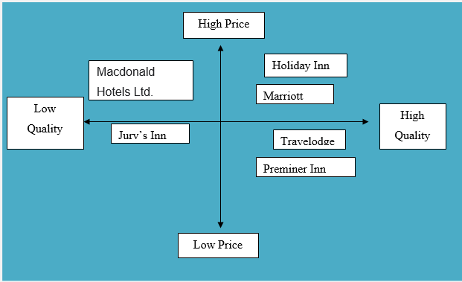
Figure 1: positioning map
(Source: Created by the learner)
Competitor analysis
The porter five force model is widely used in order to analyse the competitive market of companies. Here the model is applied below in the context of Travelodge in order to analyse its competitive market (Please see the Appendix 1).

The marketing environment macro PESTLE (Please see Appendix 2)

Objectives
Specific | Measurable | Attainable | Relevance | Time
To enhance customer reach by 5% | Through the comparison customer reach | Promoting the brand through traditional and digital media | It will help increase brand awareness | 3 months
Increase sales by 3% | Measured by the comparison of sales and revenue | By generating mode leads | It helps amplify the customer base | 2 months
Increase brand awareness by 5% | By taking surveys, and using social media tools. | It can be achieved through digital and social media tools | Helps to generate more leads | 4 month
Table 4: SMART objectives
(Source: Created by the learner)

Strategy

Creating customer value and engagement strategy
The organisation has made itself stand out from other companies as it provides the customers with the mixed experience of working and having leisure time altogether. The value proposition is generated in the market by making the customers unable to work staying within the hotel room and work. Moreover, it also provides customers with customised services at the most economic prices. Bowman's strategic clock can be used in order to identify the pricing strategy of the company through its eight positions. The organisation will use a Hybrid pricing strategy as it will enable them to keep the prices competitive and attract target market customers.
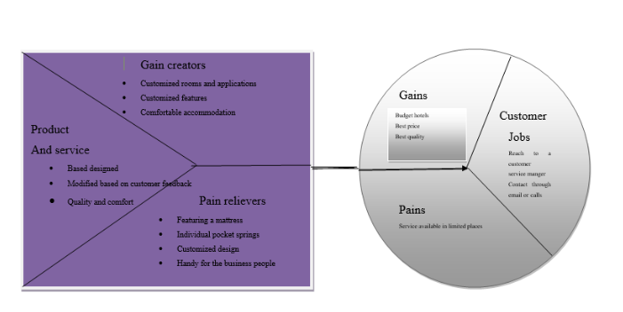
Figure 2: Value proposition Map
(Source: Created by the learner)

Tactics
The marketing mix is a framework that has four key factors such as promotion, pricing, place and product (Al Bade, 2018)
Product- Travelodge was established in 1985 and was perceived as the first value hotel brand that has been launched in the UK. The hotel's travelogue is mostly placed in large towns, major cities, vital roadside areas, seaside and other places (travelogue, 2022). Travelodge has more than 580 hotels and popular brands such as Travelodge plus, new super rooms and others. It has more than 40,000 guest end rooms with 200 cafe and bar restaurants and 14 Travelodge plus hotels (Travelodge, 2022).
Price- It takes 34 dollars to spend one night in Travelodge which suggests that the company follows a value pricing strategy and attracts businessmen and business travellers mainly. The prices keep varying with the demands in the market however the company claims to provide rooms at the lowest costs and the rooms can be amended with a small amendment fee.
Place- It has been found that the UK is counted as one of the most common and desired places for tourist activities. However, it also holds rank among the 50 best counties for non-leisure travel across the world in 2021 (Statista, 2022). Travelodge has hotels in countries such as Canada, the United States, the United Kingdom, New Zealand, and Spain and so on. The website of the company can be used to check the availability of rooms and the rooms can also be booked through external applications such as Airbnb and others.
Promotion-Travelodge uses its digital and social media platforms to market its hotels and services and launched an advertisement campaign of 25 million dollars in 2015. Moreover, the company has also spent more than 100 million dollars in order to modernise thorn hotels and elevate their rooms and equipment which can also be seen in their advertisements. The company also uses social media platforms such as Instagram, Facebook and others. The RACE model can be discussed here to illustrate the promotional tactics that have four stages reach, act, convert and engage (Wilson et al., 2019).
- Reach: Customer reach can be increased through Omni channel
- Act: The brand will interact through social media with the customers
- Convert: Generating leads from social media applications and websites
- Engage: By provisioning value-added services and promotional offers.

Action

Gantt chart
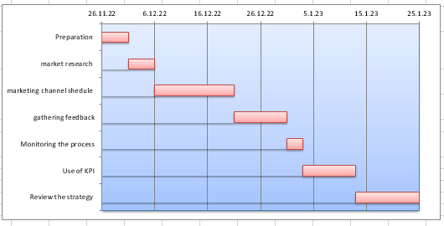
Figure 3: Gantt chart
(Source: created by the learner)
The organisation will include social media and traditional marketing channels as it contains the young generation of people in the UK. The company will also generate traffic from online booking applications, websites and others.

Control
USP of Travelodge: best features and customised hotel rooms (Travelodge, 2022).
Features: Freeview TV, Hansgrohe Raindance 3Jest adjustable shower, iron, Coffee machine and other facilities.
Benefits: No need to visit outside for amenities as all of them are available inside.
KPI: Sales, Feedback from customers, social media reach and others.

Conclusion
To sum up it can be said that as it is forecasted that the travel and tourism industry will accelerate growth in 2023 it will create a great opportunity for Travelodge to increase its customer reach and brand value. The hybrid pricing style, brand image and market reputation will enable the organisation to attract customers. However, it can be mitigated through training and development. The organisation also has the opportunity to use AI, VR and AR technologies to provide customers with the experience of virtual tourism. Finally, it has a great scope to utilise different marketing channels to achieve its objectives.

Reference list
Al Badi, K.S., 2018. The impact of marketing mix on the competitive advantage of the SME sector in the Al Buraimi Governorate in Oman. SAGE Open, 8(3), p.2158244018800838.
Amoiradis, C., 2019. A Theoretical Approach To Sustainable Tourism Marketing. Economics & Law, 1(2), pp.1-7.
Huang, M.H. and Rust, R.T., 2021. A strategic framework for artificial intelligence in marketing. Journal of the Academy of Marketing Science, 49(1), pp.30-50.
Statista.com. 2022. Gender pay gap of full-time tourism and hospitality jobs in the UK 2021, by industry. [Online] Available at:<https://www.statista.com/statistics/899116/gender-pay-gap-full-time-tourism-and-hospitality-industries/:> [Accessed on 26th November 2022]
Statista.com. 2022. Travelodge revenues 2013-2021. [Online] available at:<https://www.statista.com/statistics/429089/travelodge-total-revenue-united-kingdom-uk/:> [Accessed on 26th November 2022]
Statista.com. 2022. United Kingdom: online usage penetration rate 2018-2027. [Online] Available at:<https://www.statista.com/statistics/553589/predicted-internet-user-penetration-rate-in-the-united-kingdom-uk/:> [Accessed on 26th November 2022]
Statista.com. 2022. Gross domestic product (GDP) in current prices of the United Kingdom (UK) from 1987 to 2027. [Online] Available at:<https://www.statista.com/statistics/263590/gross-domestic-product-gdp-of-the-united-kingdom/:> [Accessed on 26th November 2022]
statista.com. 2022. Most popular hotel brands in the United Kingdom (UK) as of the second quarter of 2022. [Online] Available at:<https://www.statista.com/statistics/951262/most-popular-hotel-brands-uk/:> [Accessed on 26th November 2022]
Statista.com.2022. Most well-known social networks in the UK (2022). [Online] Available at:<https://www.statista.com/statistics/1309958/most-well-known-social-networks-in-the-uk/:> [Accessed on 26th November 2022]
Travelodge.co.uk. 2022. Amazing value prices. [Online] available at:<https://www.travelodge.co.uk/about/amazing-value-prices/:> [Accessed on 26th November 2022]
Travelodge.co.uk. 2022. Our company. [Online] available at:<https://www.travelodge.co.uk/about/our-company/:> [Accessed on 26th November 2022]
travelodge.co.uk. 2022. Our Partners. [Online] available at:<https://www.travelodge.co.uk/partners:> [Accessed on 26th November 2022]
Travelodge.co.uk.2022. Where would you like to go? [Online] available at:<https://www.travelodge.co.uk/destinations:> [Accessed on 26th November 2022]
Travelodge.wpengine.com. 2022. Travelodge UK Hotels Limited gender pay disclosure for 2021. [Online] available at:<http://travelodge.wpengine.com/wp-content/uploads/2022/03/Travelodge-Hotels-Gender-Pay-report-2021-FINAL.pdf:> [Accessed on 26th November 2022]
Una.org.uk. 2022. International Literacy Day. [Online] Available at:<https://una.org.uk/international-literacy-day-factsheet:> [Accessed on 26th November 2022]
Wilson, M.A., Odem, M.A., Walters, T., DePass, A.L. and Bean, A.J., 2019. A model for holistic review in graduate admissions that decouples the GRE from race, ethnicity, and gender. CBE—Life Sciences Education, 18(1), p.ar7.

Appendices:
Appendix 1
Forces | Implications
Competitive rivalry | The competitive rivalry is high as there are many companies such as Premier Inn, Marriott International, Hyatt, Holiday Inn and others (Statista, 2022).
Supplier power | The power of suppliers is low as there are severe supply chain management issues which impact the organisations negatively.
Buyer power | The power of the buyer is high as the UK is one of the most popular tourist destinations in the UK for both domestic and international tourists.
The threat of substitution | Threat of substitution is high due to the presence of adequate rivals.
The threat of new entry | Is moderate as it takes huge resources to open a hotel business. However, the construction industry can start hotel businesses easily due to the availability of primary resources.
Table 3: Porter five forces analysis
(Source: Created by the learner)

Appendix 2

Element | Factor | Implications
Political | Brexit: The UK voted to leave the EU in 2016. The process was implemented on 31st January 2020 officially. This incident is known as Brexit (BBC, 2022). | It will impact the travel and tourism industry negatively as the majority of the UK labours were migrant workers from the EU. As a result Travelodge will be negatively impacted in terms of hiring employees.
Economic | Inflation: the inflation rate of the UK was 3.1% in 2021. It has increased rapidly to 10.1% in 2022 (Statista, 2022) | The increased inflation will increase the prices of the hotels and service charges of the products which impact the industry negatively. As a result, the sales and customer base will decrease of Travelodge.
Social | Literacy rate: The literacy rate in the UK is 99% (una, 2017). | The travel and tourism industry will get positively impacted due to higher literacy rates as they will get skilled employees. Thus, it will be easier for Travelodge to train the employees.
Technical | Internet penetration rate: the internet penetration rate of the UK is 91.43% which has leapt to 92.74% in 2022 (Statista, 2022). | The tourism industry will be positively benefit from the increased internet penetration rate as it will enhance the success of marketing plans of the UK. Thus, it will also be beneficial for Travelodge as the company can promote their brands through digital and social media platforms.
Legal | The equality act 2010: it is the prime act that protects the employees and citizens of the UK from any type of workplace discrimination. | The travel and tourism industry is a 14% gender pay gap between the salary of female and male employees. It will impact the tourism industry negatively in terms of retention and hiring. Thus it will also impact Travelodge negatively as the organisation will face challenges in recruiting female employees it will also hinder the brand image of the company.
Environment | The climate protection act 2008: As per this law, the UK government has announced to achieve net Zero by 2050. | The tourism industry will be negatively impacted by this act as they need to upgrade their infrastructure to improve their waste management practices which will result in the expenditure of higher resources. Thus, Travelodge will also get negatively impacted due to more expenditure on CSR activities.
Table 4: PESTLE analysis
(Source: Created by the learner)





