Module code: BMSW4004
Module name: Problem Solving and Decision Making
Task 2 – Report
Student Name: Natalija Petkoska
Student ID: 2026720
Lecturer Name: Maria Popova

Table of Contents
Introduction 3
Employee retention problem in the workplace and its impact 3
Analysing the employee retention problem 4
Solutions to retain the workforce 5
Methods of Decision making to evaluate the best-suited solution 8
Convey the employee retention strategy to the stakeholders 10
Monitoring and reviewing employee retention solutions 10
Conclusion 11
Reference list 12

Introduction
Employee retention is one of the major concerns of the organisation to utilise its resources and ensures the growth of an organisation (Singh, 2019). The study has discovered the employee retention problem of an organisation. It has also discussed the impact of poor employee retention and analysed the issues triggering the low employee retention rate of the organisation. It has demonstrated some theories and opted the Herzberg's two factors theory to provide a solution to the organisation. The study has also highlighted the methods of implementation, conveying the information to the employees and the approaches to monitor and review the solution.

Employee retention problem in the workplace and its impact
The study has discovered that the organisation is experiencing employee retention problems. The organisation dealing with the crisis for a few year and employee retention is a strategy of the organisation to reduce employee turnover by eliminating the causes of employee dissatisfaction. Dissatisfaction among the employees decreases the productivity of the employees and leads them to quit the job. Therefore, enhancing the rate of employees’ retention is vital for employee relations and the productivity of the organisation. Employee retention is necessary for the following reasons:
Employee experience
Experienced employees are assets for companies. The workforce gains expertise in a specific sector if they work at the organisation. The longer period they stay in the organisation they become more aware of their responsibilities and functions of the operation. They can efficiently handle the problems and can find out solutions for the same (Pavlenco, 2021). However, employee departures hamper the process and it de-motivates other employers as well. The management needs to look for new talents which are time-consuming method. It takes time for the recruits to adapt to the new workplace.
Reducing cost
Employee retention is a major strategy of an organisation for cost reduction. The process of recruitment and selection is expensive as it involves various stages including preparation of job description, placing advertisements in various mediums, selecting candidates, conducting the interviews, evaluating the applicants, and after that conducting the induction and orientation procedure. These are elaborated process which incurs cost. Therefore, poor employee retention will lead to the expenditure of the company (Kamalaveni et al., 2019).
Training and development
Training the new employees ensures that the company must train them to perceive their roles and understand their responsibilities in the organisation. However, if the organisation spends resources on the development of the existing workforce it will enhance their skills and increase the overall productivity of the organisation. Therefore, retaining and developing the existing workforce is beneficial for the organisation.
Improve the organisational culture
It takes time to develop the corporate culture of an organisation. Employees need to adapt to the culture it takes time for them to adjust to it. Employee retention also ensures the strong cultural values of the organisation (Wagstaff and Burton-Wylie, 2018).
Improved productivity and customer satisfaction
Employee retention assists the management to gain the trust of the employees as it is a useful tool for improving employee relations. Employee retention is possible when the employees are satisfied with their work. As a result, it helps to develop the motivation of the workforce and improve the level of productivity. Thus, the organisation can ensure the satisfaction of the customers as well.

Analysing the employee retention problem
The study has researched and discovered a few reasons for the employee retention problem of the organisation.
Rigid working Hour
The organisation follows traditional methods for its employee policies. As a result, some of its policies are rigid and conventional. The company maintains its working hour very strictly and the long working hours sometimes generate fatigue among the employees. They are unable to maintain a balance between their professional and personal life. The level of stress is rising in the workforce which is leading them to leave the organisation.
Below standard remuneration
The organisation needs to reconsider the compensation packages of the employees. The salary package of the organisation is below the standard of the industry. It is one major issue of employee attrition in the organisation (Khalid and Nawab, 2018).
Issues with leave
A few outdated employee relation policies of the organisation generate dissatisfaction among the workforce. The leave policies of the company are restricting the employees to take breaks for vacation and other recreational activities. As a result, the employees are unable to take refreshing work breaks to drive away from the monotony of work life. It is affecting their productivity and they are getting de-motivated.
Communication gap with management
There is a gap in communication between the management and the workforce. It is creating barriers to employee motivation as well. The inefficiency and lack of leadership skills of some managers and supervisors are contributing to employee satisfaction (Andersson, 2019).
Lack of employee career growth
Nowadays any organisation needs to provide the opportunity for growth for the employees. Therefore, employee counselling, promotions, appropriate appraisal methods, and other strategies for the employees' growth are necessary for an organisation.

Solutions to retain the workforce
The study has discussed some solutions to retain the workforce based on a few management models. These might enhance the retention rate of the organisation.
Herzberg’s two factors theory
It is a dual-factor theory developed by Fredrick Herzberg. The theory states that some factors in the workplace help to enhance the satisfaction of the employees such as rewards, recognition, opportunities for personal growth, and more. On the other hand, certain factors reduce the level of employee satisfaction and motivation. The dissatisfactory factors are known as hygiene factors such as salary-related issues, work environment, policies of the organisation, relationship with the management, lack of communication and many more (Bevins, 2018).
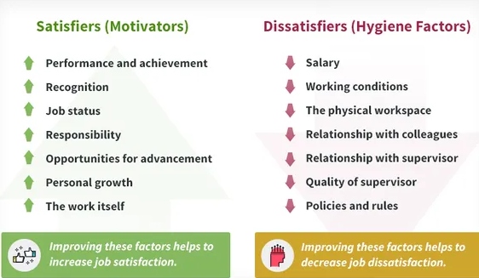
Figure 1: Herzberg’s two factors theory
(Source: Bevins, 2018)

The management can analyse the policies and strategies based on these factors and plan the solution by eliminating the dissatisfaction factors.
Maslow’s hierarchy of needs model
After observing human behaviour Abraham Maslow has suggested that human behaviours vary depending on needs. He has categorised the needs into five stages. It is a triangular model. At the base of the model is a physiological need which describes the basic needs such as the need for shelter, food, air, and water, sleep and similar needs. The next level of needs is safety security and needs which includes health, welfare, and security of property, the safety of laws and regulations and more. The third level of need is love and social belonging needs which includes social recognition, love, family, friendship and similar needs. The fourth level of the need is self-esteem needs which consists of self-respect, achievement, recognition by others and more. The final level of need is the self-actualisation needs which are the need for creativity, self-development, morality, personal growth and similar needs. According to the model once one need is fulfilled an individual move to the next level (Medeni et al., 2018)
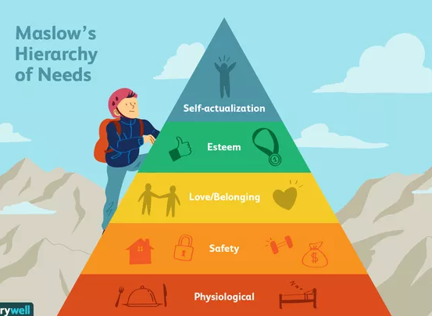
Figure 2: Maslow’s Hierarchy of Needs
(Source: Medeni et al., 2018)

The organisation can evaluate the need of the employees by implementing a theory of needs of Maslow and planning strategies based on the model.

Job Characteristics Model
It is a model developed by J. Richard Hackman and Greg R. Oldham who were psychologists. The theory discovered that certain job-related factors such as task significance, task identity, skill variety, feedback and autonomy enhance the job satisfaction of the workforce. These factors lead to job satisfaction, motivation, and high performance (Sever and Malbašić, 2019)

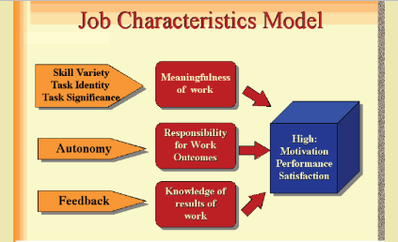
Figure 1: Job Characteristics model
(Source: Sever and Malbašić, 2019)
The organisation can adopt the job characteristics model to engage its employees at work. It supports making and effectively designing the job. The employees also feel motivated and confident to perform the tasks productively.

Methods of Decision making to evaluate the best-suited solution
After analysing all the above theories and models, the study will emphasise opting for Herzberg’s two-factor theory to resolve the employee retention problems of the organisation (Bevins, 2018). It has considered the option of choosing Maslow's hierarchy of need model. However, there are certain drawbacks to the model in the context of the organisation. The model stresses identifying the need of the people. In the context of management, it is difficult to identify the need of the employees and resolve their issues individually. The employees will be at different levels of need and it will be difficult to find out solutions for everyone uniformly.
On the other hand, the job characteristics model is a reflective model for enhancing employee performance. However, the model primarily considers the tasks related factors within a workplace. It ignores the other humanitarian aspects of the workforce such as an analysis of the reasons for employee dissatisfaction.
Therefore, Herzberg,s two-factor theory will provide the best-suited solution for the organisation. It considers both the factors of employee satisfaction and dissatisfaction and tries to provide a solution after analysing all the factors.
Planning and implementation of employee retention solution
The recommended planning and solutions for employee retention are based on the model Herzberg’s two-factor theory. Therefore, it is vital to discover the hygiene factors or the factors which are de-motivating the employees (Bevins, 2018). The study has also discussed certain factors such as rigid working hours, substandard remuneration, communication gap with management, issues related to leaving, and lack of career planning for the workforce. Since the major issue of employee retention is identified the management can implement the satisfier factors to resolve those issues.
Flexible working hour
The organisation needs to restructure its policies to offer employees more flexibility as per the need of the modern era. The working hours can be divided into shifts so that the employees can select the shifts as per their convenience. Removing the hygiene factor of the rigid working hour will enable employee satisfaction.
Restructuring the compensation policies
After reviewing the compensation policy, the organisation can conduct market research to recognise the standard salary of the industry. It can restructure the compensation policy as per the market standard. Eliminating the problem related to the compensation will help to implement the satisfier factors and will motivate the employees at work.
A transparent two-way communication system
Two-way communication is very important for the organisation (Men and Yue, 2019). Implementation of a transparent policy for two-way communication will abolish the dissatisfaction of the communication gap and the employees will become satisfied as they can interact and provide feedback to the management. They will feel that they are part of the management it will act as satisfier for the workforce.
Flexible leave policy
It is necessary the drive away from the monotony at work and refreshes the employees to restore their mental health. Implementation of the flexible leave policy will eliminate the hygiene factor related to the mental health of the employees and will ensure the motivator factor for the employees (Men and Yue, 2019).
Career planning and growth
Career planning of the employees is crucial to ensure their growth within the organisation. By implementing career planning, systematic appraisals, and promotion policies the organisation can eliminate the hygiene factor of lack of career opportunities for the employees. On the other hand, implementation of career planning will enable the satisfiers and motivate the employees (Khalid and Nawab, 2018).

Convey the employee retention strategy to the stakeholders
The policies for the retention of employees need to be communicated to the workforce effectively. The following steps can be taken to cover the new policies for the employees.
- Arranging a company-wide all-hands meeting and announcing the changes of policies in front of the workforce can be productive. The process of implementation also can be explained to the employees.
- It will also provide the opportunities to answer all the queries of the employees. As a result, there will be no scope for doubts.
- Conveying the timeframe of the implementation of the new policies to generate transparency.
- Generating official mail by conveying the information is an essential part of the process
- Maintaining minutes and memos of the meeting and keeping an official record are also vital for the effectiveness of the process (Khalid and Nawab, 2018).

Monitoring and reviewing employee retention solutions
It is significant to maintain employee retention metrics to discover and review the rate of employee retention. It is a way of calculating the number of employees who have left the organisation in a particular timeframe and subtracting them from the total employees and then finding out the aggregate by division (Khalid and Nawab, 2018). Regular communication will also be effective to get feedback from the employees about the new solution.

Conclusion
In the conclusion section, it can be stated that it is vital to retain the employees to sustain the growth of the organisation. The study has demonstrated the importance of employee retention in the context of an organisation and suggested various approaches and theories restructure the policies of the organisation and enhance employee satisfaction to retain the workforce.

Reference list
Andersson, R., 2019. Employee communication responsibility: its antecedents and implications for strategic communication management. International Journal of Strategic Communication, 13(1), pp.60-75.
Bevins, D.T., 2018. Herzberg's two factor theory of motivation: A generational study.
Kamalaveni, M., Ramesh, S. and Vetrivel, T., 2019. A review of literature on employee retention. International Journal of Innovative Research in Management Studies (IJIRMS), 4(4), pp.1-10.
Khalid, K. and Nawab, S., 2018. Employee participation and employee retention in view of compensation. SAGE Open, 8(4), p.2158244018810067.
Medeni, T.D., Aydın, A., Medeni, T. and Soylu, D., 2020. DEVELOPMENT OF A NEEDS HIERARCHY FOR ORGANIZATONS TO COMPLEMENT NEEDS HIERARCHY FOR INDIVIDUALS IN TODAY’S DIGITAL AGE. In The International Scientific Conference of Librarians Western Balkan Information and Media Literacy Conference.
Men, L.R. and Yue, C.A., 2019. Creating a positive emotional culture: Effect of internal communication and impact on employee supportive behaviors. Public relations review, 45(3), p.101764.
Pavlenco, T., 2021. EMPLOYEE EXPERIENCE MANAGEMENT IN MODERN CONDITIONS. DEVELOPMENT OF MODERN ECONOMIC SCIENCE IN THE CONTEXT OF DIGITALIZATION, p.98.
Sever, S. and Malbašić, I., 2019, November. Managing employee motivation with the job characteristics model. In DIEM: Dubrovnik International Economic Meeting (Vol. 4, No. 1, pp. 55-63). Sveučilište u Dubrovniku.
Singh, D., 2019. A literature review on employee retention with focus on recent trends. International Journal of Scientific Research in Science and Technology, 6(1), pp.425-431.
Wagstaff, C.R. and Burton-Wylie, S., 2018. Organisational culture in sport: A conceptual, definitional and methodological review. Sport & Exercise Psychology Review, 14(2), pp.32-52.

