  Component One: Student Journal (learning log) 750 words +/- 10%  Contribution to Overall Module Assessment: 25% | Student No: | Ipsita Patra 2231297
 | Module Title: | Hotel Administration and Front Office
 | Module Code: | BMIH4004
 | Lecturer: | Muhammad Cassamo
Introduction
Front desk personnel are instrumental in guaranteeing that each visitor has an exceptional experience throughout their sojourn at a hotel. The guest-residents' interactions throughout their stay, including check-in, exit, and the entire stay, have a significant impact on the hotel's reputation, guest satisfaction, and the creation of a favourable first impression for new guests. Although most hotels look for specific skills and qualities in their front desk employees, such as a comprehensive comprehension of providing outstanding customer service, the precise demands may differ depending on the hotel's configuration and the varied requirements of its clientele (Bardi, 2021). Certain essential skills are required of individuals employed at the front desk of a hotel. Following explanations are given according to the Gibbs reflective model to explain my learning and experiences during this journey.

Description - What Happened
My first experience in the hotel sector entailed working in the front office. Interacting with visitors throughout the check-in process and answering their questions made clear how important good communication is. I learned from these exchanges how important it is to be kind and clear in order to provide guests with a great experience (Abbott and Lewry, 2014). For instance, during a hectic check-in, I found that prompt and accurate communication was crucial to making sure visitors had a warm and seamless welcome experience.

Emotions: What emotions did I experience?
Throughout the early stages, I encountered a range of sentiments—apprehension regarding the management of numerous obligations and eager anticipation of the novel educational encounter (Weick and Sutcliffe, 2011). It was impossible to avoid the palpable pressure to maintain a professional and cordial demeanour while performing efficiently (Bardi, 2021). Nevertheless, as each engagement progressed, my self-assurance and comfort level increased, specifically in regards to attending to visitor queries and delivering aid.
Evaluation: What aspects of the event worked well and poorly?
My capacity for flexibility and comprehension of the various requirements of guests was significantly improved as a result of the exposure to the varied visitor interactions that were provided by the experience. On the other side, the most difficult part was handling many duties at the same time, which required much enhanced organisational and multitasking abilities in order to properly manage a variety of obligations (Baum, 2012).

What are some important lessons that may be drawn from the experience?
The event brought to light the crucial significance of refining organisational abilities and enhancing one's ability to juggle several responsibilities inside the front office. Gaining these abilities is crucial for both one's own personal development and for enabling a more seamless and effective guest service experience. (Baum and Devine, 2017). Acknowledging the criticality of prompt and precise decision-making, particularly in high-stress circumstances such as traveller inquiries or check-ins, emerges as an essential element requiring enhancement.
In conclusion, what are some things that I might have done differently or additionally?
When I think back on the experience, I see that taking a more methodical approach to some problems would have considerably increased my productivity. For instance, if the workspace had been more properly organised, the check-in procedure might have been shortened, which would have improved guest service and the overall experience (Blue and Harun, 2013).
Action Plan: In the event that it occurs again, what steps will I take?
In light of what lies ahead, I want to focus my attention into actively strengthening organisational abilities by reorganising and improving the workplace (Rudd, 2015). In addition, I want to seek the help and insights of experienced coworkers in order to gain efficient ways for handling numerous activities concurrently, which will ultimately result in a more streamlined work flow and an improved experience for the customers. Furthermore, I aim to actively seek opportunities for ongoing learning and skill development to continually improve my performance in the front office (Shin et al, 2019).

Conclusion
Undoubtedly, the first interaction holds immense importance as it shapes visitors' initial perception of an establishment. In the context of hotels, the front desk staff serves as the primary point of contact for guests (Bardi, 2021). This team bears the crucial responsibility of delivering exceptional customer service to all hotel guests. Given the multiple tasks they handle simultaneously, these employees must adeptly and swiftly manage various responsibilities, showcasing effective and efficient performance, particularly under pressure.

References
Abbott, P. and Lewry, S. (2014) Front office. Routledge.
Bardi, J.A. (2021) Hotel-Front-Office-Management.
Baum, T. (2012) Skills and training for the hospitality sector: a review of issues. Journal of vocational Education and Training, 54(3), pp.343-364.
Baum, T. and Devine, F. (2017) Skills and training in the hotel sector: The case of front office employment in Northern Ireland. Tourism and Hospitality Research, 7(3-4), pp.269-280.
Wang, D., Park, S., and Fesenmaier, D. R. (2018). The role of smartphones in mediating the touristic experience. Journal of Travel Research, 57(1), 52-66.
Word Count: 718

Component Two
Contribution to Overall Module Assessment: 25%
Trip Advisor Review Response 150 words +/-10%
Dear Robert,
Thank you so much for such a great response. We appreciate your genuine response and your review means a lot to us as you mentioned our hotel as your second home. Our team of Ibis Nottingham Centre feels assured that we’ll meet you soon to offer you better service than your previous stay. As you have mentioned that we offered clean bed and room, we hope we can offer better travel experience in the near future (Fallon and Rutherford, 2011).
Our team will gladly welcome you with warmth and kindness every time you visit us with seamless technology and improved infrastructure.
Kind regards,
Ipsita Patra

Screen shot of Trip Advisor review used-
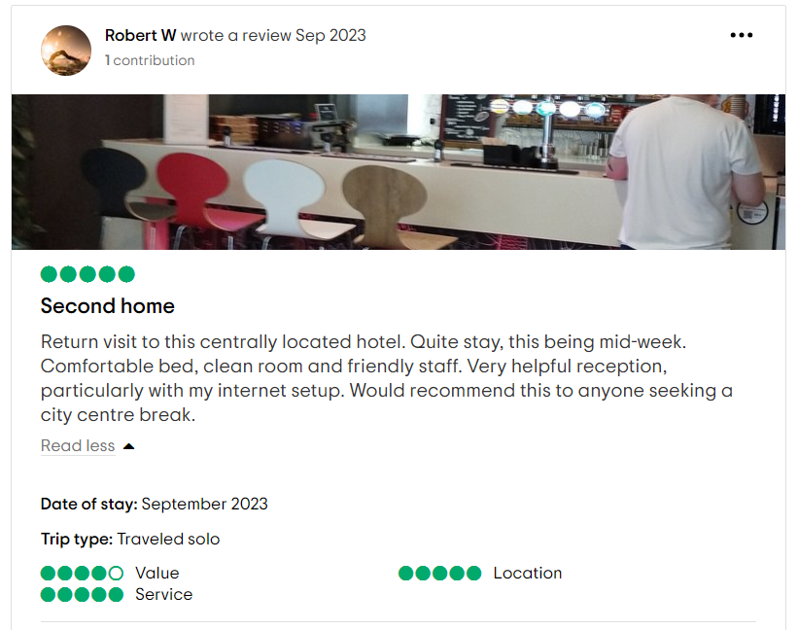
Letter of complaint response 500 words +/- 10-%
Dear Mr Ronald Federick,
I hope this letter finds you well, and I want to begin by expressing my sincere apologies for taking the time to share your feedback regarding your stay at our hotel. We value in your opinion and consider your input invaluable in our ongoing efforts to enhance the quality of services. I would like to extend our sincerest apologies for the inconveniences and disappointments you experienced during your stay on Saturday, 26th August in 205.
First and foremost, I would like to address your concerns regarding the quality of breakfast on Sunday morning. We understand that the satisfying meal is important to kick start your day and I am deeply sorry that you found them to be cold and tasteless. This is certainly not the level of service we strive to provide (Tesone, 2009). I assure you that we are already taking steps to improve our breakfast services to ensure that such issues will never occur again. Your feedback has been shared with our kitchen and service staffs and we are working diligently to enhance the quality of our breakfast offering.
I also want to express my deep apology for the disturbance of experience to do to the crying baby in the neighbouring room. It is our responsibility to ensure a peaceful and comfortable environment for all our guests (Vallen, Vallen, and Jerome, 2012). We regret that we fell short in this regard and we are in the process of reviewing our home allocation procedures and noise reduction facilities So that in the future such so that such inconveniences may not offer affecting our guest in future.
Regarding the trendiness of room 205, I am extremely disappointed that the condition of the bathroom and toilet was subpar. Hygiene is a paramount importance to us and we will take this matter very seriously. I assure you that we will reinforce our cleaning and inspection procedures to ensure the rooms are incredibly clean and hygiene for all our guests.
Your feedback is important to our own point commitment to improve our guest services. We truly value your input and use your comment to drive positive changes within our establishment. We appreciate your understanding and patience as we work to rectify the issues you have raised.
In light of the problems countered, I would like to offer You our sincerest apologies and the gesture of goodwill. We would like to invite you for a complimentary buffet lunch at our hotel to experience the improved services that we are implementing. Please contact our reservations team to arrange this at your convenience.
I thank you for bringing this matter to our attention. Your concerns have not fallen on deaf ears and we are taking immediate steps to address them. We hope to regain your trust and welcome you for a more constant experience in the near future.
Thank you for choosing our hotel, Mr Frederick. We look forward to having opportunities to serve you better during your next visit.

Best regards,
Ipsita Patra
Assistant General Manager
Ibis Nottingham Centre

Component Three:
Contribution to Overall Module Assessment: 50% (1000 words +/- 10%)
Writing in essay format

Element 1 – Pre-Arrival

when the process of hotel industry is talked about, it encompasses 4 different stages. Each stage is crucial for successful guest stay. Pre arrival, Arrival, duration of stay, and departure are the names. Effective management of each stage is important to ensure guest satisfaction, loyalty, overall success of the hotel. That is, it will revolve around describing this four stages.
Arrival Stage sets the foundation of guest experience and plays an important role in shaping their perception of the hotel. Effective management of this step involves different elements. It is segmented into three parts, reservation management, guest data collection, and pre-arrival communication. Reservation management is important as it recordes all the information before a guest arrives. Beck et al., (2016) emphasised on the seamless booking process is through various channels such as hotels, website, third party platforms, direct contact etc. It is seen in Marriott International Hotels robust online reservation system which allows guests to choose room, make special requests, and receive confirmation e-mail promptly. The collection of guest information is also important for personalising their experience. I report by Casavana and Brooks (2018), Presented that hotels can employ GRM system to gather data and create profile. Ritz-Carlton uses comprehensive guest database to track guest preferences and ensure personalised services upon arrival. Effective communication before guest arrival is also important for managing expectations. Kim and Kim (2020), emphasised the importance of sending welcome emails or messages providing useful information about the hotel and its services. Hotel excels in this area by spending personalised pre-arrival emails that includes information on local attraction, weather updates and personalised greeting.

Element 2 – Arrival

This stage marks the beginning of guests on-site Experience. Of this stage is important and vital to make a lasting first impression. Effective check in process is crucial in setting a positive tone for the stay. As discussed by Sigala (2018), The implementation of mobile check in and check out, Keyless entry options have become incredibly popular among the guests. For instance, the mobile app developed by Accor Hotel allows guests to check in on-line, access their room and even make request for local services or housekeeping. Welcome and personal greeting can significantly import a guests perception of their stay. Tussadiyah (2016), Highlights that hotel staff interpersonal skills and genuine hospitality is required in this regard. The Four Seasons Hotel and Resorts are renowned for their warm welcome, with staff trained to address guests by name upon arrival. Allocating room based on guest preferences whenever possible enhances satisfaction. Hence, a literature presented by O’Neil and Matilla (2016) suggested that the use of predictive analytics process can help a hotel to get better review. The Cosmopolitan of Las Vegas, for example, users guest started to provide some preferences ensuring a tailored experience.
Element 3 – Duration of stay

The duration of stay is a critical phase in the guest cycle. It requires continuous attention to meet and exceed guest expectations. Providing frequent and efficient services during stay is fundamental. Research by Ryu et al., (2019) highlights the importance of service quality and responsiveness. Even the Hilton Hotel offer Butler service to capture guests need 24/7 showcasing an exemplary service. Sigala (2018), Note that personalization involves tailored services, amenities, and recommendation. The level of satisfaction of guest during their stay also depends on personalised service. The ability to customise the guests experience according to their preferences is growing trend in the hotel industry. The InterContinental Hotels Group utilises the IHG Rewards programme which offers personalised experiences and amenities based on the guest preferences and loyalty status. Finally, engaging with guests during this stay and seeking feedback can also lead to improvement. By valuing real time feedback can help a hotel to identify any loopholes. The Peninsula hotels use tablets in guest room, allowing guests to provide feedback instantly that helps in addressing issues promptly and enhancing their experiences.
Element 4 – Departure

The departure stage represents the culmination of a guest stay. It is vital to leave a lasting positive impression to encourage repeat visit and word of mouth recommendation. First, the checkout process needs to be seamless and efficient. Kim et al., (2020) Suggests offering express check-in check-out option. The Radisson Blue Edwardian London has. The swift checkout process where guests receive their invoice via e-mail. Everything ques in the font desks. Second, the departure stage provides an opportunity for a font farewell and the poster engagement. Expressing gratitude and inquiring about the guest experience is impeccable. The Ritz Carlton takes extra step of sending personalised thank you notes and conducting post stay surveys to gather feedback. Offering incentives to encourage loyalty and repeat visit is a growing trend. A study by Wang et al., (2018) Highlights the importance of loyalty programmes in guest retention. The Marriott Bonnevie programme, for instance, provide exclusive benefits and rewards such as room upgrade and free nights to loyal guests.
In conclusion, managing the four stages of the hotel guest cycle requires careful attention to various key elements, as outlined in the literature and illustrated by industry examples. From pre arrival preparation to departure, each stage place by vital role in shaping against overall experience. Effectively managing these stages can lead to higher guest satisfaction, increased loyalty and positive impact on hotels, reputation and bottom line. The hospitality industry need to continuously focus on refining these elements that undoubtedly contribute to the ongoing evolution of the guest cycle.

References
Abbott, P. and Lewry, S. (2014) Front office. Routledge.
Bardi, J.A. (2021) Hotel-Front-Office-Management.
Baum, T. (2012) Skills and training for the hospitality sector: a review of issues. Journal of vocational Education and Training, 54(3), pp.343-364.
Baum, T. and Devine, F. (2017) Skills and training in the hotel sector: The case of front office employment in Northern Ireland. Tourism and Hospitality Research,7(3-4), pp.269-280.
Beck, J. D., D'Amore, L. L., and Ye, Q. (2016). Enhancing the customer experience in hotels: A study of luxury hotels in the United States. International Journal of Hospitality Management, 55, 51-59.
Blue, G.M. and Harun, M. (2013) Hospitality language as a professional skill. English for specific purposes, 22(1), pp.73-91.
Kasavana, M. L., and Brooks, R. M. (2018). Managing Front Office Operations. American Hotel & Lodging Educational Institute.
Kim, H., and Kim, S. Y. (2020). The impact of pre-arrival hotel email communications on guest satisfaction and behavioral intentions. International Journal of Hospitality Management, 84, 102316.
Kim, J. J., Schwartz, Z., and Marans, R. W. (2018). Assessing the feasibility and implications of real-time guest feedback in hotels. International Journal of Contemporary Hospitality Management, 30(10), 3125-3142.
O'Neill, J. W., and Mattila, A. S. (2016). Hotel room assignment with personalized amenity requests. International Journal of Hospitality Management, 54, 69-75.
Rudd, D. (2015) Incorporation of Communication Skills in Hospitality Education. International Journal of Learning, 12(7).
Ryu, K., Lee, H. R., and Kim, W. G. (2019). The influence of the quality of the physical environment, food, and service on restaurant image, customer perceived value, customer satisfaction, and behavioral intentions. International Journal of Contemporary Hospitality Management, 31(1), 242-258.
Shin, H., Perdue, R.R. and Kang, J. (2019) Front desk technology innovation in hotels: A managerial perspective. Tourism Management, 74, pp.310-318.
Sigala, M. (2018). The impact of artificial intelligence on the tourism and hospitality sector. Journal of Tourism Futures, 4(1), 30-53.
Tesone, D. (2010). Principles of management for the hospitality industry. London: Routledge.
Tussyadiah, I. P. (2016). Factors of satisfaction and intention to use peer-to-peer accommodation. International Journal of Hospitality Management, 55, 70-80.
Vallen, G.K.and Vallen, Jerome J. (2014) Check-in check-out :managing hotel operations Ninth edition.; Pearson new international.

