The effect of EGR on combustion and exhaust emissions characteristics of a spark-ignition system
Irfan Yaqoob
BSc (Hons) Automotive Engineering Exhibition Paper
University of Wales Trinity Saint David

ABSTRACT

This paper reports on the exhaust gas recirculation (EGR) technique which is widely used in automotive spark injection engines and other engines, because it provides an effective mean of reducing nitrous oxide emissions (NO_{x}) (Serrano, 2005). Recirculating exhaust gas through the EGR valve into the intake manifold lowers combustion temperature and reduces emission levels of oxides of nitrogen (Knowles, 1984). This experiment has been conducted with and without EGR to analyse the benefit of EGR by applying fixed throttle positions of 100%, 50%, 25% at measurements taken at point between 1000-5000 revolutions per minute (RPM) on the dynamometer. The practical investigation was conducted by the monitoring of exhaust gases, utilising the exhaust gas analyser in conjunction with running the VW Lupo 1 lt (2001) petrol engine on the dynamometer. However, it has been noted that, although EGR system assisted in reducing NO_{x} emissions (Hori, 1997), in order to control global warming issues, it was beneficial to use external Exhaust Gas Recirculation (EGR) to improve SI engine (Hori, 1997).

INTRODUCTION
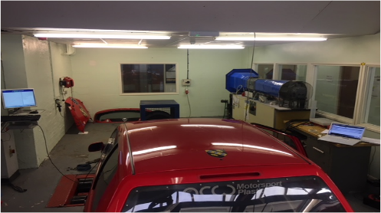
The main objectives of this report was to investigate the exhaust gas recirculation (EGR), emission control system, and the effect of the emissions produced, with the focus on reducing the harmful emissions from the internal combustion engine. The first mention of the effect of on-road traffic on air quality was in the 1940s in California (Lenz, 1993). However, automotive emissions comprise of NO_{x}, hydrocarbons (HC), and carbon monoxide (CO) (Pritchard, 2005). Each of these emissions lends themselves strongly to a particular health problem of growing concern (Pritchard, 2005). The Current regulated emission limit of internal combustion engines is becoming even more stringent. The ongoing European emissions standard Euro 6 entered into force in September 2014 reducing the NO_{x} limit of about 50% compared to the previous Euro 5 standard (Belgiorno, 2017). On the other hand, the CO₂ limit in Europe for passenger cars will be cut from the present value of 130 g/km, for the average fleet, to 95 g/km by 2021 (Belgiorno, 2017). To control these environmental/health issues the automotive industries have introduced many types of technology in order to control emissions. The Exhaust Gas Recirculation (EGR) has been widely used as it helps in the control of Nitrogen Oxide (NO_{x}) emissions from automobile exhausts (William, 2010). Even so, while controlling harmful emissions it is also increasing other emissions e.g. it reduces NOx but increases CO, HC and CO2. However, the automotive industries prefer this as NOx is more harmful to people’s health than the other gases. In order to understand the exhaust gas recirculation (EGR) principle SI engines, were used for examination. This test was conducted on a multipoint fuel injector system VW Lupo 1.0 engine (2001), Euro 3 legislation. This has taken the form of conducting experiments with EGR and without EGR. The spark ignition engine of the VW Lupo 1.0 litre was examined by using an exhaust gas analyser and dynamometer. In addition, emission in the internal combustion engine was monitored by turning EGR on and off and by increasing the RPMs.
- The main aim of this report was to evaluate the impact of Exhaust Gas Recirculation (EGR) on a vehicle emissions control system.

EXPERIMENTAL SETUP AND METHODOLOGY
The purpose of the practical exercise was to evaluate the effect of the EGR on VW Lupo 1.0 Litre by monitoring the exhaust emissions particularly of NOx. To evaluate the EGR it was necessary to block the EGR with a metal gasket as can be seen in the figure (1). The reason why it is blocked and not just disconnected, is because if the EGR was disconnected from the vehicle ECU, it illuminates the engine management light on the dashboard (Van, 2003).
Figure 3 Lupo connected to the fume extractor
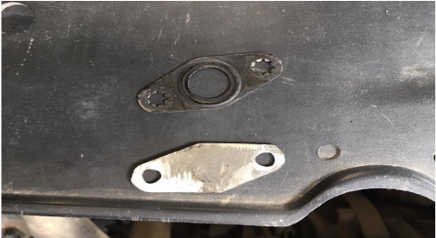

Figure 1 Metal gasket for VW Lupo EGR

The range of emission tests was performed on the VW Lupo by utilising the chassis dynamometer, exhaust gas analyser and installed OBD software on the laptop. This enabled us to monitor the throttle position as can be seen in the figure (2). Before commencing this exercise, it was necessary to check the fire exit and the health and safety hazards regulation. When the vehicle was placed on the chassis dynamometer, it

Figure 2 VW Lupo connected with Laptop and dynamometer
was also necessary to check for any safety issues. These included ensuring that it is in a straight line, that the wheel is stable on the dynamometer, that it is connected by the safety rope to the ground and that it is connected to the fume extractor as shown in figure (3).
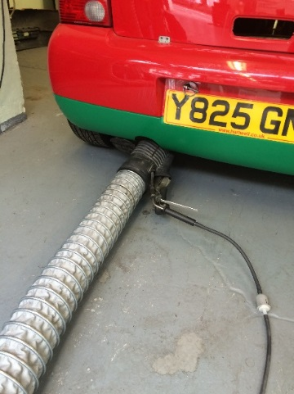

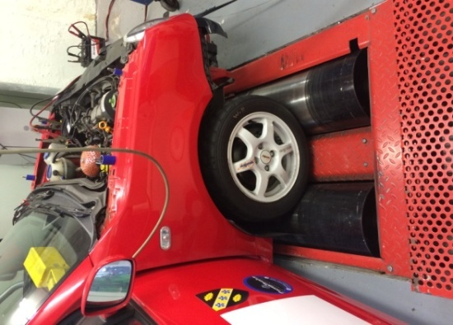
After completing all safety checks, it was necessary to communicate with the laboratory technician who was important during the live testing. This is because the laboratory technician was controlling the vehicle, RPM, throttle position and dynamometer with remote control.

Figure 4 Lupo placed on dynamometer

Communication between the author and the technician was mainly by use of body language, because it was hard to hear while the engine was running at high revs. Before the experiments, the technician was informed of the test procedures and provided with a testing list. This was to avoid miscommunication during testing which could have resulted in false measurements. The room temperature was recorded at 21ºC using the temperature gauge in the university laboratory.

EXPERIMENTAL ENGINE
A four cylinder 1 litre four-valve per cylinder gasoline port fuel injection engine was used to perform the experiments. General details of this engine are presented below in Table (1).

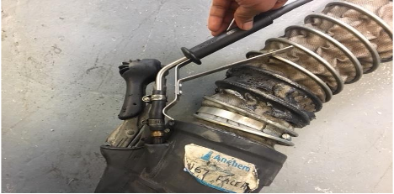
Table 1 show the main characteristics of the Lupo engine
Main characteristics of the tested petrol engine
Cylinders | Straight 4
Bore | 67.1 mm
Stroke | 70.6 mm
Bore/stroke ratio | 0.95
Capacity | 1 litre / 999 cc
maximum power output | 49.7 PS (49 bhp) (36.5 kW) at 5000 rpm
Specific torque | 86.09 Nm/litre
compression ratio | 10.7:1
Air/Fuel ratio | 14.7.1
Fuel system | MPFI
Engine coolant | Water
Gear ratio | 3.46 (1st gear)
Diff ratio | 3.88
Maximum speed | 152 km/h (94 mph)
CO₂ Emissions | 139 g/km

EQUIPMENT

The equipment that has been used is listed as follows: -
  - VW Lupo 1 lt
  - Chassis dynamometer
  - Gas analyser
  - Delphi OBD software
  - Excel spreadsheet.

LIVE TESTING
The live testing was conducted in the three experiments in order to obtain reasonably realistic results and allow comparisons to be made between them. The live testing procedures were fixed to the throttle position between the 1000 RPM and the 5000 RPM for 46 seconds. This was to enable monitoring the exhaust emissions with and without EGR. The recommendation for testing exhaust emissions is 40 seconds (Zervas, 2003). The fixed throttle position monitored on the author’s laptop. To fix the throttle position at 25%, 50% and 100%, it was necessary to apply some sort of load through the dynamometer. In addition, the applied dynamometer load/force was varied during the live 46 seconds testing both with and without EGR for each of the RPMs. Although the purpose was to monitor exhaust emissions, much work was involved in varying and monitoring the load due to variations within the dynamometer. The load/force was investigated to establish the reason for this variation with and without EGR. During the first test, the probe on the exhaust gas analyser was repeatedly ejected, as can be seen in the figure (5).

Figure 5 Exhaust gas analyser was repeatedly ejected
The probe was not adjusting properly due to the high acceleration involved. An unconnected probe can affect the parameters of the results. This probe was the main asset in the project in which measurements of the exhaust emissions from the tailpipe were taken. The results cannot be accurate or realistic without utilising a proper probe which has been fitted efficiently.
RESULTS AND ANALYSIS/EVALUATION
Results were obtained from the range of tests on the VW Lupo 1Lt which utilised the dynamometer with and without EGR. These tests were to fulfill the investigation of the exhaust emissions, in particular, NO_{x}, which is the main aim of this study. These results evaluated the effect of EGR at part load. CO and CO₂ were measured as percentages of exhaust but the measurement was made in units of ppm for the HC and NO_{x} occurring in the exhaust gases.
NO_{x} AND O₂
In the graph (1) below, the blue line represents with EGR, which shows that the NO_{x} level is less than the orange line which represents the without EGR. Without EGR NO_{x} level is high after 2000 RPM because of the internal combustion chamber temperature increases as a result of NO_{x} formation at a higher temperature which has been previously mentioned (Cadman, 1986). To control this temperature, the EGR recirculates the exhaust gases back into the intake manifold, which reduces the combustion temperature (Cadman, 1986).
Graph 3 The blue line represents hydrocarbon emissions level is increases with EGR
Graph 1 The orange line represents NOx is higher without EGR
Consequently, a reduced amount of oxygen is available for combustion in the intake mixture due to this air displacement (Hussain et al., 2012). The effective air/fuel ratio is decreased as a result of this reduced oxygen availability for combustion as shown in graph (2) below.
Graph 4 The blue line represents carbon monoxide emissions level is increases with EGR
Graph 2 The blue line represents oxygen level is low with EGR
It can be seen that with EGR, when 2000 RPM was reached, oxygen level was 0.65 percent and that without EGR oxygen level was 3.00 percent. However, the overall oxygen level was found to be higher as can be seen in the further results shown below.

HC, CO AND CO₂
Results shows that with EGR the amount of oxygen is reduced which causes lower temperatures. As a result of these lower combustion temperatures HC emission increases. As shown in the graph (3) below, in the part load condition, incomplete combustion along with greatly increased CO and HC levels with EGR is indicated.
CO is partially burned fuel. This happens when there is a rich air/fuel mixture. As represented by the blue line in the Graph (4) below.
CO was found to be increasing with EGR. The lack of oxygen available in the cylinder has stopped the oxidizing process, resulting in incomplete combustion as mentioned previously. Lower than normal CO (with the exception of a rich condition) are due to problems creating lower than normal combustion. CO is therefore a good indicator of a rich fuel mixture. CO will only increase when the fuel mixture is rich.
Proper combustion of HC and O₂ results in Carbon dioxide. In the graph (5) below, the blue line represents the CO₂ level which is higher with the EGR. This increase in CO₂ emissions with EGR is due to the exhaust gases having been recirculated back into the intake manifold along with fresh air. This means that some CO₂ is being constantly recirculated.
Graph 5 The blue line represents carbon dioxide emissions level is increases with EGR
LAMBDA
Graph (6) below the orange line represent without EGR and the blue line represent with EGR. It was found that without EGR the lambda values are higher than with EGR. These results represent that the engine was running on lean mixture without EGR (too much oxygen as shown in oxygen graph (2) above).
Graph 7 Wheel torque against the engine RPM, which represents the wheel torque, is higher without EGR
Graph 6 The orange line represents lambda value is higher with without

CALCULATIONS
Calculations were made with the fixed throttle was at 25%, with and without EGR. The reason for undertaking this calculation, as mentioned above, is because the force/load applied by the dynamometer, through the wheel, was varied both with and without EGR.
WHEEL TORQUE
Calculation of wheel torque was done at 25% of fixed throttle, with and without EGR. The formula below was used to find the wheel torque.
WT= Dynamometer Force × Wheel radius
The orange line, which represents the wheel torque without EGR, was higher than the blue line. This graph (7) below also shows that wheel torque was affected without EGR. This is because you are not losing the power used through the recirculation of the exhaust gases. Anything that is recycled is using energy (Fontana, 2010).
ENGINE TORQUE
This graph (8) shows a similar trend line to the wheel torque. This calculation also shows that the without EGR engine torque is higher at 25 % throttle. The formula below was used to find the engine torque.
$$=\frac{Wheel torque}{Gear ratio ×Diff ratio ×Transmission efficiency}$$
WORK DONE

This clearly shown in graph (9) that the power without EGR is higher than the power with EGR. The orange line represents the without EGR and blue line represents the with EGR. The formula below was used to find the work done. At 4000 RPM the power is decreased than increased with EGR. This could be because the engine was running lean with EGR or this could be due to exhaust gases recirculating at this point.
Graph 9 Work done against the engine RPM, which represents the work done, is higher without EGR
$$Work done =Engine ×2π ×No of Revs/sec$$
FUEL
Graph 10 Fuel against the engine RPM, which represents the fuel flow, is higher without EGR

The amount of Air/fuel that has been used can also be calculated in kilogram per sec during the exhaust emissions testing on the dynamometer. If engine is 30% efficient the fuel power efficiency can be converted into kilowatts by use of the simple equation: -
$$eff=\frac{30}{100}=0.3 Kw$$
The equation used to find fuel power is: -
$$Fuel power =\frac{Work done}{Fuel efficiency}$$

$$Fuel=\frac{4.8}{0.3}=16 Kw$$
As 1kg of fuel, produces 44 x10⁶ Joules of energy, then the fuel power converted into joules is equal to 16 x10³ joules. Therefore, the engine uses 16x10³ joules per sec of fuel.
Graph 8 Engine torque against the engine RPM, which represents the engine torque, is higher without EGR
$$Fuel =\frac{16 x {10}^{3} }{44 × {10}^{6}}=3.63×{10}^{-4} Kg/sec$$

With EGR the engine required less fuel as represented by the blue line. However, without EGR it required more fuel during testing at 25% throttle (part load). Therefore, according to this graph (10) below EGR does affect fuel consumption (Heywood, 1988) p581. Increasing the fuel availability results in increased cylinder pressure and temperature and results in an increase in NOx emissions (Krishnan, 2017). At 4000 RPM the fuel flow is decreased than increased with EGR. This could be because the engine was running lean with EGR or this could be due to exhaust gases recirculating at this point

AIR

The amount of fuel has been calculated above, so the amount of air could be calculated by using this fuel value. To calculate the amount of air used in kilograms per sec, it was necessary to use the air/fuel ratio which is 14.7 (Silvis, 1997). Therefore, multiply the air/fuel ratio by fuel value
$$Air=14.7×3.63×{10}^{-4}=5.34×{10}^{-3 }kg/sec$$
The air graph (11) below shows that with EGR the engine used less air than without EGR. The orange line represents the air used without EGR. The EGR recirculates the exhaust gases back into the intake manifold, which reduces the combustion temperature (Cadman, 1986). The effective air/fuel ratio is decreased as a result of this reduced oxygen availability for combustion. At 4000 RPM the air flow is decreased than increased with EGR. This could be because the engine was running lean with EGR or this could be due to exhaust gases recirculating at this point.
Graph 11 Air against the engine RPM which represents the air flow is higher without EGR

EXHAUST MASS

Fuel and air values above were added in order to find the exhaust mass from the exhaust tailpipe. The following formula was used: -
$Exhaust mass=5.34×{10}^{-3}+3.63 ×{10}^{-4}=5.70×{10}^{-3} kg/sec$
The graph (12) below shows that the exhaust mass was also affected by the EGR. The exhaust mass is higher without EGR; this is represented by the orange line. After 3000 RPM the exhaust mass has been decreased possibly with EGR because the engine is running lean mixture or this could be due to exhaust gases recirculating at this point.
Graph 12 Exhaust mass against the engine RPM which represents the exhaust mass is higher without EGR

DISCUSSION

In this study it was found that EGR is an effective means of controlling NO_{x} generated in the combustion process without significant adverse effect on fuel economy at 25% throttle or part load. With or without EGR, the fuel economy and NO_{x}, HC and CO emissions vary and depend on air/fuel ratios, retarded spark timings. In this study it was found the use of EGR was effective in controlling NOx emission with less penalty on fuel economy as shown in the graph (10) above (Dürnholz, 1992). Sasaki a et al. conducted experiments in 1998 using EGR on direct injection gasoline engines. He reported that an appropriate volume of EGR improves both fuel economy and NO_{x} emissions. This circumstance, one presumes, is due to EGR increasing the intake temperature. This improved the flame propagation in the relatively lean region of the air/fuel mixture. This region of the air/fuel mixture is distributed non-uniformly. However, Heywood (1988) mentioned on page 830 that “there are three reasons why this dilution is an improvement on the fuel conversion efficiency. (1) As a result of the change in the thermodynamic properties of the burned gases, there is increased expansion stroke work for any expansion ratio. (2) for any mean effective pressure, pumping work decreases as result of the intake pressure increasing due to increasing dilution. (3) Because the burned gas temperatures are lower, there is a reduction in heat lost to the walls. Because there are no strict engine NO emission requirements, the obvious diluent is excess air. (At part throttle engines have traditionally operated lean)” (Heywood, 1988).
“Agrawal et al. (2004) has suggested that NO_{x} formation in engines is very dependent on the temperature. It is therefore necessary to keep close control of the combustion temperature in order to reduce NO_{x} emissions in the exhaust”. “Agarwal. (2006) suggested that to control the NO_{x} emissions, the primary requirement is a reduction in the temperature in the cylinder”. In the NEDC, the EU COMMISSION REGULATION (EU) 2017/1151 of 1 June 2017, EGR is used to reduce the NO_{x} and to reduce the pumping losses in order to improve the fuel consumption. The EGR must stay on for more time due to the change in the drive cycle. This will be more relevant on roads, which allow higher speeds (European commission, 2017). If the EGR is turned on all the time, the engine will not be reliable. This indicates that the EGR should be turned on straight away. The reason behind this is to reduce the emissions at cold start and quickly make the engine more efficient. The EGR warms up the engine more quickly by the use of exhaust gases from the manifold. The faster the EGR heats up the engine the faster the catalytic converter will work and this will lower emissions. Further low temperature testing strategy emissions measurements are to be found in the (Annex VIII European Commissions 2017).

FUTURE RESEARCH

In this paper, the argument has concentrated particularly on the reduction of NOx. This is not easy to achieve with after-treatment devices attached to the exhaust system. For an engine design that meets the current emission standards and also assures a low fuel consumption, the following requirements are necessary:
1) A relatively small engine displacement with turbocharging (in combination with charge air cooling to increase engine performance).
2) Map controlled EGR (closed loop)
3) Map controlled injection timing with selective adjustment of start of injection under FTP75 operating conditions incorporating a catalytic converter.

CONCLUSION

The experimental data, produced from this project has confirmed that EGR systems are a favourable method for decreasing the NO_{x} emissions from PFI gasoline engines. This paper shows that EGR is an efficient method for reducing NO_{x} levels. This project also showed that the increase in emissions of CO, HC, and CO₂ caused by using EGR, can be reduced by using exhaust after-treatment techniques. It also showed that while EGR increases HC emissions, these can be reduced by a leaner mixture and delayed ignition timing. That EGR provides better fuel economy at any given A/F ratio without influencing CO emissions was also shown (Bielaczyc, 2007).

REFERENCE/ BIBLIOGRAPHY

Anon, 2017. COMMISSION REGULATION (EU) 2017/1151. , pp.1–643. Available at: publications.europa.eu/.../32017R1151.ENG.pdfa1a.l_17520170707en00010643.pdf [Accessed February 5, 2018].

Bosch, Robert. Automotive Handbook. 9th ed. Cambridge: Bentley Publishers, 2014. Print.
Bosch GmbH, Robert Bosch GmbH. Gasoline-Engine Management. 3rd ed. Chichester: John Wiley & sons Ltd, 2006. Print.
Bielaczyc, P., Woodburn, J., and Szczotka, A., 2016 "Exhaust Emissions of Gaseous and Solid Pollutants Measured over the NEDC, FTP-75 and WLTC Chassis Dynamometer Driving Cycles," SAE Technical Paper

Gov, 2017. 2015 UK GREENHOUSE GAS EMISSIONS, FINAL FIGURES. https://www.gov.uk/government/uploads/system/uploads/attachment_data/file/604350/2015_Final_Emissions_statistics.pdf. Available at Gov.uk.

Hori, M. et al., 1997. Development of New Selective NOx Reduction Catalyst for Gasoline Leanburn Engines. SAE Technical Paper Series.
Knowles, D., 1984. Automotive emission control and computer systems, Reston, VA: Reston Pub. Co.
Lenz, H.P et al. Emissions, Air Quality And Effects Of Exhaust GAS Constituents. Warrendale: Society of Automotive Engineers, INC, 1993. Print.
Pritchard, E. & Johnson, R.R., 2005. Hybrid Electric School Bus Technical Feasibility. SAE Technical Paper Series.

Heywood, J.B., 1988. Internal combustion engine fundamentals, New York: McGraw-Hill

Stone, Richard, and Jeffrey K Ball. Automotive Engineering Fundamentals. Warrendale [PA]: SAE International, 2004. Print.
Serrano, J.R. et al., 2005. Global Analysis of the EGR Circuit in an HSDI Diesel Engine in Transient Operation. SAE Technical Paper Series.

Van Nieuwstadt, M., 2003 "Coordinated Control of EGR Valve and Intake Throttle for Better Fuel Economy in Diesel Engines," SAE Technical Paper

Hussain, J. et al., 2012. RETRACTED: Effect of Exhaust Gas Recirculation (EGR) on Performance and Emission characteristics of a Three Cylinder Direct Injection Compression Ignition Engine. Alexandria Engineering Journal, 51(4), pp.241–247.
Qin, J. et al., 2010. Study on the Effect of EGR System on the Emissions from a Small Off-road Gasoline Engine. SAE Technical Paper Series

