
Applied Industrial Placement (SPORT)
M5X02295
Placement Portfolio

Tom Drakeley
1707423
-
Placement Portfolio
-
UWTSD
-
Mark Napieralla

TASK A – (Reflective Learning Log 1 - 500 words – First Experience of Placement)
Recommend to link the reflective experience to two different key themes.
My First Experience of Placement-

As part of my placement with UWTSD I’m required to undertake the role of both coach and mentor for the majority of the placement. Through previous learnings of coaching and mentoring I have undertaken in collage and university, I believe this placement has allowed me to further my skills in both roles.
The first coaching session of my placement took place at the LC2 sports hall in Swansea city centre, where we met Year 4-6 of Lon Las Primary school for tennis coaching sessions. These sessions occur as often as once a week as a primary schools initiative for healthy lifestyles. As this weeks activity was tennis, all pupils were separated into 6 groups of 8 to ensure that everyone had a partner. As there were 6 groups, the sports hall was divided up into 6 courts to allow everyone to take part at the same time. Once the initial greetings had taken place, a group was assigned to each coach and their assistant.
During my session my group went through multiple activities designed to improve their general technique before finishing with two doubles tournaments. As a result of the activities, I felt that significant improvements in technique and awareness were visible.
In addition to the coaching, I was also set the role of mentoring one of the trainee coaches. This role consisted of observing the coach I had been assigned to as well as giving advice to improve their performance. Doing this process would not only help to improve the mentee but also my own performance upon reflection. I had been assigned a coach before the session, so I felt it was important to establish a relationship prior to observing, we had a informal conversation for approximately 10 minutes. I felt this was important to allowing the coach to trust me as well as building a level of respect between each other. This is commonly advised when starting a coach and mentor relationship, as Clutterbuck states “Mutual consent, a willingness to participate in the relationship, is normally seen as an essential precursor to effective relationships in both coaching and mentoring” (Clutterbuck and Megginson, 2007).

Initially, I was quite nervous about leading a session as I hadn’t done much coaching of primary school pupils, so I had nothing to compare against. I often found myself wondering if I would be able to control my group if they became over excited or whether I’d be able to motivate them if they became uninterested. Because of these thoughts, I felt a great deal of nerves before they had arrived. However, once the session began these thoughts and feelings quickly faded away, I put this down to good planning of the session beforehand as I was able to keep all the pupils challenged as well as providing fun activities throughout the session. Now upon reflection, I see that its vastly down to preparation of the session that ensures a smooth execution as well as enabling me to reduce my stress levels prior to the session.

Upon reflection, I felt the vast majority of the session went well. I felt this was due to my ability to instruct my group with the appropriate language and terminology, to ensure full understanding of each activity. As well as choosing a game sense approach for the session, an approach that enhances the students ability to understand how a specific technique or skill is required in a game scenario (Breed and Spittle, 2011) this allowed for progressive improvement in technique right the way through the session. In addition to these factors, ensuring the group maintained a high level of motivation was relatively easy as the session had been designed to be fun, as the following statement suggests “hence athletes are autonomously motivated, and hence act with a sense of volition and psychological freedom (e.g., personal significance or fun), they will thrive” (Pelletier, Fortier, Vallerand, & Brière, 2001; Podlog et al., 2015 Cited in Delrue et al., 2019)

In conclusion of my first experience on placement I feel that I was successful in both coaching and mentoring on a basic level, however for the next part of my placement I would hope to further my knowledge of different techniques to manage larger groups. Whether that be through using new control measures such as “sit down, hands on your head” or using a varied pitch approach.

TASK A – (Reflective Learning Log 2 - 500 words – Mid Point Experience)
Recommend to link the reflective experience to two different key themes.
Over the last two weeks I have taken part in multiple activities, ranging from coaching to mentoring. In the first week, I attended Meadow view sports complex as a coach for their half-term football camp. We went as a collection of coaches for the morning sessions which mainly focused on technical skills such as passing and shooting, through multiple fun activities, before handing the children over to the afternoon coaches whom would implement the new taught skills into a game. The session was a great success as the majority of the children showed positive progression on technical ability and tactical knowledge.
In the second week, I had the opportunity to mentor a coach who was managing a court in a school badminton tournament down at the LC2 sports hall. My role on this day was to observe the coach throughout the day and giving advice if warranted. Once the tournament was over I spoke to the coach for around 20 minutes about how he felt he performed, what he could have done differently and what he is going to change/add in for the next session. This conversation flowed well with positive feedback coming from both me and the coach. These conversations are fundamental to a coaches development of self awareness as the following statement suggests “using self-awareness exercises as the basis for conversations is a powerful technique for developing awareness” (Parsloe and Leedham, 2000).

Prior to the coaching session up at the meadow view sports complex, a great deal of planning took place to ensure that all possibilities were covered as we didn’t know the group sizes or abilities. This allowed apprehension levels to be greatly reduced upon arrival. Once the session started I felt confident that I could coach any group that I was given due to the predetermined session plan. Upon reflection of the session I now feel that minor adjustments to my terminology during explanations could have benefited the group. However, I’m generally pleased with the outcome of the session.
In relation to the mentoring, due to the previous sessions progress of the mentor and mentee relationship I felt confident observing the coach as I had a better understanding of his strengths and weaknesses, this allowed me to focus my observations on the aspects of his performance that we had previously discussed in the post session conversation that took place in the previous week. I also felt the coach performed with greater confidence as he now understands which aspects of his performance he must improve.
Upon reflection of both events I felt I showed positive progression in my coaching and mentoring in general. Firstly, I was able to control the group well with varied control measures and I felt that I had chosen the appropriate activities for the groups ability. Secondly, during the mentoring session I was confident in relaying feedback whilst trusting my own judgement in analysing my mentees performance. I believe this progression is down to confidence within my ability to perform, this can be directly linked to elite sports athletes research, as the following statement eludes its “found that subjective performance and confidence were statistically significant and positively correlated” (Levy, A. R., Nicholls, A. R., Polman, C. J, 2010 Cited in Skinner, 2013)

However, some aspects of my performance did fall under expectations. During the coaching of the football camp some players excelled faster than others which resulted in a drop of motivation from some of the players, due to this I hope to develop my planning of the activities for future sessions to include additional progression to ensure all participants are challenged. In relation to mentoring next week, I would like to further develop my knowledge of how to stimulate creative thinking within my mentee as its an important aspect of self-development Megginson eludes that “in the context of coaching and mentoring, thinking creatively is important, because of our habitual responses lock us in patterns of behaviour that are often self-defeating and do not deliver what it is that we are intending” (Clutterbuck and Megginson, 2007).

TASK A – (Reflective Learning Log 3 - 500 words – Mid Point Experience)
Recommend to link the reflective experience to two different key themes.
Over the last week, I have been involved in two sessions down at the LC2 sports hall. The first session consisted of me coaching Pontarddulais primary school, years 3-4. During this session I taught multi-skills (running, throwing and catching) at the age that the group were, it is essential to teach these basic skills in order to give a base level of sporting ability. During the session, focus on ensuring fun was had by all was at the forefront of the sessions aims. The session flowed well which allowed us to complete each planned activity, in turn providing progression of skills for all participants.
The second session down at the LC2 sports hall was my third session mentoring my coach, during this session the coach delivered a multi-sports session, where he would lead the cricket activity. During the session all the children were engaged and appeared to have a great deal of fun and were motivated right the way through. Once the session ended, me and the coach went for a post-session chat to discuss his performance. This lasted around 10 to 15 minutes and was very productive.
In relation to the coaching session, I was extremely pleased with the progression seen by all the participants as it can be quite challenging to develop skills at a young age, I felt this was down to the focus on ensuring fun was had by all, as the following statement supports “Positive links between enjoyment and frequency of cognitive learning strategy”(Obergriesser and Stoeger, 2020). However, positive progression was clear to see, which gave me an additional indication that the session was successful .
Similar can be said about the mentoring session, it was clear to see that the coach I had been mentoring had made vast improvements in his management side of coaching, using appropriate control methods and adapting his terminology to ensure greater understanding of instructions, these improvements displayed in the progressions of his group.
A small aspect of my coaching session did make me question the decision making during the planning as some of the activities were difficult to complete successfully, such as the ball bounce and catch and the long range throws. Although these were questionable choices for activities, it allowed me to think on my feet and make alterations that then ensured that all participants were challenged appropriately whilst still maintaining the 80/20 success rate.
Upon reflecting on this weeks activities, I hope to build on my performance in my coaching and mentoring for next week through focusing on my weaknesses from the previous two weeks to ensure I improve for a more rounded performance. In relation to mentoring, I hope to develop my ability to relay information to the coach in a positive manner, whilst also improving my choice of activity to suit the participants.

TASK A – (Reflective Learning Log 4 - 500 words – Near end of Experience)
Recommend to link the reflective experience to two different key themes.
Over the last two weeks of my placement I have lead two sessions down at the LC2 sports hall. The first of which was a mentoring session, my mentee was part of a team of coaches which lead a full day of multi-sports activities. My mentee had been assigned to the cricket and football stations with an additional coach as support. He coached well right the way through the sessions and adapted well to each group that came through his activities. Secondly, I coached a cricket session to a small group of year 6 students from a local primary school. The sessions aims were to teach various bowling, batting and fielding techniques, whilst also including some tactical coaching. This session went smoothly and all participants showed vast improvements by the end of the session.
In relation to the mentoring, it was clear to see the change in my mentees performance in comparison to the first few session on we had together. I felt confident to leave him run the session with no need for intervention or advice. He’s grown from strength to strength with each session he’s lead and has also shown me aspects of coaching that I would like to improve on. In our post session conversation, my mentee said he felt much more confident in this session as he had focused on his weaknesses in the days prior to the session.
As for my coaching session, initially I felt slightly anxious as I’m not a frequent cricket player and I wanted to ensure that all my demonstrations were correct. However once I’d began the session, the feeling of anxiety quickly passed as the weeks learning of techniques and tactics were at the forefront of my mind. The group showed positive progression from start to finish which made me very pleased with my performance.
Upon reflection of my mentoring session, I believe it was successful due to the level of trust I have in my mentee, trust allows both parties to have confidence within their performance and I believe this is the contributing factor to the success of the session. A study lead by Sherman (2005) supports this belief as it “identified honesty and trust as the most important qualities in a mentor.” (Sherman, 2005, cited in Eller et al, 2014). Additionally, I feel that the post session conversations will have had a large effect on the understanding of performance, which in turn allows the coach to develop aspects that have been discussed for future sessions.

In relation to my coaching session, firstly, I believe the positive progression was as a result of my coaching style, I ensured that the participants felt comfortable to attempt any technique and encouraged creativity, it’s important for participants to learn from their mistakes without feeling worried to try new things. The following statement supports this, “athletes should be encouraged to make a decision by evaluating options and being allowed to make mistakes and purposely inspect these mistakes so that it does not occur in the future.” (Kaya, 2014). However certain aspects of my coaching could do with attention, such as my preparation of knowledge for a sport. As I hadn’t played much cricket prior to the session I felt I should have researched further into ruling and common tactics of the game.

TASK A – (Add 250 words on link to future Continued Professional Development and Reference list based on total referenced material in Task A)
Continued Professional Development post placement (250 words - Link to pre placement module)
Upon reflection of my placement, I’m now able to identify certain aspects of my performance that need to be improved to ensure a more rounded performance in the future. I plan on improving these aspects through the use of CPD courses that are available to me through my final year as well as in future employments.
Firstly, I hope to improve my ability to adapt to unforeseen situations. I felt I lacked in experience of how to mange a situation that may not have been planned, which causes confusion and unnerve during a session. I can develop this as one of my attributes through either undertaking more coaching experiences which will gradually develop my ability to react to new scenarios, or I could enrol myself onto a leadership course such as the Ivy house leadership programme, where “world-class personal and professional development, normally reserved for senior executives; giving them the knowledge and skills to become extraordinary leaders and live extraordinary lives” (Ivy House, 2020). This course would be greatly beneficial as this would also include aspects of dealing with unforeseen situations.

Secondly, I feel improvements in my risk assessments would greatly benefit me in future coaching or mentoring sessions, this is seen as greatly important as liability laws are also applicable to coaching. Donoghue states, Donoghue states “requiring the exercise of reasonable care to avoid injuring anyone who ought reasonably to be considered as being affected by one’s actions or omissions” (Donoghue, 1932 cited in Partington, 2014) whilst Blyth also claims “it is plainly apparent that coaches must display reasonable care when assuming such a role” (Blyth v Birmingham waterworks, 1856, Partington, 2014).
Secondly, I feel improvements in my risk assessments would greatly benefit me in future coaching or mentoring sessions, this is seen as greatly important as liability laws are also applicable to coaching. Donoghue states, Donoghue states “requiring the exercise of reasonable care to avoid injuring anyone who ought reasonably to be considered as being affected by one’s actions or omissions” (Donoghue, 1932 cited in Partington, 2014) whilst Blyth also claims “it is plainly apparent that coaches must display reasonable care when assuming such a role” (Blyth, 1856, Partington, 2014)
I feel this as on numerous occasions I felt a more thorough risk assessment would have helped eliminate risks that were initially not seen as a threat. I could aim to improve this on a personal level through gaining more experience or I could enrol on a “safe sport’ course which is provided by S.A associates training, they’re aim is to “ highlight the UK requirements of Health & Safety Legislation for risk assessments to be undertaken for all sports activities and events before, during and after they take place” (Safety in Sport Training, 2020)

References from TASK A (10+ references)
References
-Breed, R. and Spittle, M., 2011. Developing Game Sense Through Tactical Learning. Cambridge: Cambridge University Press, p.10.
-Clutterbuck, D. and Megginson, D., 2007. Further Techniques For Coaching And Mentoring. [Place of publication not identified]: Elsevier, pp.17-19.

-Clutterbuck, D. and Megginson, D., 2007. Further Techniques For Coaching And Mentoring. [Place of publication not identified]: Elsevier, pp.115

-Delrue, J., Reynders, B., Broek, G., Aelterman, N., De Backer, M., Decroos, S., De Muynck, G., Fontaine, J., Fransen, K., van Puyenbroeck, S., Haerens, L. and Vansteenkiste, M., 2019. Adopting a helicopter-perspective towards motivating and demotivating coaching: A circumplex approach. Psychology of Sport and Exercise, [online] 40, pp.110-126. Available at: <https://www-sciencedirect-com.ezproxy.uwtsd.ac.uk/science/article/pii/S1469029217304569?via%3Dihub> [Accessed 9 July 2020].
-Obergriesser, S. and Stoeger, H., 2020. Students’ emotions of enjoyment and boredom and their use of cognitive learning strategies – How do they affect one another?. Learning and Instruction, [online] 66, pp.2-3. Available at: <https://reader.elsevier.com/reader/sd/pii/S0959475218308946?
token=B382D2C1A3A5FB2D44E7A6BE407C6F3A7B27DE
B8303E9A2884E6B0E5646D1F72C5A355130B6C487504D716AC351A6A0D> [Accessed 11 July 2020].

Partington, N., 2014. Legal liability of coaches: a UK perspective. The International Sports Law Journal, [online] 14(3-4), pp.232-241. Available at: <https://link-springer-com.ezproxy.uwtsd.ac.uk/content/pdf/10.1007/s40318-014-0056-2.pdf> [Accessed 20 July 2020].

-Parsloe, E. and Leedham, M., 2000. Coaching and Mentoring: Practical Methods to Improve Learning. Work Study, [online] 49(6), pp.23-24. Available at: <https://www.dawsonera.com/readonline/9780749456122> [Accessed 9 July 2020].
-Professional Development - Leadership - Ivy House London. 2020. Ivy House. [online] Available at: <https://www.ivyhouse.co.uk/our-programmes-2/?gclid=EAIaIQobChMIl4mr0vXM6gIVwbTtCh2NKgnYEAAYBCAAEgKEYvD_BwE> [Accessed 14 July 2020].

-Skinner, Benjiman R., "The Relationship Between Confidence and Performance Throughout a Competitive Season"(2013).Available at: https://digitalcommons.usu.edu/cgi/viewcontent.cgi?article=1284&context=gradreports [Accessed 11 July 2020].
-Sherman, 2005 cited in Eller, L., Lev, E. and Feurer, A., 2014.
Key components of an effective mentoring relationship: A qualitative study. Nurse Education Today,
[online] 34(5), pp.815-820. Available at: <https://reader.elsevier.com/reader/sd/pii/S0260691713002724?token=
F7853F111E04234809FEED2CE9B02D10C4F1
44FC2FA9FFCD7A9B21178081057A70D6A2FB743B23C0E26AD0BAFAE9813D> [Accessed 14 July 2020].

-Satraining.co.uk. 2020. Safety In Sport Training. [online] Available at: <https://www.satraining.co.uk/training-courses/health-safety-courses-h-s/other-courses/safety-in-sport-training/> [Accessed 14 July 2020].

TASK B – (Picture Board – 5 pics (40MB upload limit to Turnitin) (Experience, Roles, Improvements)
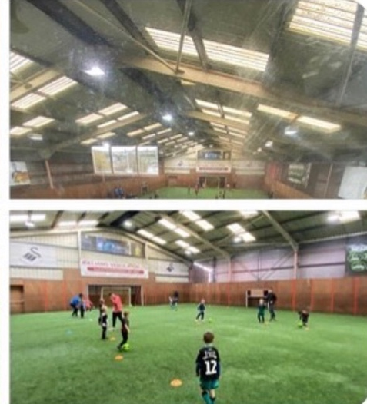  Picture | Text (Paragraph)  These pictures were taken during the meadow view sports complex football camp. During this particular session I led a group of 6-10 year olds through multiple ball skills activities. This session on the whole was a success, however improvements on controlling the group were noticeable for future sessions.
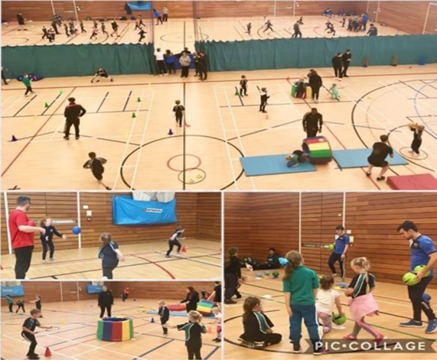 | This picture was taken during my first multi-skills coaching activities, each coach was assigned to station where we’d either teach running, throwing and catching. This session in particular was a success as a great level of improvement was seen by all participants.
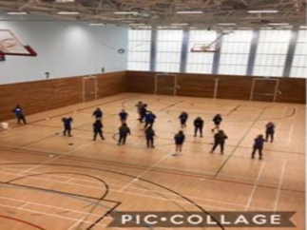 | This photo was taken during the mentoring session that first met my mentee, during this session I observed and took notes on my mentees performance, before relaying constructive information to help the coach improve his performance for future sessions.
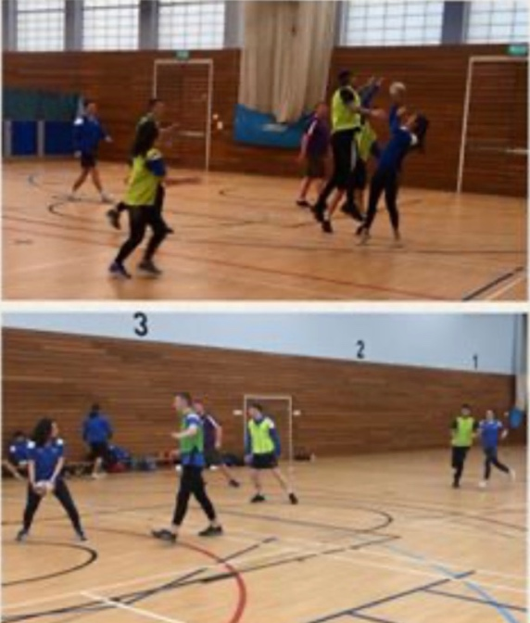 | These pictures were taken during the second half of the day of netball coaching. During this time I was mentoring my mentee on his ability to demonstrate and give instruction. His initial performance was poor as he conducted himself in a quiet and laissez faire manner, however after some coaching points, his confidence grew, enabling him to perform at his best.
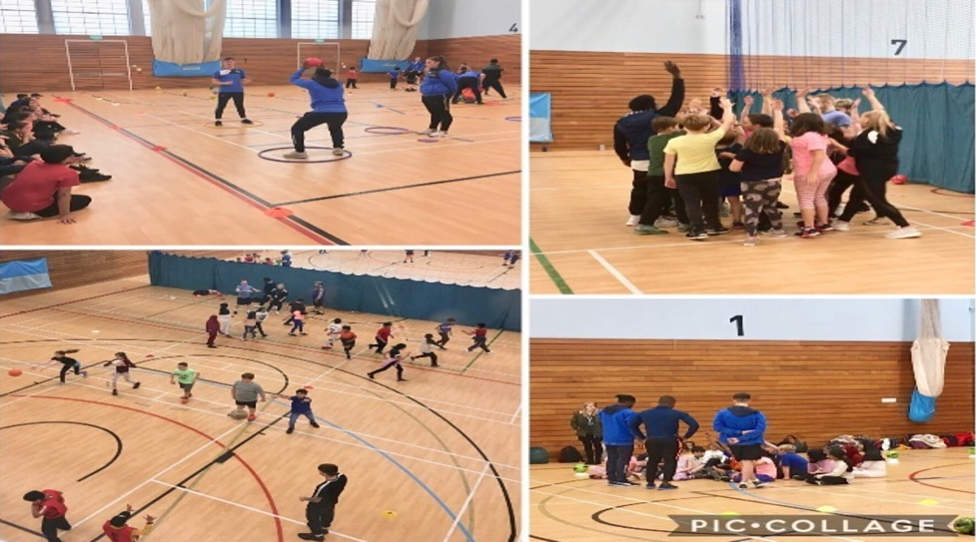 | I have chosen to include this picture (from a multi-schools, multi skills day) as it reflects the positive control measures that were taught over this placement. On a personal level, I believe that the control measures we were taught enabled us to lead smooth and successful sessions, a skill I will continue to develop throughout my future coaching & mentoring activities.

TASK B – (Picture Board Cont.–5 pics (40MB upload limit to Turnitin) (Experience, Roles, Improvements)
Picture | Text (Paragraph)
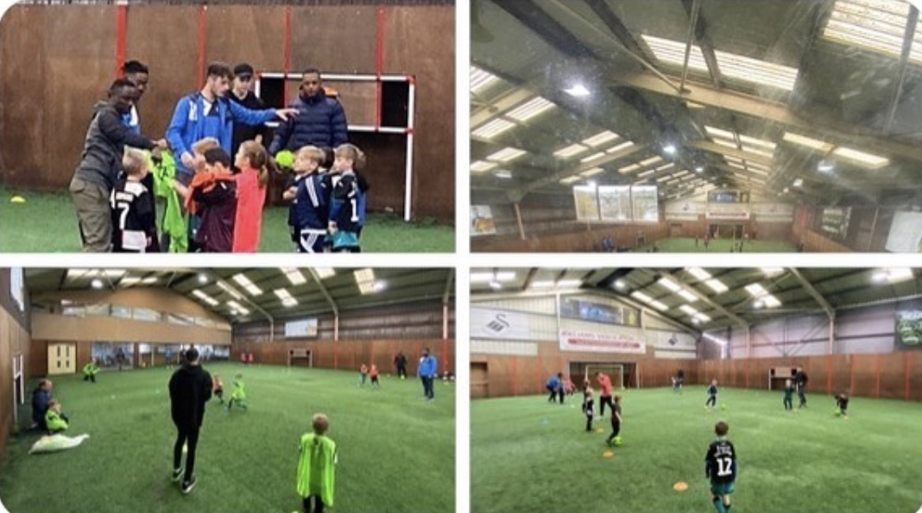 | This picture is from the meadow view complex where me and a team of coaches lead a morning session for a half -term football camp. The session lasted 3 hours with 2 groups and was a great success. During this time I was mentoring two coaches, they performed in a professional manner as well as showing compassion to participants whom were struggling.
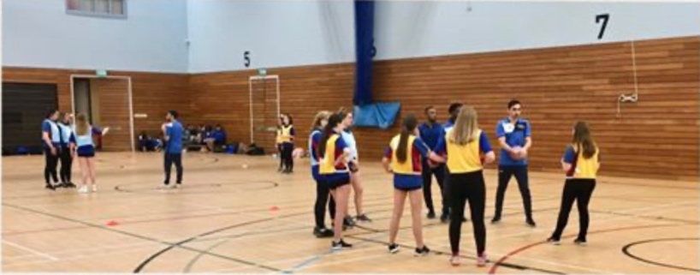  I | This picture is from a netball session lead by a collection of coaches. This session lasted around 3 hours and all participants excelled in their performance and tactical awareness.
 | During this session I lead a cricket and football activity for a primary school group. We had around 70 kids come through our station, with each one improving greatly with their athletic abilities. However, this session taught me to ensure that I had a backup plan for activities as the original intended activities over challenged many of the participants
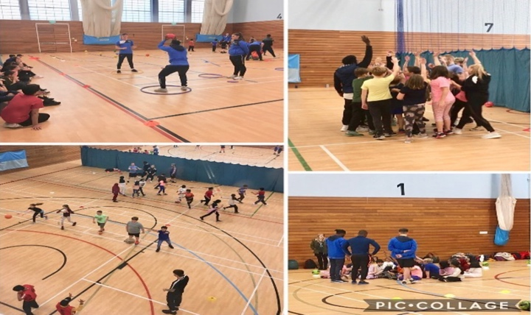 | This session was the multi-skills session that I lead with my peers. We taught basic catching, throwing and running techniques to give each participant a general baseline of ability. This session was very successful as all the participants had fun and showed signs of development.
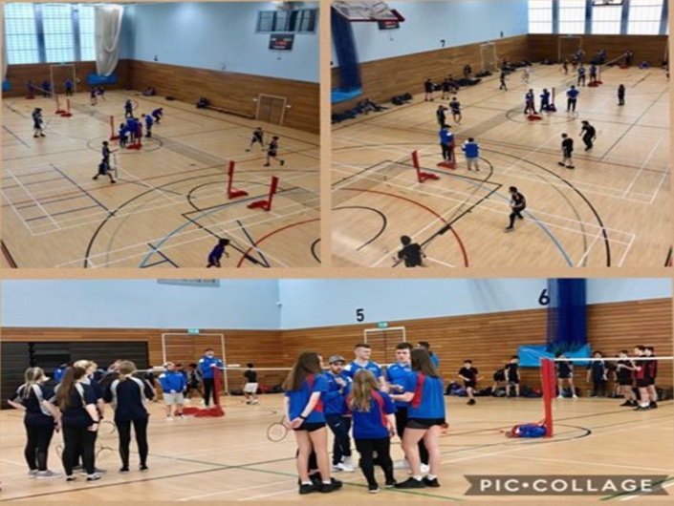 | This picture was taken during the schools badminton tournament which I was mentoring one of the coaches during his time as an umpire and coach. This was a fantastic session which enabled the coach to develop his skills in a professional environment .

TASK C Evidence – Employer Report (Signed),
NOTE – This will be compared against the report sent to the University.
NOTE – You will need to complete additional copies if you have more than one provider.
Placement Employer Report - Evaluation of Student Performance

Student Name:Tom Drakeley. ………. Dates of Employment: 27/04/20 // 22/06/20

Interest in Work

○ |  |  | High interest in job. Very enthusiastic. |  |  | X  | More than average amount of interest and enthusiasm for job. |  |  | ○  | Satisfactory amount of interest and enthusiasm for job. |  |  | ○  | Interest spasmodic. Occasionally enthusiastic. |  |  | ○  |  | Little interest or enthusiasm for job.
Initiative

○  |  |  |  | Self-starter. Asks for new jobs. Looks for work to do. |  | X  |  | Acts voluntarily in most matters. |  | ○  |  | Acts voluntarily in routine matters. |  | ○  | Relies on others. Must be told frequently what to do. |  |  | ○  |  | Usually needs to be told what to do next.
Organisation and Planning

X  |  |  |  | Does an excellent job of planning and organising work. |  | ○  |  | Usually organises work well. |  | ○  |  | Does normal amount of planning and organising. |  | ○  |  | More often than not fails to organise and plan work effectively. |  | ○  |  | Consistently fails to organise and plan work effectively.
Ability to Learn

○  |  |  |  | Exceptionally quick. |  | X  | Quick to learn. |  |  | ○  |  | Average. |  | ○  |  |  | Slow to learn. | ○  |  |  | Very slow to learn.
Quality of Work

○  |  |  |  | Very thorough in performing work. Very few errors if any. |  | X  |  |  | Usually thorough. Good work with few errors. | ○  | Work usually passes review. Has normal amount of errors. |  |  | ○  |  | More than average amount of errors for a trainee. |  | ○  |  | Work usually done in a careless manner. Makes errors often.
Quantity of Work

○  |  |  |  |  | Highly productive in comparison with other students. | X  |  | More than expected in comparison with other students. |  | ○  |  | Expected amount of productivity for a student. |  | ○  | Less than expected in comparison with other students. |  |  | ○  |  | Very low in comparison with other students.
Judgement

○  |  | Exceptionally good. Decision based on thorough analysis of problem. |  |  |  | X  |  | Uses good common sense. Usually makes the right decision. |  | ○  |  |  | Judgement usually good in routine situations. | ○  |  | Judgement often undependable. |  | ○  |  | Poor judgement. Jumps to conclusions without sufficient knowledge.
Dependability

○ | Can always be depended upon in any situation. |  |  |  |  | X  | Can usually be depended upon in most situations. |  |  | ○  | Can only be depended upon in routine situations. |  |  | ○  | Somewhat unreliable, needs above average checking. |  |  | ○  | Unreliable.
Please give your view of the student’s performance (see guidance definitions below):

 | A | B | C | D | E
Self-management & development |  | X
Managing Tasks | X
Communication skills |  | X
Working with & relating to others |  | X
Applying knowledge |  | X
Applying initiative in work problems | X

A - Outstanding
(consistently exceeded the standard expected of a placement student)

B -Very Good
(frequently exceeded the standard expected of a placement student)

C - Good
(always achieved (at least) the standard expected of a placement student)

D -Satisfactory
(achieved (at least) the minimum accepted standard for a placement student)

E - Unsatisfactory
(did not achieve the minimum accepted standard for a placement student)

Your opinion of their overall performance: __B___ (A to E)

Concluding Comments /Overall observations of Student Performance:

An adaptable student who applies imitative and wull take responsibility and accountability. _______________________________________________________________________________________
______________________________________________________________________________________________________________________________________________________________________________
_______________________________________________________________________________________

Finally, could you please confirm that the student either completed the minimum requirement for placement (200 hours and 8 Weeks) or is in the process of completing this prior to the contractual term?

I confirm that I am the student’s nominated supervisor/their nominee and am able to comment knowledgeably on their performance whilst on placement.

Name …Andrew Thomas…….. Signed………A.Thomas………………………………

Position…Programme Director……… Date…6/7/20…………………..(Circa 1st August)

TASK C Evidence – Ethics Form – Signed by Organisation and Lecturer
NOTE – You will need to complete additional copies if you have more than one provider.

TASK C Evidence – Ethics Form Continued

TASK C Evidence – Ethics Form Continued

TASK C Evidence – Ethics Form Continued

TASK C Evidence – Post Placement Review and Feedback
Dear Participant

Many thanks for your involvement in the work placement. I hope that you had a positive experience. The University of Wales Trinity Saint David reviews the provision annually for enhancement purposes and so we would be pleased to hear your feedback on any aspect of the placement.

Yours sincerely

Andrew Thomas, Placement Coordinator Sports Management Portfolio

Name of provider’s organisation: |  | University of Wales Trinity Saint Davids
Name of student: |  | Tom Drakeley
What were the positive aspects?
It’s difficult to just name a few, I have learnt so much through this experience. Not only about my coaching and mentoring skills, but also my own personal ability. I thoroughly enjoyed every experience I was put into and felt like I improved from each and every one.

Were there any problems?
I had no issues whatsoever during my time on placement, I believe this was down to the constant support of my mentor and the other teaching staff around me.

Do you have any recommendations for enhancement for the future?
Signed: | T.Drakeley
Name in block capitals: | TOM DRAKELEY
Position (please tick one): | ☐ Placement Provider  ☒ Student  ☐ Placement Tutor |  | Date:

TASK C Evidence – Student Placement Induction Checklist
Student Name: | Tom Drakeley
Name of Placement Provider organisation: | UWTSD Coaching
Placement Site Address: | Varied (Mainly LC2)

Health & Safety Issues | No | Yes | Date
- Introduction to key staff members and their roles explained
- Location of welfare facilities (e.g. toilets, kitchen, rest room, showers, etc.)
- Emergency procedures
- Copy of safety policy received or location known
- Location of first aid facilities and contact for first aiders
- Fire procedures and location of fire-fighting equipment
- Accident/incident reporting and location of accident book
- Use/control measures for hazardous substances in the workplace (e.g. COSHH) – if applicable
- Display Screen Equipment Regulations and associated procedures – if applicable
- Manual handling procedures – if applicable
- Protective clothing/equipment arrangements – if applicable
- Instruction on equipment you will be using (list equipment)
- Specific training for tasks to be undertaken
- Specific information relating to risk assessments covering tasks to be undertaken
- Location of health and safety information and advice
- Specific disability related induction issues
- Other issues covered/to be covered please state:

As a minimum, the topics listed above should be included within the induction that you provide for the student on placement, preferably on their first day. Please check off the subjects as they are covered.

PLACEMENT PROVIDER CONFIRMATION

I confirm that the student has been provided with the induction specified above:
Signed:
Print Name:

Position: |  | Date:

STUDENT CONFIRMATION

I confirm that I have been provided with an appropriate induction as specified above:
Signed: | T.Drakeley
Print Name: | Tom Drakeley
Position: | Intern | Date:

NOTE – If this is not completed please ask your supervisor on the placement to complete ASAP. However, please inform the placement coordinator at the earliest possible opportunity if this procedure does not take place.


UWTSD SPORT
Placement

