Speak Your Mind: Reducing Mental Health Stigma
Alezimar Santos
Student ID: 2409190
Module: BMHP5014 – Changemakers: Creativity and Value Creation
Component 2 – Academic Poster and Written Pitch
University: University of Wales Trinity Saint David
Date: 30/03/2026

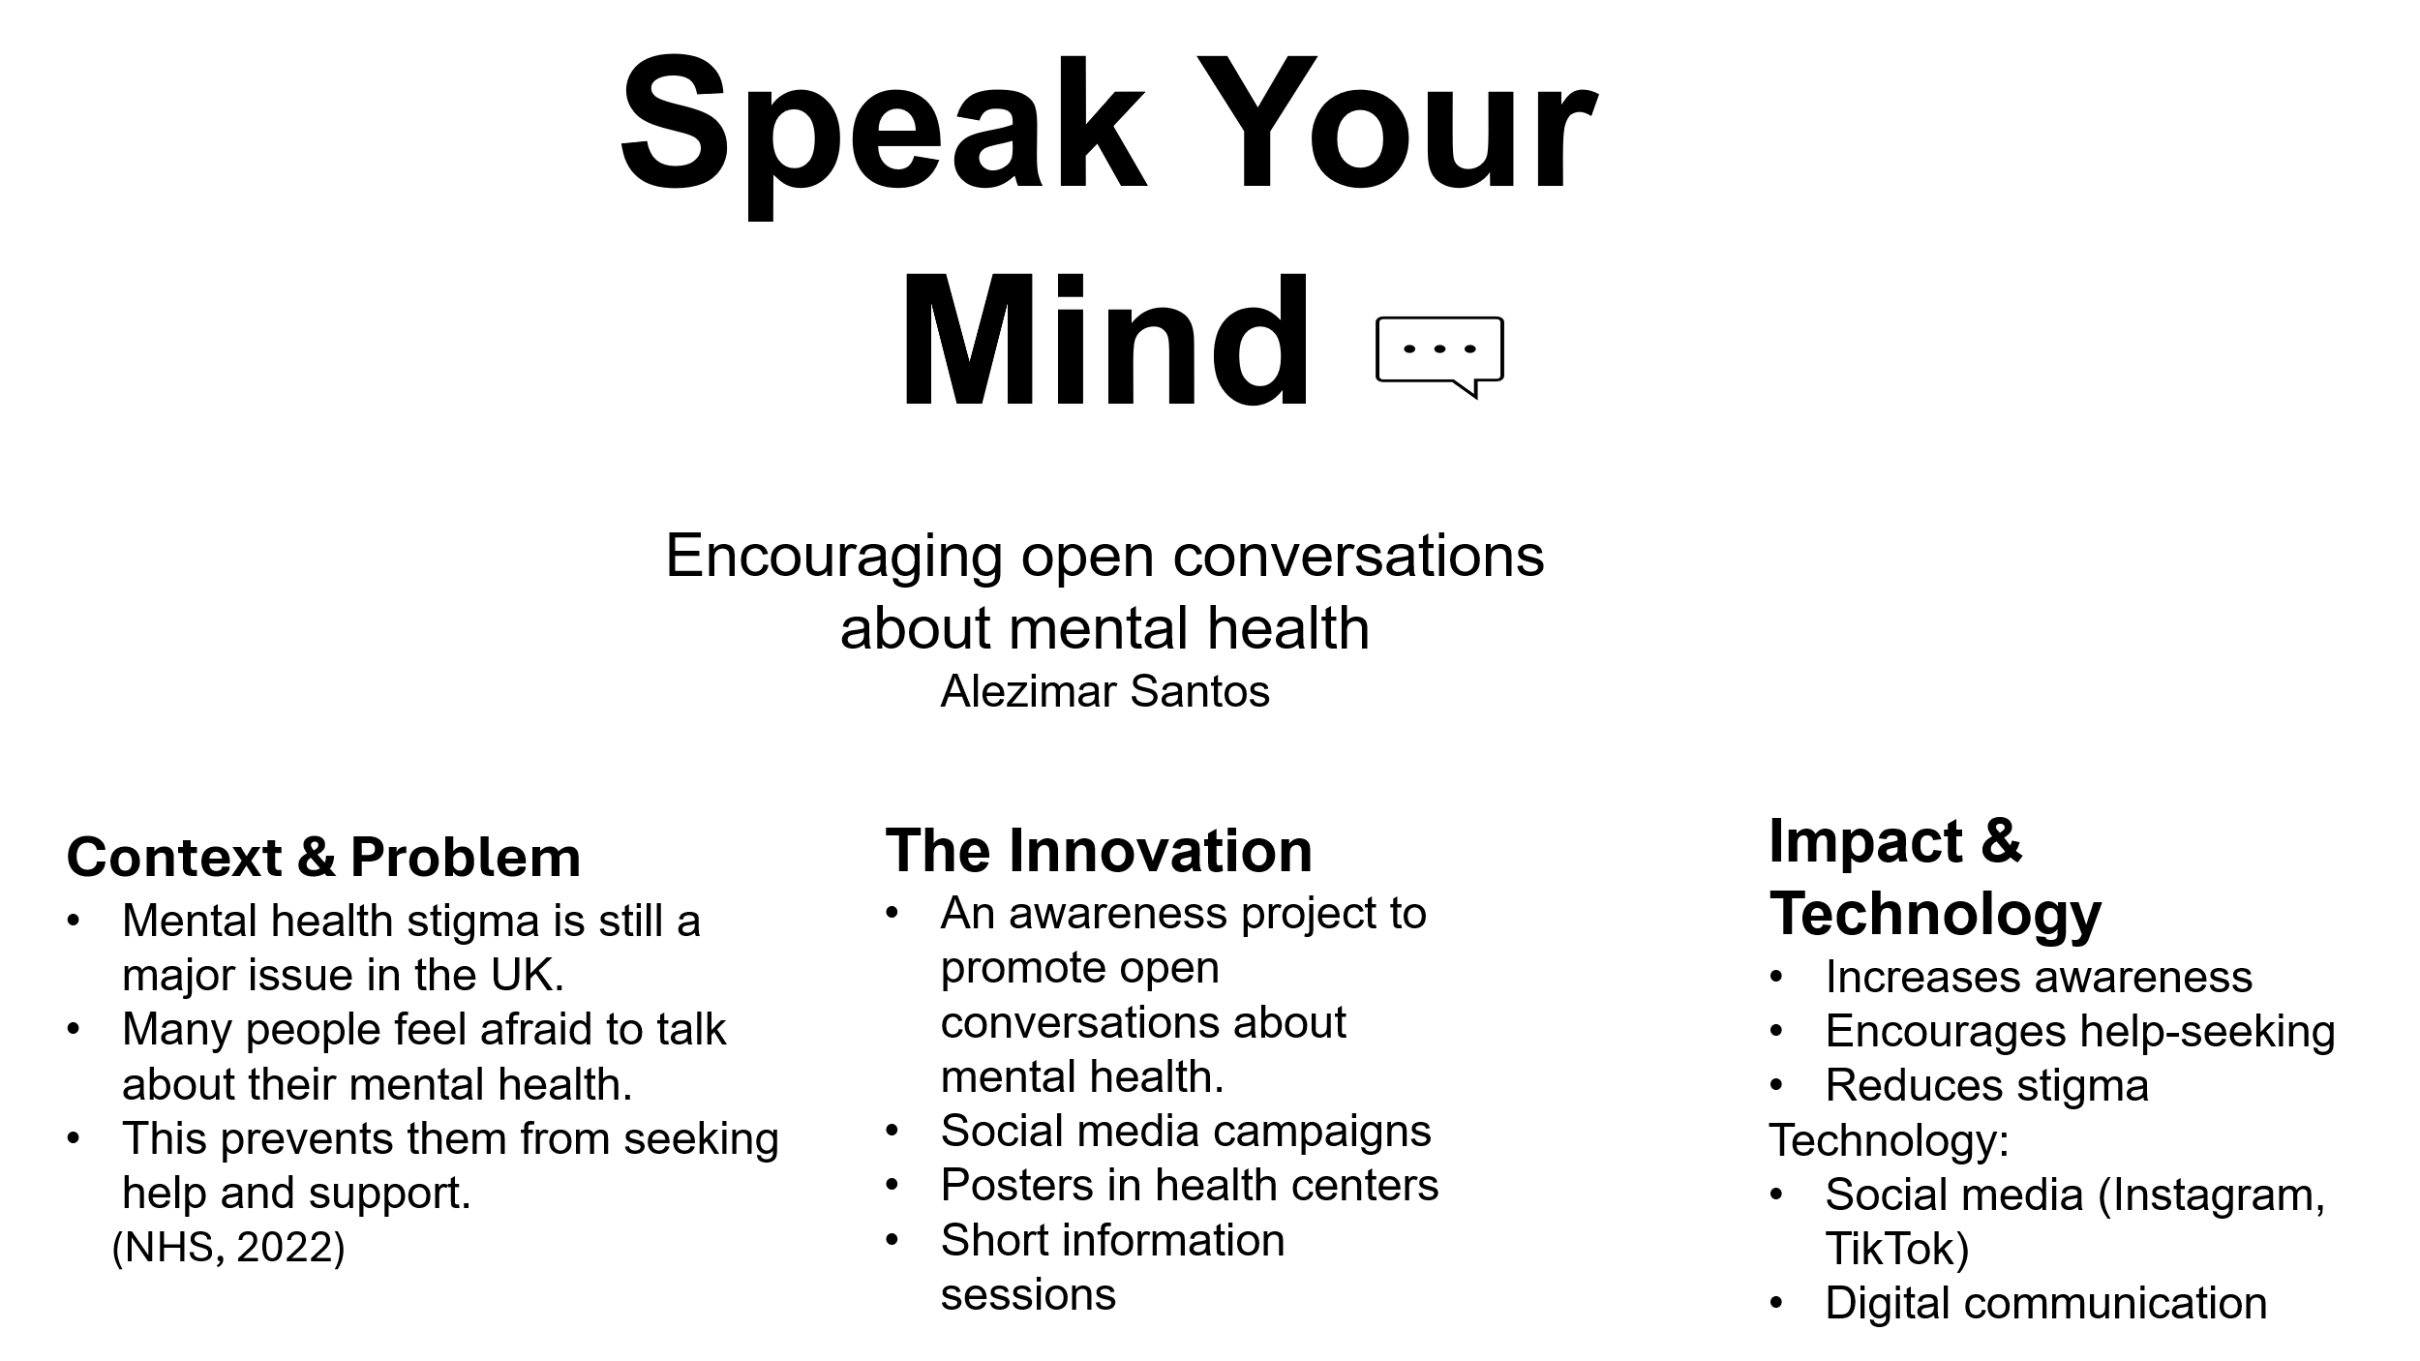

Speak Your Mind: Reducing Mental Health Stigma

Introduction
I am proposing an innovation called “Speak Your Mind”, which aims to reduce mental health stigma in health and social care. Mental health is a growing concern in the UK, but many people still feel uncomfortable talking about their experiences. This can prevent individuals from seeking help and accessing support services.
The Innovation
My idea is to create a small awareness project called “Speak Your Mind”. The purpose of this project is to encourage people to talk more openly about mental health. The project will include social media campaigns, posters in health centres, and short information sessions. These activities will help to share simple information and create a safe space for discussion. This innovation focuses on using simple and creative communication to improve understanding and reduce stigma in society.
Why This Matters
Mental health stigma can have serious consequences. Many people feel judged or misunderstood, which can stop them from asking for help. This can lead to worsening mental health conditions and lower quality of life. By encouraging open conversations, this project can help individuals feel supported and understood. It can also increase awareness and promote early intervention, which is important in health and social care. This innovation is relevant today because mental health issues are increasing, especially among young people in the UK. Mental health stigma can also lead to social isolation and reduced access to important support services.
Implementation Plan
To implement this project, several steps would be followed. First, the campaign would be designed, including social media content and informational materials. This would involve creating simple and clear messages about mental health. Second, a small pilot project would be introduced in a local community or health centre. This would allow testing the campaign's effectiveness. Third, the project would be launched on social media platforms such as Instagram and TikTok to reach a wider audience. Finally, short information sessions would be delivered to young adults and service users to encourage open discussions. Key stakeholders would include health professionals, community organisations, and social media platforms. Resources needed would be low-cost materials and digital tools. The effectiveness of the project would be monitored through feedback and engagement levels to ensure continuous improvement.
This project would also align with current UK health policies, such as the NHS Long Term Plan and mental health strategies, to improve access and reduce inequalities.
Timeline:
The project could be developed over 3–6 months, including planning, testing, and full implementation.
Value, Feasibility, and Challenges
This innovation provides value by promoting mental health awareness and encouraging early support. It is a low-cost project that can be easily implemented in local communities and health settings. However, there may be some challenges. For example, some individuals may still feel uncomfortable discussing mental health due to stigma. There may also be limited engagement from the target audience. To overcome these challenges, the project should use relatable content and inclusive communication. Working with trusted organisations and using social media can also help to increase engagement. In the future, this project could be expanded to schools and workplaces to reach a wider audience.
Conclusion
In conclusion, the “Speak Your Mind” project has the potential to reduce mental health stigma and encourage open conversations. By using simple and creative methods, this innovation can support individuals and improve access to mental health services. I strongly recommend that this project should be supported and implemented in local communities and health settings to promote well-being and reduce inequalities.

References
NHS (2022) Mental health services. Available at: https://www.nhs.uk (Accessed: 30 March 2026).
Mind (2021) Mental health facts and statistics. Available at: https://www.mind.org.uk (Accessed: 30 March 2026).
World Health Organization (2022). Mental health: strengthening our response. Available at: https://www.who.int (Accessed: 30 March 2026).
Public Health England (2019) Prevention concordat for better mental health. Available at: https://www.gov.uk (Accessed: 30 March 2026).
Department of Health and Social Care (2018). No health without mental health. Available at: https://www.gov.uk (Accessed: 30 March 2026).
Time to Change (2020) Attitudes to mental health and stigma. Available at: https://www.time-to-change.org.uk (Accessed: 30 March 2026).
NHS England (2019). The NHS Long Term Plan. Available at: https://www.longtermplan.nhs.uk (Accessed: 30 March 2026).
Mental Health Foundation (2022) Mental health statistics: prevalence and impact. Available at: https://www.mentalhealth.org.uk (Accessed: 30 March 2026).
National Institute for Health and Care Excellence (2022) Mental health and wellbeing. Available at: https://www.nice.org.uk (Accessed: 30 March 2026).
Office for National Statistics (2022) Mental health statistics in the UK. Available at: https://www.ons.gov.uk (Accessed: 30 March 2026).

