EVIDENCE OF LEARNING (E-PORTFOLIO)
Name of the student: Serbanica Cristina Raluca
Name of the university: University of Wales Trinity Saint David
Student’s ID: 1812752
Executive summary
The portfolio helps in focusing on the evidence of learning along with various aspects of evaluation. The evaluation of the topics includes the definition of academic writing along with its importance. The required critical analysis has been derived with the required number of examples. The importance of critical analysis has been derived from various important factors. The factors have been derived in such a way that the definite evaluation of evidence of learning can be modulated. The required amount of analysis along with a set of 3 slides of presentation has been done for generating an effective communication chain among the students.

Contents
Introduction 4
Purpose of the project 4
Academic writing 5
Critical analysis 8
PowerPoint Presentation 10
Conclusion 11
References 12

Introduction
The portfolio is based on the evidence of learning corresponding to the various factors involved in the process. The portfolio will help in highlighting academic writing along with the importance of academic writing. The definition will be discussed for assessing the required area of development of the individuals. The development may differ in various aspects in terms of personal as well as professional. The necessary critical analysis will be defined with the required examples for a better understanding of the chosen topic. The critical analysis along with its importance of it will be highlighted.
The importance and the process of enhancement towards the work to maintain the quality. The quality of work can be produced and managed by a detailed review or analysis of the topic. Academic writing is a sector where the writing procedure is based on detailed project preparation along with various considerations of the factors. The detailed review of the portfolio helps to result in executing different areas of academic writing along with all the learning processes. All the learning processes will be defined for evaluation by personal or professional individuals.

Purpose of the project
The portfolio will highlight the evidence of learning as well as various aspects of it. The factors like academic writing will be the primary area to be demonstrated for understanding the significant approaches of it (Strobl et al., 2019). The importance of academic writing is vast in terms of detailed research and detailed monitoring activities. The academic research section is very much required as the importance of academic writing is one of the key areas of evidence learning.

Significance of this section
Importance of academic writing helps in identifying the key areas that will be helpful for constructing evidence learning. The portfolio will also develop the idea of critical analysis along with its importance. The necessary examples will be given for understanding the accurate importance of it in the evidence of the learning sector. The evidence of learning is a portion that helps in binding all the required activities that showcase the procedure of making unique project reports related to the academy.

Academic writing
Definition
Academic communication is the area where communication happens in the context of collaborating on various ideas, research, and information in the biggest community of academics. Academic writing can be classified into two subcategories (French, 2020). One is the type of writing that is being represented by the students for their regular practice of submission. The assessments or the assignments are prepared by the students in the context of various purposes. These practices are done for university study as well as many kinds of submissions of the assignment. On the other hand, there is a type of academic writing that defines the process of writing any study materials into a study journal or into any academic book. There are various features of academic writing such as evidenced, balanced, precise, structured, etc. These features help to understand the different types of academic writing formats (Iwasaki et al., 2019). These formats are widely used for publishing in various areas such as academic journals or any books representing academic views.
Importance of academic writing
There are few importance of academic writing in terms of the students. Academic writing has been an integral part of the students. The concerned professors are always responsible to create certain knowledge among the students. The importance is as follows:
Helps in conveying the understanding: The students sometimes face the issue in terms of explaining any complex topic to others. Complex concepts always challenge the students to learn more and act accordingly (Barrett et al., 2019). The thorough revision of the critical topic helps the students to get the basic idea of the topics and then as per the understanding, the messages are conveyed to others.
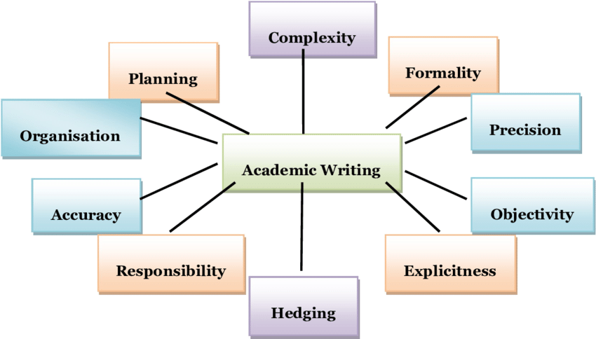
Figure 1: Features of academic writing
(Source: Barrett et al., 2019)

Thinking related to analytical overview: Thinking about a certain topic is important at the time of academic writing. Critical thinking helps in generating the idea of a certain topic and conveys the message to the audience in a proper manner. The process involves taking all the information from the topic and then it will help to convey the message towards the audience by having all the required information (Donnelly and Patrinos, 2021). Based on the findings from the project, it is the responsibility of the students to identify all the required findings and then implement them in a proper manner.
Focusing on the technique and style: Academic writing is the process of having a formal way of writing any particular content. The content helps to develop various styles and techniques that differentiate academic writing from less formal writing. There are various styles of academic writing such as essays, reports, portfolios, and presentations (Darling-Hammond et al., 2020). The students are responsible to discover all the required development areas in terms of knowing the structures of essays, reports, etc. The knowledge of writing those formats will help the students to gain a piece of proper knowledge about the types of conveying messages to the audiences. Learning the formats will help the students to gain more areas to apply to their academic writing skills.
Explaining the similarity score
The students are responsible to discover all the necessary development areas in terms of knowing the structures of essays, reports, etc. The knowledge of writing those formats will help the students to gain a piece of proper knowledge about the types of conveying messages to the audiences. The portion helps in finding the different activities related to the writing which is unique. The evaluation helps in maintaining the similarity score that does not have any sort of matches with the sources.
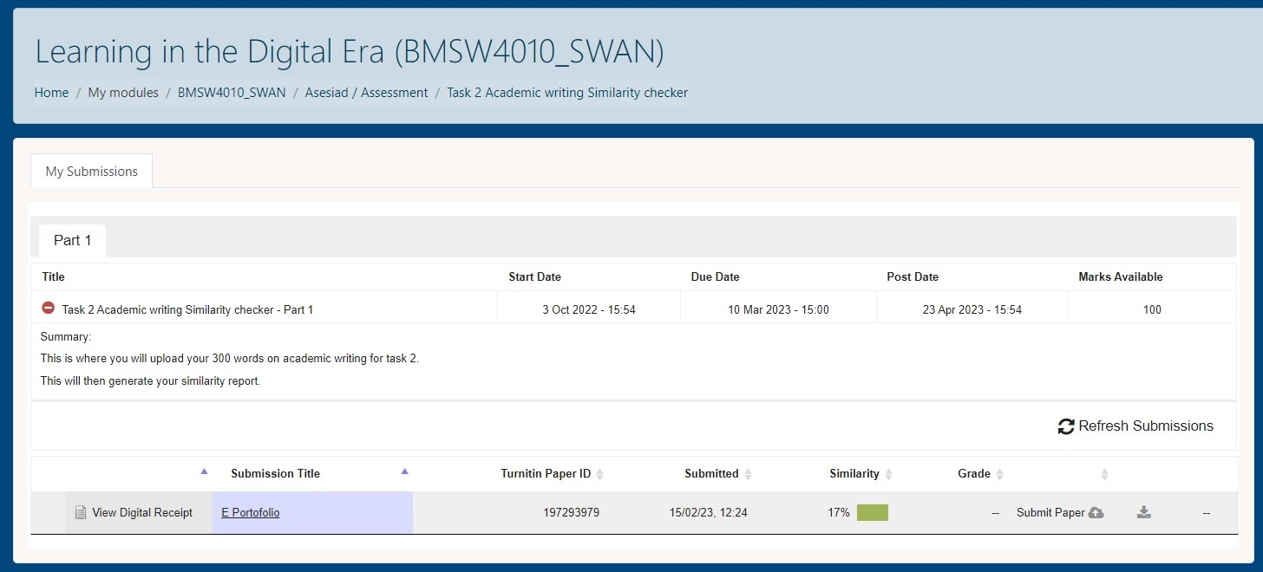

Critical analysis
Definition of critical analysis
Critical analysis is a definite process of having an accurate evaluation of a certain topic. The evaluation process involves various stages that include reading, listening and analysing the required academic topic. From an academic point of view, universities are responsible to set certain goals for the students that help in learning critical analysis (Knight et al., 2020). It is important to analyse a certain topic before starting and analysing the certain topic helps in collecting more desired results in terms of evaluation of any academic project.
Stages of critical analysis
The process defines the various stages of creating positive results. The stages are description, analysis and evaluation. The description portion helps in understanding what the project needs to say or the different approaches to finish the project. A particular individual is responsible to have a detailed review of the provided subjects. The detailed review will help in understanding the significant approaches that need to be adopted for doing the assignment (qizi Agzamkhanova and Golovko, 2023). In the analysis stage, the students are responsible to analyse the project in terms of finding the importance of the given subject as well as the processes that can be executed for evaluating the project. Evaluation is the final stage of critical analysis that helps in the progression of the project as per the outcomes generated after the successive analysis.
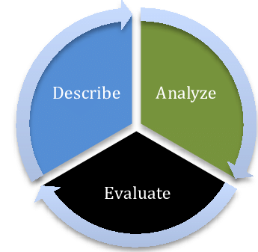
Figure 2: Stages of critical analysis
(Source: qizi Agzamkhanova and Golovko, 2023)
Role of critical analysis for producing quality work
Enhancement in creativity: The students can have good creativity options in terms of considering critical analysis. A definite or accurate analysis of a certain topic helps in building curiosity about a certain topic. Curiosity helps in gathering more knowledge in terms of identification or determination of the key areas that need to be used for building the assignment.
Self-reflection: Critical thinking is the process of evaluating self-disciplined, self-corrective as well as self-monitored features in students.
Developing career prospects: In the time of the global pandemic, the employees or the students are intended to learn new things as well as have a definite critical analysis about a certain topic. The whole world has gone through the toughest phase during this time (Strobl et al., 2019). The losses faced by every industry have been a serious issue and the students along with the employees are responsible for taking the required decisions for career development by analysing this tough situation.

PowerPoint Presentation link :
https://uowtsd-my.sharepoint.com/personal/1812752_student_uwtsd_ac_uk/_layouts/15/stream.aspx?id=%2Fpersonal%2F1812752%5Fstudent%5Fuwtsd%5Fac%5Fuk%2FDocuments%2FVideo0%20%281%29%202%2Ewebm&referrer=OfficeHome&referrerScenario=EDGEWORTH

References

- Englander, K. and Corcoran, J.N., (2021). Power, identity, and academic literacy: a Coda. Academic Literacy Development: Perspectives on Multilingual Scholars' Approaches to Writing, pp.329-343.
- Sletto, B., Stiphany, K., Futrell Winslow, J., Roberts, A., Torrado, M., Reyes, A., Reyes, A., Yunda, J., Wirsching, C., Choi, K. and Tajchman, K., (2020). Demystifying Academic Writing in the Doctoral Program: Writing Workshops, Peer Reviews, and Scholarly Identities. Planning Practice & Research, 35(3), pp.349-362.
- Trinh, E. and Herrera, L.J.P., (2020). Writing as an art of rebellion: Scholars of color using literacy to find spaces of identity and belonging in academia. In Amplified Voices, Intersecting Identities: Volume 2 (pp. 25-33). Brill.

Conclusion
The portfolio helps in focusing on the evidence of learning along with various important factors that are involved in the topic. Academic writing has been derived for self-evaluation along with the importance that has also been described for understanding the required area of development. The critical analysis has also been derived along with the importance and understanding. The importance of critical analysis has been demonstrated for the desired evaluation that helps in the development of academic writing skills. A required presentation has been presented with the help of PowerPoint. The presentation has been derived to evaluate the communication chain among the employees. The communication among the students along with the lecturers will be developed as per the discussed topic.

References
Barrett, P., Treves, A., Shmis, T. and Ambasz, D., (2019). The impact of school infrastructure on learning: A synthesis of the evidence.
Darling-Hammond, L., Flook, L., Cook-Harvey, C., Barron, B. and Osher, D., (2020). Implications for educational practice of the science of learning and development. Applied developmental science, 24(2), pp.97-140.
Donnelly, R. and Patrinos, H.A., (2021). Learning loss during COVID-19: An early systematic review. Prospects, pp.1-9.
Englander, K. and Corcoran, J.N., (2021). Power, identity, and academic literacy: a Coda. Academic Literacy Development: Perspectives on Multilingual Scholars' Approaches to Writing, pp.329-343.
French, A., (2020). Academic writing as identity-work in higher education: forming a ‘professional writing in higher education habitus’. Studies in Higher Education, 45(8), pp.1605-1617.
Huisman, B., Saab, N., van den Broek, P. and van Driel, J., (2019). The impact of formative peer feedback on higher education students’ academic writing: a Meta-Analysis. Assessment & Evaluation in Higher Education, 44(6), pp.863-880.
Iwasaki, C., Tada, Y., Furukawa, T., Sasaki, K., Yamada, Y., Nakazawa, T. and Ikezawa, T., (2019). Design of e-learning and online tutoring as learning support for academic writing. Asian Association of Open Universities Journal, 14(2), pp.85-96.
Knight, S., Shibani, A., Abel, S., Gibson, A. and Ryan, P., (2020). AcaWriter: A learning analytics tool for formative feedback on academic writing. Journal of Writing Research.
qizi Agzamkhanova, G.R. and Golovko, Y.V., (2023). REASONS AND TECHNIQUES TO IMPROVE ACADEMIC WRITING SKILLS. Emergent: Journal of Educational Discoveries and Lifelong Learning (EJEDL), 4(01), pp.103-109.
Sletto, B., Stiphany, K., Futrell Winslow, J., Roberts, A., Torrado, M., Reyes, A., Reyes, A., Yunda, J., Wirsching, C., Choi, K. and Tajchman, K., (2020). Demystifying Academic Writing in the Doctoral Program: Writing Workshops, Peer Reviews, and Scholarly Identities. Planning Practice & Research, 35(3), pp.349-362.
Strobl, C., Ailhaud, E., Benetos, K., Devitt, A., Kruse, O., Proske, A. and Rapp, C., (2019). Digital support for academic writing: A review of technologies and pedagogies. Computers & education, 131, pp.33-48.
Trinh, E. and Herrera, L.J.P., (2020). Writing as an art of rebellion: Scholars of color using literacy to find spaces of identity and belonging in academia. In Amplified Voices, Intersecting Identities: Volume 2 (pp. 25-33). Brill.

