


SECURING THE DATA LINK LAYER (L2) ON THE WELSH AMBULANCE NETWORK INFRASTRUCTURE

Geraint Hill 9900497
BSc DA6CNS Computing (Computer Networks & Cybersecurity)

Supervisor: Munyaradzi Murira

Project submitted as part of the requirements for the award of BSc Computer Networks & Cyber Security

July 2022

Declaration of Originality

I, Geraint Arfon Hill declare that I am the sole author of this Project; that all references cited have been consulted; that I have conducted all work of which this is a record, and that the finished work lies within the prescribed word limits.

Signed : .............................................

Date : ...............................................

FORM OF CONSENT

I Geraint Arfon Hill hereby consent that my Project, submitted in candidature for the BSc Cyber DA6CNS Computer Networks and Cyber Security photocopying (subject to the law of copyright), and that the title and abstract may be made available to outside organisations.

Signed : .............................................

Date : ...............................................

Copyright Acknowledgement

I acknowledge that the copyright of this project report, and any product developed as part of the project, belong to University of Wales Trinity Saint David, Swansea.

ABSTRACT/SYNPOSIS

This report is about securing the Data Link Layer (also referred as the L2) in the Welsh Ambulance Service Team (WAST) network. The report researches L2 protocols that are used by WAST and describes how they are beneficial to the organisation network.

Whilst WAST utilise these standard protocols, this report highlights how in their basic form the protocols place WAST in a weakened security posture, since the protocols have been configured with the minimum consideration to the risks., This report highlights the risk that addresses the considerations that should have been taken before deployment. L2 is where the user and other equipment connect to the network. Much of the focus in WAST is aimed on the edge where the “outside”, or traffic considered untrusted traverses, thus L2 is often overlooked as it is assumed that anything connecting internally to the network is trusted. The report highlights that its not only threat actors that pose a risk to the WAST L2 infrastructure, misconfigurations of equipment by administrators can also lead to unintended severe outages.

Whilst the WAST network is geographically large, the way that WAST has designed its topology means that it is not too late to secure L2 at all sites. Many of the sites can be protected and a detailed phased approach can be undertaken to implement the new changes suggested in this report. This can be done with minimal disruption to the production network.

The report concludes with recommendations going forward and provides a comprehensive template that can be applied to all L2 devices before they are installed on the network, this assures that the future of L2 deployments are secure and provide WAST with a stronger security posture at L2.

Table of Content

Abstract/Synopsis
Table of Content
List of Figures
List of Tables
Acknowledgements

Contents

CHAPTER 1 AIMS AND OBJECTIVES 11
1.1 Aim 11
1.2 Objectives 11
1.3 Structure 11
CHAPTER 2 LITERATURE REVIEW 12
2.1 Introduction 12
2.2 Request for comments (RFC) 13
2.3 Dynamic Host Configuration Protocol (DHCP) 13
2.4 Spanning Tree Protocol (STP) 14
2.5 Rapid Spanning Tree Protocol (RSTP) 15
2.6 Hot Standby Routing Protocol (HSRP) 17
2.7 Cisco Discovery Protocol (CDP) 19
2.8 Vlan Trunking Protocol (VTP) 19
2.9 Dynamic Trunking Protocol (DTP) 20
2.10 Port Security 20
2.11 Conclusion 22
CHAPTER 3 RESEARCH AND METHODOLOGY 23
3.1 Introduction 23
3.2 Philosophy 23
3.3 Apporach 24
3.4 Strategy 24
3.5 Document Review 25
3.6 Configuration Deployment 26
3.7 Testing 26
3.8 Risks and linitations 26
3.9 Conclusion 26
CHAPTER 4: DESIGN AND IMPLEMENTATION 27
4.1 Introduction 27
4.2 Problem formulation 27
4.3 Design 31
4.4 Implementation 32
4.5 Conclusion 34
CHAPTER 5: TESTING AND EVALUATION 34
5.1 Introduction 34
5.2 HSRP Attack 35
5.2 RSTP Attack 37
5.3 CDP Attack 39
5.4 DTP Attack 41
5.5 VTP Attack 43
5.6 DHCP Attack 47
5.7 Mitigations 52
5.8 HSRP Mitigation 54
5.9 RSTP Mitigation 58
5.10 DHCP Mitigation 63
5.11 VTP Mitigation 66
5.12 CDP Mitigation 69
CHAPTER 6 CONCLUSION AND RECOMMENDATIONS 69
CHAPTER 7 REFLECTIONS 70
CHAPTER 8 REFERENCES 72
APPENDICES 76
ETHICS FORM 83
GLOSSARY 89

LIST OF FIGURES

Figure 1: An illustration of STP. On the left a looped topology. On the right Loop Free, the redundant links have been placed in the disabled or blocked state
Figure 2: STP comparison of ports states.
Figure 3: HSRP resilience demonstrated. A path to each of the HSRP routers and the virtual IP used by the HSRP group.
Figure 4 Research Onion
Figure 5 Deductive approach
Figure 6: An overview of the network at WAST’s VPH Site
Figure 7: L2 topology at WAST displaying the protocols used.
Figure 8: The home lab topology.
Figure 9:HSRP: Shows the router is Standby for L3 decisions. The priority is 160 and was set by the author.
Figure 10: HSRP: sh standby output.
Figure 11: HSRP: Yersinia on the Kali Linux machine displaying HSRP traffic that it sees.
Figure 12: HSRP: The attack vector being selected, to send a packet to become the active router.
Figure 13: HSRP: Yersinia, the source IP being configured, last two octets 6.66 to signify an attacker.
Figure 14: HSRP: The results of the attack being shown. Port flapping in place, meaning disruption is recognised.
Figure 15: HSRP: sh standby output following the attack shows that 6.66 with priority of 255 is now the active rotuer.
Figure 16: RSTP: sh spanning tree output.
Figure 17: RSTP: Yersinia, the attack to claim the root role is selected. This will cause all switches to calculate their best path to Yersinia.
Figure 18: RSTP: The root bridge is recognised on int F1/0/48 (The trunk to where yersinia is located. The Yersinia Mac address is also identified as the root bridge.
Figure 19: CDP: Normal CDP output. Displaying what cisco devices are connected to the WAST-SW1 device.
Figure 20: CDP: Normal CDP output. Displaying what cisco devices are connected to the WAST-SW2 device.
Figure 21: After the CDP attack is carried out by Yersinia, it floods the CDP database, if continued this will kill the switch. Note: Platform “Yersinia”.
Figure 22: DTP: The attack is selected to negotiate a trunk against a switch that doesn’t have the switchport forced to access mode.
Figure 23: DTP: The attack is sent and the packed to force the switch to trunk is acknowledged. All VLAN’s will now be visible.
Figure 24: DTP: The interface is reset and the trunk is formed. The interface connecting the Yersinia to the network is now trunking.
Figure 25: VTP: Showing the vlan database. 2 the only one created by the administrator.
Figure 26: VTP: Yersinia. Attack to add a VLAN.
Figure 27: VTP: Yersinia: name of malicious VLAN, VLAN number is 666.
Figure 28: VTP: Yersinia: VTP traffic exchanged.
Figure 29: VTP: We can now see that VLAN 666 has been added to the database.
Figure 30: VTP: VLAN 666 removed by Yersinia.
Figure 31: DHCP normal operation, only 2 bindings on WAST server.
Figure 32: DHCP: Yersinia: attack to send packets selected.
Figure 33: DHCP: Yersina: The attack takes place, and DISCOVER messages flooded. Note: The amount of DHCP traffic sent in milliseconds (ms). If not stopped it would kill the device.
Figure 34: DHCP: The ip dhcp binding on the core is cleared for ease of viewing.
Figure 35: DHCP: The depleted addresses on the server with randomly generated mac addresses by Yersinia.
Figure 36: Percentage of organisations that have the following rules or controls in place.
Figure 37: HSRP: Show Standby shows that Core is the active router.
Figure 38 : HSRP: The key-chain for authentication on Core 1 is configured.
Figure 39: HSRP: immediately recognises that a device with authentication is sending HSRP packets.
Figure 40: HSRP: Standby router is unknown now as Core 2 (sw1) has no authentication configured.
Figure 41: HSRP: SW1 believes it is the active router.
Figure 42:HSRP: Authentication is now configured on Core 2(sw1).
Figure 43: HSRP: Standby 2 instance is now working as intended with authentication string.
Figure 44: HSRP Yersinia is used to carry out same attack on HSRP, now with authentication configured. This is the malicious IP.
Figure 45: HSRP listens on multicast 224.0.0.2, the malicious IP (presented backwards in yersinia).
Figure 46: HSRP: Non authenticated HSRP messages
Figure 47: HSRP: Non authenticated HSRP messages on SW1 are dropped.
Figure 48: RSTP shows SW1 is the root bridge.
Figure 49: RSTP shows that both 1/0/1 an 1/0/48 are partaking in RSTP and that the both interfaces are forwarding Note: another tell- tale sign that this is the root bridge.
Figure 50: RSTP:Root guard being configured on a per interface basis.
Figure 51: RSTP: SW2, displays its interface to reach the root.
Figure 52: RSTP: Shows that the a BPDU with superior priority on a port configured with root guard will put the port in the blocking state.
Figure 53: RSTP: Yersina: Displays the configuration on the malicious users interface.
Figure 54: RSTP: The same attack carried out earlier is primed.
Figure 55: RSTP: BPDU’s are sent.
Figure 56: RSTP: The access port of the malicious user is immediately shut, protecting RSTP.
Figure 57: RSTP: SW2 clearly displays the status of the malicious port and the reason its shut. Administrator could investigate immediately.
Figure 58: RSTP: BPDUGuard configured on a port receiving BPDU frames.
Figure 59: RSTP:BPFU guard demonstrated, placing the interface in error disabled.
Figure 60: DHCP : snooping config on int fa1/0/24.
Figure 61: Switchport security to protect against multi MAC addresses being used.
Figure 62: DHCP: The attack is carried out.
Figure 63: The Security policy immediately shuts the port. Protecting the DHCP service.
Figure 64: DHCP: Shows normal binding after the attack. The mitigation is successful.
Figure 65: The normal operating VLAN database on SW1.
Figure 66: VLAN 13 on SW2 is added to show a difference in the VLAN database between switches.
Figure 67: VTP authentication configured on the vtp domain.
Figure 68: VTP: a new vlan is created (99).
Figure 69: VLAN database has been overwritten (13 has deleted, 999 has added). The overwriting has occurred.

LIST OF TABLES

Table 1: An example of some of the attacks explored in this report and suggested mitigations
Table 2: Research Design
ACKNOWLEDGEMENTS

To Swansea Bay University Health Board (SBUHB) for giving me the opportunity to pursue this degree.
To WAST for supporting my needs to finalise this project.

To WAST network team for providing me with the network equipment for testing.

CHAPTER 1 AIMS AND OBJECTIVES

1.1 Aim

The aim of this report is to evaluate if the current Layer 2(L2) / Data Link implementation at Welsh Ambulance Service Team (WAST) is secure enough or if further measures can or need to be implemented to ensure WAST are in the optimal posture and are adequately protected against threats and vulnerabilities.

1.2 Objectives

To meet the aim, the following objectives will need to be met:

- Research L2 protocols that are used across the WAST health board and identify best practices for securing them
- Conduct an extensive analysis of L2 protocols on existing WAST network
- Replicate the existing infrastructure in a home laboratory environment
- Identify the vulnerabilities and implement the recommended mitigations safely
- In a testing environment, apply configuration to enable the mitigations and interrogate them by attacking the specific protocols
- Evaluate the results of the mitigations and decide if there’s a business case to implement them
- Provide the IT Ops board with a clear plan to implement the new measures on the production network
It is predicted that most of the security measures offered in this report will be applied on a small site before implementing across the board, eventually to the main sites upon its success.

The report should re-invent and future proof the existing configuration that is currently copied to L2 devices and act as a baseline for future deployments.

1.3 Structure

This report consists of six chapters, which are listed below The report begins with a look at the main protocols that operate at L2 and how they work. This will provide the reader with an understanding on how the protocols are designed to work and how they benefit L2 topologies implemented by organisations, and will also highlight their vulnerabilities. Research methods and philosophy will be discussed and will provide a guideline on how this topic was researched and the report created. This report will also provide an understanding on how conclusions and evidence for mitigations has been assessed. An assessment of the WAST L2 infrastructure will be presented and will provide an overview of why this report was written, including a vision of how the L2 mitigation measures will benefit WAST and what needs to be done to get there.

Chapter one outlined the aims and objectives and provided an introduction to the project

Chapter two consists of the literature review, outlining all the protocols that will be investigated and tested in this report

Chapter three provides the research and methodology subjects and how they aide the writer in structuring evidence

Chapter four provides an overview of the current infrastructure in WAST and the problems it faces

Chapter five provides the testing and evaluation of the protocols, it explores how they configured in WAST and what happens if a vulnerability is exploited (maliciously or accidentally), after this, mitigations are put in place and the same vulnerability is attacked to assess the effects

Chapter six provides an overall conclusion and recommendation for the mitigations

CHAPTER 2 LITERATURE REVIEW

2.1 Introduction
In this chapter we will explore the main L2 protocols and how they work. It is important that the L2 protocols are used in the most efficient way on a case per case basis – how the protocol is implemented in one organisation may not benefit another organisation. The chapter will set out how the protocols are standardised and how developments are documented. All the L2 protocols discussed in this chapter are utilised by WAST. Some of them have been administratively configured, and some are on by default, a manufacturers (Cisco) factory setting. The chapter also discusses how WAST have configured / not configured these protocols on their L2 infrastructure.

2.2 Request for comments (RFC)
RFC’s are created and maintained by the Internet and Engineering Task Force (IETF) and provides the internet community with a white paper for protocols and standards that are available to use. RFC is also a tool used by engineers to discuss and provide feedback for improvements on standards. All protocols discussed in this paper will have an RFC number associated, as they have already been standardised and widely discussed.

2.3 Dynamic Host Configuration Protocol (DHCP)
RFC 2131[1] outlines the DHCP protocol. DHCP uses the Bootstrap Protocol (BOOTP) protocol found in RFC 951[2] to automatically assign itself a reusable internet protocol (IP) address. For administrators, this negates the need to manually configure IP addresses on hosts to have internetwork connectivity. Typically, a server or a router is configured to provide the DHCP service. When a client boots up, it will request an IP address. At first, the host will not know what the IP address of the DHCP server is, so it will send a DISCOVER message as a broadcast. Once a DHCP server has received the DISCOVER message, it will send an OFFER of an available unique IP address to use for a specified leased time. Once received the offer the client will REQUEST the IP address and then the server will ACKNOWLEDGE this request. If the DHCP server does not reside on the same network that the client connects to, then a layer 3 device can have a configurable “IP helper” address that forwards the request to a server located on a different network[3].
One of the main issues facing DHCP is that the clients request an IP address dynamically without administrative intervention. If a DHCP pool on a server becomes depleted, then clients will not obtain an IP address required for internetwork connectivity. Unless suitable monitoring of DHCP pools is in place, and this can become expensive in an enterprise environment as these features are usually licenced, administrators will not be aware unless users report issues which means resolution is part of a reactive process.
Another issue that arises with DHCP is that clients initiate the DHCP process sending a DISCOVER packet. A server then responds with an OFFER. If a rogue device that can issue IP addresses is installed on the network it can be used to manipulate network traffic either by issuing a false default gateway, or simply to provide other false information that will cause traffic to be unroutable.
In order to mitigate this, DHCP snooping can be configured. DHCP snooping is implemented to ensure that DHCP negotiations are only accepted by authorised devices. DHCP snooping registers interfaces (registered interface) as trusted ports to ensure that any replies from unauthorised servers are not sent.[4].

2.4 Spanning Tree Protocol (STP)
Spanning Tree Protocol (STP 802.1D) provides loop free networks by disabling or blocking redundant links. If a link that is active fails, then the redundant link in the blocked state will become active after a convergence period. There are many flavours of STP, the needs of the organisations requirements will dictate the STP mode. In WAST, Rapid STP(RSTP) (802.1W) is used due to the quick convergence time during a topology change. WAST also have a relatively small Virtual Local Area Network (VLAN) database, therefore the requirement for something like multi-instance STP (MSTP 802.1s) is not required[5]. RSTP is easily configured.
Switches use Bridge Protocol Data Units (BPDU) packets to communicate with other switches. If a switch receives a BPDU packet, they will start exchanging information about themselves so a suitable root bridge can be autonomously elected. A root bridge is required so that the L2 loop free topology can be efficiently created since all switches calculate the best route to the root. L2 networking decisions are automated and these are based on cost (speed of interfaces) to the root. In STP certain variables determine the cost to elect a root bridge, with the lowest cost winning. If STP protocol is left in its native “out of the box” form, the switch with the lowest MAC address would become the root[6]. It is not good practice to leave STP in its native form and to elect the root bridge by lower mac address. It is always best for an administrator specify the root bridge by overriding default values. Older switches will have less processing power than newer switches. This was one of the contributing factors for this report title. The author discovered that an old switch (hidden away in a non critical hub room at a 999 contact centre) had become the root bridge. Default values were left because the guidance in configuring RSTP was not followed and there are still no protective measures in place to prevent this from happening in the future.
If there was no STP protocol running on the network, looped traffic will cause a broadcast storm causing switch’ Central Processing Unit (CPU) to run high, rendering the switch redundant. This could cause critical services to cease working. Other than maintaining the Content Addressable Memory (CAM) table, a switch’ main function is to forward traffic (frames) out of all interfaces other than the one it received it on[7]. In the looped topology, frames will continue to be forwarded through the network without discard, the frames build up quickly and will soon take all the processes. Users will report no network access or the network running very slow at the very least. STP is enabled by default on all Cisco switches[8]. L2 protocols do not propagate past Layer 3 (L3) boundaries, therefore a STP change at one site will nott affect a STP change in another site because they are behind routers (L3 device).

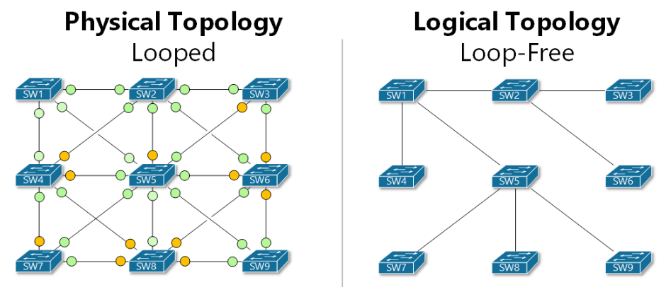
Figure 1: An illustration of STP. On the left a looped topology. On the right Loop Free, the redundant links have been placed in the disabled or blocked state[9].

2.5 Rapid Spanning Tree Protocol (RSTP)
WAST have moved away from the native STP that is enabled by default and use RSTP. According to Cisco the root bridge should be placed on the Core Switch in any network[10], as it is regarded the central point of the network (where all devices connect to). In WAST headquarters (HQ) Core 1 is the root bridge and Core 2 is the secondary, this is set by configuring the bridge ID to be lower than the default 32768[11]. When a switch is connected to the network, it immediately sends a BPDU packet with the bridge ID value configured. If that matches the MAC address is then used to contest who has the lowest priority. If a low bridge ID is configured on the core, then it will immediately beat the default 32768 and the new switch will find the best path to the root.
One of the risks in any STP instance is that if a switch that is configured with a lower variables used in cost and calculations in the election process, a L2 topology change will take place. The superior BPDU (lowest costs) will claim root bridge status for the switch, changing the L2 topology in all scenarios. All L2 traffic (frames) will flow to the root. Although this change propagates immediately, the convergence time in the default STP protocol can be up-to 50 seconds as opposed to 0.5 seconds for RSTP, this is because port states differ in convergence[12] :
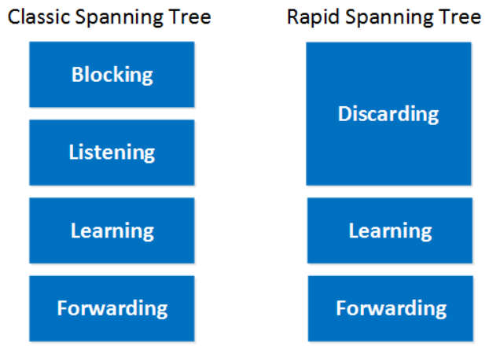
Figure 2: STP comparison of ports states[13].
A root bridge status could be changed either maliciously by a threat actor or accidentally by an administrator. If a threat actor was using a program that could send BPDU frames, they could incrementally keep changing the topology of the network resulting in network outages that last up to 45 seconds at a time, causing major disruption. In a different attack they could claim and maintain the root role and inspect network traffic without the knowledge of the organisation. Each of these scenarios would be detrimental.
The importance of STP is acknowledged in the networking industry due to the fact that it is already an out of the box setting[14]. This is to avoid network loops occurring at installation of a switch on the network. A L2 network loop / broadcast storm[15] are a result that frames are repeatedly sent through the network. The accumulation of frames increase the switch Central Processing Unit (CPU), eventually causing a switch to become redundant. STP be a difficult to troubleshoot as all the switches will be running slowly and topology changes will be confusing. A physical sign of a broadcast storm is that all the interface lights on a switch will be orange. One of the most important lessons from this report is that STP should never be disabled, and a suitable flavour of STP should always be enabled on networks, without STP, networks would not be able to operate. As part of additional security in relation to RSTP in WAST, access ports should be set to non trunking uplinks and bpdu-guard should be enabled on these interfaces. Configuring bpdu-guard places the access port into interface in error-disabled mode if the switch receives a BPDU packet on the interface. Bpdu-guard should not be put on interfaces connecting to other switches. Port-fast should be placed on the interfaces as part of this configuration, this places the access port into the forwarding state (ignoring STP messages and places the interface into the forwarding state following a convergence). Further measures to protect spanning tree is configuring root guard. Root guard prevents interfaces having a root path on that interface. An interface with root guard enabled will always remain up, however will be placed in a root inconsistent state, meaning it will not forward frames[16]. Currently in WAST, none of these mitigations are in place. These mitigations will be explored later in this report.

2.6 Hot Standby Routing Protocol (HSRP)
HSRP (RFC 2281)[17] can be configured on a number of routers or L3 switches. Its function is for a cluster of Layer 3 (L3) Switches / routers appear as one. HSRP can also be considered a L2 and L3 protocol as it uses a virtual MAC address (a L2 address). If the active router(determined by the administrator) in the cluster fails, then another will change from the standby state to the active state. In Vantage Point House (WAST South East HQ) Core 1 is the active router and Core 2 is the standby. If core 1 fails then core 2 will become active, this is seamless with no network disruption to the clients. To determine if a router in the group has gone down, hello packets are exchanged every 3 seconds. If a hello packet is not received the standby will assume that the router is no longer reachable for the rest of the network. HSRP is a very useful redundancy protocol.
WAST use Virtual Routing and Forwarding (VRF) to segregate the secure traffic and admin traffic. When the traffic routes through the firewalls on the configured interface, it is handed to the L3 switch that runs the Open Shortest Path First (OSPF) routing protocol internally. Core 1 deals with the routing of this traffic whilst it is in the active state. Core 2 acts as standby and would assume active state if Core 1 failed. In the production network, downtime can adversely affect services, especially those requiring Transmission Control Protocol (TCP) sessions. TCP requires network stability and acknowledgements when sessions are created as opposed to User Data Gram Protocol (UDP) where traffic is transmitted and if it the receiving end doesn’t receive the message; the issue is ignored[18]. In HSRP the hand off to the new active means that the transition is seamless, and traffic is less impacted. This is more important for when TCP packets are sent over the network. The HSRP protocol uses a virtual MAC of 0000.0C07.AC00[19], this is standardised, if Core 1 is redundant, the Virtual Internet Protocol V(IP) address and the mac address will remain the same for the clients, therefore when Address Resolution Protocol(ARP) is used, as far as hosts are aware, there is no network change.

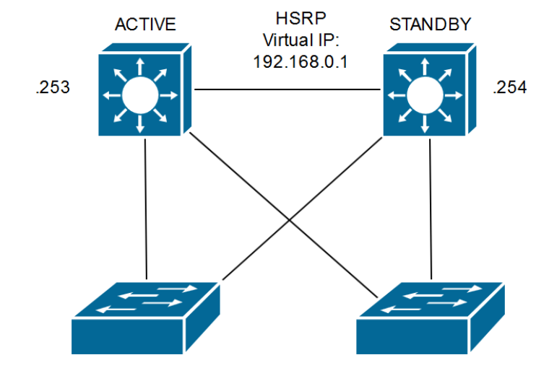
Figure 3: HSRP resilience demonstrated. A path to each of the HSRP routers and the virtual IP used by the HSRP group[20].
In WAST, HSRP v2 is used, however there is no authentication configured between the L3 switches. If a threat actor wanted to, they could send a HSRP with a higher configured priority or a higher IP address in event of a priority tie. With authentication in place, HSRP will simply ignore the challenge. In the event a threat actor does manage to become active router, they could route all traffic and have full visibility or simply cause severe disruption[20].

2.7 Cisco Discovery Protocol (CDP)
CDP is enabled in the WAST network, It is Cisco Proprietary and is the equivalent of the open standard Link Layer Discovery Protocol (LLDP). CDP is enabled by default. All of the L2 equipment in WAST is Cisco. CDP allows administrators to see what other cisco device are connected to the switch. It is not only switches that are displayed in the CDP table, other devices are routers, access points (APs) or Voice over Internet Protocol (VOIP) phones. The CDP entries provide valuable information, such as model number, IP address, IP prefixes, connecting interfaces, and versions of code that are running on connected Cisco devices. CDP is enough to perform reconnaissance on the network for documentation or troubleshooting. If a threat actor wanted to see vulnerable points of the network, they could gain information this way and base attacks on the results. Threat actors could perform an attack on the CPU of Cisco devices by flooding the target with CDP advertisements[21]. Secure CDP can be enabled and Type Length Value (TLV) filtered lists configured to ensure only selected information is displayed, making it harder for malicious users to gain information. The only way to stop the CDP CPU attack is to disable the CDP process [22]completely. Given the usefulness of this tool, CDP should be left to run.

2.8 Vlan Trunking Protocol (VTP)
VTP is used to manage VLAN databases. In its deployment guide[23], Cisco state that administrators must carefully choose whether implementing VTP on their network is safe. A VLANs initial design is to break up broadcast domains on a local switch. However in real time production networks, VLANs are spanned over multiple switches in order to provide easy and secure access for users. WAST are no exception. On Core 1, VTPv2 is enabled as a server, and all the other switches are clients. This means that VTP is centrally managed from the core. However, a misconception is that only the Server can override the VLAN database, this is not the case. A VTP Client can also overwrite a VLAN database[24]. Without VTP authentication enabled there is a real risk that VLANs could be modified by any Server or Client partaking in the VTP process.. In VTP, a revision number of the VLAN database is configured. However, when a VLAN is created it increments that figure. If an old switch was introduced into the network (reused from a different site), there is a risk that the VLAN database of that site could be overwritten. This is called a VTP bomb.. If a VLAN database is overwritten, all the VLANS that did exist on the switch does not exist anymore, In its purest form, if a vtp bomb happened in WAST, immediately network connectivity would be broken, causing all 999 / 111 calls to drop, phones de-register, all Access Points (APs) will lose connectivity with the controller, all network devices will be unreachable. To prevent this issue, it is recommended to turn VTP off, which could be manageable for WAST. Another solution is to put all switches other than the cores into VTP “transparent mode”. This means that the switches see the VTP traffic but do now update. Finally, if using VTP, the best practice is to implement VTP version 3 (VTPv3) where authentication could be implemented, meaning the configuration must be checked before installing new switches[24]. This provides an extra layer of security.
If an attacker managed to gain access to a network, and carries out a specified VTP attack, there is a possibility that they could Add, remove or modify VLAN information. Having access to the complete VLAN database[25], offers the attacker the platform to carry out further attacks such as vlan hopping

2.9 Dynamic Trunking Protocol (DTP)
If a switch is connected to another switch’s interface with DTP enabled a trunk could be formed meaning that access to VLANs across the network could be allowed. A trunk is an interface where all VLANs, unless specified traverse. This access could mean that the “sniffing” of traffic utilising a tool such as Wireshark[26] could provide an attacker valuable information of the traffic going over the network. Subsequently, Wireshark can also be used to sequence voice traffic captured and listen to 999 calls.. The best mitigation for this would be to turn DTP off on each interface, change the native VLAN, create a blackhole VLAN on every unused access port, and shut all unused access ports[27]. Administratively this would be frustrating, however it could prevent anyone gaining traffic information.

2.10 Port Security
One way to prevent attacks against a switch’ MAC address table is to enforce port security. WAST currently has no port security enabled and thus a malicious threat actor can connect to the interface, obtain an IP address and essentially access resources, depending on the complexity of their attack. L2 port security would restrict how many mac addresses can be learned on a given interface. All devices have a unique MAC address, an interface could be configured to allow a particular MAC address. If any other device which will have a different MAC address connects to the interface, the interface could be forced to Protect, Restrict or Shutdown[28]. MAC addresses can easily be spoofed(copied), which makes these attacks appealing.
If the interface security outcome is forced to Protect, the interface will stay up, bur drop any traffic and will not send a message to the administrator of the violation. Restrict violation means the interface will remain up, drop the traffic and advise the administrator of the violation. Shutdown, shuts the interface and sends a message[29]. In WAST, users connect AP’s to interfaces, many wireless devices (MAC addresses) connect to the AP’s, however switchport security can be implemented as the AP’s are Control And Provisioning Wireless Access Points (CAPWAP). The AP tunnels all traffic to the Wireless Lan Controller (WLC); therefore the switch doesn’t see the client MAC Addresses as it is dealt with by the AP before it gets to the interface on the switch[30]. Secondly, Cisco Voice over IP (VOIP) phones are used to connect computers. On the back of the phone there is an extra Local Area Network (LAN) interface for the computer to connect to, as a result two Mac Addresses will be learnt on WAST data interfaces, the one belonging to the phone and the other to the computer. To mitigate this, maximum MAC addresses for this type of port could be increased to two, however, if a device is faulty or changed it could present an administrative overhead. By default, the MAC address table is refreshed every five minutes[31]. With port security enabled, this could mean five minutes downtime for a user as the process in WAST is to raise a service desk ticket to investigate an issue and it is unlikely following this process that the issue will be immediately resolved. Further, a five-minute outage for a 999 / 111 call taker will affect productivity and could have serious consequences for the public who rely on the service.
Some of the attacks currently researched and their suggested mitigations. This report will offer a deeper understanding into these: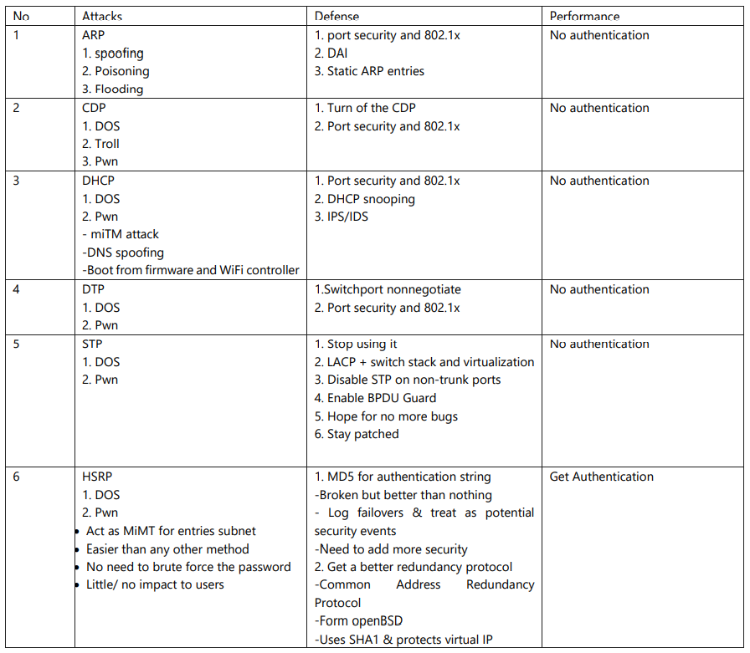
Table 1 An example of some of the attacks explored in this report and suggested mitigations[32]
Although the protocols and mitigations in the table above are discussed, considerations for the WAST production network need to be taken before the implementation. The table provides a brief overview to the user of the challenges discussed in this section.

2.11 Conclusion

In this section we have explored all the L2 protocols that are utilised in WAST. The protocols researched will provde the networking team, who may already understand these protocols, gain better knowledge how they are implemented in their organisation. This section has also provides an example of how a misconfiguration has resulted in a L2 weakness. The final part of this section, provides an insight into the later chapter on some of the mitigations that are used to protect the network at L2.

CHAPTER 3 RESEARCH AND METHODOLOGY

3.1 Introduction
Sections 1&2 explained the aim and objectives of the report and investigated the L2 protocols used by WAST in order to provide a solid interrogation to their vulnerably. This section will explore the methodology and the testing criteria required for the design and implementation and will set out the limitations. This section will outline the best suited philosophy and strategies for the progress of this project.

3.2 Philosophy
In order to complete a successful project, a suitable philosophy needs to be inherited that will enable the progression of the topic. One of the most common philosophies that can be utilised when selecting a methodology is the Research Onion which is shown in Figure 4.
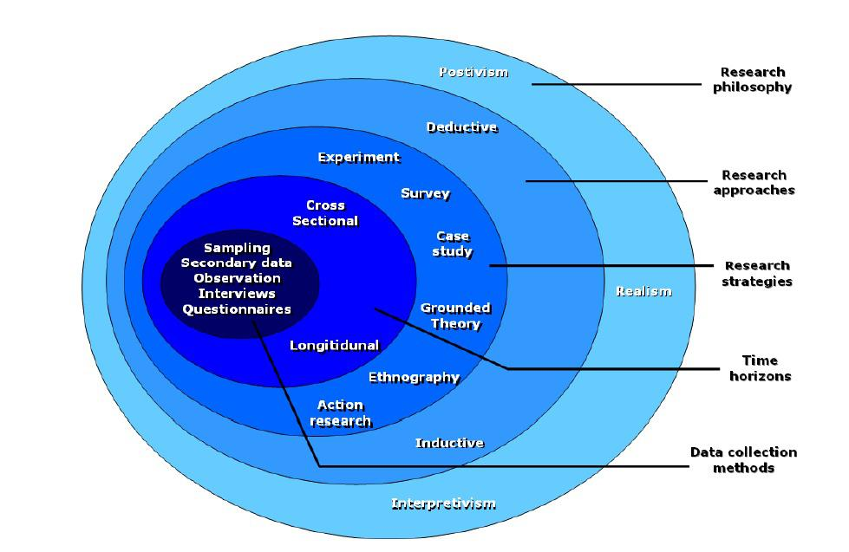
Figure 4 Research Onion [33]

In this report, Positivism will be the research philosophy. The threats and the mitigations discussed have already been widely researched and well documented by professionals who work in the networking and cyber security and networking field. The implementations that are demonstrated in this report have also been considered viable mitigations that would significantly reduce the risk of an attack or misconfiguration of the vectors in this report[34].

3.3 Apporach

The deductive Figure 5 approach complements positivism philosophy as much of the research has already been carried out and whitepapers available. The mitigations have been cited by networking authorities. In this paper, the theory behind each of the protocols in their current state will be explored, and a hypothesis of what would happen if a relative attack occurred formed. The results of the attacks will be measured in this report, pre and post mitigations.
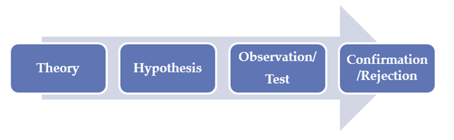
Figure 5 Deductive approach[35]

3.4 Strategy

Table 2 provides three research designs that could be adopted. In this report “casual research” will be research method of choice.
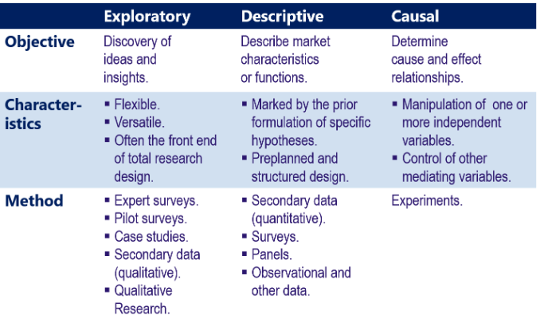
Table 2: Research Design[36]

In networking, many of the protocols are set out in RFC. The RFC acts as a white paper on how the protocols are standardised[37]. As the RFC explains in detail the working of the protocols. The protocols are used to automate L2 decisions for network administrators. The risk that these protocols bring can severely disrupt the network if exploited intentionally or unintentionally. This projectss main focus is to present a problem with current Network configurations at WAST and show how the heavily researched mitigations could possibly benefit the organisation.

3.5 Document Review
A review of the current documentation will be a critical part of this report. WAST are a cisco house at L2 of their network, meaning there is already extensive information about the technologies available. This enables the report to research and offer a robust solution that meets the security requirements going forwards. For every cisco deployment, there are best practice documents that can be referenced. This ensures that any configuration has been verified and should be safe to implement, of course careful considerations must be made if they are suited for the WAST network.

3.6 Configuration Deployment
There will be no software created for this report, however configuration on devices will be required to replicate the network. The configuration will be made in a private network segregated from the production network. Occasionally when implementing cisco commands in a production environment things do not go to plan, and engineers can be faced “fire-fighting” issues as a result. Configuring a lab is a good way of testing outcomes. Pending results, any implementations on the production network will be reviewed and a change control produced for review by the IT Board at WAST for discussion and authorisation. The change control will highlight the work carried out and the rollback plans if it fails. As the main focus of the work will be carried out on non-production equipment, the risk of any outage is minimal.

3.7 Testing
Testing will be the final strategy used in this report. As with the other strategies experiments will be a critical part of the project, and the key decisions on whether the implementations can be carried out in the WAST environment depend heavily on the testing. The testing will provide the data that will influence the decision making. The two test beds will be an attack before the L2 mitigations (or how things are now) and an attack after the mitigations have been implemented. The testing will identify any issues. The private network will be a replica of the production network but a smaller scale using only the required configuration and using redundant equipment, however the principle will still remain the same. The way protocols work do not differ on a model basis. If equipment is upgraded the protocols should operate the same way, however configuration may vary slightly.

3.8 Risks and liMitations

The testing will be carried out on a private network therefore risk to disruption on the production network is virtually non-existent. The private network topology is set out in the testing section. A virtual machine using Kali Linux is used on a private computer and bridged to the private network.

3.9 Conclusion

We have discussed the Research Methods adopted in this project. Positivism Philosophy was selected as the literature is widely available and extensive work has already been carried out in this field. From the wealth of the literature available, a comparison can be made and a deductive approach used to assess the relationship between the findings. A casual approach was chosen as this is an experimentative paper and expectations may not be met, which will result in further experiments or processes. As discussed, there are many white papers and case studies available that explore the protocols, and this report is highly dependable on academic documents. In order to assess the protocols for the report, and to get it as accurate to the WAST network as possible, software development was used. This enabled the report to run many commands and gave the flexibility to carry out new commands in a safe environment. Although not a true representation of the equipment used in production, comparable and the limitations section highlights this. For implementation on the WAST network, a change control would be submitted for approval, APPENDIX 1.

CHAPTER 4: DESIGN AND IMPLEMENTATION

4.1 Introduction
Chapter three reviewed the Research and Methodology strategies and how they are used to form this report. This chapter will review the current L2 architecture in WAST and identify issues in its current form. We will review how left in its current state, these protocols pose a real risk to the network. This chapter, will provide WAST with a way plan to securing L2, and after evaluation, providing WAST with a route map to an improved posture,

4.2 Problem formulation
WAST’s Network at their HQ in Vantage Point House (VPH) Cwmbran has recently benefitted from a technical refresh. Figure 6 is an overview of the network there. As the HQ site, VPH has the largest network footprint of all WAST sites. Physical access into the HQ is restricted by a sign in / sign out process. An escort service is required if outside contractors require access. Secure doors using the Paxton platform require control cards that protects all secure areas, which include all Hub rooms. Overall physical security is appropriate.

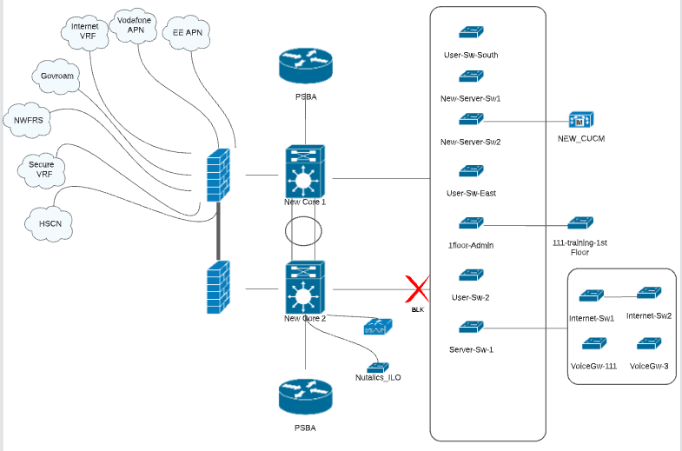

Figure 6: An overview of the network at WAST’s VPH Site

The VPH site is a critical service provider. Critical WAST services hosted at VPH include 999 call handlers and 111 call handlers, who on a daily basis, receive a number of emergency and non-emergency phone calls from the public requiring at times urgent medical attention. Ambulances are despatched from the control room once triage has been assessed over the phone and all emergencies are tracked and logged from there using inhouse systems, all connected to the WAST network. Due to the nature of the site, resiliency and network uptime is paramount. When an outage occurs, which it has done in the recent past, operators can be forced to paper, meaning a delay in the response to medical emergencies, this not only affects regional services, but can have an effect on National services as the workload is shifted. Typically, much of the resilience lies in L3 (routing), and so not much attention has been given to L2, perhaps because from misconception that all attacks are made from outside the network (untrusted). WAST have invested in high end equipment, that is capable of running the network comfortably.
There is always a severe risk of service disruption and downtime whether from third party network providers, cyber-attacks, or misconfiguration. In January 2022 a severe outage occurred when one of the outside links to a data centre rerouted traffic from a 10Gb link over a 1Gb link. This caused a bottleneck and 999 calls into the VPH centre had to be rerouted to South East Ambulance Services in England. The scale of the outage is one that WAST aim to avoid in future. Following the outage, the directorate asked that all departments draw up an analysis of their systems and protect inhouse systems.
Cyber criminals that endeavour to cause disturbance to a critical service could target the network, and the threat is real. The Firewalls at the edge of the network consist of 2x Fortigate Firewalls 1100 that provide Next Generation Firewall Services including Intrusion Prevention and Intrusion Detection Services with multiple resilient connections via numerous Virtual Routing and Forwarding (VRF) interfaces. The Secure VRF is segregated and secured via stringent access control lists to ensure no contamination from the wider network jeopardises critical service performance.
The two Core switches are Catalyst 9500 switches and the high specification exceeds the required specification for L2 requirements at VPH. The access switches are a mix of Catalyst 9300, 3850 and 3750X. L2 protocols are used, however, this report will highlight some of the improvements that can be made to ensure that the network is protected against certain attacks and misconfigurations. Network outages at L2 can be very disastrous.
According to the Pearson Vue academy, who provide networking training for professionals, in 2016 the main L2 attacks consisted of[38]:
Media Access Control (MAC) Attacks
VLAN “Hopping” Attacks
Gratuitous Address Resolution Protocol (GARP) Attacks
Spanning Tree Protocol (STP) Attacks
Cisco Discovery Protocol (CDP)
Hot Standby Routing Protocol (HSRP) attack.
Dynamic Host Control Protocol (DHCP) Starvation.
Mitigation of these vulnerabilities are relatively straight forward. If starting a network build from the beginning, these protective measures could be easily implemented. However, in a production environment where the network uptime has been over a year, unexpected behaviour could be experienced, which directorates are keen to avoid.
Not all of the vulnerabilities will be mitigated in this report, as a realistic evaluation needs to be undertaken on whether it is essential that certain protocols are actually secured. This said, risks of running them will be highlighted. We must bear in mind, that although a cyber-attack could cause a network outage, so could a network administrator who accidentally misconfigures a service. The outcome of the decisions will be presented in the final conclusion.
VPH is one of the larger sites with many switches, however, as you can see, WAST utilise much of the protocols that are susceptible to attacks highlighted above.
- Rapid Spanning Tree Protocol (RTSP) is used as loop prevention measures in the Layer 2 network.
- Virtual Local Area Network (VLANs) are used to segregate services,
- VLAN Trunking Protocol (VTP) is used to manage the VLAN databases.
- Cisco Discovery Protocol to identify Cisco devices connected to interfaces. Good for troubleshooting or documenting the network.
- Hot Standby Routing Protocol to provide routing redundancy between the L3 Core Switches.
- Dynamic Host Configuration Protocol to automatically assign unique Internet Protocol addresses to hosts / clients.

When the switches are unboxed, a template (created by WAST) is used to install new configuration onto them. Since the template was created, approximately 10 years ago, some useful features have been left out that could protect against any unwanted behaviour or disturbance. The main objective of the features would be to protect against an engineer, who could inadvertently carry out an action that a cyber attacker with malicious intent would do.
Within WAST, when expanding the network, most likely for user access such as when a new department moves into an area, a project is generated. Usually a Multi-Mode Fibre is run to a dedicated area (if there is not one there at present), and a Switch is installed to enable the interfaces for user access. As used switches may be reused to save money, this presents a risk as switches are removed without erasing configuration. If legacy configuration on a switch is present, and a new switch is installed on the production network without checking the configuration, it could be disastrous. Occasionally, non-network staff are utilised to connect a switch and an engineer will discuss steps over the phone. Similarly, third party may have access to hub rooms and connect their equipment into WAST infrastructure (firewalls, switches, routers), without WAST administrators knowing L2 issues could start to present themselves in an unwanted fashion.
To note, most of WAST sites are small ambulance stations that use the Public Service Broadband Aggregation (PSBA) as a breakout. Behind each PSBA router is a WAST 24 port Cisco 2960 Switch that provides the ambulance staff wireless, phone and a computer terminals. There are circa 90 ambulance stations located all around Wales that WAST provide network connectivity for. There are also a further four main regional offices, Ty Elwy (North Wales), Llanfairfechan (North Wales), Llangynnor (Camarthenshire) and Thanet House (Swansea). These are also crucial as they provide 111 and 999 services through a regional control room. These four sites are slightly smaller than VPH, however share a common infrastructure.
The main focus of this report will be at the authors VPH, however any findings can be applied to all sites as the intention of this report is to eventually apply a security posture at all of WAST sites.

4.3 Design
The L2 network at each WAST Regional HQ consist of a number of High Performance Cisco Catalyst 9300 switches to provide high speed access and availability for user devices and servers.
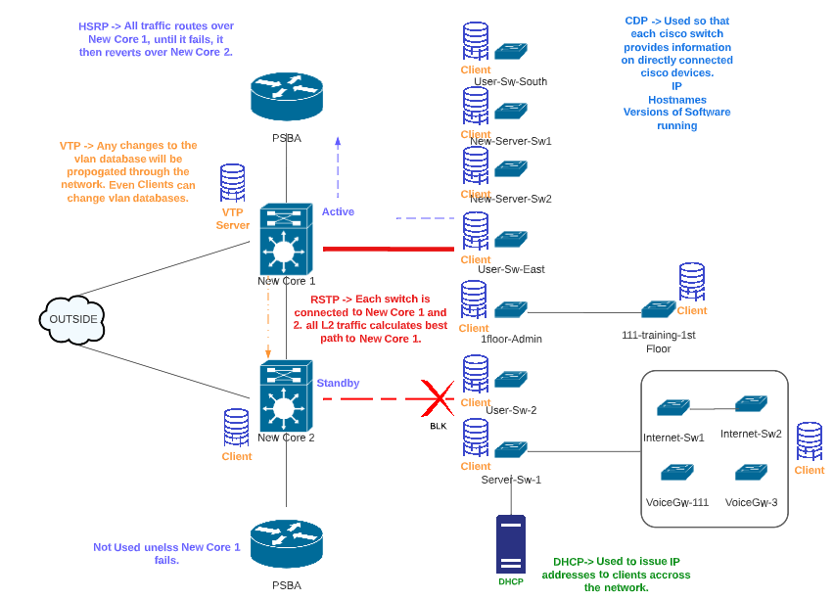
Figure 7: L2 topology at WAST displaying the protocols used.

Software Design Networking(SDN) would remove the L2 decision making from the switches once connected to the network by using a central controller for all networking decisions[39]. WAST are a very long way to transition to an SDN model, mainly due to costing and resources, therefore must use the traditional network practice until a time comes to migrate to an SDN architecture that will remove the complexity of Layer 2 protocols.
For clarity, the purpose of the Design and Implementation section is not to remove or replace the current protocols in use at WAST, but to use them in the most secure and safest way, without causing any disruption to the production network.
The overall design of the L2 network will be to use the protocols securely, this will be tested in the home lab environment and depending on the results, implemented in VPH, and then the other regional HQ’s. The home lab will be able to test all the protocols discussed in the literature review and is set up using routers, switches and a Kali Linux platform that can simulate a threat actor or a misconfigured L2 device.

4.4 Implementation
The home lab (see Figure 8) consists of a Cisco Catalyst 2900 series router, 2 x Cisco Catalyst 3750G 24 port switches, a Cisco 3750x 48 port switch, a Kali Linux machine and a Lenovo Think Pad laptop. The router is a DHCP server. The 24 port Switches are the Cores and the 48 port switch is a server / access port. The cores in the laboratory are not to the same performance as the ones in production environment, however they run the protocol suites adequately for testing purposes.
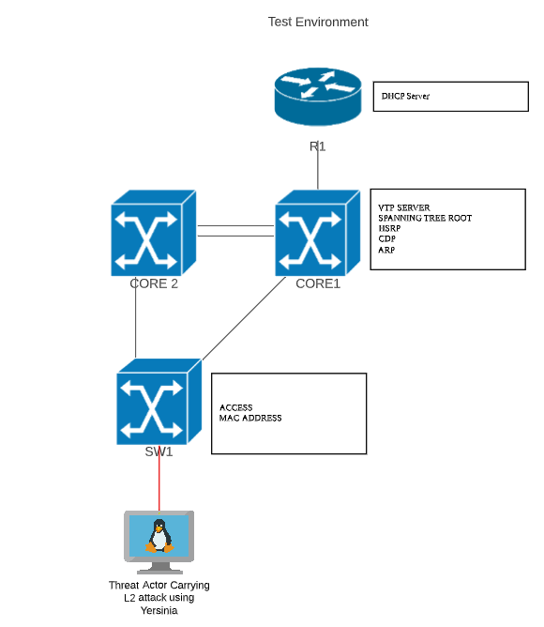
Figure 8: The home lab topology.
R1 (the 2900 Series Router) has DHCP pools configured for each of the VLANs, as well as a management IP address for network reachability. The DHCP pools are configured to issue DHCP addresses for the laptops and they can show IP bindings (DHCP leases). The configuration of the home lab switches will be as close as possible to the ones on the WAST production network. The difference in models may cause some issues in some of the protocols being supported, however, a network simulation program such as GNS3 can be used to run unsupported IOS commands[40]. Unnecessary configuration will be omitted in the home lab network to provide uncomplicated output. The subnets used in the home lab will be different to the ones used in WAST, to ensure that no attacks could be accidentally leaked onto the production environment, especially if the home lab laptop connects via VPN. The home lab will run the same modes of the two protocols, using the Kali Linux machine. An attempt to disrupt the protocols will be made prior and after recommended security measures have been implemented which will be used to assess the suggested measures.
APPENDIX 2 shows a copy of the running configuration of these devices.
A copy of the running configuration of these devices in APPENDIX 2.

4.5 Conclusion
This chapter has discussed the current network landscape at one of the WAST main sites (VPH). The current budget at WAST, and the vision of the network manager provides the report a clear path to follow when it comes to implementing L2 security. The traditional network (connecting switches) to the core with redundant link will remain. The protocols that are used will remain on the WAST network. There is no scope to move to SDN, therefore WAST must secure L2 as much as possible. The current template which is copied to the running configuration to a new switch will need to be reviewed and amended with a new template that will be created following the outcomes of the next chapter. The configuration of the protocols that are currently running on the WAST network have not been adapted to recent guidelines, and if not for this report, may not have been reviewed at all. The highlight of this report is that it can be presented to the IT Operations board, and the findings discussed. A proactive response can made to get the measures in place.

CHAPTER 5: TESTING AND EVALUATION

5.1 Introduction
Chapter four, provided a background to the problems facing WAST at L2. This chapter will provide the outcome of the attacks made on the existing configuration and then the configuration that includes the mitigations.

5.2 HSRP Attack

HSRP allows routers to be clustered and share a virtual IP (VIP). The VIP is used as the default gateway IP for hosts, if the priority router becomes unreachable, the secondary will take the VIP and traffic will not be affected.

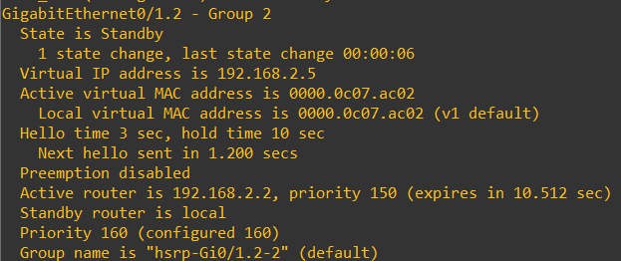
Figure 9:HSRP: Shows the router is Standby for L3 decisions. The priority is 160 and was set by the author.
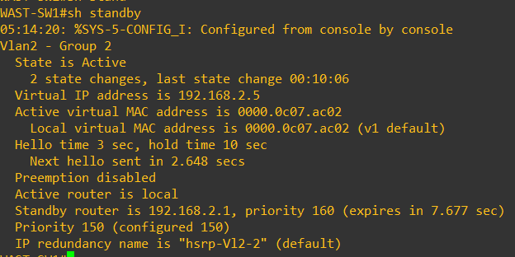
Figure 10: HSRP: show standby output.

SW1 is a L3 switch, and is the active HSRP router. The Priority is 150 and therefore the lowest priority wins. The VIP for the HSRP routers is 192.168.2.5 for VLAN2 hosts in this scenario. The virtual MAC for the HSRP address is 000.0c07.ac02. This is correct and is stated in all the HSRP documentation.
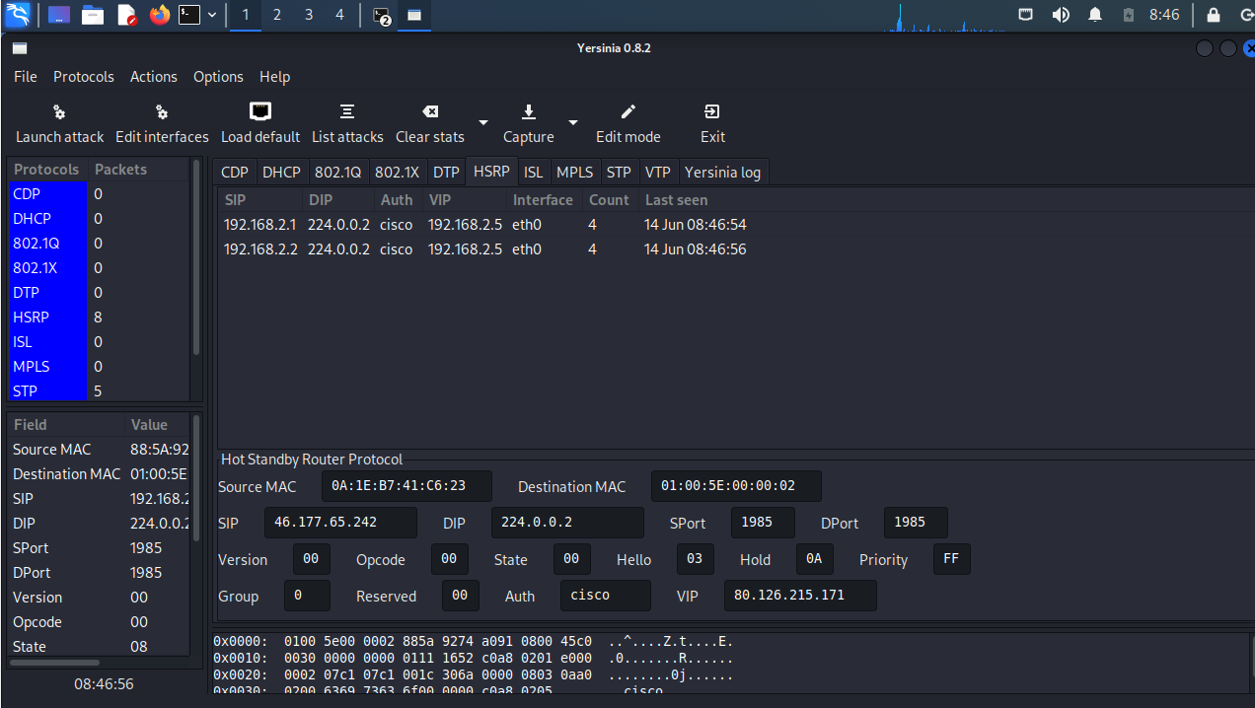
Figure 11: HSRP: Yersinia on the Kali Linux machine displaying HSRP traffic that it sees.

Whilst the HSRP in the lab environment is configured and is working correctly, Yersinia is launched and we can see the HSRP traffic. 224.0.0.2 is the multicast address that HSRP uses to communicate between participants[41].

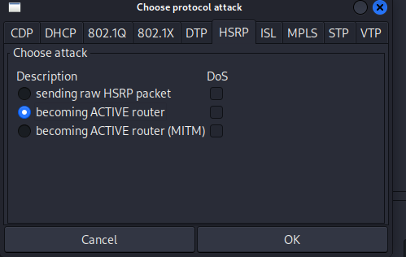
Figure 12: HSRP: The attack vector being selected, to send a packet to become the active router.

There is no Denial of Service (DoS) attack that can be carried out using Yersinia, however, disruption can easily be caused. The Kali Linux machine is set to become the ACTIVE router, meaning all L3 traffic (traffic destined for other networks) will flow to it thus it poses a real risk, not only for performance, but also security.
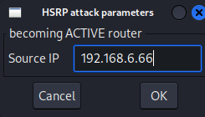
Figure 13: HSRP: Yersinia, the source IP being configured, last two octets 6.66 to signify an attacker.

A random IP address, that can be easily identified is used to become the ACTIVE router.
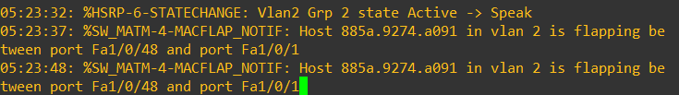
Figure 14: HSRP: The results of the attack being shown. Port flapping in place, meaning disruption is recognised.
Once the attack is started, we can see immediately that the current ACTIVE router, is starting to encounter issues on its interfaces.

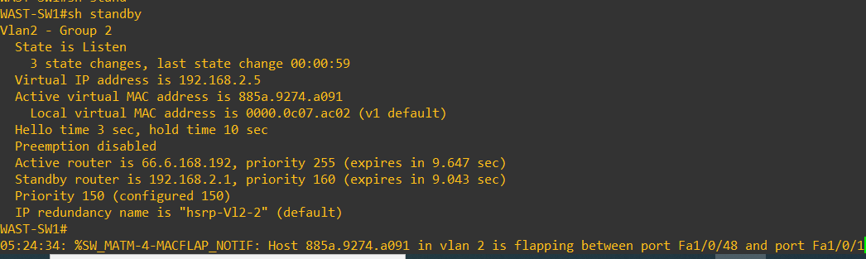
Figure 15: HSRP: show standby output following the attack shows that 6.66 with priority of 255 is now the active router.

“show standby” command is run and the output states that the ACTIVE router is now 66.6.168.192 (the Yersinia IP backwards). All L3 Traffic is now routing to the Kali Linux machine.

5.2 RSTP Attack

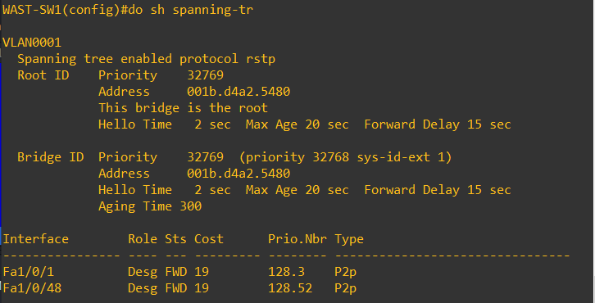
Figure 16: RSTP: show spanning tree output.

Prior to any attack, SW1 is displayed as the spanning-tree root. The L2 topology is converged and each path is built to the root (SW1) based on best cost calculation. All ports on the root bridge are designated forwarding. The priority has not been changed from the default of 32768. This means any switch that is connected can become the root bridge if it has a lower mac address than 001b.d4a2.5480

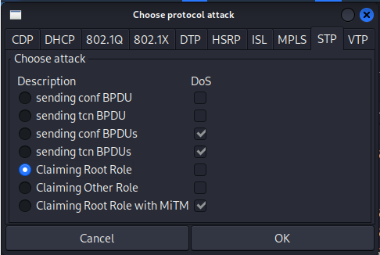
Figure 17: RSTP: Yersinia, the attack to claim the root role is selected. This will cause all switches to calculate their best path to Yersinia.

There are many attacks that can be used to disrupt spanning-tree operation. This attack (claiming root role) could happen if a rogue switch is connected to an interface on the network. The attack is run.

All ports on the root bridge are designated forwarding. The priority has been changed from the default of 32768. This is to ensure that an administrator has determined the root bridge and has not left it to the switches to automatically distinguish. The switch no longer displays “This bridge is the root” and it shows the MAC address that the malicious program has used. 001b.d4a2.5480.

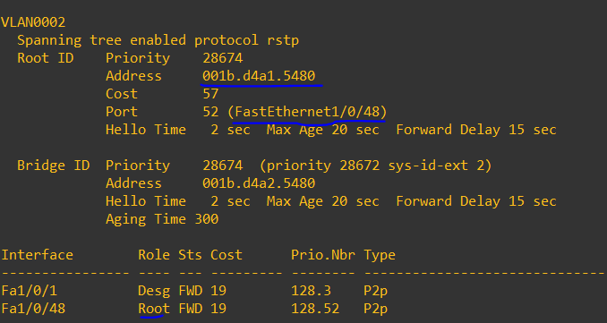
Figure 18: RSTP: The root bridge is recognised on int F1/0/48 (The trunk to where Yersinia is located. The Yersinia Mac address is also identified as the root bridge.

The attack is carried out and we can see that the root designation has changed. 001b.d4a2.5480 was the mac address of the original root bridge, if we look carefully 001b.d4a1.5480 (lower than the original, has been used to used by Yersinia) to win the election as the new root bridge. Also Yersinia has changed the bridge priority from the default of 32768 to 28674, again lower than the default. As set out in STP documentation, the lowest values win in the election of the root bridge. All L2 traffic (not destined for other networks) will now flow to the root.

5.3 CDP Attack

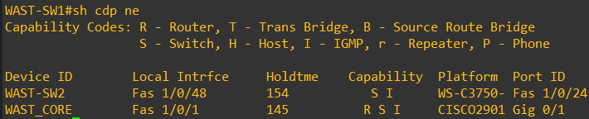
Figure 19: CDP: Normal CDP output displaying what Cisco devices are connected to the WAST-SW1 device.

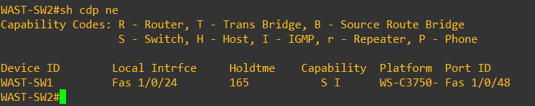
Figure 20: CDP: Normal CDP output displaying which Cisco devices are connected to the WAST-SW2 device.

The purpose of CDP is to display to the administrator all directly connected Cisco devices. Figures 19 and 20 show connected to SW1 is SW2 on interface Fast Ethernet 1/0/48 and that device is a 3750 switch named WAST-SW2 connected on interface Fast Ethernet 1/0/24. A “show cdp entry” command will display further information, including IP address and software version running. This can provide administrators with valuable information for troubleshooting or mapping the entire Cisco estate. It could provide malicious threat actors the same information for exploiting vulnerabilities and building a topology.

Also connected to SW1 is the WAST_CORE, which is the edge router. The edge router is the router that provides internetwork connectivity and is the gateway for traffic in and out of the network. In the production environment, due to the nature of WAST operations, edge routers have very high specification Firewalls that control this access. CDP is enabled by default to all cisco devices, other than firewalls. For security, firewalls do not partake in CDP / Link Layer Discovery Protocol (the open standard equivalent to CDP)[42]. Note that the Kali Linux machine that is used to carry out the simulated attacks is connected to interface Fa0/17 but is not displayed in the CDP table as it is not a Cisco device.

WAST SW2 is connected to WAST SW1.

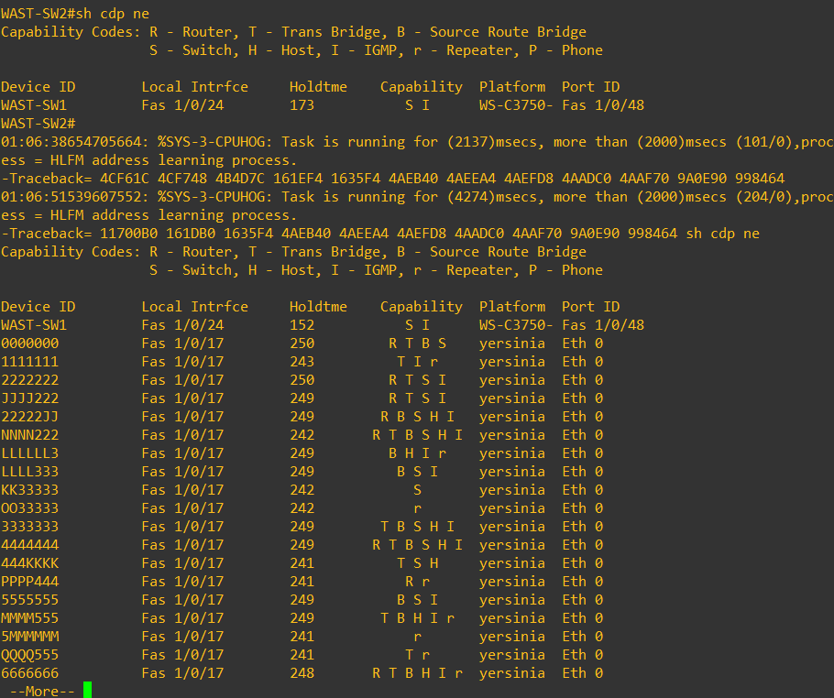
Figure 21: After the CDP attack is carried out by Yersinia, it floods the CDP database, if continued this will kill the switch. Note: Platform “Yersinia”.

Following the CDP attack, we can see that on SW2, WAST-SW1 is still shown as connected to the same interface. Also displayed are some unhelpful, automatically generated Device ID’s, all connected to Fast Ethernet 1/0/17 (the Kali Linux machine). It has identified the platform as Yersinia – the attacking tool.

If the administrator was to hit the space bar on this output, it will display another page, full of the same automatically generated information. The danger is that this attack will kill the CPU of the switch and make it redundant. The information at the top of the output shows CPU Hog messages identifying to this process. The root of the issue on the one switch is easily identifiable as connected to Fast Ethernet 1/0/17, however this attack on multiple switches could troublesome.

5.4 DTP Attack
As with CDP, DTP is also enabled by default on all Cisco switches[43] which gives the cisco switch the ability to autonomously determine whether it is going to use a connected interface as a trunk or an access link. If an interface is not specifically assigned a role or is left in its default form, it will form a trunk link with another Cisco switch. If a malicious threat actor connects to an interface and carries out a DTP attack, it will form a trunk. Trunk interfaces carry all VLAN traffic, including network L2 management traffic[44].

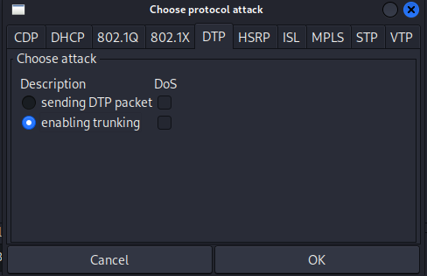
Figure 22: DTP: The attack is selected to negotiate a trunk against a switch that does not have the switchport forced to access mode.

With DTP enabled, the Kali Linux machine is connected to an interface with no configuration. The switchport is not shut or assigned a role. Yersina offers a packet to the switch to enable trunking.

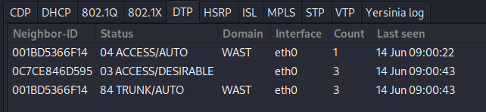
Figure 23: DTP: The attack is sent and the packet to force the switch to trunk is acknowledged. All VLAN’s will now be visible.

The attack begins, and the exchange of negotiations is carried out. It takes seconds for the trunk to form.

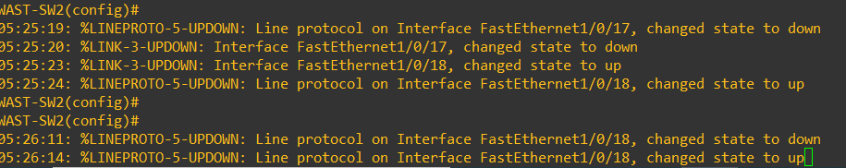
Figure 24: DTP: The interface is reset and the trunk is formed. The interface connecting the Yersinia to the network is now trunking.

The interface is in the up / up state, meaning both interface and protocol is up and traffic can be sent over the trunk (to the malicious users computer).

5.5 VTP Attack
The amount of VLANs on the WAST network is relatively small, and they don’t span around all the switches in VPH. However VTP is used to manage the VLAN database. Although convenient, it is not good practice to use VTP as it can cause disaster for networks, such as a VTP bomb. One of the main reasons for writing this report was an experience of a VTP bomb[45] caused by the author on a medical grade network. A hospital site with more than 100 VLAN’s was brought down after a switch was installed that had a VTP process with a higher revision number than the Core switch. All the VLAN database was overwritten with a test switch’ VLAN database, consisting of just five VLANs. Although it wasn’t a malicious attack, the event and administration error caused critical services to be rerouted to other hospitals and an investigation ensued. One of the biggest outcomes was the lack of understanding of L2 protocols and how misconfigurations could lead to major problems.

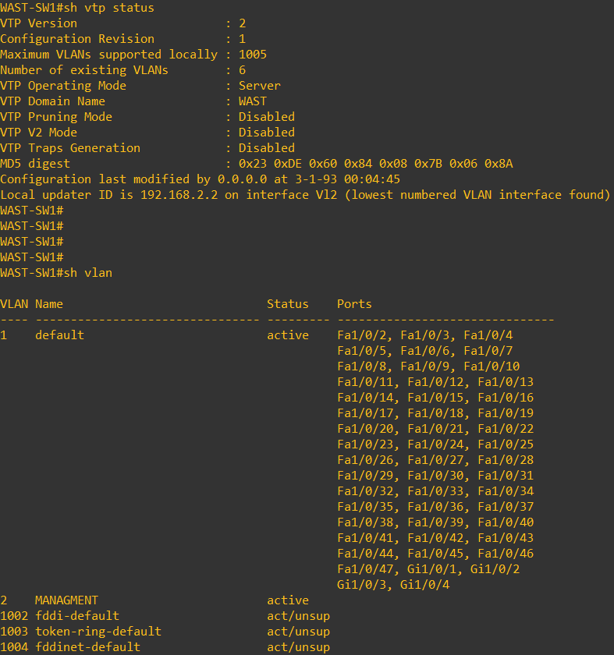
Figure 25: VTP: Showing the VLAN database. 2 the only one created by the administrator.

The above figure shows the VTP role of WAST-SW1 as server. Any VLAN created will propagate through the network. The “show vlan” command displays the VLAN database, VLAN 1 (the default), and VLAN 2 which is the management and was manually created.

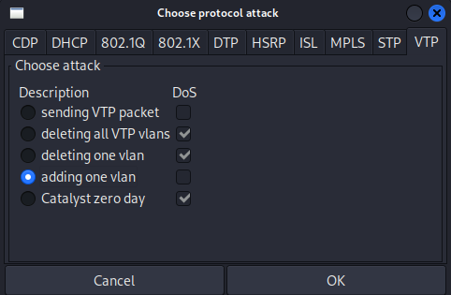
Figure 26: VTP: Yersinia. Attack to add a VLAN.

The flavour of attacks is displayed in Figure 26. With just a click of a button, the whole switch could be wiped. The DoS attacks could prove catastrophic; however, the extent and effectiveness of the attacks can be demonstrated.

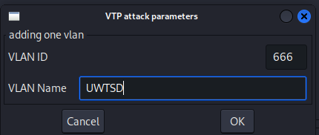
Figure 27: VTP: Yersinia: name of malicious VLAN, VLAN number is 666.

A new VLAN could be created across the switch estate, ID 666 and Name UWTSD is used so the reader can easily identify the newly created VLAN.

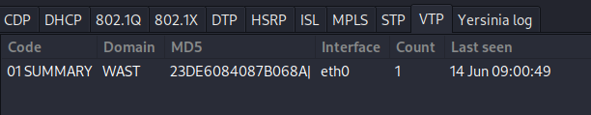
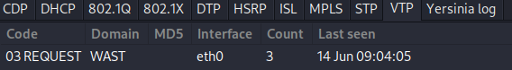
Figure 28: VTP: Yersinia: VTP traffic exchanged.

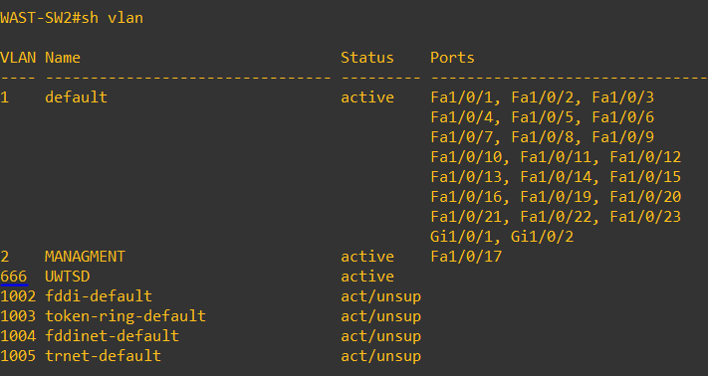
Figure 29: VTP: We can now see that VLAN 666 has been added to the database.

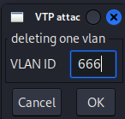
Figure 28: VTP: Deleting the malicious VLAN for demonstration.

The same process goes for removing the VLAN from the database. Under the same attack tool, the Kali Linux requests the VLAN to be removed.

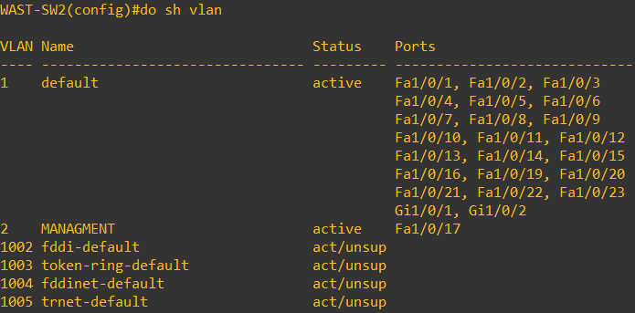
Figure 30: VTP: VLAN 666 removed by Yersinia.
VLAN 666 is now removed from the database. Although this is a test environment, a removal of the Server VLAN in a production environment will mean that all clients would not be able to communicate with essential services. In the 999 realm, all Cisco phones register to the Cisco Unified Call Manager server (CUCM), if CUCM is not reachable, all the phones will cease to work. Granted, there is a fall-back analogue option, however 999 will be put back to pen and paper, resulting in delayed response times. Another scenario is the ambulance despatching service, using specialist software, operators use computers that communicate with a specialist server. If that server is unreachable, operators will need to use the phones. However, if the Cisco Phones are also down (due the server VLAN is deleted), they will be pushed to the analogue method.

5.6 DHCP Attack

DHCP is used to provide network devices with a usable unique IP address, and it can also be used to dynamically assign IP addresses for network essential services (such as default gateways, time servers, wireless LAN controllers). WAST utilise four x Windows 2019 servers for DHCP and redundancy, however the pools are configured with the same IP ranges, so if one server was lost, another would become the primary, the database is shared. This does not mitigate DHCP depletion. If DHCP depletion occurred, a host that requests an IP will assign itself an Automatic Internet Protocol Addressing(AIPA), which is not routable and belongs to the 169.X.X.X range[46]. Hosts not being able to communicate on a network will amount to many service desk calls until the root cause is discovered and resolved.

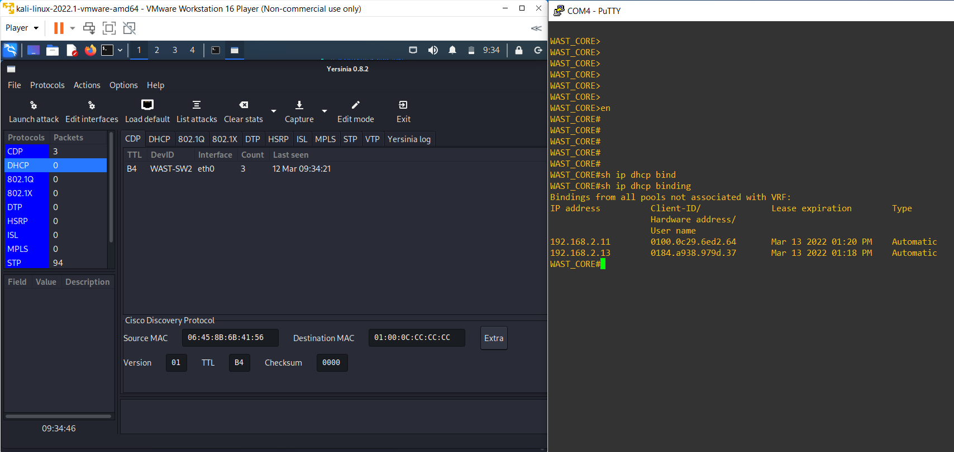
Figure 31: DHCP normal operation, only 2 bindings on WAST server.
In Yersinia, the DHCP attack is not started. WAST_CORE (the router that has the DHCP server for simulation) displays two DHCP bindings in a /24 subnet, the /24 subnet allows for 254 usable IP addresses meaning 254 devices can obtain a usable, routable IP address for that particular subnet / VLAN[47].

If all the addresses are taken, hosts will need to be configured for a different VLAN or the existing subnet would need to be expanded.
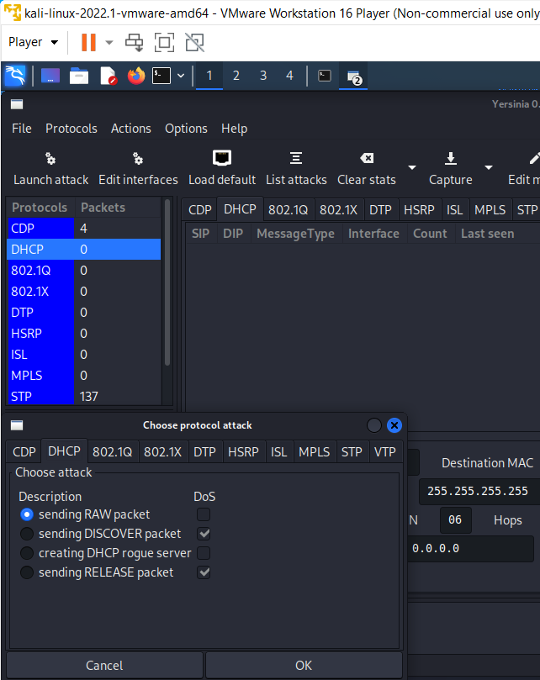
Figure 32: DHCP: Yersinia: attack to send packets selected.
There are few attacks against DHCP. A rogue server attack would simulate an end user connecting their own router into the network to expand it for fellow colleagues or an actual attack to act a s a MiTM to sniff traffic.

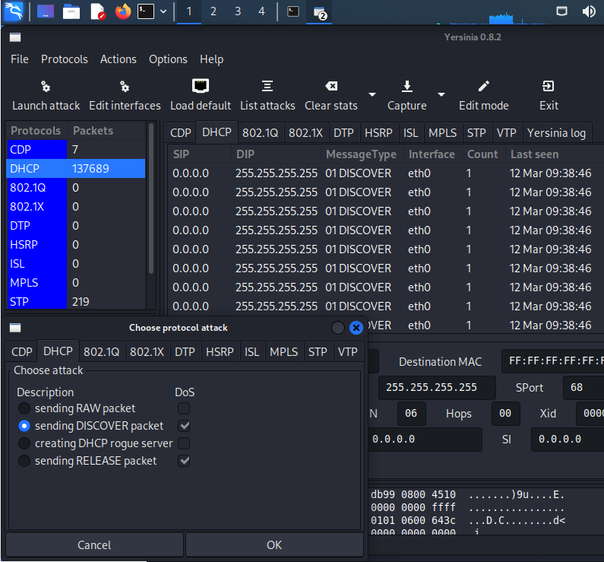
Figure 33: DHCP: Yersina: The attack takes place, and DISCOVER messages flooded. Note: The amount of DHCP traffic sent in milliseconds (ms). If not stopped it would kill the device.

In this attack, using the DORA principle, the attack sends DHCP discover messages to the server. The traffic count on DHCP packets is extremely high as the process starts.

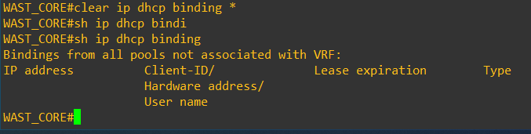
Figure 34: DHCP: The IP DHCP binding on the core is cleared for ease of viewing.
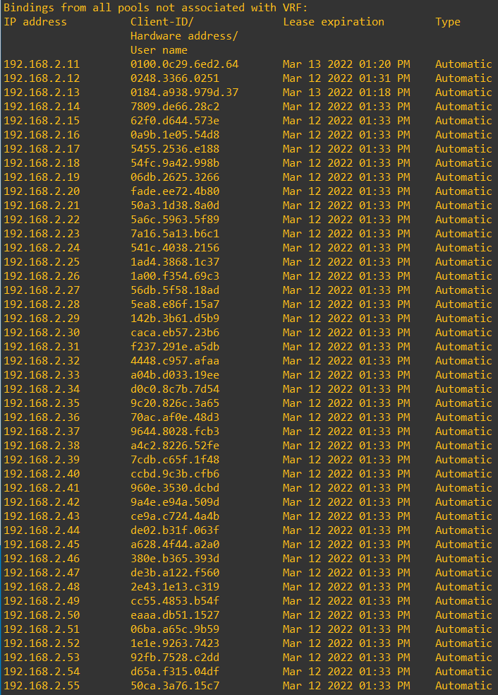
Figure 35: DHCP: The depleted addresses on the server with randomly generated MAC addresses by Yersinia.

In milliseconds, as the DORA process is continued, the IP DHCP binding is depleted, and his will carry on until the attack can be stopped. The MAC addresses in the figure are all randomly generated, poisoning the MAC address table on the switch.

5.7 Mitigations

The protocols investigated have been in place and used for many years. Whilst widely used, and some updates in versions of the protocols have been adapted, few changes in relation to best practices and securing them have occured. Higher layers of the OSI model, particularly the application, will see many threats and changes. Vendors are constantly keeping their user applications patched as this is where most of the attacks are seen to be targeted. The user is deemed the biggest threat to the network. L2 is often ignored in Cyber Security, however as discussed in this report, it is very vulnerable. It is true to say that your network is only as good as your weakest link. If L2 (one of the lower layers) is vulnerable, the layers above will also be affected all the way up to the highest layer, layer 7, the user application layer.
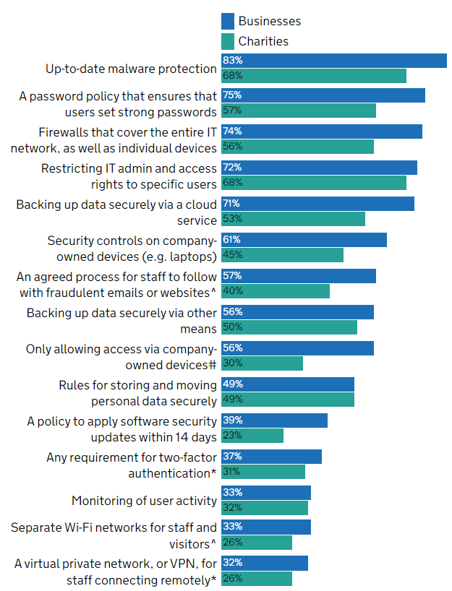
Figure 36 [48] Percentage of organisations that have the following rules or controls in place.

Interestingly L2 implementations seem to be overlooked in the Cyber Security Breaches Survey 2022 above. A section that covers security control on company devices for example (eg laptops) could provide a vague interpretation that this covers network devices. However this reinforces that most of the cyber threat is user targeted. A sign that L2 continues to be overlooked or generalised.

5.8 HSRP Mitigation

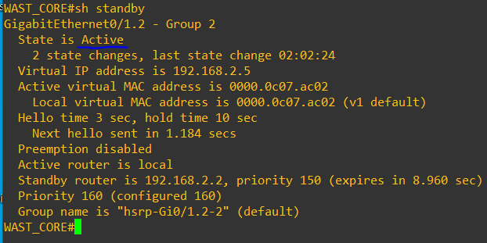
Figure 37: HSRP: Show Standby shows that Core is the active router.

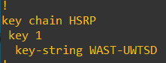
Figure 38 : HSRP: The key-chain for authentication on Core 1 is configured.

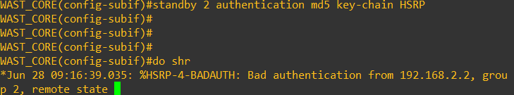
Figure 39: HSRP: immediately recognises that a device with authentication is sending HSRP packets.

Since authentication is initiated on Core1, Core 2 HSRP packets are ignored, and bad authentication notices are given in the logs. Int Gi0/1.2 is part of standby 2 (VLAN 2) instance.
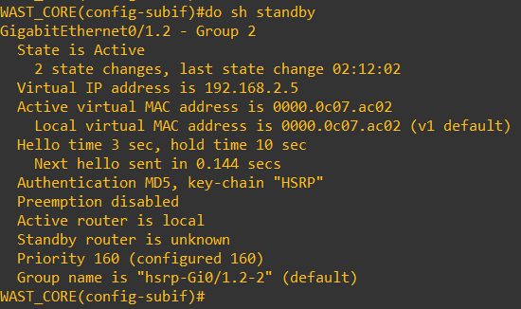
Figure 40: HSRP: Standby router is unknown now as Core 2 (sw1) has no authentication configured.

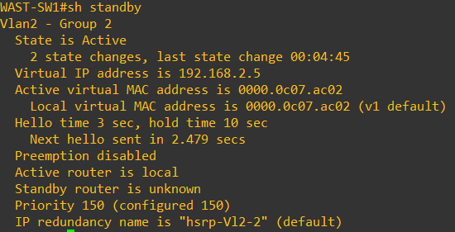
Figure 41: HSRP: SW1 believes it is the active router.
This would cause some network disruption as two routers are now claiming to be the active.

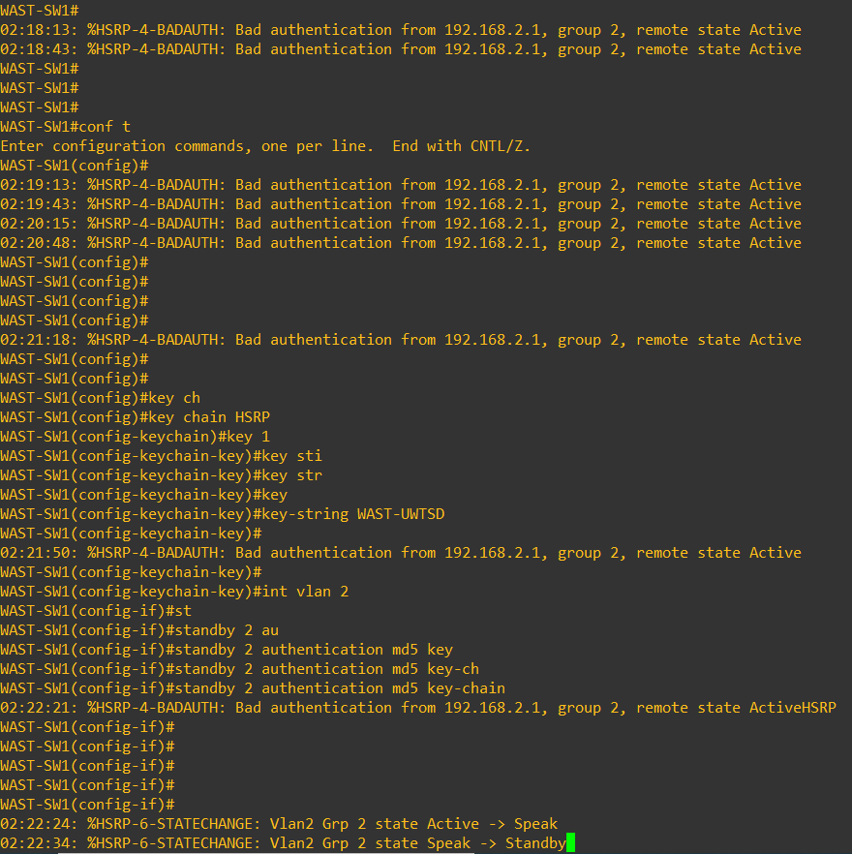
Figure 42:HSRP: Authentication is now configured on Core 2(sw1).

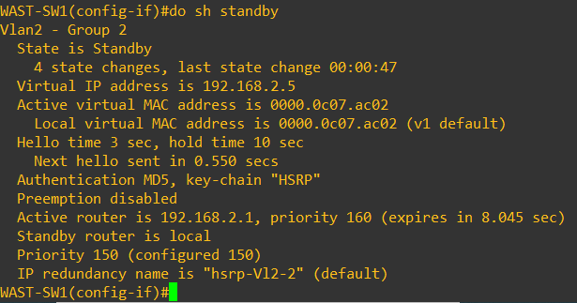
Figure 43: HSRP: Standby 2 instance is now working as intended with authentication string.

Yersinia
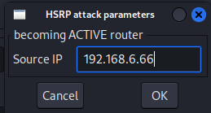
Figure 44: HSRP Yersinia is used to carry out same attack on HSRP, now with authentication configured. This is the malicious IP.

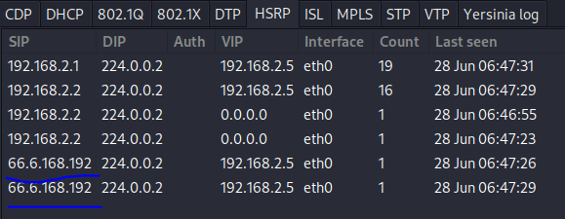
Figure 45: HSRP listens on multicast 224.0.0.2, the malicious IP (presented backwards in yersinia).

Figure 46: HSRP: Non authenticated HSRP messages on Core are dropped.

Figure 47: HSRP: Non authenticated HSRP messages on SW1 are dropped.

Debug on the Core shows that 192.168.6.66 has no or invalid authentication configured, and the messages are dropped.

5.9 RSTP Mitigation

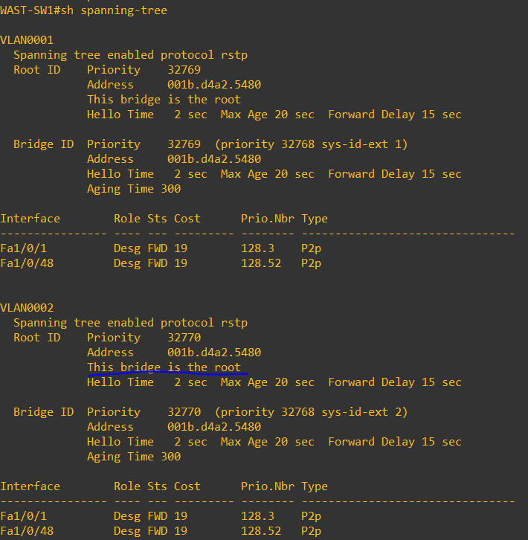
Figure 48: RSTP shows SW1 is the root bridge.
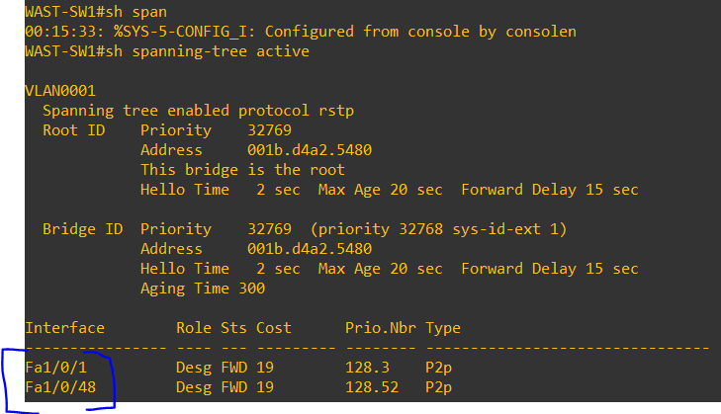
Figure 49: RSTP shows that both 1/0/1 an 1/0/48 are partaking in RSTP and that the both interfaces are forwarding Note: another indication that this is the root bridge.

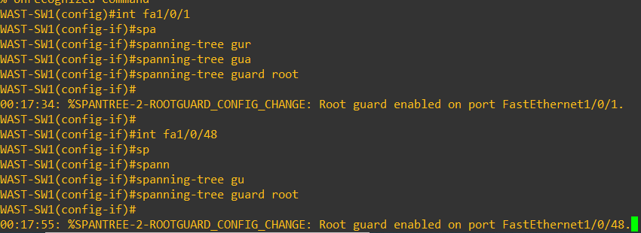

Figure 50: RSTP:Root guard being configured on a per interface basis.

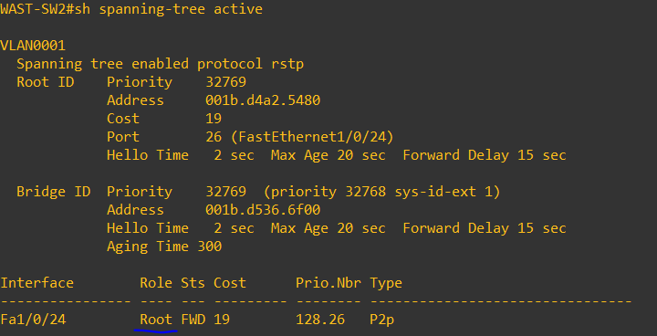
Figure 51: RSTP: SW2, displays its interface to reach the root.

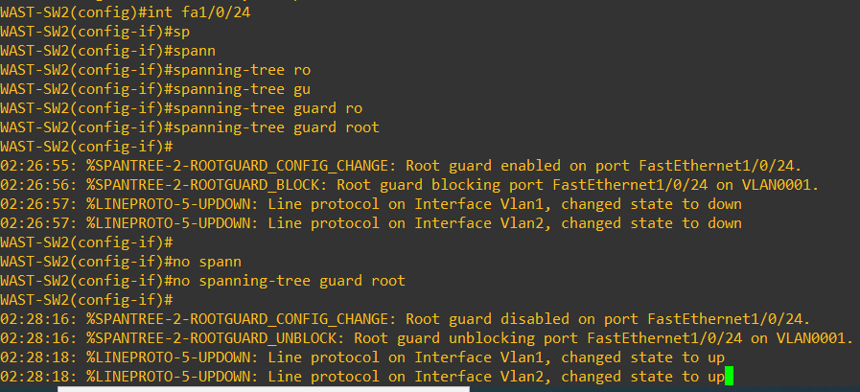
Figure 52: RSTP: Shows that the a BPDU with superior priority on a port configured with root guard will put the port in the blocking state.

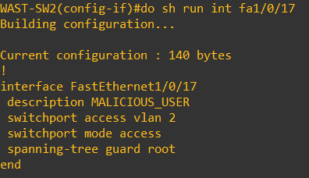
Figure 53: RSTP: Yersina: Displays the configuration on the malicious threat actor’s.

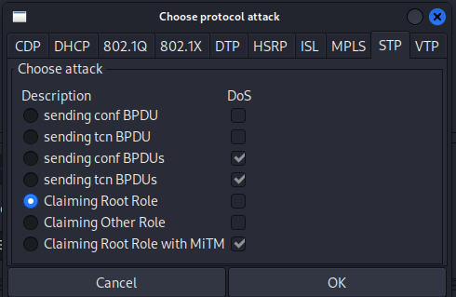
Figure 54: RSTP: The same attack carried out earlier is primed.

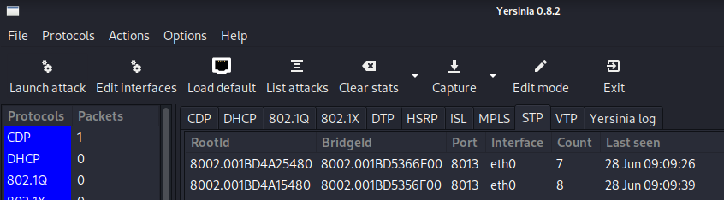
Figure 55: RSTP: BPDU’s are sent.

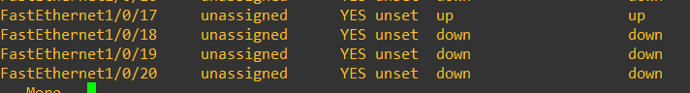
Figure 56: RSTP: The access port of the malicious threat actor is immediately shut, protecting RSTP.
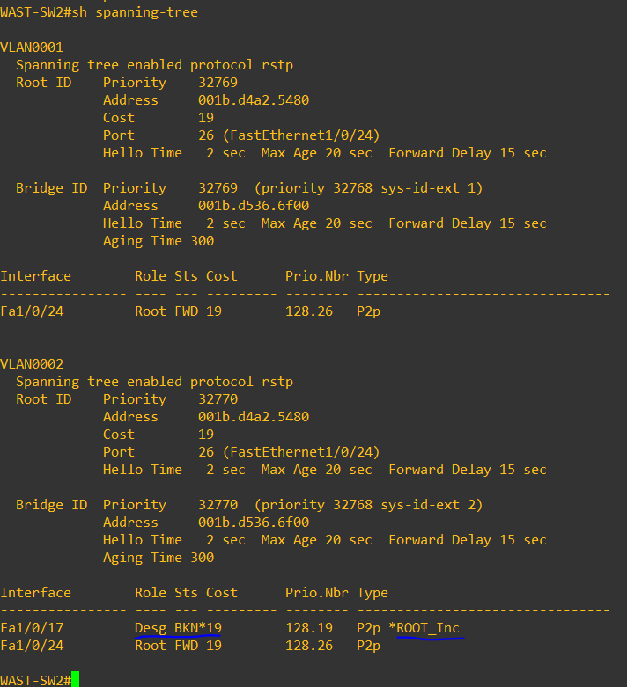
Figure 57: RSTP: SW2 clearly displays the status of the malicious port and the reason its shut. Administrator could investigate immediately.

Root guard protects against superior BPDU.

If we wanted to prevent another switch being connected to an interface, we could implement BPDU Guard on every access port. BPDU will stop ANY unexpected switch being connected to an interface. Interface Fa1/0/24 is connected to sw1. If we put BPDU guard on this interface the interface will shut because it doesn’t allow BPDU packets. BPDU guard can be placed on all access interfaces.
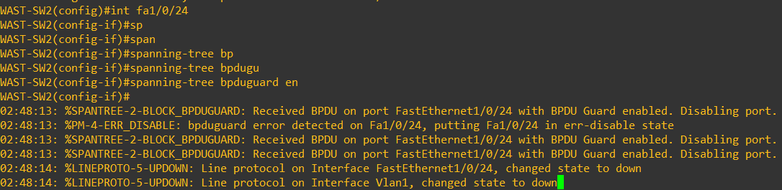
Figure 58: RSTP: BPDU Guard configured on a port receiving BPDU frames.

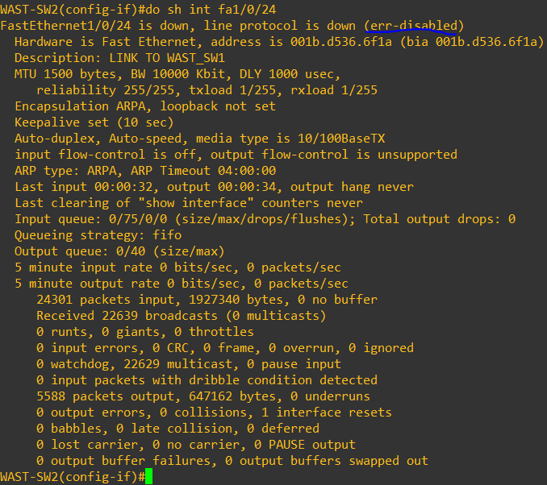
Figure 59: RSTP:BPFU guard demonstrated, placing the interface in error disabled.

5.10 DHCP Mitigation

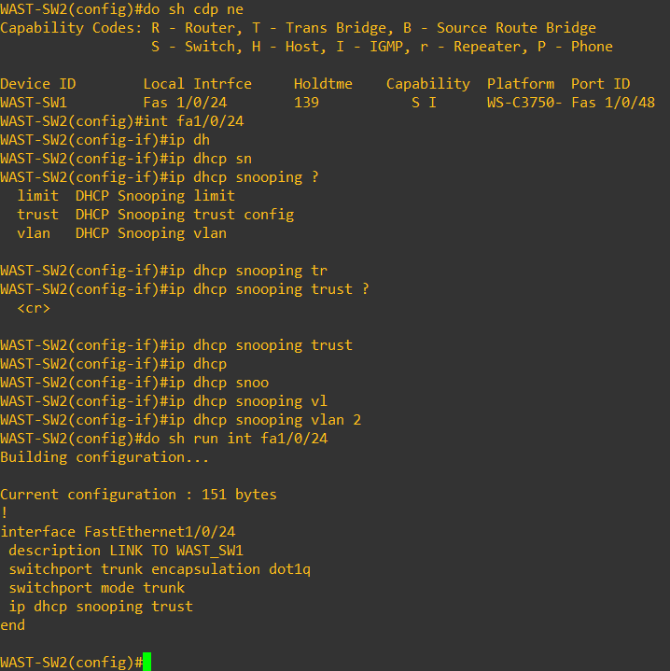
Figure 60: DHCP : snooping config on int fa1/0/24.

DHCP snooping is on a per interface basis. All ports are untrusted, until a trusted statement is issued on a trusted interface. Any DHCP offer and acknowledgement (see DORA) messages will be ignored on untrusted interfaces but allowed on trusted interfaces. This means that any DHCP traffic on untrusted interfaces will be dropped. Rogue servers in this instance will not be able to send DHCP messages.

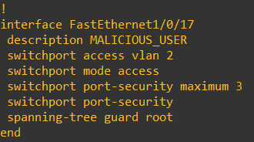
Figure 61: Switchport security to protect against multi MAC addresses being used.

Switchport Security in the above scenario will mitigate against MAC Spoofing and attacks against DHCP. Switchport port-security maximum 3 will place an interface into the “shut” state. If any interface receives traffic for more than three MAC addresses with the above configuration, then it will automatically shut the interface.

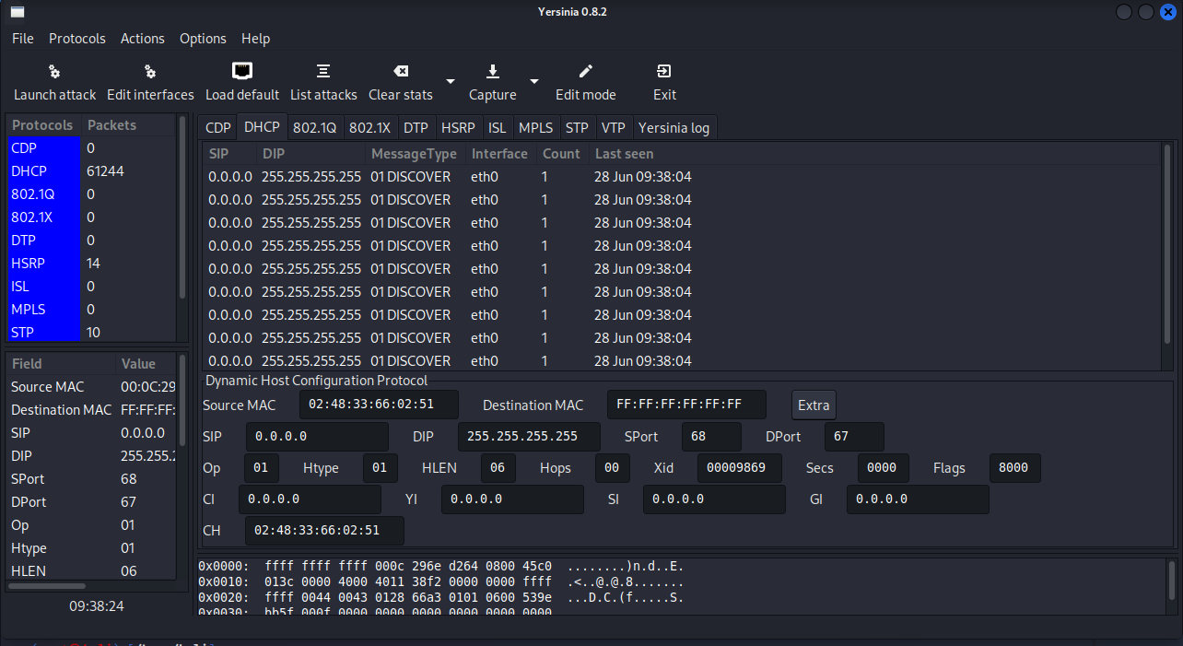
Figure 62: DHCP: The attack is carried out.

The configuration is placed on the malicious threat actor interface and the DHCP attack (where the yersinia device generates random MAC addresses for DHCP bindings) is initiated. The attack is against the trusted DHCP server; therefore, the traffic is allowed, however the switchport security is in place and therefore shuts the interface.

Figure 63: The Security policy immediately shuts the port. Protecting the DHCP service.

The output above shows switchport security autonomously closing the port, the interface and the MAC address that caused the violation.

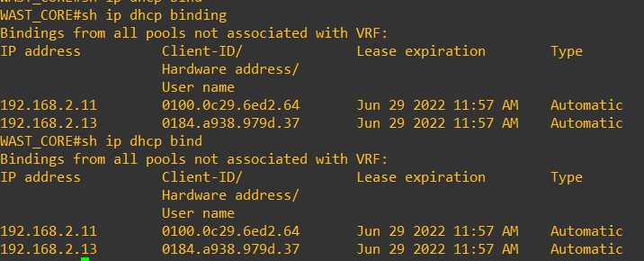
Figure 64: DHCP: Shows normal binding after the attack. The mitigation is successful.

On the DHCP server, it shows that the bindings are clear from the attack and that the DHCP bindings are actually no affected and services are functioning normally.

5.11 VTP Mitigation
As we can see from the below output, SW1 and SW2 are in the same VTP domain however they have different VLAN databases.

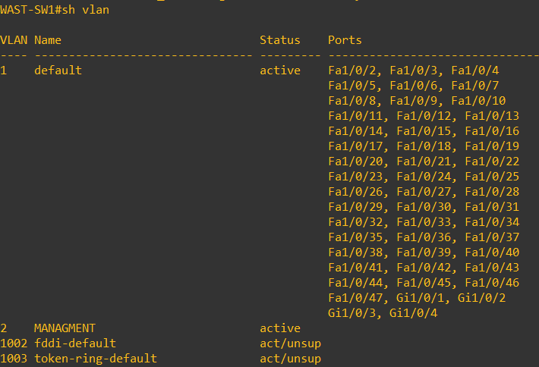
Figure 65: The normal operating VLAN database on SW1.

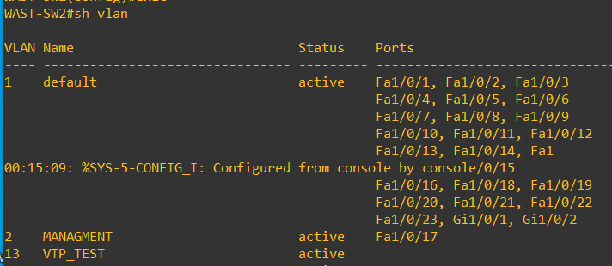
Figure 66: VLAN 13 on SW2 is added to show a difference in the VLAN database between switches.

The reason for this is that SW1 has authentication set, meaning that VTP is now secured. If we add the authentication on SW2 side:

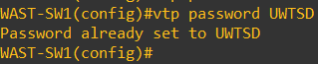
Figure 67: VTP authentication configured on the VTP domain.
SW1 and SW2 will have the same VLAN database. Only expected switches with VTP authentication enabled will be able to exchange VLAN databases.
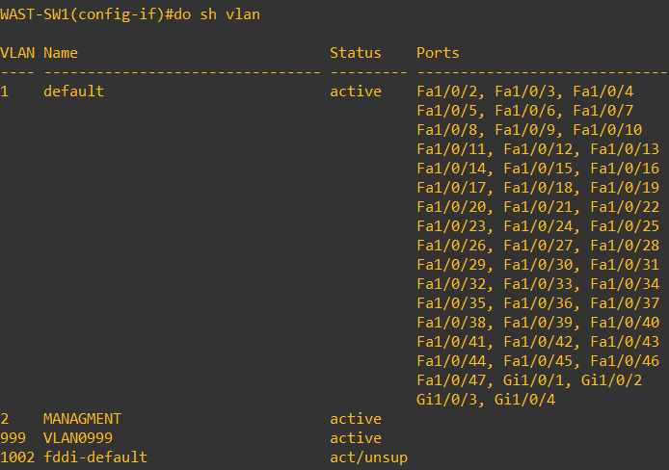

Figure 68: VTP: a new VLAN is created (99).

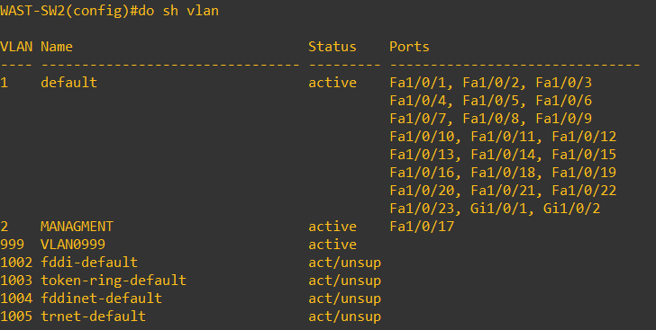
Figure 69: VLAN database has been overwritten (13 has deleted, 999 has added). The overwriting has occurred.
SW1 and SW2 post authentication mitigation is a good way of ensuring consistency in the VLAN database and to ensure that the risk to the core VLAN database is secured as well as it could be. Further steps can be taken, for example the core could be configured as a server, and the remaining as transparent. This means that only the core will be able to create new VLANs throughout the network. In transparent mode, the switches ignore the updates. As WAST is a small network, this would be acceptable. Another mode of VTP is client, VLANs cannot be created when VTP is in a client mode, however if a client has a higher revision number than the server, it will rewrite the servers database with its own. In WASTs scenario, the core will be nominated as the VTP server, and the connecting switches will be transparent. VLANs will be manually created on the transparent switches[49].

5.12 CDP Mitigation

CDP was assessed, and although an attack could be carried out, the usefulness of CDP and what it does for engineers far outweighs the risk. Information from CDP provides engineers the ability to quickly troubleshoot and understand the topology of the network. CDP mitigations are very limited and consist of not running CDP at all (no visibility of connected devices) or to limit information provided about connecting Cisco (not only switches) devices. For this reason, CDP will remain, however the risk is understood and will be noted.

CHAPTER 6 CONCLUSION AND RECOMMENDATIONS
This report covers the configuration of L2 security on a production network at WAST. The layer 2 landscape is not currently adequate enough to protect the network from failure. The suite of protocols / measures available would provide WAST with a better stature in defence. The research highlighted outcomes of not having the correct measures in place, and the steps required to take in order to implement the measures, and their key benefits.
This report has provided an extensive insigt int the research of L2 protocols, how they work and how to secure them. The research of the protocols in this report should aide network administrators who have some basic knowledge of layer 2 to further understand how they were designed to work and some of the challenges they face once implemented. Since their initial development, the protocols have had to evolve, probably due to organisations facing big outages since they’ve expanded their networks to enterprise levels. Implementation of the protocols in the early stages of the network means that they are not suitable to the size they’ve become today, however the developments in the protocols do not make them bullet proof and greater understanding on impact needs to be considered, this report aims to reach this objective. Scalability of companies, the landscape and constant threats means these protocols must continue to be under review and that this report is not a final solution. This report has demonstrated how temperamental L2 is, but also how important it is to make sure it performs well, an impact of a L2 outage affects all the layers above it (3 – 7), for a company that carries out critical services, this can be devastating. WAST IT board of directors have been very supportive of this project as the report and work has highlighted that all the networking switches support the mitigation measures. What is also positive is that the key changes can be implemented without great risk, however a Change Control will be required to cover the work. In a change control, these measures will need to be explained to non-technical staff, however a copy of this report can be provided for their general understanding.

CHAPTER 7 REFLECTIONS
This report explored weather the L2 protocols used in WAST could be secured effectively without causing too much of an impact on network performance. The author believes that the L2 attacks and mitigations in this report were effective.

As part of this report, some of the mitigations have been seen as “quick wins” and have already been implemented on the production environment. DTP has been mitigated against in VPH by forcing all the non-trunking interfaces as access ports. BPDU guard and port fast has also been put on these interfaces. A new configuration template has been created for the various switch models, these can be used as a base template, meaning only configuration that is not known (IP addressing etc) needs to be applied.

The project was enjoyable. Some of the more complex mitigations will need further investigation, especially when configuring authentication and forcing root guard as how these changes behaved in the laboratory may affect live systems and servers differently, but this will be covered in an extensive change control.
The objectives of this report were to:
- Research L2 protocols that are used across the WAST health board and identify best practices for securing them :
All the L2 protocols used in WAST were researched, whitepapers and case studies were used to formulate a discussion on the best way forward for WAST.
- Conduct an extensive analysis of L2 protocols on existing WAST network
The L2 protocols identified were discussed and set out in this report.
- Replicate the existing infrastructure in a home lab environment:
Although the equipment in the home laboratory was much older, the author did manage to replicate the configuration and perform adequate tests to ensure they worked as they should.
- Identify the vulnerabilities and implement the recommended mitigations safely:
The vulnerabilities were met, however a lot more could be written about other attacks and it was hard to decide which attack on the protocols was best for this report.
- In a testing environment, apply configuration to enable the mitigations and interrogate them by attacking the specific protocols:
All the mitigations were tested and decent results drawn from them. The configuration took some time, and it did take extra research to identify why some of the commands had no effect initially.
- Evaluate the results of the mitigations and decide if there’s a business case to implement them:
The author believes that the report provides enough evidence to provide to the ops board to pursue implementing the measures. Some of the measures have been implemented already with agreement from the board.
- Provide the IT Ops board with a clear plan to implement the new measures on the production network:
This will take some time, however, the board is onside with the current plan.

CHAPTER 8 REFERENCES

[1] “RFC 2131 - Dynamic Host Configuration Protocol.” https://datatracker.ietf.org/doc/html/rfc2131 (accessed May 24, 2022).
[2] “RFC 951 - Bootstrap Protocol.” https://datatracker.ietf.org/doc/html/rfc951 (accessed May 24, 2022).
[3] “DHCP - Configuring the Cisco IOS DHCP Server [Support] - Cisco Systems.” https://www.cisco.com/en/US/docs/ios/12_4t/ip_addr/configuration/guide/htdhcpsv.html (accessed May 24, 2022).
[4] D. A. Pradana and A. S. Budiman, “The DHCP Snooping and DHCP Alert Method in Securing DHCP Server from DHCP Rogue Attack,” IJID (International Journal on Informatics for Development), vol. 10, no. 1, pp. 38–46, Jun. 2021, doi: 10.14421/ijid.2021.2287.
[5] “Varieties of Spanning Tree Protocols (3.2) > STP | Cisco Press.” https://www.ciscopress.com/articles/article.asp?p=2832407&seqNum=5 (accessed May 24, 2022).
[6] “Spanning Tree Protocol (STP) Overview - Cisco Meraki.” https://documentation.meraki.com/MS/Port_and_VLAN_Configuration/Spanning_Tree_Protocol_(STP)_Overview (accessed May 24, 2022).
[7] “What Is the Purpose of a Switch in Networking?” https://www.fiberopticshare.com/what-is-the-purpose-of-a-switch-in-networking.html (accessed Jul. 19, 2022).
[8] “Configuring STP [Support] - Cisco Systems.” https://www.cisco.com/en/US/docs/switches/metro/me3600x_3800x/trash/swstp.html (accessed May 24, 2022).
[9] “What Spanning-Tree does? | NetworkAcademy.io.” https://www.networkacademy.io/ccna/spanning-tree/what-stp-does (accessed May 24, 2022).
[10] “STP Topology Tuning > Advanced STP Tuning | Cisco Press.” https://www.ciscopress.com/articles/article.asp?p=2995351&seqNum=2 (accessed May 24, 2022).
[11] “Configure the Spanning Tree Switch Priority - Sun Ethernet Fabric Operating System.” https://docs.oracle.com/cd/E39109_01/html/E21706/z40037c31415627.html (accessed Jul. 19, 2022).
[12] “Understanding RSTP - TechLibrary - Juniper Networks.” https://www.juniper.net/documentation/en_US/junos/topics/concept/stp-rstp-qfx-series-understanding.html (accessed May 24, 2022).
[13] “Rapid Spanning-Tree (RSTP).” https://networklessons.com/spanning-tree/rapid-spanning-tree-rstp (accessed May 24, 2022).
[14] A. Kasu, “Spanning Tree Protocol Item Type Thesis”, Accessed: Jul. 25, 2022. [Online]. Available: http://hdl.handle.net/20.500.12648/1100
[15] “The Ultimate Guide to Spanning Tree Protocol (STP).” https://www.itprc.com/spanning-tree-protocol-stp/ (accessed Jul. 25, 2022).
[16] “Spanning Tree Review – rfc-1925.com.” https://rfc-1925.com/spanning-tree-review/ (accessed Jul. 19, 2022).
[17] “RFC 2281 - Cisco Hot Standby Router Protocol (HSRP).” https://datatracker.ietf.org/doc/html/rfc2281 (accessed May 24, 2022).
[18] “TCP vs UDP VPN: Learn the differences | NordVPN.” https://nordvpn.com/blog/tcp-or-udp-which-is-better/ (accessed Jun. 28, 2022).
[19] “Understanding and Troubleshooting HSRP Problems in Catalyst Switch Networks - Cisco.” https://www.cisco.com/c/en/us/support/docs/ip/hot-standby-router-protocol-hsrp/10583-62.html (accessed Jul. 19, 2022).
[20] “HSRP attack - vulnerability of the network redundancy protocol - NETVEL.” https://netvel.sk/en/hsrp-attack/ (accessed May 24, 2022).
[21] S. R. Rodriguez, “Topology Discovery Using Cisco Discovery Protocol.” [Online]. Available: http://www.faqs.org/rfcs/rfc2922.html
[22] “Cisco Content Hub - Secure Cisco Discovery Protocol.” https://content.cisco.com/chapter.sjs?uri=/searchable/chapter/content/en/us/td/docs/ios-xml/ios/cdp/configuration/15-sy/cdp-15-sy-book/nm-cdp-secure-cdp.html.xml (accessed May 24, 2022).
[23] “Understanding VLAN Trunk Protocol (VTP) - Cisco.” https://www.cisco.com/c/en/us/support/docs/lan-switching/vtp/10558-21.html (accessed May 24, 2022).
[24] “VTP Risk Analysis - Port Security - Cisco Certified Expert.” https://www.ccexpert.us/port-security/vtp-risk-analysis.html (accessed May 24, 2022).
[25] Y. Bhaiji, “LAYER 2 ATTACKS & MITIGATION TECHNIQUES,” 2006.
[26] “Wireshark · Go Deep.” https://www.wireshark.org/ (accessed Jul. 19, 2022).
[27] R. Bull, J. Matthews, and K. Trumbull, “VLAN Hopping, ARP Poisoning & Man-In-The-Middle Attacks in Virtualized Environments,” 2016.
[28] M. A. Raihan, M. Afroze, and M. Asif Hossain, “SECURING A NETWORK BY USING VLAN, PORT SECURITY AND ACCESS CONTROL LIST Prepared By Supervised By,” 2016.
[29] “Security - Configuring Port Security [Support] - Cisco Systems.” https://www.cisco.com/en/US/docs/general/Test/dwerblo/broken_guide/port_sec.html (accessed Jul. 19, 2022).
[30] “hjp: doc: RFC 5415: Control And Provisioning of Wireless Access Points (CAPWAP) Protocol Specification.” https://www.hjp.at/doc/rfc/rfc5415.html (accessed May 24, 2022).
[31] “The MAC Address Table (7.3) > Ethernet Switching | Cisco Press.” https://www.ciscopress.com/articles/article.asp?p=3089352&seqNum=6 (accessed Jun. 21, 2022).
[32] Z. Zaw and T. Kyaw, “PERFORMANCE ANALYSIS OF NETWORK PROTOCOL ATTACKS USING EVIL FOCA,” 2020.
[33] “Analysis of Saunders Research Onion - Thesismind.” https://thesismind.com/analysis-of-saunders-research-onion/ (accessed May 24, 2022).
[34] “Research philosophy: Towards an understanding - ProQuest.” https://www.proquest.com/docview/200824349?pq-origsite=gscholar&fromopenview=true (accessed May 24, 2022).
[35] “Deductive Approach (Deductive Reasoning) - Research-Methodology.” https://research-methodology.net/research-methodology/research-approach/deductive-approach-2/ (accessed May 24, 2022).
[36] “Business Research Design – Rof’s.” https://rofianto.wordpress.com/2016/07/26/business-research-design/ (accessed May 24, 2022).
[37] “IETF | RFCs.” https://www.ietf.org/standards/rfcs/ (accessed Jul. 25, 2022).
[38] “7 Popular Layer 2 Attacks | 7 Popular Layer 2 Attacks | Pearson IT Certification.” https://www.pearsonitcertification.com/articles/article.aspx?p=2491767 (accessed Apr. 25, 2022).
[39] “3 Advanced Ethernet — An Introduction to Computer Networks, desktop edition 2.0.8.” http://intronetworks.cs.luc.edu/current/html/ethernet2.html (accessed Jun. 07, 2022).
[40] “GNS3 | The software that empowers network professionals.” https://www.gns3.com/ (accessed Jun. 07, 2022).
[41] “Hot Standby Router Protocol (HSRP): Frequently Asked Questions - Cisco.” https://www.cisco.com/c/en/us/support/docs/ip/hot-standby-router-protocol-hsrp/9281-3.html (accessed Jun. 21, 2022).
[42] “Introduction to CDP (Cisco Discovery Protocol).” https://networklessons.com/cisco/ccie-routing-switching/introduction-to-cdp-cisco-discovery-protocol (accessed Jun. 21, 2022).
[43] “Dynamic Trunking Protocol (3.2.3) > Cisco Networking Academy’s Introduction to VLANs | Cisco Press.” https://www.ciscopress.com/articles/article.asp?p=2181837&seqNum=8 (accessed Jun. 21, 2022).
[44] “Release 15.1SY Supervisor Engine 2T Software Configuration Guide - Layer 2 LAN Port Configuration [Cisco Catalyst 6500 Series Switches] - Cisco.” https://www.cisco.com/c/en/us/td/docs/switches/lan/catalyst6500/ios/15-1SY/config_guide/sup2T/15_1_sy_swcg_2T/layer2.html (accessed Jun. 21, 2022).
[45] “Configuring VTP”, Accessed: Jun. 21, 2022. [Online]. Available: https://tools.cisco.com/bugsearch/
[46] “How to use automatic TCP/IP addressing without a DHCP server | Microsoft Docs.” https://docs.microsoft.com/en-us/windows-server/troubleshoot/how-to-use-automatic-tcpip-addressing-without-a-dh (accessed Jun. 21, 2022).
[47] “IP Addressing and Subnetting for New Users - Cisco.” https://www.cisco.com/c/en/us/support/docs/ip/routing-information-protocol-rip/13788-3.html (accessed Jun. 21, 2022).
[48] “Cyber Security Breaches Survey 2022 - GOV.UK.” https://www.gov.uk/government/statistics/cyber-security-breaches-survey-2022/cyber-security-breaches-survey-2022 (accessed Jun. 28, 2022).
[49] “Understanding VLAN Trunk Protocol (VTP) - Cisco.” https://www.cisco.com/c/en/us/support/docs/lan-switching/vtp/10558-21.html (accessed Jul. 12, 2022).

[1] “RFC 2131 - Dynamic Host Configuration Protocol.” https://datatracker.ietf.org/doc/html/rfc2131 (accessed May 24, 2022).
[2] “RFC 951 - Bootstrap Protocol.” https://datatracker.ietf.org/doc/html/rfc951 (accessed May 24, 2022).
[3] “DHCP - Configuring the Cisco IOS DHCP Server [Support] - Cisco Systems.” https://www.cisco.com/en/US/docs/ios/12_4t/ip_addr/configuration/guide/htdhcpsv.html (accessed May 24, 2022).
[4] D. A. Pradana and A. S. Budiman, “The DHCP Snooping and DHCP Alert Method in Securing DHCP Server from DHCP Rogue Attack,” IJID (International Journal on Informatics for Development), vol. 10, no. 1, pp. 38–46, Jun. 2021, doi: 10.14421/ijid.2021.2287.
[5] “Varieties of Spanning Tree Protocols (3.2) > STP | Cisco Press.” https://www.ciscopress.com/articles/article.asp?p=2832407&seqNum=5 (accessed May 24, 2022).
[6] “Spanning Tree Protocol (STP) Overview - Cisco Meraki.” https://documentation.meraki.com/MS/Port_and_VLAN_Configuration/Spanning_Tree_Protocol_(STP)_Overview (accessed May 24, 2022).
[7] “What Is the Purpose of a Switch in Networking?” https://www.fiberopticshare.com/what-is-the-purpose-of-a-switch-in-networking.html (accessed Jul. 19, 2022).
[8] “Configuring STP [Support] - Cisco Systems.” https://www.cisco.com/en/US/docs/switches/metro/me3600x_3800x/trash/swstp.html (accessed May 24, 2022).
[9] “What Spanning-Tree does? | NetworkAcademy.io.” https://www.networkacademy.io/ccna/spanning-tree/what-stp-does (accessed May 24, 2022).
[10] “STP Topology Tuning > Advanced STP Tuning | Cisco Press.” https://www.ciscopress.com/articles/article.asp?p=2995351&seqNum=2 (accessed May 24, 2022).
[11] “Configure the Spanning Tree Switch Priority - Sun Ethernet Fabric Operating System.” https://docs.oracle.com/cd/E39109_01/html/E21706/z40037c31415627.html (accessed Jul. 19, 2022).
[12] “Understanding RSTP - TechLibrary - Juniper Networks.” https://www.juniper.net/documentation/en_US/junos/topics/concept/stp-rstp-qfx-series-understanding.html (accessed May 24, 2022).
[13] “Rapid Spanning-Tree (RSTP).” https://networklessons.com/spanning-tree/rapid-spanning-tree-rstp (accessed May 24, 2022).
[14] A. Kasu, “Spanning Tree Protocol Item Type Thesis”, Accessed: Jul. 25, 2022. [Online]. Available: http://hdl.handle.net/20.500.12648/1100
[15] “The Ultimate Guide to Spanning Tree Protocol (STP).” https://www.itprc.com/spanning-tree-protocol-stp/ (accessed Jul. 25, 2022).
[16] “Spanning Tree Review – rfc-1925.com.” https://rfc-1925.com/spanning-tree-review/ (accessed Jul. 19, 2022).
[17] “RFC 2281 - Cisco Hot Standby Router Protocol (HSRP).” https://datatracker.ietf.org/doc/html/rfc2281 (accessed May 24, 2022).
[18] “TCP vs UDP VPN: Learn the differences | NordVPN.” https://nordvpn.com/blog/tcp-or-udp-which-is-better/ (accessed Jun. 28, 2022).
[19] “Understanding and Troubleshooting HSRP Problems in Catalyst Switch Networks - Cisco.” https://www.cisco.com/c/en/us/support/docs/ip/hot-standby-router-protocol-hsrp/10583-62.html (accessed Jul. 19, 2022).
[20] “HSRP attack - vulnerability of the network redundancy protocol - NETVEL.” https://netvel.sk/en/hsrp-attack/ (accessed May 24, 2022).
[21] S. R. Rodriguez, “Topology Discovery Using Cisco Discovery Protocol.” [Online]. Available: http://www.faqs.org/rfcs/rfc2922.html
[22] “Cisco Content Hub - Secure Cisco Discovery Protocol.” https://content.cisco.com/chapter.sjs?uri=/searchable/chapter/content/en/us/td/docs/ios-xml/ios/cdp/configuration/15-sy/cdp-15-sy-book/nm-cdp-secure-cdp.html.xml (accessed May 24, 2022).
[23] “Understanding VLAN Trunk Protocol (VTP) - Cisco.” https://www.cisco.com/c/en/us/support/docs/lan-switching/vtp/10558-21.html (accessed May 24, 2022).
[24] “VTP Risk Analysis - Port Security - Cisco Certified Expert.” https://www.ccexpert.us/port-security/vtp-risk-analysis.html (accessed May 24, 2022).
[25] Y. Bhaiji, “LAYER 2 ATTACKS & MITIGATION TECHNIQUES,” 2006.
[26] “Wireshark · Go Deep.” https://www.wireshark.org/ (accessed Jul. 19, 2022).
[27] R. Bull, J. Matthews, and K. Trumbull, “VLAN Hopping, ARP Poisoning & Man-In-The-Middle Attacks in Virtualized Environments,” 2016.
[28] M. A. Raihan, M. Afroze, and M. Asif Hossain, “SECURING A NETWORK BY USING VLAN, PORT SECURITY AND ACCESS CONTROL LIST Prepared By Supervised By,” 2016.
[29] “Security - Configuring Port Security [Support] - Cisco Systems.” https://www.cisco.com/en/US/docs/general/Test/dwerblo/broken_guide/port_sec.html (accessed Jul. 19, 2022).
[30] “hjp: doc: RFC 5415: Control And Provisioning of Wireless Access Points (CAPWAP) Protocol Specification.” https://www.hjp.at/doc/rfc/rfc5415.html (accessed May 24, 2022).
[31] “The MAC Address Table (7.3) > Ethernet Switching | Cisco Press.” https://www.ciscopress.com/articles/article.asp?p=3089352&seqNum=6 (accessed Jun. 21, 2022).
[32] Z. Zaw and T. Kyaw, “PERFORMANCE ANALYSIS OF NETWORK PROTOCOL ATTACKS USING EVIL FOCA,” 2020.
[33] “Analysis of Saunders Research Onion - Thesismind.” https://thesismind.com/analysis-of-saunders-research-onion/ (accessed May 24, 2022).
[34] “Research philosophy: Towards an understanding - ProQuest.” https://www.proquest.com/docview/200824349?pq-origsite=gscholar&fromopenview=true (accessed May 24, 2022).
[35] “Deductive Approach (Deductive Reasoning) - Research-Methodology.” https://research-methodology.net/research-methodology/research-approach/deductive-approach-2/ (accessed May 24, 2022).
[36] “Business Research Design – Rof’s.” https://rofianto.wordpress.com/2016/07/26/business-research-design/ (accessed May 24, 2022).
[37] “IETF | RFCs.” https://www.ietf.org/standards/rfcs/ (accessed Jul. 25, 2022).
[38] “7 Popular Layer 2 Attacks | 7 Popular Layer 2 Attacks | Pearson IT Certification.” https://www.pearsonitcertification.com/articles/article.aspx?p=2491767 (accessed Apr. 25, 2022).
[39] “3 Advanced Ethernet — An Introduction to Computer Networks, desktop edition 2.0.8.” http://intronetworks.cs.luc.edu/current/html/ethernet2.html (accessed Jun. 07, 2022).
[40] “GNS3 | The software that empowers network professionals.” https://www.gns3.com/ (accessed Jun. 07, 2022).
[41] “Hot Standby Router Protocol (HSRP): Frequently Asked Questions - Cisco.” https://www.cisco.com/c/en/us/support/docs/ip/hot-standby-router-protocol-hsrp/9281-3.html (accessed Jun. 21, 2022).
[42] “Introduction to CDP (Cisco Discovery Protocol).” https://networklessons.com/cisco/ccie-routing-switching/introduction-to-cdp-cisco-discovery-protocol (accessed Jun. 21, 2022).
[43] “Dynamic Trunking Protocol (3.2.3) > Cisco Networking Academy’s Introduction to VLANs | Cisco Press.” https://www.ciscopress.com/articles/article.asp?p=2181837&seqNum=8 (accessed Jun. 21, 2022).
[44] “Release 15.1SY Supervisor Engine 2T Software Configuration Guide - Layer 2 LAN Port Configuration [Cisco Catalyst 6500 Series Switches] - Cisco.” https://www.cisco.com/c/en/us/td/docs/switches/lan/catalyst6500/ios/15-1SY/config_guide/sup2T/15_1_sy_swcg_2T/layer2.html (accessed Jun. 21, 2022).
[45] “Configuring VTP”, Accessed: Jun. 21, 2022. [Online]. Available: https://tools.cisco.com/bugsearch/
[46] “How to use automatic TCP/IP addressing without a DHCP server | Microsoft Docs.” https://docs.microsoft.com/en-us/windows-server/troubleshoot/how-to-use-automatic-tcpip-addressing-without-a-dh (accessed Jun. 21, 2022).
[47] “IP Addressing and Subnetting for New Users - Cisco.” https://www.cisco.com/c/en/us/support/docs/ip/routing-information-protocol-rip/13788-3.html (accessed Jun. 21, 2022).
[48] “Cyber Security Breaches Survey 2022 - GOV.UK.” https://www.gov.uk/government/statistics/cyber-security-breaches-survey-2022/cyber-security-breaches-survey-2022 (accessed Jun. 28, 2022).
[49] “Understanding VLAN Trunk Protocol (VTP) - Cisco.” https://www.cisco.com/c/en/us/support/docs/lan-switching/vtp/10558-21.html (accessed Jul. 12, 2022).

APPENDICES

APPENDIX 1 – CHANGE CONTROL FORM

Service Desk Reference: | Submission date: |  | Priority:  Low/Moderate/High/Now

Change Summary:

Who will be doing the work?
Name: |  | Geraint Hill
Team: |  | Networking
Telephone:
Email: |  | Geraint.hill@wales.nhs.uk

Where and when is the work taking place?
Start Date:
Completion date:
Project/Service Desk request:
Location Site and Room:
Equipment to be worked on:
ICT and Other Staff supervising/doing the work: |  | Geraint Hill
Impact on other systems/departments: |  | None

Why Is The Work Being Done? Justify the work – include details of testing if applicable,

Describe the Work to Be Done Include details of patches, backup and rollback strategy etc.,

Risk Assessment
Reverse the commands.

Success Measures

Details of 3rd Party Involvement
None

Other Information
WAST ICT Request for Change
Change Approval
Responsible: | Geraint Hill
Accountable: | Geraint Hill

Consulted:

Informed:

Work Signoff
 | Completed By | Confirmed By | Date | Comments

Change Completed:

Work Completed:

APPENDIX 2 – RUNNING CONFIG OF HOME LAB

hostname WAST_CORE
!
boot-start-marker
boot-end-marker
!
!
!
no aaa new-model
network-clock-participate wic 0
network-clock-participate wic 1
!
ip cef
!
!
!
ip dhcp excluded-address 192.168.2.1 192.168.2.10
!
ip dhcp pool WAST_MANAGMENT
network 192.168.2.0 255.255.255.0
default-router 192.168.2.1
!
!
!
no ipv6 cef
multilink bundle-name authenticated
!
!
!
!
!
!
!
voice-card 0
!
!
!
!
!
!
!
!
license udi pid CISCO2901/K9 sn FCZ1748C2RN
hw-module pvdm 0/0
!
!
!
!
redundancy
!
!
!
!
!
!
interface Embedded-Service-Engine0/0
no ip address
shutdown
!
interface GigabitEthernet0/0
ip address 192.168.1.1 255.255.255.0
duplex auto
speed auto
!
interface GigabitEthernet0/1
no ip address
duplex auto
speed auto
!
interface GigabitEthernet0/1.2
encapsulation dot1Q 2
ip address 192.168.2.1 255.255.255.0
!
interface BRI0/0/0
no ip address
!
interface BRI0/0/1
no ip address
!
interface BRI0/1/0
no ip address
!
interface BRI0/1/1
no ip address
!
ip forward-protocol nd
!
no ip http server
no ip http secure-server
!
!
!
!
!
control-plane
!
!
voice-port 0/0/0
!
voice-port 0/0/1
!
voice-port 0/1/0
!
voice-port 0/1/1
!
!
!
!
!
!
mgcp profile default
!
!
!
!
!
gatekeeper
shutdown
!
!
!
line con 0
line aux 0
line 2
no activation-character
no exec
transport preferred none
transport output pad telnet rlogin lapb-ta mop udptn v120 ssh
stopbits 1
line vty 0 4
login
transport input all
!
scheduler allocate 20000 1000
!
end

WAST_SW1

ip access-list standard ACL_SNMP
Permit 192.168.0.0 0.0.255.255

No ip http server
Vtp mode transparent
ip domain-name
ip name-server
no ip domain lookup
spanning-tree mode rapid-pvst

snmp-server view ALL-ACCESS iso included
snmp-server group Group1 v3 priv read ALL-ACCESS access ACL_SNMP
snmp-server user PRTG Group1 v3 auth sha Prometheus priv aes 128 Prometheus access ACL_SNMP

Username wast-local-user priv 15 secret WastAdm1n

SNMP V2

LetmeCU

Line vty 0 15
session-timeout 60
exec-timeout 15 0
logging synchronous
login local
transport input ssh

line con 0
exec-timeout 15 0
logging synchronous
login local

banner login ^CCCCC
|| ||| || ||||| ||||||| ||||||||||||
|| || || || || || || ||
|| || || || |||||||||| |||||| ||
|||| |||| || || || ||
|| || || || ||||||| ||
-----------------------------------------------------------------
Welsh Ambulance Service Trust
-----------------------------------------------------------------
O N L Y A U T H O R I Z E D A C C E S S
-----------------------------------------------------------------
*****************************************************************
* Unauthorised access or use of this equipment *
* is prohibited and constitutes an offence *
* under the Computer Misuse Act 1990. *
* If you are not authorised to use this *
* system, terminate this session now. *
*****************************************************************
^C

logging host

logging buffered 16777216
clock timezone BST 0 0
clock summer-time BST recurring last Sun Mar 01:00 last Sun Oct 02:00
ntp server 10.61.240.97
Ntp server 10.61.0.19 perfer

int range Fa1/0/1 - 47
switchport mode access
switchport access vlan 2
spanning tree bpdu-guard enable
spanning tree portfast

int fa1/0/48
switchport mode trunk
description UPLINK

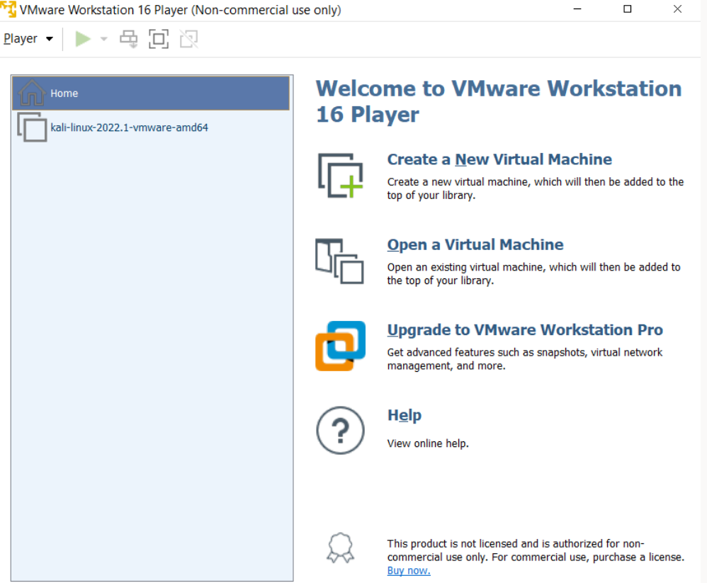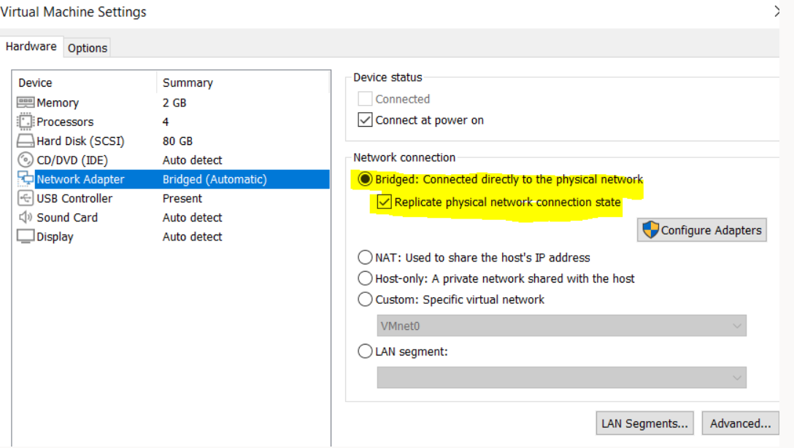

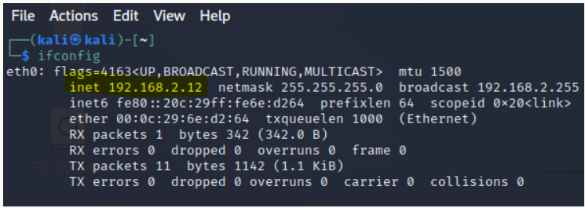

ETHICS FORM
APPLICATION FOR ETHICAL APPROVAL

In order for research to result in benefit and minimise risk of harm, it must be conducted ethically. A researcher may not be covered by the University’s insurance if ethical approval has not been obtained prior to commencement.

The University follows the OECD Frascati manual definition of research activity: “creative work undertaken on a systematic basis in order to increase the stock of knowledge, including knowledge of man, culture and society, and the use of this stock of knowledge to devise new applications”. As such this covers activities undertaken by members of staff, postgraduate research students, and both taught postgraduate and undergraduate students working on dissertations/projects.

The individual undertaking the research activity is known as the “principal researcher”.

Ethical approval is not required for routine audits, performance reviews, quality assurance studies, testing within normal educational requirements, and literary or artistic criticism.

Please read the notes for guidance before completing ALL sections of the form.

This form must be completed and approved prior to undertaking any research activity. Please see Checklist for details of process for different categories of application.

SECTION A: About You (Principal Researcher)

Full Name: |  |  | Geraint Arfon Hill
Tick all boxes which apply:
Member of staff: | ☐ | Student: |  | ☒ | Honorary research fellow: | ☐

Faculty/School/Centre: | University of Wales Trinity St Davids
Campus: | Bay Campus
E-mail address: | 9900497@student.uwtsd.ac.uk
Contact Telephone Number: | 07908269850
For students:
Student Number: | 9900497 | Undergraduate | ☒
Programme of Study: | Cyber Security and Networking | Taught Postgraduate | ☐
Director of Studies/Supervisor: |  | Research | ☐

SECTION B: Approval for Research Activity

Has the research activity received approval in principle?  (please check the Guidance Notes as to the appropriate approval process for different levels of research by different categories of individual) |  | YES | ☐ | NO | ☒
 |  |  |  | Date
If Yes, please indicate source of approval (and date where known): | Research Degrees Committee |  | ☐
 | Faculty Research Committee |  | ☐
 | Other (write in) |  | ☐
Approval in principle must be obtained from the relevant source prior to seeking ethical approval.

SECTION C: External Ethical Guidance Materials

Please list the core ethical guidance documents that have been referred to during the completion of this form (including any discipline-specific codes of research ethics, and also any specific ethical guidance relating to the proposed methodology). Please tick to confirm that your research proposal adheres to these codes and guidelines.
☒
☐
☐

SECTION D: External Collaborative Research Activity

Does the research activity involve collaborators outside of the University? |  | YES | ☒ | NO | ☐
If Yes, please provide the name of the external organisation and name and contact details for the main contact person:
Institution | WAST healthboard
Contact person name | Tony Raine
Contact person e-mail address | Tony.raine@wales.nhs.uk

Where research activity is carried out in collaboration with an external organisation
Does this organisation have its own ethics approval system? | YES | ☐ | NO | ☒
If Yes, please attach a copy of any final approval (or interim approval) from the organisation

SECTION E: Details of Research Activity

Indicative title: | Securing the Data Link Layer (L2) on the WAST network infrastructure
Proposed start date: | 09/2018 | Proposed end date: | 07/2022
The aim of this report is to evaluate if the current L2 implementation at WAST is secure enough or if further measures can or need to be implemented to ensure WAST are in the optimal posture and are adequately protected against threats and vulnerabilities.

1.2 Objectives

To meet the aim, the following objectives will need to be met:

- Research L2 protocols that are used across the WAST health board and identify best practices for securing them
- Conduct an extensive analysis of L2 protocols on existing WAST network
- Replicate the existing infrastructure in a home lab environment
- Identify the vulnerabilities and implement the recommended mitigations safely
- In a testing environment, apply configuration to enable the mitigations and interrogate them by attacking the specific protocols
- Evaluate the results of the mitigations and decide if there’s a business case to implement them
- Provide the IT Ops board with a clear plan to implement the new measures on the production network
It is predicted that most of the security measures offered in this report will be applied on a small site before implementing across the board, eventually to the main sites upon its success.

The report should re-invent and future proof the existing configuration that is currently copied to L2 devices and act as a baseline for future deployments.

Proposed methods
Provide a brief summary of all the methods that may be used in the research activity, making it clear what specific techniques may be used. If methods other than those listed in this section are deemed appropriate later, additional ethical approval for those methods will be needed. (Maximum 600 words)
To implement these changes on the WAST production network could cause some disruption to critical services, such as the 999 telephony and services and also the less urgent 111 calls, however these services need to be considered as crucial as each other. Complacency when bulk configuring these devices could be an issue. WAST do not have a central management for pushing out configuration and rely on engineers like myself to configure devices. To ensure that configuration is correctly applied, it is important that under any circumstance a Change control process is adhered to and that the work is suitably planned, understood and communicated. Failure to do this will result in loss of confidence.

Location of research activity
Identify all locations where research activity will take place.
Initially at VPH HQ in Cwmbran where author is based.

(this box should expand as you type)
Research activity outside of the UK
If research activity will take place overseas, you are responsible for ensuring that local ethical considerations are complied with and that the relevant permissions are sought. Specify any local guidelines (e.g. from local professional associations/learned societies/universities) that exist and whether these involve any ethical stipulations beyond those usual in the UK (provide details of any licenses or permissions required). Also specify whether there are any specific ethical issues raised by the local context in which the research activity is taking place, for example, particular cultural sensitivities or vulnerabilities of participants.
(this box should expand as you type)

SECTION F: Scope of Research Activity

Will the research activity include: | YES | NO
Use of a questionnaire or similar research instrument? | ☐ | ☒
Use of interviews? | ☐ | ☒
Use of diaries? | ☐ | ☒
Participant observation with their knowledge? | ☐ | ☒
Participant observation without their knowledge? | ☐ | ☒
Use of video or audio recording? | ☐ | ☒
Access to personal or confidential information without the participants’ specific consent? | ☐ | ☒
Administration of any questions, test stimuli, presentation that may be experienced as physically, mentally or emotionally harmful / offensive? | ☐ | ☒
Performance of any acts which may cause embarrassment or affect self-esteem? | ☐ | ☒
Investigation of participants involved in illegal activities? | ☐ | ☒
Use of procedures that involve deception? | ☐ | ☒
Administration of any substance, agent or placebo? | ☐ | ☒
Working with live vertebrate animals? | ☐ | ☒
Other primary data collection methods, please explain in this box | ☐ | ☒

If NO to every question, then the research activity is (ethically) low risk and may be exempt from some of the following sections (please refer to Guidance Notes).

If YES to any question, then no research activity should be undertaken until full ethical approval has been obtained.

GLOSSARY

WAST – Welsh Ambulance Service Team. A health board in Wales that organises ambulatory care.

LAYER 2 – Data Link layer. The protocol data unit is a frame. Switches reside on this layer of the Open System Interconnection Model.

SBUHB – Swansea Bay University Health Board. A health board in South Wales where the author worked.

RFC – Request for Comments. Where protocols are documented for Information Technology purposes.

DHCP – Dynamic Host Configuration Protocol. Used to autonomously issue Internet Protocol Version 4 (IPv4) addresses to hosts.

STP – Spanning Tree Protocol. A protocol that ensures a loop free network. Enabled by default on switches.

RSTP – A mode of Spanning Tree Protocol. Known for its simplicity and rapid convergence time.

HSRP – Hot Standby Routing Protocol. A redundancy protocol.

CDP – Cisco Discovery Protocol. Cisco Propriety protocol to display what other Cisco devices are connected. The open standard equivalent is Link Layer Discovery Protocol (LLDP).

VTP – VLAN Trunking Protocol. A way to manage VLAN’s easily over the network.

DTP – Dynamic Trunking Protocol. Enabled by default, allows switches to dynamically form trunk links between them.

OSPF – Open Shortest Path First. An interior routing protocol that uses link states to make routing decisions autonomously.

VPH – Vantage Point House. The building in South Wales that WAST use as a headquarters (HQ).

VLAN – Virtual Local Area Network, A segmented network used to increase broadcast domains.

