Reflective Portfolio

Module: Professional and Career development
Student Name: Aliyah Hussain
Student Number: 1814483
Module Leader: Olu Adegbite
Module code: BMSW 40

Executive summary

This will be a reflective portfolio which will be split in two different parts. One will be a discursive report, which will explain about me, and the second one will be the reflective report.

Contents
Introduction 4
A. Discursive report 5
Introduction 5
Body 5
Conclusion 9
B.Reflective report 9
Introduction 9
Body 9
Conclusion 11
Conclusion 13
References 14
Appendices 15

Introduction

In this report they will be two kinds of types which will discursive report and a reflective report. They will be two kinds of tools that will be used to help this report which will be the Johari Window and the Psychometric test we did in the lesson. As we have learnt this in lesson going to expand how this would help in different kind of careers. What we have experience and what we have learnt from this. In part B of the report will be explaining the steps for an interview how to be prepared for it. However will be a better understanding of Curriculum vitae, how this is used to for applying jobs. Will be an action plan shown for my personal goals, and different employment goals. Finally from the feedback was given we will explain the parts that could be improved, does that reflect me in person.

Discursive report

Introduction
In this discursive report will base on the results obtained from use of one of the self-awareness test tools which where learnt in the class. The main three self-awareness test tools are, SWOT, The Johari Window and last one is the psychometric test. By using this test tools I will be combining them together to make a better understanding for my career aspiration and the progression even if there is obstacles in the way how I would work towards to reach my goals

Body
Self-wareness is an awareness of one's own personality or individuality (Merriam-webster.com, 2019). The meaning of this is you got to know your own character in life, to reach in different goal you would like to accomplish in. I very important to know yourself, as it would help for different careers in life.
In class we learnt three kinds of tools that could help us in our career path one is the Johari window which will be explained what we have learnt from this and how it can help in the future. Also there is SWOT where it is important to combined them together as you can work together to understand what you can improve on and the finally one is psychometric test which gives you a better understanding of your personality. As you can see in the appendices I have put the Johari window table show example but below they will be one of me to explain about my self-awareness as we did in groups to understand each other’s skills. The Johari Window Model was created in 1955 by Joseph Luften and Harry Ingham. The name is derived from the first names of the creators (Mulder, 2020). This model can help people to have a better understanding when communicating with others. It is good to give feedback to people as sometimes they not aware of their behaviour or it could be that they are aware of their behaviour, but not admit that quickly. This is where The Johari Window Model could help with this; it provides insight into the behaviour of yourself and others. This is where it is broken in to 4 equal quadrants, each showing a different part of your or others inner-self. The four different parts of The Johari Window Model are, open area, blind area, hidden area, unknown area.
The open area- this is the information that is based on the persons, behaviour, attitude, feelings, emotions, knowledge, etc. This is known by the person themselves or could be known by the group others (Businessballs.com, 2020). This is where it shows that you know yourself and which the group knows about you. This is where you would be happy to talk about, sometimes it is important to discuss clearly things we know or that the others know, so it is more direct. This is where the other makes out to be a certain way but you may perceive yourself to be different. But the main aim is to have this in the group because when you are working in this area with other people we are at our most effective and productive as well as the group is as well. This can give good communications with each other by having fewer distractions, confusion, conflicts (Businessballs.com, 2020).
The Blind area- this is where it is viewed differently from others and we look at ourselves in different ways. This is where the others know about you which are unaware of. This is where people would think twice to open up to us just in case there hurt our feelings, or they even must of tried to tell us our blind spots but we do not pay attention to it. But this is where in group or work environment you can take some responsibilities for helping individual to reduce their blind area, by giving them feedback and encouraging disclosure.
The hidden area- this is where you know stuff about yourself but others does not know about you. It depends on what you share with others but this is all based on the relationship and trust we have with others around us. Some information we do not like to share as we might not be comfortable about it. This area can be hidden sensitive, fears, manipulative intentions, secrets, anything that they know but will not reveal it (Businessballs.com, 2020).
The unknown area- this is where the information about yourself the other would not know either yourself.
The reason why this is important is that it can help in different kind of ways in life. Specially working in a work environment it helps the managers or the colleagues to know you better and have a better understanding with yourselves. This is important where you want to ask yourself what you would like to achieve in your training or anything that you are doing. Also I would advise you to put your outputs and how will you measure that they have been achieve. This is how the Johari Window theory and principles can be used to assist this (Businessballs.com, 2020). By doing the Johari window has told me things I didn’t expect to know about myself and learnt things that I need to work on this is where I would use the SWOT to help me to improve in different situations. 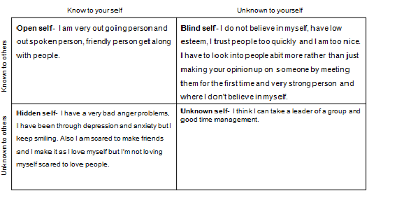
By me doing this Johari Window has helped me a lot I have found things that I didn’t understand which I used thing that was my weakness which is where the SWOT analyse comes in. One of my weaknesses is one of the blind spots; I can trust people too quickly without understanding them sometimes, where as this a threat as well for my future personal career plans. Given a good example for this if I reach my goal which is to have my own business and we are doing a deal I would take things for words without going back thinking to given an answer. To turn this over to make it to my strength I would go and think about the deal and read through everything to understand what can of deal I would be making to any kind of business that will be contributed towards my personal career plan. But as you can see in the open self to me this is strength as it would show that I can communicate with different kind of people and understanding how they would like to be around people. The hidden spot is where it’s a secret I keep to myself for no one to know but in my opinion I think this would be a threat, as in a working environment I would have to be calm and handle the situation in a correct manner. By resolving this situation I would learn to understand each other point of view from the situation then I would analyze it and then give feedback to solve the solution. The unknown part which I have learnt myself by doing is that I could be a leader ship which I was kind of didn’t expect, where as this is a strength for me to carry on and would come under one of the others which is the opportunities as it would be given be better ideas for making progression to my goal.
the Psychometric test which was revealing about myself and which I am defender as you can see in my appendice that I have added the test I done to know my personality to what I think I am. The meaning of defenders is true altruists, where I would be kind to people as I would like to me treated back. Engaging with the work and the people they are comfortable with and with enthusiasm and generosity (16Personalities, 2020). This is test helps yourself in different ways as you would pick up to understand. This is an unknown self where I didn’t know about myself that I am a defender, as you can see I am 82% of introverted and 18% is the extraverted. This means that I am layed back to myself I like to be a closed book not let everyone know things about me and like my own company most of the time which is one of the Johari Windows hidden self. Whereas extraverted means you’re outgoing person like to be loud and like to be heard. The work I will be time management which is a bigger strength this is showing I am punctual at all time and can be relied to my job on time. From this I have learnt the different kind of weakness I have got which I would have to learn standing to stand up for myself to say no for myself to maintain my confidence and enthusiasm (16Personalities, 2020). I have learnt myself of introverted build in the process shields accepts, which I could put in my career plan. My purpose of this test is to have a better understanding using the other models to help me to improve it. For example there is one model which is SMART and they stand for specific, measurable, achievable and time bond. However this is where you would have a 5 years plan in your specific role you would like to do. Even if obstacles come your way but you would be unfolding the blind facts to get there might not be a straight line and be swirl to get there. Therefore you would use the SWOT to help to understand the issues solve the solution. This test has found strengths I didn’t know about myself which I am reliable and patient. I would like to say I would like to go beyond the aim. Reading through my test to understand if I have any weakness I have fare few, which I could be a threat for later on career I have. As a defender I would over load myself with situations, as I would struggle to meet everyone expectations. But over all this is an open self as I would let people know what I am trying to explain show to them and I wouldn’t ask for help as I would feel like I am being a burden to them. However this can fall in to different categories which I personally could be strength, weakness, opportunities, therefore change the ways I work around different kind solutions. As I would to like to have a business of my own in the future this could be obstacles to get to my goal. Demonstrating a personal action plan, as you can see in the appendices vie have done a brief demonstrating to where I would like goals to be. However they will be obstacles that I will be tackling to get where I want but myself determent to achieve my goal. I could have so many opportunities where I could take place to get help be and even in my psychometric test as it shows I am defender and it’s not what I would be comfortable with this is an unknown self.

Conclusion
The whole understanding of this was to demonstrate and show a better understanding of each of the test and how I would use them in my personal life and to achieve. Knowledge things I didn’t know about myself and to maintain and work around it.

B.Reflective report

Introduction
In this reflective report will be explaining about the job search we did and the steps of each to get to an interview. Also will be using the Gibbs Cycle to write the reflection of the whole feedback I was given and how I felt when preparing for the interview. You will have a better understanding of the importance of the job advert. This will show you as well how this could influence our career development.

Body
Job description is the responsibilities written and all the duties that would be taken place for the position for the job (Collinsdictionary.com, 2020). As you can see in the appendices of the job description what they are looking for. This job is bases in a play centre environment for the people have disabilities or additional need and their siblings. As this job is seeking for a service coordinator and lead play practitioner and will be working in mid- January. However the description says 20 hours of service coordinator and 10 hours a week a delivery leader. Person specification is where the job candidate must have in order to complete the task the company is offering. This is where it could be base on the outline of the educational requirements and the training experience as well as your own personal qualifications (BusinessDictionary.com, 2020). The reasons why applied for this job is I personally think that the job description matches my experience I have in me. As there is a copy of the cover letter in the appendices, as this is bases on my career plan I would like do in future is to have my own business with helping people with different kind of disabilities and additional circumstances. I have knowledge in developing, keeping the team working.
CV is short for curriculum vitae, this is where a short written description of yourself such as education, qualifications, pervious jobs and sometimes also your personal interests. This is where you would send to an employer when you trying to apply for a job (Dictionary.cambridge.org, 2020). CV is basically the employee tells us what you do and what they expect of you off this role. Whereas the cover letter means that that the employee would explain in that letter if I had this job I would make a valuable addition to your team. So this is where you’re like sales persons and you trying to make them buy you for what you are saying to them.
So I will be using the GIBBS cycle which is a reflection cycle. This is a frame work of the six stages and can be used to guide reflection. The six stages are description, feelings, evaluation, conclusion and finally action. There is a picture in the appendices to show you the reflective cycle.
Description
This is where we was got told to go away and find a job that we would like to apply for. So I was finding a job that was based on what I like to do and know that I can take different experience I have done ahead with me. By doing this we was preparing for the interview so this is where we had do a Cv based on the person qualification we have or currently we could be doing. However a cover letter is need for the job this is where you kind of tell them all the skills you have and what you will be bringing to the table, where you are being more specific. As the job description was printed out and the CV and the cover letter, then it were time for the preparation for the interview, think what question is going to be asked. The interview is been taken my 2 employee that will be asking question and what we have, what is the reason why we applied for this job. Before leaving the interview this is where we had to write something that comes on our head straight away mine was passion. You have to have passion about your job, as you won’t be enjoying it and you can lose the job if your time management starts to lack and the way you are working in the environment of the job you have applied for.
Feelings
I was very anxious about all this as it was very over whelming over all. Doing the job search was fine by me but sometimes I was getting annoyed as I wasn’t finding the right kind of job till I found this one. I was really struggling to do my cover letter as I thought to myself I was not that good and it made me feel really bad, cause I was worrying if it wasn’t right and I wouldn’t able to improve it there but at the end I got it done. I was happy that I had time to prepare myself for the interview, cause of my anxiety I be really over whelmed about the whole situation. As the time came for the interview I was so nervous that I could tell in there mock interview how nervous I was, I was struggling in different kind of ways, like my mind went full blank like some stuffs was not in the answer but I did not want to be quite and not say anything at all. But wants everything was done I did feel a big realise inside me and I was much calm. In the interview I felt comfortable at all time, they was easy to speak to and I was not pressured which made me feel better in myself. Like the feedback was not as bad as I thought it would be , getting 74% out of 100 I think that is really good and did make me happy but was concerned on some parts which I could work on as I will be explaining next on the evaluation.

Evaluation
I think I have had the good and the bad experience in preparing myself for this and ding the interview as well. I have learnt things in a kind of a different way, which as I though I was correct but I was wrong. I think the good experience is that I know I can do this and I did not have any self belief in me that I could even do this or I would give up quickly. Looking at my feedback from the interview that was taken play for the job advert I saw. Was good and bad experience I had. The good from the feedbacks that I was moderately dressed for the interview however I maintained the eye contact with them at all time. As I was also able to manger my panicking tendencies well. However the bad kind of experience which I think it was where I would need to improve is the use of words in professional conversation. I was slacking on my body language, answering the questions that have been asked and not to be going of the script and explaining a different answer in the interview so staying focus. I was able to identify my weakness but when it was time to explain I was giving slow replies. My CV and my cover letter needed better improvement has most things where missing in them.

Conclusion
I think I could of done better in interview and for preparing as in the CV they was few mistakes and this is where I could of done better, my the information making there was not lot of space between them. Key skills was put in the wrong place and I wasn’t be specific about them so this is where I would update my CV and correct it for the next jobs I would apply for. However you got to keep your employment up to date where as I did not have that and had so many missing gaps which were missing so when they looking at the CV they would not know if I am employed or unemployed at the moment. They were no hobbies and reference and this is where I could have added it to have a better chance of getting the job. The cover letter was simpler problems I need to close the gaps but this is where I would put them together and also I could of written the job title for what I am was applying for and for the signature I just need to bold it.
Action
I think next time I go through an interview I will make sure I am prepared properly I would even rehearse at home so I know what I would be saying. I would be making sure that I use the right vocabulary in the interview and making sure I do not go off the script from the question and to keep it simple and short and which they could understand me more clearly. Writing my weakness down and strengths and reading through them so if they were a question asked on this I would know how to reply to them in a correct manner. Making sure my body language is correct at all times, and before anything making sure my CV is correctly presented and the cover letter is as well. I think next time I would take glass of water in an interview next time so if I was nervous I could give my brain a quick refresh.

Conclusion

They were two kinds of reports I have written which is one is the discursive report and the other is the reflective report. Where the first report was based on the self awareness tools that was used in the class and explain each of them and then combining them together to have a better understanding of each of them and how they come together. Finding this I did not know about myself and how I would resolve situation with the tools. As the second part of the report was base on the mock interview was taken in the class how I was feeling and the outcome of the over all. This is where I used the Gibbs cycle to do my reflective report. This reports was to set up us for our career in future and how you would go about it in interview and how would prepare yourself. This is where to have better understanding in a professional categories.

References

- 16Personalities. (2020). Introduction | Defender Personality (ISFJ-A / ISFJ-T) | 16Personalities. [online] Available at: https://www.16personalities.com/isfj-personality [Accessed 16 Jan. 2020].
- 16Personalities. (2020). Introduction | Defender Personality (ISFJ-A / ISFJ-T) | 16Personalities. [online] Available at: https://www.16personalities.com/isfj-personality [Accessed 16 Jan. 2020].
- Businessballs.com. (2020). Johari Window: Model and Free Diagrams - BusinessBalls.com. [online] Available at: https://www.businessballs.com/self-awareness/johari-window-model-and-free-diagrams/ [Accessed 1 Jan. 2020].
- Businessballs.com. (2020). Johari Window: Model and Free Diagrams - BusinessBalls.com. [online] Available at: https://www.businessballs.com/self-awareness/johari-window-model-and-free-diagrams/ [Accessed 1 Jan. 2020].
- Businessballs.com. (2020). Johari Window: Model and Free Diagrams - BusinessBalls.com. [online] Available at: https://www.businessballs.com/self-awareness/johari-window-model-and-free-diagrams/ [Accessed 5 Jan. 2020].
- Businessballs.com. (2020). Johari Window: Model and Free Diagrams - BusinessBalls.com. [online] Available at: https://www.businessballs.com/self-awareness/johari-window-model-and-free-diagrams/ [Accessed 14 Jan. 2020].
- Collinsdictionary.com. (2020). Job description definition and meaning | Collins English Dictionary. [online] Available at: https://www.collinsdictionary.com/dictionary/english/job-description [Accessed 22 Jan. 2020].
- Dictionary.cambridge.org. (2020). CURRICULUM VITAE | meaning in the Cambridge English Dictionary. [online] Available at: https://dictionary.cambridge.org/dictionary/english/curriculum-vitae [Accessed 21 Jan. 2020].
- Merriam-webster.com. (2019). Definition of SELF-AWARENESS. [online] Available at: https://www.merriam-webster.com/dictionary/self-awareness [Accessed 20 Dec. 2019].
- Mulder, P. (2020). What is the Johari Window Model? Theory, example & template | toolshero. [Online] toolshero. Available at: https://www.toolshero.com/communication-skills/johari-window-model/ [Accessed 1 Jan. 2020]

Appendices

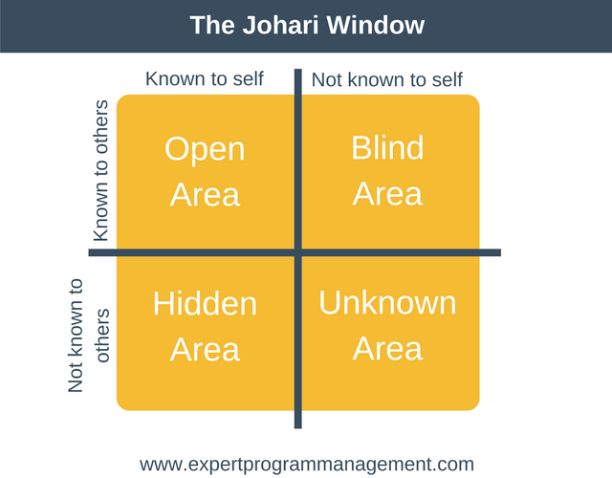
(Expert Program Management, 2020)
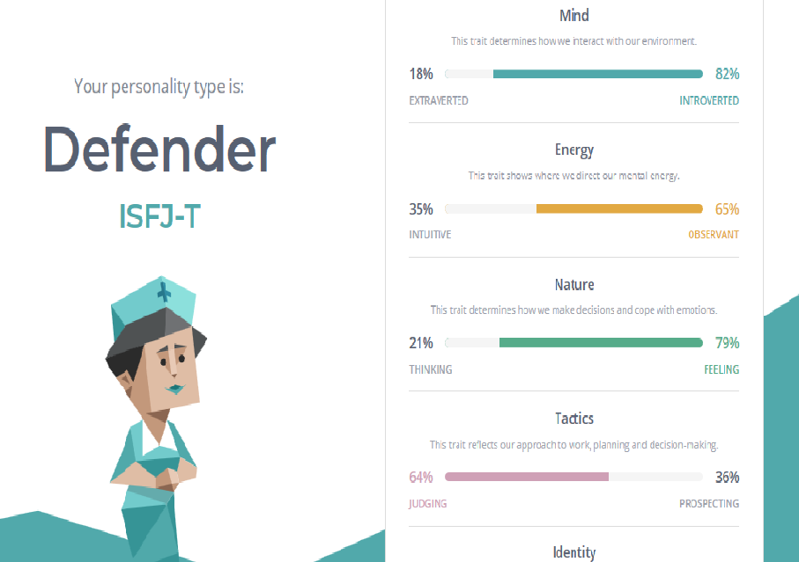
(16Personalities, 2020)

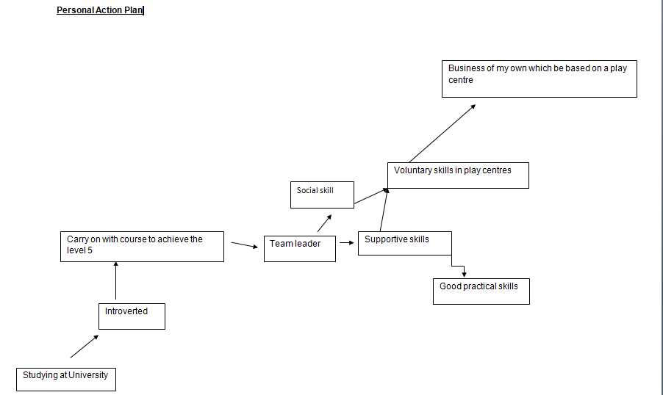
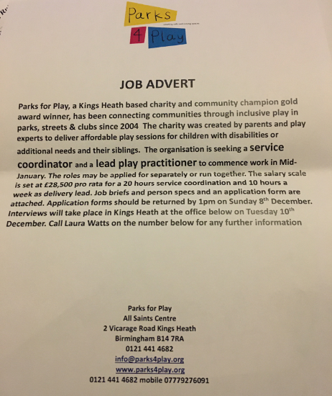
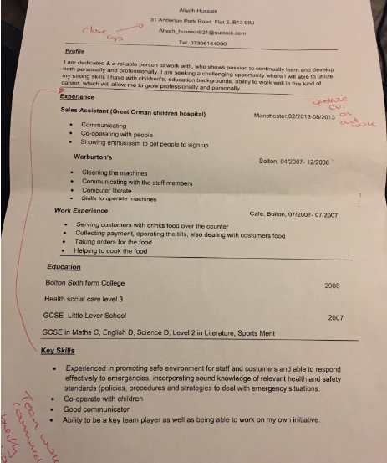

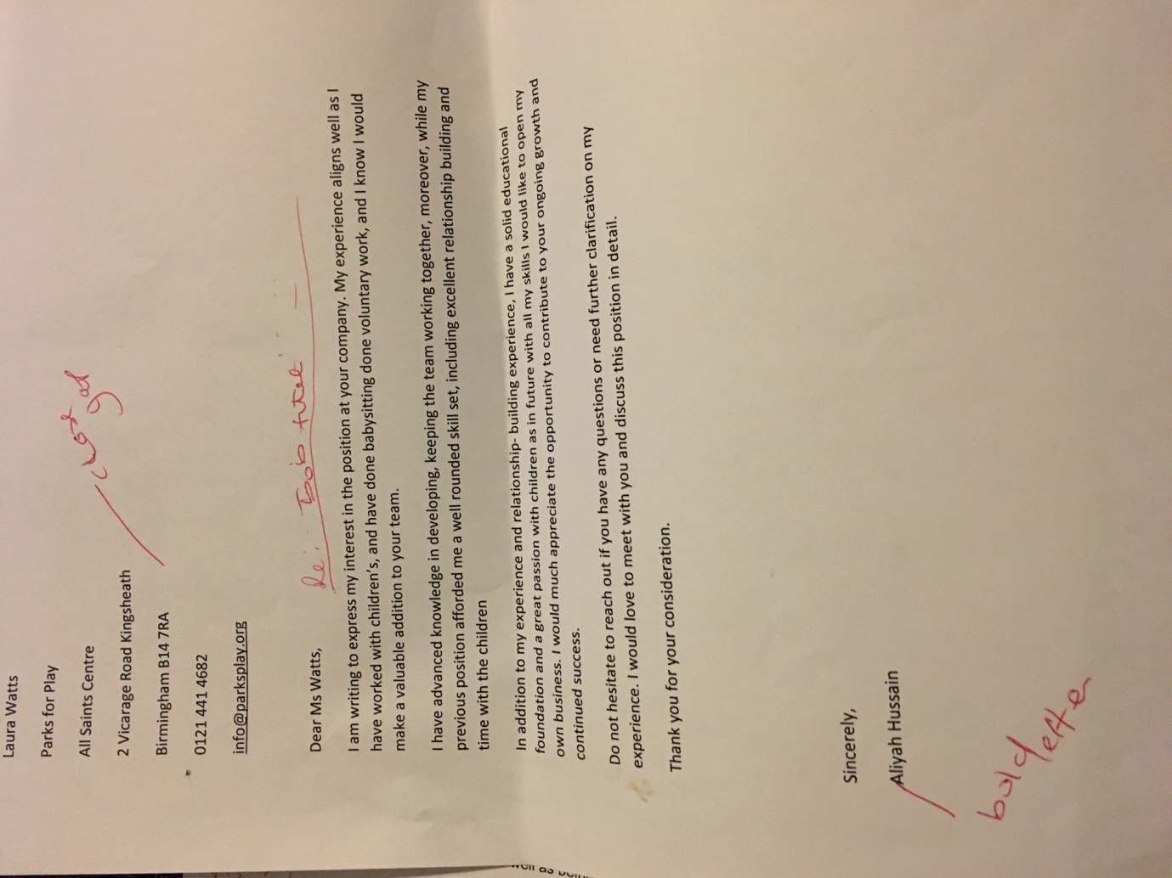

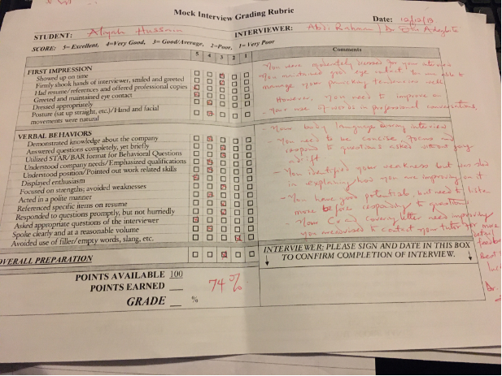

(University, 2020)

